C.V. RAMAN GLOBAL UNIVERSITY

BHUBANESWAR, ODISHA-752054

DEPARTMENT OF COMPUTER SCIENCE & ENGINEERING



C CASE STUDY

SUB GROUP – 23

REPORT ON TOPIC -

“Library Management System”

SUBMITTED BY:

|  |  |  |
| --- | --- | --- |
| NAME | BRANCH | REGD NO |
| RISHAV RANA | CSE | 2201020027 |
| ROSHAN KUMAR | CSE | 2201020114 |
| HARSH VATSA | CSE | 2201020084 |
| VIVEK KUMAR DEO | CSFE | 2201020691 |
| RAKESH KUMAR | CSIT | 2201020880 |

**CONTENT**

* Introduction
* OBJECTIVE OF THE LIBRARY MANAGEMENT SYSTEM
* Technology Stack Used in Library Management System
* Library Management System Workflow
* Source Code
* Output
* Real-Life Applications
* **Advantages of Library Management System**
* Conclusion
* Reference

**INTRODUCTION**

A Library Management System (LMS) is a software application designed to manage and automate the day-to-day operations of a library. Traditionally, libraries maintained physical records for book inventory, member details, and book transactions, which was time-consuming and prone to human errors. A Library Management System helps to streamline these processes by digitizing records and enabling efficient book tracking, member registration, and transaction management.

The primary goal of an LMS is to simplify library operations, making it easier for librarians and users to access, issue, and return books. By integrating features such as book cataloging, member management, search functionality, and report generation, the system enhances the efficiency of library staff and improves the overall user experience.

In traditional libraries, book records and membership details are maintained manually, which is prone to errors and inefficiencies. This system replaces manual record-keeping with a structured digital approach, where book and member information is stored in arrays and processed using functions. The program ensures better organization, faster book searches, and easier transaction management.

In modern libraries, managing thousands of books and hundreds of members manually is inefficient and error-prone. A Library Management System (LMS) automates these processes, making operations seamless and effective. Libraries in schools, colleges, universities, public libraries, and corporate institutions use such systems to handle their vast collections efficiently.

OBJECTIVE OF THE LIBRARY MANAGEMENT SYSTEM

The **Library Management System (LMS)** is designed to **automate and streamline** the operations of a library, replacing traditional manual record-keeping with a **digital and efficient** approach.

#### ****Key Objectives:****

### ****1. Automate Book and Member Management****

* **Problem:** Manually maintaining book records and member details is time-consuming and prone to errors.
* **Solution:** LMS allows librarians to **digitally store, update, and retrieve** book and member details in an organized manner.

### ****2. Reduce Manual Errors****

* **Problem:** Paper-based records can be lost or misplaced, and manual data entry increases errors.
* **Solution:** The system ensures **accurate and error-free** record management using structured data storage (arrays and structs).

### ****3. Improve Book Tracking****

* **Problem:** Finding whether a book is available or issued manually is difficult.
* **Solution:** The LMS allows users to **check book availability instantly** before issuing.

### ****4. Efficient Book Issuance Process****

* **Problem:** Manually tracking which member has borrowed which book is difficult.
* **Solution:** The system **updates the book quantity and member’s book count** after each issuance, ensuring a proper record.

### ****5. User-Friendly Interface for Librarians and Members****

* **Problem:** Complex systems make it hard for librarians to manage books and members.
* **Solution:** The LMS provides a **menu-driven system** with simple options to perform all tasks like adding books, adding members, issuing books, and displaying available books.

### ****6. Scalability for Future Enhancements****

* **Problem:** Traditional systems cannot easily adapt to growing libraries.
* **Solution:** The LMS can be extended with **database storage, fine calculation, book returns, search functionalities, and a graphical interface** in the future.

### Technology Stack Used in Library Management System

The Library Management System (LMS) is developed using the **C programming language**, utilizing basic data structures and standard libraries for efficient book and member management.

#### ****1. Programming Language: C****

* Provides **fast execution** and **low memory usage**.
* Well-suited for **command-line-based applications**.

#### ****2. Development Environment****

* **GCC (GNU Compiler Collection)** – Compiles and runs the C program.
* **Code::Blocks / Dev-C++ / Visual Studio Code** – Commonly used IDEs for development.

#### ****3. Libraries Used****

* **stdio.h** – Handles input/output functions (printf(), scanf(), fgets()).
* **stdlib.h** – Provides memory management and system functions (exit()).
* **string.h** – Supports string operations (fgets(), strcspn()).

#### ****4. Data Structures Used****

* **Structures (struct)** – Organizes book and member details in a single entity.
* **Arrays** – Stores multiple books and members efficiently.

#### ****5. Menu-Driven Interface****

* Uses **Switch Case (switch)** statements for an interactive menu.

#### ****6. Input Handling Techniques****

* Uses **fgets()** for safe string input.
* **getchar()** is used to handle input buffer issues.

Library Management System Workflow

1️ **Librarian Adds Books**

* The librarian enters book details such as **title, author, book ID, and quantity** into the system.
* The system stores the book data in a structured format for easy retrieval.

2️ **Member Registration**

* A new member registers by providing their **name and personal details**.
* The system assigns a **unique member ID** for identification.
* The member ID helps track issued books and borrowing history.

3️ **Book Borrowing Request**

* A registered member selects a book and requests to borrow it.
* The system identifies the member using their **unique ID** and checks their borrowing history.
* If the member has reached the borrowing limit, the system **denies the request**.

4️ **Availability Check**

* The system **searches the database** to check if the requested book is available.
* If the book is **out of stock**, the system notifies the member and places them on a **waitlist**.

5️ **Book Issuance**

* If the book is available, the system **assigns it to the member** and updates the due date.
* The system also maintains records to track the **return date** and any overdue penalties.

6️ **Inventory Update**

* The system reduces the book quantity in the inventory.
* If the last copy is borrowed, the book status is updated to **"Unavailable"**.
* If the book is returned, the system **restores its availability** in the database.

SOURCE CODE

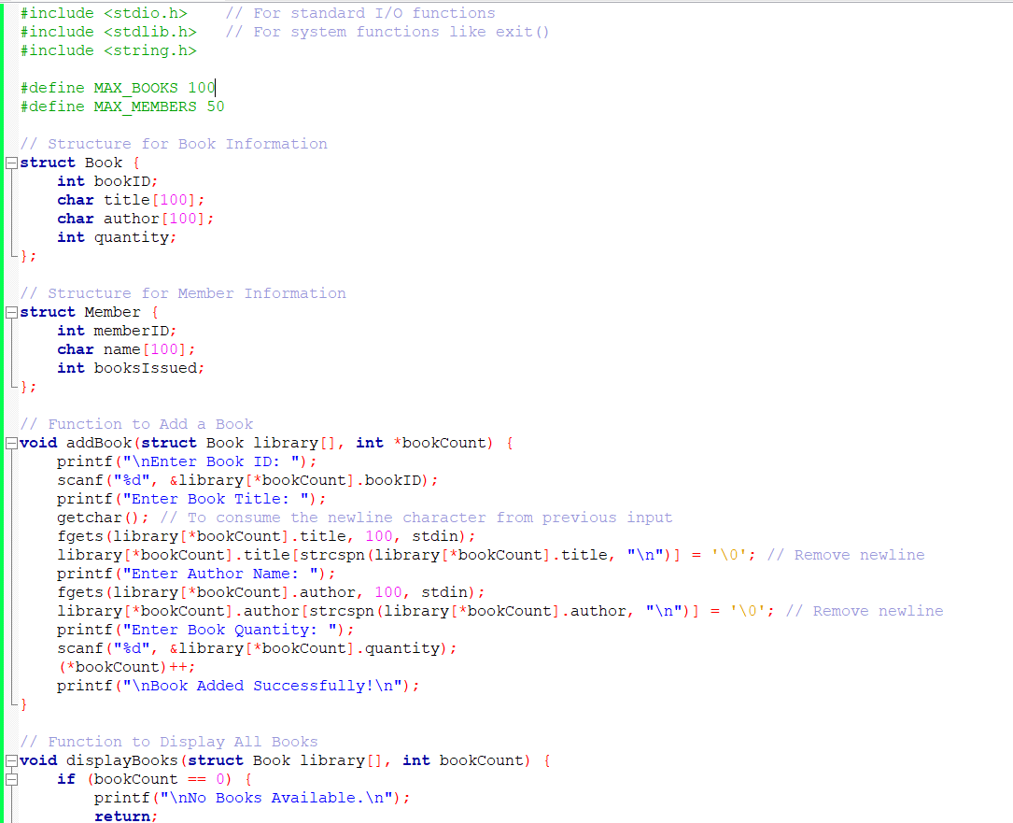

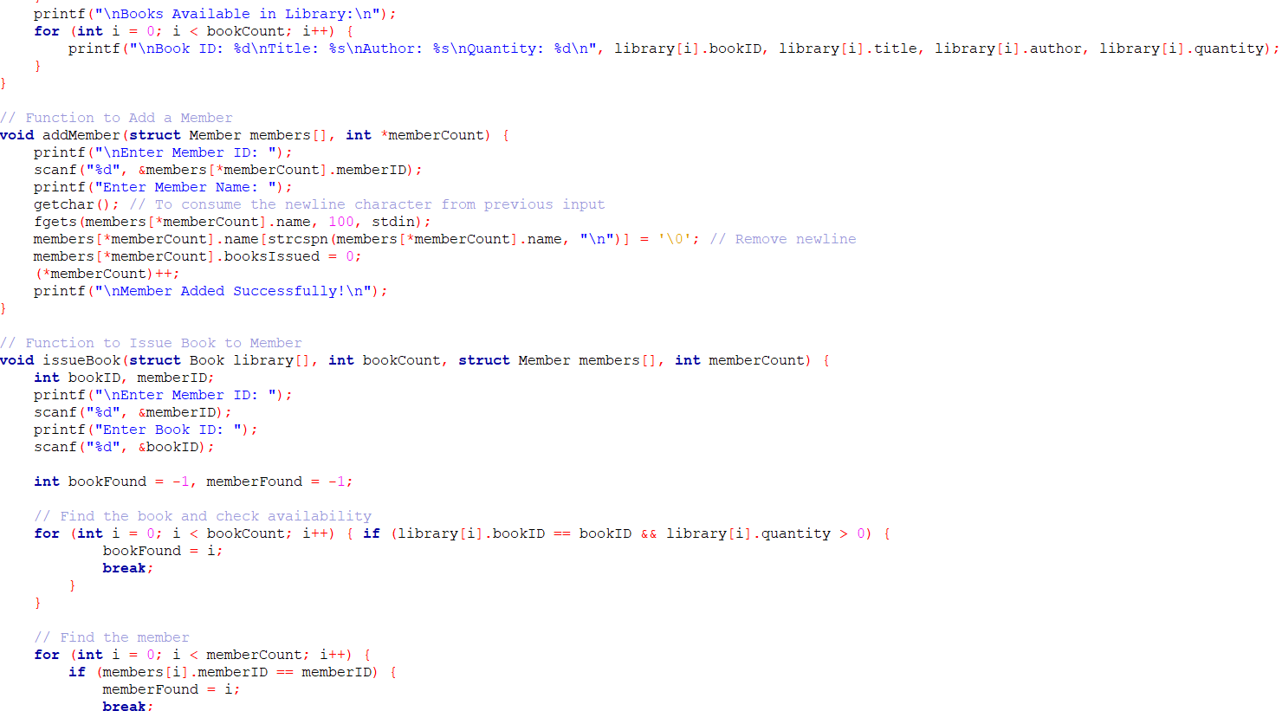

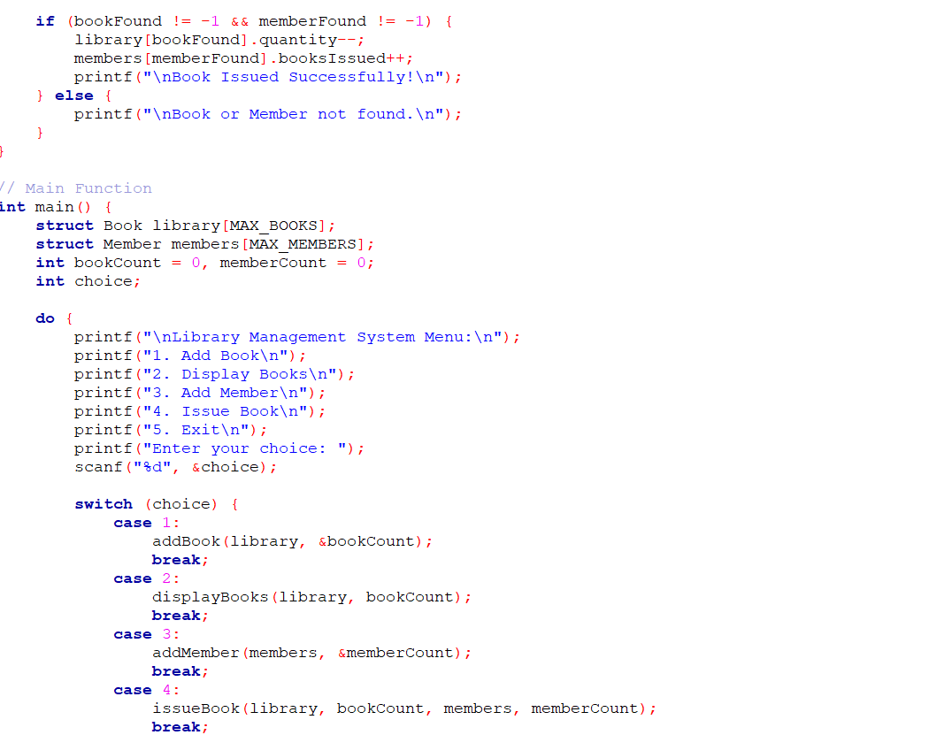

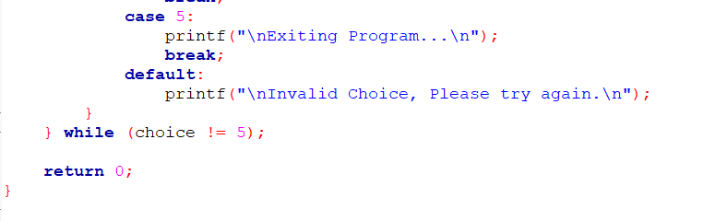

OUTPUT:

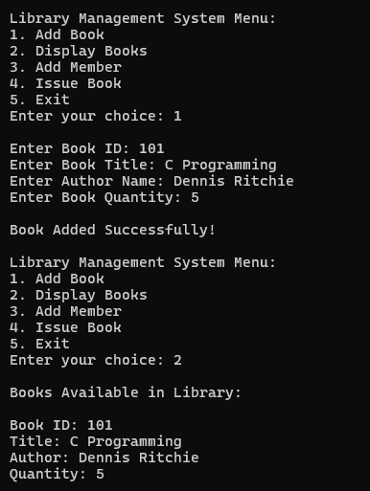

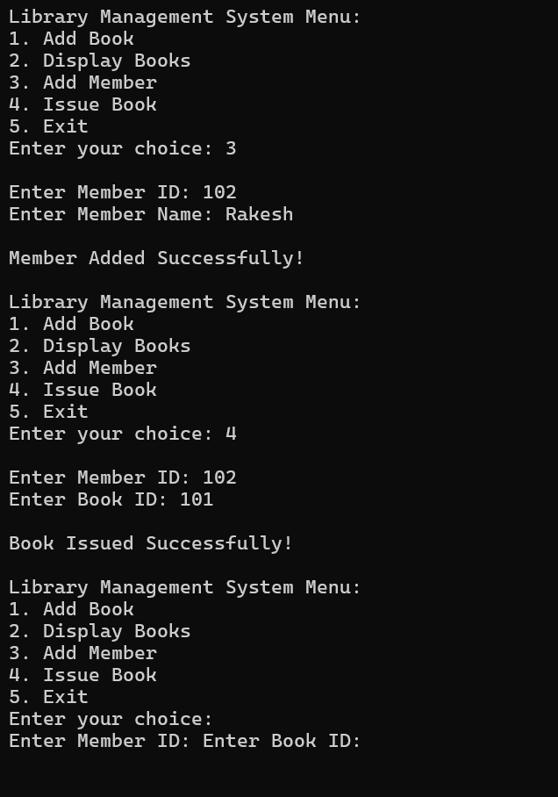

Real-Life Applications

**🏫 Universities & Schools**

* Manage large student book records efficiently.
* Automate book lending and return processes.

**📚 Public Libraries**

* Track books, members, and borrow history in real-time.
* Prevent book loss and improve inventory management.

**🏢 Corporate Libraries**

* Maintain a structured database of books for employees.
* Simplify internal knowledge-sharing and research access

**Advantages of Library Management System** 📚

**Automation & Efficiency**

* Reduces manual work in book management.
* Speeds up book issuing and returning processes.

**🔹 Accurate Record-Keeping**

* Keeps track of books, members, and borrowing history.
* Prevents errors in book transactions.

**🔹 Time & Cost Savings**

* Eliminates paperwork and reduces administrative costs.
* Saves time for librarians and members.

**🔹 Easy Book Search & Availability Check**

* Allows users to search books quickly.
* Checks real-time availability before issuing.

**🔹 Better Inventory Management**

* Updates book stock automatically after each transaction.
* Prevents book losses and misplacements.

**🔹 Secure & Reliable System**

* Protects member and book data from loss or unauthorized access.
* Reduces chances of duplicate entries or missing records.

Conclusion

**Automates library operations** – Simplifies book management, member registration, and borrowing processes.

✅ **Enhances efficiency** – Reduces manual work, minimizes errors, and ensures accurate record-keeping.

✅ **Better inventory management** – Keeps real-time track of book availability and prevents losses.

✅ **Saves time and cost** – Reduces administrative burden and eliminates paperwork.

✅ **User-friendly and reliable** – Provides an easy-to-use interface for both librarians and members.

✅ **Scalable solution** – Suitable for schools, universities, public libraries, and corporate organizations.

Reference

* <https://sist.sathyabama.ac.in/sist_naac/documents/1.3.4/1822-b.e-cse-batchno-66.pdf>
* <https://dl.acm.org/doi/fullHtml/10.1145/3309545>
* <https://doi.org/10.1145/3309545>
* <https://link.springer.com/article/10.1007/s10708-021-10560-w>