# Multiple ways are configured to run the test:

## Directly executing test:

In this case right click on tetscase and run As -> TestNG Test

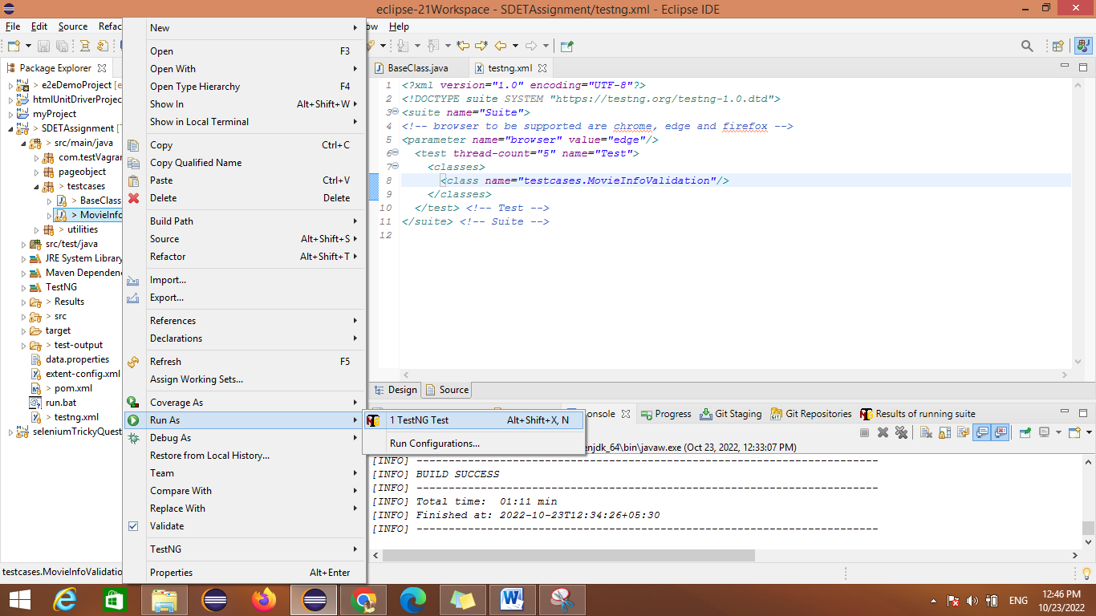

## By testng.xml

Here testing file is having parameter for different browser (chrome, edge and firefox) by default it will run on chrome.

Right click on testing.xml -> run As -> testNG suite

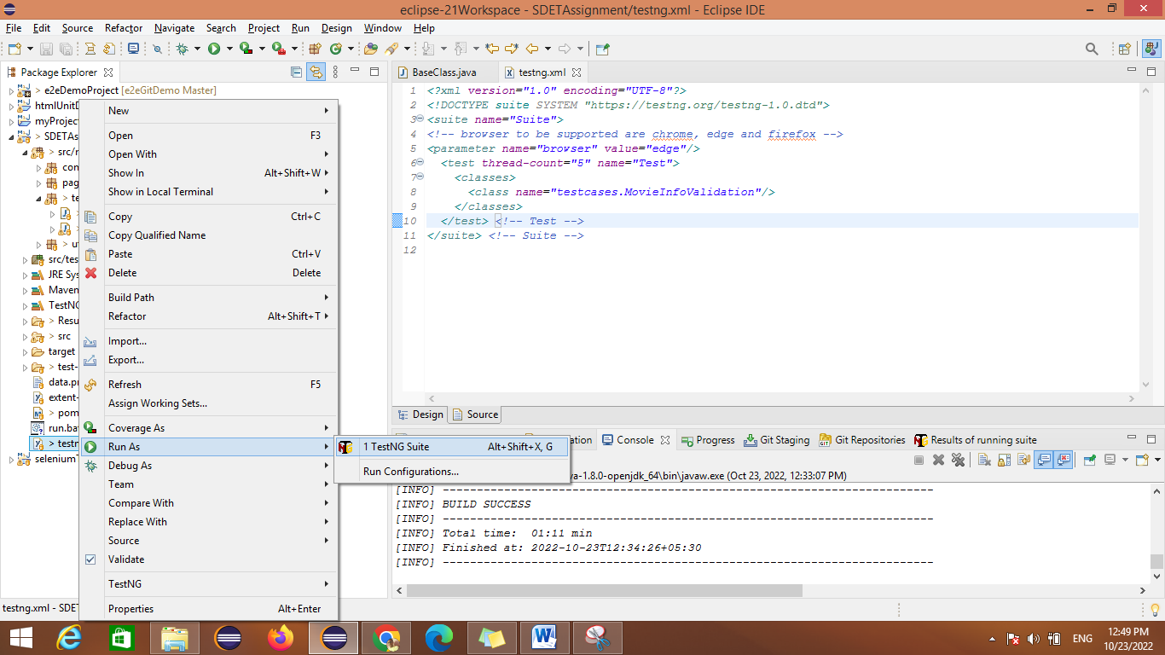

## pom.xml:

Right click on pom.xml -> Run As -> Maven test

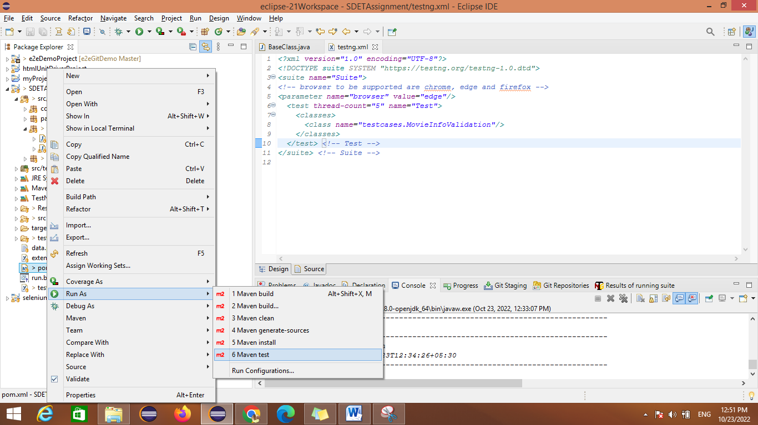

## Command line:

Launch command prompt and change the location using

cd <location of project>

then type command

mvn clean install

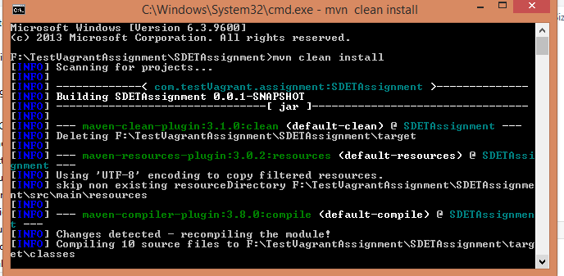

## Batch file

run.batch file is created, double click on the run.bat file

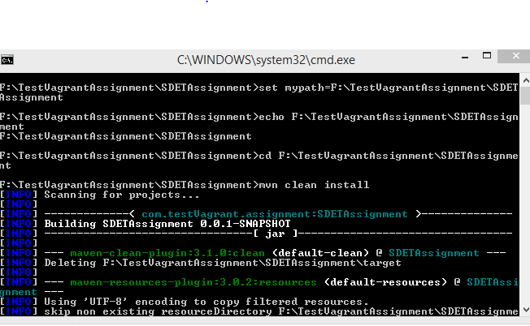

# Reporting:

Reports will found in Results folder

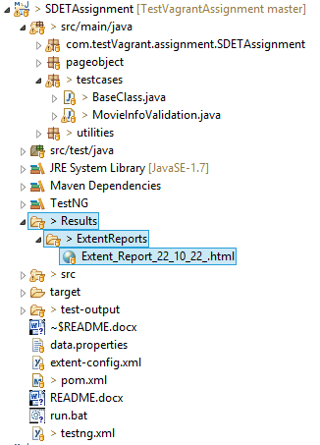

For reporting ExtentReport is used where all the validation will be displayed

Below is the sample report how it look

## Passed report:

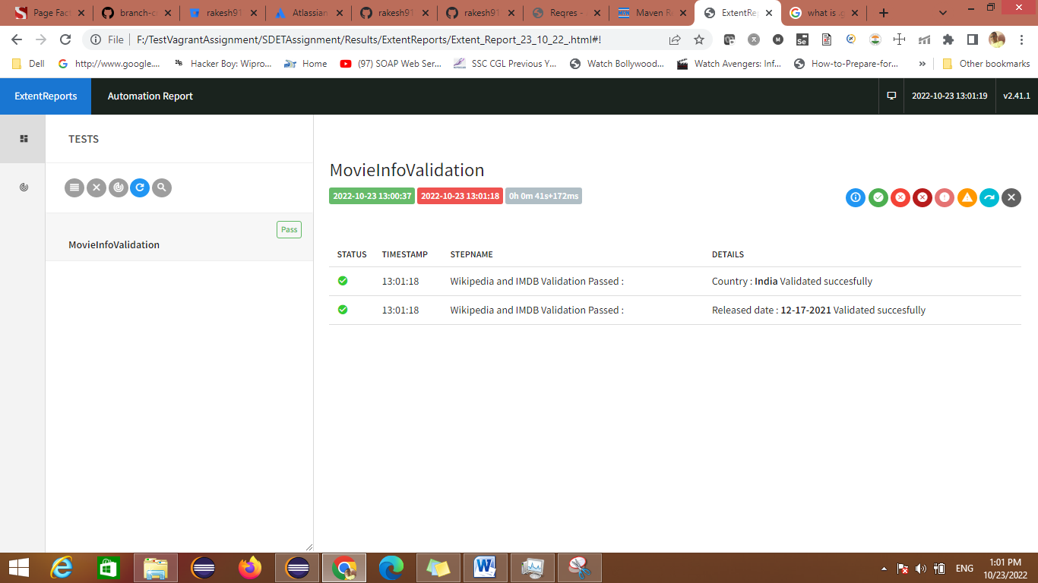

## Failed report:

