SAP CPI Mini Project 1

HTTP-Based Integration using SAP Cloud Integration and Postman

1. Project Title
Building and Testing an HTTP-Triggered Integration Flow in SAP Cloud Integration using Postman

Overview
The objective of this mini-project was to create my first integration flow (iFlow) in SAP Cloud Integration (SAP CPI) and expose it through an HTTP endpoint.
The integration was tested using Postman. Authentication was implemented using the Basic Auth client credentials provided by the SAP BTP environment. Postman was used to authenticate with the BTP Auth endpoint using Client ID and Client Secret
This project helped me understand the basic architecture of SAP Cloud Integration, iFlow creation, HTTP communication, authentication, deployment, and API testing.
Flow Diagram
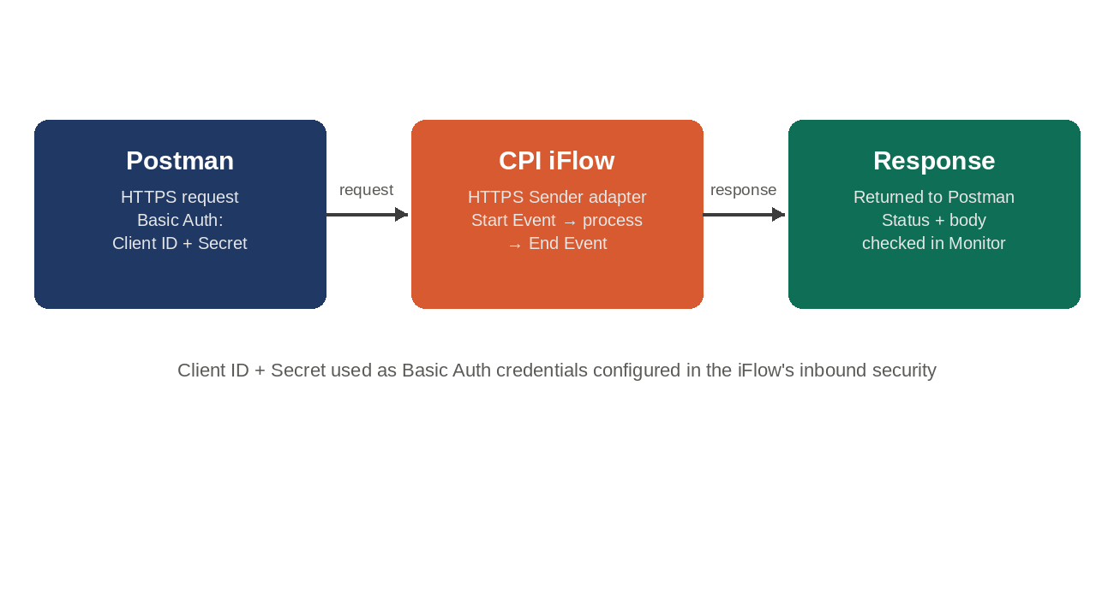

Configuration Summary
iFlow trigger | HTTPS Sender adapter
Authentication | Basic Authentication (Client ID as username, Client Secret as password)
Testing tool | Postman
Request type | HTTPS request to the deployed iFlow endpoint
Verification | Response checked in Postman + Message Processing Log in CPI Monitor

Steps Completed
- Created an Integration Package (CPI Learning Projects) and a new iFlow(HTTP_Postman_Demo) inside SAP Integration Suite
- Added a Start Event, basic processing logic, and an End Event to define the iFlow's execution path
- Configured the Sender side with an HTTPS adapter, defining the address/endpoint path for the iFlow
- Set the inbound security to Basic Authentication so only authorized callers could trigger the flow
- Deployed the iFlow, moving it from design-time into the live runtime
- Opened Postman and created a new HTTPS request pointed at the deployed endpoint URL
- Under Postman's Authorization tab, selected Basic Auth and entered the Client ID as the username and Client Secret as the password from the service key in the BTP account
- Sent the request and received a successful response, confirming the iFlow processed the call correctly
- Cross-checked the run in CPI's Monitor > Message Processing Log to confirm the message was logged and processed without errors

What This Demonstrates
- Practical understanding of the full iFlow lifecycle: design, configure, deploy, test, monitor
- Hands-on use of Basic Authentication as an inbound security mechanism
- Ability to test and validate cloud integration endpoints independently using Postman, a standard tool for API-based integration work

Test Screenshots
IFLOW

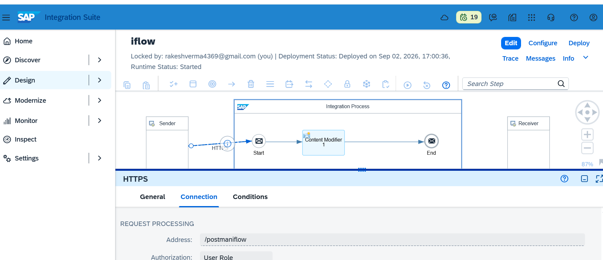

IFLOW EndPoint

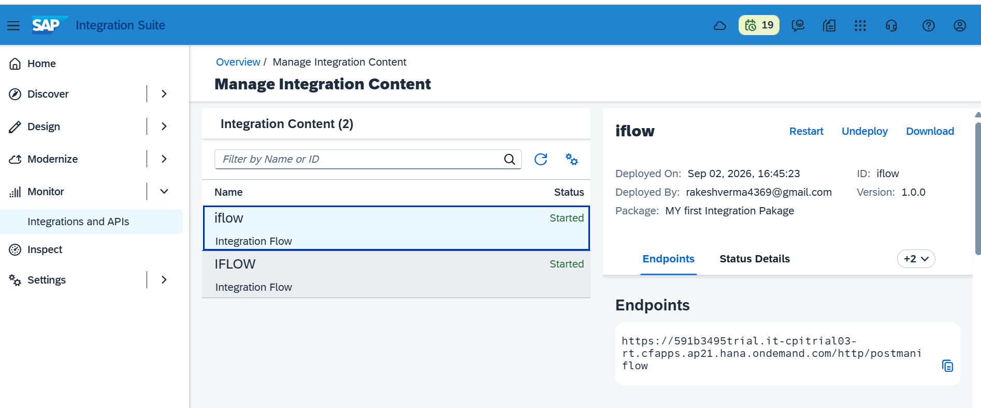

Postman api test result
