**show databases;**

**show tables;**

**-- it show the whole table**

**-- drop table blinkit_data;**

**select* from blinkit_data;**

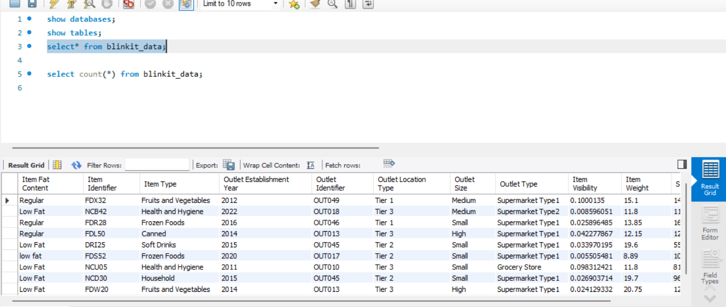

**-- we can count the number of rows in table**

**select count(*) from blinkit_data;**

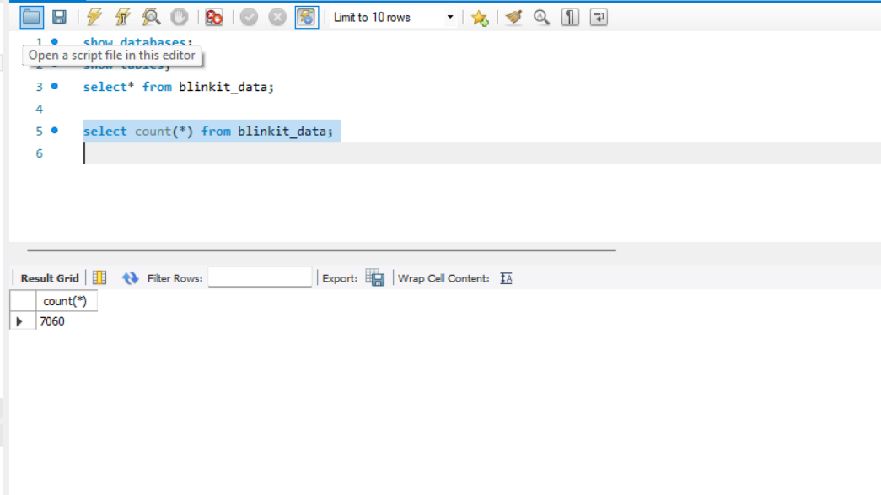

**-- altering the column name**

**alter table blinkit_data rename column**

**ItemFatContent to Item_Fat_Content;**

**-- turn on safe mode**

**set sql_safe_updates=0;**

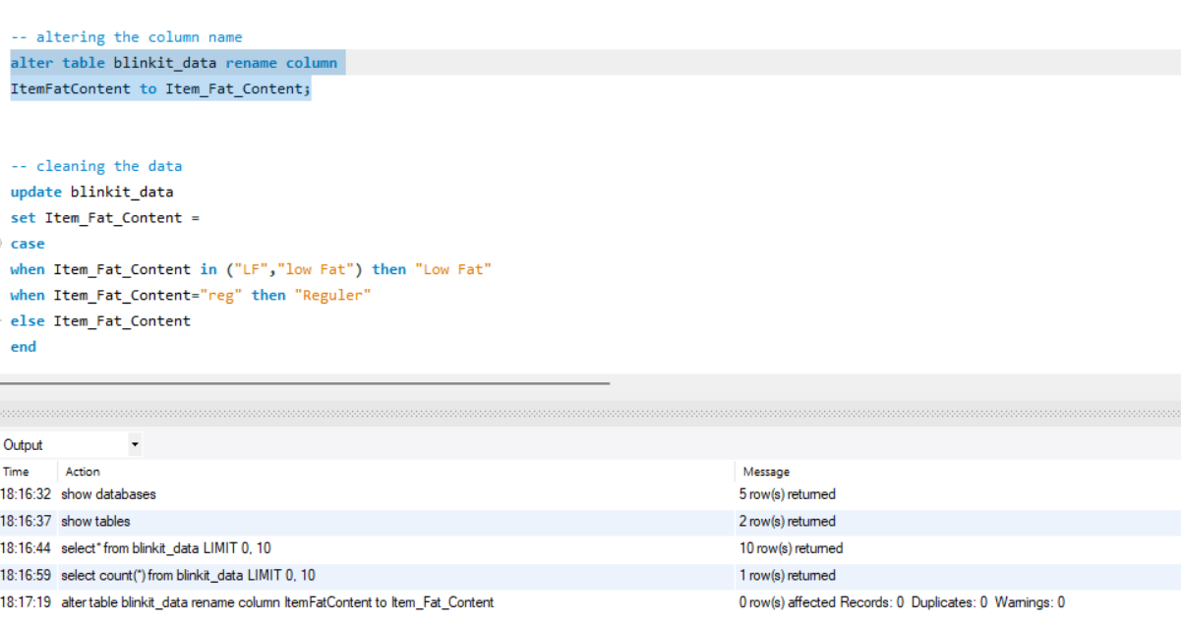

**-- cleaning the data**

**update blinkit_data**

**set Item_Fat_Content =**

**case**

**when Item_Fat_Content in ("LF","low Fat") then "Low Fat"**

**when Item_Fat_Content="reg" then "Reguler"**

**else Item_Fat_Content**

**end**

**-- now all rows are distinct**

**select distinct(Item_Fat_Content) from blinkit_data;**

**-- Blinkit requirements**

**-- KPI**

**-- finding the total sales in millions**

**-- Cast is used to calculate in millions with decimal point**

**select CAST(SUM(Sales)/1000000 as decimal(10,2)) as Total_sales from blinkit_data**

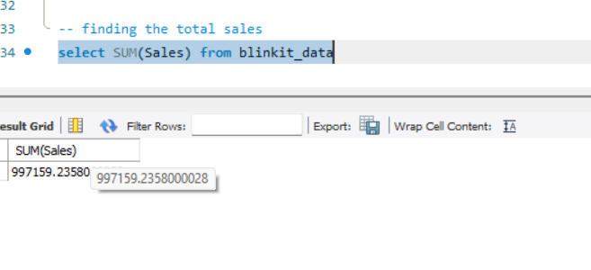

**-- 2. Find out avg of total sales**

**select AVG(Sales) as avg_sales from blinkit_data**

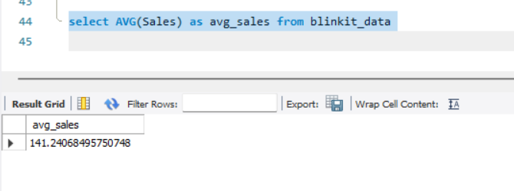

**select CAST(AVG(Sales) asdecimal(10,1)) as avg_sales from blinkit_data**

**select count(*) as NO_of_Items from blinkit_data;**

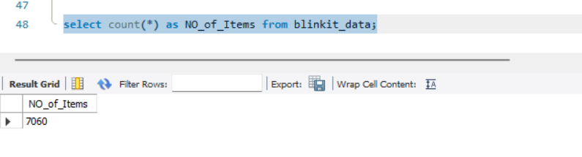

**-- find out total sales for low fat**

**select CAST(SUM(Sales)/1000000 as decimal(10,2)) as Total_sales from blinkit_data**

**where Item_Fat_Content="Low Fat"**

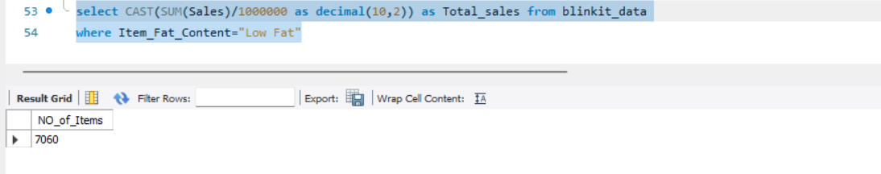

**-- find out for year 2022**

**select CAST(SUM(Sales)/1000000 as decimal(10,2)) as Total_sales from blinkit_data**

**where OutletEstablishmentYear=2022**

**select CAST(SUM(Sales)/1000000 as decimal(10,2)) as Total_sales from blinkit_data**

**where OutletEstablishmentYear=2022**

**-- find out avg rating**

**select avg(Rating) from blinkit_data;**

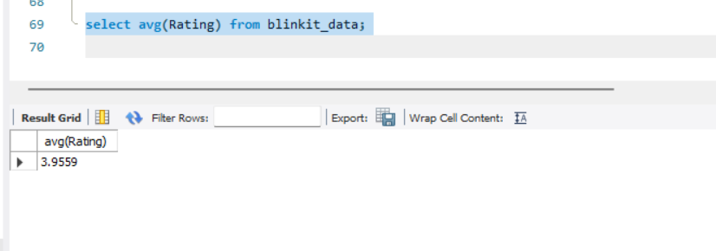

**-- find avg rating with decimal and cast**

**-- Granular requirements**

**-- Total sales by fat content**

**SELECT**

**Item_Fat_Content,**

**CAST(SUM(Sales) AS DECIMAL (10 , 2 )) AS Total_Sales,**

**CAST(AVG(Sales) AS DECIMAL (10 , 2 )) AS Total_Sales,**

**COUNT(*) AS NO_of_Items,**

**CAST(AVG(Rating) AS DECIMAL (10 , 2 )) AS avg_rating**

**FROM**

**blinkit_data**

**GROUP BY Item_Fat_Content**

**ORDER BY Total_Sales DESC**

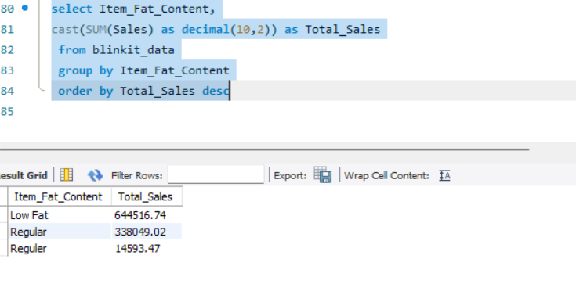

**-- 2. Total sales by item type**

**select Item_Fat_Content,**

**cast(SUM(Sales) as decimal(10,2)) as Total_Sales,**

**cast(avg(Sales) as decimal(10,2) )as Total_Sales,**

**count(*) as NO_of_Items,**

**CAST(AVG(Rating) as decimal(10,2)) as avg_rating**

**from blinkit_data**

**group by Item_Fat_Content**

**order by Total_Sales desc**

**select ItemType,**

**cast(SUM(Sales) as decimal(10,2)) as Total_Sales,**

**cast(avg(Sales) as decimal(10,2) )as Total_Sales,**

**count(*) as NO_of_Items,**

**CAST(AVG(Rating) as decimal(10,2)) as avg_rating**

**from blinkit_data**

**group by ItemType**

**order by Total_Sales desc**

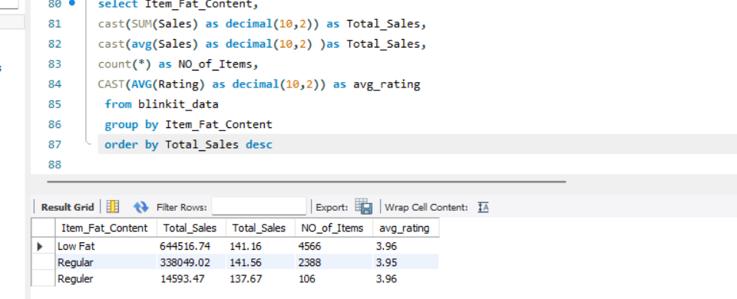

**-- fat content by outlet for total sales**

**select * from blinkit_data;**

**select OutletLocationType,Item_Fat_Content,**

**cast(sum(Sales) as decimal(10,2)) as Total_sales,**

**cast(AVG(Sales) as decimal(10,2)) as avg_sales,**

**count(*) as No_of_items,**

**cast(avg(Rating) as decimal(10,2)) as avg_rating**

**from blinkit_data**

**group by OutletLocationType,Item_Fat_Content**

**order by Total_Sales asc**

**-- 4.Fat content by outlet for total sales**