EMPLOY RECORD

My task is made of Employ record so how the project work we saw one by one step.

The first file open the splashroot window it is mouse rotate window.

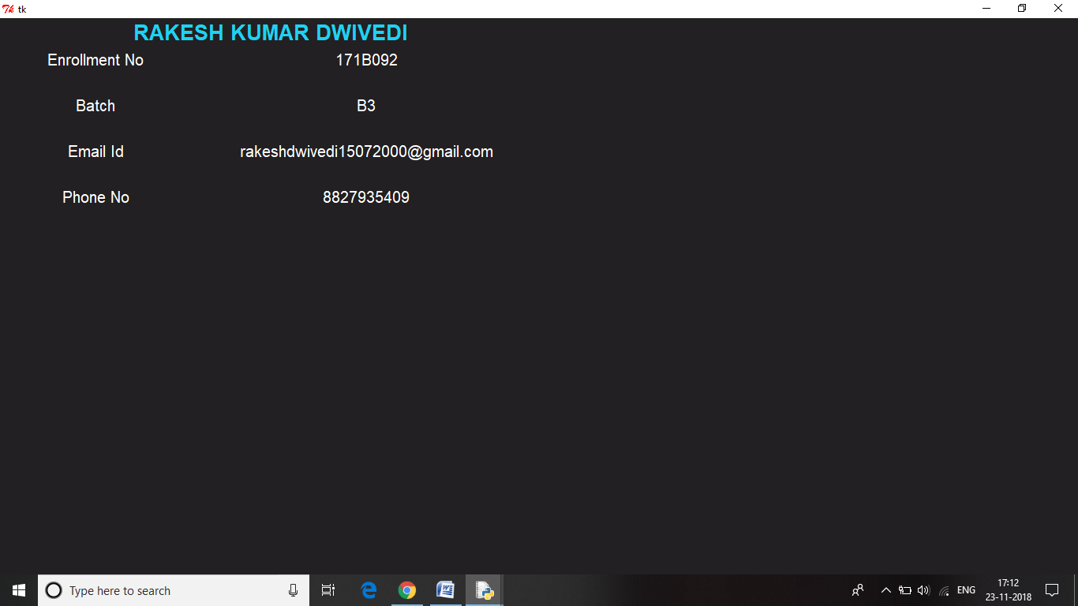

After splashwindow my login window is open and in this window my login function is call user name is not fixed but my password id fixed . so the password is “12345”Andreset Button is also working . when press the submit Button than go to main program.

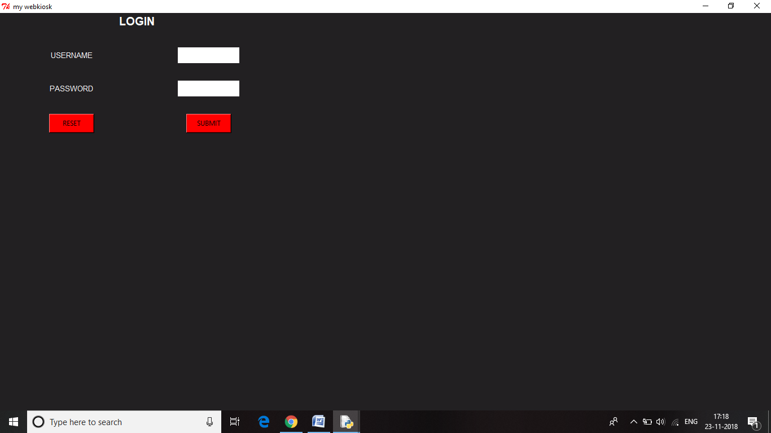

After the login window call the main program so main function will call

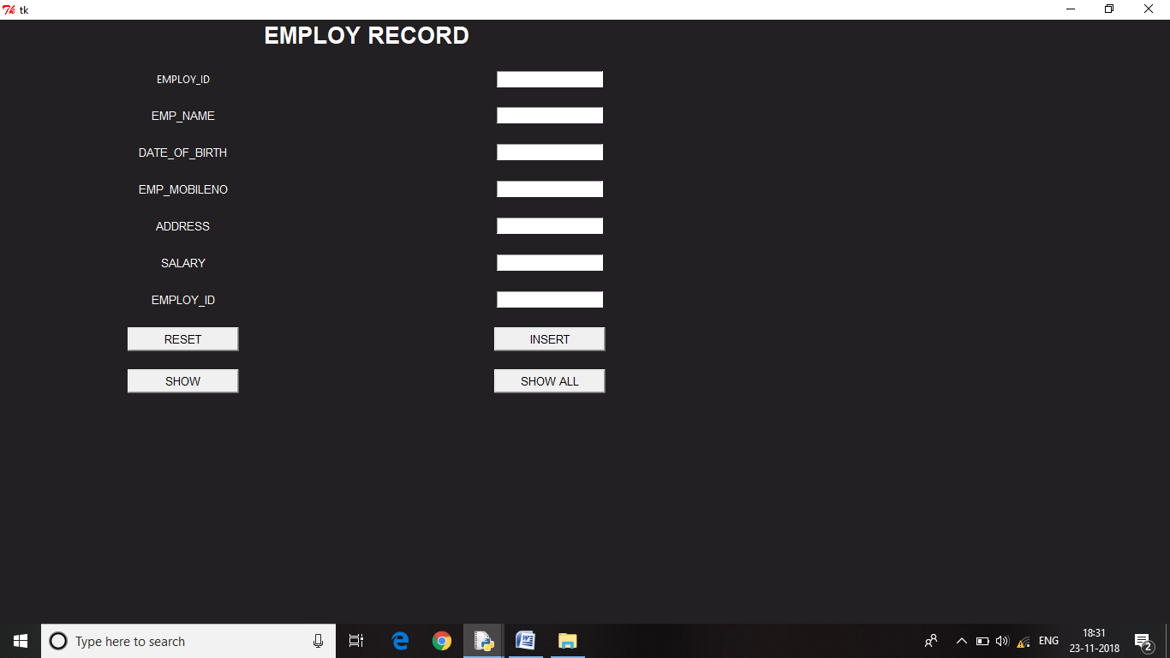

Reset Button remove everythigs in employ record and insert Button store the data of every employ if see data Every_Employ then press Show_all Button.

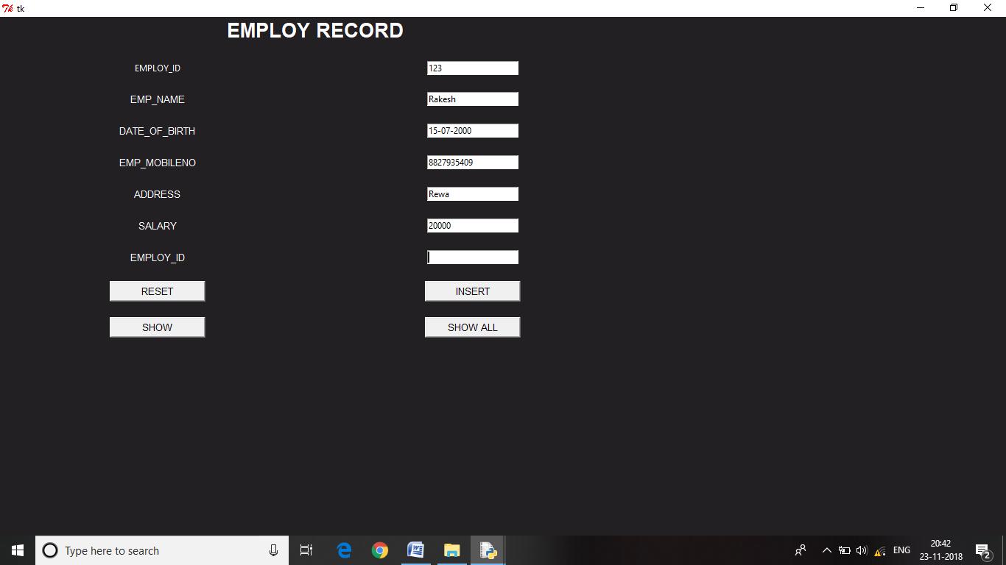

After the insertion enter EMPLOY_ID of employ press the show Button achive particular Employ_Record

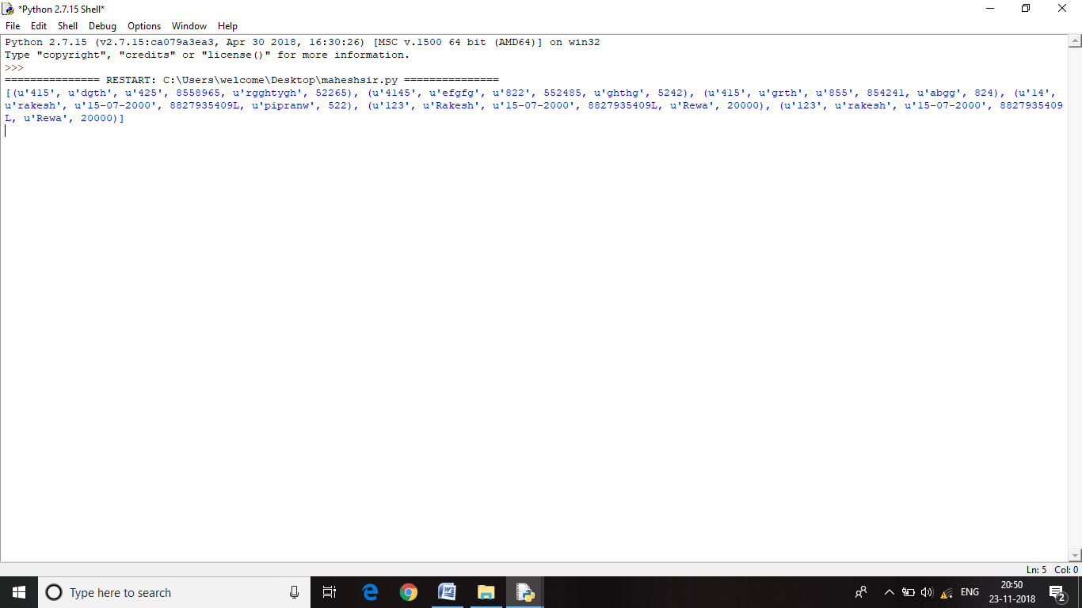

Enter the FETCH EMPLOY_ID (ex 123,142 etc) press SHOW Button 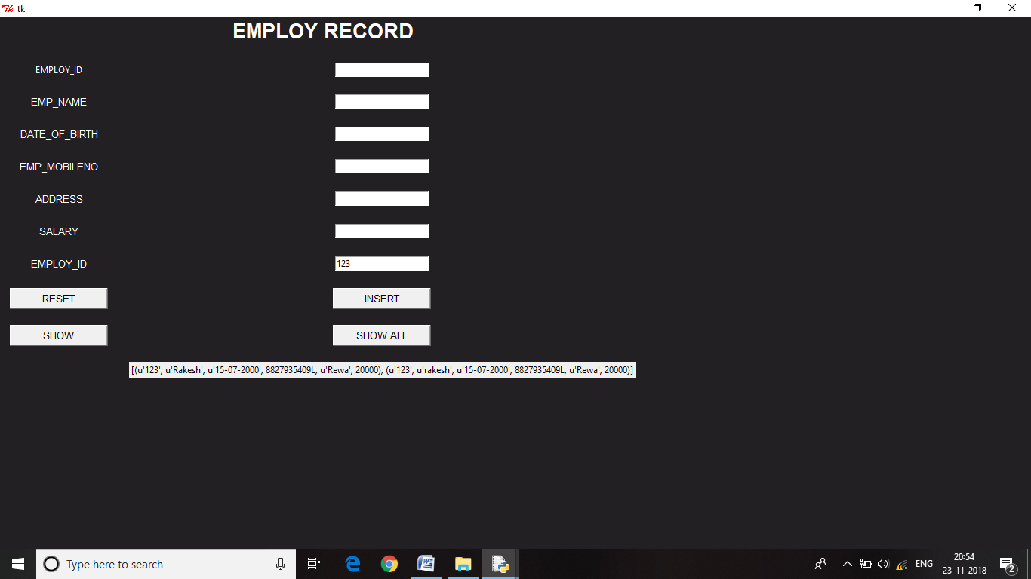

RAKESH KUMAR DWIVEDI

ENROLLMENT NUMBER-171B092

BATCH :- B3