Dear Sir

Recommending for Financial Sanction for P+C in case of Mr. Bhanu Pratap // Rs 12 lacs // 10.10 % // 240 months // CM Assessment// Bhopal // 3000017606

Parties to the Loan
S. No. | Name | Constitution (select from dropdown) | Capacity (Applicant / Co-applicant / Guarantor) | Age at the time of |  | Relationship with Applicant | CIBIL Score | Income Considered (Y / N) | Property Ownership (Y / N)
 |  |  |  | Application | Maturity
1 | Bhanu Pratap | Individual | APPLICANT | 28 | 48 | SELF | 748 | Y | Y
2 | Om Wati | Individual | CO APPLICANT | 57 | 77 | MOTHER | -1 | N | N

Proposed Loan Break-up
S. No. | Type of Loan | Nature of Transaction | Loan Amount (Rs.) | Tenure (Months) | Proposed ROI | EMI (Rs.)
1 | Home Loan | Purchase from Builder | 12,00,000 | 240 | 10.10% | 11,660

Property Detail:
- Property is located in Plot 78 Himanshu Green Mandideep.
- Plot size - 700 Sq.ft
- Property owner – Applicant
- Property use – Self use

Applicant Details:
- Applicant Mr. Bhanu Pratap is 28 Years of age and 8th class by his qualification.
- Applicant is residing in relative house in ward no. 17, Maharana Pratap Mandideep.
- Applicant is residing self, father, mother & 2 brother.
- Applicant is self-employed.
- Applicant mother is housewife.
- Applicant father engaged his business as helping held.
- Applicant both brother is Pvt Salaried.
Applicant Business Detail
- Applicant is Proprietor of M/s Delhi Bike Service from Last 6 years.
- Business is being operated from Rented premises at Ward No 23, Gulmohar Colony Mandideep. Paying rent 6k pm.
- Nature of business is Retail sale of Auto Parts & Two-Wheeler Service Centre.
- Purchases are being done from Bhopal/ Mandideep on credit payment terms of 15-30 days.
- Supply of products is within Local Area. Credit payment terms allowed on Cash.
- Price Range – Auto Part is Rs 50 to 5000 & Services charges is Rs 150 – 200.
- Average Monthly Sale of parts is approx. Rs 75-80k pm.
- Average operational trade margins are 25- 30%.
- Monthly service receipts are Rs 35-40k and margin are 60-70% approx.
- There are 2 fixed staff and their monthly salary payout is approx. Rs 14k pm.
- Average stock maintained of approx. Rs 4 lacs as claimed by applicant.

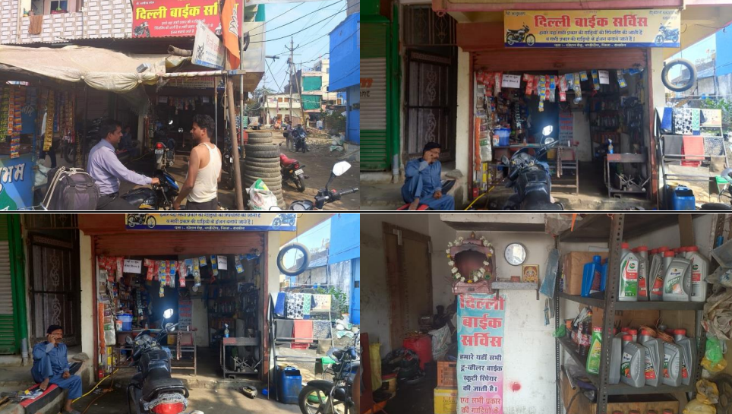

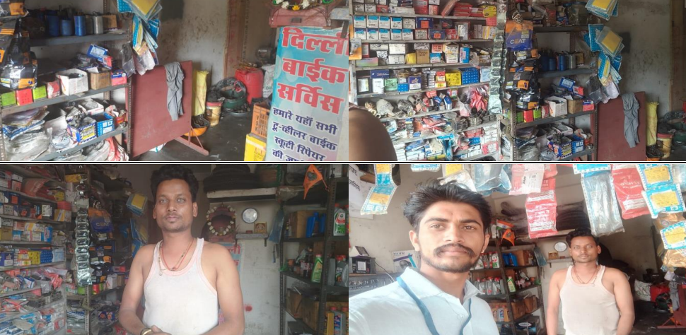
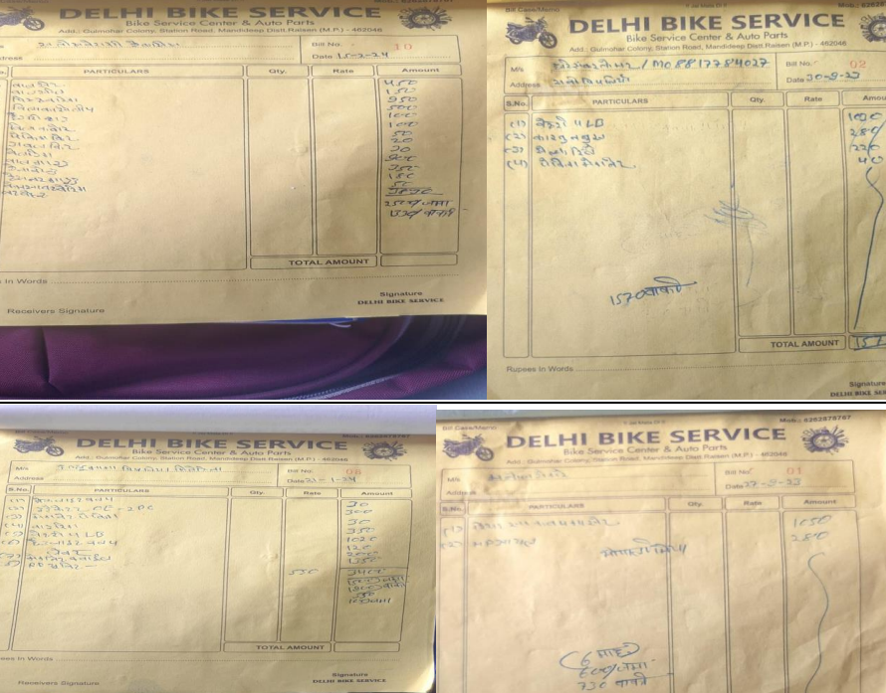

Eligibility

Assessed Sale / Operational income | Peak Business hours | Normal Hours | Daily | Monthly
Books (With Receipts) / Non Books (Without Receipts) |  |  |  | 1,10,000
A. Total Assessed Income |  |  |  | 1,10,000
Less- Business Expenses
Cost of Goods [Books (With Receipts) / Non Books (Without Receipts)] |  |  |  | 56,250
Rent of Business premises if applicable |  |  |  | 6,000
Salaries and Wages |  |  |  | 14,000
Interest Paid on loans to Local Money lenders
Interest Paid to Banks and FIs
Freight Cost
Power Bill
Statutory Taxes if any
Phone Bills
Admin Expenses
Business Promotion Expenses
Others (Specify) |  |  |  | 3,000
B. Total Business Expenses |  |  |  | 79,250
C. Net Income from Business (A-B) |  |  |  | 30,750
Other Income (Monthly)
Nature of Income |  | Verification Tool (Specify) |  | Amount
Rental
Agri. Income
Part Time income
Interest Income
Others
Monthly Income of Applicant’s Family (Mention Relation with Applicant)
Income Source (Salary/Business/others) |  | Verification Tool (Specify) |  | Amount
D. Total Other Income (Monthly) |  | 0
E. Total Family Income (C+D) p.m. |  | 30,750
Household Expenses |  | Monthly
Food, Clothing and other Household Expenses
Power and Water Bills
Mobile Recharge Expenses
DTH/Cable Recharge Expenses
Medical Expenses
Education/Fees Expenses
Commuting expenses for all family members
Residential Rent Expenses
Loan EMI
Other (Specify)
F. Total Household Expenses |  | 0
Net Disposable Income(E-F) |  | 30,750
Eligible Loan Amount as per CM Assessed Income FOIR norms |  | 18,98,819
Applied Loan Amount |  | 12,00,000
EMI for applied Loan Amount |  | 11,660
FOIR for Applied Loan Amount |  | 37.92%

RTR
Deviation

Deviation | Mitigates
DPD | Closed PL having 89 days DPD in June 22. As discussed with customer he said that shop closed for 3-4 months due to dispute of shop owner and find new shop.
Business stability | Customer running business since last 6 years but we have registration proof June 23. Customer having shop rent agreement 1.5 years approx

Sanction Condition

- Repayment taken from Applicant main account.
- All internal assessments/ verifications carried out by ABHFL to be positive.
- Disbursal is subject to legal verification/ technical valuation of the underlying of the property being positive as per ABHFL norms.
- Any Letter issued prior to this Sanction Letter stands null and void.
- Short IMD taken Approval to be taken (If applicable).
- Subject to Positive RCU and FI
- LTV norms as per policy.
- Subject to shop rent agreement documented.

