R – Python Conversion

1. R has separate packages and libraries that give a different time complexity than Python. Thus, converting an R code into Python will make the code less efficient. However, R provides a reticulate package that helps execute Python programs using R script. Also, Python provides a library called PypeR that helps run R code using Python. But, interchanging the codes will not give an optimized code and will destroy its uniqueness. Therefore, it is recommended to learn Python and R both so that you can understand the mechanism of code irrespective of programming languages.

Source (<https://intellipaat.com/community/52399/how-to-convert-an-r-program-into-python>)

2. R <-> Python

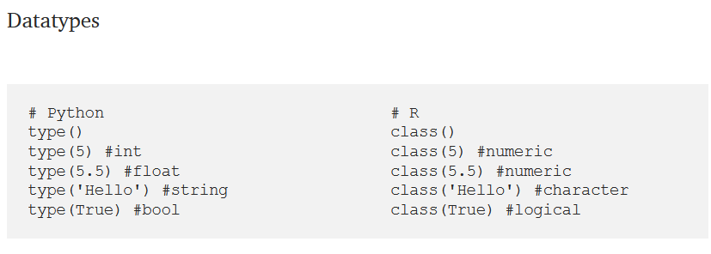

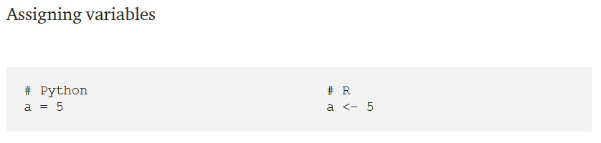

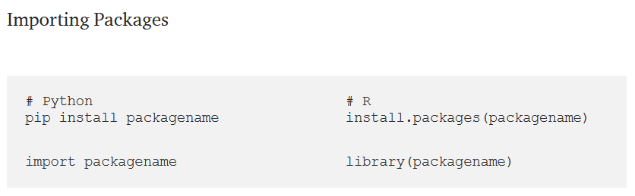

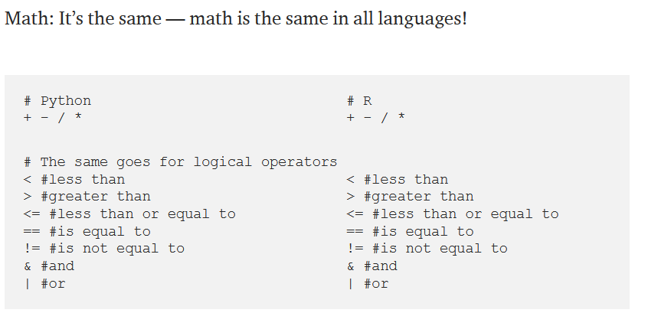

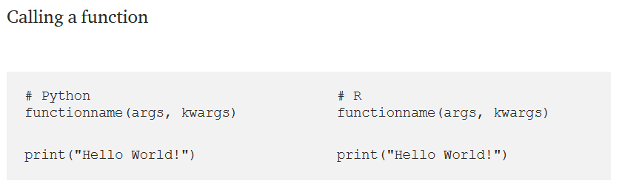

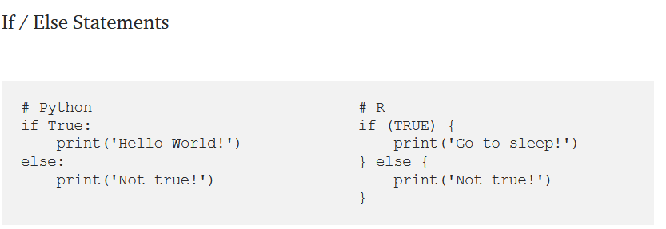

Lists/Vectors

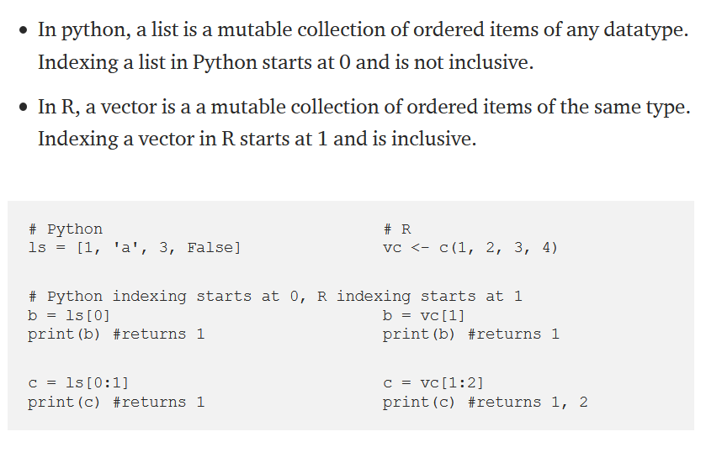

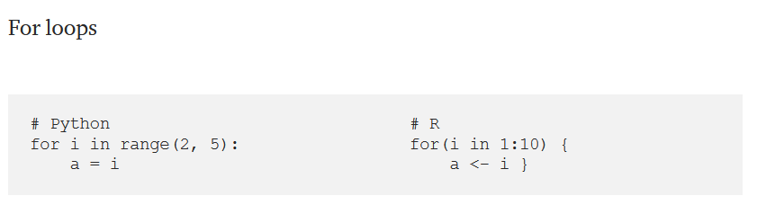

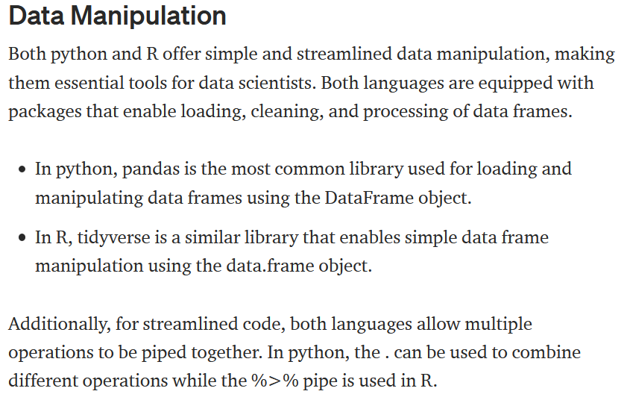

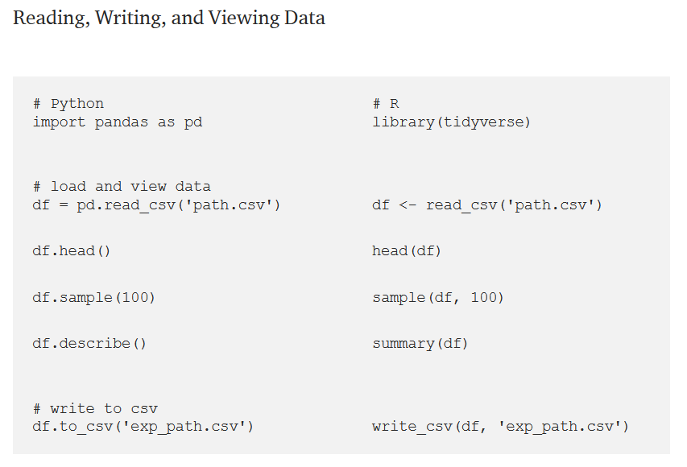

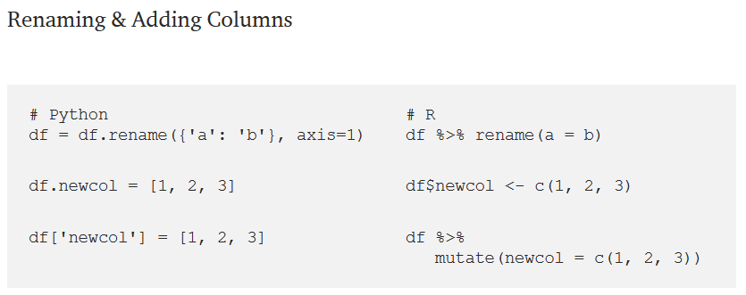

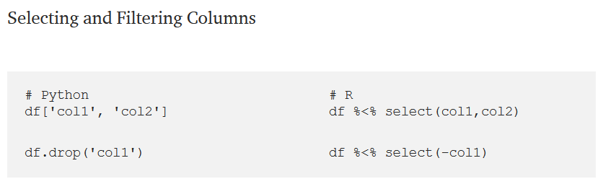

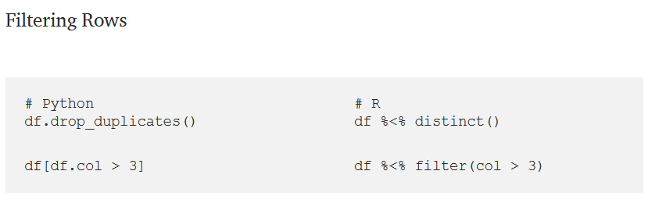

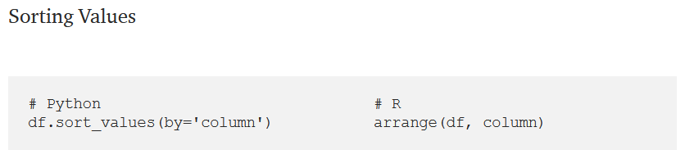

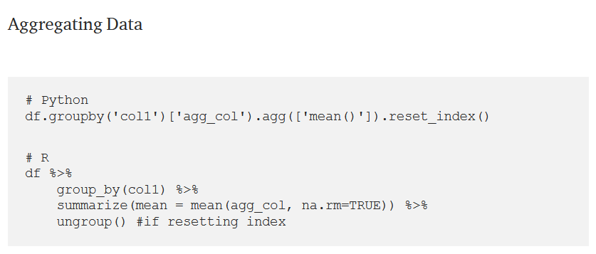

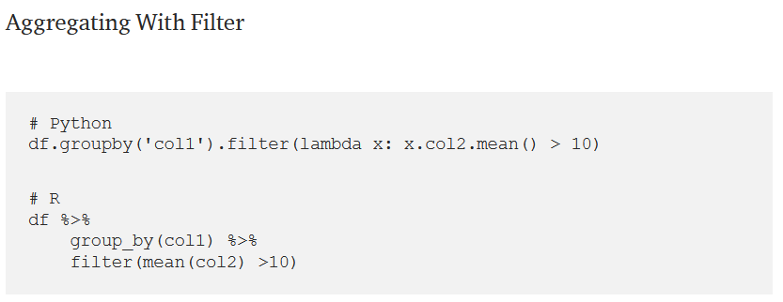

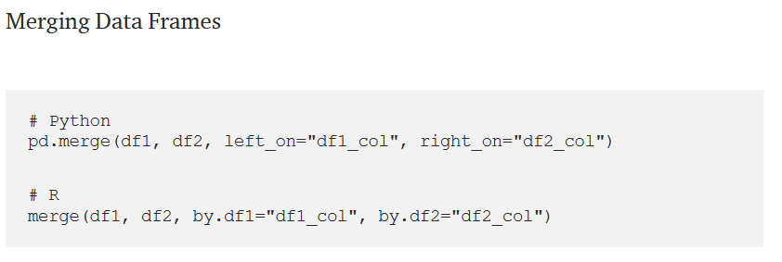

Source (<https://towardsdatascience.com/essential-guide-to-translating-between-python-and-r-7cb18b786e5d>)

3. Calling Python from R

Source : <https://rstudio.github.io/reticulate/articles/calling_python.html>

4. There are many ways to manipulate data from R to Python

Source : <https://www.mit.edu/~amidi/teaching/data-science-tools/conversion-guide/r-python-data-manipulation/>