**Experiment -05**

Performance analysis of routing protocols using simulation tool.

**Aim:**

To Performance analysis of routing protocols using simulation tool.

1. Construct 3 to 4 networks each connected by a router and enable packet transmission between all the networks.

*Sol:*

*Description*

To construct three networks connected by a router and enable packet transmission between them, start by creating three separate networks with distinct subnets (e.g., 192.168.1.0/24, 192.168.2.0/24, and 192.168.3.0/24). Configure the router with three interfaces, each assigned to a different subnet, and set the corresponding IP addresses as gateways for each network. Connect devices in each network and assign appropriate IP addresses and default gateways. Lastly, configure static or dynamic routing on the router to enable inter-network communication, and verify connectivity through ping tests between devices in different networks.

Procedure:

**Network Design:**

1. **Network 1 (LAN 1)**: 192.168.1.0/24
2. **Network 2 (LAN 2)**: 192.168.2.0/24
3. **Network 3 (LAN 3)**: 192.168.3.0/24

Each network will be connected to its own interface on a single router, allowing communication between all devices in each network.

**Steps:**

**Step 1: Set Up the Network Environment**

1. **Place a Router** and **three Switches** (one for each network).
2. **Connect each switch to the router** using Ethernet cables.
   * **Router Interface 1**: Connect to **Switch 1** (for Network 1)
   * **Router Interface 2**: Connect to **Switch 2** (for Network 2)
   * **Router Interface 3**: Connect to **Switch 3** (for Network 3)

**Step 2: Assign IP Addresses to Router Interfaces**

* Assign IP addresses to the router interfaces based on the networks:
  + **Interface 1**: 192.168.1.1 (Gateway for Network 1)
  + **Interface 2**: 192.168.2.1 (Gateway for Network 2)
  + **Interface 3**: 192.168.3.1 (Gateway for Network 3)

**Step 3: Configure Devices in Each Network**

* Connect PCs, laptops, or servers to each switch.
* Assign IP addresses and set the **default gateway** for each device in the respective network:
  + **Network 1** (e.g., 192.168.1.10, Gateway = 192.168.1.1)
  + **Network 2** (e.g., 192.168.2.10, Gateway = 192.168.2.1)
  + **Network 3** (e.g., 192.168.3.10, Gateway = 192.168.3.1)

**Step 4: Enable Routing on the Router**

1. Access the router's command-line interface (CLI) and enter configuration mode:

Router> enable

Router# configure terminal

1. Configure each interface with the appropriate IP address:

Router(config)# interface gig0/0

Router(config-if) ip address 192.168.1.1 255.255.255.0

Router(config-if) # no shutdown

Router(config-if) # exit

Router(config)# interface gig0/1

Router(config-if) # ip address 192.168.2.1 255.255.255.0

Router(config-if) # no shutdown

Router(config-if) # exit

Router(config)# interface gig0/2

Router(config-if) #ip address 192.168.3.1 255.255.255.0

Router(config-if) no shutdown

Router(config-if) #exit

**Step 5: Configure Routing**

* If this is a basic setup, routing will be enabled automatically if the router's interfaces are correctly configured. If needed, enable routing manually:

Router(config)# ip routing

**Step 6: Test Connectivity**

* From a device in **Network 1**, try to ping a device in **Network 2** and **Network 3** to confirm packet transmission.

Example:

ping 192.168.2.10 # Ping a device in Network 2

ping 192.168.3.10 # Ping a device in Network 3

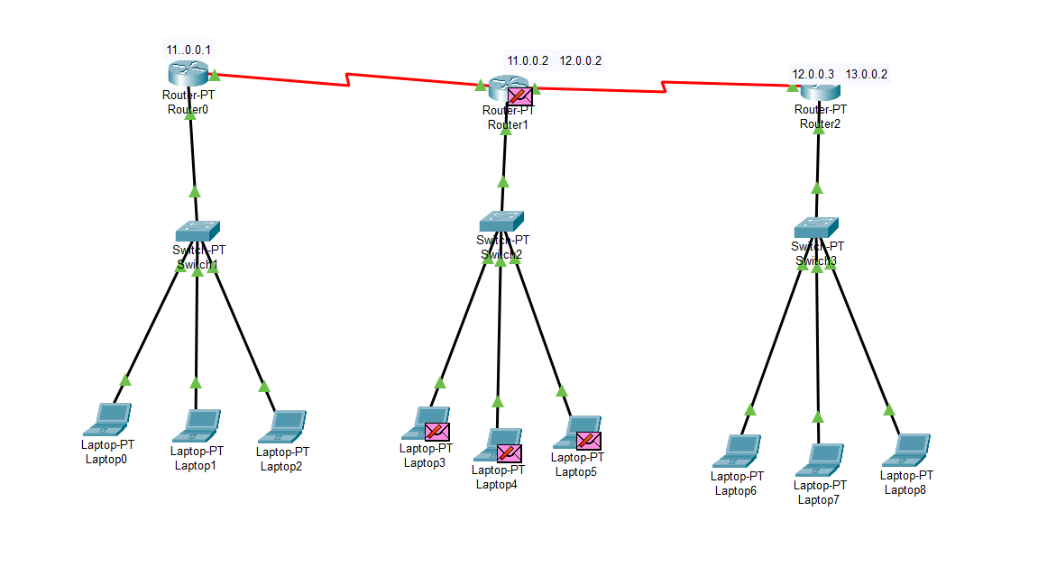

**Result:**

After completing these steps, all devices in Network 1, Network 2, and Network 3 should be able to communicate with each other, verifying that packet transmission is enabled between the networks**.**