BLUESTOCK MUTUAL FUND ANALYTICS CAPSTONE

FINAL PROJECT REPORT

Prepared By
Rakesh Banoth

Submitted On
11 June 2026

Technologies Used
Python
SQLite
Pandas
NumPy
Power BI
GitHub

Bluestock – Fintech

EXECUTIVE SUMMARY
The Bluestock Mutual Fund Analytics Capstone project was developed to analyse mutual fund performance and provide meaningful investment insights through data-driven techniques.

The project involved building an ETL pipeline, performing exploratory data analysis, calculating financial metrics such as Sharpe Ratio, VaR, and CVaR, developing a recommendation engine, and creating an interactive Power BI dashboard.

The dashboard enables investors to compare funds, monitor performance trends, and assess risk. The project successfully achieved all defined objectives and delivered a complete end-to-end analytics solution.

DATA SOURCES
For this project, mutual fund datasets were used to analyse fund performance, investor trends, and risk metrics. The data contains information such as fund names, categories, NAV values, returns, and benchmark performance.
The datasets were collected and organized before starting the analysis process. Since the data came from different sources, it required cleaning and validation to ensure accuracy.
The following fields were mainly used in the analysis:
• Fund Name
• Fund Category
• NAV (Net Asset Value)
• Historical Returns
• Benchmark Returns
• Risk Indicators
This data was later processed through the ETL pipeline and used for analytics, reporting, and dashboard development.

ETL DESIGN
To prepare the data for analysis, an ETL (Extract, Transform, Load) process was followed throughout the project.

The first step was data extraction. The mutual fund datasets were collected and imported into the project environment for processing.

The next step was data transformation. During this phase, missing values were handled, duplicate records were removed, column formats were standardized, and the dataset was cleaned to improve data quality.

Finally, the cleaned data was loaded into SQLite databases and CSV files. These processed datasets were then used for exploratory data analysis, performance evaluation, risk assessment, and dashboard development.

The ETL process helped ensure that the final dataset was accurate, consistent, and ready for further analysis.

ETL Workflow
Raw Data - Data Cleaning - Data Transformation - SQLite Database - Analytics - Power BI Dashboard

EDA FINDINGS
Exploratory Data Analysis (EDA) was performed to better understand the dataset and identify patterns in mutual fund performance.
The analysis helped in understanding the distribution of fund categories, investor behaviour, and market trends. Different visualizations were created to identify important insights from the data.

Some key observations from the analysis are:
• Equity funds generally showed higher returns with higher risk.
• Debt funds provided more stable performance with lower volatility.
• SIP investments showed consistent growth trends over time.
• Different categories exhibited unique risk and return characteristics.
The findings from EDA provided valuable insights that supported further performance and risk analysis.

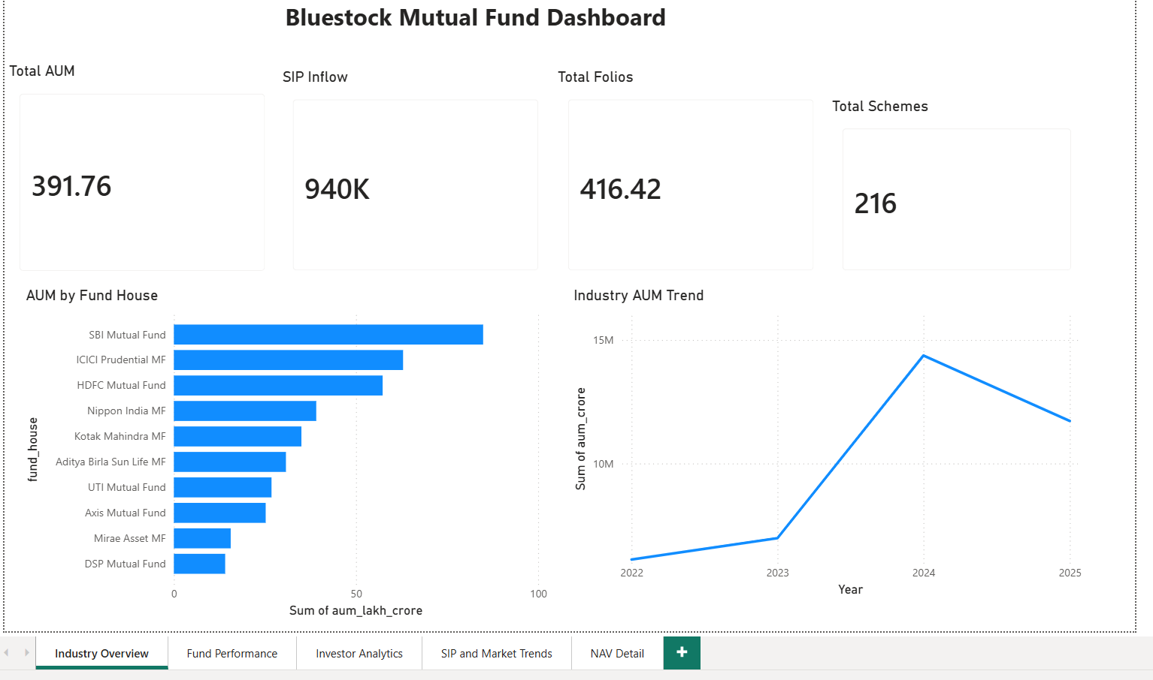

Figure 1: Industry Overview Dashboard

INVESTOR ANALYTICS
Investor analytics was performed to understand investment behaviour and trends across different mutual fund categories.

The analysis shows that SIP-based investments continue to be one of the preferred investment methods among investors. Consistent investments through SIPs help reduce market timing risks and encourage long-term wealth creation.

The dashboard also highlights how investor participation varies across fund categories and market conditions. These insights can help investors make better investment decisions based on their risk appetite and financial goals.

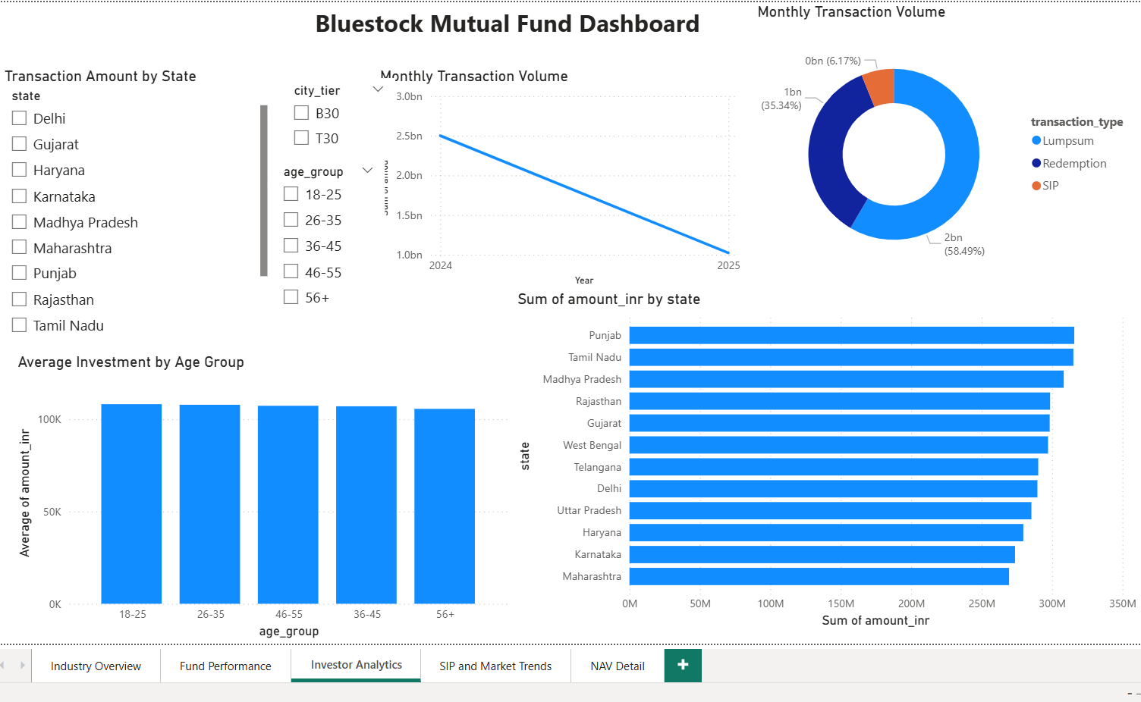

Figure 2: Investor Analytics Dashboard

PERFORMANCE ANALYSIS
The performance analysis focused on evaluating mutual funds based on their returns and overall growth trends.

Different fund categories were compared to understand their performance over time. The analysis showed that equity-oriented funds generally delivered higher returns, while debt funds offered more stable performance with lower risk.

Comparing fund performance helps investors identify funds that align with their investment objectives and risk tolerance.

The results from this analysis were later used in the recommendation engine and dashboard visualizations.
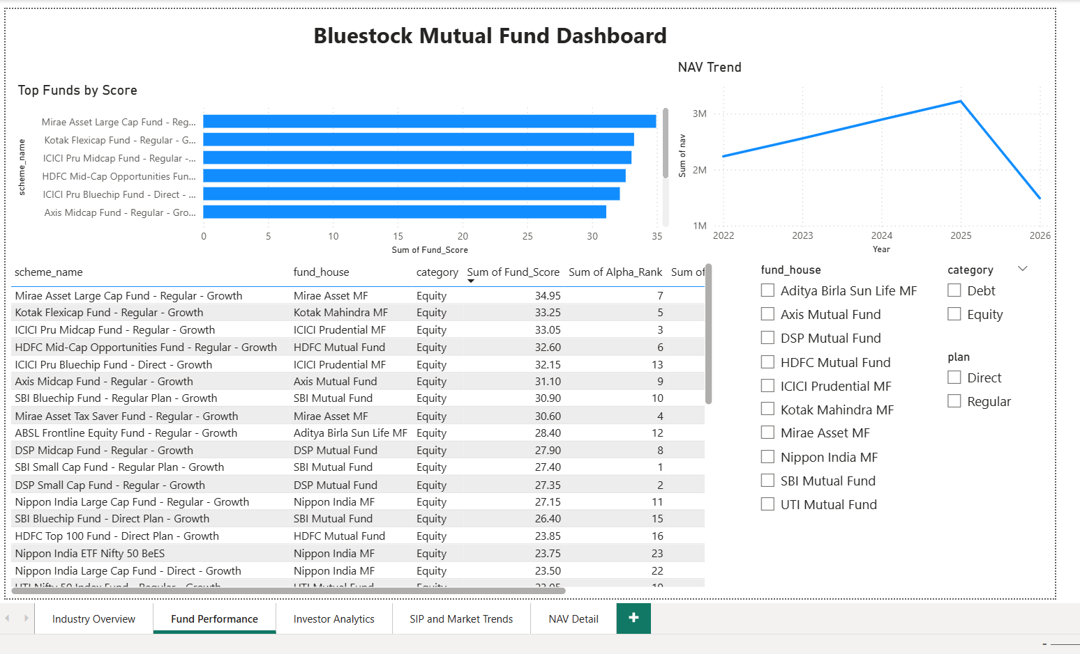

Figure 3: Fund Performance Analysis

BENCHMARK COMPARISON
Benchmark comparison was conducted to evaluate how individual mutual funds performed relative to market benchmarks.

By comparing fund returns with benchmark indices, it becomes easier to understand whether a fund is outperforming or underperforming the market.

The analysis showed that some funds consistently generated returns above their benchmark, while others closely tracked benchmark performance.
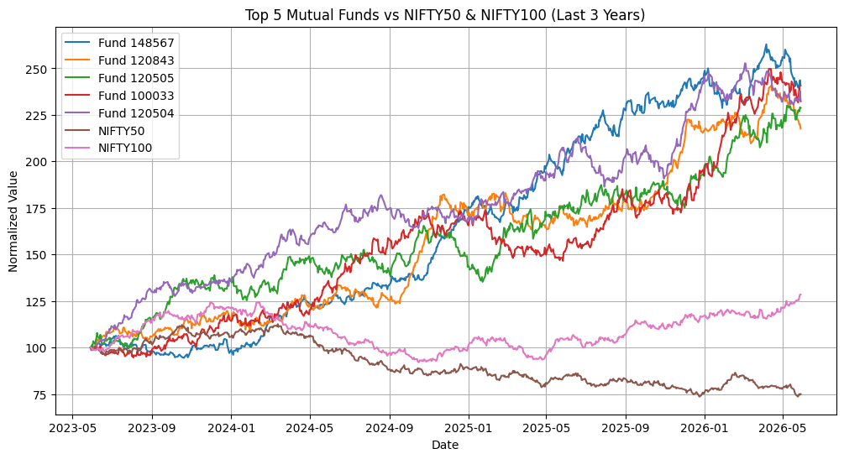

Figure 4: Benchmark Comparison Analysis

SHARPE RATIO ANALYSIS
Sharpe Ratio was used to measure the risk-adjusted performance of mutual funds. This metric helps determine how much return an investor receives for the level of risk taken.

Funds with higher Sharpe Ratios generally provide better returns relative to their volatility. The analysis showed that some funds consistently delivered stronger risk-adjusted performance than others.

This metric was useful in identifying funds that generated stable returns while maintaining reasonable risk levels.
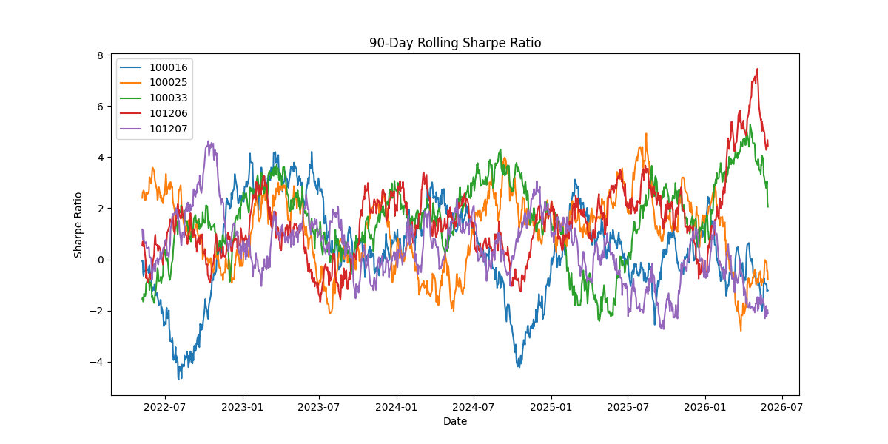

Figure 5: Rolling Sharpe Ratio Analysis

VaR AND CVaR ANALYSIS
Risk assessment was carried out using Value at Risk (VaR) and Conditional Value at Risk (CVaR).

VaR estimates the maximum expected loss over a given period at a specific confidence level. CVaR provides additional insight by measuring the average loss beyond the VaR threshold.

The analysis helped identify high-risk and low-risk funds and provided a better understanding of downside risk exposure.

These risk measures can help investors make more informed investment decisions based on their risk tolerance.

RECOMMENDATION ENGINE

A recommendation engine was developed to suggest mutual funds based on performance and risk metrics.

The recommendation logic considers multiple factors such as returns, Sharpe Ratio, risk measures, and overall fund performance.

This feature helps investors identify suitable mutual funds according to their investment preferences and objectives.

The recommendation engine improves decision-making by providing a data-driven approach to fund selection.

DASHBOARD OVERVIEW
An interactive Power BI dashboard was developed to visualize key mutual fund metrics and insights.

The dashboard includes multiple sections covering industry overview, fund performance, investor analytics, SIP trends, and NAV analysis.

Users can interact with filters and visualizations to explore fund performance across different categories and time periods.

The dashboard provides a simple and effective way to understand mutual fund data and investment trends.
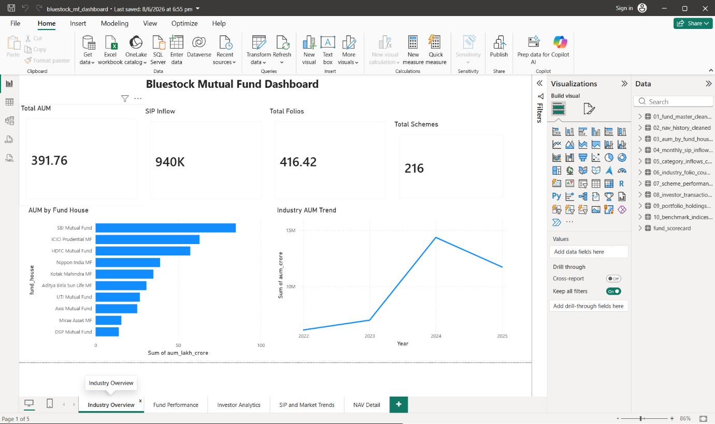

Figure 7: Power BI Dashboard Overview

KEY FINDINGS

• Equity funds generally delivered higher returns compared to debt funds.
• SIP investments showed consistent long-term growth.
• Risk-adjusted performance varied significantly across funds.
• Some funds consistently outperformed benchmark indices.
• Dashboard visualizations made it easier to identify investment trends and fund performance patterns.

LIMITATIONS
This project is based on historical mutual fund data, and past performance does not guarantee future results.
Market conditions can change over time, affecting fund performance and risk levels.
Some datasets had limited information, which may affect the completeness of the analysis.
The recommendation engine is intended for analytical purposes and should not be considered direct financial advice.

RECOMMENDATIONS
Investors should consider both returns and risk before selecting mutual funds.
Regular monitoring of fund performance can help improve investment decisions.
Diversification across different fund categories may help reduce overall portfolio risk.
Future improvements can include real-time data integration and advanced predictive analytics models.

CONCLUSION
The Bluestock Mutual Fund Analytics Capstone successfully demonstrated the use of data analytics techniques in mutual fund analysis.
The project covered data collection, ETL processing, exploratory data analysis, performance evaluation, risk assessment, recommendation generation, and dashboard development.
The final solution provides meaningful insights that can help investors better understand mutual fund performance and make informed investment decisions.
Overall, the project achieved all planned objectives and delivered a complete analytics solution.

REFERENCES
• Mutual Fund Dataset Sources
• Power BI Documentation
• Python Documentation
• Pandas Documentation
• NumPy Documentation
• SQLite Documentation

