Task-1
Temperature Monitoring and LCD Display
Code:
//Temperature sensor and the display using Arduino
#include <Wire.h>
#include <LiquidCrystal_I2C.h>
#include <DHT.h>

#define DHTPIN 12
#define DHTTYPE DHT11

DHT dht (DHTPIN, DHTTYPE);

LiquidCrystal_I2C lcd (0x27, 16, 2);

void setup () {
lcd.init();
lcd.backlight();
dht.begin();

lcd.setCursor(0, 0);
lcd.print("Temp Monitor");
delay(2000);
lcd.clear();
}

void loop() {
float temp = dht.readTemperature();
float hum = dht.readHumidity();

if (isnan(temp) || isnan(hum)) {
lcd.setCursor(0, 0);
lcd.print("Sensor Error");
return;
}

lcd.setCursor(0, 0);
lcd.print("Temp: ");
lcd.print(temp);
lcd.print(" C");

lcd.setCursor(0, 1);
lcd.print("Hum: ");
lcd.print(hum);
lcd.print(" %");

delay(2000); }
Photos of the project:
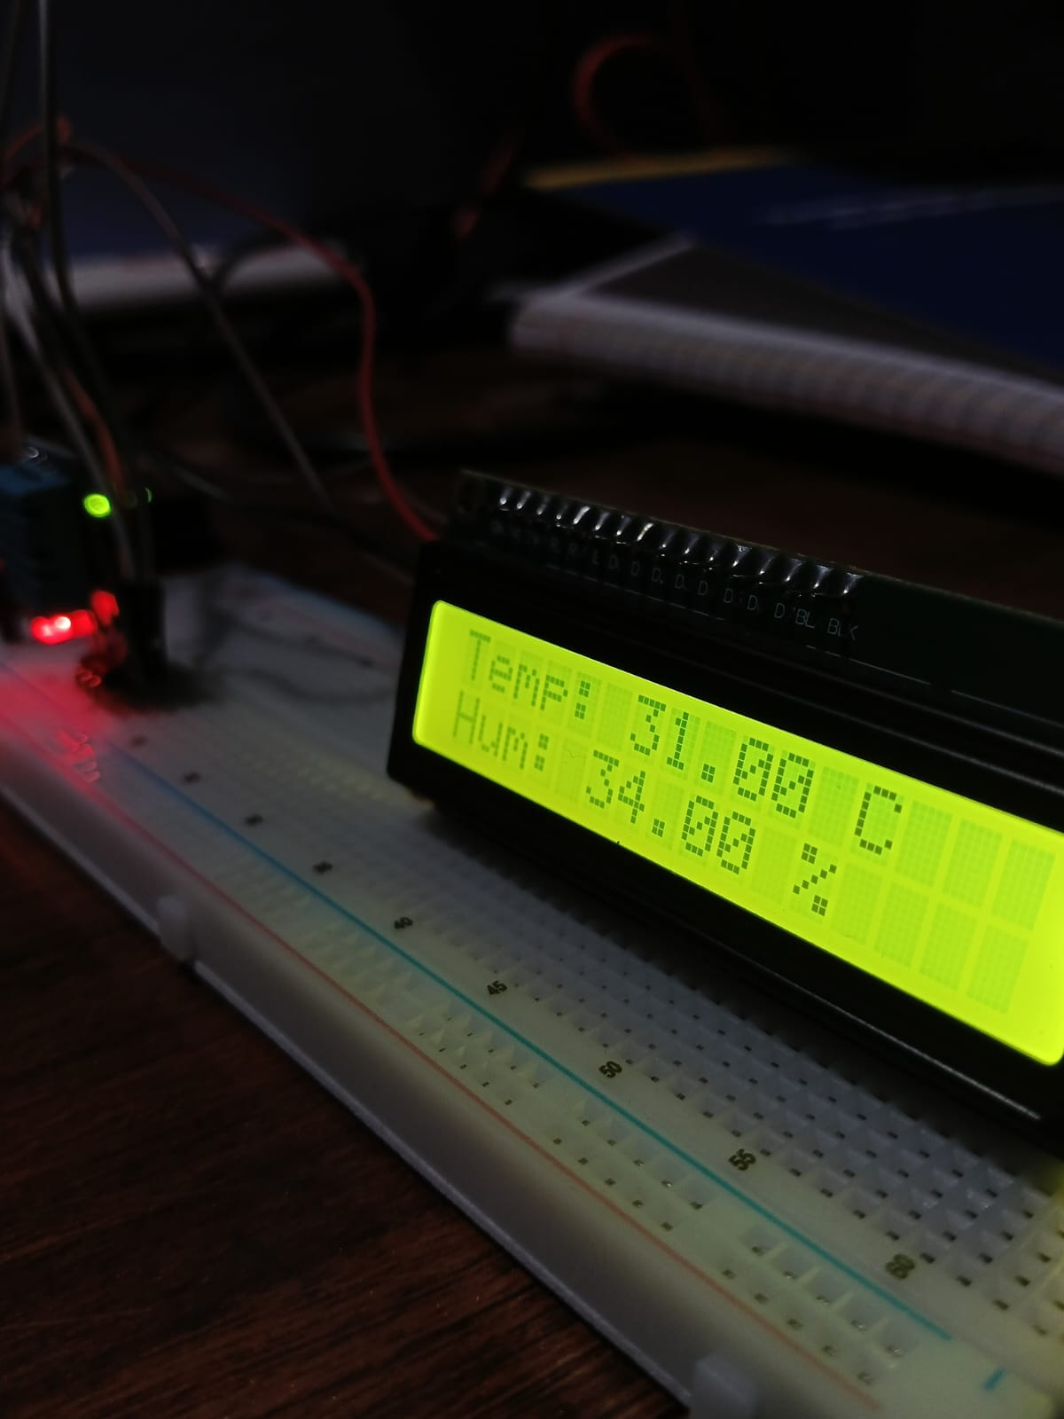
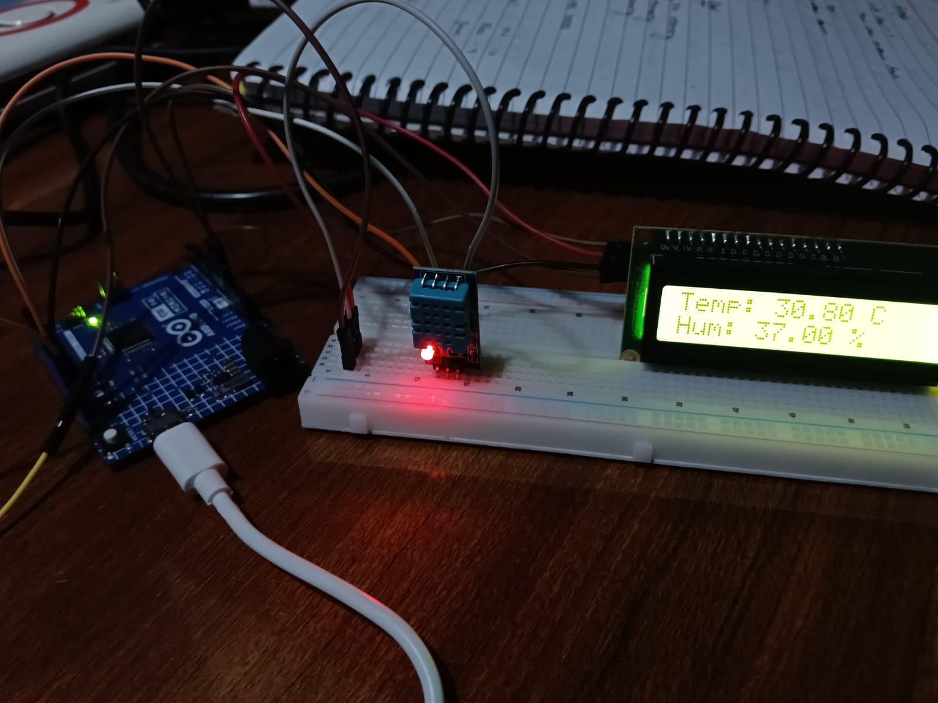
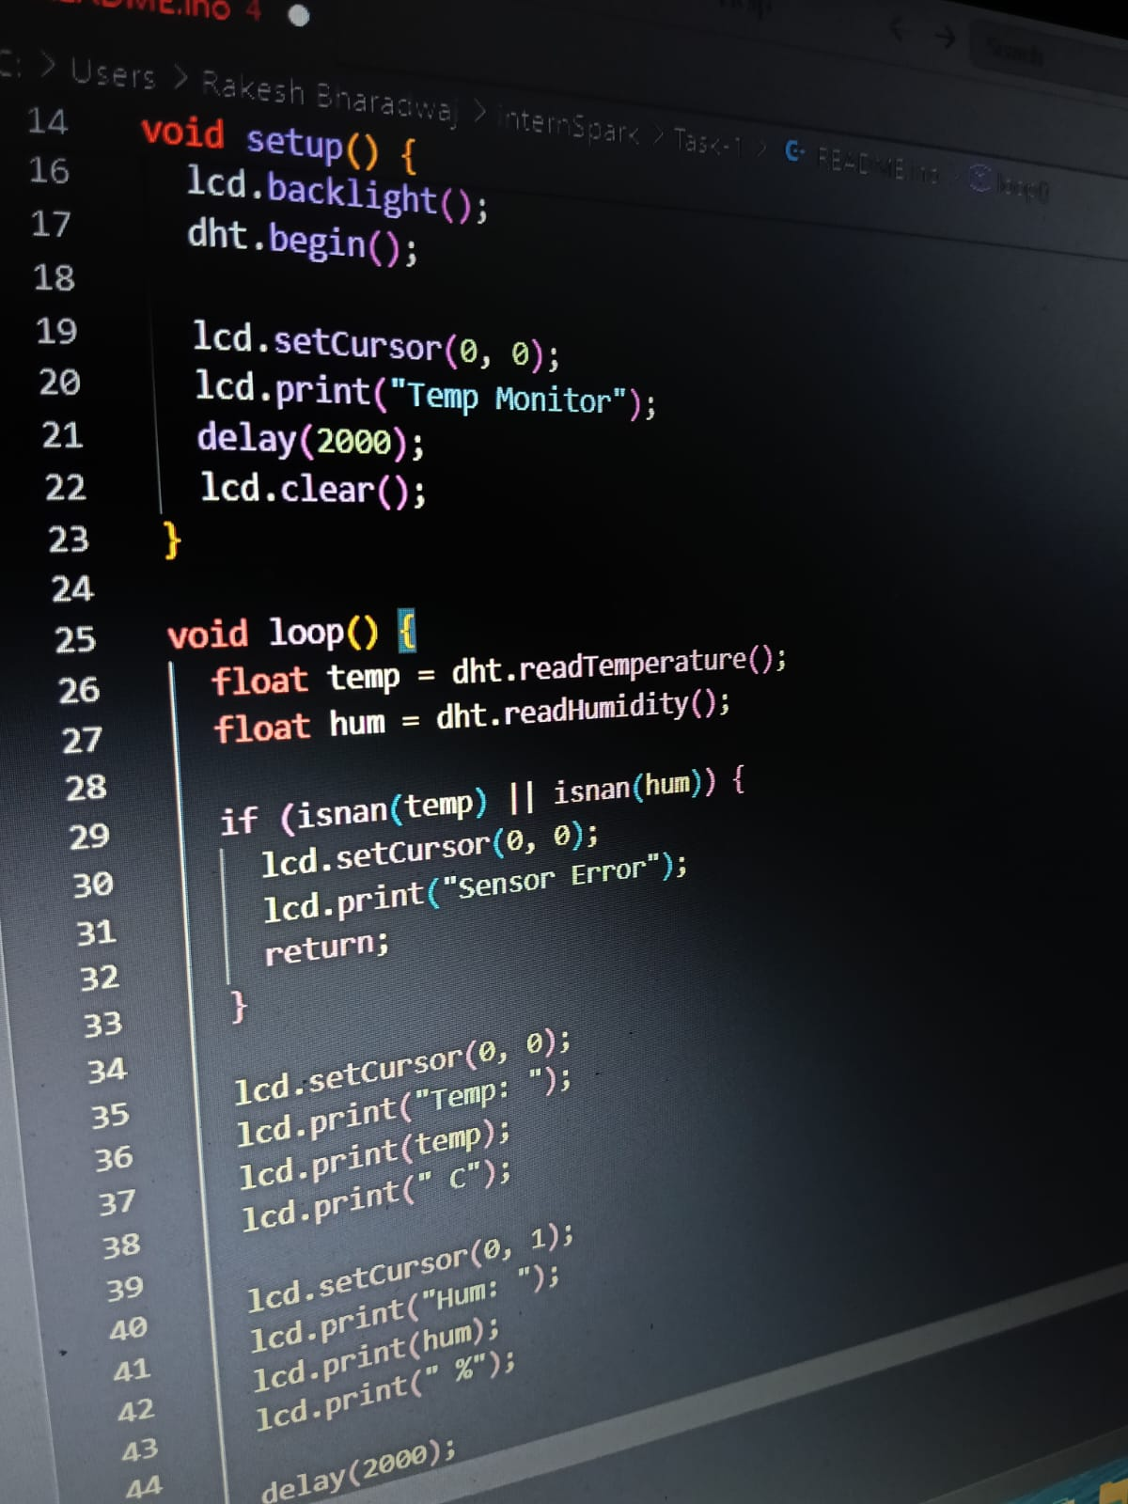
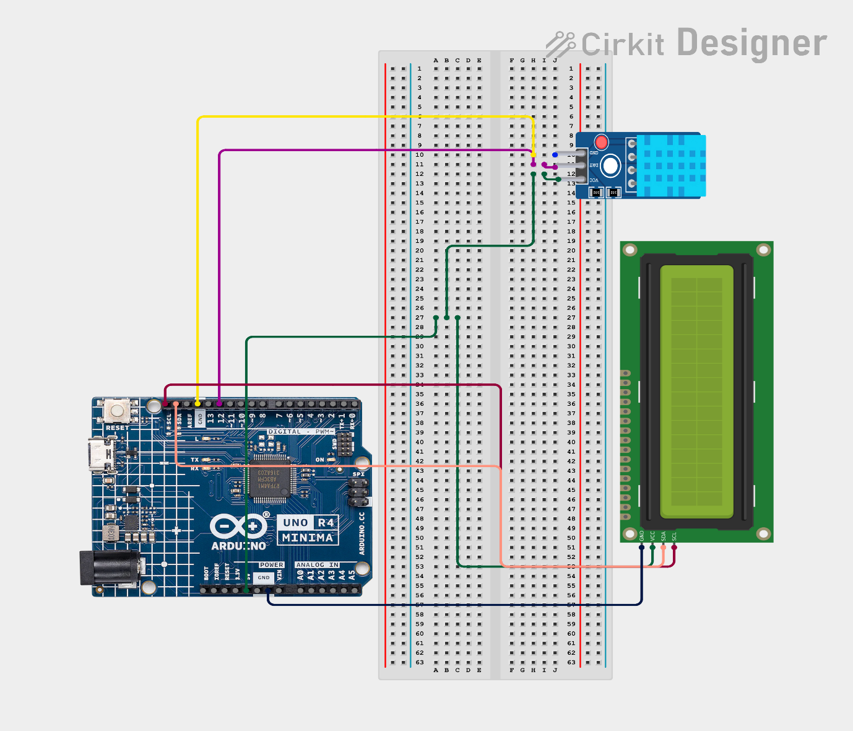
Circuit Design:

