ACTIVITY BASED LEARNING ASSIGNMENT – PYTHON
10 – Case Studies

1. Progressive Electricity Billing System
Problem Statement
To calculate electricity bills based on units consumed, applying different tariff rates, fixed charges, surcharges, and rebates.
Objective
To calculate the electricity bill for each consumer and find the highest and average bills.
Algorithm
- Start.
- Enter the number of consumers and their electricity units.
- Check whether the units are valid.
- Calculate the bill using the given tariff rates.
- Add fixed charges, surcharges, or rebates if applicable.
- Display each consumer's bill.
- Calculate the highest and average bills.
- Stop.
CODE :
#1: Progressive Electricity
months = []
units = []
number_of_months = int(input("Enter the number of months: "))

for i in range(number_of_months):
month = input(f"Enter month {i + 1}: ")
unit = int(input(f"Enter units used in {month}: "))
months.append(month)
units.append(unit)

fixed_charge = 50
unusual_limit = 30

print("PROGRESSIVE ELECTRICITY BILLING")
print("-" * 60)
print("Month Units Energy Fixed Surcharge Rebate Total")
print("-" * 60)

bills = []
for i in range(len(months)):
u = units[i]
if u < 0:
print(months[i], ": invalid units, bill skipped")
bills.append(0)
continue

if u <= 100:
energy = u * 3
elif u <= 200:
energy = 100 * 3 + (u - 100) * 5
elif u <= 300:
energy = 100 * 3 + 100 * 5 + (u - 200) * 7
else:
energy = 100 * 3 + 100 * 5 + 100 * 7 + (u - 300) * 9
surcharge = 0
if u > 300:
surcharge = 0.10 * energy
rebate = 0
if u <= 100:
rebate = 20
total = energy + fixed_charge + surcharge - rebate
bills.append(total)
print(f"{months[i]:<5}{u:>6}{energy:>9.2f}{fixed_charge:>8.2f}", end="")
print(f"{surcharge:>10.2f}{rebate:>8.2f}{total:>10.2f}")

print()
print("MONTH-TO-MONTH COMPARISON")
for i in range(1, len(bills)):
if bills[i - 1] > 0 and bills[i] > 0:
change = (bills[i] - bills[i - 1]) / bills[i - 1] * 100
note = ""
if change >= unusual_limit:
note = "<-- UNUSUAL INCREASE"
print(f"{months[i-1]} -> {months[i]}: {change:7.1f}% {note}")

highest = max(bills)
print()
print("Highest bill :", months[bills.index(highest)], "=", highest)
print("Average bill :", round(sum(bills) / len(bills), 2))
OUTPUT :
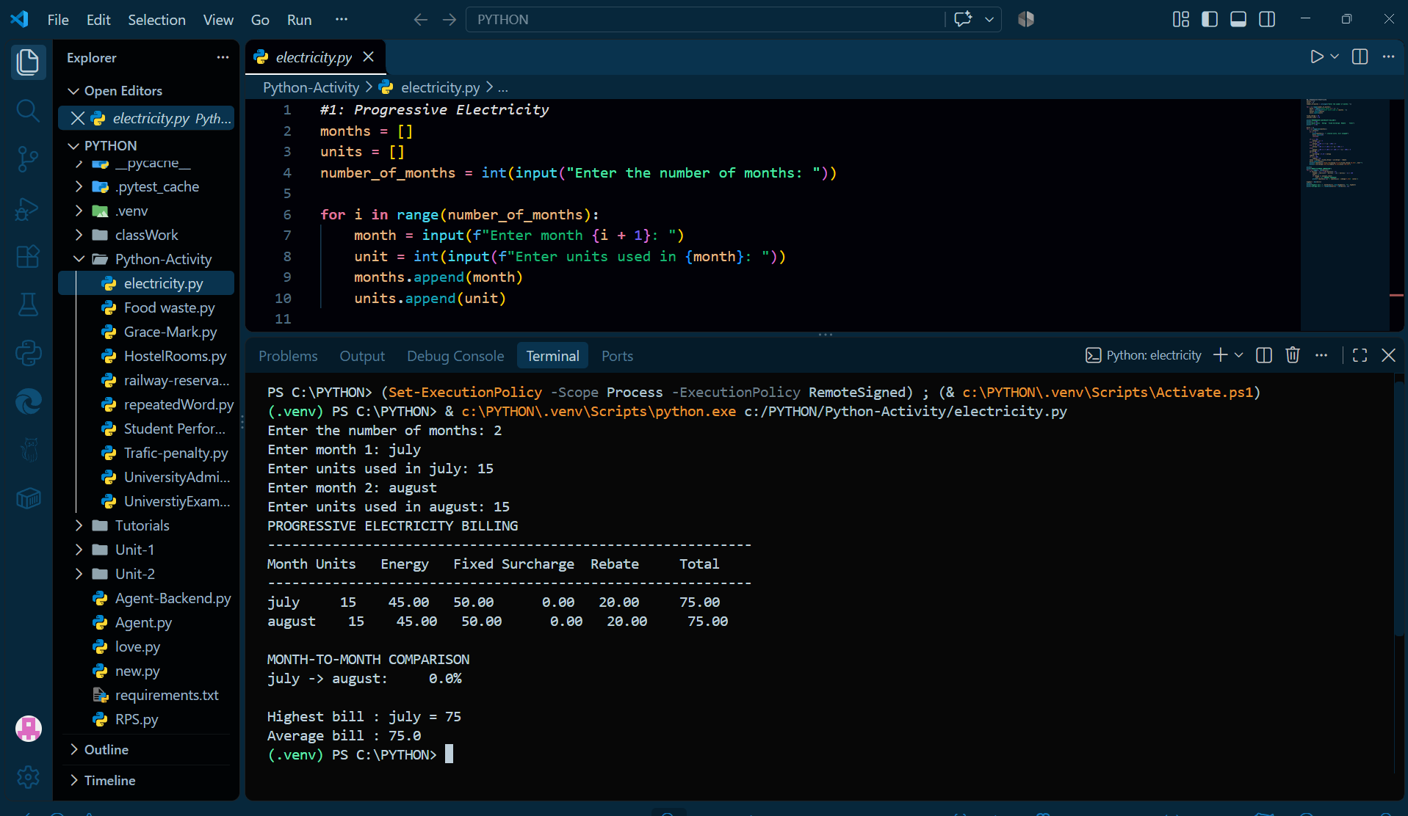
Test Case | Input | Expected Output | Purpose
TC1 | 50 units | Bill = ₹180 | Check the lowest usage slab and rebate.
TC2 | 350 units | Bill = ₹2,195 | Check progressive rates and surcharge.
TC3 | Negative units | Invalid input skipped | Check negative-unit handling.

2. Food Waste Monitoring System
Problem Statement
To calculate daily food waste by comparing the number of meals prepared with the number of meals served.
Objective
To identify food waste and find the day with the highest waste.
Algorithm
- Start.
- Enter the meals prepared and served each day.
- Calculate leftover meals and waste percentage.
- Check whether the waste exceeds 10%.
- Display daily waste details.
- Find the total waste and the day with the highest waste.
- Stop.
CODE :
# Case Study 53: Food Waste Monitoring System
days = ["Mon", "Tue", "Wed", "Thu", "Fri", "Sat", "Sun"]
prepared = []
served = []

for day in days:
while True:
try:
prepared.append(int(input(f"Enter meals prepared on {day}: ")))
break
except ValueError:
print("Please enter a whole number.")

while True:
try:
served.append(int(input(f"Enter meals served on {day}: ")))
break
except ValueError:
print("Please enter a whole number.")

limit = 10 # acceptable waste percentage

print("FOOD WASTE MONITORING")
print("-" * 55)
print(f"{'Day':<5}{'Prepared':>9}{'Served':>8}{'Left':>6}{'Waste%':>9} Status")
total_prepared = 0
total_left = 0
worst_day = ""
worst_percent = -1
flagged = []
for i in range(len(days)):
if served[i] > prepared[i] or prepared[i] <= 0:
print(f"{days[i]:<5} invalid data (served more than prepared)")
continue
left = prepared[i] - served[i]
percent = left / prepared[i] * 100
if percent > limit:
status = "EXCEEDS LIMIT"
flagged.append(days[i])
else:
status = "OK"
total_prepared += prepared[i]
total_left += left
if percent > worst_percent:
worst_percent = percent
worst_day = days[i]
print(f"{days[i]:<5}{prepared[i]:>9}{served[i]:>8}{left:>6}{percent:>9.2f} {status}")

print("-" * 55)
if total_prepared > 0:
print(f"Overall waste : {total_left} meals ({total_left / total_prepared * 100:.2f}%)")
print(f"Worst day : {worst_day} ({worst_percent:.2f}%)")
print("Days over limit :", len(flagged), flagged)
OUTPUT :
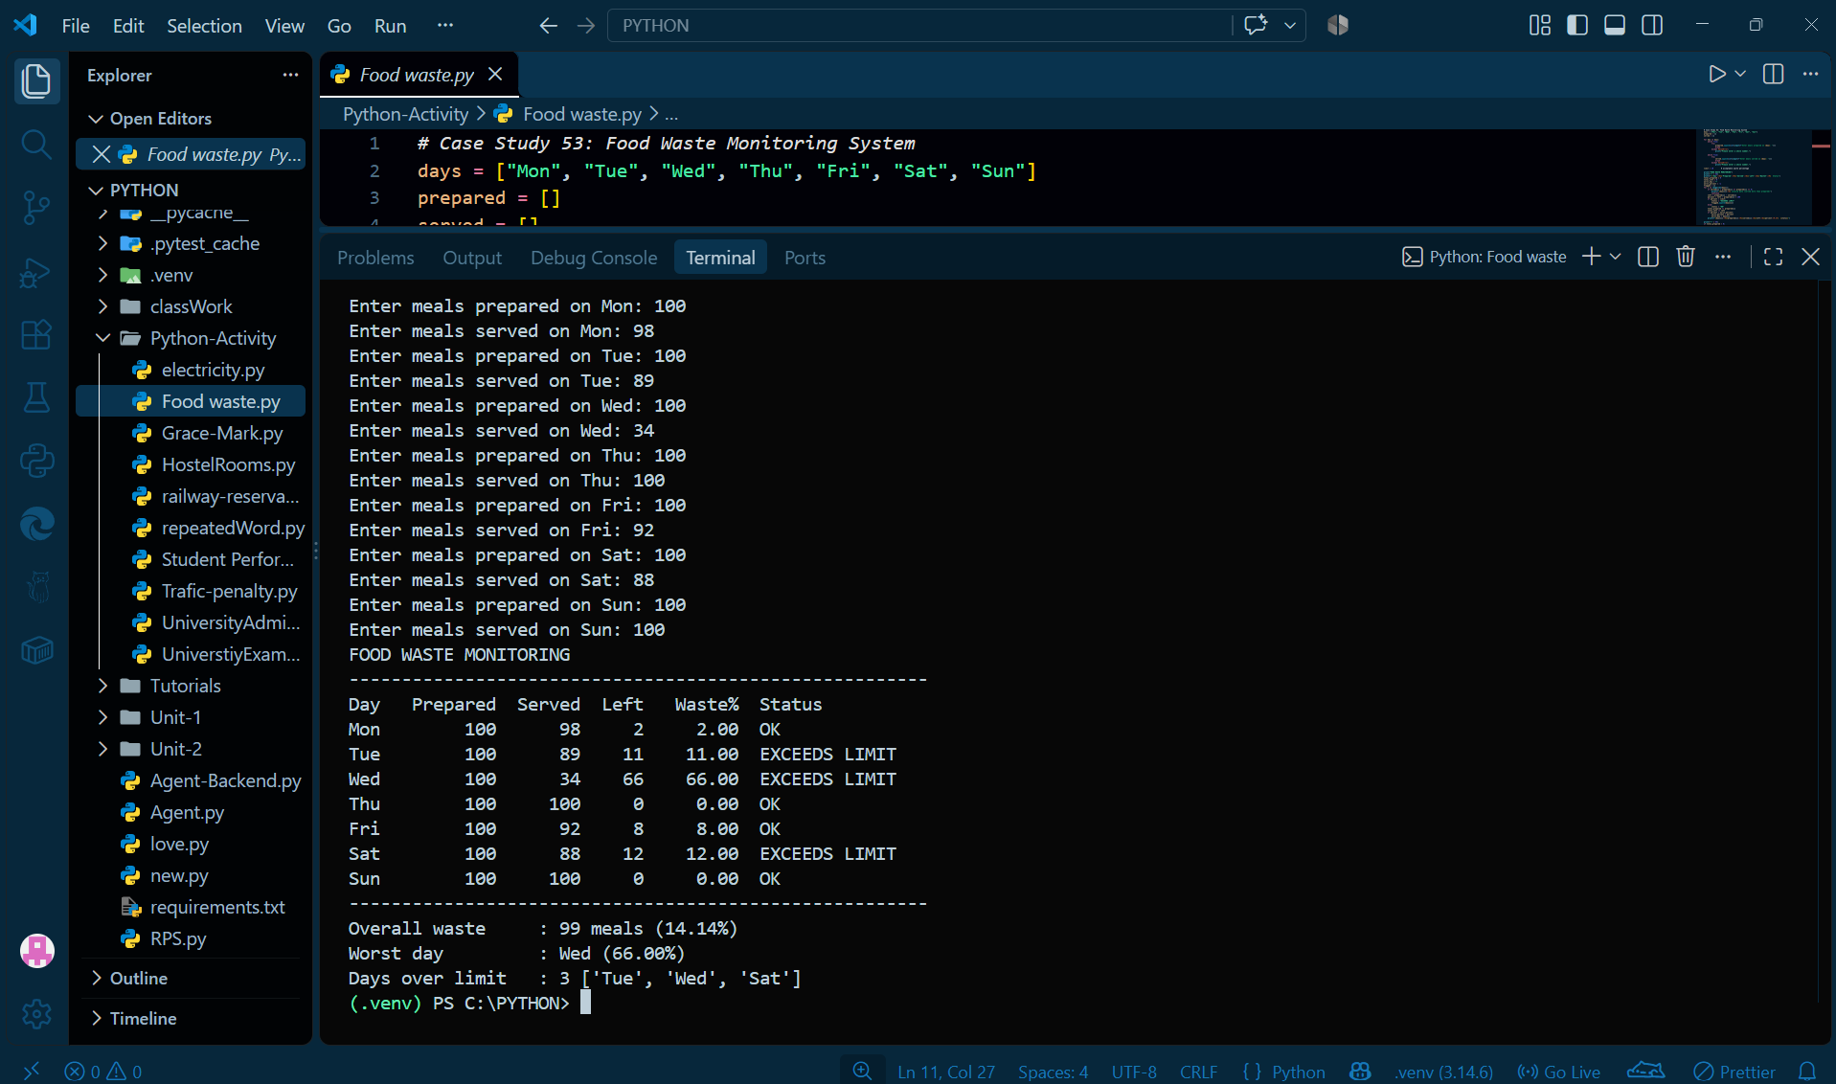
Test Case | Input | Expected Output | Purpose
TC1 | Prepared: 100 meals; served: 90 | Waste = 10%; within limit | Check waste at the limit.
TC2 | Prepared: 100 meals; served: 80 | Waste = 20%; exceeds limit | Check waste above 10%.
TC3 | Prepared: 100 meals; served: 110 | Invalid day skipped | Check when served meals exceed prepared meals.

3. Examination Result and Grace-Mark Validation
Problem Statement
To calculate student results using subject marks, grace marks, and grading rules.
Objective
To determine whether a student passes and assign the appropriate grade.
Algorithm
- Start.
- Enter marks for five subjects.
- Check whether the marks are valid.
- Apply grace marks if allowed.
- Check whether the student passes each subject.
- Calculate the average and assign a grade.
- Display the final result.
- Stop.
CODE :
# Case Study 11: Examination Result and Grace-Mark Validation

pass_mark = 40
max_mark = 100
max_per_subject = 5 # grace allowed in one subject
max_total = 8 # total grace allowed per student
subject_count = 5

while True:
try:
student_count = int(input("Enter the number of students: "))
if student_count <= 0:
print("Enter a number greater than 0.")
continue
break
except ValueError:
print("Enter a valid whole number.")

students = []
for student_number in range(1, student_count + 1):
name = input(f"\nEnter the name of student {student_number}: ").strip()
while not name:
print("Student name cannot be empty.")
name = input(f"Enter the name of student {student_number}: ").strip()

student_marks = []
for subject_number in range(1, subject_count + 1):
while True:
try:
mark = int(input(f"Enter marks for subject {subject_number} (0-100): "))
student_marks.append(mark)
break
except ValueError:
print("Enter a valid whole number.")

students.append((name, student_marks))

print("\nRESULT WITH GRACE-MARK VALIDATION")
print("-" * 66)
for name, original in students:
final = []
needed = []
valid = True
for mark in original:
if mark < 0 or mark > max_mark:
valid = False
final.append(mark)
if mark < pass_mark:
needed.append(pass_mark - mark)

print("Student:", name, original)
if not valid:
print(" Invalid marks entered. Result withheld.")
continue

grace_used = 0
if len(needed) > 0:
too_big = False
for grace_needed in needed:
if grace_needed > max_per_subject:
too_big = True
if too_big:
print(" Grace denied: shortage in a subject is more than", max_per_subject)
elif sum(needed) > max_total:
print(" Grace denied: total needed", sum(needed), "> limit", max_total)
else:
for index in range(len(final)):
if final[index] < pass_mark:
grace_used += pass_mark - final[index]
final[index] = pass_mark
print(" Grace given:", grace_used, "marks ->", final)

result = "Pass"
for mark in final:
if mark < pass_mark:
result = "Fail"
if result == "Fail":
print(" Final Result: FAIL")
else:
average = sum(final) / len(final)
if average >= 75:
grade = "Distinction"
elif average >= 60:
grade = "First Class"
elif average >= 50:
grade = "Second Class"
else:
grade = "Pass Class"
print(f" Final Result: PASS Average = {average:.1f} Class = {grade}")
OUTPUT :
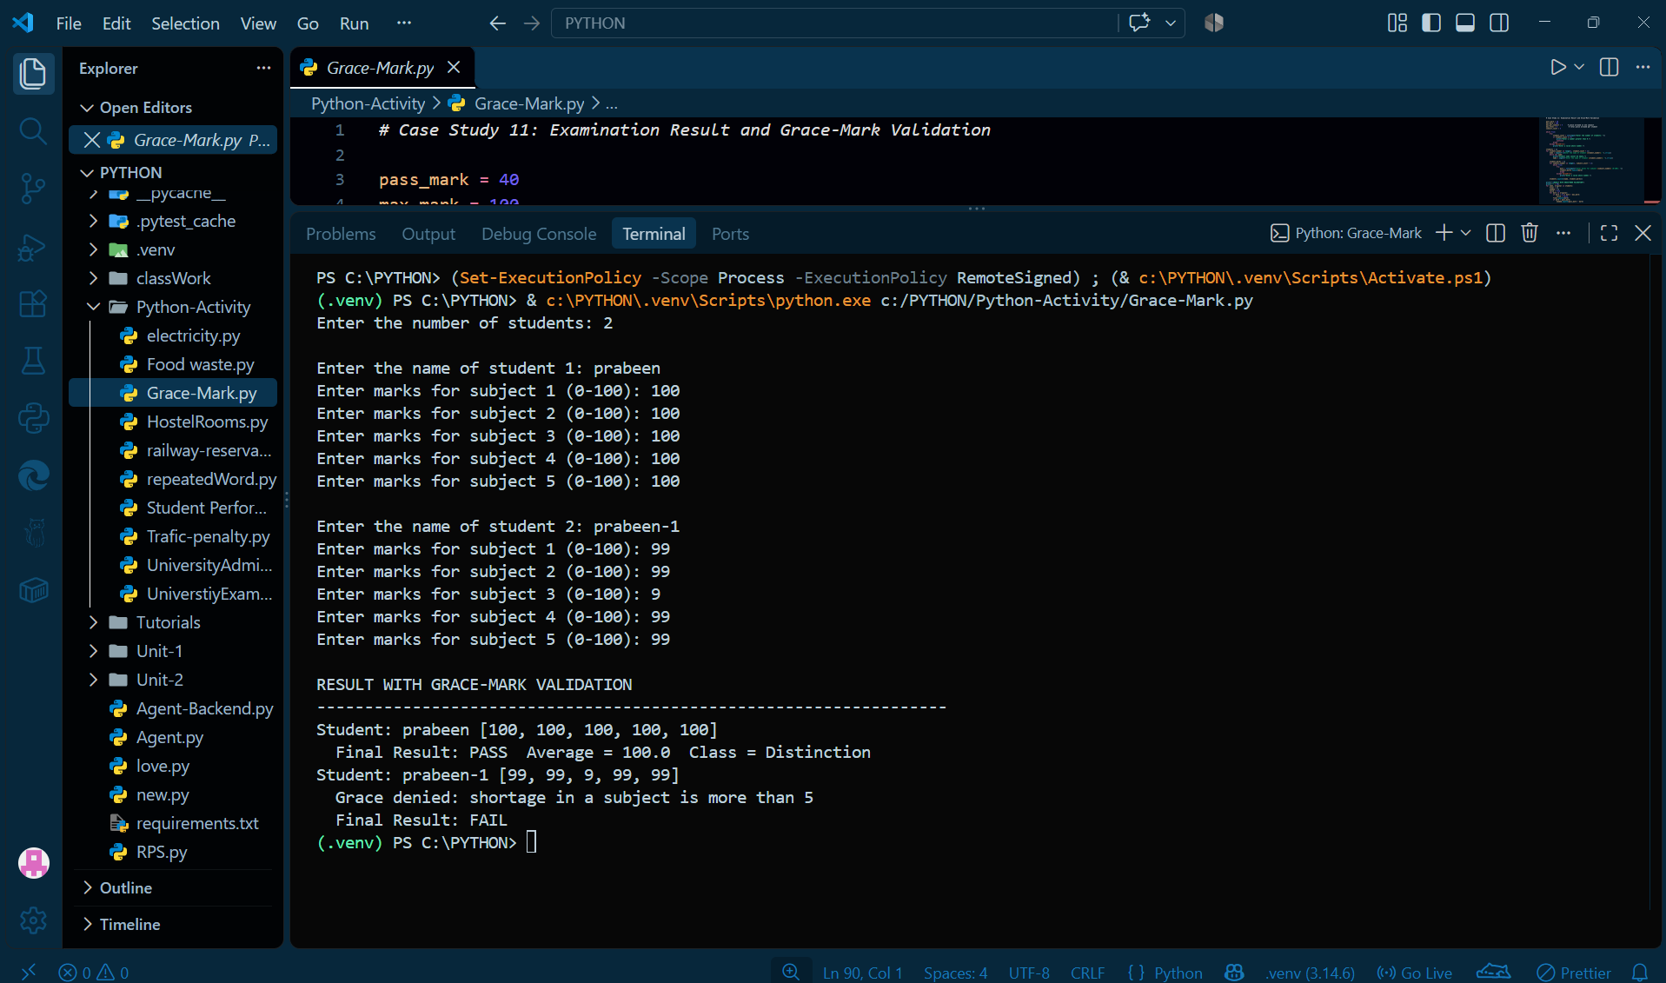
Test Case | Input | Expected Output | Purpose
TC1 | Marks: 80, 75, 70, 85, 90 | PASS; Distinction | Check a student with high marks.
TC2 | Marks: 38, 38, 60, 70, 80 | PASS with 8 grace marks; Second Class | Check grace marks within the total limit.
TC3 | Marks: 34, 60, 70, 80, 90 | FAIL | Check when the shortage exceeds the per-subject grace limit.
TC4 | One subject mark = 110 | Result withheld | Check invalid marks above 100.

4. Classroom and Timetable Validation
Problem Statement
To check classroom capacity and identify timetable clashes involving rooms, classes, or faculty.
Objective
To verify whether classrooms and timetables are valid.
Algorithm
- Start.
- Enter classroom details and timetable information.
- Check whether the rooms exist and have enough capacity.
- Check class timings and room availability.
- Identify room or faculty clashes.
- Display the validation results.
- Stop.
CODE :
def read_integer(prompt):
while True:
try:
return int(input(prompt))
except ValueError:
print("Please enter a whole number.")

print("Enter room details.")
room_count = read_integer("Number of rooms: ")
rooms = []
for i in range(room_count):
print("Room", i + 1)
room = input("Room name: ").strip()
capacity = read_integer("Capacity: ")
rooms.append((room, capacity))

print("\nEnter course details.")
course_count = read_integer("Number of courses: ")
courses = []
for i in range(course_count):
print("Course", i + 1)
code = input("Course code: ").strip()
faculty = input("Faculty name: ").strip()
room = input("Room name: ").strip()
day = input("Day: ").strip()
start = read_integer("Start hour (24-hour time): ")
end = read_integer("End hour (24-hour time): ")
strength = read_integer("Number of students: ")
courses.append((code, faculty, room, day, start, end, strength))

problems = []
bad = []
print("\nTIMETABLE VALIDATION")
print("-" * 60)

# Part 1: check every course on its own
for code, faculty, room, day, start, end, strength in courses:
cap = -1
for r, c in rooms:
if r == room:
cap = c
if end <= start:
problems.append(code + ": invalid time " + str(start) + "-" + str(end))
bad.append(code)
if cap == -1:
problems.append(code + ": room " + room + " does not exist")
bad.append(code)
elif strength > cap:
msg = str(strength) + " students > capacity " + str(cap) + " of " + room
problems.append(code + ": " + msg)
bad.append(code)

# Part 2: compare every pair of courses for clashes
for i in range(len(courses)):
for j in range(i + 1, len(courses)):
c1, f1, r1, d1, s1, e1, n1 = courses[i]
c2, f2, r2, d2, s2, e2, n2 = courses[j]
if d1 == d2 and s1 < e1 and s2 < e2 and s1 < e2 and s2 < e1:
if r1 == r2:
problems.append(c1 + " & " + c2 + ": room " + r1 + " clash on " + d1)
bad.append(c1)
bad.append(c2)
if f1 == f2:
problems.append(c1 + " & " + c2 + ": " + f1 + " has two classes at once")
bad.append(c1)
bad.append(c2)

if len(problems) == 0:
print("No problems found.")
else:
for p in problems:
print("-", p)

accommodated = 0
for course in courses:
if course[0] not in bad:
accommodated += 1
print()
print("Courses accommodated:", accommodated, "of", len(courses))
if len(problems) == 0:
print("RESULT: Proposed timetable is VALID")
else:
print("RESULT: Proposed timetable is NOT valid")
OUTPUT :
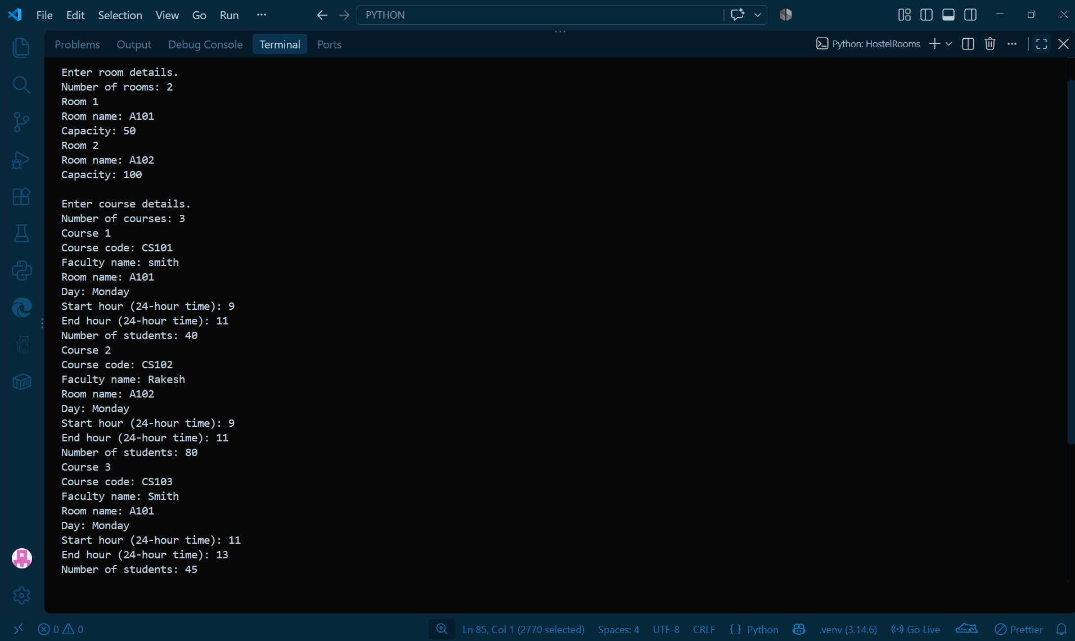
Test Case | Input | Expected Output | Purpose
TC1 | Room capacity is sufficient; no timetable clashes | Valid timetable | Check a valid classroom schedule.
TC2 | Student strength exceeds room capacity | Timetable marked invalid | Check classroom capacity validation.
TC3 | Two classes assigned to the same faculty at overlapping times on the same day | Faculty clash detected | Check overlapping faculty schedules.

5. Railway Fare and Reservation Calculator
Problem Statement
To calculate railway fares based on distance, travel class, passenger age, and cancellation rules.
Objective
To calculate ticket fares, concessions, and cancellation refunds.
Algorithm
- Start.
- Enter passenger details, distance, and travel class.
- Calculate the basic fare using distance slabs.
- Apply the travel-class multiplier and age concession.
- Calculate cancellation charges if applicable.
- Display the final fare or refund.
- Stop.
CODE :
# Case Study 6: Railway Fare and Reservation Calculator
classes = ["SL", "3A", "2A", "1A"]
multipliers = [1.0, 2.5, 3.5, 5.0]
reservation_fee = [20, 40, 50, 60]
cancel_flat = [60, 120, 200, 240]

print("RAILWAY FARE AND RESERVATION CALCULATOR")

try:
distance = int(input("Enter distance in km: "))
travel_class = input("Enter class (SL/3A/2A/1A): ").strip().upper()
n = int(input("Number of passengers: "))
except ValueError:
print("Invalid input. Distance and number of passengers must be whole numbers.")
else:
c = -1
for k in range(len(classes)):
if classes[k] == travel_class:
c = k

if distance <= 0 or c == -1 or n <= 0:
print("Invalid input. Please enter distance > 0, a valid class and passengers > 0.")
else:
# Base fare for the distance using slabs.
if distance <= 200:
base = distance * 1.0
elif distance <= 500:
base = 200 * 1.0 + (distance - 200) * 0.8
else:
base = 200 * 1.0 + 300 * 0.8 + (distance - 500) * 0.6
full_fare = base * multipliers[c]
print()
print(f"Base fare for {distance} km = Rs.{base:.2f}")
print(f"Fare in class {travel_class} = Rs.{full_fare:.2f}")
print()
print(f"{'Passenger':<12}{'Age':>4}{'Concession':>14}{'Fare':>10}{'Res.Fee':>9}")

names = []
fares = []
total_fare = 0
total_fee = 0
valid_passengers = True
for p in range(n):
name = input("Passenger name: ").strip()
try:
age = int(input("Age: "))
except ValueError:
print("Invalid age. Please enter age as a whole number.")
valid_passengers = False
break
if age < 0:
print("Invalid age. Please enter an age of 0 or above.")
valid_passengers = False
break
if age < 5:
fare = 0
fee = 0
concession = "Free (<5)"
elif age <= 11:
fare = full_fare * 0.5
fee = reservation_fee[c]
concession = "50% child"
elif age >= 60:
fare = full_fare * 0.6
fee = reservation_fee[c]
concession = "40% senior"
else:
fare = full_fare
fee = reservation_fee[c]
concession = "None"
names.append(name)
fares.append(fare)
total_fare += fare
total_fee += fee
print(f"{name:<12}{age:>4}{concession:>14}{fare:>10.2f}{fee:>9.2f}")

if valid_passengers:
print("-" * 49)
print(f"Total fare = Rs.{total_fare:.2f} Reservation fee = Rs.{total_fee:.2f}")
print(f"TICKET AMOUNT = Rs.{total_fare + total_fee:.2f}")

answer = input("\nCancel the ticket? (yes/no): ").strip().lower()
if answer == "yes":
try:
hours = float(input("Hours before departure: "))
except ValueError:
print("Invalid input. Please enter the hours as a number.")
else:
penalty = 0
for f in fares:
if f > 0:
if hours >= 48:
cut = cancel_flat[c]
if cut > f:
cut = f
elif hours >= 12:
cut = f * 0.25
elif hours >= 4:
cut = f * 0.50
else:
cut = f
penalty += cut
refund = total_fare - penalty
print(f"Cancellation penalty = Rs.{penalty:.2f}")
print(f"Refund amount = Rs.{refund:.2f}")
OUTPUT :
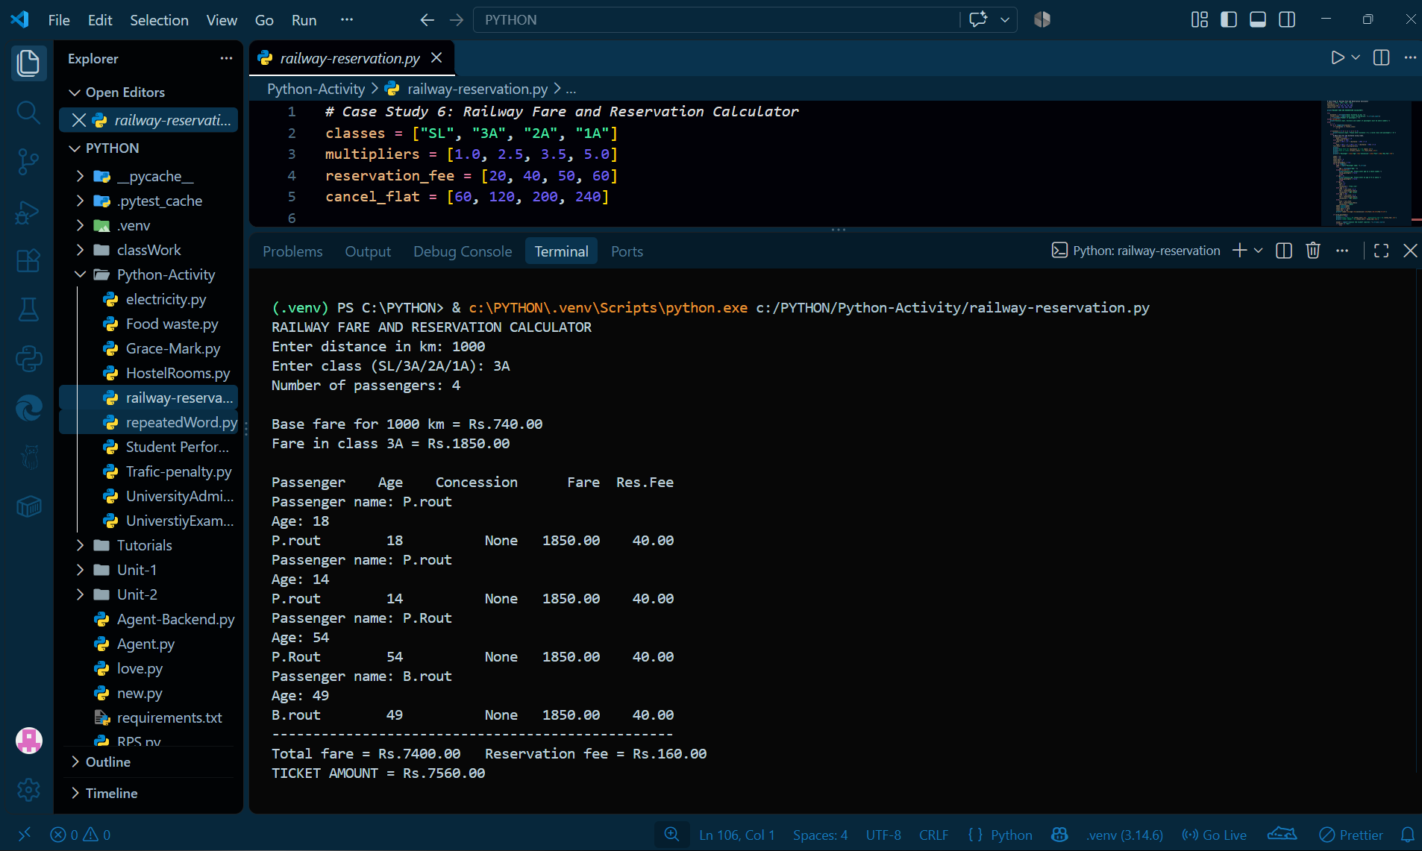
Test Case | Input | Expected Output | Purpose
TC1 | Distance: 100 km; class: SL; adult passenger | Ticket total = ₹120 | Check standard fare and reservation fee.
TC2 | Distance: 100 km; passenger age: 4 | Ticket total = ₹0 | Check the fare exemption for children under 5.
TC3 | Negative distance | Invalid input | Check negative-distance validation.
TC4 | SL ticket; fare ₹100; cancellation 24 hours before departure | Cancellation penalty = ₹25; refund = ₹75 | Check cancellation within the 12–48-hour window.

6. Repeated Word and Phrase Detection
Problem Statement
To identify repeated words and consecutive two-word phrases in a given text.
Objective
To count word occurrences, find repeated phrases, and identify the most frequent word.
Algorithm
- Start.
- Enter the text.
- Convert the text to lowercase and remove punctuation.
- Count each word and record its positions.
- Find repeated consecutive two-word phrases.
- Display repeated words, phrases, and the most frequent word.
- Stop.
CODE :
# Case Study 36: Repeated Word and Phrase Detection
text = input("Enter a paragraph: ")

# Step 1: clean the paragraph (lower case, remove punctuation)
clean = text.lower()
for ch in ".,!?;:":
clean = clean.replace(ch, "")
words = clean.split()
print("Total words:", len(words))

# Step 2: count every word and remember its positions
unique = []
counts = []
positions = []
for i in range(len(words)):
w = words[i]
if w in unique:
k = unique.index(w)
counts[k] += 1
positions[k].append(i + 1)
else:
unique.append(w)
counts.append(1)
positions.append([i + 1])

print()
print("REPEATED WORDS")
print(f"{'Word':<12}{'Count':>6} Positions")
found = 0
for k in range(len(unique)):
if counts[k] > 1:
print(f"{unique[k]:<12}{counts[k]:>6} {positions[k]}")
found += 1
if found == 0:
print("No repeated words.")

# Step 3: repeat the same idea for two-word phrases
phrases = []
p_counts = []
p_positions = []
for i in range(len(words) - 1):
ph = words[i] + " " + words[i + 1]
if ph in phrases:
k = phrases.index(ph)
p_counts[k] += 1
p_positions[k].append(i + 1)
else:
phrases.append(ph)
p_counts.append(1)
p_positions.append([i + 1])

print()
print("REPEATED TWO-WORD PHRASES")
found = 0
for k in range(len(phrases)):
if p_counts[k] > 1:
print(f"{phrases[k]:<14}{p_counts[k]:>4} {p_positions[k]}")
found += 1
if found == 0:
print("No repeated phrases.")

# most frequent word
if unique:
best = 0
for k in range(len(unique)):
if counts[k] > counts[best]:
best = k
print()
print("Most frequent word:", unique[best], "(", counts[best], "times )")
else:
print()
print("No words to analyze.")
OUTPUT :
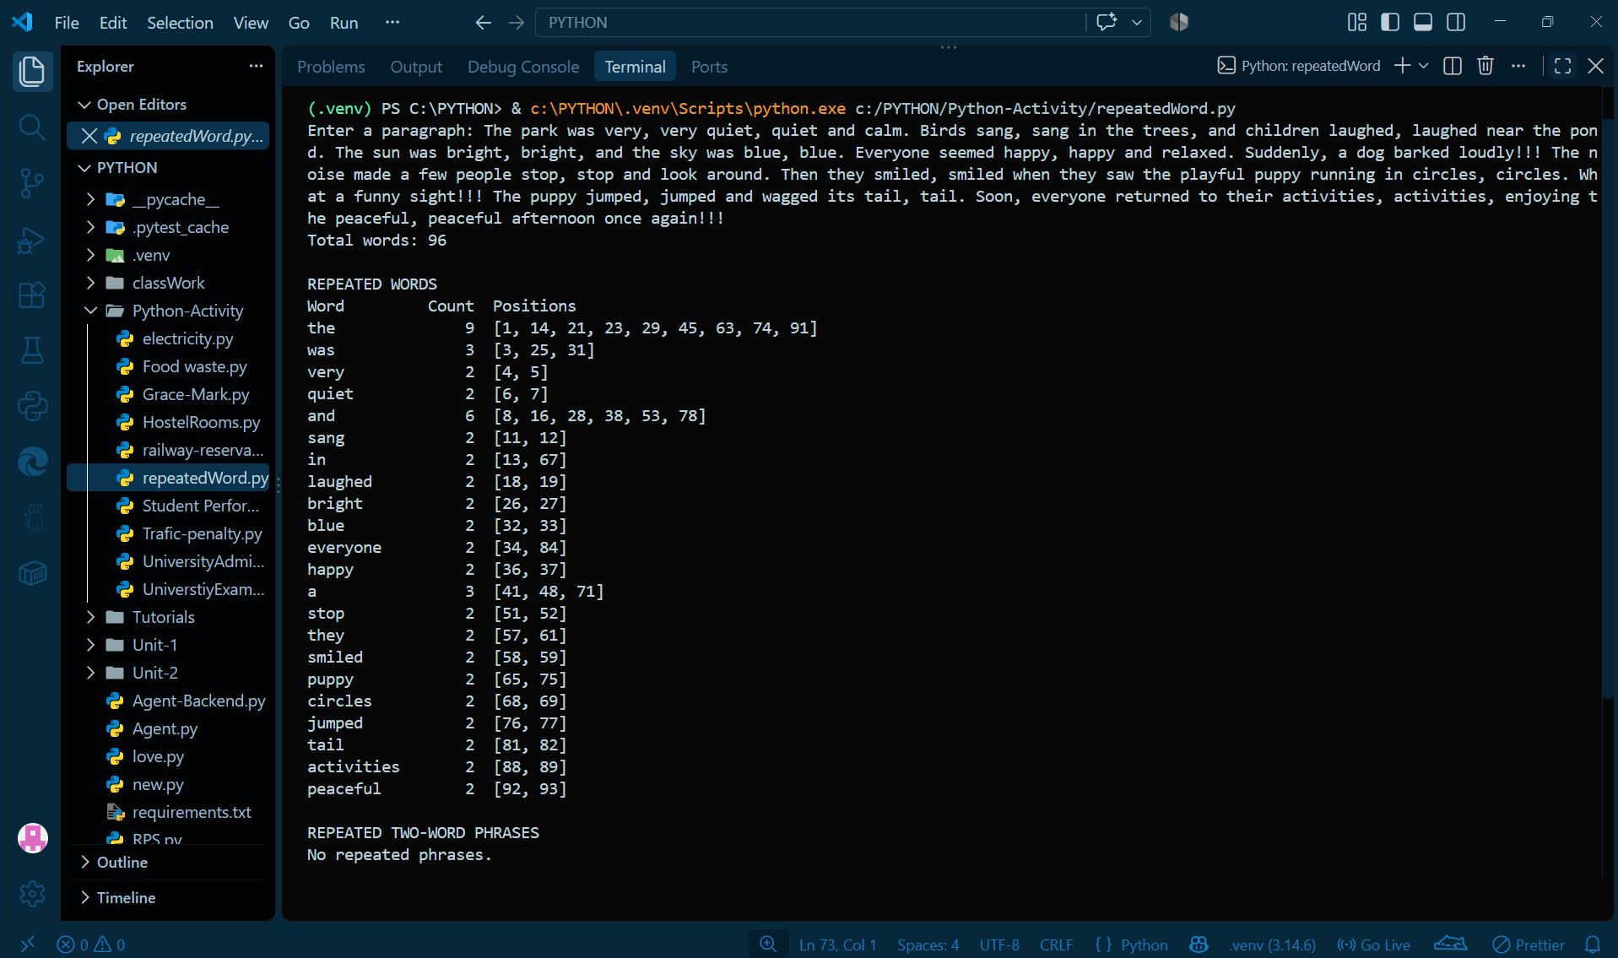
Test Case | Input | Expected Output | Purpose
TC1 | apple mango apple banana | Repeated word: apple | Check repeated-word detection.
TC2 | go home go home | Repeated phrase: go home | Check consecutive repeated-phrase detection.
TC3 | red blue green | No repeated words or phrases | Check text with no repetitions.

7. Student Performance Trend Analysis
Problem Statement
To analyze student marks across three examinations and identify performance changes.
Objective
To find subject-wise improvement, weak subjects, and overall performance trends.
Algorithm
- Start.
- Enter marks for three examinations.
- Calculate the change in marks for each subject.
- Identify subjects where the student scored below 40 in all three exams.
- Compare the overall averages of the first and third exams.
- Display whether performance improved, declined, or remained stable.
- Stop.
CODE :
# 2: Student Performance Trend Analysis

def read_integer(prompt, minimum=None):
while True:
try:
value = int(input(prompt))
if minimum is not None and value < minimum:
print(f"Please enter a number greater than or equal to {minimum}.")
continue
return value
except ValueError:
print("Please enter a valid whole number.")

student_count = read_integer("Enter the number of students: ", minimum=1)
students = []

for student_index in range(student_count):
student_name = input(f"Enter the name of student {student_index + 1}: ").strip()
while not student_name:
print("Student name cannot be empty.")
student_name = input(f"Enter the name of student {student_index + 1}: ").strip()
students.append(student_name)

subject_count = read_integer("Enter the number of subjects: ", minimum=1)
subjects = []

for subject_index in range(subject_count):
subject_name = input(f"Enter the name of subject {subject_index + 1}: ").strip()
while not subject_name:
print("Subject name cannot be empty.")
subject_name = input(f"Enter the name of subject {subject_index + 1}: ").strip()
subjects.append(subject_name)

marks = []
exam_names = ("Exam 1", "Exam 2", "Exam 3")

for student in students:
student_marks = []
print(f"Enter marks for {student}:")
for subject in subjects:
exam_marks = []
for exam in exam_names:
exam_marks.append(read_integer(f" {subject} - {exam}: "))
student_marks.append(exam_marks)
marks.append(student_marks)

weak_limit = 40
print("STUDENT PERFORMANCE TREND ANALYSIS")
print("=" * 52)

improving = 0
declining = 0
stable = 0
for s in range(len(students)):
print("Student:", students[s])
print(f"{'Subject':<11}{'Ex1':>5}{'Ex2':>5}{'Ex3':>5}{'Change':>8} Trend")
t1 = 0
t3 = 0
weak_subjects = []
for j in range(len(subjects)):
e1, e2, e3 = marks[s][j]
change = e3 - e1
if change > 0:
trend = "Improved"
elif change < 0:
trend = "Declined"
else:
trend = "Same"
if e1 < weak_limit and e2 < weak_limit and e3 < weak_limit:
weak_subjects.append(subjects[j])
trend = trend + " (WEAK)"
t1 = t1 + e1
t3 = t3 + e3
print(f"{subjects[j]:<11}{e1:>5}{e2:>5}{e3:>5}{change:>+8} {trend}")
avg1 = t1 / len(subjects)
avg3 = t3 / len(subjects)
overall = avg3 - avg1
if overall >= 5:
category = "Improving"
improving += 1
elif overall <= -5:
category = "Declining"
declining += 1
else:
category = "Stable"
stable += 1
print(f"Average: {avg1:.1f} -> {avg3:.1f} (change {overall:+.1f})")
print("Classification:", category)
if len(weak_subjects) > 0:
print("Consistently weak in:", ", ".join(weak_subjects))
print("-" * 52)

print("SUMMARY: Improving =", improving, "| Stable =", stable, "| Declining =", declining)
OUTPUT :
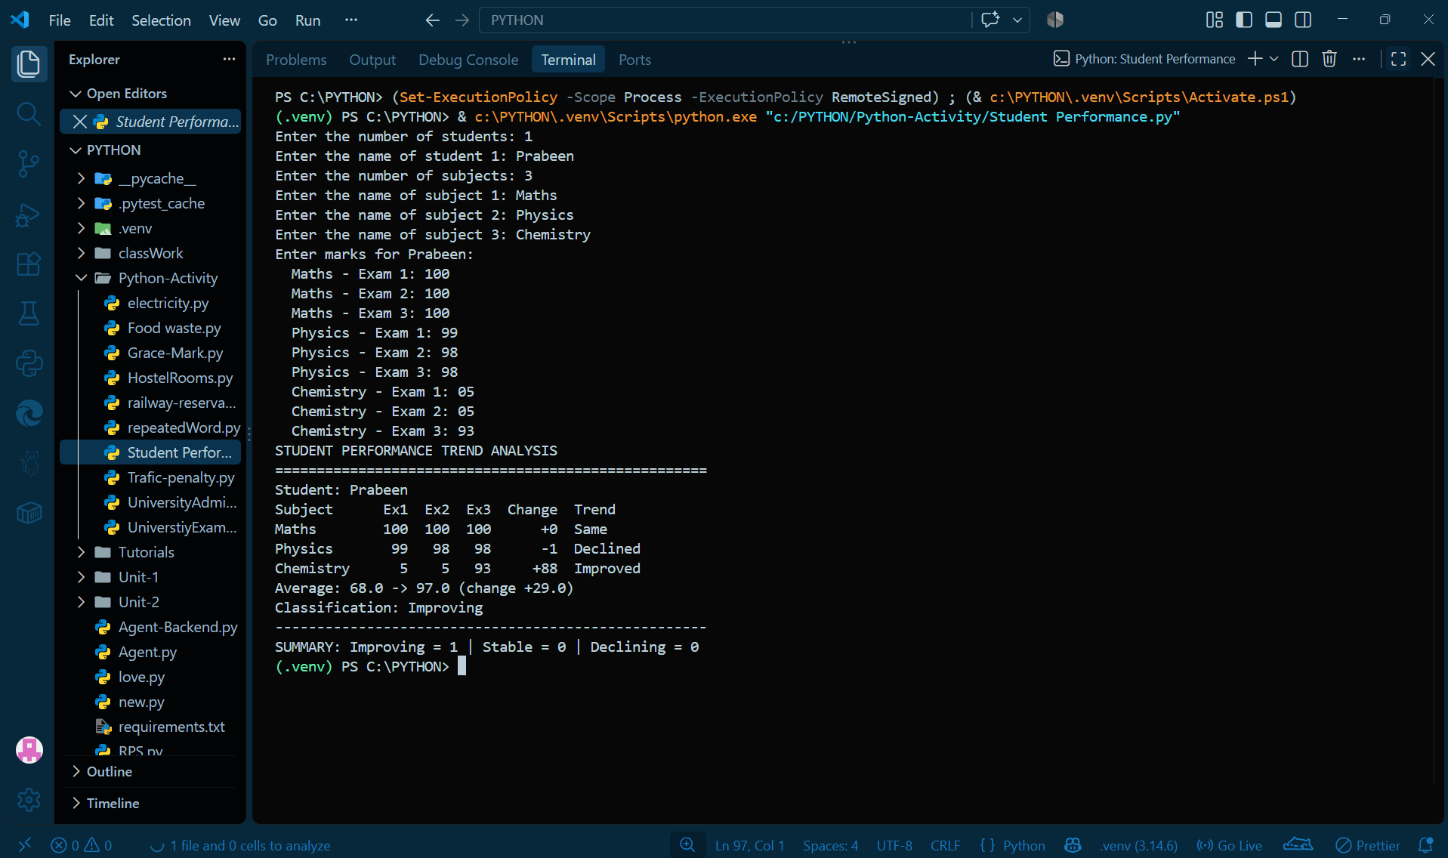
Test Case | Input | Expected Output | Purpose
TC1 | Exam marks: 50, 55, 60 | Improving | Check an increase of at least 5 marks.
TC2 | Exam marks: 80, 70, 60 | Declining | Check a decrease of at least 5 marks.
TC3 | Exam marks: 30, 35, 38 | Overall trend: Stable; subject identified as weak | Check a weak subject and a trend within the stable range.

8. Traffic Violation Penalty Calculator
Problem Statement
To calculate traffic fines based on violation type, vehicle type, and previous violations.
Objective
To calculate penalties and identify drivers who meet the program's licence-disqualification conditions.
Algorithm
- Start.
- Enter the driver's details, vehicle type, and violations.
- Find the basic fine for each violation.
- Apply the vehicle multiplier and repeat-offence penalty.
- Calculate the total fine for each driver.
- Check the licence-disqualification conditions.
- Display the fines and driver status.
- Stop.
CODE :
# 3: Traffic Violation Penalty Calculator

offences = ["Over speeding", "Red light jumping", "No helmet", "Drunk driving", "No licence"]
base_fines = [1000, 1500, 500, 10000, 5000]
vehicle_types = ["two-wheeler", "car", "heavy"]
multipliers = [1.0, 1.5, 2.0]
repeat_extra = 0.5 # 50% extra for a repeat offence

records = []
while True:
try:
record_count = int(input("Enter the number of violation records: "))
if record_count < 0:
print("Please enter a non-negative number.")
continue
break
except ValueError:
print("Please enter a valid whole number.")

for record_number in range(1, record_count + 1):
print(f"\nRecord {record_number}")
driver = input("Driver name: ").strip()
vehicle = input("Vehicle type (two-wheeler, car, heavy): ").strip()
offence = input(
"Offence (Over speeding, Red light jumping, No helmet, "
"Drunk driving, No licence): "
).strip()

while True:
repeat_input = input("Repeat offence? (yes/no): ").strip().lower()
if repeat_input in ("yes", "y"):
repeat = True
break
if repeat_input in ("no", "n"):
repeat = False
break
print("Please enter yes or no.")

records.append((driver, vehicle, offence, repeat))

drivers = []
totals = []
counts = []
drunk = []

print("\nTRAFFIC VIOLATION PENALTY CALCULATOR")
print("-" * 62)
for driver, vehicle, offence, repeat in records:
o_index = -1
v_index = -1
for k in range(len(offences)):
if offences[k] == offence:
o_index = k
for k in range(len(vehicle_types)):
if vehicle_types[k] == vehicle:
v_index = k
if o_index == -1 or v_index == -1:
print(f"{driver:<8}{offence:<20} -> Unknown offence/vehicle, record skipped")
continue
fine = base_fines[o_index] * multipliers[v_index]
if repeat:
fine = fine + fine * repeat_extra
# Add to this driver's totals.
if driver not in drivers:
drivers.append(driver)
totals.append(0)
counts.append(0)
drunk.append(False)
d = drivers.index(driver)
totals[d] += fine
counts[d] += 1
if offence == "Drunk driving":
drunk[d] = True
print(f"{driver:<8}{vehicle:<13}{offence:<20}Fine = Rs.{fine:>9.2f}")

print()
print("DRIVER SUMMARY")
print("-" * 62)
for d in range(len(drivers)):
reasons = []
if drunk[d]:
reasons.append("drunk driving")
if counts[d] >= 3:
reasons.append("3 or more violations")
if totals[d] > 10000:
reasons.append("fine above Rs.10000")
print(f"{drivers[d]:<8} violations = {counts[d]} total fine = Rs.{totals[d]:.2f}")
if len(reasons) > 0:
print(" LICENCE DISQUALIFIED:", ", ".join(reasons))
else:
print(" Licence status: OK")
OUTPUT :
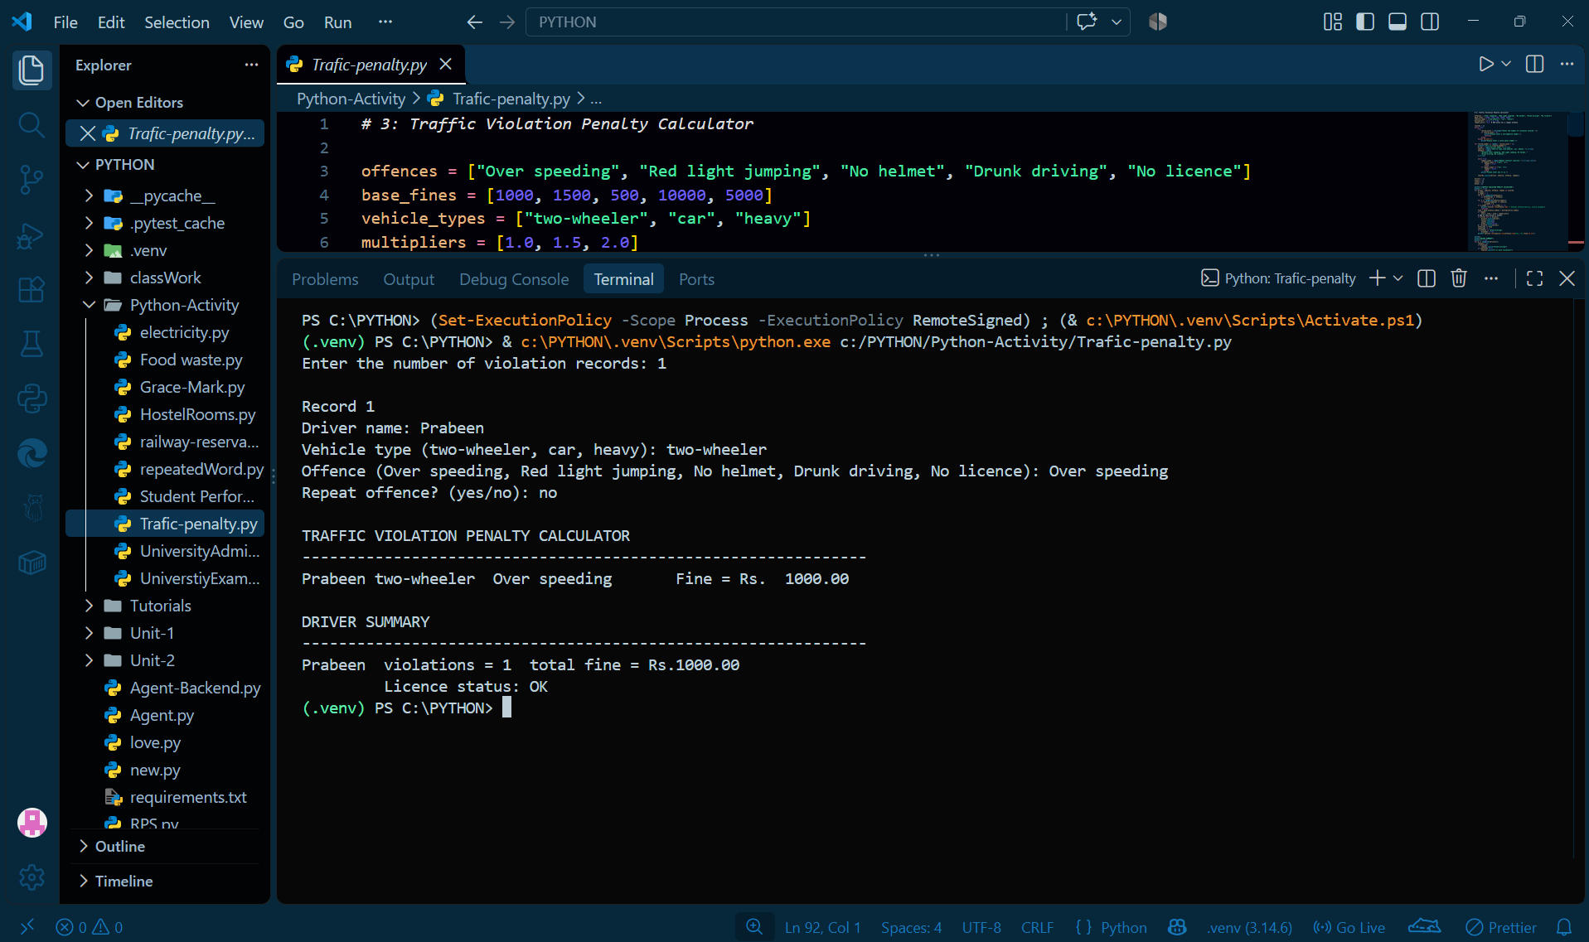
Test Case | Input | Expected Output | Purpose
TC1 | Two-wheeler; over-speeding; first offence | Fine = ₹1,000 | Check the standard fine.
TC2 | Car; no helmet; repeat offence | Fine = ₹1,125 | Check the vehicle multiplier and repeat-offence penalty.
TC3 | Car; drunk driving; first offence | Fine = ₹15,000; licence disqualified | Check the drunk-driving fine and disqualification rule.
TC4 | Unknown vehicle type | Record skipped | Check invalid vehicle handling.

9. University Scholarship Allocation
Problem Statement
To develop a Python program that checks students' eligibility for scholarships based on academic marks, attendance, and family income, then ranks eligible applicants and allocates scholarships according to available seats.
Objectives
- Check eligibility using predefined criteria.
- Rank eligible applicants based on merit.
- Allocate scholarships according to available seats.
- Display selected applicants and the waiting list.
Algorithm
- Set minimum aggregate, subject marks, attendance, and maximum income criteria.
- Input applicant details and available seats.
- Check each applicant's eligibility.
- Store eligible applicants and rank them using Bubble Sort.
- Award scholarships to top-ranked applicants.
- Display the rank list and scholarship decisions.
CODE :
# Case Study 1: University Scholarship Allocation
# User input version

min_aggregate = 75
min_subject = 50
min_attendance = 75
max_income = 300000

def read_float(prompt):
while True:
try:
return float(input(prompt))
except ValueError:
print("Please enter a valid number.")

def read_int(prompt):
while True:
try:
return int(input(prompt))
except ValueError:
print("Please enter a valid integer.")

print("UNIVERSITY SCHOLARSHIP ALLOCATION")
print("-" * 60)
count = read_int("Enter number of applicants: ")

applicants = []
for i in range(1, count + 1):
print(f"\nApplicant {i}")
name = input("Enter name: ").strip()
agg = read_float("Enter aggregate percentage: ")
subj = []
for subject_no in range(1, 4):
subj.append(read_float(f"Enter subject {subject_no} mark: "))
att = read_float("Enter attendance percentage: ")
income = read_float("Enter family income: ")
applicants.append((name, agg, subj, att, income))

seats = read_int("Enter number of seats: ")

keys = []
print("\nELIGIBILITY CHECK")
print("-" * 60)
for name, agg, subj, att, income in applicants:
reasons = []
if agg < min_aggregate:
reasons.append("aggregate < 75")
low = False
for m in subj:
if m < min_subject:
low = True
if low:
reasons.append("a subject mark < 50")
if att < min_attendance:
reasons.append("attendance < 75")
if income > max_income:
reasons.append("income > 3,00,000")
if len(reasons) == 0:
print(f"{name:<8} ELIGIBLE")
# tie-break key: higher aggregate, higher attendance, lower income, name
keys.append((-agg, -att, income, name))
else:
print(f"{name:<8} NOT ELIGIBLE ({', '.join(reasons)})")

# bubble sort the keys (tuples compare element by element)
n = len(keys)
for i in range(n - 1):
for j in range(n - 1 - i):
if keys[j] > keys[j + 1]:
temp = keys[j]
keys[j] = keys[j + 1]
keys[j + 1] = temp

print()
print("RANK LIST")
print(f"{'Rank':<6}{'Name':<8}{'Agg':>6}{'Att':>6}{'Income':>9} Decision")
for r in range(n):
neg_agg, neg_att, income, name = keys[r]
if r < seats:
decision = "SCHOLARSHIP AWARDED"
else:
decision = "Waiting list"
print(f"{r+1:<6}{name:<8}{-neg_agg:>6}{-neg_att:>6}{income:>9} {decision}")
if n == 0:
print("No eligible applicants.")
OUTPUT :
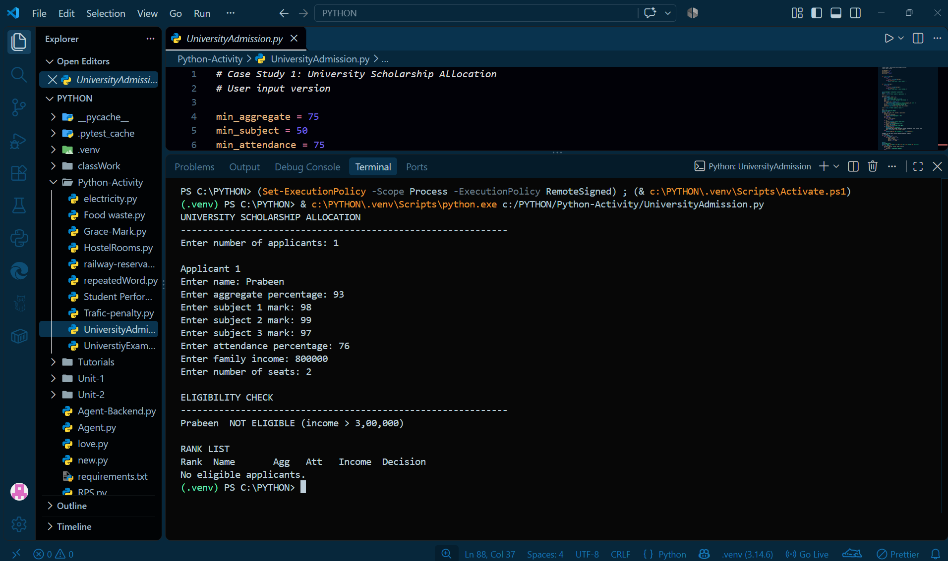
Test Case | Input Condition | Expected Output
TC1 | All criteria satisfied | Eligible
TC2 | Aggregate below 75% | Not eligible
TC3 | Subject mark below 50 | Not eligible
TC4 | Attendance below 75% | Not eligible
TC5 | Income above ₹3,00,000 | Not eligible
TC6 | Eligible applicants exceed seats | Merit-based selection

10. University Examination Result Moderation
Problem Statement
To develop a Python program that modifies students' examination marks using moderation rules and compares the original results with the moderated results.
Objectives
- Calculate the average marks for each subject.
- Apply bonus marks to subjects with low averages.
- Provide grace marks to eligible students to achieve passing marks.
- Compare and display original and moderated results.
Algorithm
- Input student names, subject names, and marks.
- Calculate each subject's average marks.
- Add 5 bonus marks if the subject average is below 55.
- Raise marks from 35–39 to 40 after applying the bonus.
- Ensure marks do not exceed 100.
- Compare and display original and moderated results.
CODE :
# Case Study 76: University Examination Result Moderation

pass_mark = 40
max_mark = 100
avg_limit = 55 # Rule 1: subject average below this -> +5 for all
bonus = 5
grace_low = 35 # Rule 2: marks 35..39 are raised to 40

def read_positive_integer(prompt):
while True:
try:
value = int(input(prompt))
if value > 0:
return value
print("Please enter a number greater than zero.")
except ValueError:
print("Please enter a valid whole number.")

def read_non_empty_text(prompt):
while True:
value = input(prompt).strip()
if value:
return value
print("This value cannot be empty.")

student_count = read_positive_integer("Enter the number of students: ")
students = [
read_non_empty_text(f"Enter the name or ID of student {i + 1}: ")
for i in range(student_count)
]

subject_count = read_positive_integer("Enter the number of subjects: ")
subjects = [
read_non_empty_text(f"Enter the name of subject {j + 1}: ")
for j in range(subject_count)
]

marks = []
for student in students:
row = []
for subject in subjects:
while True:
try:
mark = int(input(f"Enter {student}'s mark in {subject} (0-{max_mark}): "))
if 0 <= mark <= max_mark:
row.append(mark)
break
print(f"Marks must be between 0 and {max_mark}.")
except ValueError:
print("Please enter a valid number.")
marks.append(row)

# Step 1: column-wise average of every subject (original marks)
add_bonus = []
print("\nSUBJECT AVERAGES (before moderation)")
for j in range(len(subjects)):
total = 0
for i in range(len(students)):
total = total + marks[i][j]
avg = total / len(students)
if avg < avg_limit:
add_bonus.append(True)
print(f"{subjects[j]:<9}{avg:6.1f} -> below {avg_limit}, +{bonus} moderation")
else:
add_bonus.append(False)
print(f"{subjects[j]:<9}{avg:6.1f}")

# Step 2: apply both rules to build the moderated list
moderated = []
for i in range(len(students)):
row = []
for j in range(len(subjects)):
m = marks[i][j]
if add_bonus[j]:
m = m + bonus
if m >= grace_low and m < pass_mark:
m = pass_mark
if m > max_mark:
m = max_mark # never exceed maximum marks
row.append(m)
moderated.append(row)

# Step 3: compare original and moderated results
print()
print("RESULT COMPARISON")
print(f"{'Stu':<5}{'Original marks':<20}{'Result':<8}{'Moderated marks':<20}{'Result':<8}")
for i in range(len(students)):
r1 = "Pass"
r2 = "Pass"
for j in range(len(subjects)):
if marks[i][j] < pass_mark:
r1 = "Fail"
if moderated[i][j] < pass_mark:
r2 = "Fail"
note = ""
if r1 == "Fail" and r2 == "Pass":
note = "<-- now PASS"
print(f"{students[i]:<5}{str(marks[i]):<20}{r1:<8}{str(moderated[i]):<20}{r2:<8}{note}")
OUTPUT :
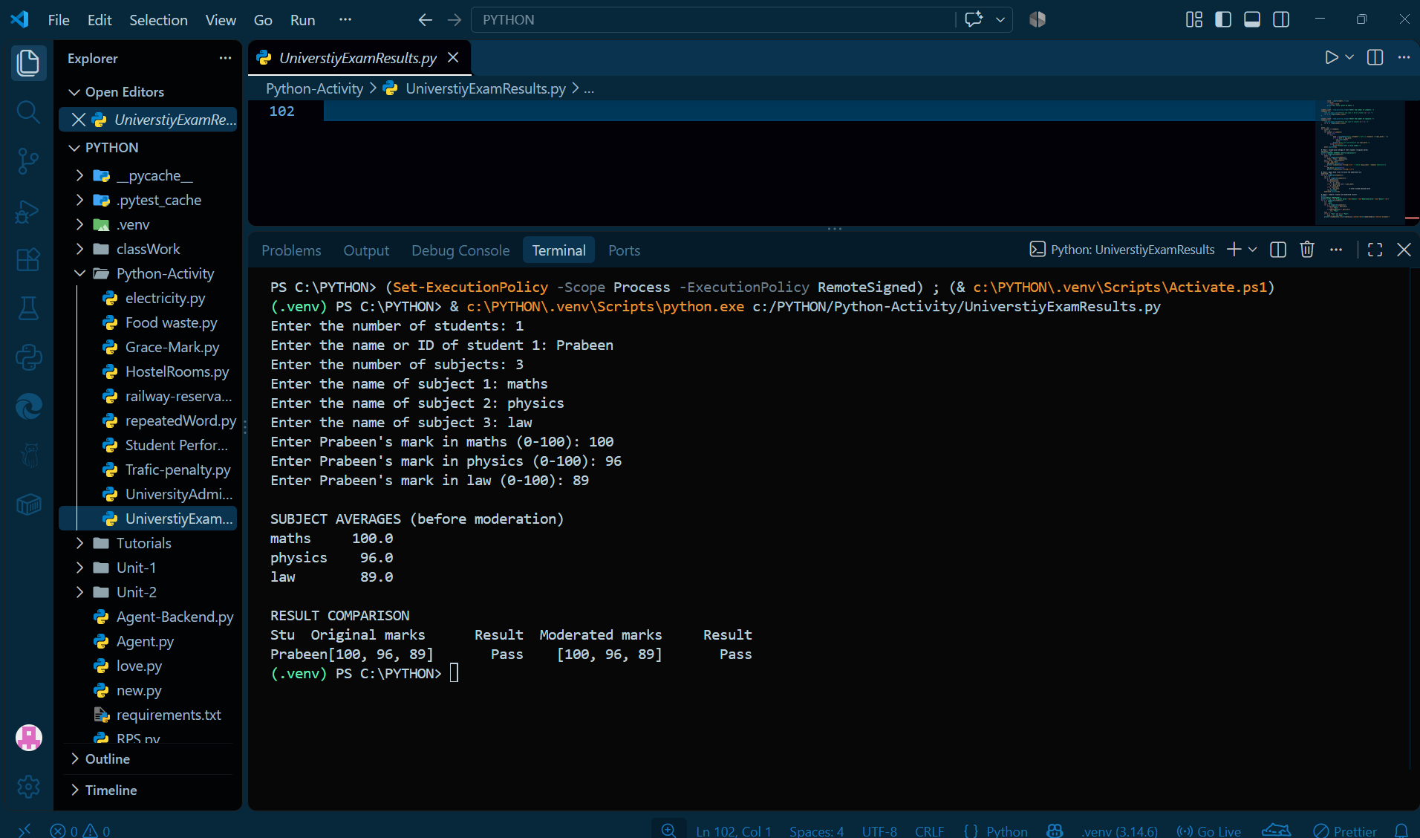
Test Case | Input Condition | Expected Output
TC1 | Subject average below 55 | Add 5 bonus marks
TC2 | Subject average ≥ 55 | No bonus
TC3 | Marks between 35 and 39 | Raise to 40 if applicable
TC4 | Moderated marks exceed 100 | Cap at 100
TC5 | Marks below passing mark | Fail
TC6 | Invalid marks entered | Ask for valid input

