INTRODUCTION TO SCHOOL MANAGEMENT SYSTEM

Fed up with struggling with a system, which seems to add to your workload, which doesn't work the way your school does?
Do you want a scalable computerized system with plenty of timesaving features that help to get jobs done accurately and quickly?
Do you want professional-looking reports and correspondence?
.........Then look at School Management System.

The appearance of your student records says a lot about the quality of your school. Other educators and registrars make judgments based on student records that can permanently affect a student's life. SMS capabilities include the basics such as transcripts, report cards, attendance, and discipline as well as many other specialized capabilities, including parental access to real time student grades on the Internet. This means that not only administrators but also parents, teachers, and students have access to real-time data. With traditional reporting methods parents may not find out how their student is performing in school until the end of the quarter or semester -- usually too late to correct a problem situation. SMS allows parents to know how their student is doing on a continual basis by using the internet. SMS can even send electronic progress reports to parents via email on a weekly, monthly, or even daily basis.

You operate a quality program—NOW you can be sure your records communicate that quality. Here realizes the need for an effective school management system and that is exactly what we are striving for!

The School Management System (SMS) will replace the paper-based data collection and information exchange system among the various departments of a particular school.

The School Management System provides an innovative solution for Today’s school record-keeping challenges. This school management software will give you room to handle your responsibilities whether you’re just starting or are an experienced professional.

School Management System opens a universe of opportunities to automate the laborious paperwork involved in proper school management. With our proposed record-keeping software the management can more effectively interact with the students as they develop skills and character for success. They will not only have more time to spend with them, but it will be quality time because they will have up-to-date student information to facilitate them.

Project Description

School Management Software (SMS Standard Desktop / SMS Standard Enterprise Version 1.1) is a complete and customized solution for a school handling regular management work. By going through the flow of application one can easily maintain its student detail, fees detail, Employee detail, Certificate details, Time Table and Exam scheduling, Exams and Question Paper detail and Transportation Detail. This software includes the management of students, Employee, Accounts, Transportation, library, Fees, Exam, Time Table, Inventory and its respective reports with administrative module to provide better security. User-friendly menus can easily generate all the reports.

ARCHITECTURE

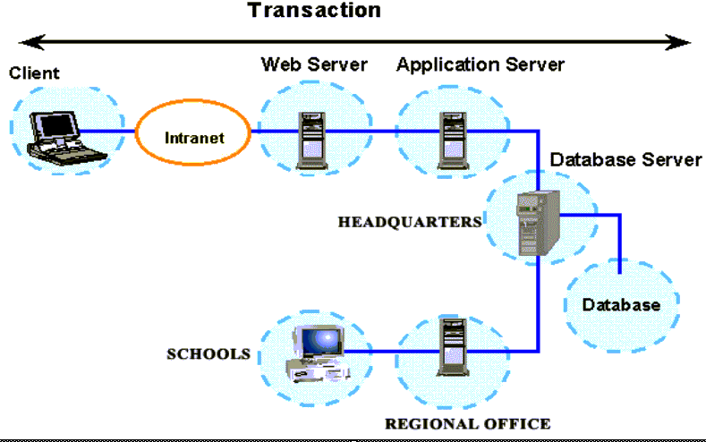

Modules
As per your requirement of Schools we analysed that SMS Standard Desktop or Enterprise Version1.1 application should consists of the following modules.
- Student Management
  - Based on Students from Secondary and Higher Secondary
    - Student Personal Details
    - Parents Details
    - Certificates Management (Extracurricular & Transfer Certificate)
    - Class and Section Allocation
    - Pass / Fail Entry
    - Discharging of students
    - Identity Card generation of students

- Fee Management
  - Based on Day wise and Fixed
    - Fee Configuration Master
    - Monthly Fee Collection
    - Admission Fee Collection
    - Other Miscellaneous fee Collection like Transportation Fee, Sports Fees, and Lab Fees etc.
    - Fee Fine Collection
    - Printing Of Fee Receipt
    - Exam Terms Fee Collection
    - Cheque Return

- Payroll
  - Based on Allowances, Deductions, and Leaves
    - Employee Master
    - Allocation Of Allowances, Deductions and Leaves
    - Attendances Entry
    - Maintaining of Leave Record
    - Processing Of Monthly Salary

- Human Resource / Recruitments
    - Advertisement Editor
    - Maintaining Interview Schedule
    - Maintaining Interview Results
    - Final Recruitments
    - Direct Recruitments
    - Department Allocation

- Question Paper
    - Question Paper Editor
    - Question Paper Browser
    - Mark sheet Entry
    - Processing Results on the basis of Secondary and Higher Secondary Classes

- Time Table
  - Based on Shifts and Periods Time
    - Schedule Allocation Master
    - Class Time Table
    - Teachers Time Table
- Inventory:
    - Item Master Details
    - Items Below Reorder Level
    - Departments-Wise Requisition Details
    - Item-Wise Requisition Details
    - Departments-Wise Inward Status
    - Requisition Status
    - Purchase Requisition Details
    - Item-Wise Issue Details
    - Issue Details
    - Supplier-Wise Chillan Details
    - Quality Control Statuses as per Chillan
    - Supplier Quality Analyses
    - Material Receipt Details

- Accounts
    - Ledger Making
    - Payment Voucher Entry
    - Receipt Voucher Entry
    - Journal Voucher Entry
    - Contra Voucher Entry
    - Purchase Voucher Entry
    - Sales Voucher Entry
    - Closing Stock Entry
    - Company Information Entry
    - Changing Financial Year
    - Salary Posting
    - Fee Posting

- Library
    - Book Entry Master
    - Event Entry Master
    - Magazine Entry Master
    - Damage/Loss Books Entry
    - Subject Master
    - Book Restriction Master
    - Library Membership Information
    - Book Issued Information
    - Book Return Information
    - Book Bank Information
    - Library Fine Entry
    - Staff Request Entry for Book
    - Issued Book To Staff
    - Book Searching Title, Author, Subject Wise

- Report Generation Based on
  - Teachers Report
    - Teacher Performance Report
    - Subject wise question paper

  - Students Report
    - Student Detail Report
    - Academic Performance Report
    - New Admission Report
    - Student Birthdays Report
    - Identity Card Generation
  - Fees
    - Date Wise Fee Collection
    - Fine Fees Report
    - Pending Fees Report
    - Fee Concession Report

  - Payroll
    - Allowances Reports based on Designation/Grade/Employee
    - Leave Reports based on Designation/Grade/Employee
    - Pay Slip Generation

  - Results / Examination Reports
    - Class Section wise Results
    - Mark sheet Generation
    - Supplementary Mark sheet Generation
    - Class Wise Question Paper Generation

  - Accounts Reports
    - Group wise Ledger List
    - Trial Balance Generation
    - Generation Of Balance Sheet
    - Generation Of Profit and Loss A/c
  - Library Reports
    - Issued Book Report
    - Book Bank Report
    - Library Fine Report
- Administrator
  - Create a new user
  - Define Access rights
  - Year Ending and posting of data

- Utilities
  - Backup
  - Calculator
  - Search

