**DOCKER vs Streambase Architecture**

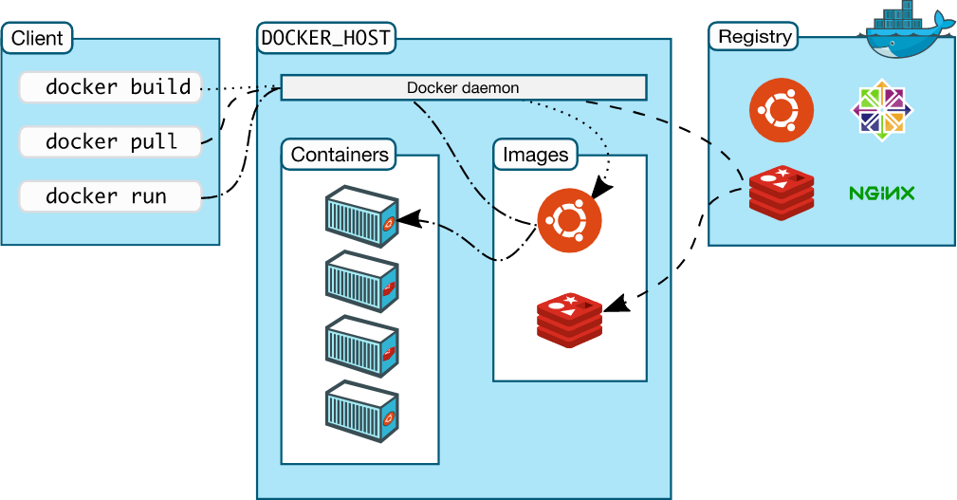

* Here containers are nothing, but the executable component and Images are the image of our application which is containerized and is run as an application.
* The following example configures a three-node cluster, with node each running the same testapp StreamBase Application:
  + **docker network create example.com**
  + **docker run -d --name nodeA -e NODENAME=A.cluster -p 2000:2000 --network example.com --hostname A.example.com example/testapp:1.0.0-RELEASE**
  + **docker run -d --name nodeB -e NODENAME=B.cluster -p 2001:2000 --network example.com --hostname B.example.com example/testapp:1.0.0-RELEASE**
  + **docker run -d --name nodeC -e NODENAME=C.cluster -p 2002:2000 --network example.com --hostname C.example.com example/testapp:1.0.0-RELEASE**
* Clusters are dynamically created and removed as nodes are installed and removed. That is, clusters do not have an independent existence from their nodes.

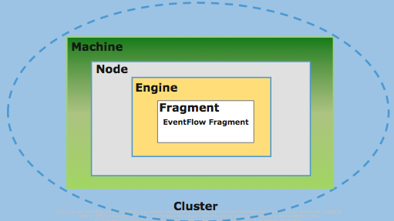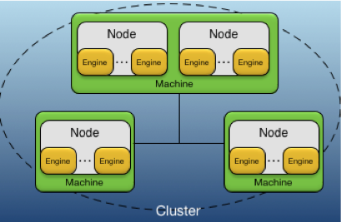

* So, with respect to above command, we have created 3 Nodes(container) named as nodeA, nodeB and nodeC.

The following concepts are used to describe the deployment architecture:

⦁ **Machine** — an execution context for a node.

⦁ **Application** — business specific functionality.

⦁ **Fragment** — an executable part of an application.

⦁ **Cluster** — a logical grouping of nodes that communicate to support an application.

⦁ **Node** — a container for engines.

⦁ **Engine** — executable context for a fragment.

* **Conceptual Model**