Install, Deploy and Run Services on DOCKER

* Download docker desktop for windows : <https://hub.docker.com/editions/community/docker-ce-desktop-windows/>
* Double-click Docker Desktop Installer.exe to run the installer.
* When prompted, ensure the Enable Hyper-V Windows Features option is selected on the Configuration page.
* Ensure that hardware virtualization support is turned on in the BIOS settings.Save the BIOS settings and boot up the machine normally.

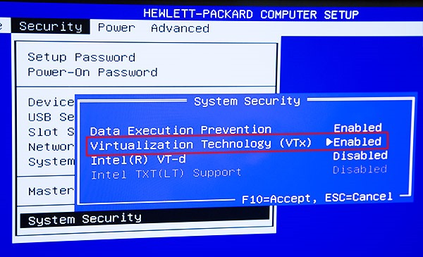

* Turn windows features on or off and Select and enable Hyper-V.

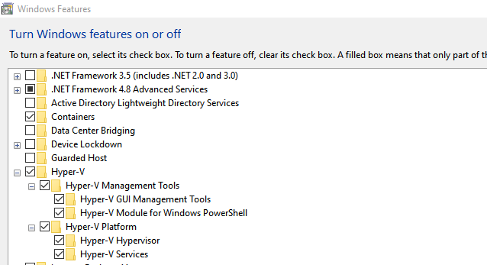

* If Hyper-V was not previously enabled, reboot the machine to apply the change.
* Docker Desktop does not start automatically after installation. To start Docker Desktop, search for Docker, and select Docker Desktop in the search results.

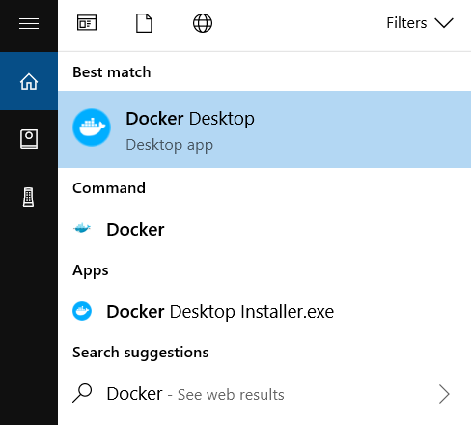

* Check for the System Path Variable and add the Variables as shown below if not present.
  + C:\Program Files\Docker\Docker\resources\bin
  + C:\ProgramData\DockerDesktop\version-bin

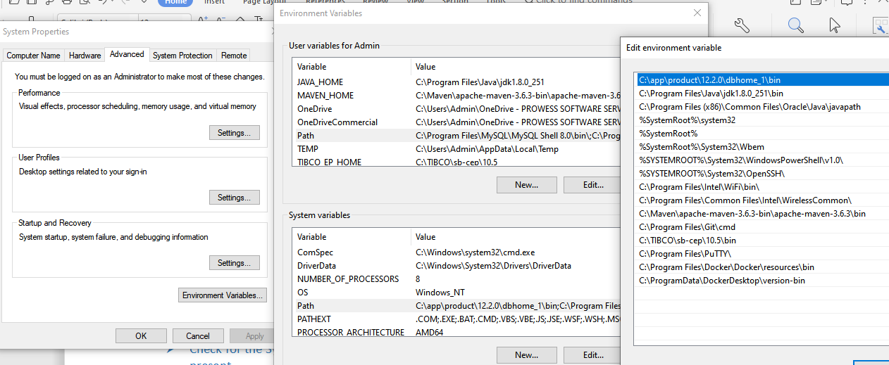

* After the above configuration is done open command prompt and check docker version as shown below :

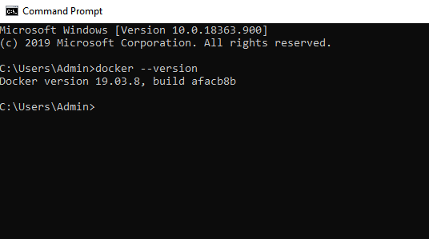

* The Docker version for you might be different from the one shown above.