**Scenario: Read the Customer Data from a csv file in Query Table**

**Example1-Read operation**

1. Create a new event flow fragment and name it as QueryOperatorLab.
2. Now go to the folder src/maineventflow and click on QueryOperatorLab.sbapp
3. From the palette view click on Input Stream and Drag it into the canvas.
4. Name the Input Stream as Customer Information.
5. In the Edit Schema tab Give the Field Name as CustomerId and Select the type as int.

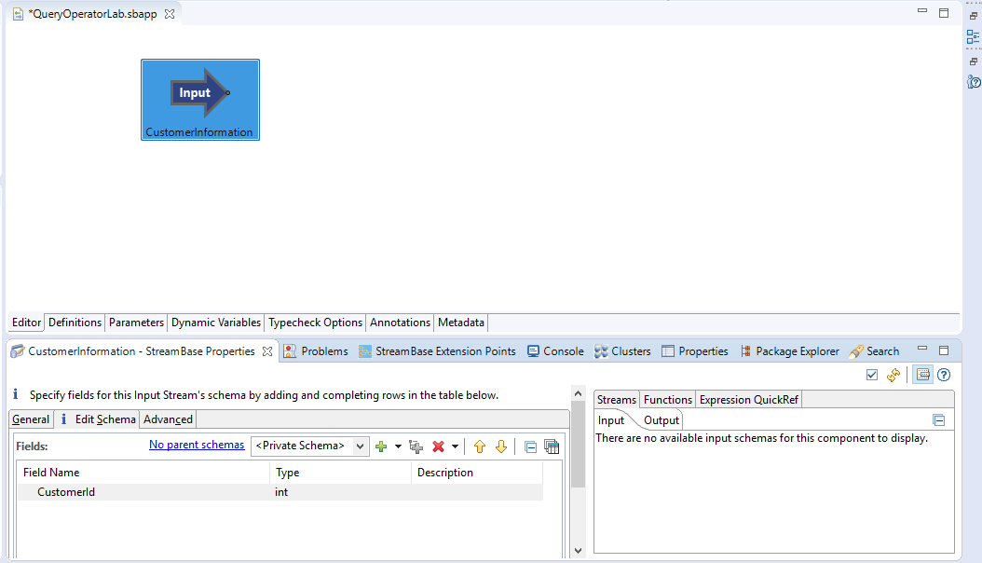

1. Now Drag the Query table to the canvas.
2. In the General Tab Give the name as CustomerDetailedInformation.

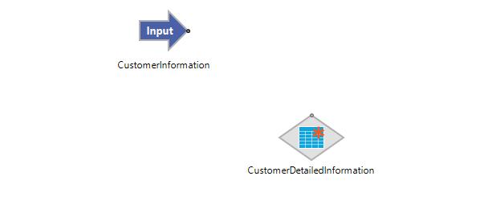

1. In the Table Settings leave the values as Default as mentioned in the screenshot below.

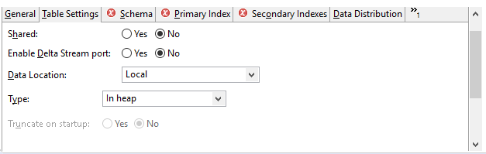

1. Create a Private schema which contains values CustId, Customer Name, Mobile Number, Address, Balance as shown in the below screenshot.

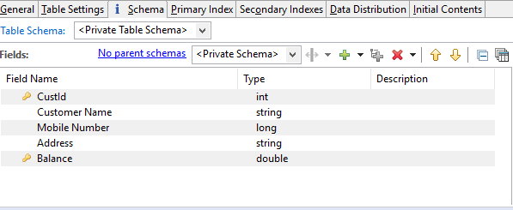

10.Now go to the primary Index tab.

11. select the CustId and Balance as primary key from the available fields.

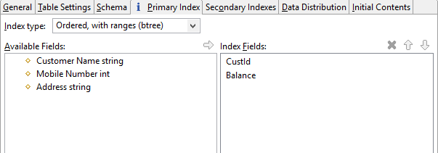

12. Now leave the secondary Indexes and Data Distribution as Default.

13. Load initial row from the text below.

Note: The rows are based upon the defined schema in the schema tab.

Example: Schema: Student Id(int) but if you define Alex in the row it throws an error.

Student Id (int)-Alex wrong

Student Id(int)-1 Correct

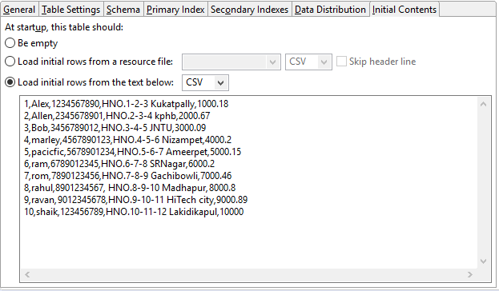

14. Now Drag the Query Operator onto the canvas and name it as GetCustomerDetailedInformation.

15. Now connect the input port to the Query Operator port and the Query operator port to the Query table.

16. In the Query Operator settings go to Query and Perform a read operation.

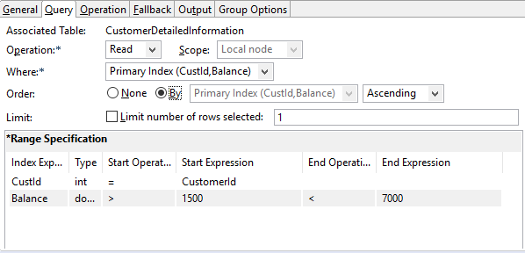

Note: CustId is the input from the Associated Table (Query Table) and the CustomerId is the input from the input table.

17. Now go to operation and click on the third radio button (using Fall back tab).

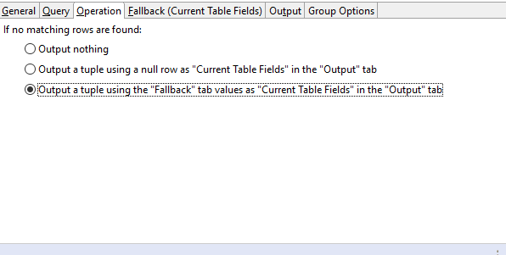

18. Here we set CustId as 0(Here 0 means does not exist)

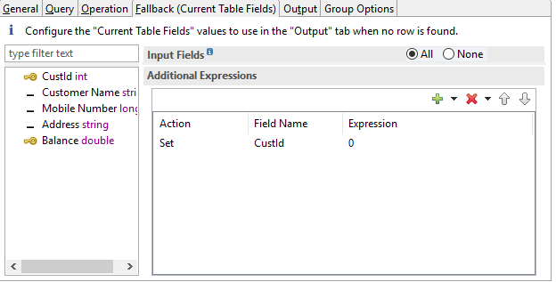

19. In the Output tab select All in the Current Table Fields and None in the Input Fields.

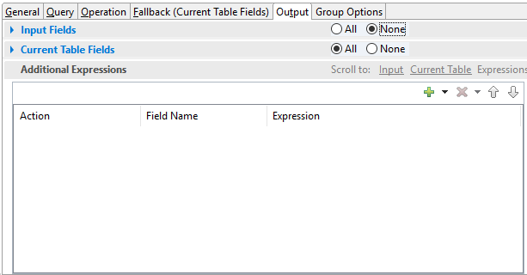

20. Now Drag the Output to the canvas and name it as CustomerDetails.

21.save the file

22.Run the file.

**Output**

23. Enter the customer id as 1 in the manual input.

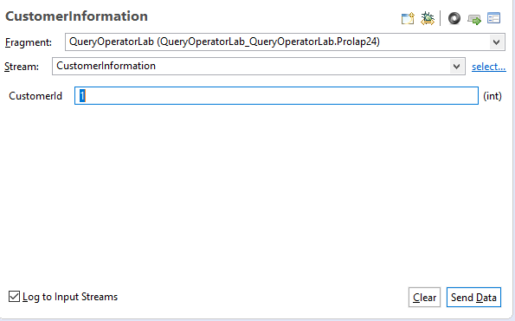

24.The output is shown in the screenshot below.

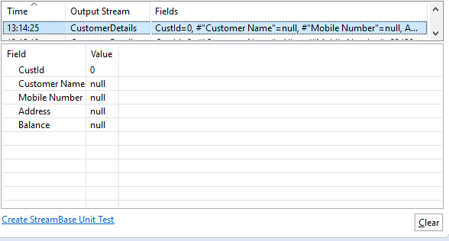

**Note:** CustId = 1 exists in our input but does not satisfies the query condition, so it returns CustId as 0(doesn’t exist) and shows null to the remaining fields.

25. Enter the customer id as 2 in the manual input.

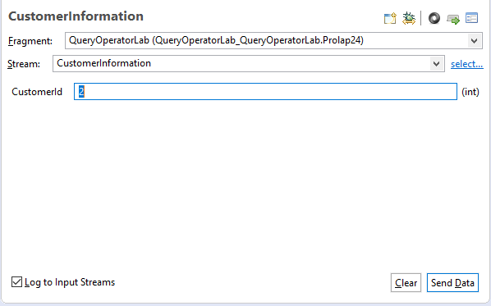

26.The corresponding output is shown in the screenshot below.

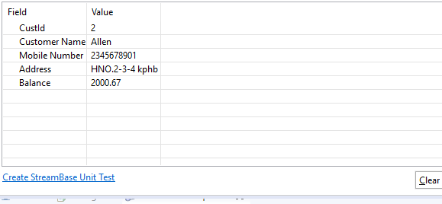

**Example 2:** **write operator**

1. Drag the Input Stream operator to the canvas and name it as CustomerInfo.

2. In the schema tab Define the schema as shown in the screenshot below.

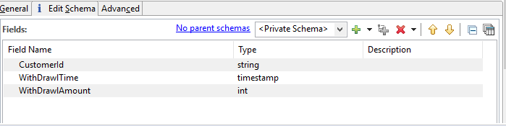

3. Now Drag the Query Table to canvas and name it as WithDrawlTime.

4. In the Table settings leave the values as Default as shown in the screenshot below.

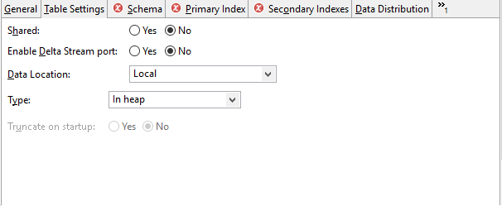

5. in the schema tab define the schema as shown in screenshot below.

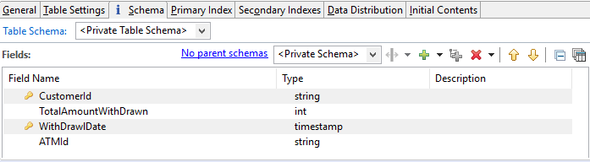

6. Select CustomerId and WithDrawlDate in the primary Index.

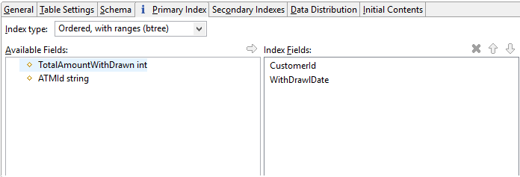

7.Leave the Secondary Indexes and Data Distribution Default.

8. select Load initial rows from the text below.

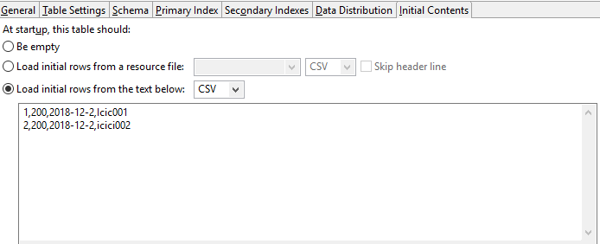

1. Now Drag the Query Operator to the canvas and connect input stream to the Query operator and Query Operator to the Query table.
2. Name the Query Operator as GetWithDrawlTime.
3. In the Query Perform a Write operation (CustomerId in index expression Is from the Query Table and CustomerId in the match expression is the input of input Stream)

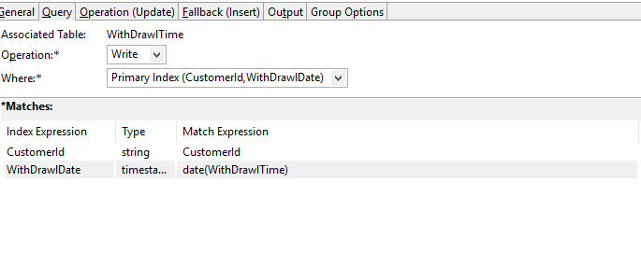

1. In the Operation select drop down update.
2. Select Insert new row using values in Fallback.
3. In Action Set the field name TotalAmountWithDrawn and Expression tab give the expression as

WithDrawlAmount+old.TotalAmountWithDrawn.

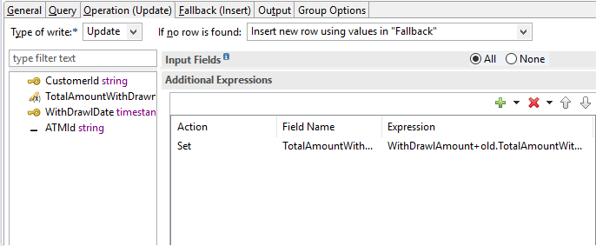

1. In the Fallback tab click on Action Set, Field Name TotalAmountWithDrawn and Expression as

WithDrawlAmount

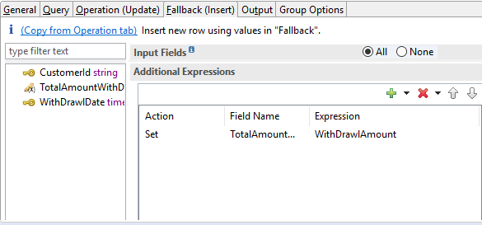

1. In the Output select All from Input Fields and None in both Old Table Fields and New table Fields.

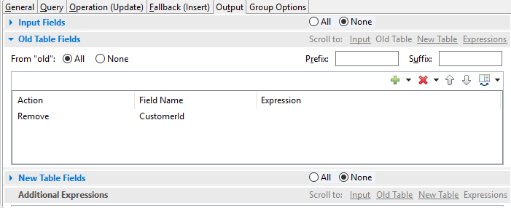

1. Now Drag the output tab to the canvas and name it as customerWithDrawlstatus.
2. Save the file.
3. Run the file.

**Output**

1. Enter the input from Manual Input as shown in below.

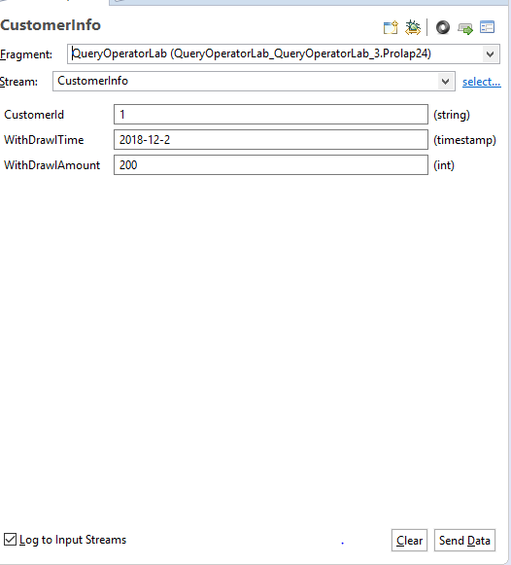

21.The corresponding output is Shown in the screenshot below.

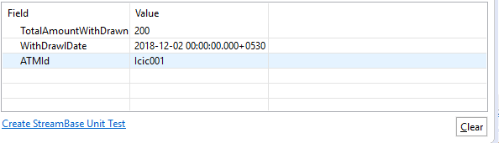

23. Final view.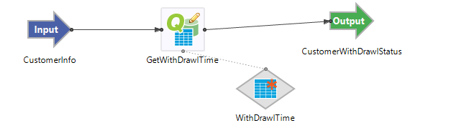

**Example-3 Deleting row**

1. In the above event flow fragment create a new Input stream.

2. Name it as Customer Data.

3. Define the schema as shown in the screenshot.

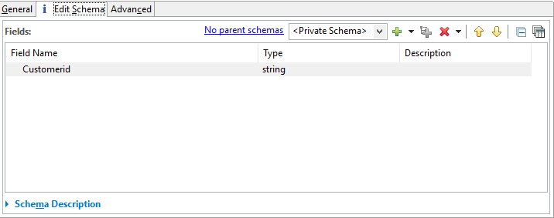

4. Now Drag the Query operator to the canvas and connect the Query Operator to existing Query table.

5. Now Perform a delete operation.

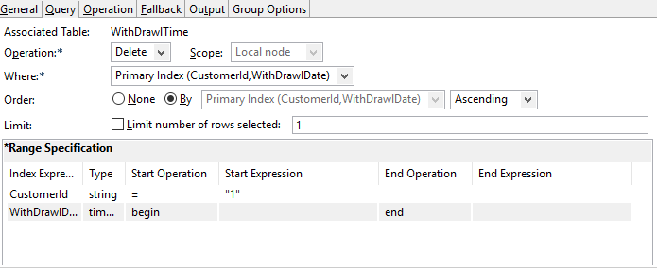

6. In the Output select Input fields to All and current fields to none.

**Output**

7. Enter the manual input.

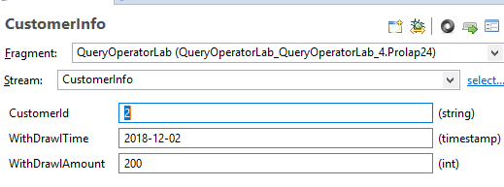

8. The corresponding output is shown in the below screenshot.

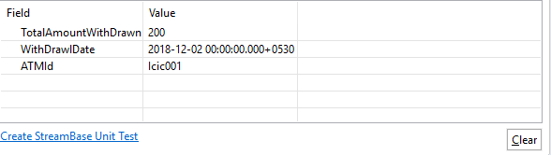

9.Here in the output stream Customer Id is missing.