**Dockerizing Streambase Application**

⦁ Create the EventFlow fragment and place all your logic inside this fragment. Select the Radio button as **EventFlow Fragment** as shown in below Screenshot.

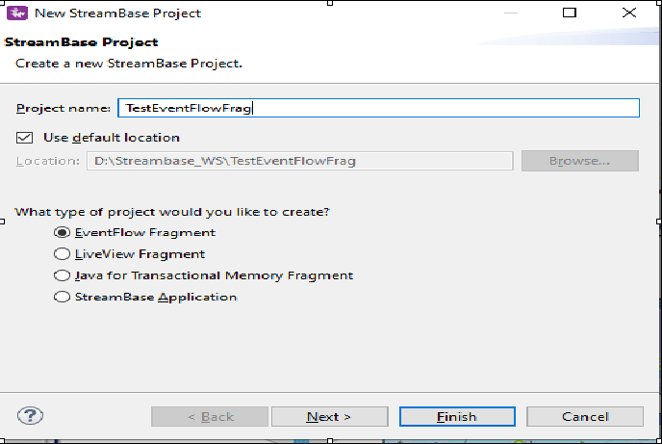

⦁ Click Next and provide the value for **Group Id**, **Artifact Id** and **Version**. Provide the packagename as <<Group Id>>.<<any name>> as shown in below screenshot. Please note down these three parameters and click finish.

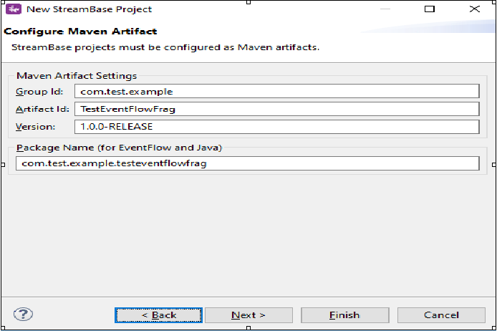

⦁ Create a WebServerRequest by Drag-Drop Adapters,Java Operators. Configure the adapter with all the required parameters, Orchestrate incoming data and finally return Response by WebServerResponse adapter. After the above application is created just do a clean install. Sample for same is as shown below:

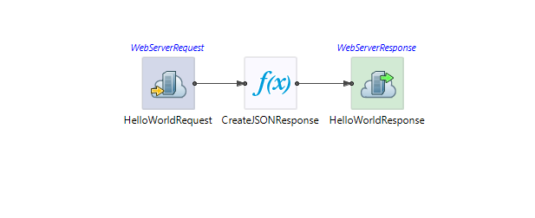

⦁ Now create a new Streambase Project. Select Radio button as **StreamBase Application**.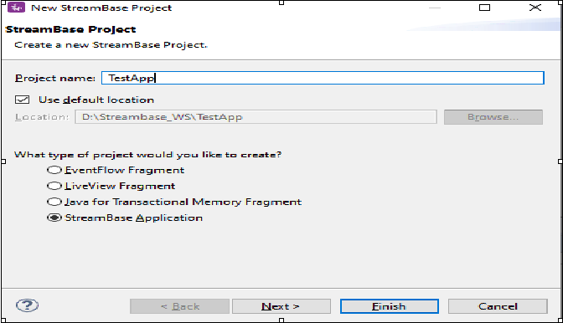

⦁ Now click next and make sure you provide the same **Group Id** and **Version** that you specified for the EventFlow Fragment created Earlier. Also click on **Enable Docker Support** checkbox and click next.

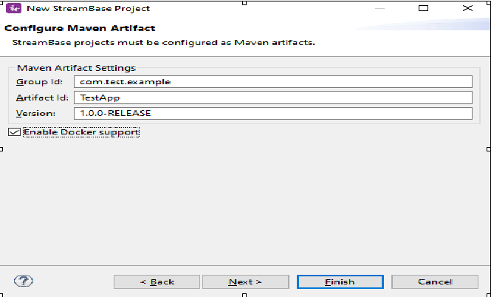

⦁ Now you can specify **description**, **testnodes**, **dockerDomain** and click finish.

* **testnodes**: Specify one or more node names for test nodes started when you run Maven Test or another Maven goal that requires Test.
* **dockerDomain**: Specify a domain name that will allow your Docker containers to communicate with each other. The domain name you specify here is configured into the TrustedHosts section of this application's security.conf file to allow all StreamBase Runtime node to participate in the same domain as the Docker containers.

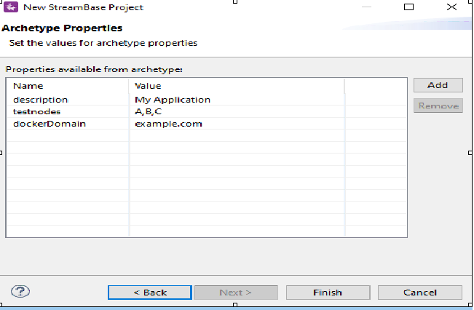

⦁ Add the EventFlow Fragment Project depedency to our main Streambase Application. Right click on Streambase Application Project **(TestApp in my case) --> StreamBase>Manage Project Dependencies**. Add the depedency for the EventFlow Fragment and click ok.

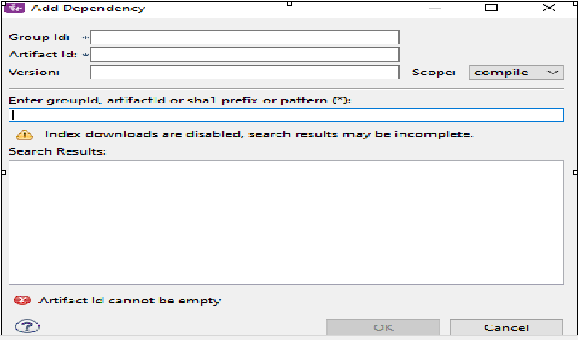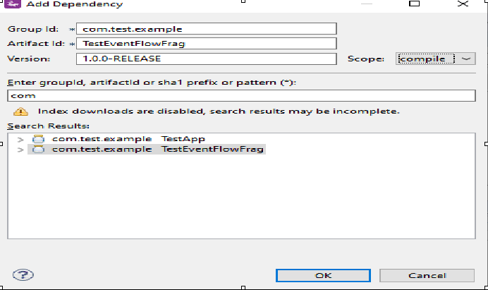

⦁ Now In the Project Explorer view, select and right-click the Streambase Application Project **(TestApp in my case)--> Run As>Maven Build...**

⦁ After that In the **Goals** field, enter **clean install** and Select the **Skip Tests** check box. Click Apply and Run.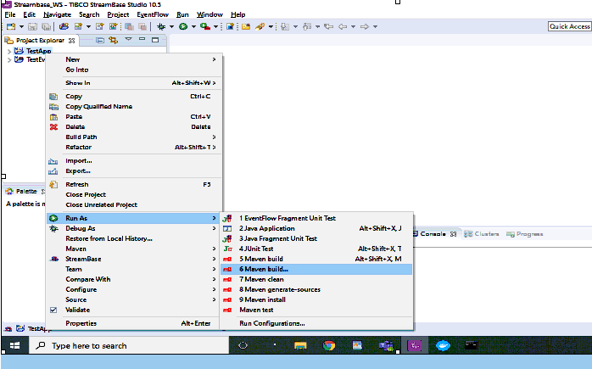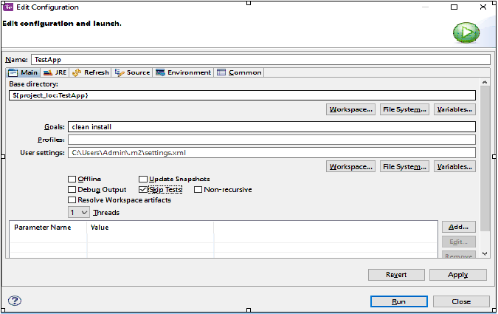

⦁ After the above step check the console and it should be showing BUILD SUCCESS message.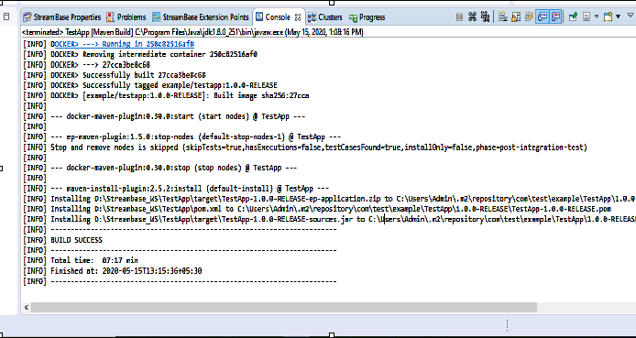

⦁ Get a list of your currently installed Docker images using either the docker images or docker image ls command: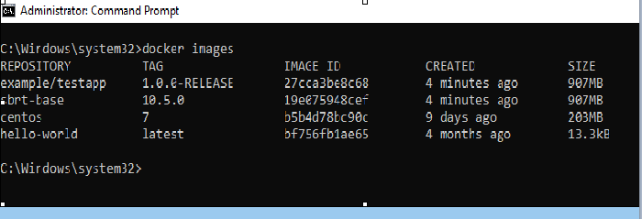

⦁ Now in docker you have run the following command:

* **docker run -d --name firstapp -e NODENAME=A.cluster -p 9191:9191 example/testapp:1.0.0-RELEASE**

(Use the image name shown in the output of your own docker images command.)

* **-p** options map your host computer's ports to streambase application port used 9191(docker port):9191(streambase application port).
* **--name** is used to name the Docker container
* **-e** is the environment variable for docker
* **NODENAME** Environment variable name for Docker
* **1.0.0-RELEASE** is the TAG that you will see when you will run docker images command.

(You must set the NODENAME environment variable for the Docker image with the -e or --env option, as shown. You can specify the node and cluster names you prefer, as long as you specify the same cluster name for Docker-hosted images that will run together as a cluster.)

⦁ After running the above command, you will see as shown in below screenshot:



⦁ Also, in docker you can see your Application is running.

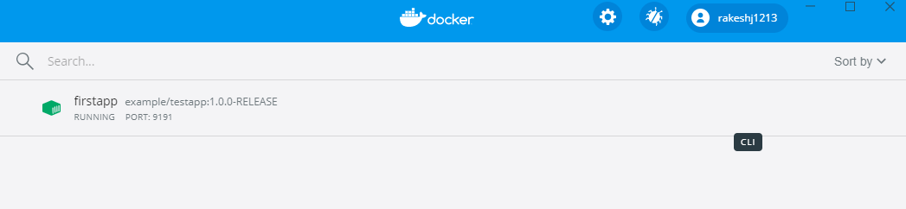

⦁ You can check logs using command **docker logs firstapp**

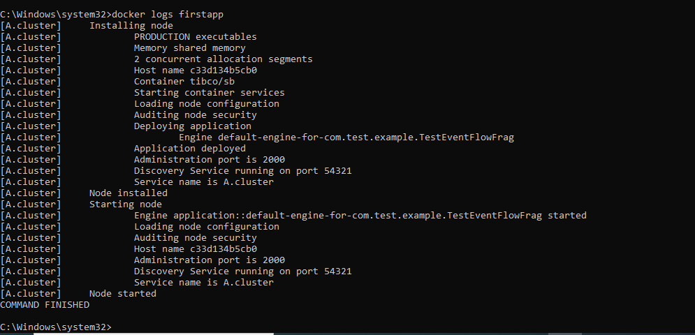

⦁ Now your application is running and same can be tested using postman as: <http://localhost:9191/HelloWorld>

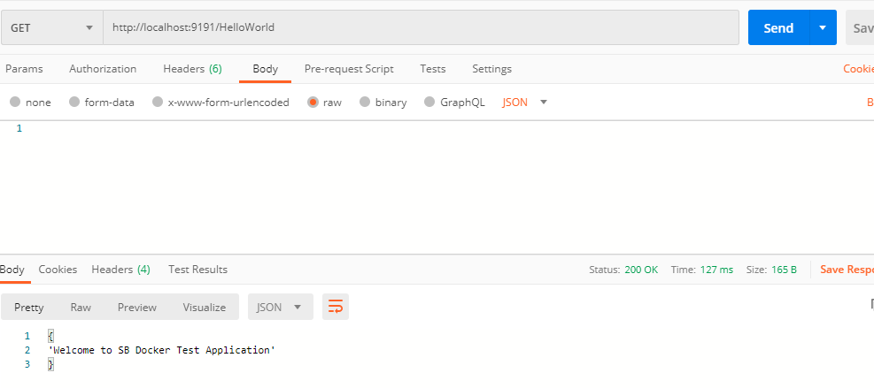

⦁ **Now with the above image details you can deploy your application, to any of the containerized application like aws, kubernetes, etc…**

⦁ After the above part is done, now we are ready to push our application to dockerhub. Please follow below steps to achieve the same :

* Create a account on dockerhub : <https://hub.docker.com/>
* Create a repository like I have created one as : teststreambasedockerapp(where prowesssoft is the docker id that I have created while signing up)

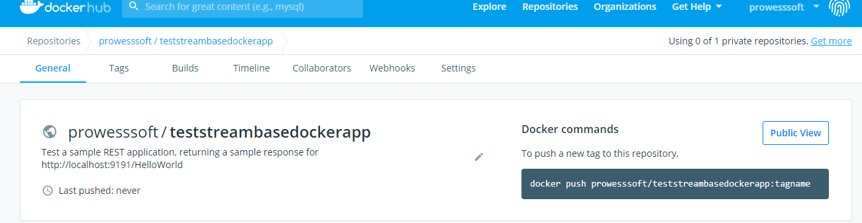

* Run docker login command from your command prompt and see for Login Succeeded.

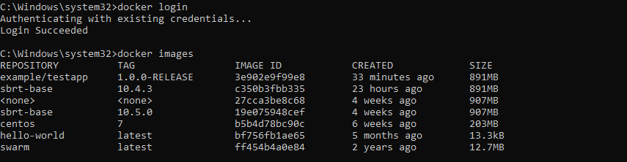

* Tag your repository with the above IMAGE ID using command : **docker tag 3e902e9f99e8 prowesssoft/teststreambasedockerapp:firstapp** where **3e902e9f99e8** is the IMAGE ID, **prowesssoft/teststreambasedockerapp** is my repository path and **firstapp** is just any application name that can be used.
* After the above command is executed successfully, do **docker push prowesssoft/teststreambasedockerapp**

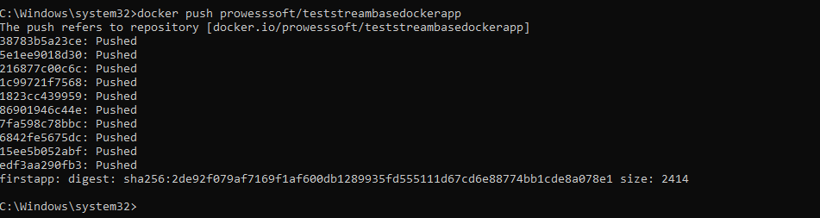

* After the above command is executed successfully, your image is pushed.

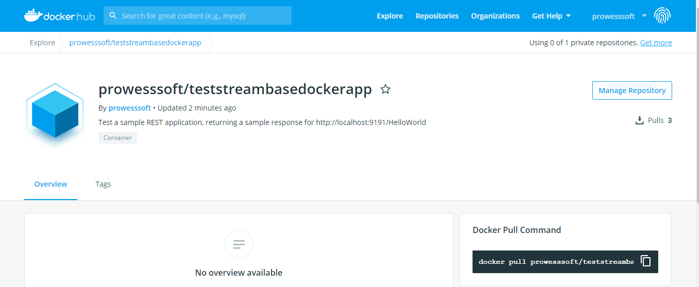

* Once the image is pushed, you can do a docker pull as : **docker pull prowesssoft/teststreambasedockerapp:firstapp** and this image can be used and deployed to any environment like kubernetes,aws,azure,etc..