RESTAURANT MANAGEMENT

"Online Restaurant Management System" is a web application. This system is developed to automate day to day activity of a restaurant. Restaurant is a kind of business that serves people all over world with ready-made food. This system is developed to provide service facility to restaurant and also to the customer. This restaurant management system can be used by employees in a restaurant to handle the clients, their orders and can help them easily find free tables or place orders. The services that are provided is food ordering and reservation table management by the customer through the system online, customer information management and waiter information management, menu information management and report.

Users:

1. Customers: Customers can book their table and can order food online.
2. Employees: Employees can log in to their account and see their job for that day.
3. Admin: Admin is the main head of this application and can generate bill, check stock details, update and see employee's details.

Tables:

1. Employees:

It stores details of employees.

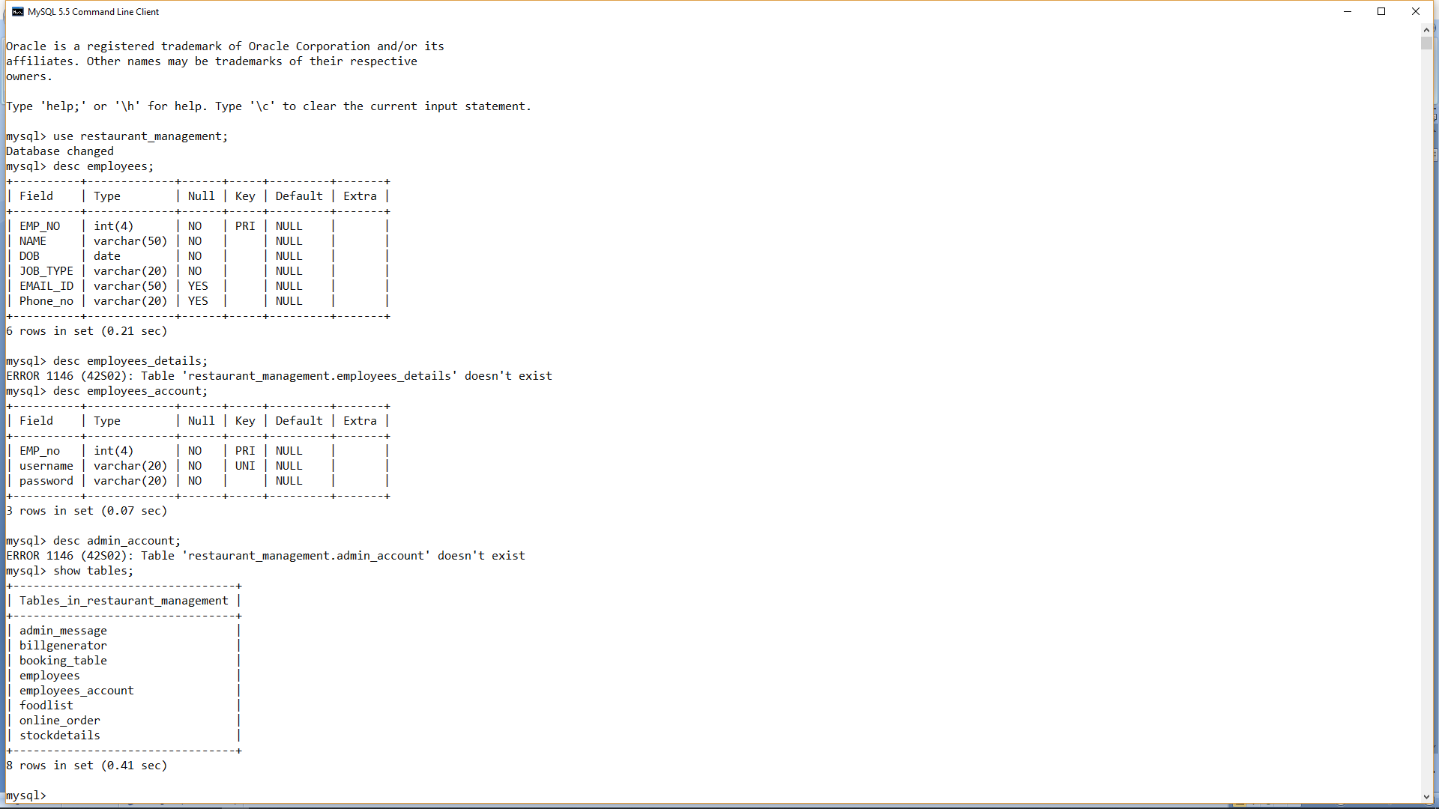

1. Employees account:

It stores account details.



1. Booking table:

It stores details of customers who have booked the table.

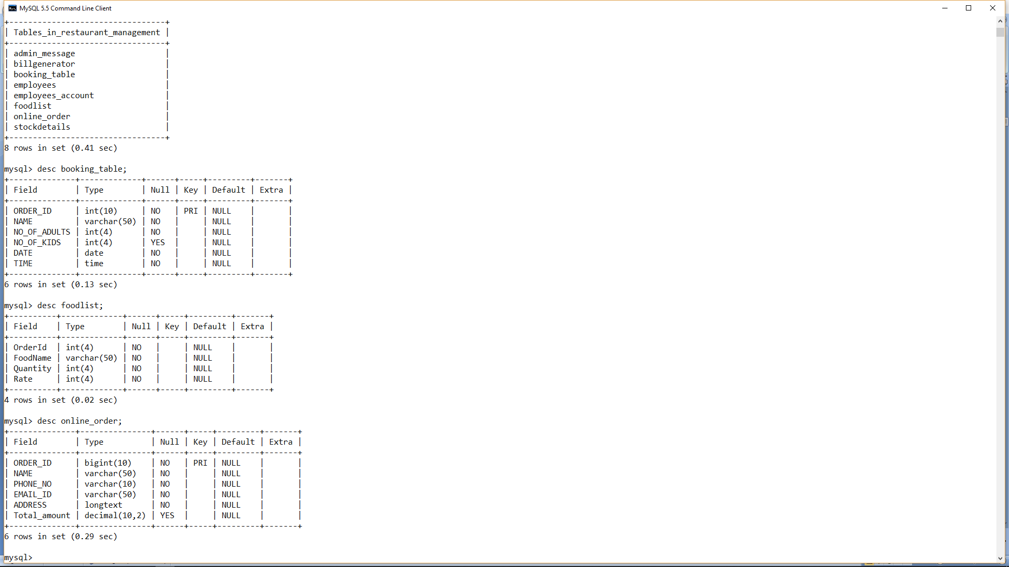

1. Food list:

It stores food lists of Customers.



1. Order Online

It stores details of customers those who had booked.



1. Stock details:

It stores availability of stock in the restaurant.

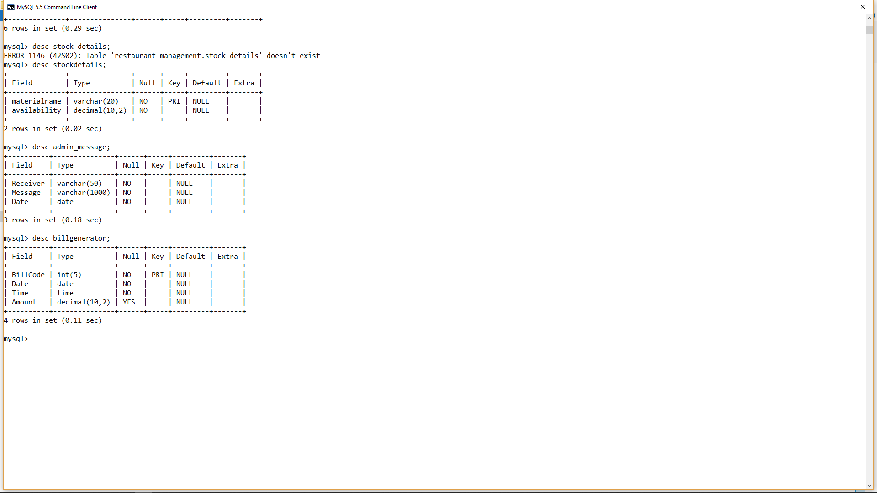

1. Admin Message:

It contains messages of admin to employees.



1. Bill generator:

It stores details of bill.



GUI:

1. Welcome GUI:  
   In this GUI, Admin can go to admin login, customers can book and order food online and employees can log in to their account.

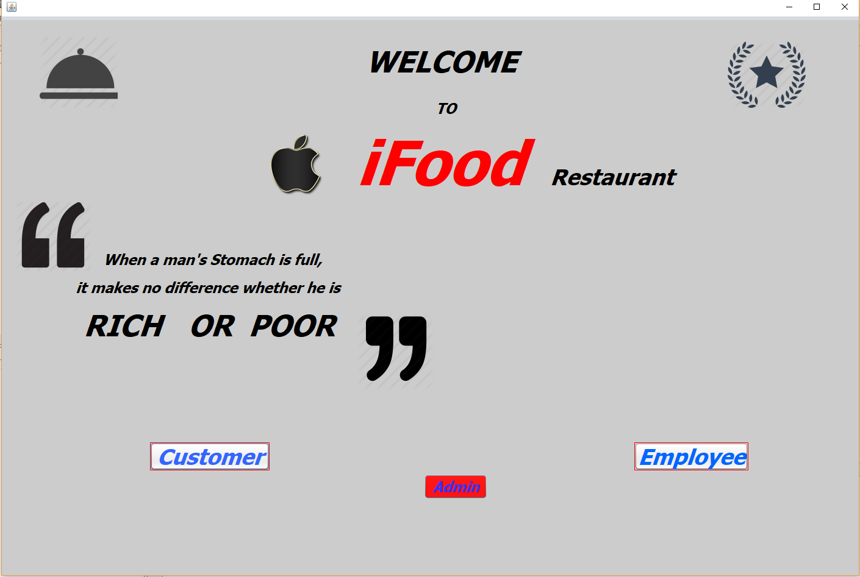

1. Customers GUI:

Customers can book tables and order food by clicking respective buttons.

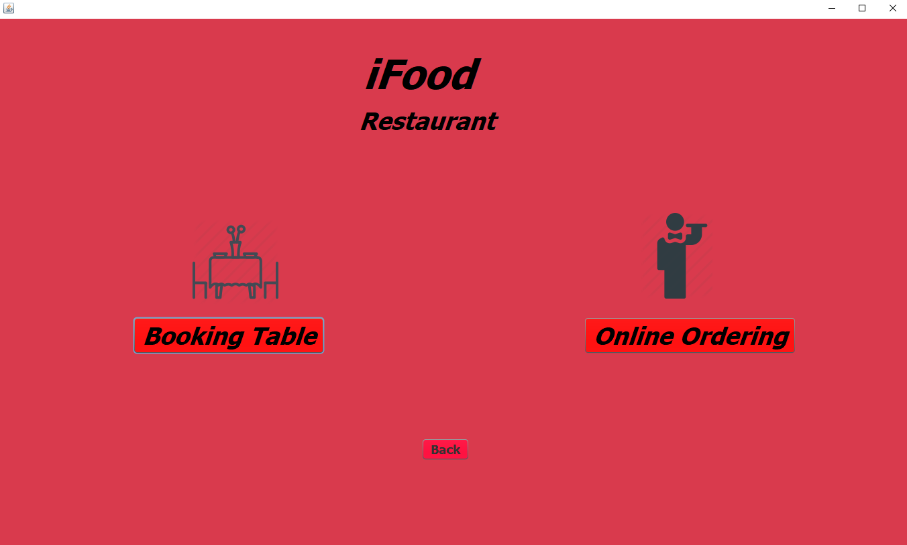

1. Order Online GUI:

In this GUI, customers can select their food and enter their details to order food.

It is linked with Foodlist table.

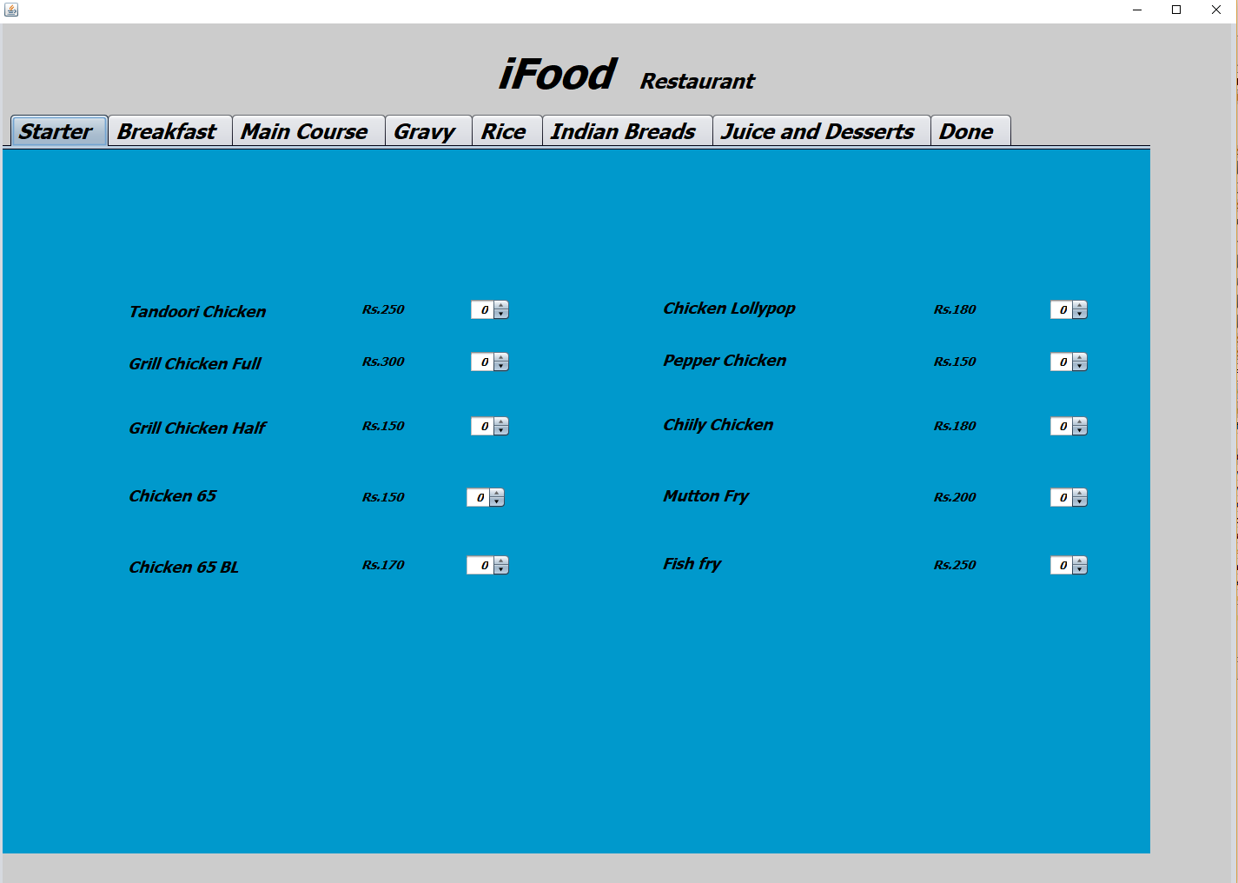

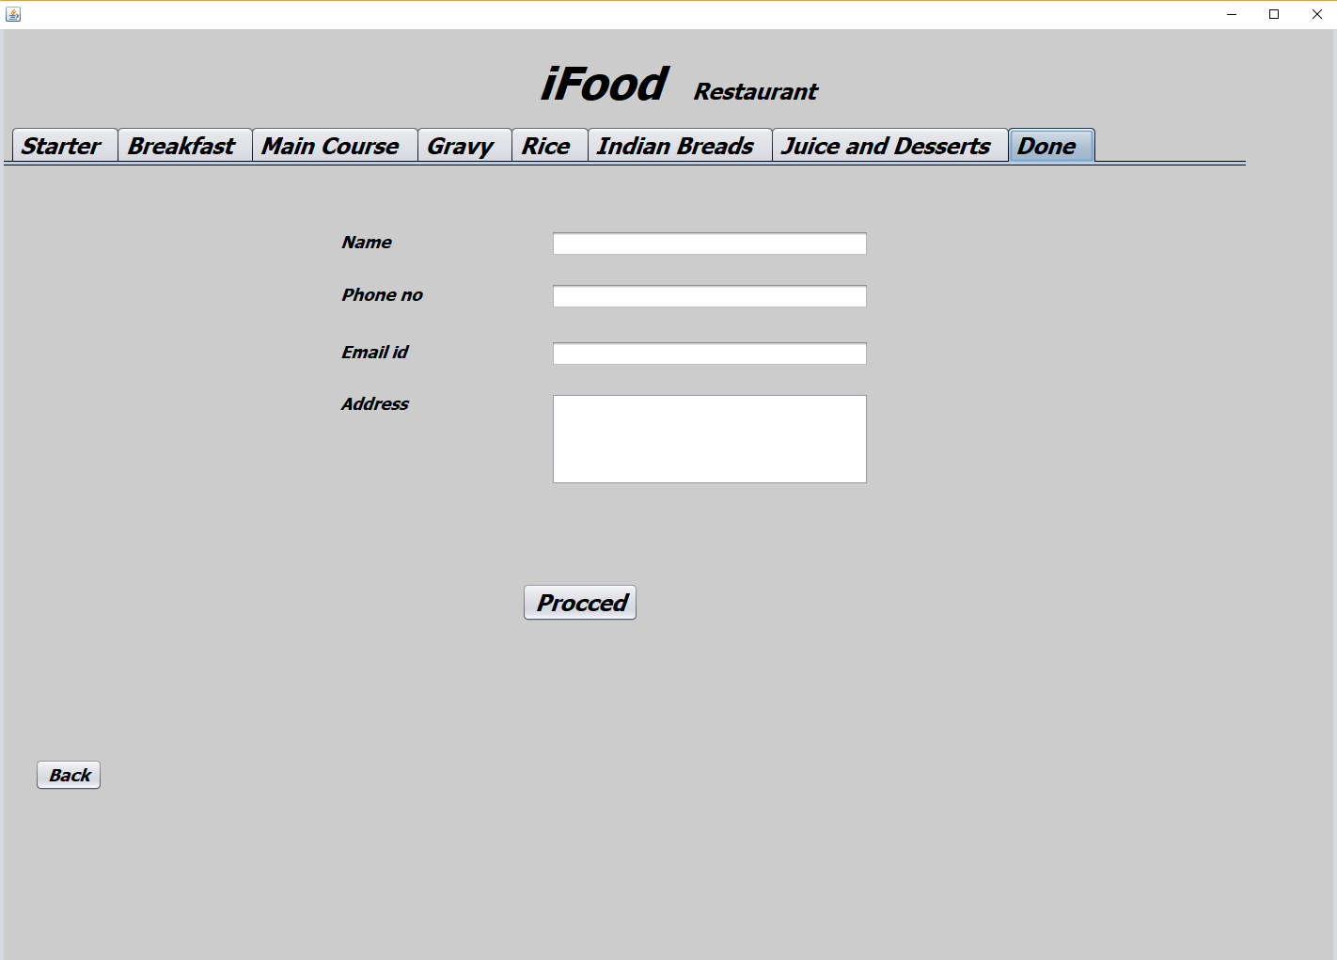

1. Order Online 2 GUI:

It shows the selected food items and display the total amount.

It is linked with foodlist table.

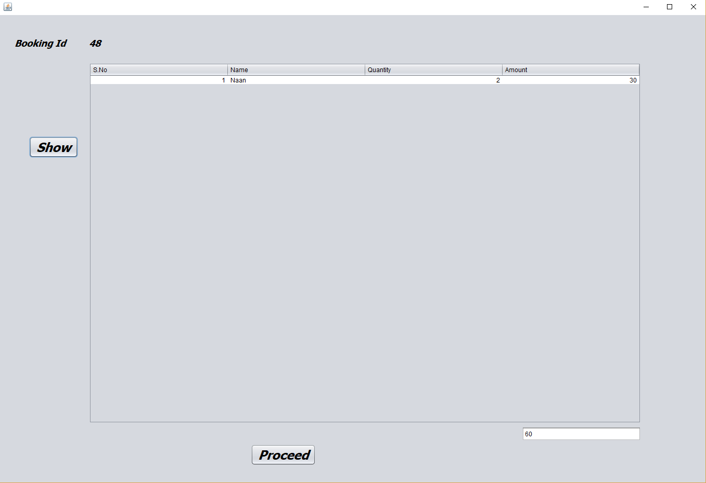

1. Order Online 3 GUI:

It shows the total amount with inclusion of GSTs.

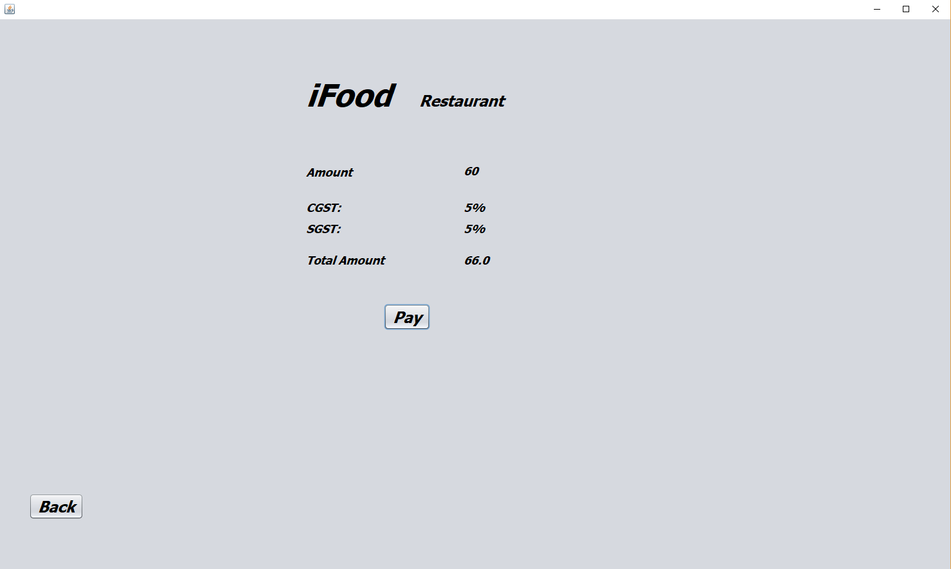

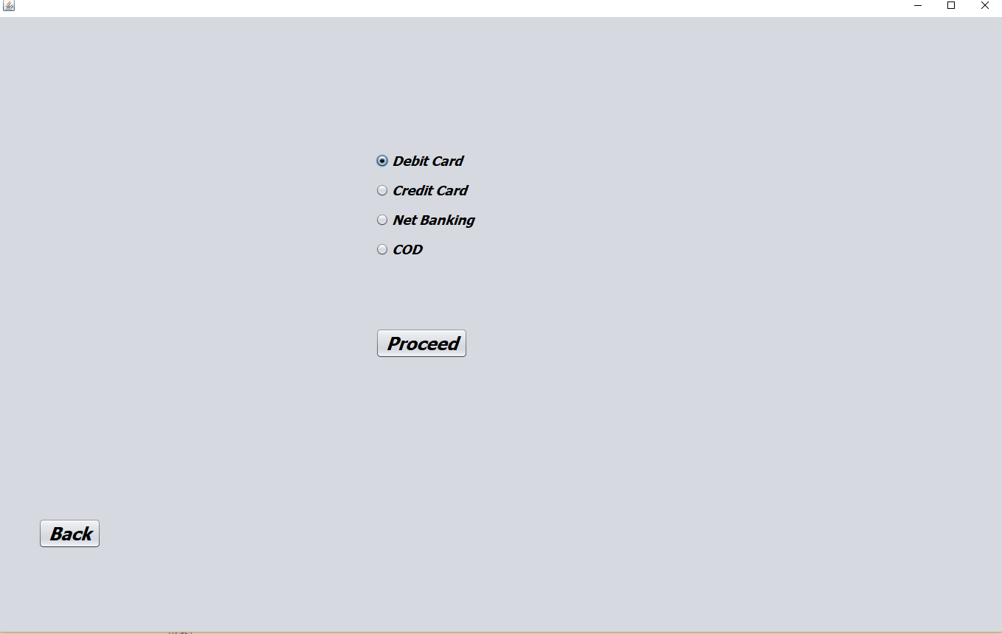

1. Payment:

In this GUI customers can enter their bank details for the payment of their food.

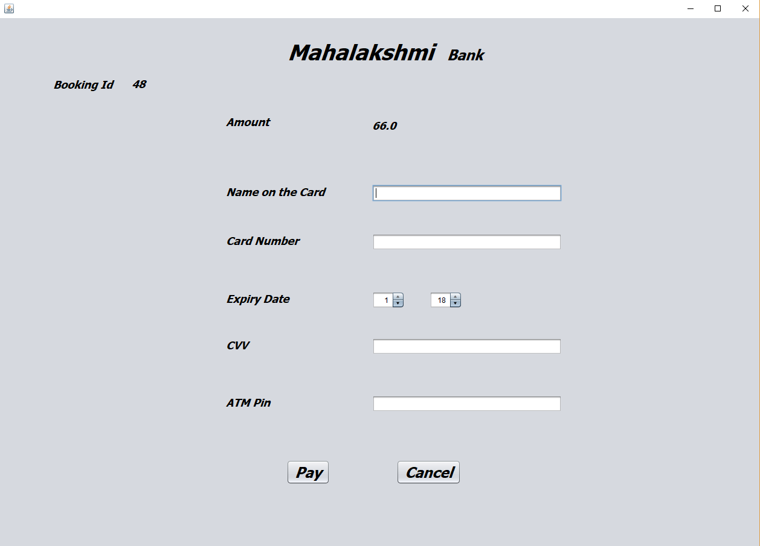

1. Done GUI:

In this GUI, booking id and all the details are shown.

It is linked with online order table.

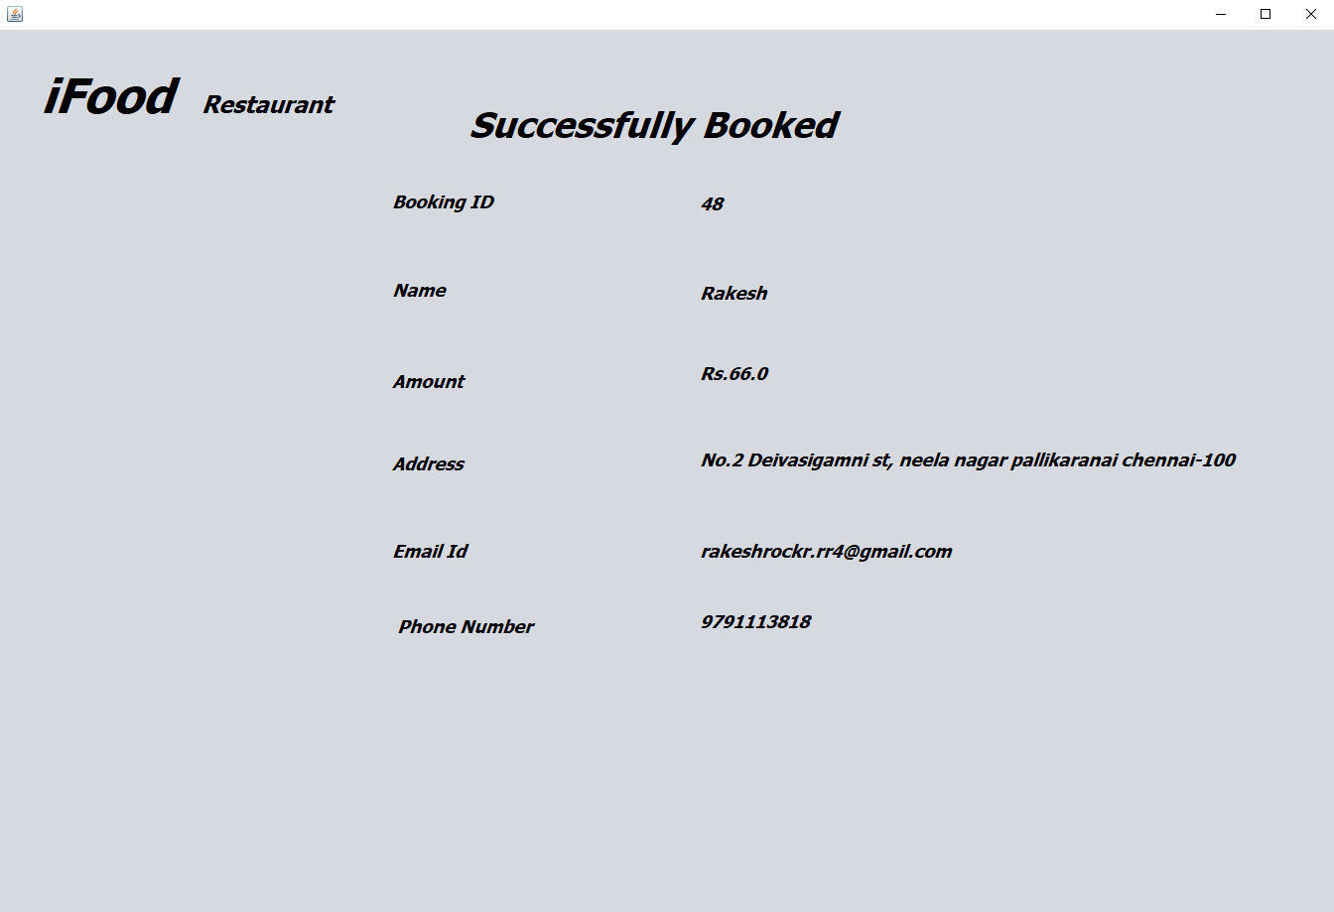

1. Booking table GUI:

In this GUI, customers can enter their details and approx. timings to book their table at that particular time.

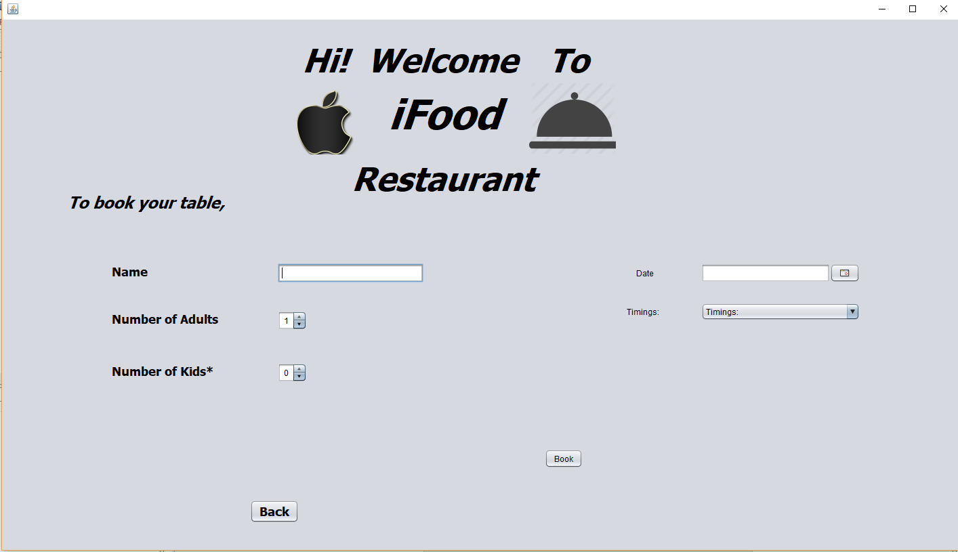

1. Employees :

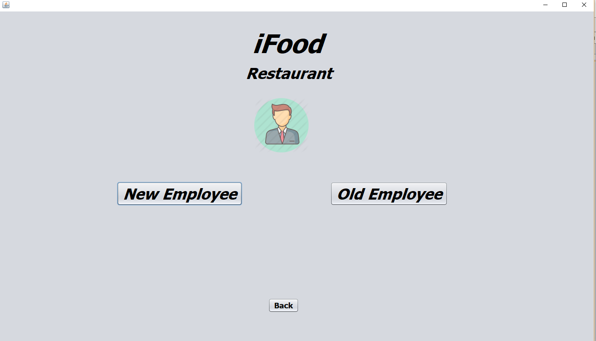

1. New Employees:

If the employees is new to the restaurant, he or she can create their account.

It is linked with employees account and employees details.

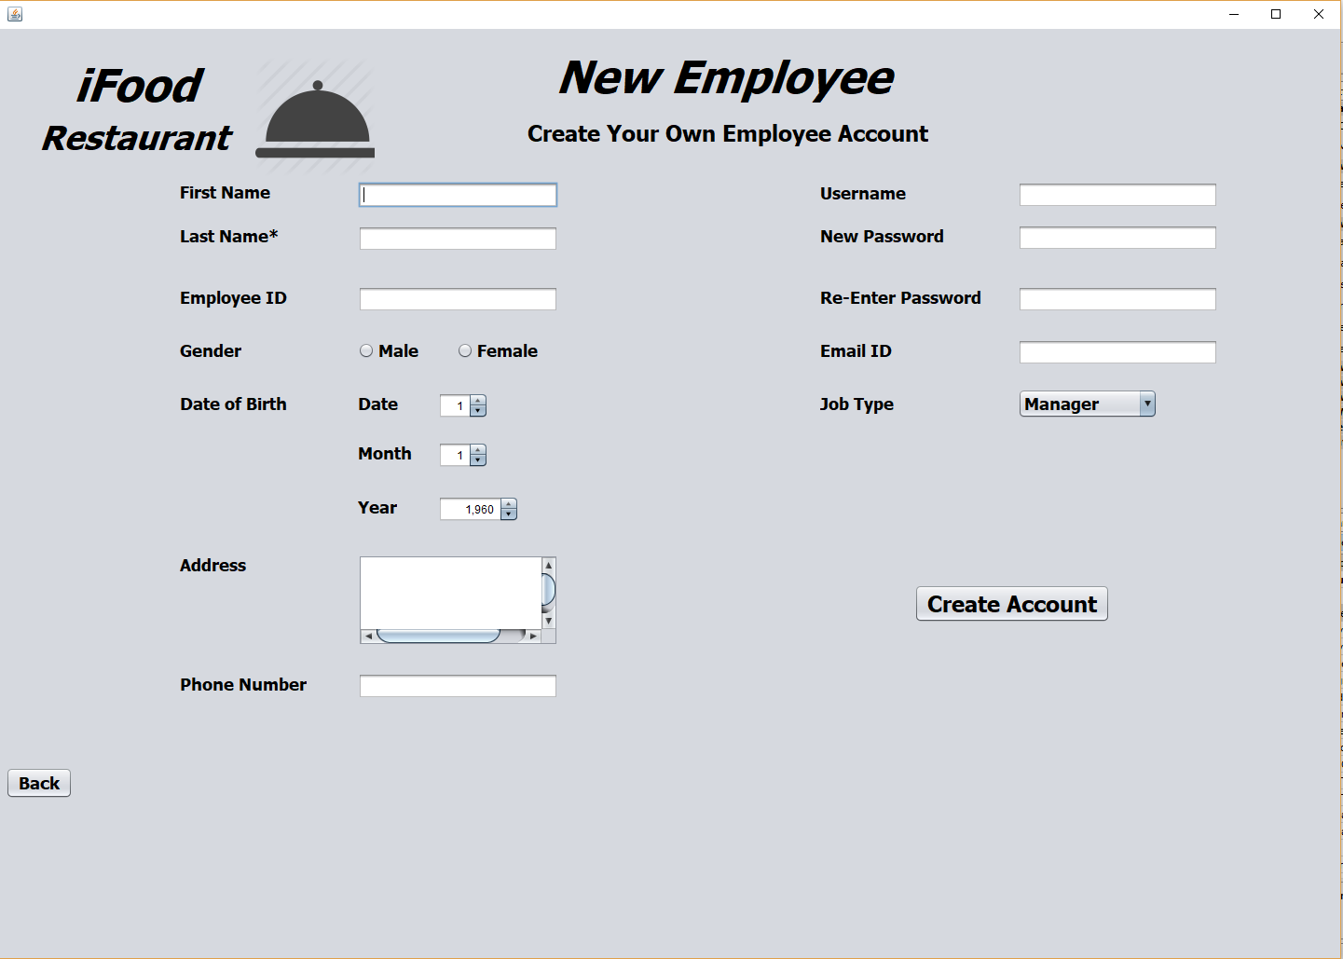

1. Sign in:

It is used to log in to employees account.

It is linked with employees account table.

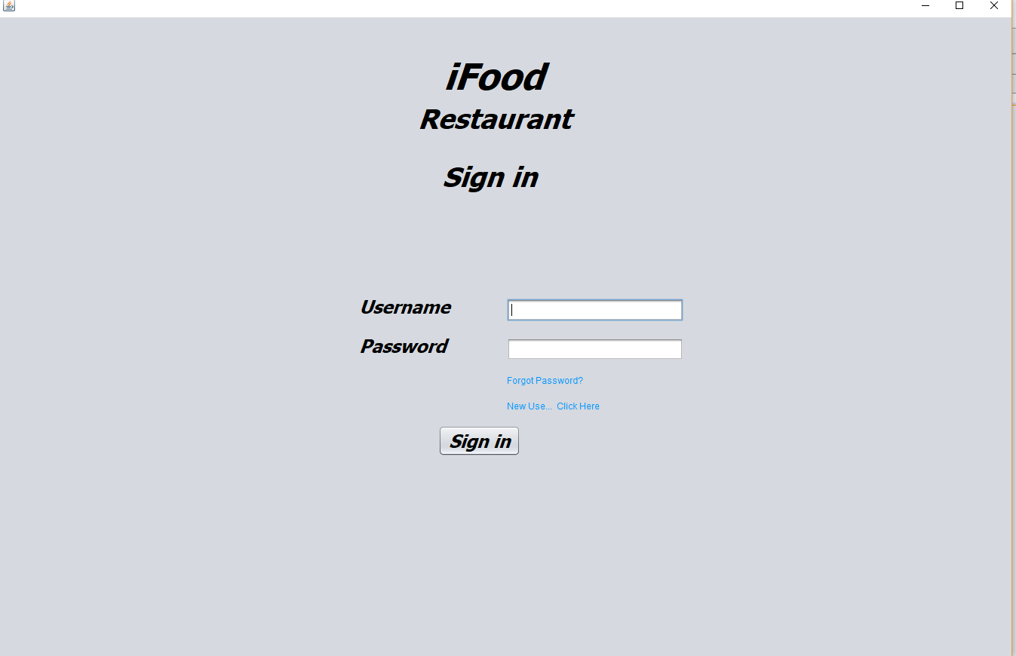

1. Employees page:

In this GUI employees can see their job for today.

It is linked with admin message table.

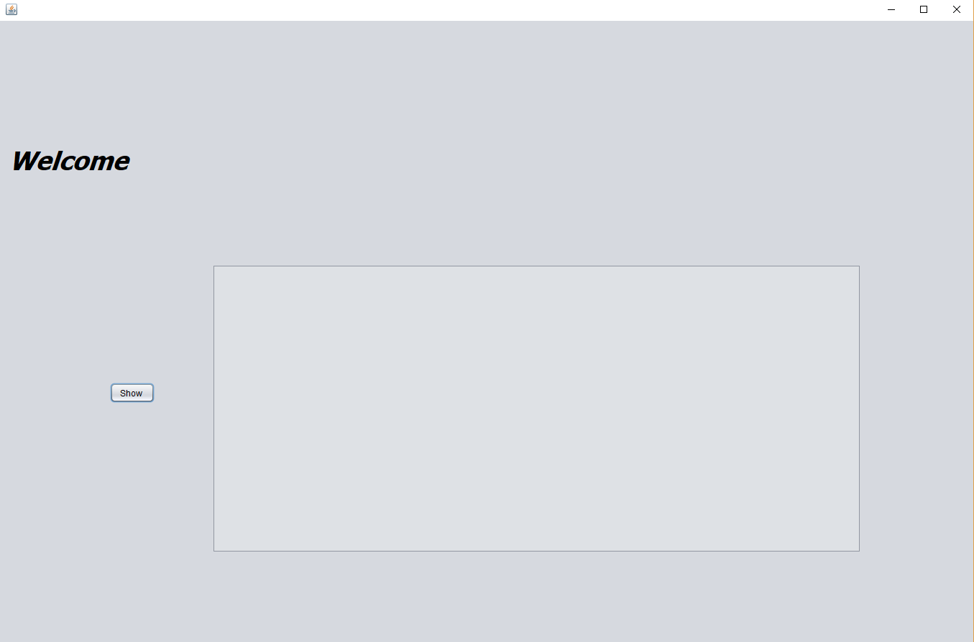

1. Admin Sign up:

In this GUI, Admin can sign up to their account and do the specific operations.

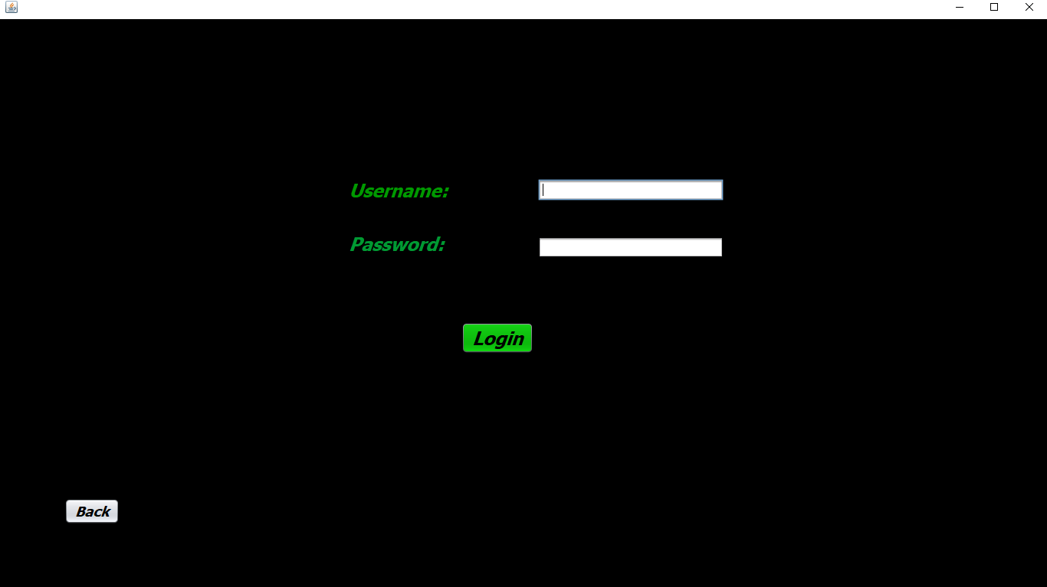

1. Admin home page:

Here, admin can select what he want to do.

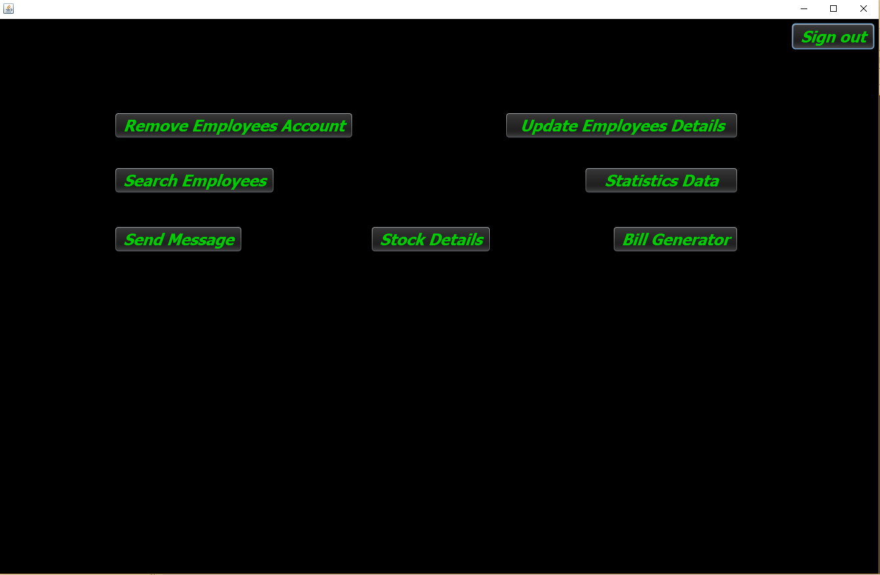

1. Admin Message:

In this GUI admin can send message to the employees about their works to do that day.

It is linked with admin message.

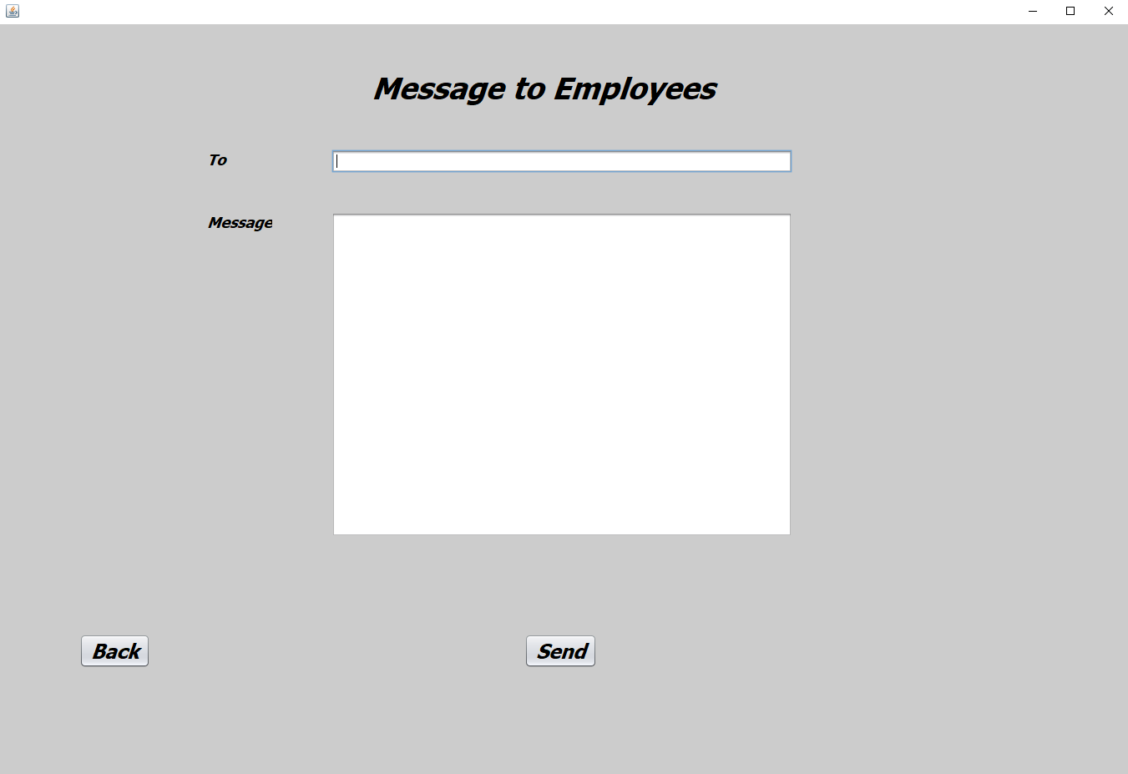

1. Search employee details:

In this GUI, admin can search any employees and can get their details.

It is linked with employees and employees account table.

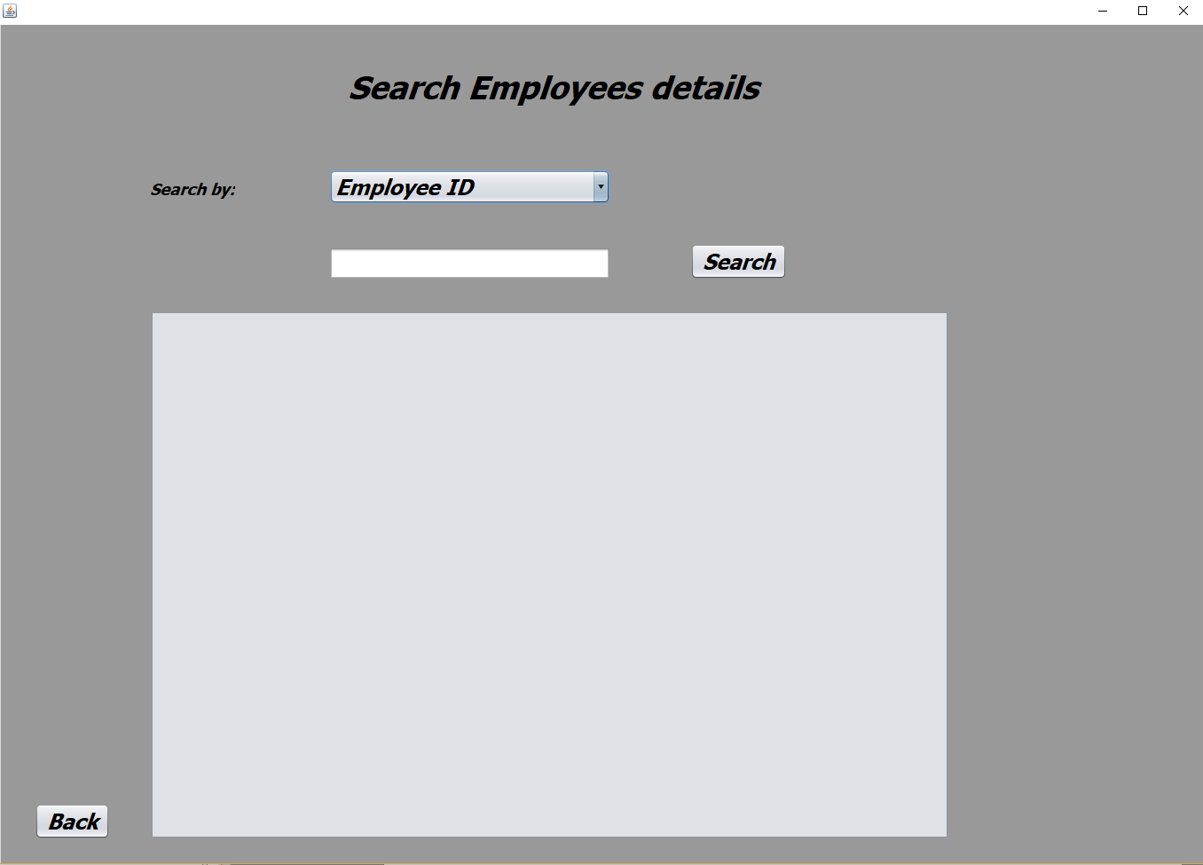

1. Update employee details:

In this GUI admin can select update employees details.

It is linked with employees account and employees table.

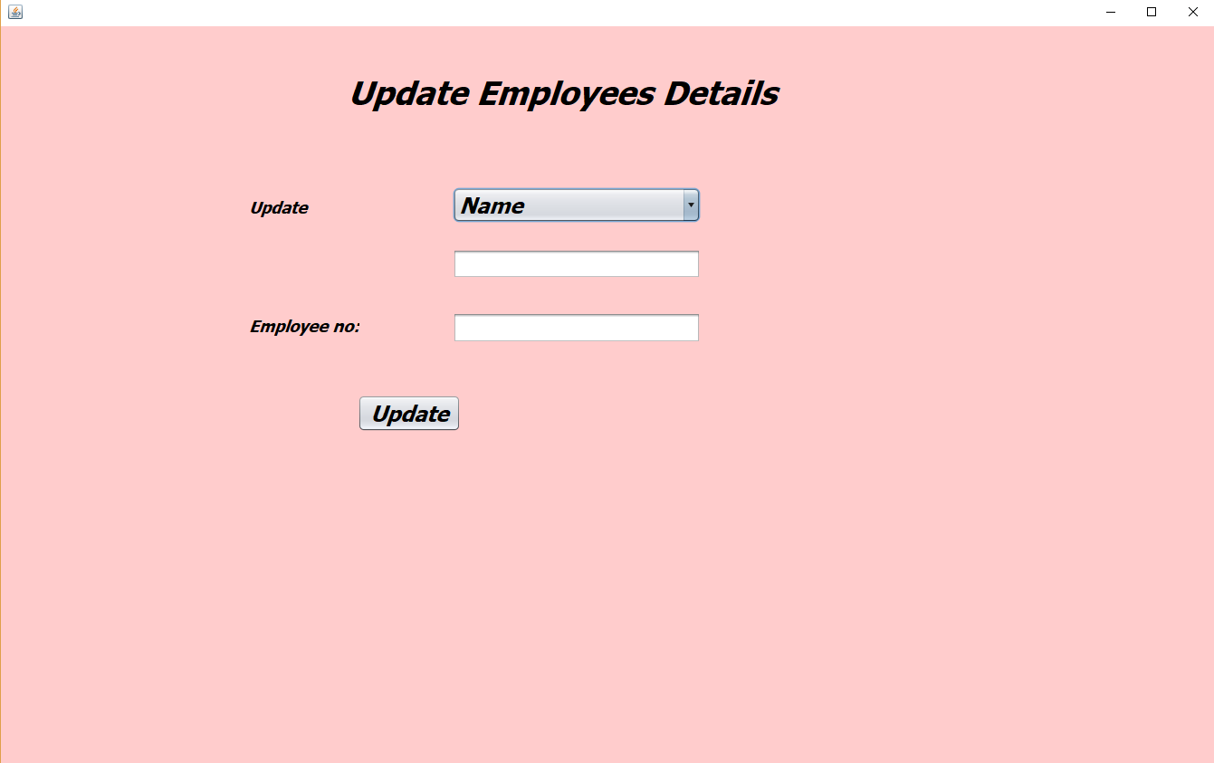

1. Bill generator:

It is used to generate bill by giving appropriate code for the food.

It is linked with bill generator table.

