Signature Based Document Retrieval using GHT of Background Information

Partha Pratim Roy  Laboratoire d’Informatique  Université François Rabelais  Tours, France  partha.roy@univ-tours.fr | Souvik Bhowmick  CVPR Unit  Indian Statistical Institute Kolkata, India sou.bhowmick@gmail.com | Umapada Pal  CVPR Unit  Indian Statistical Institute, Kolkata, India umapada@isical.ac.in | Jean Yves Ramel  Laboratoire d’Informatique  Université François Rabelais  Tours, France  Jean-yves@univ-tours.fr

Abstract—This paper deals with document retrieval based on signature detection from documents with cluttered background. Here, a signature object is characterized by spatial features computed from recognition result of background blobs. The background blobs are computed by analyzing character holes and water reservoir zones in different directions. For the indexation purpose, a codebook of the background blobs is created using a set of training data. Zernike Moment feature is extracted from each blob and a K-Mean clustering algorithm is used to create the codebook of blobs. During retrieval, Generalized Hough Transform (GHT) is used to detect the query signature and a voting is casted to find possible location of the query signature in a document. The spatial features computed from background blobs found in the target document are used for GHT. The peak of votes in GHT accumulator validates the hypothesis of the query signature. The proposed method is tested on a collection of mixed documents (handwritten/printed) of various scripts and we have obtained encouraging results from the experiments.
Keywords-

INTRODUCTION
Content-based Image Retrieval (CBIR) considers retrieval of visually similar images to a given query image from a database of images. In machine readable documents searching, the query consists of a collection of words and it retrieves documents according to user query. The searching can also be performed by graphical objects such as logo, seal, signature, etc., which may enhance the capability of browsing documents from a collection [9].
Often searching a particular signature is important for document interpretation. Signature which has been using as the only identification mark in document is often examined by forensic document analysis, the banking and the finance industry to restrict frauds [6]. As unique and evidentiary entities in this wide range of business and forensic applications, signatures provide an important form of indexing that enables effective exploration of large heterogeneous document image collections.
Undoubtedly, automatic signature detection and recognition is an important stage to follow this approach. But, detection of signature from a document page involves difficult challenges due to its free-flow nature of handwriting. The segmentation of signature is not easy sometimes due to its overlapping/touching with other content information (text, graphical lines, etc.) in the document. We have shown an example of a signed document in Fig.1. It is to be noted that the signature strokes are overlapped/touched with handwritten characters in many places. Some of the overlapped regions are marked by a rectangular box in the zoomed version.
Due to the fact that, signature contains similar feature as of handwritten text, it is difficult to detect signature from such documents. Moreover, if signature touches/overlaps the handwritten part of the document image, it is very difficult to segment signature by matching only handwritten strokes information. Thus, signature based document retrieval from a heterogeneous collection is not easy. In this paper, we focus on the spotting of a query signature in a document by examining the features computed from background zones. Given a single instance of a signature queried by the user, the system has to return a ranked list of locations where the queried signature is probable to be found.
Recently, there are a few pieces of work proposed in the literature for detection of handwritten annotation and signature detection from machine printed text. Farooq et al. [4] have proposed Gabor filters for feature extraction and an Expectation Maximization (EM) based probabilistic neural network have been used for classification. Guo and Ma [3] used Hidden Markov Models (HMM) based classification for handwritten annotation separation from printed document on word level. Peng et al.[1] have used a modified K-Means clustering algorithm for classification at an initial stage and then Markov Random Field (MRF) have been used for relabeling. In another work, overlapped texts are segmented by shape context based aggregation and MRF [5].
Most of the earlier works proposed in the literature consider signature segmentation from machine printed text. The challenge remains when signature appears in handwritten documents. To the best of our knowledge, there are not much work for signature spotting in documents.
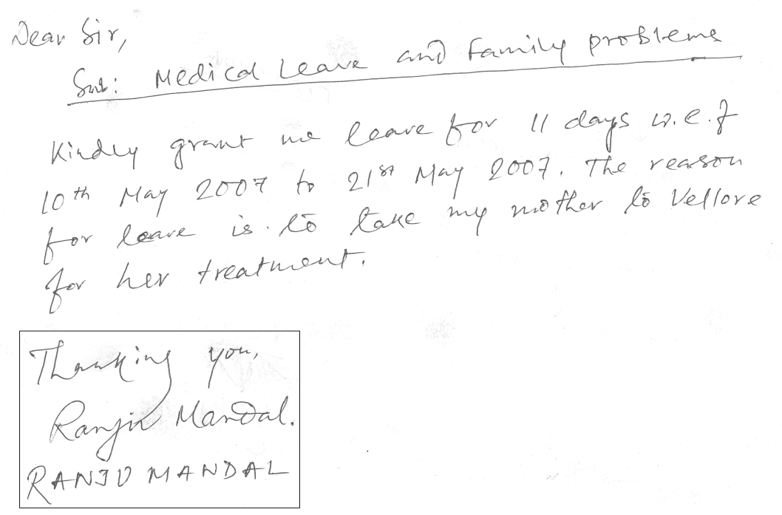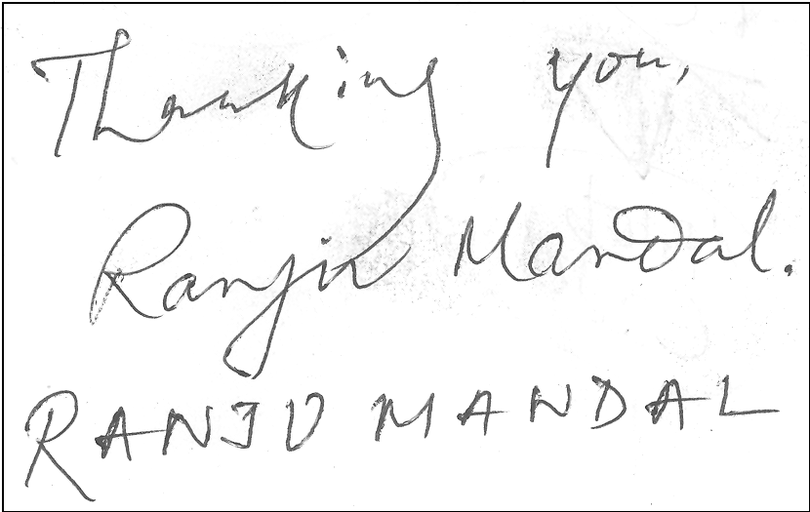
Figure 1. Sample document containing an overlapped signature on a machine printed text. A zoomed version of some touching portions in the signature is also shown below the document.
Signatures of an individual are subject to maintain some basic constraints like its shape, handwriting style, and formation of background regions. Since, the spatial arrangement among background regions in a signature objects are structured in nature and the background regions are separated, using features computed from spatial information will allow us to detect the signature. One of the advantages of using background information instead of foreground (handwritten strokes) is that, we do not need any segmentation which is the most bottle-neck part. The background regions information provide distinguish features of signature object and this approach is not used earlier. Later, Hough transform provides a way of dealing with the complexity issue of finding of object locations based on the background regions[8]. The local background regions to vote for possible detection of the object, and the peaks of voting space is used for locating signature objects.
The proposed approach considers background information of signature object for characterization. Here we label the character holes and four directional water reservoirs for each connected component of a signature as blobs for background information. To obtain the feature of these blobs, Zernike Moment feature is employed. Using these features, a K-mean clustering is used to classify the blobs into some distinct classes. For each query, we find its background blobs using holes and water reservoir concept [2]. The blobs are indexed by the codebook found by the classification step. Next, we encode their spatial information of these blobs using the distance and angular position to a reference point of the signature. This information is stored into a spatial feature bank. In a target image, the blobs are extracted and labeled. The spatial features computed from the background blobs found in the target document are used for GHT. The peak of votes in GHT accumulator validates the hypothesis of the query signature.
The main contribution of this paper is to use of background information of a signature object as high level descriptors and to generate hypothesis of the signature location based on spatial arrangement of these descriptors. This approach is robust to detect signature in noisy, cluttered document and multi-script environment. The rest of the paper is organized as follows. In Section 2, we explain the background region identification and clustering procedure in brief. In Section 3, we describe the representation of the query signature object and their detection process. The experimental results are presented in Section 4. Finally conclusion is given in Section 5.

BACKGROUND BLOBS IDENTIFICATION AND CLUSTERING
In documents, labeling individual background regions of a handwritten signature drives the detection of signature in our system. Here, the extraction of background regions and their labeling process are described as follows.

Background Blobs Extraction
In our approach, we extract the background regions using holes and water reservoir concept.
Character Hole Extraction: In a signature, for each connected component, the holes are detected. Fig.2. shows some holes from a signature image.

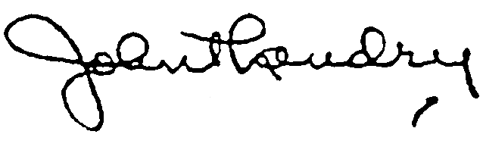
(a)
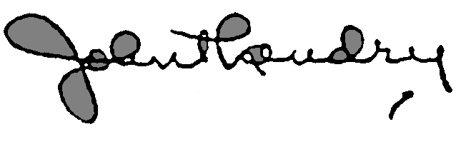
(b)
Figure.2. Character holes detected from a signature image (a) are marked by gray shade in (b).
Water Reservoir Extraction: Water reservoir is a metaphor to illustrate the cavity region of a component. The water reservoir principle [2] is as follows. If water is poured from a side of a component, the cavity regions of the background portion of the component where water will be stored are considered as reservoirs of the component. These reservoirs are used for the segmentation of the words into primitives.
Some of the water reservoir principle based features used here are as follows.
Top (Bottom) reservoir: By top (bottom) reservoirs of a component we mean the reservoirs obtained when water is poured from top (bottom) of the component. A bottom reservoir of a component is visualized as a top reservoir when water will be poured from top after rotating the component by 180°.
Left (Right) reservoir: If water is poured from the left (right) side of a component, the cavity regions of the component where water will be stored are considered as left (right) reservoirs. A left (right) reservoir of a component is visualized as a top reservoir when water is poured from the top after rotating the component by 90° clockwise (anti-clockwise).
Water reservoir area: By area of a reservoir we mean the area of the cavity region where water will be stored. The number of points (pixels) inside a reservoir is computed and this number is considered as the area of the reservoir.
Water flow level: The level from which water overflows from a reservoir is called as water flow level of the reservoir (see Figure. 3).
Height of a reservoir: By height of a reservoir we mean the depth of water in the reservoir.
Base-line: A line, passing through the deepest point of a reservoir and parallel to the reservoir flow level is the base line.
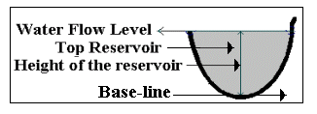
Figure.3. A top water reservoir and its different features are shown. Water reservoir is marked by gray shade.

In Figure.4, we show the water reservoir regions computed from different directions. In our proposed approach, we consider water reservoir regions in 4 different directions (Left, Right, Top and Bottom) along with holes as the background regions.

(a)
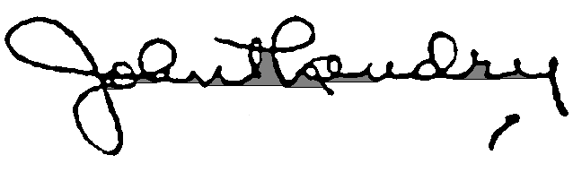
(b)
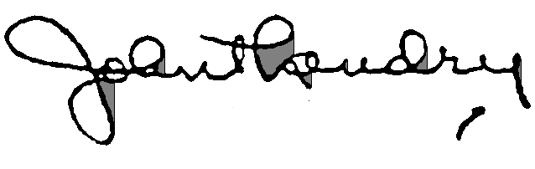
(c)
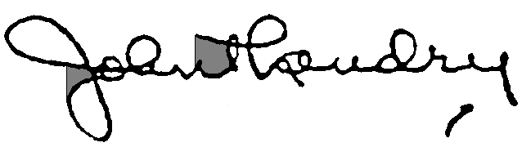
(d)
Figure.4. Water reservoirs detected in the signature image of Fig.2(a) in four directions (a) Top, (b) Bottom, (c) Right (d) Left. Different reservoirs are marked by gray shade.

Blobs Clustering
The background blobs, extracted using the previous method are used to generate blob codebook. We show some blobs in Fig.5. To recognize the blobs obtained from background of an object, we employ Zernike moment feature and K-Mean clustering. These are detailed below.


Figure.5. Examples of some background blobs extracted using character holes and water reservoir method from training signatures.
Zernike Moment Feature: Among many moment based descriptors, Zernike moments have minimal redundancy, rotation invariance and robustness to noise; therefore they are used in a wide range of applications on image analysis, reconstruction and recognition. Zernike moments are based on a set of complex polynomials that form a complete orthogonal set over the interior of the unit circle [10]. They are defined to be the projection of the image function on these orthogonal basis functions. The basis functions V_{n,m}(x,y) are given by:
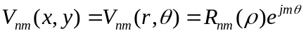 (1)
where n is a non-negative integer, m is non-zero integer subject to the constraints n-|m| is even and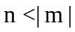, ρ is the length of the vector from origin to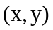, θ is the angle between vector ρ and the x-axis in a counter clockwise direction and R_{n,m}(ρ) is the Zernike radial polynomial. The Zernike radial polynomials, R_{n,m}(ρ),are defined as:
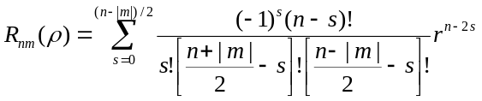
Note that, R_{n,m}(ρ) = R_{n, − m}(ρ). The basis functions in equation 1 are orthogonal thus satisfy,
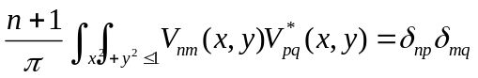where 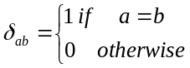
The Zernike moment of order n with repetition m for a digital image function f(x,y) is given by 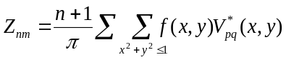 where 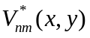 is the complex conjugate of 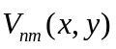.
To compute the Zernike moments of a given image, the image center of mass is taken to be the origin. In our approach, the blobs are normalized into 41*41 before applying Zernike feature computation. The size is considered from the performance of experimental data.
K-Means Clustering and Codebook Creation: The Zernike moment feature calculated from all background blobs extracted from a set of training signatures are fed to a K-means clustering to obtain the background blob codebook.
After clustering the segmented background regions, we extract K representative blobs. These blobs are selected based on the nearest distance from the centre of clusters. We make a blob codebook by these K representative blobs. The process of codebook creation is shown in Fig.6.

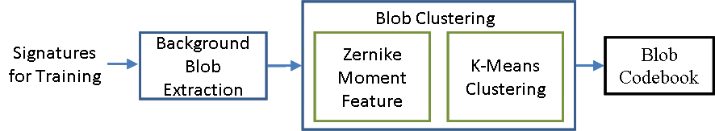
Figure.6. The flow-chart of generating blob codebook.
- SIGNATURE DETECTION USING GHT
In documents, the signatures are affected mainly by occlusion and overlapping. To take care of these problems, our approach is based on partial matching which is inspired from the Generalized Hough Transform (GHT) [8]. The extracted background blobs in a signature are considered as high level descriptors. The spatial information of these descriptors is used to vote for signature object detection under a certain pose. Here, we describe the architecture of our method with two key-parts namely, spatial information encoding and hypothesis voting. The former allows representing model shapes in a compact way in hashing structures. The latter is the main step when a query is formulated into a database.

Spatial Information Encoding
Our representation model for a signature is based on the background blobs. We characterize a signature based on spatial organization of its local background blobs and the attributes used in spatial information are described below.
Given a query signature, the background blobs are extracted first. Next, we obtain the index table called R-table using the classification result of each background blobs (BB_{i}). In the R-table, we record the distance (d_{i}) and angle (A_{i}) information using the label (L_{i}) of representative codebook blob. These are detailed below.

Reference point of signature (R): The center of gravity (CG) of the signature foreground pixels is considered as the reference point.
Distance (d_{i}): This is measured by Euclidean distance between the CG of ith background blob (BB_{i}) and signature the reference point (See Fig.7.).
Angle (A_{i}): The angle between the positive x-axis and the line joining the center of gravity of a particular blob and the reference point.
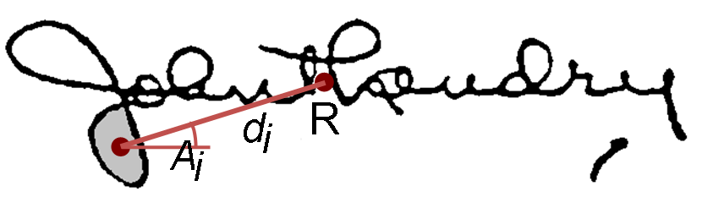
Figure.7. Spatial information encoding for the signature. Here ‘R’ is the reference point. ‘di’ and ‘Ai’ are the distance and angle respectively between CG of BBi and R.

Here in Fig.7. a blob is labeled on the signature image. The CG of the blob is joined to the Reference point “R”. Finally, we store the spatial feature (d_{i}, A_{i}) in R-table using the index id L_{i}.
- Hypothesis Voting
In an input document image chosen for indexing, we used our background blob extraction method (as discussed in Section 2.1) to extract background blobs from the document. Next, Zernike feature and 1-NN classification process are employed to label these blobs according to the codebook. For each blobs, we can make hypothesis of the location of signature reference point R based on the spatial feature stored in R-table. Accordingly, we cast a vote in that location. By accumulating hypothesis voting, the similar signature image to the query signature is detected. When a signature query is detected, a rectangular box is drawn to validate the result visually. Sometimes, the signatures are marked in the document in an angle rather than horizontal direction. Our proposed approach can detect the signature if the query and target signatures are at same angle. To detect the signature at different angle, we generated different query signatures from a single query by rotating for each 3 degree angles between (-10 to +10) and used our approach for spotting. Fig.8 shows a detection result with our approach in a handwritten document of Fig.1.
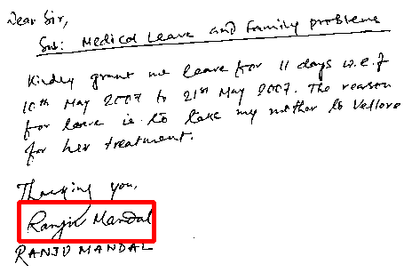
Figure.8. Signature spotting in a handwritten document.

EXPERIMENTAL RESULTS
For the experiment, documents containing signature were collected from different sources. We have used the dataset of “tobacco” industrial archives. We also tested another 40 signed documents of English and Bengali for the performance evaluation. The contents of the documents are in printed/handwriting and the signatures are touching often with the textlines. Fig.9 shows some qualitative results of our approach of signature spotting. We considered total 40 signatures for learning the codebook. The blobs are clustered in 20 classed according to training data. The testing dataset consist of total 100 documents containing signature. 50 additional documents without signatures were also included in the dataset.
The signatures are touching in different locations. Due to noise, some signature parts were missing. Sometimes, due to posting on text document, many additional text characters of document are also placed inside the signature region. Fig.10 shows the precision recall curve for document retrieval from the testing dataset. Our method is script independent and performs well in signature spotting in printed/ handwritten documents. Our method could detect a signature even if it is not in the same orientation in the target document.

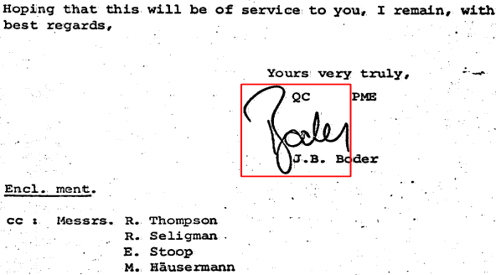
(a)

(b)
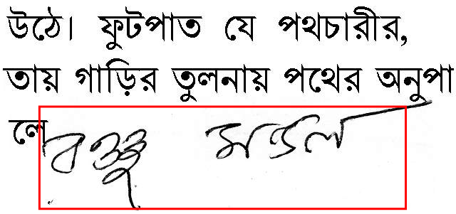
(c)
Figure.9. (a) and (b) show signature spotting in English documents taken from “tobacco” dataset. (c) Shows the spotting in Bengali document. Here spotted parts are marked by red rectangular box.

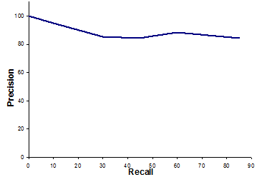
Figure.10. Precision-Recall curve for signature based document retrieval.

CONCLUSIONS
We have presented an approach for document retrieval based on signature detection using spatial arrangement of background information extracted from signature. The contribution in this paper is to use the background information recognition to obtain high level local features that can take care of complex signature. We have tested our method in a database of signature documents containing noise, occlusion and overlapping. In retrieval of document image from database, all background blobs of a document pass through a recognition process that is time consuming. So, the improvement of the performance in terms of time could be achieved if some positional information is used to remove non-signature information from the document.
ACKNOWLEDGEMENTS
This work has been supported by the Renom Project of Université François Rabelais, Tours, France (2011-2012)
REFERENCES
- X. Peng, S Setlur, V Govindaraju, R Sitaram and K Bhuvanagiri, “Markov Random Field Based Text Identification from Annotated Machine Printed Documents”, In Proc. 10th ICDAR, pp.431-435, 2009.
- U. Pal, P. P. Roy, N. Tripathy, J. Lladós: Multi-oriented Bangla and Devnagari text recognition. Pattern Recognition, vol. 43, pp. 4124-4136 (2010)
- J.K. Guo and M.Y. Ma, “Separating Handwritten Material from Machine Printed Text Using Hidden Markov Models”, In Proc. 6th ICDAR, pp.439-443, 2001.
- F. Farooq, K. Sridharan and V. Govindaraju, “Identifying handwritten text in mixed documents”, Proc. International Conference on Pattern Recognition, pp.1-4, 2006.
- X. Peng, S Setlur, V Govindaraju and Ramachandrula Sitaram, “Overlapped Text Segmentation Using Markov Random Field and Aggregation”, Proc. International Workshop on Document Analysis System, pp.129-134, 2010.
- R. Mandal, P. P. Roy, U. Pal: Signature Segmentation from Machine Printed Documents Using Conditional Random Field. ICDAR 2011, pp. 1170-1174
- U. Pal, N. Sharma, T. Wakabayashi, F. Kimura, “Handwritten Numeral Recognition of Six Popular Indian Scripts”. In Proc. 9th ICDAR, pp. 749-753, 2007.
- D. Ballard. Generalizing the Hough transform to detect arbitrary shapes. Pattern Recognition, vol. 13, pp. 111-122, 1981.
- P. P. Roy, U. Pal, J. Lladós: Document seal detection using GHT and character proximity graphs. Pattern Recognition, vol. 44, pp. 1282-1295 (2011)
- S. Li, M. C. Lee, C. M. Pun, "Complex Zernike Moments Features for Shape-Based Image Retrieval", IEEE Transactions on Systems, Man, and Cybernetics, Part A: Systems and Humans, vol. 39, no. 1, pp. 227-237, 2008.

