Signature Segmentation from Machine Printed Documents using
Contextual Information

Ranju Mandal  Computer Vision and Pattern Recognition Unit, Indian Statistical Institute, Kolkata-108, India ranjumandal@gmail.com | Partha Pratim Roy  Laboratoire d’Informatique  Université François Rabelais  Tours, France  partha.roy@univ-tours.fr | Umapada Pal  Computer Vision and Pattern Recognition Unit, Indian Statistical Institute, Kolkata-108, India umapada@isical.ac.in

Abstract
Signature separation from a document page involves difficult task due to the free-flow nature of handwriting, overlapping/touching of signature portions with printed text, noise, etc. In this paper, we have proposed an approach for segmentation of signatures from machine printed signed documents using context information. The method first detects the signature block in the document using word level feature extraction. Gradient based features and Support Vector Machine (SVM) classifier are used for the classification purposes. In the signature regions, isolated printed text characters are next removed using neighboring text line information. This neighboring information is very useful for touching zone segmentation. Using this zonal information initially some candidate points for touching segmentation are found based on Douglas Peucker algorithm. Finally, the touching strokes of signature are separated from text characters using skeleton and contour processing. The experiment is performed in “tobacco” dataset¹ and we have obtained promising results from it.

Keywords- Signature segmentation, Printed/handwritten text separation, Touching segmentation, Signature verification.

Introduction
Automatic signature detection and segmentation from a document image page is a challenging task. Accurate signature detection and extraction from the document is very important in many organizations such as banking and finance industry. In such organizations, signature is often examined by forensic document analysis experts to restrict frauds. There are many pieces of research works which deal with automatic online/offline signature verification and recognition [6, 8]. However, these approaches use only isolated signatures and they may fail if background text touch/overlap with such signatures.
A machine printed document which contains a signature, there may have some printed text that may touch and/or overlap with signature. We have shown an example of such signed document in Fig.1. It is to be noted that the signature strokes are overlapped/touched with printed text characters in many places. Proper segmentation of such signatures is needed before applying the methods for signature verification and recognition. Many research work exist on printed and handwritten text separation based on word or line level classification [3,4,15]. Guo and Ma [3] used Hidden Markov Models (HMM) based classification for handwritten annotation separation from printed document on word level. Farooq et al. [4] have proposed Gabor filters for feature extraction and an Expectation Maximization (EM) based probabilistic neural network have been used for printed and handwritten classification. Pal and Chaudhuri [15] proposed a line-wise printed and handwritten text separation scheme where script based characteristics are used. To the best of our knowledge, there exists not much work which handles the problem of overlapped and touched machine printed text on a signature in printed signed documents.

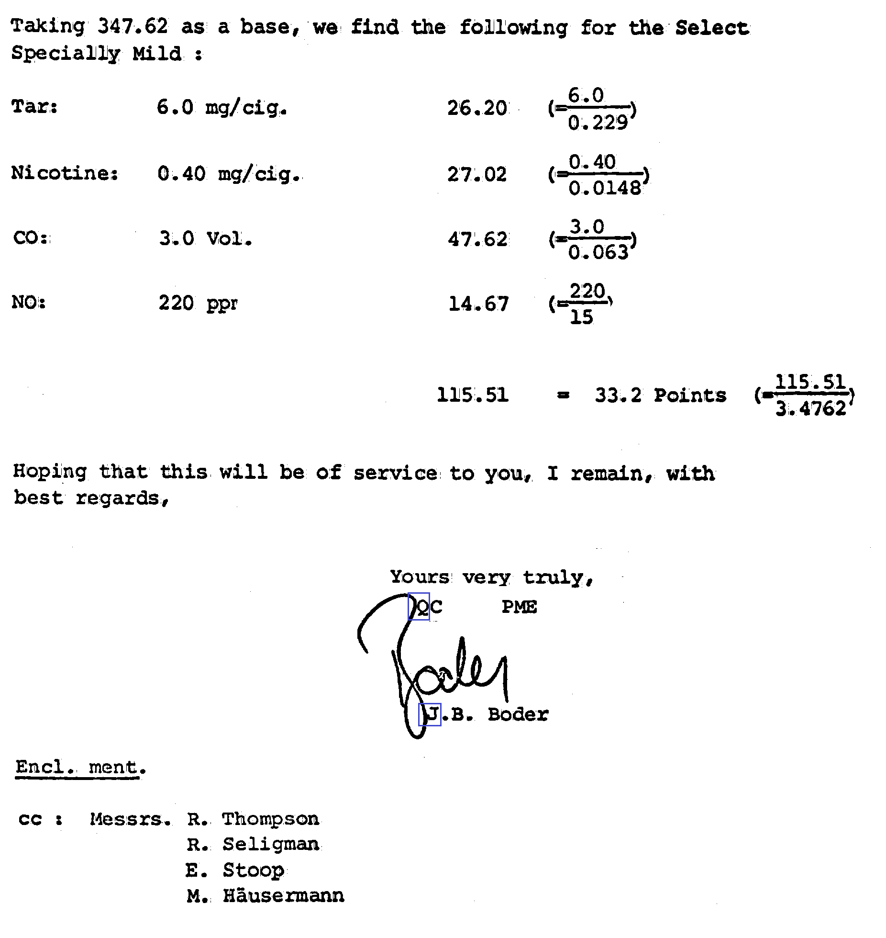

Figure 1. Sample document of overlapped signature on a machine printed text. Some touching portions in the signature are marked with blue box.

In this paper, we focus our work on the segmentation of signature from a document by eliminating the printed text portions that touch or overlap the signature. First, words blocks are extracted from a document image using a morphological operation and then the signature block is detected using 400 dimensional gradient based block level feature analysis. To remove isolated characters included in signature block, neighboring printed word information is used. Using the context information of neighbor printed character information; the possible regions of touching characters are detected. Next some candidate points for touching segmentation are found based on Douglas Peucker algorithm. A stroke based analysis on the skeleton image and contour analysis have been performed in these hypothetical regions for elimination of the overlapping/touched text characters from signature strokes.
The rest of the paper is organized as follows: In Section II, we have discussed briefly the signature block detection using gradient based features. The proposed methodology of signature segmentation is detailed in Section III. Experimental results and performance analyze are discussed in Section IV. Finally, conclusion and future work are presented in Section V.

Signature Region Extraction
The binarized text document image is first segmented into words based on the inter-character spacing in words. For this purpose a morphological dilation operation has been performed and a connected component labeling is applied to find the bounding box of the word patches in the document.
Next, we compute 400 dimensional gradient based feature of each of the segmented word patches. The word-image is normalized into 126x126 size and converted to gray-scale image by applying a set of mean-filtering. Next the resultant gray image is segmented into 9X9 blocks. A Roberts filter is then applied on the image to obtain gradient image. The direction of gradient is quantized into 16 directions and the gradient strengths are accumulated with each of the quantized direction. Histograms of the values of 16 quantized directions are computed in each of 9x9 blocks. Finally, 9x9 blocks are down sampled into 5x5 by a Gaussian filter. Thus, we get 5x5x16 = 400 dimensional feature.
We feed this 400 dimensional gradient feature into a SVM classifier (Gaussian kernel with Radial Basis Function) for classification of signature blocks [11]. The SVM is defined here for two-class problem: signature blocks and printed word blocks identification. To train our classifier for detecting a signature blocks on printed document, we have used 3080 signature from GPDS signature dataset [9] and 7684 English words as training data sets. English words are extracted from different types of printed documents like books, daily newspaper, official documents, magazine, journal etc. Results of signature block and text word blocks are shown in Fig.2.

Signature stroke analysis and separation

This section details the removal of the printed text characters from the signature block in two steps: printed text zone selection and segmentation of text characters. The binary signature blocks may contain some spurious noise pixels and irregularities on the boundary of the characters, leading to undesired effects on the system. We removed such small noise components and smoothed the rest of the image for signature segmentation.

Printed text zone selection and removal of isolated characters

Beside the touching/overlapping printed characters with the signature, there may appear some isolated printed text characters in the signature block. This happens during signature block extraction using morphological operation in the binary image and later during connected component analysis of the morphological image. The isolated text characters that are very near to signature may be included with the signature block for their proximity. We identify such isolated text characters from the signature block and remove them. For this purpose, first, we detect the zones of printed text characters in the signature block. The printed text character zone refers to the area where signature block contains the isolated or touching/overlapping printed characters. The other area in the signature block refers to signature zone.

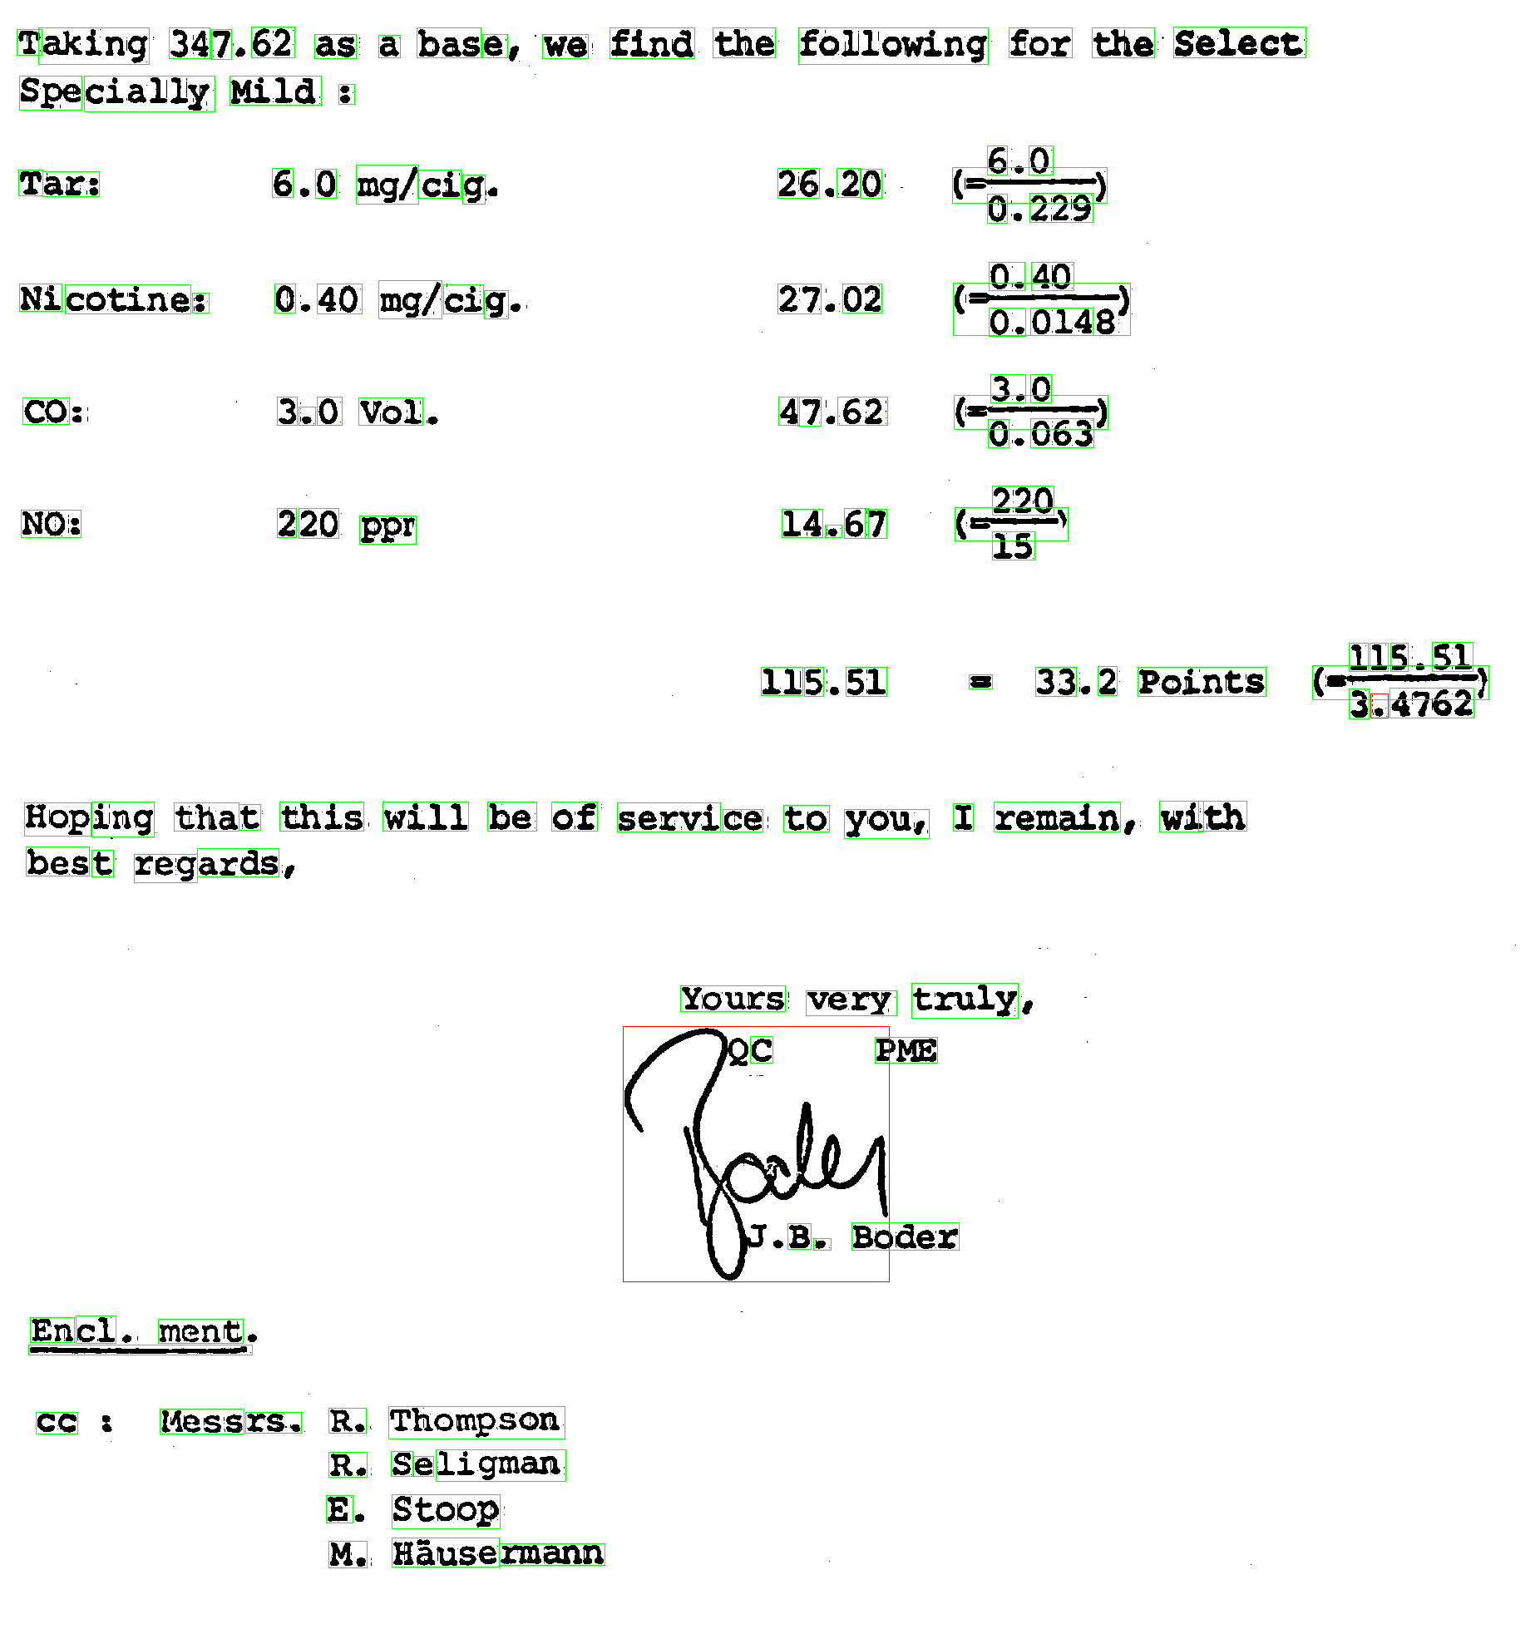
Figure 2. Document after signature and text separation. Bounding box of signature is marked by red colour while text blocks are marked by green.
The zones of printed text characters are estimated using neighbouring printed words height and position information. The neighbor word blocks of a signature block are decided using boundary growing algorithm of the signature block components. The upper and lower line of printed text characters is calculated from neighbor character information and the area between these two lines are considered as printed text character zone. See Fig.3(a) where these zones are marked by horizontal lines. It is to be noted that, there may present more than one printed text zone in the signature block and we detect all of them using neighbor text character analysis.
Next, the isolated connected components in the signature block are considered for removal. If the isolated text characters’ sizes are less than or equal to the estimated printed text character size and they fall inside the text zones, these components are identified as printed characters and thus eliminated from signature block. See Fig.3(a), where we have shown the characters included in signature block. Fig.3(b) shows removal of isolated text characters from a signature block of Fig.3(a).

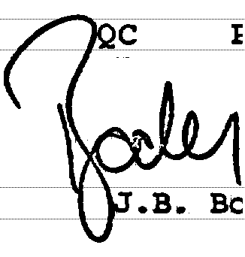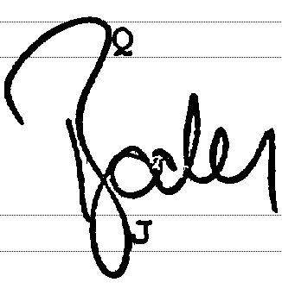
(a) (b)
Figure 3. (a) Signature block with printed text zone (the printed text character zones are marked by horizontal lines) (b) Signature after removal of isolated characters.

Segmentation of touched/overlapped printed text

The printed text characters which are included in the signature block and are touched/overlapped with the signature cannot be separated using word block classification analysis. To remove such characters we computed the hypothetical zones of printed text characters and assume that the touching/overlapped printed characters exist is these zones only. From the experiment we noted that accuracy of our hypothetical zones is 98.35%.
For segmentation of these touching printed characters, we use the skeleton and the contour information of signature block. Skeleton/thinned image produce the junction points of strokes of signature portion and text characters whereas contour image help us to estimate the corner regions in the signature block for effective segmentation.
The skeleton image is obtained by a rotation invariant rule-based thinning algorithm [10] from each of the signature block. Due to spurious effect of thinning, sometimes the strokes can be over-segmented. To avoid this, the image is smoothed before thinning process. The junction points in this thinned image are next searched by detecting the pixel locations where there are 3 or more neighbors. The junction points which lie in the printed text zones, computed earlier, are kept for possible segmentation. We analyze the contour information near these junction points for segmentation.
The corner points in the contours are next computed for separation of printed text and signature portions. To do so, we employ a polygonal approximation method to the contour pixels of signature block. Polygonisation provides corner-points which are at the corner of edges. We have used the Douglas and Peucker[14] polygonal approximation algorithm. The value of the tolerance threshold in this algorithm is set with the average stroke width (stroke width computation is discussed later) of the signature block. This algorithm is well adapted to localize hard curvature points along a border. The corner points are necessary for segmentation because, usually when the characters are touched with the signature strokes, they form corners at the touching region. Junction and corner points obtained from printed text zone are shown in Figs. 4(a) and 4(b).
For a component, the stroke width is calculated as follows. A component is scanned both row-wise and column-wise. Suppose n different runs of lengths r₁, r₂,….r_{n} with frequencies f₁, f₂ …..f_{n}, respectively, are obtained from the component by the scanning. Then the stroke width is considered as the run-length r_{i} having maximum frequency. In other words, stroke width will be r_{i} if f_{i} = max(f_{j}), j = 1, 2,…..n.
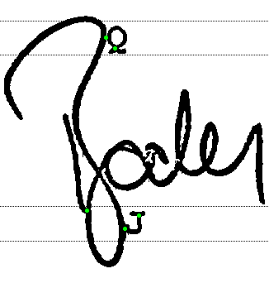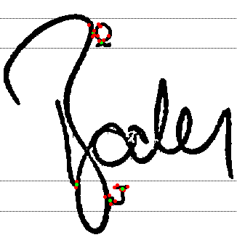
(a) (b)
Figure 4.(a) Signature showing green points as junction points lie on printed text zone (b) Red points represents corner points.

After computing the skeleton and corner points of the printed text regions, we separate text characters which are touched/overlapped in these regions. For this purpose, we first detect the signature strokes that pass from signature zones (outside of printed zone) to printed text zones. For each of these strokes, we traverse the thinned image of that signature stroke and mark the junction points in its path. Next, we find all the corner points which are closed to the junction points. At each junction points, we compute different segmentation cuts based on the corner points and orientation of thinned lines in the skeleton. A segmentation cut is defined by the line obtained by joining two corner points near to junction point. The best segmentation cut is chosen according to the orientation of signature stroke at the junction point. The segmentation cut is verified by checking the boundary of the remaining portion. If the boundary of the remaining box lies in the printed text zone, we identify them as text characters and remove them. The continuation of such segmentation follows until it ends or crosses the printed text zone.

Result and Disscussion
For our experiment, we have used the dataset of “tobacco” industrial archives. We have used 105 signed machine printed English document for the performance evaluation. The documents are written in English and the signatures on these documents also contain English text characters. Fig.5 shows a final result of signature segmentation.
For quantitative performance of the system, we use common ratio of precision (P) and recall (R) for evaluation of separation of printed characters and handwritten strokes from signature block. For the experiment, we have tested a total of 18200 patches (17730 printed and 470 signature patches) and we have achieved an overall accuracy of 98.71%. For the experiment of touching character segmentation in signature region, we considered 1120 strokes and we have achieved an overall precision of 90.30% and recall of 86.2%.



Figure 5. Final result of signature stroke segmentation from a signature block.

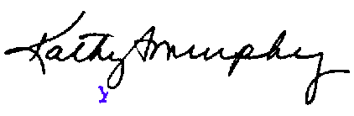
(a)
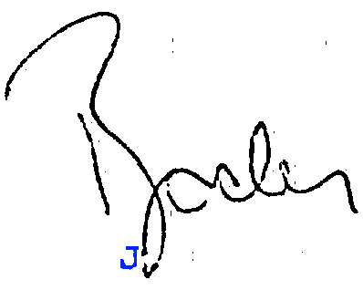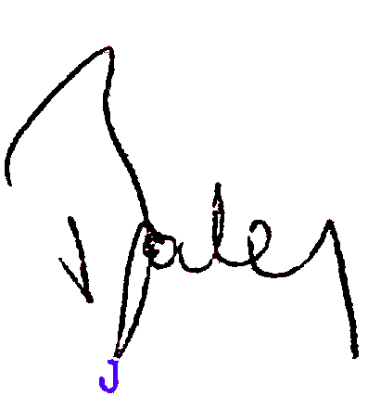
(b) (c)
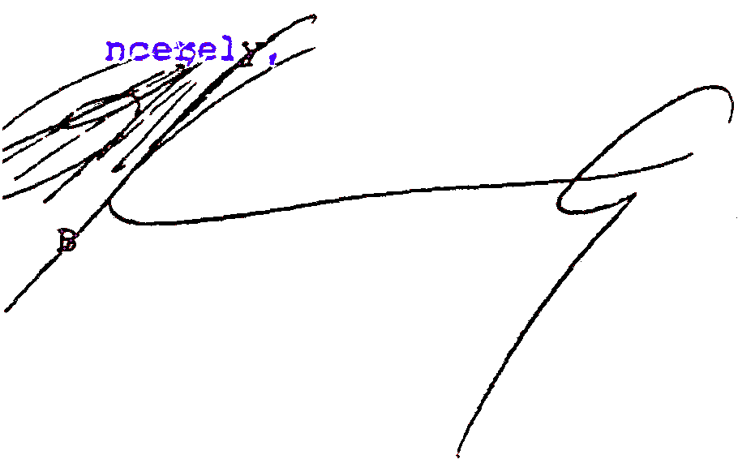
(d)
Figure 6. Signature segmentation results are shown. (a-c) segmented correctly and (d) an incorrect result. Here two characters ‘y’ and ‘B’ are not segmented from the signature because of heavy touching.

To get the qualitative idea of the segmentation results we have shown some results of the proposed approach in Fig.6. Most of the errors occurred because of heavy touching (See Fig.6(d)) of signature strokes with text characters. When the signature stroke touches many characters in the printed text zone, the segmentation of characters is not proper. On the other side, if some isolated strokes of signature exist in the printed text zone, they are misclassified as text characters and thus removed from signature.

Conclusion
Signature detection and extraction from a document page is an important task. In this paper, we proposed an approach for efficient segmentation of signature from document images. In our approach, at first, we detected the signature regions in machine printed text document using a word-level classification by gradient feature and SVM classifier. Next, neighbor text information of signature region is used for detecting touching/overlapping zones of printed text characters in the signature region. The touching/overlapped text characters are separated using junction points obtained from thinned image and corner points in the contour. The result of our experiment shows that the performance of our system is encouraging. There are scopes for improvements using this approach by extending the investigation to more accurate segmentation and classification and in future we plan to do it.

References

- X. Peng, S Setlur, V Govindaraju, R Sitaram and K Bhuvanagiri, “Markov Random Field Based Text Identification from Annotated Machine Printed Documents”, In Proc. 10th ICDAR, pp.431-435, 2009.
- M. A. U. Khan, M. K. K. Niazi and M. A. Khan, “Velocity-Image Model for Online Signature Verification", IEEE Trans. on Image Processing, pp.3540-3549, vol. 15, No. 11, 2006.
- J.K. Guo and M.Y. Ma, “Separating Handwritten Material from Machine Printed Text Using Hidden Markov Models”, In Proc. 6th ICDAR, pp.439-443, 2001.
- F. Farooq, K. Sridharan and V. Govindaraju, “ Identifying handwritten text in mixed documents”, Proc. International Conference on Pattern Recogniton(ICPR), pp.1-4, 2006.
- X. Peng, S Setlur, V Govindaraju and R. Sitaram, “Overlapped Text Segmentation Using Markov Random Field and Aggregation”, In Proc. DAS, pp.129-134, 2010.
- J. F. V. Bonilla, M. A. Ferrer-Ballester, C. M. T. González, J. B. Alonso: Off-line signature verification based on grey level information using texture features. Pattern Recognition, vol. 44 no. 2, pp. 375-385, 2011
- U. Pal, N. Sharma, T. Wakabayashi, F. Kimura, “Handwritten Numeral Recognition of Six Popular Indian Scripts”. In Proc. 9th ICDAR , pp. 749-753, 2007.
- J.P.Swanepoel and J. Coetzer, “Off-line Signature Verification Using Flexible Grid Features and Classifier Fusion”, In Proc. ICFHR, pp. 297-302, 2010.
- M. Blumenstein, Miguel A. Ferrer and J.F. Vargas, “The 4NSigComp2010 off-line signature verification competition: Scenario 2”, In Proc. ICFHR, pp. 721-726, 2010.
- M.Ahmed and R. Ward, “A Rotation Invariant Rule-Based Thinning Algorithm for Character Recognition”, IEEE Trans. on PAMI,vol. 24, no. 12, pp.1672-1678, 2002.
- V.Vapnik, “The Nature of Statistical Learning Theory”, Springer Verlang, 1995.
- Y. Boykov and V. Kolmogorov, “An experimental comparison of min-cut/max-flow algorithms for energy minimization in vision”, IEEE Trans. on PAMI, vol. 26, no. 9, pp. 1124-1137, 2004.
- V. Kolmogorov and R. Zabih, “What energy functions can be minimized via graph cuts?”, IEEE Trans. on PAMI, vol. 26, no. 2, pp. 147-159, 2004.
- D. Douglas and T. Peucker. Algorithms for the reduction of the number of pointsrequired to represent a digitized line or its caricature. The Canadian Cartographer, 10(2):112-122, 1973.
- U. Pal and B. B. Chaudhuri, "Machine-Printed And Hand-Written Text Lines Indentification", Pattern Recognition Letters, Vol.22, No. 3-4, pp. 431-441, 2001.

