Problems

1. Query: 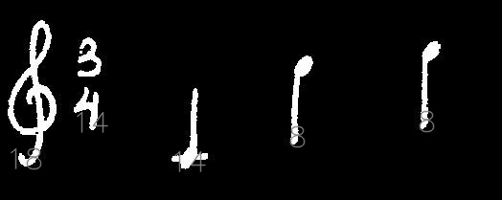  
   Text:  
   approximately same, but it reduces precision.
2. Over-line or under-lines sometimes connect some symbols, I don’t know these should be really same or not. (There is also some problem for small queries.)  
   Query: 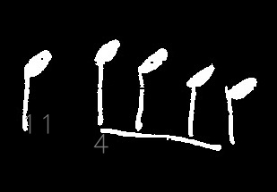  
   Text : 

  

**Output**

text A B C D E F G H pre rec

ADD1 1 0 0 2 1 0 0 0 0.75 1

ADD2 1 0 0 2 0 0 0 0 0.857 1

ADD3 0 0 0 3 0 0 0 0 0.8 0.889

ADD4 1 0 0 3 0 0 0 0 0.786 0.917

ADD5 1 0 0 1 0 0 0 0 0.812 0.867

ADD6 2 0 0 1 0 0 0 0 0.789 0.833

BBB1 0 0 1 0 0 0 0 0 0.75 0.714

BBB2 0 4 0 0 0 0 0 0 0.75 0.75

BBB3 0 2 0 0 0 0 0 0 0.769 0.741

CC1 0 0 1 0 0 0 0 0 0.778 0.724

CC2 0 0 1 0 0 0 0 0 0.786 0.71

CC3 0 0 2 0 0 0 0 0 0.8 0.727

CCC1 0 0 0 0 0 0 0 0 0.8 0.667

E1 0 0 0 1 1 0 1 0 0.758 0.676

E2 1 0 0 2 0 0 0 0 0.694 0.658

E3 0 0 0 3 0 0 0 0 0.641 0.641

E4 0 0 0 2 0 0 0 1 0.595 0.625

F1 0 0 0 0 0 0 0 0 0.595 0.61

F2 0 1 0 0 0 0 0 0 0.581 0.595

F3 0 0 0 0 0 1 0 1 0.578 0.605

F4 0 0 0 0 0 0 0 0 0.578 0.591

G1 0 0 0 1 0 0 1 0 0.574 0.6

G2 0 0 0 1 0 0 0 1 0.551 0.587

H1 0 0 0 1 0 0 1 2 0.528 0.596

H10 0 0 0 0 0 0 0 1 0.537 0.604

H11 0 0 0 0 0 0 0 2 0.536 0.612

H2 0 0 0 0 0 0 0 1 0.544 0.62

H3 0 0 0 0 0 0 0 1 0.552 0.627

H4 0 0 0 1 0 0 0 0 0.542 0.615

H5 0 0 0 0 0 0 0 2 0.541 0.623

H6 0 0 0 0 0 0 0 2 0.54 0.63

H7 0 0 0 0 0 0 0 1 0.547 0.636

H8 0 0 0 1 0 0 0 1 0.545 0.643

H9 0 0 0 2 0 0 0 1 0.536 0.649

Thumbs !

Y1 0 0 0 0 0 0 0 1 0.529 0.649

Z1 0 0 0 0 0 0 0 3 0.507 0.649

* A text name “ADD1” means it contains 1 “A” querry and 2 “D” queries.