Automation Framework Analysis

Driver Management
MissionQaTest uses static WebDriver leading to non-thread-safe execution.

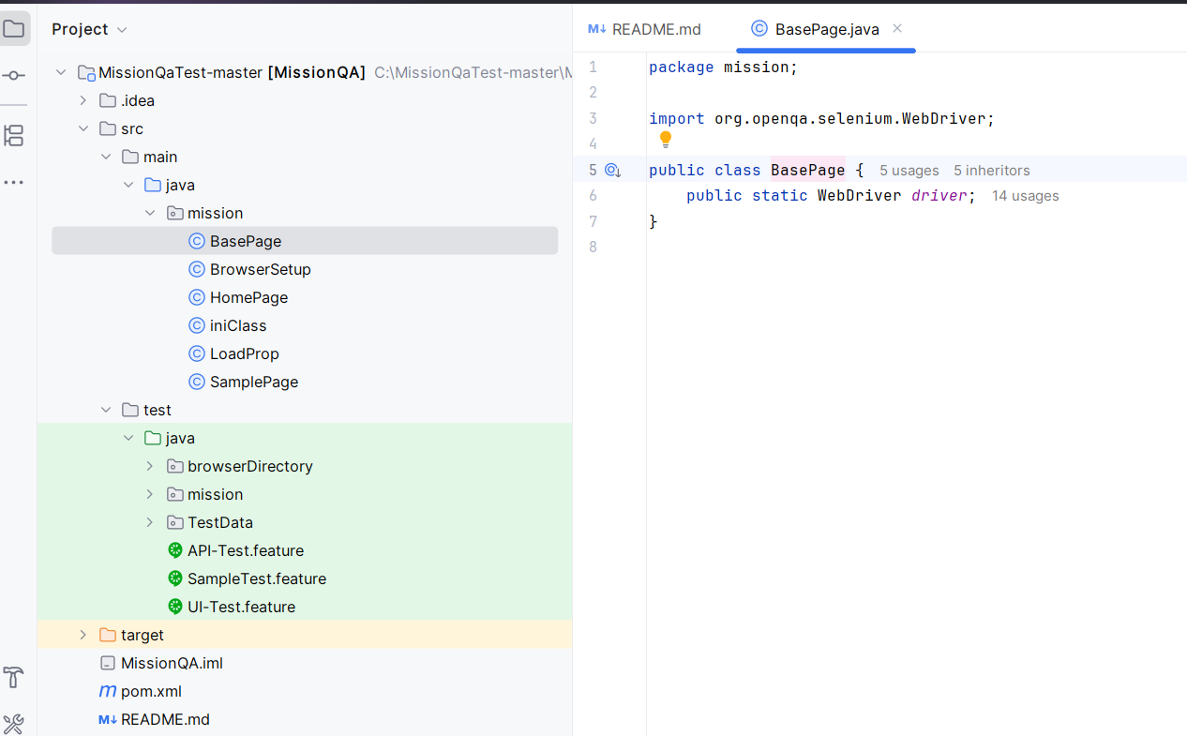
VedLogicAssignment uses ThreadLocal DriverManager ensuring parallel-safe execution.
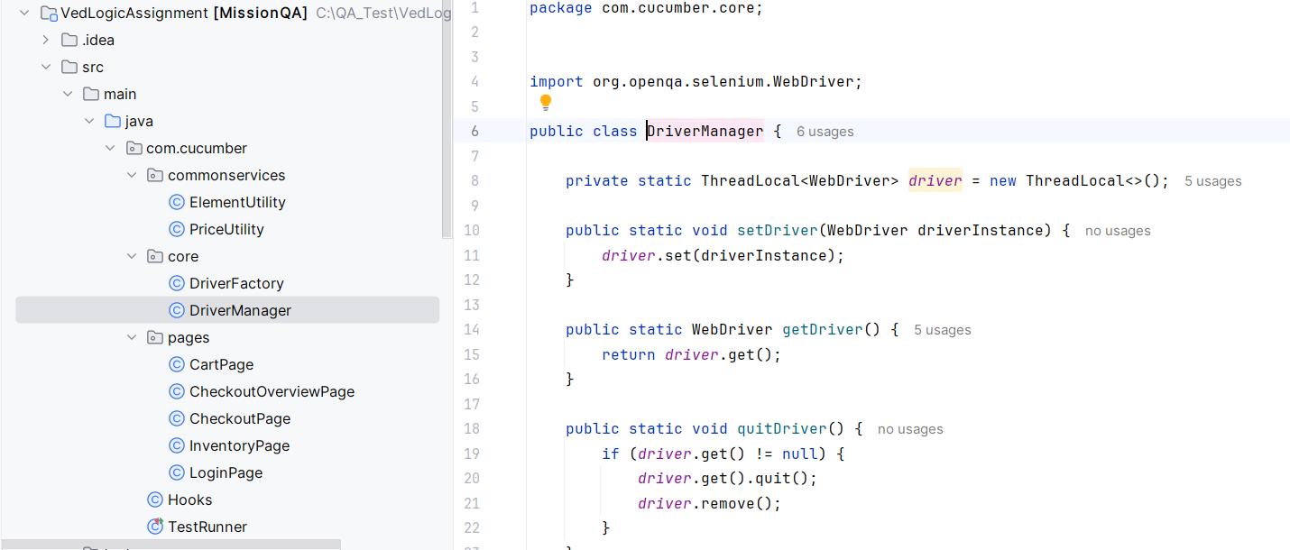
Base Class Design
MissionQaTest relies on Base class inheritance causing tight coupling.
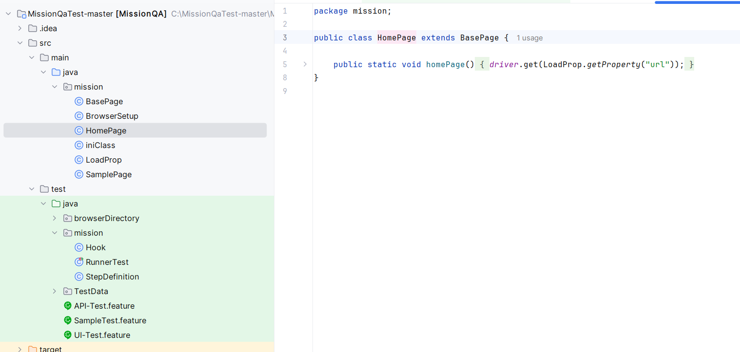
VedLogicAssignment removes Base and uses constructor injection.
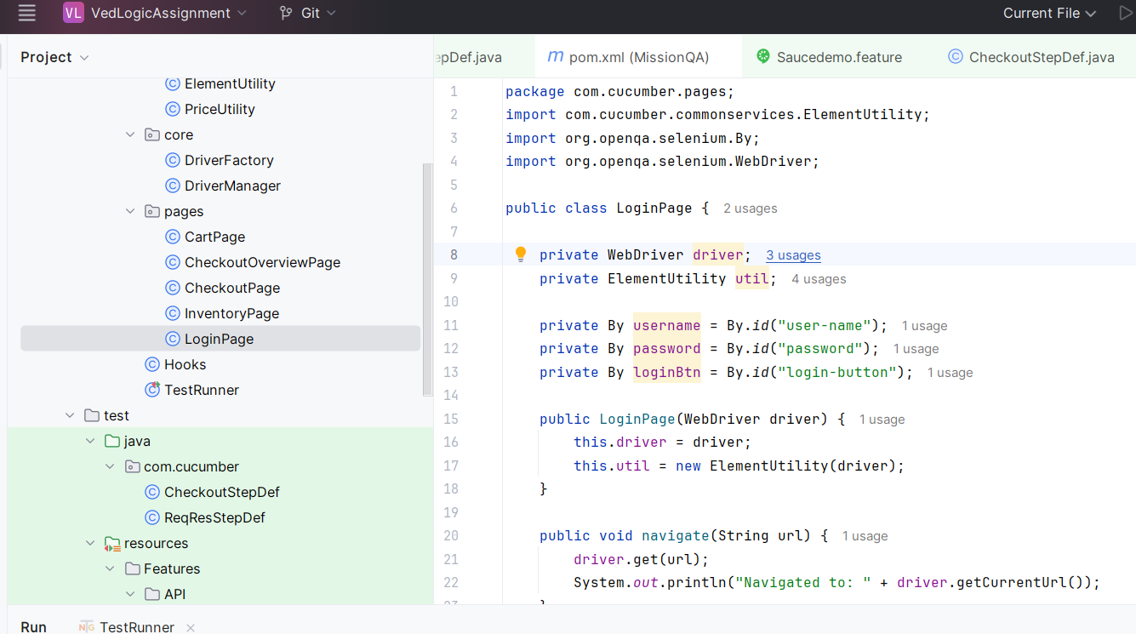

Page Object Implementation
MissionQaTest directly uses driver.findElement.
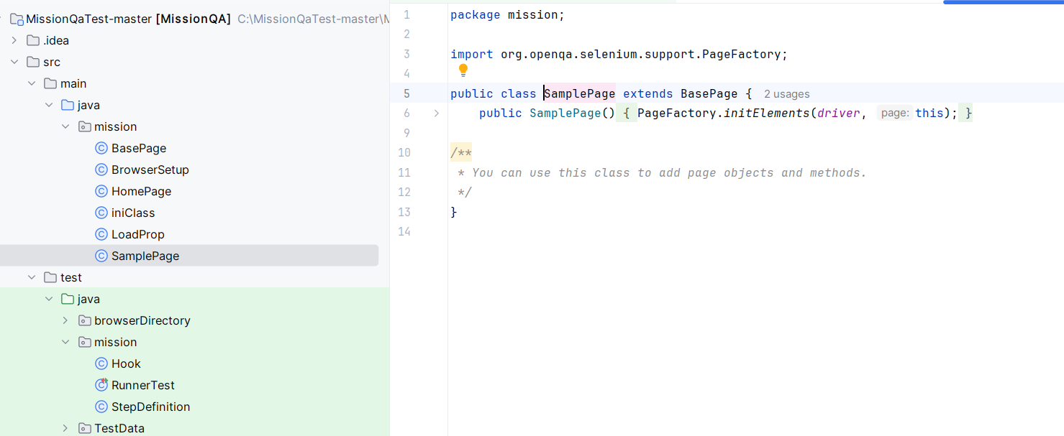
VedLogicAssignment uses utility layer (ElementUtil) improving reusability.
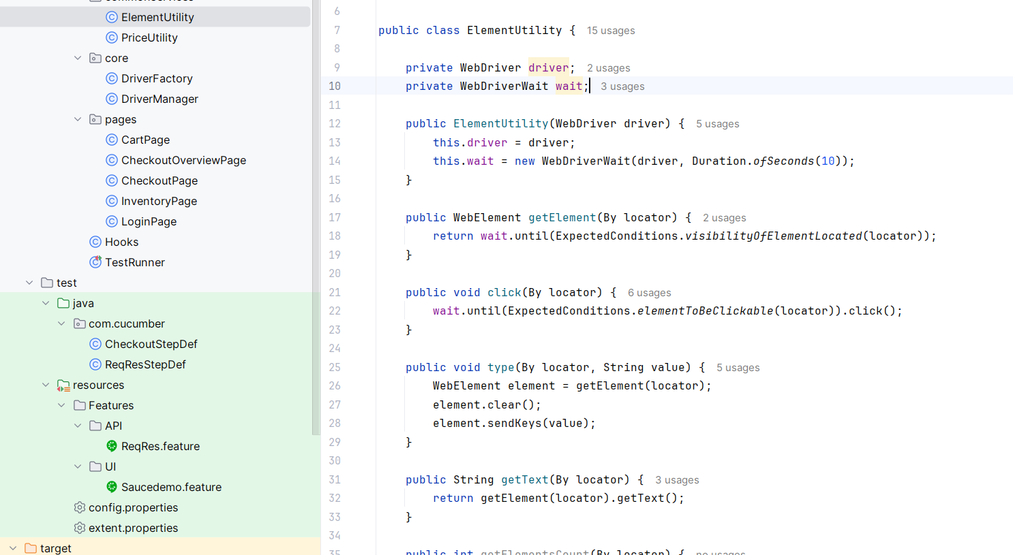

Element Handling
MissionQaTest lacks waits.
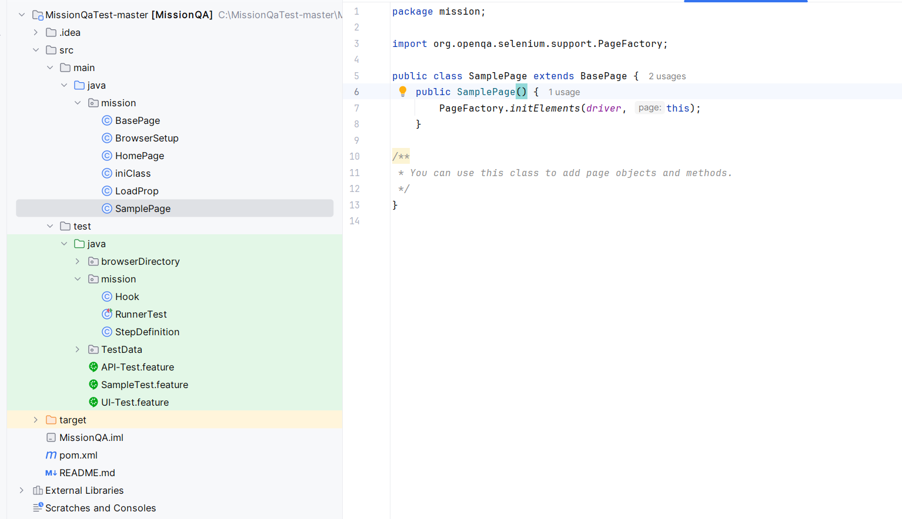
VedLogicAssignment uses explicit waits for stability.
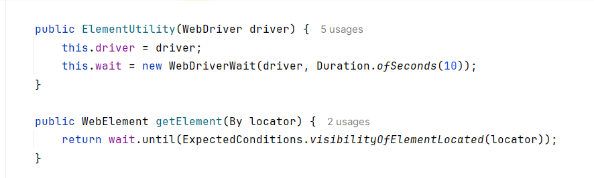

Hooks Design
MissionQaTest launches browser for all tests.
VedLogicAssignment conditionally skips browser for API tests.

Step Definitions
MissionQaTest extends Base.
VedLogicAssignment uses DriverManager with loose coupling.

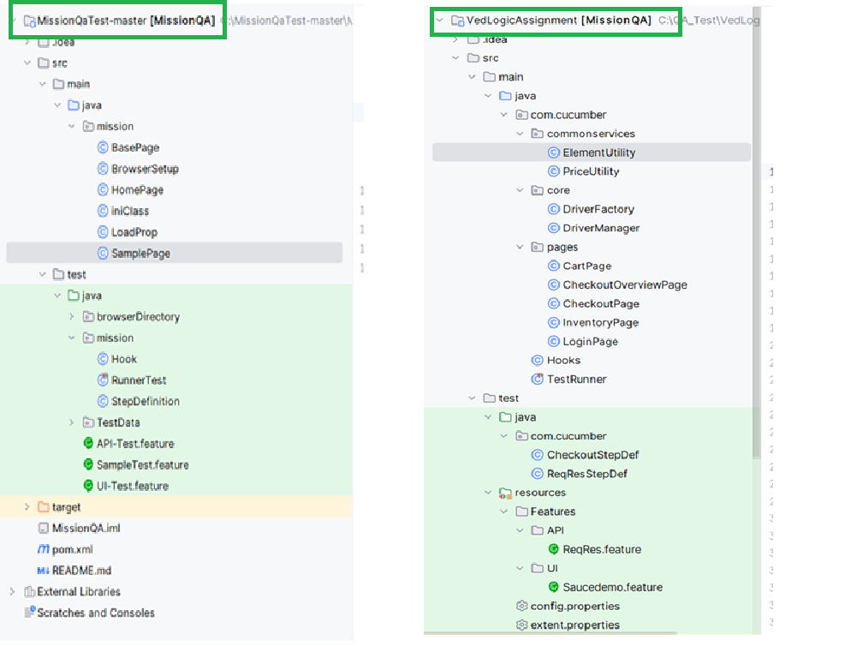

Framework Structure
MissionQaTest has flat structure.
VedLogicAssignment has modular layered architecture.

Feature Files
Mission QA has got feature files in same folder and VedLogic Assignment has feature files arranged folder wise & segregated
