Current Configuration:

Style.css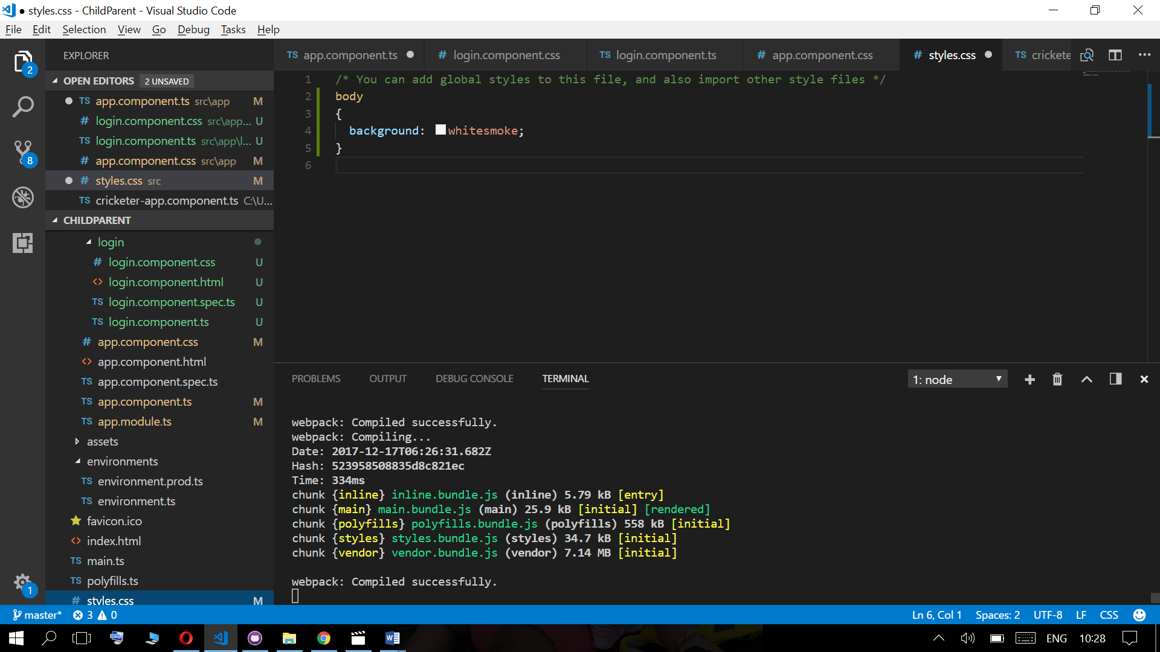

Parent CSS – app.component.css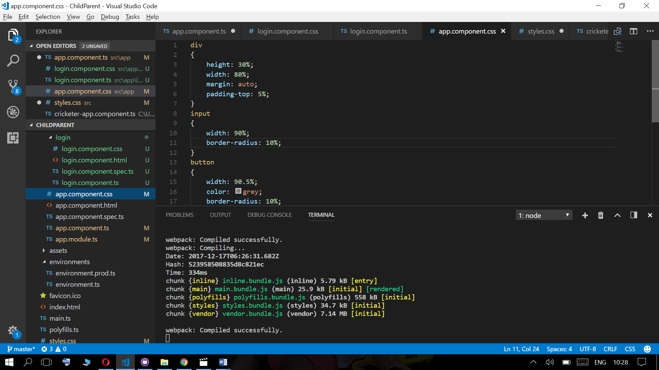

Chile CSS – login.component.css

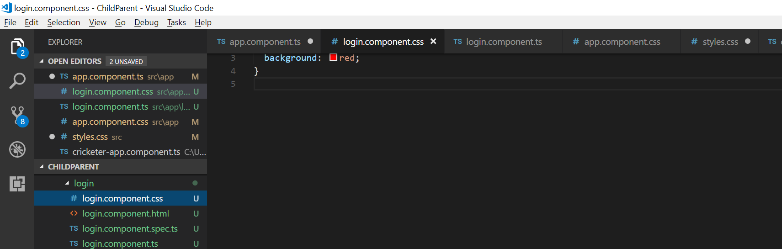

Without View Encapsulation:

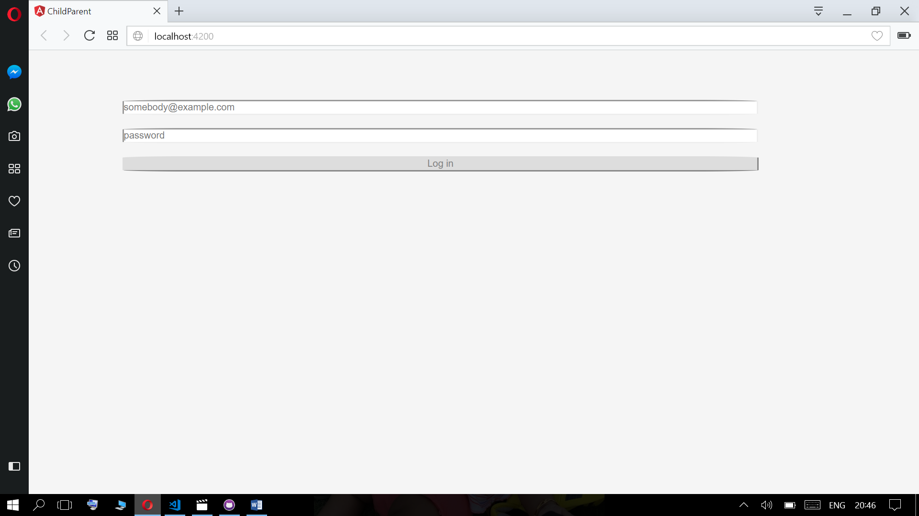

With View Encapsulation.Emulated

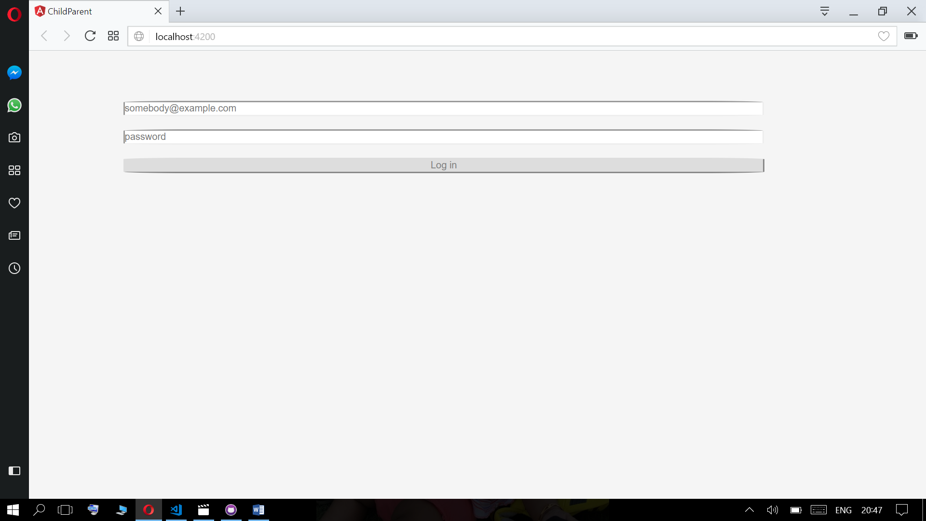

With View Encapsulation: None,

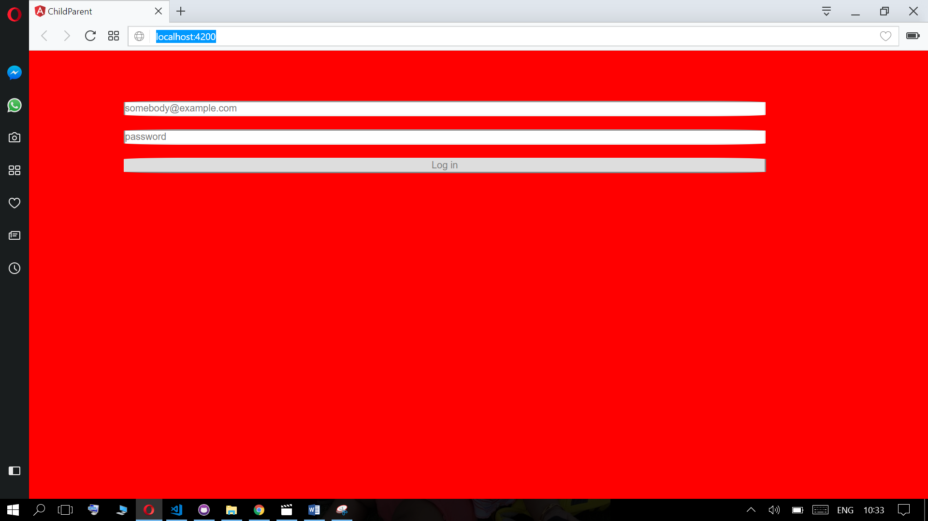

With ViewEncapsulation:Native,

