INVENTORY MANAGEMENT SYSTEM
PROJECT REPORT
Major Project Report Submitted as Part of the Online Internship Program
Submitted by
NAME: Rakesh Patwardhan
USN : 4JK24EC080
Department: Electronics and communication Engineering
College: AJ Institute Of Engineering And Technology
Internship Guide/Mentor: Nitin
Internship Organization/ Platform: Corizo EduTech Private Limited
Internship Duration: 08/09/2026--05/10/2026
Academic Year: 2026–2027

TABLE OF CONTENTS
1. Project Title
2. Abstract
3. Introduction
4. Problem Statement
5. Objectives
6. Scope of the Project
7. Existing System
8. Proposed System
9. Data Structures Used
10. Algorithms Used
11. Programming Language
12. Software Requirements
13. Hardware Requirements
14. Functional Requirements
15. Non-Functional Requirements
16. Modules
17. System Architecture
18. Flowchart
19. Algorithm / Pseudocode
20. Database / File Structure
21. Implementation Details
22. Complexity Analysis
23. Test Cases
24. Output Screenshots
25. Advantages
26. Limitations
27. Future Scope
28. Conclusion

1. Abstract
The Inventory Management System is a web-based application developed to simplify the management of products, suppliers and stock movements. It provides a centralized interface through which an authorized user can add, view, search, update and delete product records, maintain supplier details, record stock-in and stock-out transactions, and review inventory reports. The application is implemented in Python using the Flask web framework. SQLite is used as the database, while HTML templates and CSS provide the browser-based interface. Product information includes SKU, name, category, price, quantity, reorder level and an optional supplier reference. Stock movements are recorded with a movement type, quantity, notes and timestamp. The application also provides dashboard information and reports, including inventory value and low-stock products, with graphical summaries. A login mechanism is included to restrict access to the application. The system replaces scattered or manual record-keeping with a structured digital process, reducing repetitive work and making inventory information easier to retrieve. The current version is designed as a local Flask application using an SQLite database. Cloud deployment and independently separated inventories for multiple registered administrators are planned enhancements, not completed features in this report.

2. Introduction
Inventory management is important for shops, stores and organizations that maintain physical products. It involves keeping accurate information about products, quantities, suppliers and stock changes. When records are maintained manually or across separate spreadsheets, it can become difficult to identify available stock, locate product details, monitor low-stock items and review previous transactions.
This project provides a simple web application that organizes common inventory operations in one place. Users can manage product and supplier records, record stock entering or leaving the store, search the product list and view reports. During development, the Flask server and SQLite database run locally.

3. Problem Statement
Manual or disconnected inventory records can lead to duplicated entries, inaccurate quantity information, slow searching and difficulty tracking stock changes. Identifying products that have reached their reorder level and calculating the overall value of inventory can also take additional time. The project addresses the need for a centralized application that stores inventory records consistently and supports day-to-day stock operations.

4. Objectives
- Develop a browser-based application for managing product records.
- Maintain supplier information and associate suppliers with products.
- Support stock-in and stock-out operations while updating available quantities.
- Provide product search and organized product listing.
- Maintain a history of stock movements.
- Generate inventory summaries and identify products at or below their reorder levels.
- Provide a login mechanism for restricting access.

5. Scope of the Project

Included in the current version
- Product creation, display, search, editing and deletion.
- Supplier creation, display, editing and deletion.
- Stock-in and stock-out transactions.
- Stock movement history and date-based filtering.
- Dashboard and inventory reports, including low-stock information.
- CSV and Excel report export functionality, subject to the required Excel library.
- Login and initial administrator account setup.

Not included / planned for later
- Public cloud deployment and a permanent public URL.
- Independent inventory data isolation for multiple self-registered administrators.
- Role-based staff permissions and invitation-based account management.
- Barcode scanning, purchase orders, invoicing and accounting integrations.

6. Existing System
In a basic manual system, product names, quantities, prices and supplier details may be recorded in notebooks or spreadsheets. Stock additions and deductions may be updated manually. This can work for a small number of products, but becomes harder to maintain as records and transactions increase.
- Searching and updating records may require repeated manual steps.
- Stock quantities can become inconsistent if a transaction is missed or recorded incorrectly.
- Previous stock movements may be difficult to trace.
- Low-stock identification and inventory valuation can take additional time.
- Separate files may not provide a single consolidated view.

7. Proposed System
The proposed system is a Flask-based web application connected to an SQLite database. It provides a single interface for product and supplier management, stock transactions, history and reporting. Product and supplier information is stored in relational tables. Each stock transaction is recorded in a separate stock_movements table and linked to its product.
The current application is intended to run locally. The future cloud version will require persistent hosted storage and changes to associate inventory records with their owner account. Those multi-user data-isolation and cloud features are planned, not part of the current implementation.

8. Data Structures Used
Structure / concept | Use in the project
Relational tables | SQLite tables store users, products, suppliers and stock movements.
Rows / records | Each product, supplier, user or stock movement is represented as a database row.
Lists / result collections | Python processes collections of database rows for display in templates.
Dictionary-like row access | SQLite rows are configured for named-column access through sqlite3.Row.
Database indexes | Indexes support lookups on product name, category, product references and stock timestamps.

No custom linked list, stack, queue, tree or hash-table implementation is identified in the current project. These structures are therefore not claimed as implemented DSA components.

9. Algorithms Used
- CRUD processing: create, read, update and delete operations use SQL statements through Python's sqlite3 interface.
- Product search: database filtering is used to find matching product information; this is not a manually implemented binary-search algorithm.
- Low-stock identification: products are selected when quantity is less than or equal to the configured reorder level.
- Stock-in: validate the quantity, increase product quantity and record an IN movement.
- Stock-out: validate sufficient stock, decrease product quantity and record an OUT movement.
- Report aggregation: database queries calculate inventory summaries and collect records for report display and export.
Specific sorting algorithms such as Bubble Sort, Merge Sort or Quick Sort are not identified as custom implementations in the current project.

10. Programming Language
Technology | Purpose
Python | Main application and server-side language.
Flask | Web framework for routes, request handling, sessions and templates.
SQL / SQLite | Database query language and local relational database.
HTML | Structure of browser pages.
CSS | Visual styling and responsive layout.
JavaScript / Chart.js | Client-side charts in the reports interface, where configured.

11. Software Requirements
Requirement | Details
Operating System | Windows 10 / Windows 11 development environment.
IDE / Editor | Visual Studio Code.
Python | Python 3.14.8 in the current development environment.
Web framework | Flask.
Database | SQLite.
Browser | Modern browser such as Google Chrome or Microsoft Edge.
Version control | Git and GitHub.
Additional libraries | Werkzeug; openpyxl for Excel export; dependencies listed in requirements.txt, if present.

12. Hardware Requirements
Component | Development environment / suggested baseline
Processor | Development laptop: Intel Core i5 13th Generation; a modern dual-core processor or better is suitable for basic local use.
RAM | Development laptop: 16 GB; 4 GB or more is a practical baseline for basic use.
Storage | Development laptop: 512 GB SSD; additional space is needed for backups and exports.
Network | Internet is needed for package installation and GitHub; local application use can run on the same computer.

The laptop specifications above reflect the development machine previously described for this project. Actual minimum requirements vary with dataset size and deployment environment.

13. Functional Requirements
- User login and initial administrator setup.
- Add products with SKU, name, category, price, quantity, reorder level and optional supplier.
- Display and search product records.
- Edit and delete product records, subject to database constraints.
- Add, display, edit and delete supplier records.
- Record stock-in and stock-out operations and update product quantities.
- Display stock movement history and filter it by date.
- Display inventory reports, inventory value and low-stock products.
- Export report data to CSV and Excel where supported.

14. Non-Functional Requirements
Requirement | Description
Performance | Common operations should complete promptly for a small inventory dataset.
Reliability | Validation and database transactions help maintain consistent records.
Security | Login protection and password hashing are used; deployment secrets must be configured securely.
Maintainability | The application is separated into Python logic, database functions, templates and CSS.
Scalability | SQLite/local setup suits a small demonstration; PostgreSQL and hosting are planned.
Usability | The browser interface provides navigation, forms, tables, messages and reports.

15. Modules
Module | Responsibilities
Login / Authentication | Initial administrator setup, login validation, session handling and logout.
Product Management | Add, display, search, edit and delete product records.
Supplier Management | Maintain supplier details and link suppliers to products.
Stock Management | Record stock-in and stock-out operations and update quantities.
Stock History | Display stock movements and support date filtering.
Reports | Show inventory summaries, low-stock products and charts; provide exports.

16. System Architecture
The application follows a simple three-part web application structure.
Layer | Components | Responsibility
Presentation | Browser, HTML templates, CSS and JavaScript | Displays forms, navigation, tables, messages and charts.
Application | Python and Flask (app.py) | Handles routes, validation, sessions, business rules and report generation.
Data | SQLite (inventory.db), accessed through database.py | Stores user, product, supplier and stock movement records.

Browser → Flask routes and application logic → database.py → SQLite database

17. Flowchart
START
↓
Open Inventory Management System
↓
Is the user authenticated?
├─ NO → Display Login / Initial Setup → Validate credentials / create first account
└─ YES → Display Dashboard
↓
Select Product / Supplier / Stock / History / Reports
↓
Validate requested operation
↓
Read or update SQLite database
↓
Display result / confirmation
↓
Continue or Logout
↓
END

18. Algorithm / Pseudocode

A. Login
1. Receive username and password. 2. Retrieve the matching user record. 3. If no user exists, display an error. 4. Verify the submitted password against the stored password hash. 5. If valid, create a login session and open the dashboard; otherwise display an error.

B. Add product
1. Receive SKU, name, category, price, quantity, reorder level and optional supplier. 2. Validate required fields and numeric values. 3. Check SKU uniqueness. 4. Insert the product if valid. 5. Commit and display the product list; otherwise show an error.

C. Stock-in
1. Receive product ID, quantity and notes. 2. Validate a positive quantity. 3. Increase the product quantity. 4. Insert a stock_movements row with movement_type = IN. 5. Commit and display confirmation.

D. Stock-out
1. Receive product ID, quantity and notes. 2. Validate a positive quantity. 3. Check available stock. 4. If sufficient, decrease product quantity and insert an OUT movement. 5. Commit; otherwise reject the operation.

19. Database / File Structure
The application uses a local SQLite database file named inventory.db. The main tables in the current schema are:
Table | Important fields | Purpose
users | user_id, username, password_hash, created_at | Stores login accounts and password hashes.
products | product_id, sku, name, category, price, quantity, reorder_level, supplier_id, created_at | Stores product details.
suppliers | supplier_id, name, email, phone, address, created_at | Stores supplier contact information.
stock_movements | movement_id, product_id, movement_type, quantity, notes, created_at | Stores stock-in and stock-out history.

- products.supplier_id references suppliers.supplier_id; deleting a supplier sets the product's supplier reference to NULL.
- stock_movements.product_id references products.product_id.
- SKU is unique for each product.
- Product quantity and reorder level must be non-negative; stock movement quantity must be positive.
The current schema does not contain a user_id ownership column in products, suppliers or stock_movements. Independent per-account inventory separation is therefore a planned enhancement, not a current feature.

20. Implementation Details

app.py
Defines Flask routes for login, initial setup, logout, product management, supplier management, stock operations, stock history and reports. It validates requests, applies business rules and renders templates.

database.py
Defines the SQLite database path, opens connections, enables foreign-key enforcement and creates tables and indexes if they do not exist.

templates/
Contains HTML pages for the dashboard, login, product editing, supplier management, stock management, stock history and reports.

static/css/style.css
Contains styling for page layout, forms, tables, navigation, dashboard cards and responsive presentation.

Git / GitHub
The project has been initialized as a Git repository in VS Code and its initial commit has been published to a private GitHub repository. Local database and environment files are excluded through .gitignore.

21. Complexity Analysis
Operation | Approximate complexity | Explanation
Insert product | O(1) average, excluding index maintenance | A new row is inserted; uniqueness and index checks add overhead.
Search product | O(n) simple scan; may be faster with suitable index | Depends on SQL filter and query plan.
Find by primary key | O(log n) typical | Uses database primary-key index.
Update product | O(log n) lookup plus update/index work | Row is located and modified.
List products | O(n) | All matching rows must be retrieved.
Low-stock report | O(n) without suitable index | Rows are checked against reorder levels.
Stock history | Approximately O(log n + k) with indexed filtering | k matching rows are retrieved; exact plan depends on query.

Space complexity is generally O(n) for n stored database records. A page loading k rows into application memory uses approximately O(k) additional memory. These are conceptual estimates; actual performance depends on SQLite query plans and dataset size.

22. Test Cases
Test case | Input / action | Expected result | Observed status
Login page | Open application | Login or initial setup page appears | Verified during development
Initial account setup | Submit valid username and matching password | Account is created | Completed
Add product | Submit valid unique SKU and details | Product appears in table | Product table and sample product verified
Duplicate SKU | Submit an existing SKU | Duplicate is rejected | Rejection observed
Product search | Search existing product | Matching record appears | Retest before submission
Edit product | Change and save a field | Updated details appear | Retest before submission
Add supplier | Submit supplier details | Supplier is saved | Retest before submission
Stock-in | Add positive quantity | Quantity increases and IN movement is recorded | Retest before submission
Stock-out | Remove quantity within available stock | Quantity decreases and OUT movement is recorded | Retest before submission
Insufficient stock | Remove more than available | Operation is rejected | Retest before submission
Stock history | Open history and filter dates | Matching movements appear | Retest before submission
Reports | Open reports page | Summary and low-stock details appear | Reports page opened
CSV / Excel export | Click export options | Report file downloads | Retest before submission

23. Output Screenshots
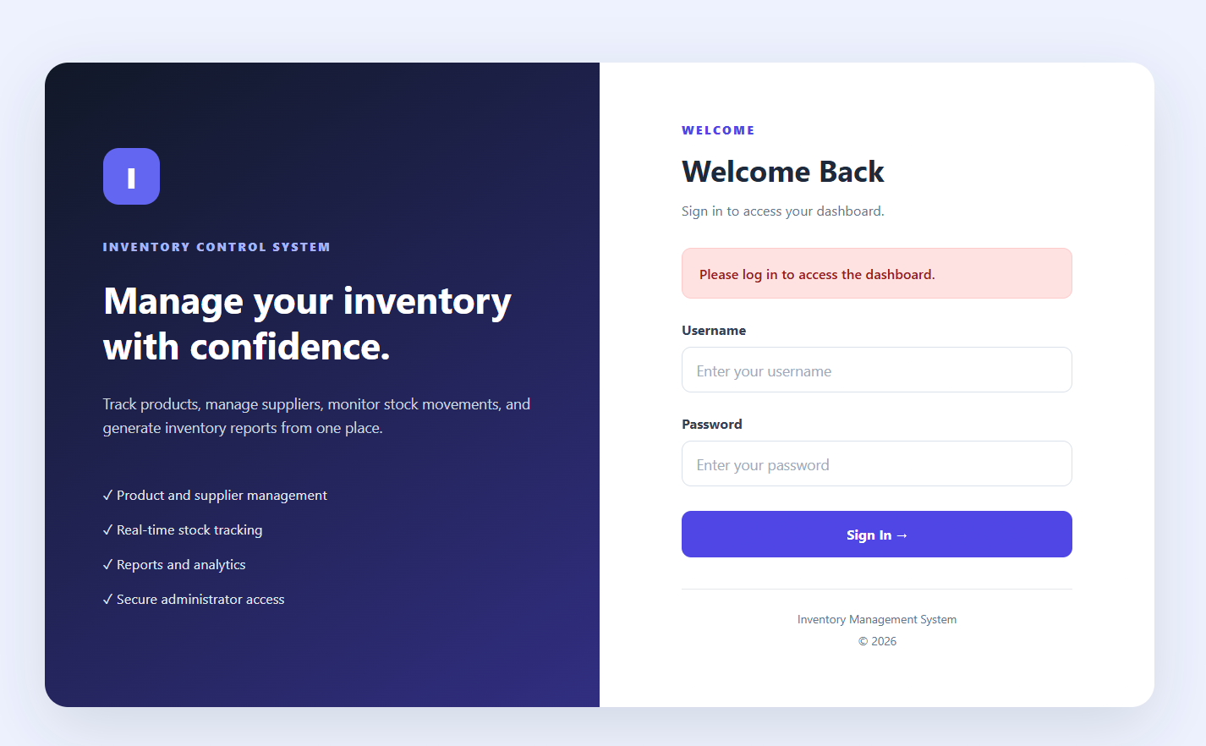
Figure 1 – Login / Initial Setup
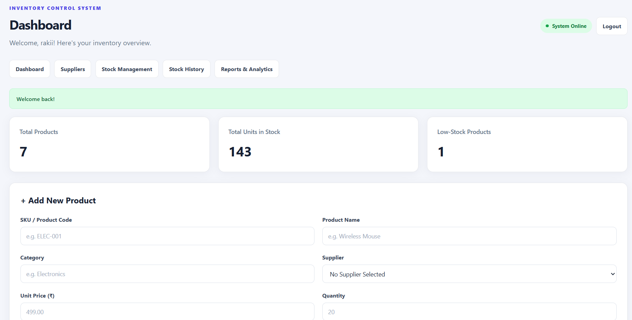
Figure 2 – Inventory Dashboard/Add Product
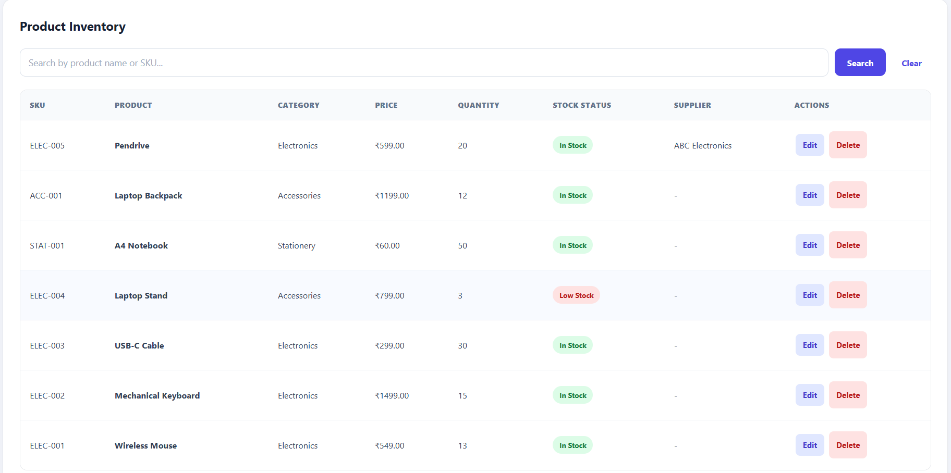
Figure 3 – Product Inventory

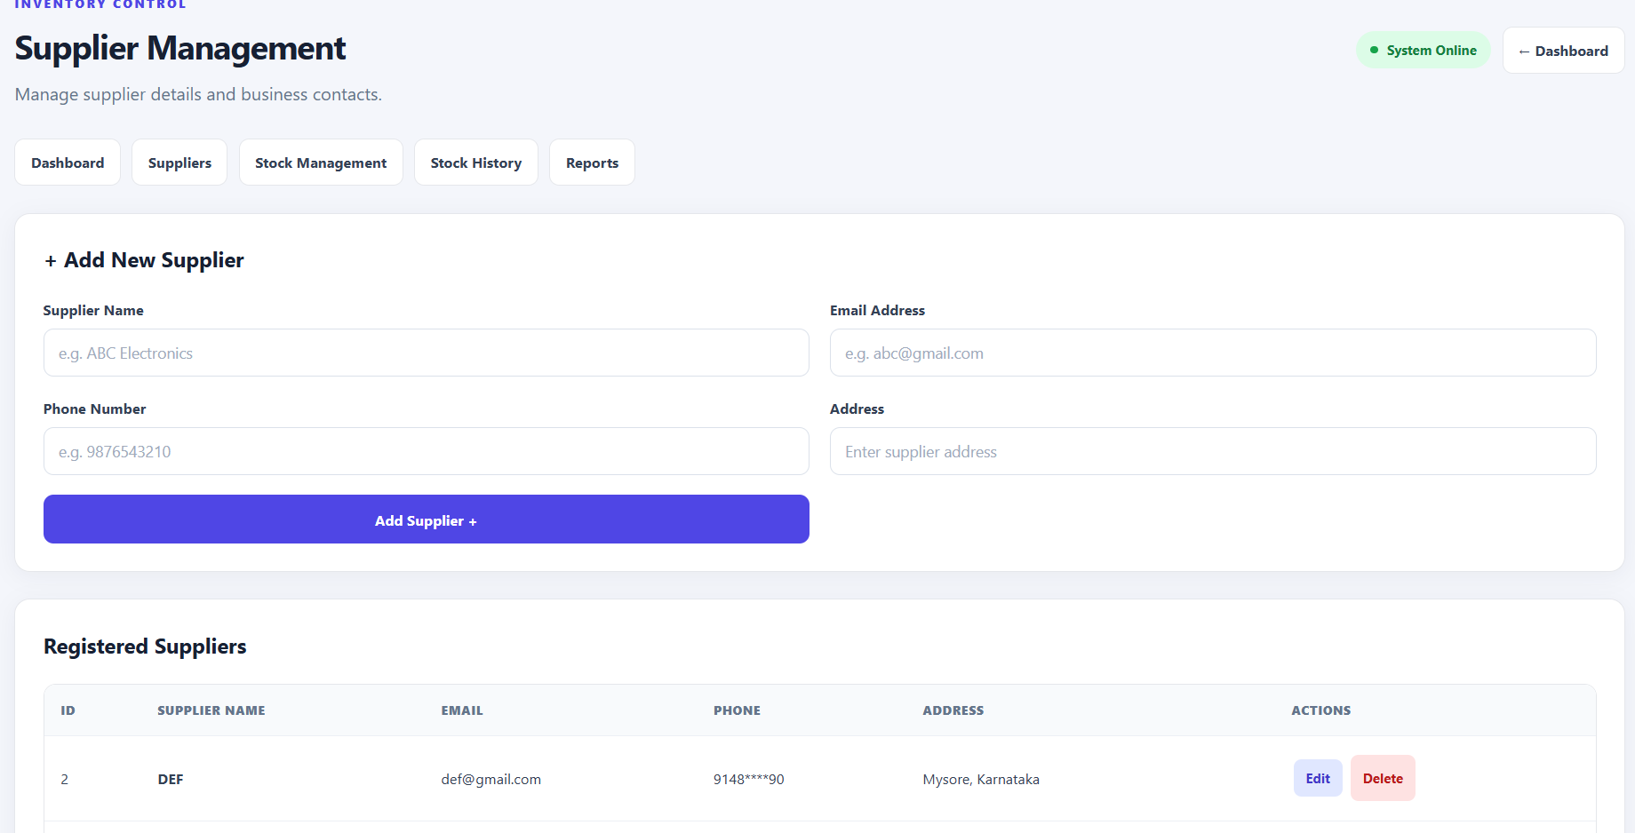
Figure 4 – Supplier Management
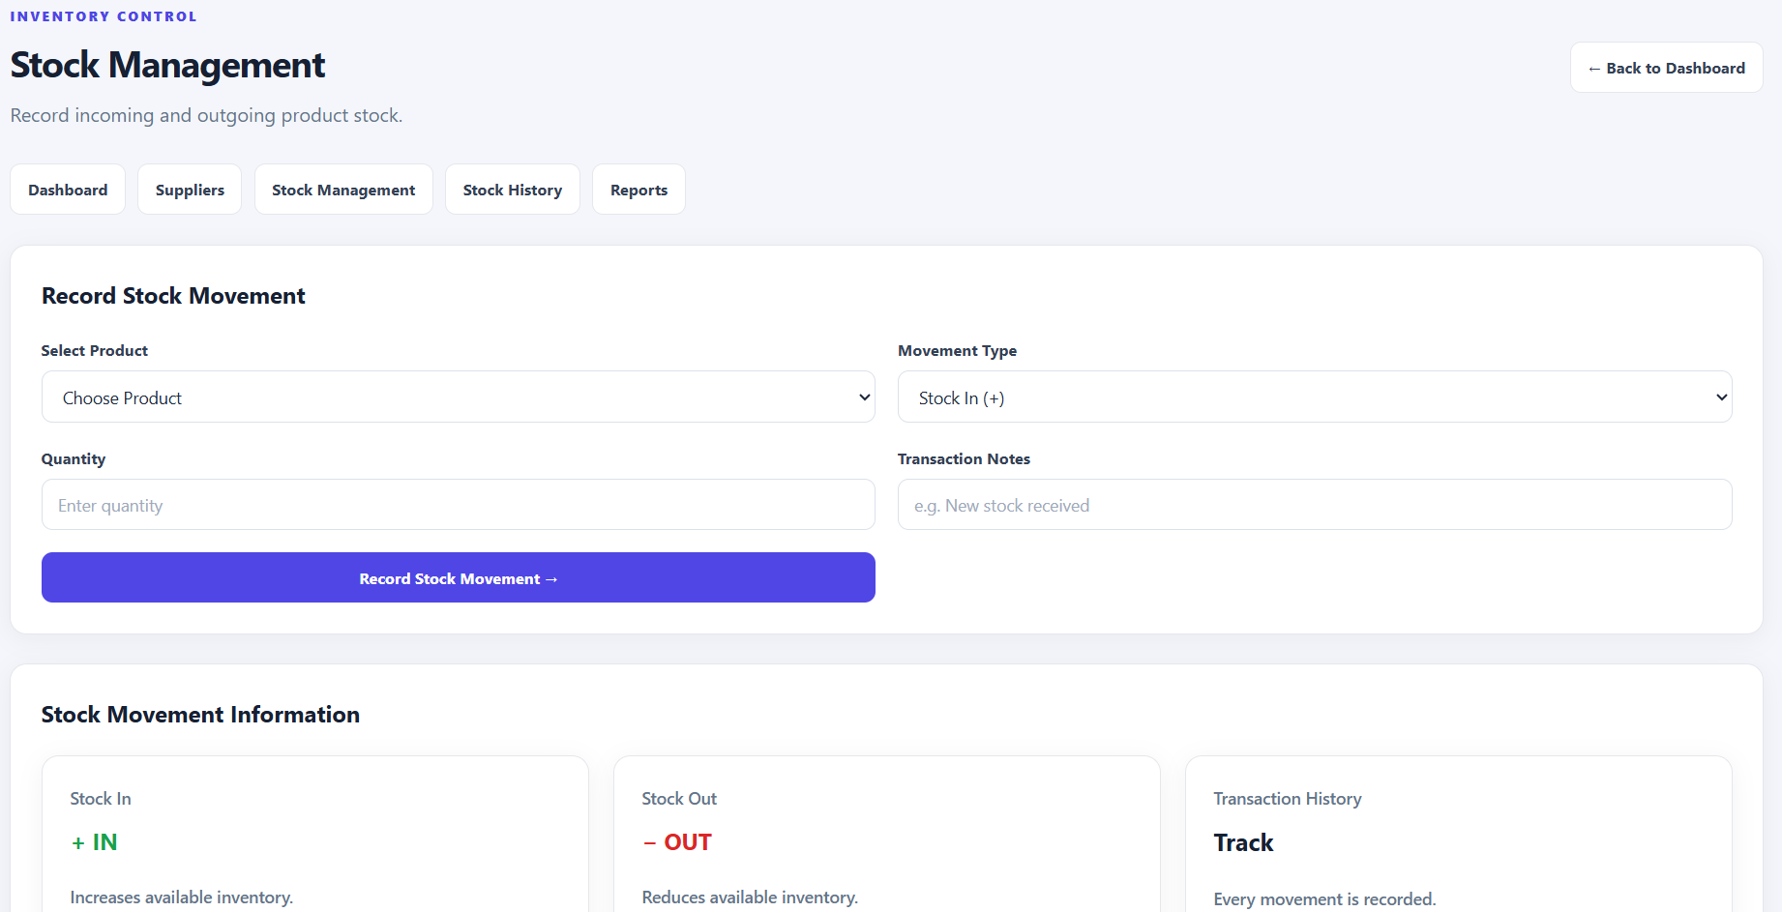
Figure 5 – Stock Management

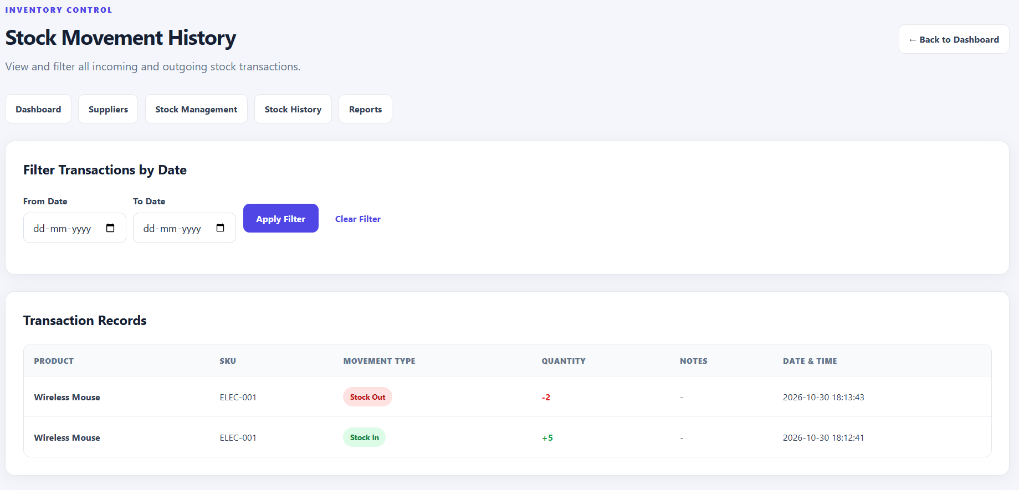
Figure 6 – Stock History
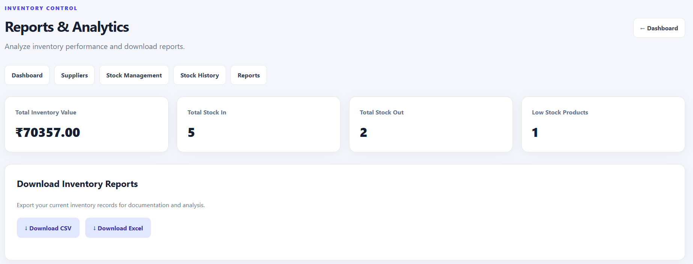
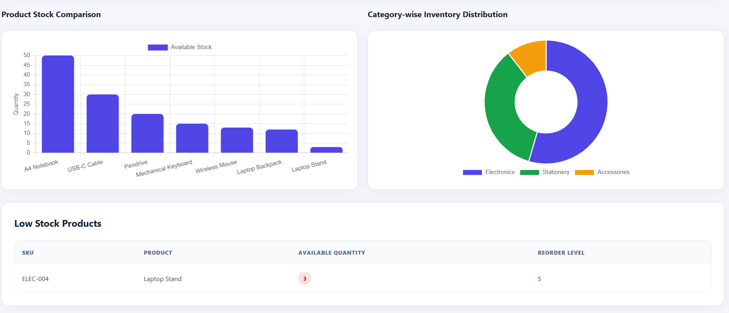
Figure 7 – Reports

24. Advantages
- Centralizes product, supplier and stock information.
- Reduces repetitive manual record-keeping.
- Provides product search and organized listings.
- Maintains stock-in and stock-out transaction history.
- Helps identify low-stock products using reorder levels.
- Provides inventory summaries and report exports.
- Uses a modular structure that can be extended.

25. Limitations
- The current application uses a local SQLite database and is not yet deployed as a public cloud website.
- The current schema does not isolate inventory records by independently registered administrator account.
- The local Flask development server is not intended for production hosting.
- Access from other devices requires network configuration or cloud deployment.
- Barcode scanning, purchase workflows and role-based staff permissions are not currently included.

26. Future Scope
- Deploy the Flask application to cloud hosting for access through a public URL.
- Migrate production data from local SQLite to persistent hosted PostgreSQL.
- Implement data ownership so each administrator has a separate inventory.
- Enforce account-specific access on every server-side database operation.
- Add staff accounts and role-based permissions under each administrator.
- Add barcode / QR-code scanning, purchase orders, sales records and invoice generation.
- Improve analytics with comparisons, downloadable PDF reports and low-stock alerts.

27. Conclusion
The Inventory Management System demonstrates how a web application can simplify common inventory activities by combining product management, supplier records, stock transactions, history and reporting in one interface. Python and Flask provide the application logic, SQLite stores the records, and HTML/CSS provide the user interface. The project establishes a functional foundation for maintaining inventory information and reviewing stock changes. It also provides a clear path for future improvements, including cloud deployment, persistent hosted storage and secure separation of inventory data between independently registered administrators. The current implementation meets the core objectives of a small inventory management application while leaving room for additional features and scalability.

