**Interactive Multimedia**

**Programming 2. Assignment set**

**Responsive Web Design and stuff**

**1. RWD:**

**Responsive web design (RWD) is one of the trendiest technology buzz words in web development. The terms was originally introduced in Ethan Marcotte’s A List Apart article** [**http://alistapart.com/article/responsive-web-design**](http://alistapart.com/article/responsive-web-design) **.**

**1. Read the article carefully**

**2. Review also all the examples in the article. Review the code and see how the responsiveness develops between different versions.**

**Answer to following questions:**

**• What is the purpose of the RWD? Why it is used? How things are done before RWD? What is the difference?**

Different devices are used to view the same websites, it is not practicable to make different webpages for different devices. So, the purpose of RWD is to serve same HTML to all devices using CSS.

**• How css media queries can help you building responsive web sites?**

We can display the HTML pages according to the size of width of the web browser with the help of css media queries. This helps to build responsive web sites.

For example: if our website is need to be browsed from devices whose browser width is less that 620px, css should contain following media queries:

@media screen and (max-device-width: 620px)

{

/* codes */

}

**• Why to use em (font) based sizing for example margins?**

It is because using em makes everything proportional and user have better view from any width of browser which makes our HTML responsive.

**2. RWD Examples:**

**See few RWD examples. Test how different screen sizes works in desktop browser. Test also sites on mobiles.**

**• https:/**[**/www.bostonglobe.com/**](http://www.bostonglobe.com/) **(Ethan Marcotte works here)**

**• This site lists good examples of sites which uses media queries, test few from here:** [**http://mediaqueri.es/**](http://mediaqueri.es/)

**Take screenshots of the sites on different devices and screen sizes.**

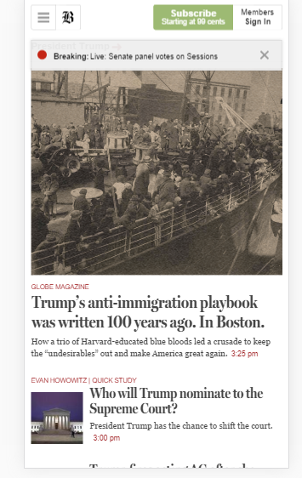

**(Img: Iphone 6 plus browser)**

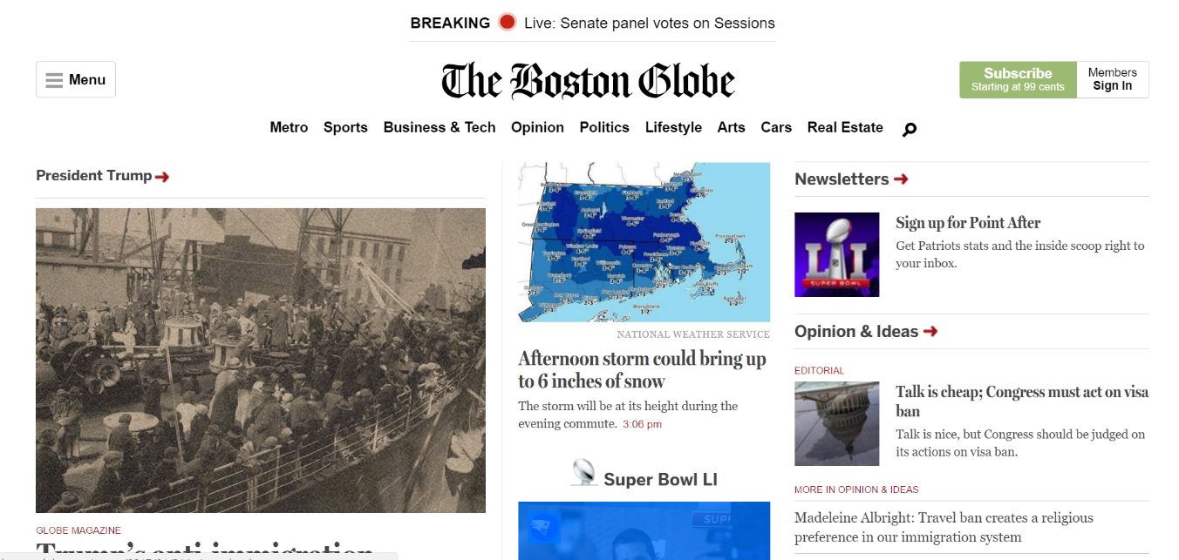

**(Img: PC browser)**

**3. RWD in practice**

**Create a simple responsive web page where nothing is defined as pixels. Use CSS-reset** [**(http://cssreset.com/what-is-a-css-reset/**](http://cssreset.com/what-is-a-css-reset/)**), and remember to follow coding conventions. Styles must be stored in separate .css files.**

**Here are few screenshots you should follow:**

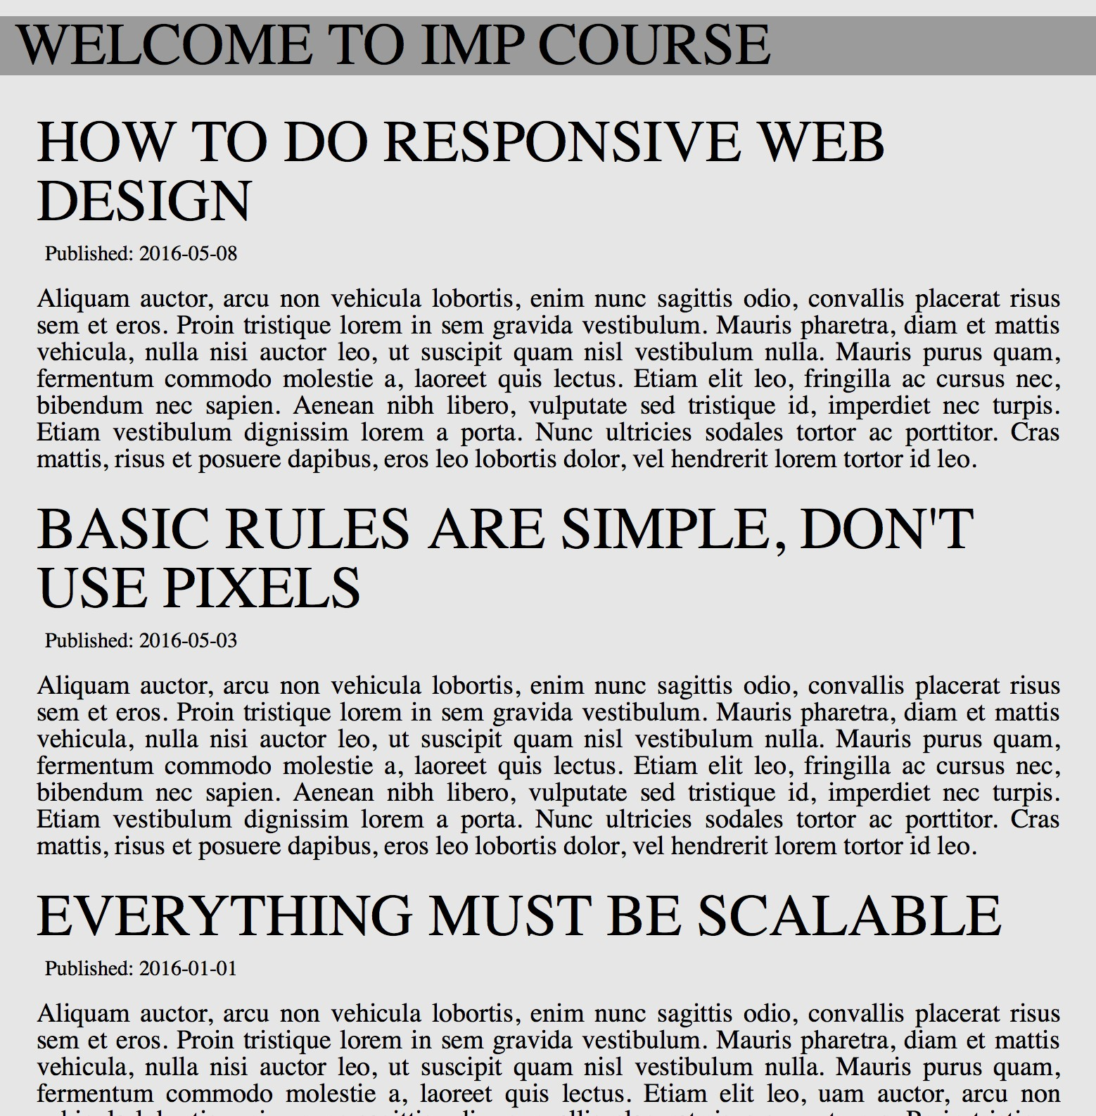

**Same page in desktop browser and in mobile browser**

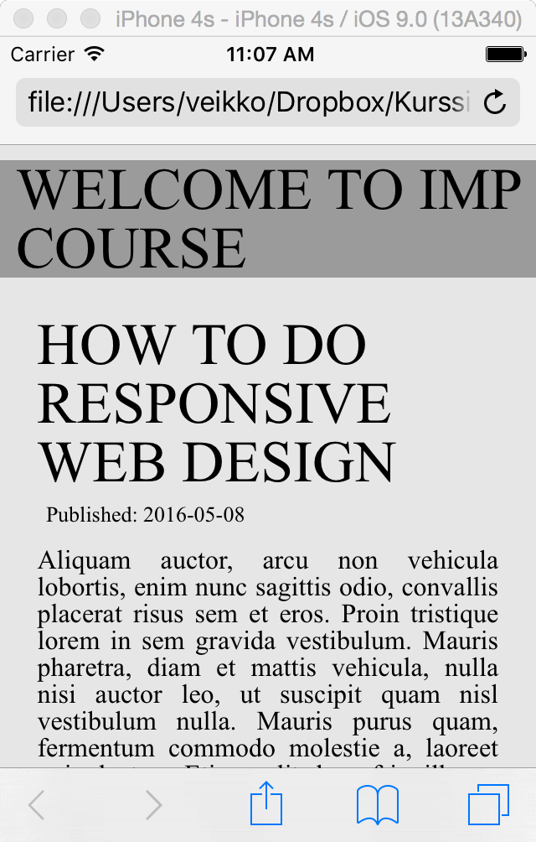

**No horizontal scroll! No media queries**

**used!**

**If you have problems on mobile (in scaling), read this article:**

**https://developer.mozilla.org/en/docs/Mozilla/Mobile/Viewport_meta_tag**

**After you have done the basic layout, how could you prevent user zooming the site on mobile?**

<meta name="viewport" content="width=device-width, initial-scale=1, maximum-scale=1, user-scalable=0">

The initial-scale property controls the zoom level when the page is first loaded. The maximum-scale, minimum-scale, and user-scalable properties control how users are allowed to zoom the page in or out.

**4. Running your stuff inside web server (locally)**

**Install express to your Node.js environment. It is simple web server. Follow instructions from here:**

[**http://expressjs.com/en/starter/installing.html**](http://expressjs.com/en/starter/installing.html) **and from here:**

[**http://expressjs.com/en/guide/routing.html**](http://expressjs.com/en/guide/routing.html)

**5. Adding stuff**

**a. Create a copy of previous task.**

**b. Add a menu to it. Menu should be on the left side of the screen on wide screen, but on the top on mobile portrait screen. See the figures below:**

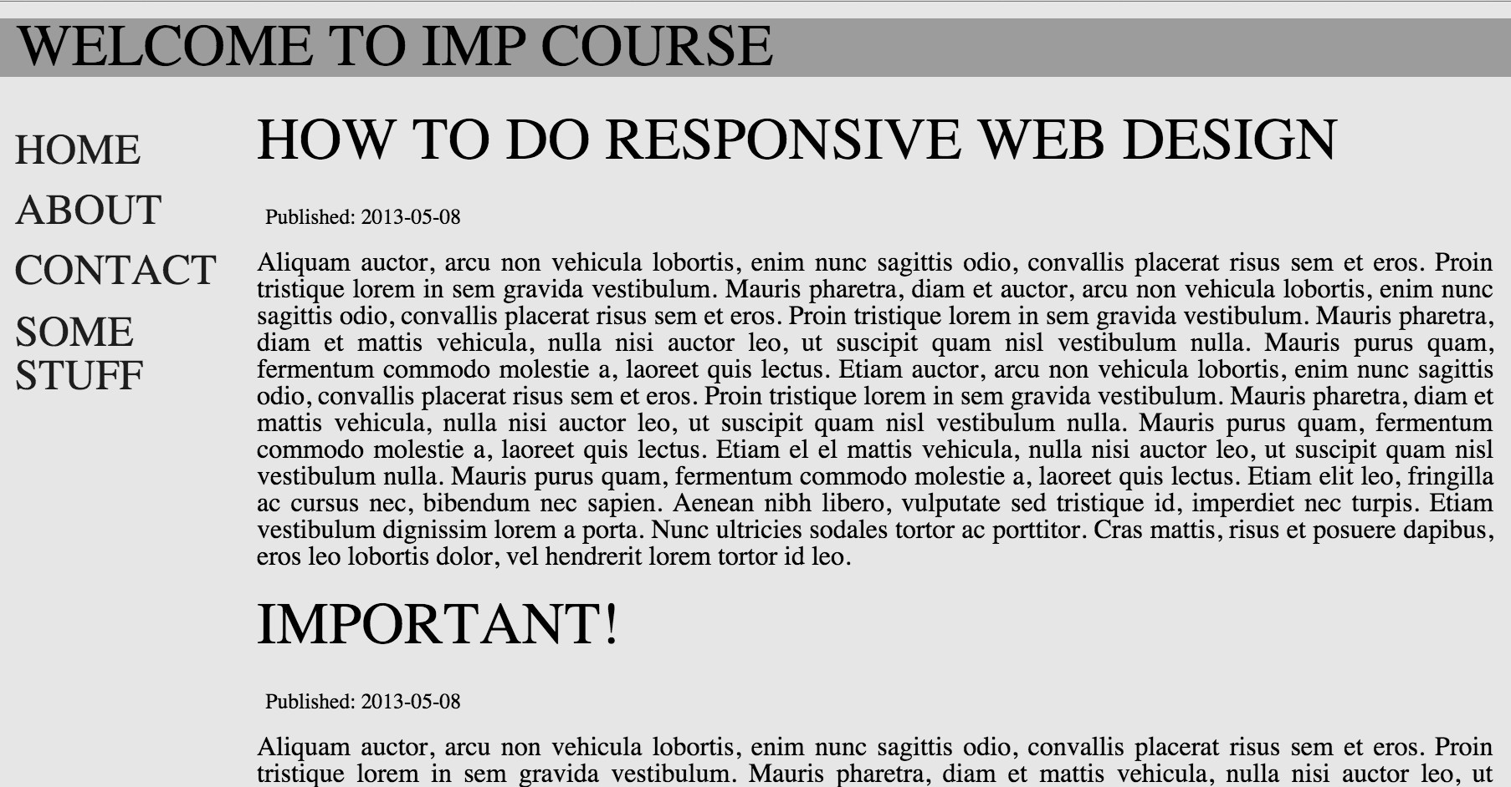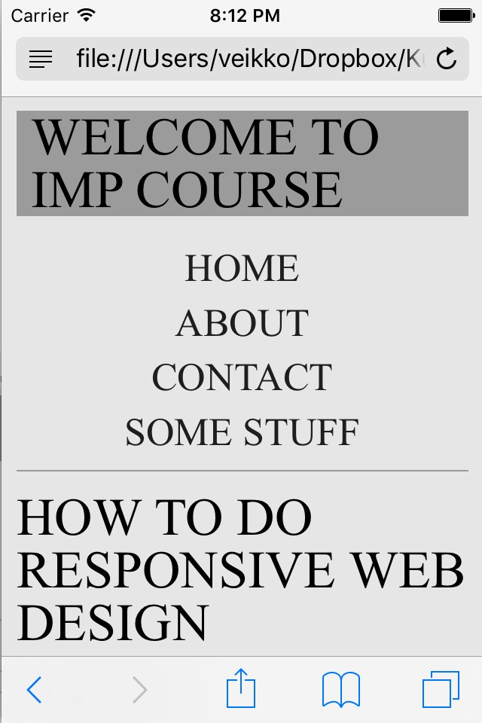

**c. HTML5 specification introduces new semantic elements. One of them is a <figure> element. Can you say why you should use it in addition to standard <img> elements?**

The <figure> tag provides a container for content that is equivalent to a figure or diagram in a book. Also, it can be used to group a caption with one or more images, a block of code or other content.

**d. Add few figure elements to previous assignment. Images should scale keeping their aspect ratio based on the width of the document. See examples:**

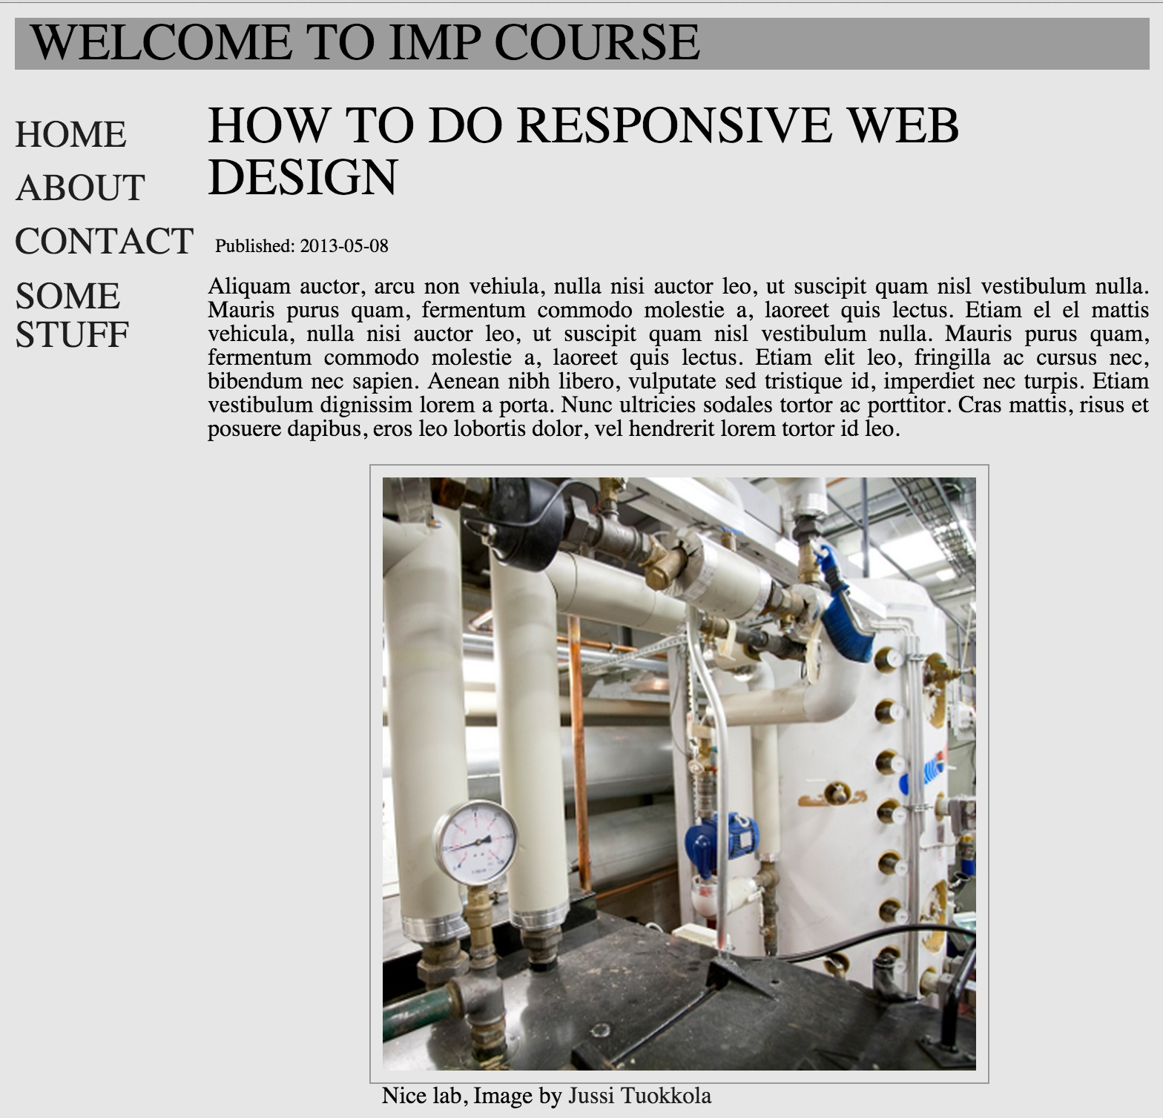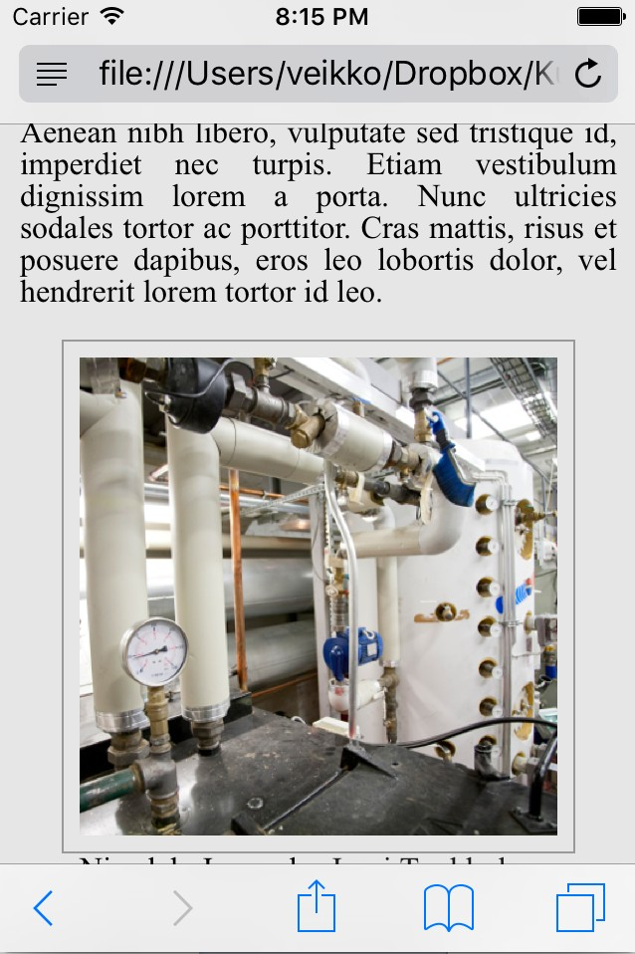

**6. Responsive person list**

**Create a copy of last week’s person list project. Make it responsive!**