K kl

**Microservices**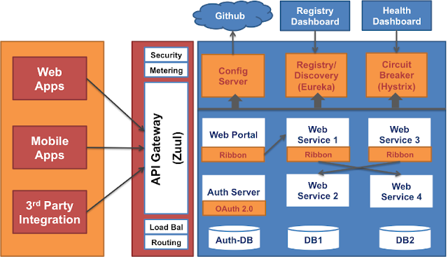

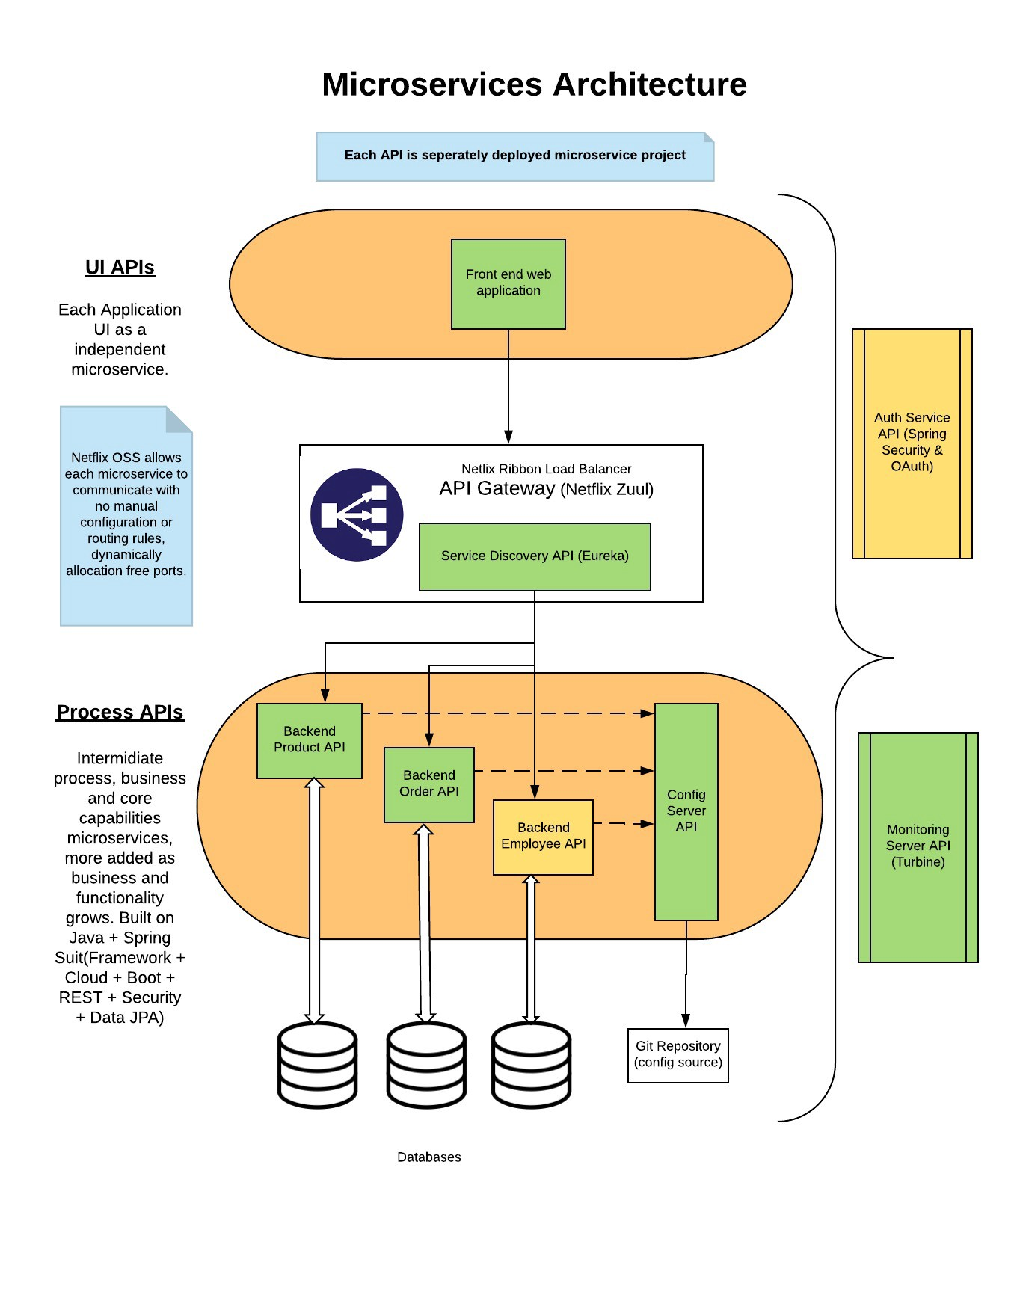

**Q1. List down the advantages of Microservices Architecture.**

|  |  |
| --- | --- |
| **Advantages of Microservices Architecture** | |
| **Advantage** | **Description** |
| ***Independent Development*** | All microservices can be easily developed based on their individual functionality |
| ***Independent Deployment*** | Based on their services, they can be individually deployed in any application |
| ***Fault Isolation*** | Even if one service of the application does not work, the system still continues to function |
| ***Mixed Technology Stack*** | Different languages and technologies can be used to build different services of the same application |
| ***Granular Scaling*** | Individual components can scale as per need, there is no need to scale all components together |

## Microservices vs. Monolithic Architecture

|  |  |
| --- | --- |
| **Microservices** | **Monolithic Architecture** |
| Every unit of the entire application should be the smallest, and it should be able to deliver one specific business goal. | A single code base for all business goals |
| Service Startup is relatively quick | Service startup takes more time |
| Fault isolation is easy. Even if one service goes down, other can continue to function. | Fault isolation is difficult. If any specific feature is not working, the complete system goes down. In order to handle this issue, the application needs to re-built, re-tested and also re-deployed. |
| All microservices should be loosely coupled so that changes made in one does not affect the other. | Monolithic architecture is tightly coupled. Changes in one module of code affect the other |
| Businesses can deploy more resources to services that are generating higher ROI | Since services are not isolated, individual resource allocation not possible |
| More hardware resources could be allocated to the service that is frequently used. In the e-commerce example above, more number of users check the product listing and search compared to payments. So, more resources could be allocated to the search and product listing microservice. | Application scaling is challenging as well as wasteful. |
| Microservices always remains consistent and continuously available. | Development tools get overburdened as the process needs to start from the scratch. |
| Data is federated. This allows individual Microservice to adopt a data model best suited for its needs. | Data is centralized. |
| Small Focused Teams. Parallel and faster development | Large team and considerable team management effort is required |
| Change in the data model of one Microservice does not affect other Microservices. | Change in data model affects the entire database |
| Interacts with other microservices by using well-defined interfaces | Not applicable |
| Microservices work on the principle that focuses on products, not projects | Put emphasize on the entire project |
| No cross-dependencies between code bases. You can use different technologies for different Microservices. | One function or program depends on others. |

## Microservice Challenges

* MicroServices rely on each other, and they will have to communicate with each other.
* Compared to monolithic systems, there are more services to monitor which are developed using different programming languages.
* As it is a distributed system, it is an inherently complex model.
* Different services will have its separate mechanism, resulting in a large amount of memory for an unstructured data.
* Effective management and teamwork required to prevent cascading issues
* Reproducing a problem will be a difficult task when it's gone in one version, and comes back in the latest version.
* Independent Deployment is complicated with Microservices.
* Microservice architecture brings plenty of operations overhead.
* It is difficult to manage application when new services are added to the system
* A wide array of skilled professionals is required to support heterogeneously distributed microservices
* Microservice is costly, as you need to maintain different server space for different business tasks.

|  |  |  |
| --- | --- | --- |
| **Parameter** | **SOA** | **Microservices** |
| Design type | In SOA, software components are exposed to the outer world for usage in the form of services. | Micro Service is a part of SOA. It is an implementation of SOA. |
| Dependency | Business units are dependent. | They are independent of each other. |
| Size of the Software | Software size is larger than any conventional software | The size of the Software is always small in Microservices |
| Technology Stack | The technology stack is lower compared to Microservice. | Microservice technology stack could be very large |
| Nature of the application | Monolithic in nature | Full stack in nature |
| Independent and Focus | SOA applications are built to perform multiple business tasks. | They are built to perform a single business task. |
| Deployment | The deployment process is time- consuming. | Deployment is straightforward and less time-consuming. |
| Cost - effectiveness | More cost-effective. | Less cost-effective. |
| Scalability | Less compared to Microservices. | Highly scalable. |
| Business logic | Business logic components are stored inside of single service domain Simple wire protocols(HTTP with XML JSON) API is driven with SDKs/Clients | Business logic can live across domains enterprise Service Bus like layers between services Middleware |

**Q2. What do you know about Microservices?**

* **Microservices**, aka ***Microservice Architecture***, is an architectural style that structures an application as a collection of small autonomous services, modeled around a **business domain.**
* In layman terms, you must have seen how bees build their honeycomb by aligning hexagonal wax cells.
* They initially start with a small section using various materials and continue to build a large beehive out of it.
* These cells form a pattern resulting in a strong structure which holds together a particular section of the beehive.
* Here, each cell is independent of the other but it is also correlated with the other cells.
* This means that damage to one cell does not damage the other cells, so, bees can reconstruct these cells without impacting the complete beehive.

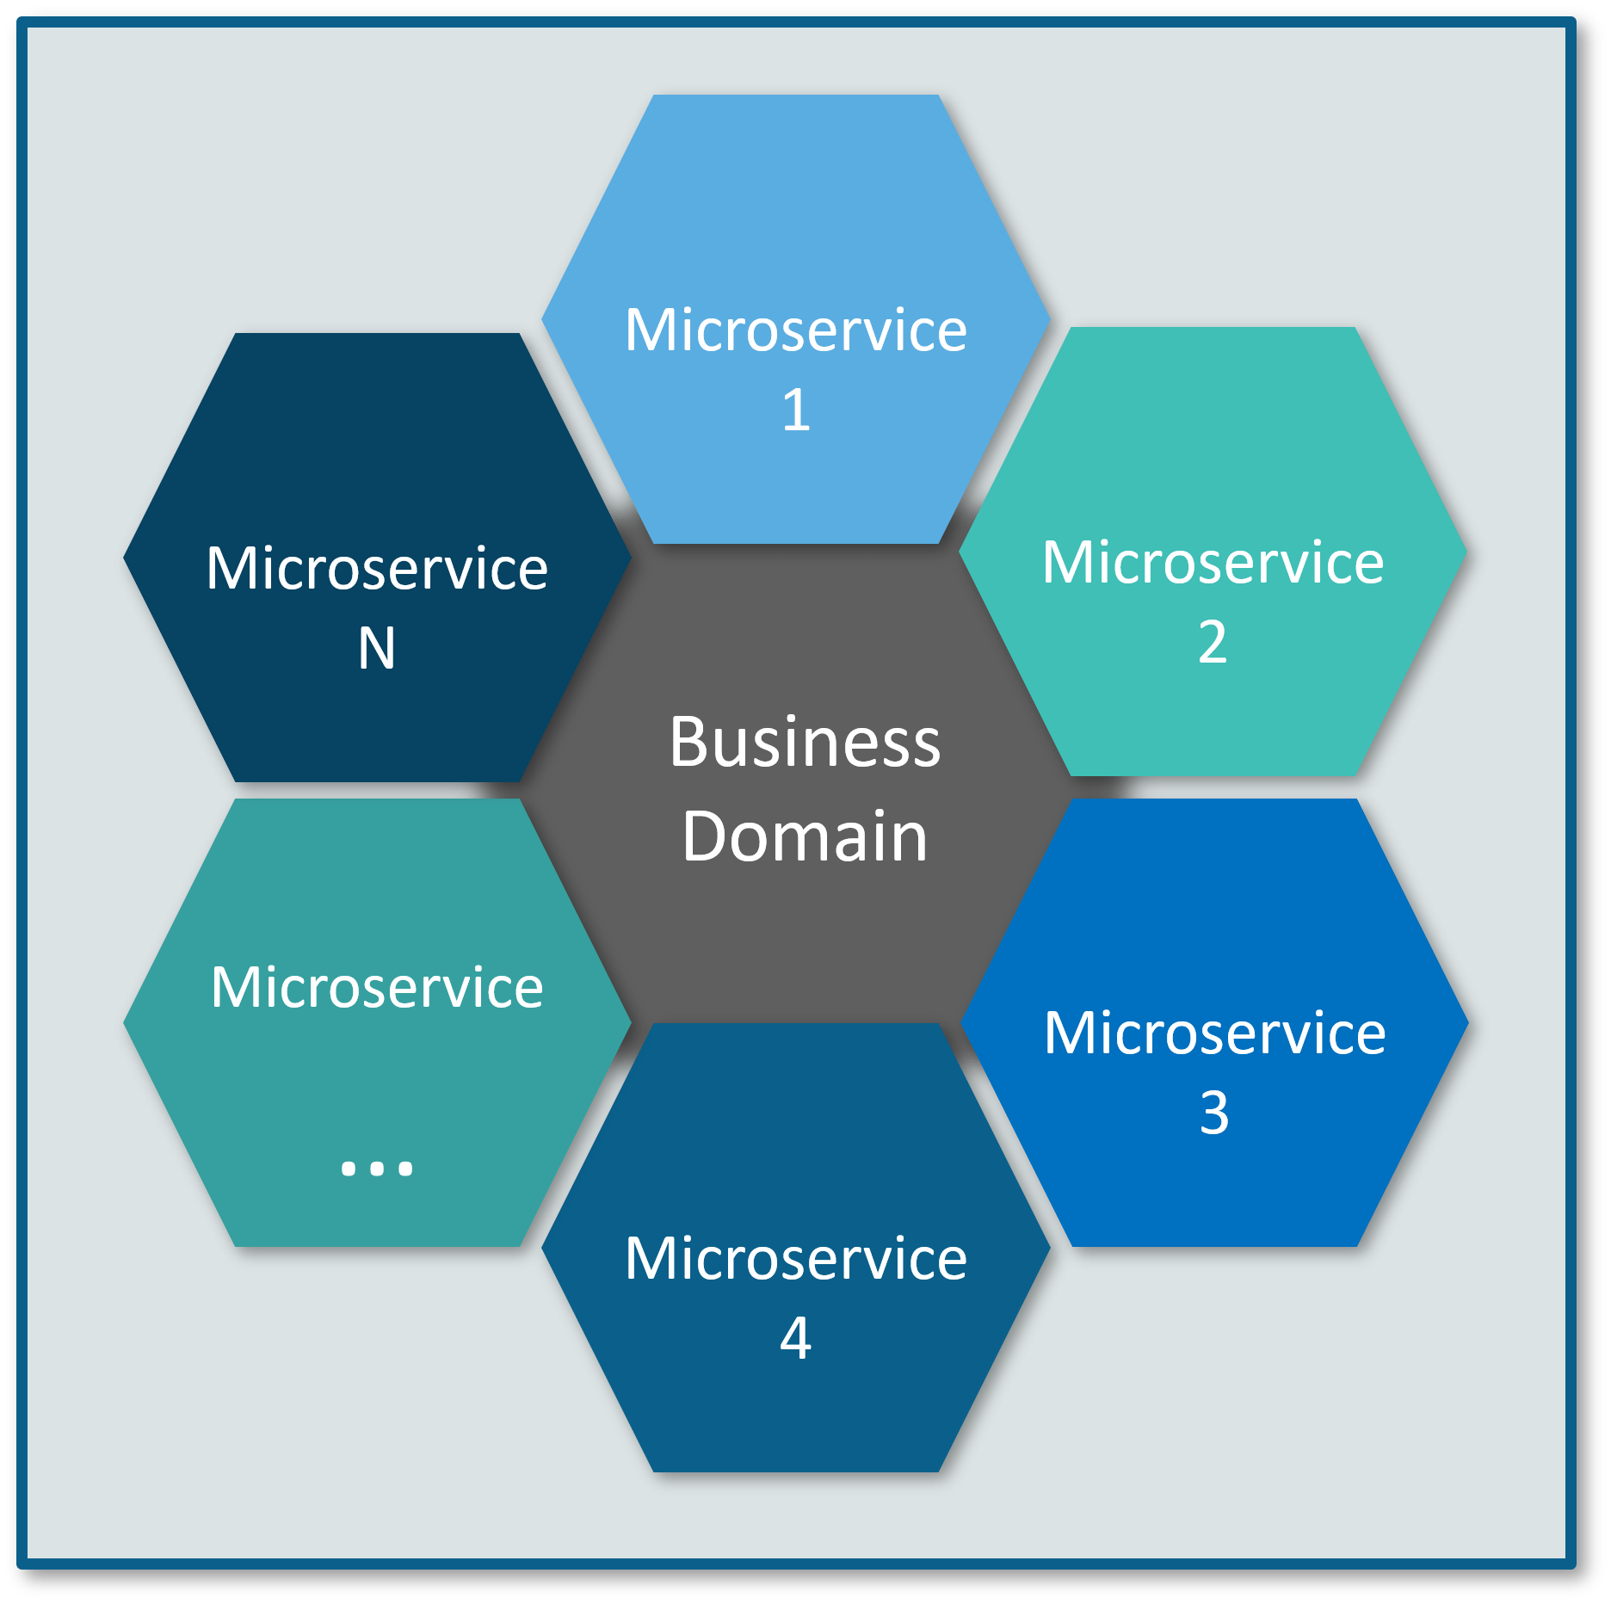

**Fig 1:** Beehive Representation of Microservices – Microservices Interview Questions

Refer to the above diagram. Here, each hexagonal shape represents an individual service component. Similar to the working of bees, each agile team builds an individual service component with the available frameworks and the chosen technology stack. Just as in a beehive, each service component forms a strong microservice architecture to provide better scalability. Also, issues with each service component can be handled individually by the agile team with no or minimal impact on the entire application.

**Q3. What are the features of Microservices?**

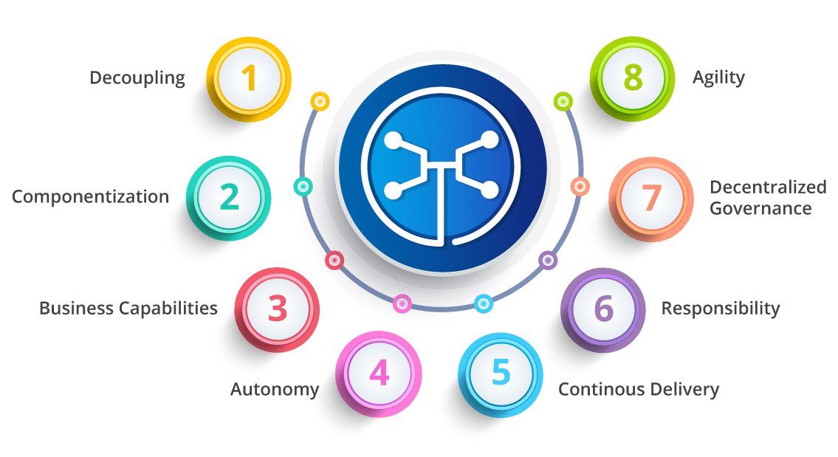

**Fig 3:**Features of Microservices – Microservices Interview Questions

* **Decoupling** – Services within a system are largely decoupled. So the application as a whole can be easily built, altered, and scaled
* **Componentization** – Microservices are treated as independent components that can be easily replaced and upgraded
* **Business Capabilities** – Microservices are very simple and focus on a single capability
* **Autonomy** – Developers and teams can work independently of each other, thus increasing speed
* **Continuous Delivery** – Allows frequent releases of software, through systematic automation of software creation, testing, and approval
* **Responsibility** – Microservices do not focus on applications as projects. Instead, they treat applications as products for which they are responsible
* **Decentralized Governance** – The focus is on using the right tool for the right job. That means there is no standardized pattern or any technology pattern. Developers have the freedom to choose the best useful tools to solve their problems
* **Agility** – Microservices support agile development. Any new feature can be quickly developed and discarded again

**Q4. What are the best practices to design Microservices?**

The following are the best practices to design microservices:

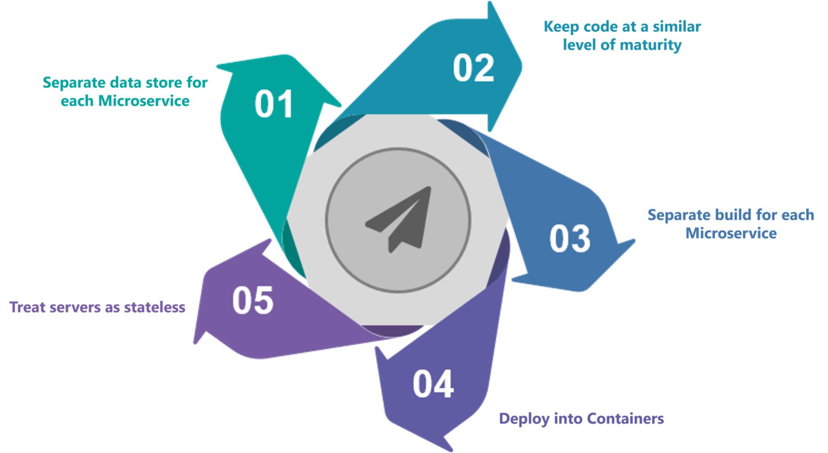

**Fig 4:**Best Practices to Design Microservices – Microservices Interview Questions

**Q5. How does Microservice Architecture work?**

A microservice architecture has the following components:

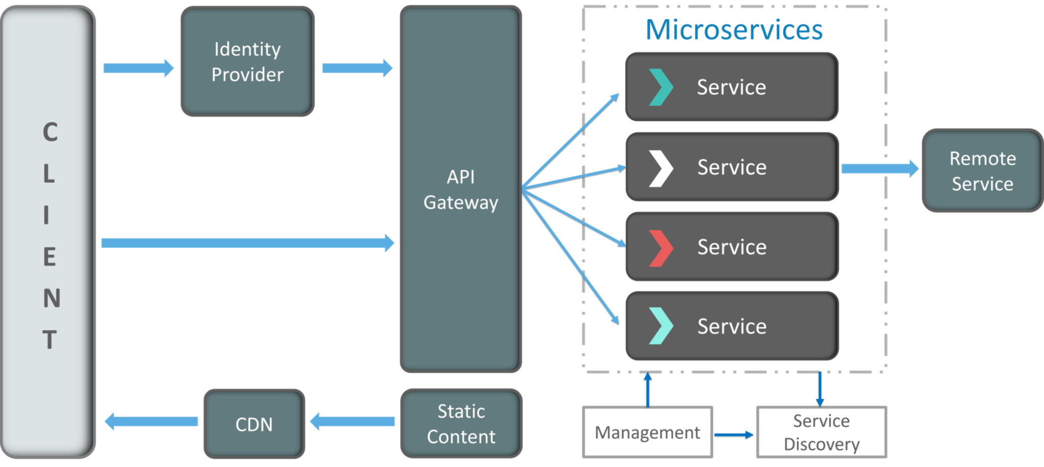

**Fig 5:**Architecture of Microservices – Microservices Interview Questions

* **Clients** – Different users from various devices send requests.
* **Identity Providers** – Authenticates user or clients identities and issues security tokens.
* **API Gateway** – Handles client requests.
* **Static Content** – Houses all the content of the system.
* **Management** –  Balances services on nodes and identifies failures.
* **Service Discovery** – A guide to find the route of communication between microservices.
* **Content Delivery Networks** – Distributed network of proxy servers and their data centers.
* **Remote Service** – Enables the remote access information that resides on a network of IT devices.

**Q6. What are the pros and cons of Microservice Architecture?**

|  |  |
| --- | --- |
| **Pros of Microservice Architecture** | **Cons of Microservice Architecture** |
| Freedom to use different technologies | Increases troubleshooting challenges |
| Each microservices focuses on single capability | Increases delay due to remote calls |
| Supports individual deployable units | Increased efforts for configuration and other operations |
| Allow frequent software releases | Difficult to maintain transaction safety |
| Ensures security of each service | Tough to track data across various boundaries |
| Mulitple services are parallelly developed and deployed | Difficult to code between services |

**Q7. What is the difference between Monolithic, SOA and Microservices Architecture?**

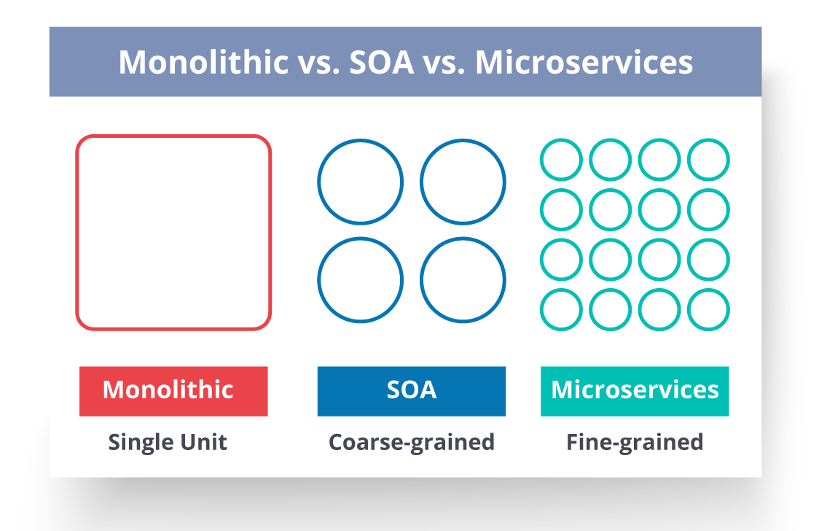

**Fig 6:**Comparison Between Monolithic SOA & Microservices – Microservices Interview Questions

* **Monolithic Architecture** is similar to a big container wherein all the software components of an application are assembled together and tightly packaged.
* A **Service-Oriented Architecture** is a collection of services which communicate with each other. The communication can involve either simple data passing or it could involve two or more services coordinating some activity.
* **Microservice Architecture** is an architectural style that structures an application as a collection of small autonomous services, modeled around a business domain.

**Q8. What are the challenges you face while working Microservice Architectures?**

Developing a number of smaller microservices sounds easy, but the challenges often faced while developing them are as follows.

* **Automate the Components**: Difficult to automate because there are a number of smaller components. So for each component, we have to follow the stages of  Build, Deploy and, Monitor.
* **Perceptibility**: Maintaining a large number of components together becomes difficult to deploy, maintain, monitor and identify problems. It requires great perceptibility around all the components.
* **Configuration Management**: Maintaining the configurations for the components across the various environments becomes tough sometimes.
* **Debugging**: Difficult to find out each and every service for an error. It is essential to maintain centralized logging and dashboards to debug problems.

**Q9. What are the key differences between SOA and Microservices Architecture?**

The key differences between SOA and microservices are as follows:

|  |  |
| --- | --- |
| **SOA** | **Microservices** |
| Follows “**share-as-much-as-possible**” architecture approach | Follows “**share-as-little-as-possible**” architecture approach |
| Importance is on **business functionality** reuse | Importance is on the concept of “**bounded context**” |
| They have **common** **governance** and standards | They focus on **people** **collaboration** and freedom of other options |
| Uses **Enterprise Service bus (ESB)** for communication | Simple messaging system |
| They support **multiple message protocols** | They use **lightweight protocols** such as **HTTP/REST** etc. |
| **Multi-threaded** with more overheads to handle I/O | **Single-threaded** usually with the use of Event Loop features for non-locking I/O handling |
| Maximizes application service reusability | Focuses on **decoupling** |
| **Traditional Relational Databases** are more often used | **Modern Relational Databases**are more often used |
| A systematic change requires modifying the monolith | A systematic change is to create a new service |
| DevOps / Continuous Delivery is becoming popular, but not yet mainstream | Strong focus on DevOps / Continuous Delivery |

**Q10. What are the characteristics of Microservices?**

You can list down the characteristics of microservices as follows:

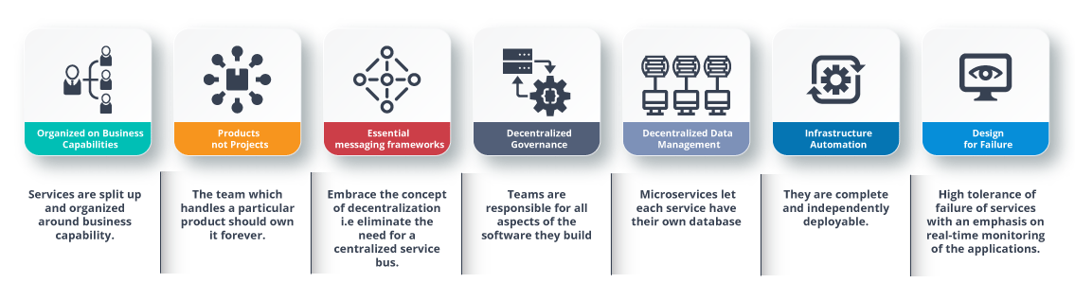

**Fig 7:**Characteristics of Microservices – Microservices Interview Questions

**Q11. What is Domain Driven Design?**

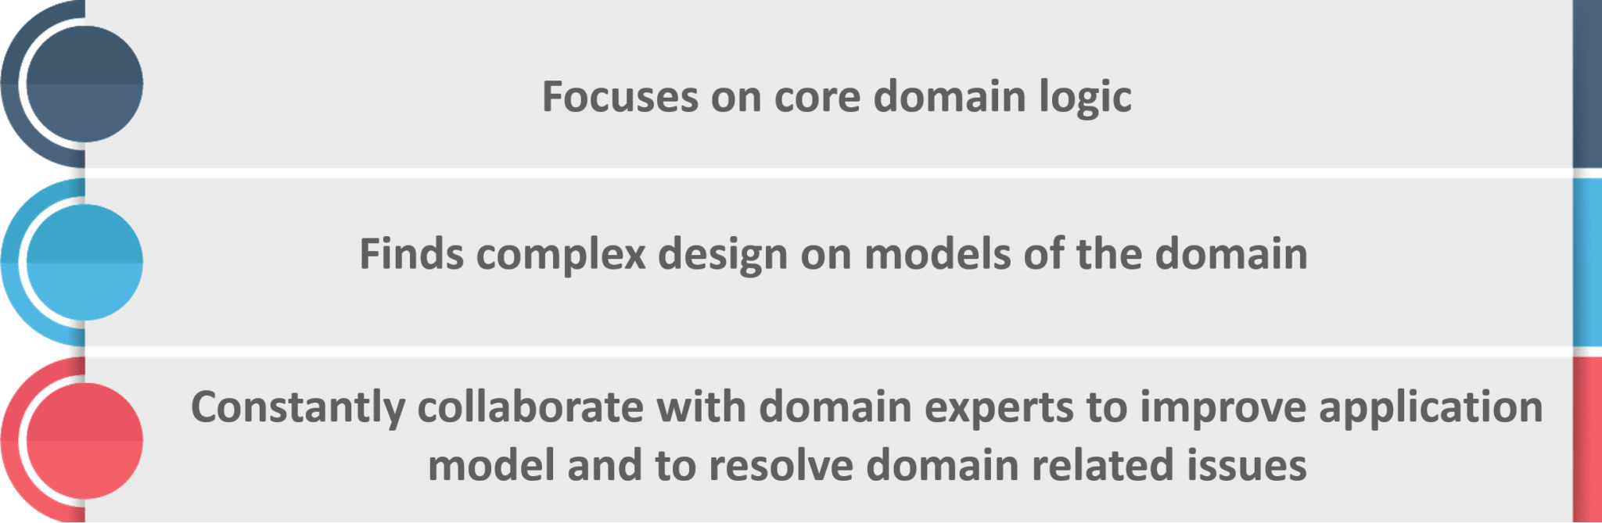

**Fig 8:**Principles of DDD – Microservices Interview Questions

**Q12. Why there is a need for Domain Driven Design (DDD)?**

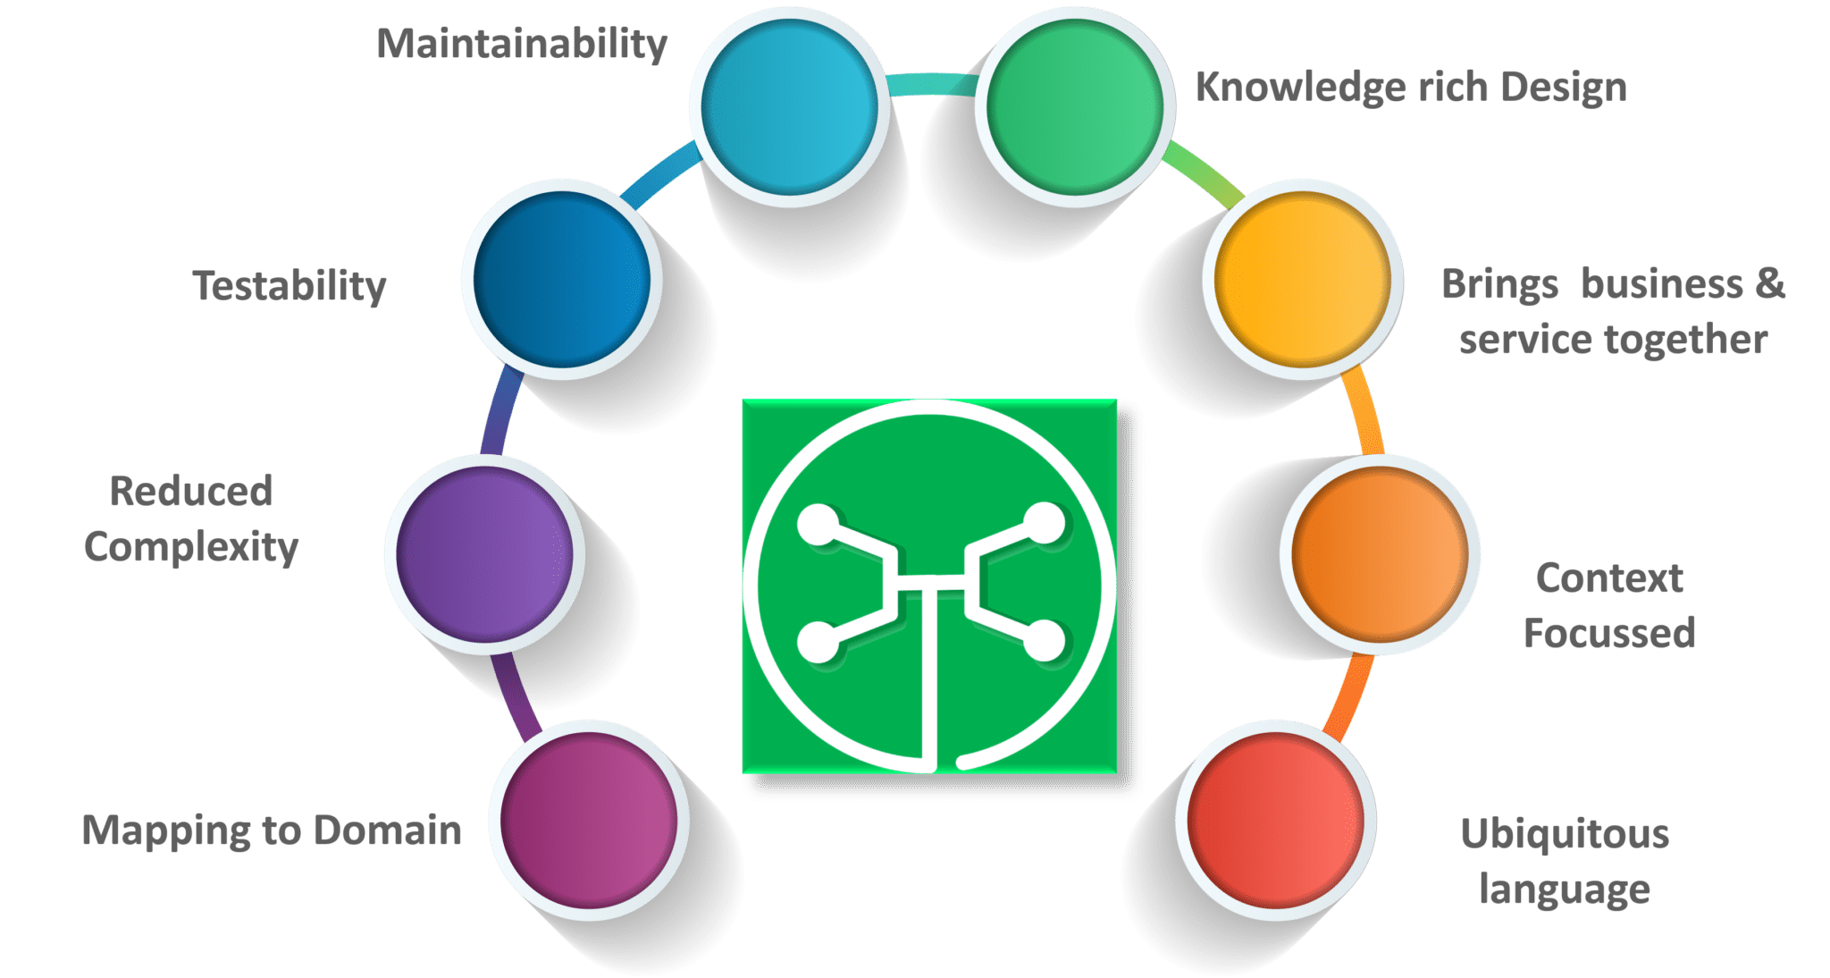

**Fig 9:**Factors Why we need DDD – Microservices Interview Questions

**Q13. What is Ubiquitous language?**

If you have to define the**Ubiquitous Language (UL)**, then it is a common language used by developers and users of a specific domain through which the domain can be explained easily.

The ubiquitous language has to be crystal clear so that it brings all the team members on the same page and also translates in such a way that a machine can understand.

**Q14. What is Cohesion?**

The degree to which the elements inside a module belong together is said to be **cohesion**.

[[](https://www.edureka.co/microservices-architecture-training)](https://www.edureka.co/microservices-architecture-training" \t "_blank)

**[Microservices Architecture Training](https://www.edureka.co/microservices-architecture-training" \t "_blank)**

* *[Instructor-led Sessions](https://www.edureka.co/microservices-architecture-training" \t "_blank)*
* *[Real-life Case Studies](https://www.edureka.co/microservices-architecture-training" \t "_blank)*
* *[Assignments](https://www.edureka.co/microservices-architecture-training" \t "_blank)*
* *[Lifetime Access](https://www.edureka.co/microservices-architecture-training" \t "_blank)*

[Explore Curriculum](https://www.edureka.co/microservices-architecture-training" \t "_blank)

**Q15.  What is Coupling?**

The measure of the strength of the dependencies between components is said to be **coupling**. A good design is always said to have **High Cohesion** and**Low Coupling**.

**Q16.  What is REST/RESTful and what are its uses?**

**Representational State Transfer (REST)/RESTful** web services are an architectural style to help computer systems communicate over the internet. This makes microservices easier to understand and implement.

Microservices can be implemented with or without RESTful APIs, but it’s always easier to build loosely coupled microservices using RESTful APIs.

**Q17. What do you know about Spring Boot?**

It’s a knows fact that spring has become more and more complex as new functionalities have been added. If you have to start a new spring project, then you have to add build path or add maven dependencies, configure application server, add spring configuration. So everything has to be done from scratch.

**Spring Boot** is the solution to this problem. Using spring boot you can avoid all the boilerplate code and configurations. So basically consider yourself as if you’re baking a cake spring is like the ingredients that are required to make the cake and spring boot is the complete cake in your hand.

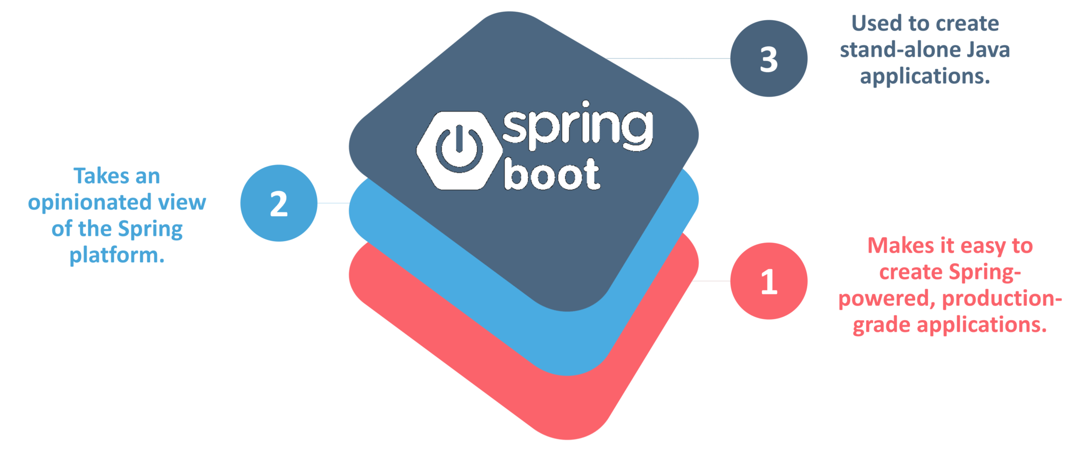

**Fig 10:**Factors of Spring Boot – Microservices Interview Questions

**Q18. What is an actuator in Spring boot?**

Spring Boot actuator provides restful web services to access the current state of running an application in the production environment. With the help of actuator, you can check various metrics and monitor your application.

**Q19. What is Spring Cloud?**

According to the official website of Spring Cloud, Spring Cloud provides tools for developers to quickly build some of the common patterns in distributed systems (e.g. configuration management, service discovery, circuit breakers, intelligent routing, leadership election, distributed sessions, cluster state).

**Q20. What problems are solved by Spring Cloud?**

While developing distributed microservices with Spring Boot we face few issues which are solved by Spring Cloud.

* **The complexity associated with distributed systems –**This includes network issues, Latency overhead, Bandwidth issues, security issues.
* **Ability to handle Service Discovery –**Service discovery allows processes and services in a cluster to find each other and communicate.
* **Solved redundancy issues –**Redundancy issues often occur in distributed systems.
* **Load balancing –**Improves the distribution of workloads across multiple computing resources, such as a computer cluster, network links, central processing units.
* **Reduces performance issues –**Reduces performance issues due to various operational overheads.

**Q21.  What is the use of WebMvcTest annotation in Spring MVC applications?**

**WebMvcTest** annotation is used for unit testing Spring MVC Applications in cases where the test objective is to just focus on Spring MVC Components. In the snapshot shown above, we want to launch only the ToTestController. All other controllers and mappings will not be launched when this unit test is executed.

**Q22. Can you give a gist about Rest and Microservices?**

**REST**

Though you can implement microservices in multiple ways, REST over HTTP is a way to implement Microservices. REST is also used in other applications such as web apps, API design, and MVC applications to serve business data.

**Microservices**

Microservices is an architecture wherein all the components of the system are put into individual components, which can be built, deployed, and scaled individually. There are certain principles and best practices of Microservices that help in building a resilient application.

In a nutshell, you can say that REST is a medium to build Microservices.

**Q23. What are different types of Tests for Microservices?**

While working with microservices, testing becomes quite complex as there are multiple microservices working together. So, tests are divided into different levels.

* At the **bottom level**, we have **technology-facing tests** like- unit tests and performance tests. These are completely automated.
* At the **middle level**, we have tests for **exploratory testing** like the stress tests and usability tests.
* At the **top level,**we have **acceptance tests** that are few in number. These acceptance tests help stakeholders in understanding and verifying software features.

**Q24. What do you understand by Distributed Transaction?**

**Distributed Transaction** is any situation where a single event results in the mutation of two or more separate sources of data which cannot be committed atomically. In the world of microservices, it becomes even more complex as each service is a unit of work and most of the time multiple services have to work together to make a business successful.

**Q25. What is an Idempotence and where it is used?**

**Idempotence** is the property of being able to do something twice in such a way that the end result will remain the same i.e. as if it had been done once only.

**Usage**: Idempotence is used at the remote service, or data source so that, when it receives the instruction more than once, it only processes the instruction once.

**Q26. What is Bounded Context?**

Bounded Context is a central pattern in Domain-Driven Design. It is the focus of DDD’s strategic design section which is all about dealing with large models and teams. DDD deals with large models by dividing them into different Bounded Contexts and being explicit about their inter-relationships.

**Q27. What is Two Factor Authentication?**

Two-factor authentication enables the second level of authentication to an account log-in process.

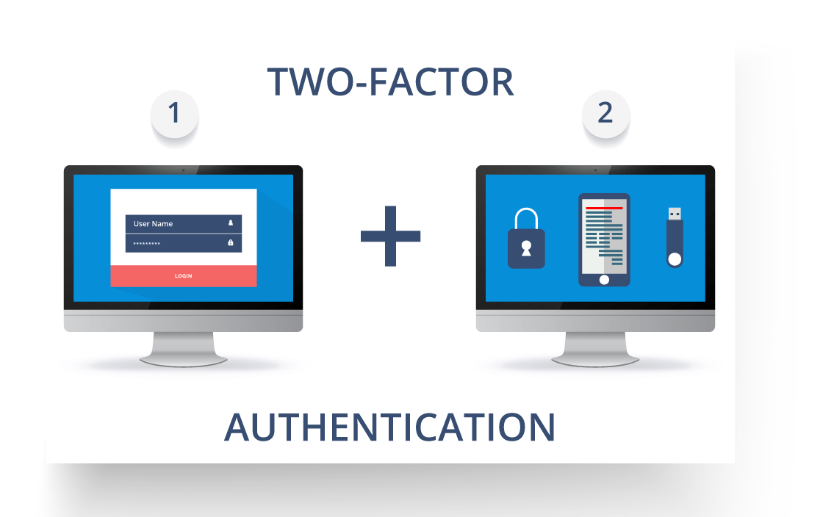

**Fig11:**Representation of Two Factor Authentication – Microservices Interview Questions

So suppose a user has to enter only username and password, then that’s considered a single-factor authentication.

**Q28. What are the types of credentials of Two Factor Authentication?**

The three types of credentials are:

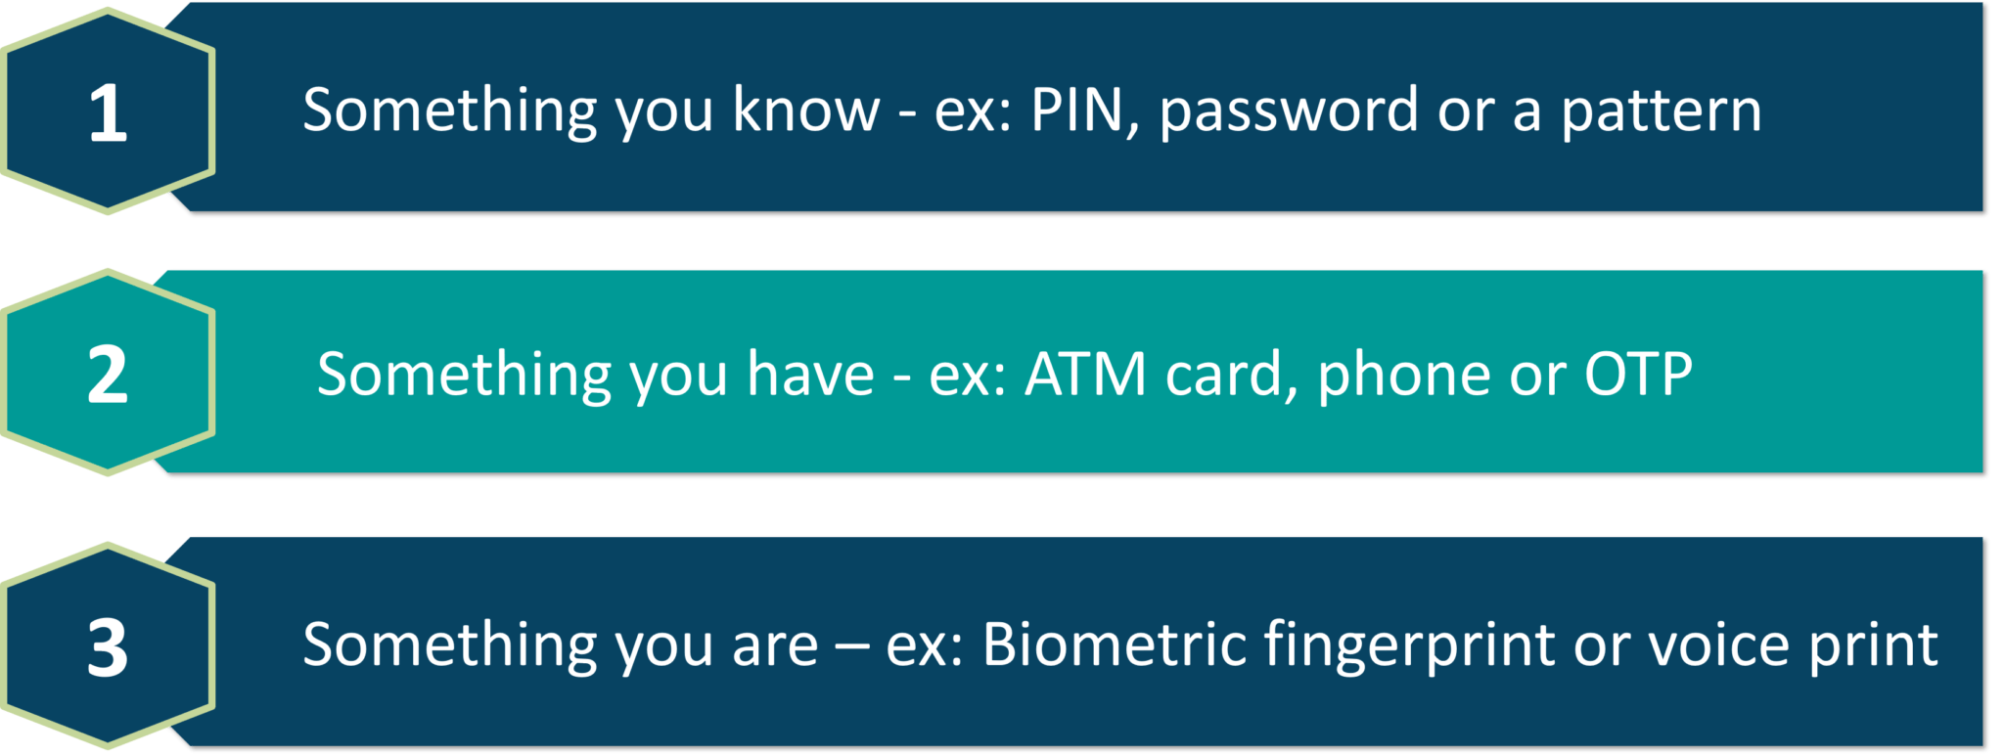

**Fig 12:**Types of Credentials of Two Factor Authentication – Microservices Interview Questions

**Q29. What are Client certificates?**

A type of digital certificate that is used by client systems to make authenticated requests to a remote server is known as the**client certificate**. Client certificates play a very important role in many mutual authentication designs, providing strong assurances of a requester’s identity.

**Q30. What is the use of PACT in Microservices architecture?**

**PACT**is an open source tool to allow testing interactions between service providers and consumers in isolation against the contract made so that the reliability of Microservices integration increases.

**Usage in Microservices:**

* Used to implement Consumer Driven Contract in Microservices.
* Tests the consumer-driven contracts between consumer and provider of a Microservice.

**Q31. What is OAuth?**

**OAuth**stands for open authorization protocol. This allows accessing the resources of the resource owner by enabling the client applications on HTTP services such as third-party providers Facebook, GitHub, etc. So with this, you can share resources stored on one site with another site without using their credentials.

**Cloud Computing Training**

**Q32. What is Conway’s law?**

*“Any organization that designs a system (defined broadly) will produce a design whose structure is a copy of the organization’s communication structure.” –****Mel Conway***

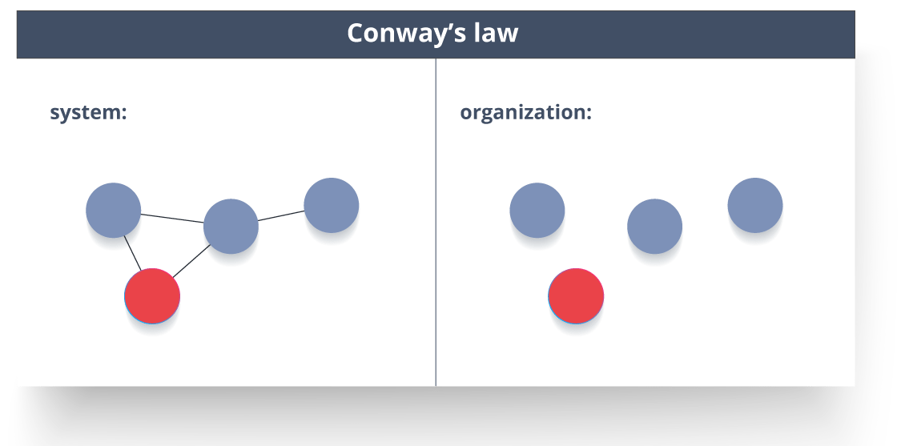

**Fig 13:**Representation of Conway’s Law – Microservices Interview Questions

This law basically tries to convey the fact that, in order for a software module to function, the complete team should communicate well. Therefore the structure of a system reflects the social boundaries of the organization(s) that produced it.

**Q33. What do you understand by Contract Testing?**

According to Martin Flower,**contract test**is a test at the boundary of an external service which verifies that it meets the contract expected by a consuming service.

Also, contract testing does not test the behaviour of the service in depth. Rather, it tests that the inputs & outputs of service calls contain required attributes and the response latency, throughput is within allowed limits.

**Q34. What is End to End Microservices Testing?**

End-to-end testing validates each and every process in the workflow is functioning properly. This ensures that the system works together as a whole and satisfies all requirements.

In layman terms, you can say that end to end testing is a kind of tests where everything is tested after a particular period.

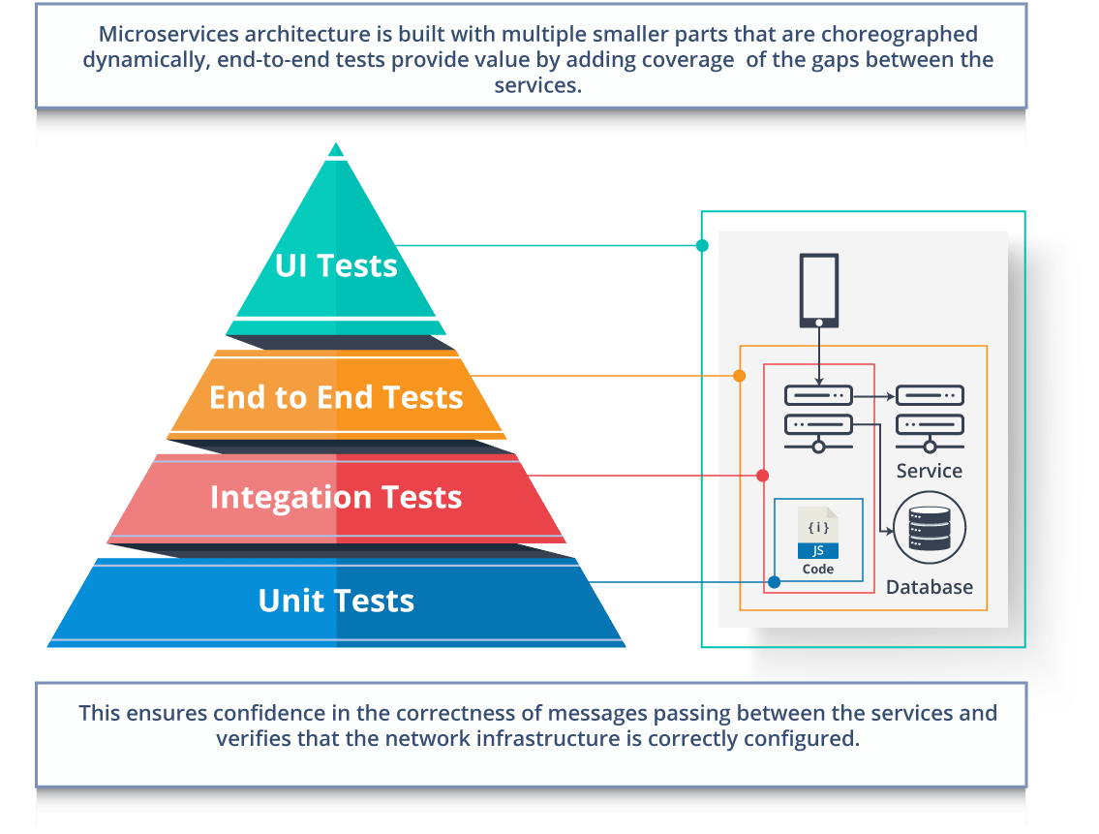

**Fig 14:**Hierarchy of Tests – Microservices Interview Questions

**Q35. What is the use of Container in Microservices?**

Containers are a good way to manage microservice based application to develop and deploy them individually*.* You can encapsulate your microservice in a container image along with its dependencies, which then can be used to roll on-demand instances of microservice without any additional efforts required.

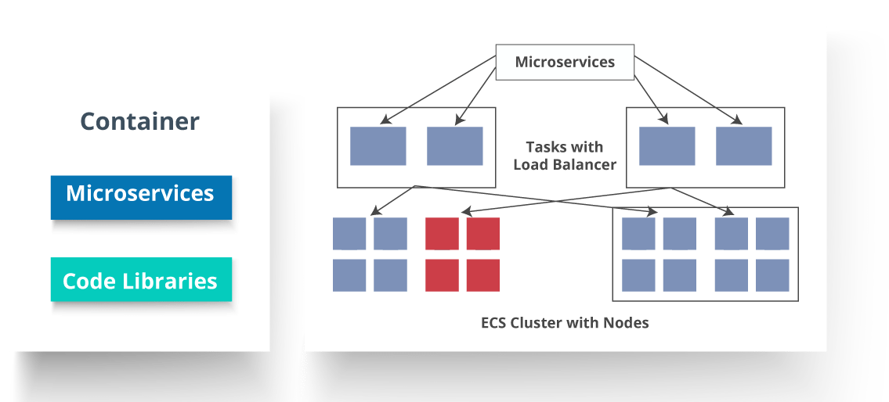

**Fig 15:**Representation of Containers and How they are used in Microservices – Microservices Interview Questions

**Q36. What is DRY in Microservices architecture?**

**DRY** stands for **Don’t Repeat Yourself**. It basically promotes the concept of reusing the code. This results in developing and sharing the libraries which in turn result in tight coupling.

**Q37. What is a Consumer-Driven Contract (CDC)?**

This is basically a pattern for developing Microservices so that they can be used by external systems. When we work on microservices, there is a particular provider who builds it and there are one or more consumers who use Microservice.

Generally, providers specify the interfaces in an XML document. But in Consumer Driven Contract, each consumer of service conveys the interface expected from the Provider.

**Q38**. **What is the role of Web, RESTful APIs in Microservices?**

A microservice architecture is based on a concept wherein all its services should be able to interact with each other to build a business functionality. So, to achieve this, each microservice must have an interface. This makes the web API a very important enabler of microservices. Being based on the open networking principles of the Web, RESTful APIs provide the most logical model for building interfaces between the various components of a microservice architecture.

**Q39. What do you understand by Semantic monitoring in Microservices architecture?**

Semantic monitoring, also known as**synthetic monitoring** combines automated tests with monitoring the application in order to detect business failing factors.

**Q40. How can we perform Cross-Functional testing?**

Cross-functional testing is a verification of non-functional requirements, i.e. those requirements which cannot be implemented like a normal feature.

**Q41. How can we eradicate non-determinism in tests?**

**Non-Deterministic Tests** (NDT)  are basically unreliable tests.  So, sometimes it may happen that they pass and obviously sometimes they may also fail. As and when they fail, they are made to re-run to pass.

Some ways to remove non-determinism from tests are as follows:

1. Quarantine
2. Asynchronous
3. Remote Services
4. Isolation
5. Time
6. Resource leaks

**Q42. What is the difference between Mock or Stub?**

**Stub**

* A dummy object that helps in running the test.
* Provides fixed behaviour under certain conditions which can be hard-coded.
* Any other behaviour of the stub is never tested.

For example, for an empty stack, you can create a stub that just returns true for empty() method. So, this does not care whether there is an element in the stack or not.

**Mock**

* A dummy object in which certain properties are set initially.
* The behaviour of this object depends on the set properties.
* The object’s behaviour can also be tested.

For example, for a Customer object, you can mock it by setting name and age. You can set age as 12 and then test for isAdult() method that will return true for age greater than 18. So, your Mock Customer object works for the specified condition.

**Q43. What do you know about Mike Cohn’s Test Pyramid?**

**Mike Cohn** provided a model called **Test Pyramid.** This describes the kind of automated tests required for software development.

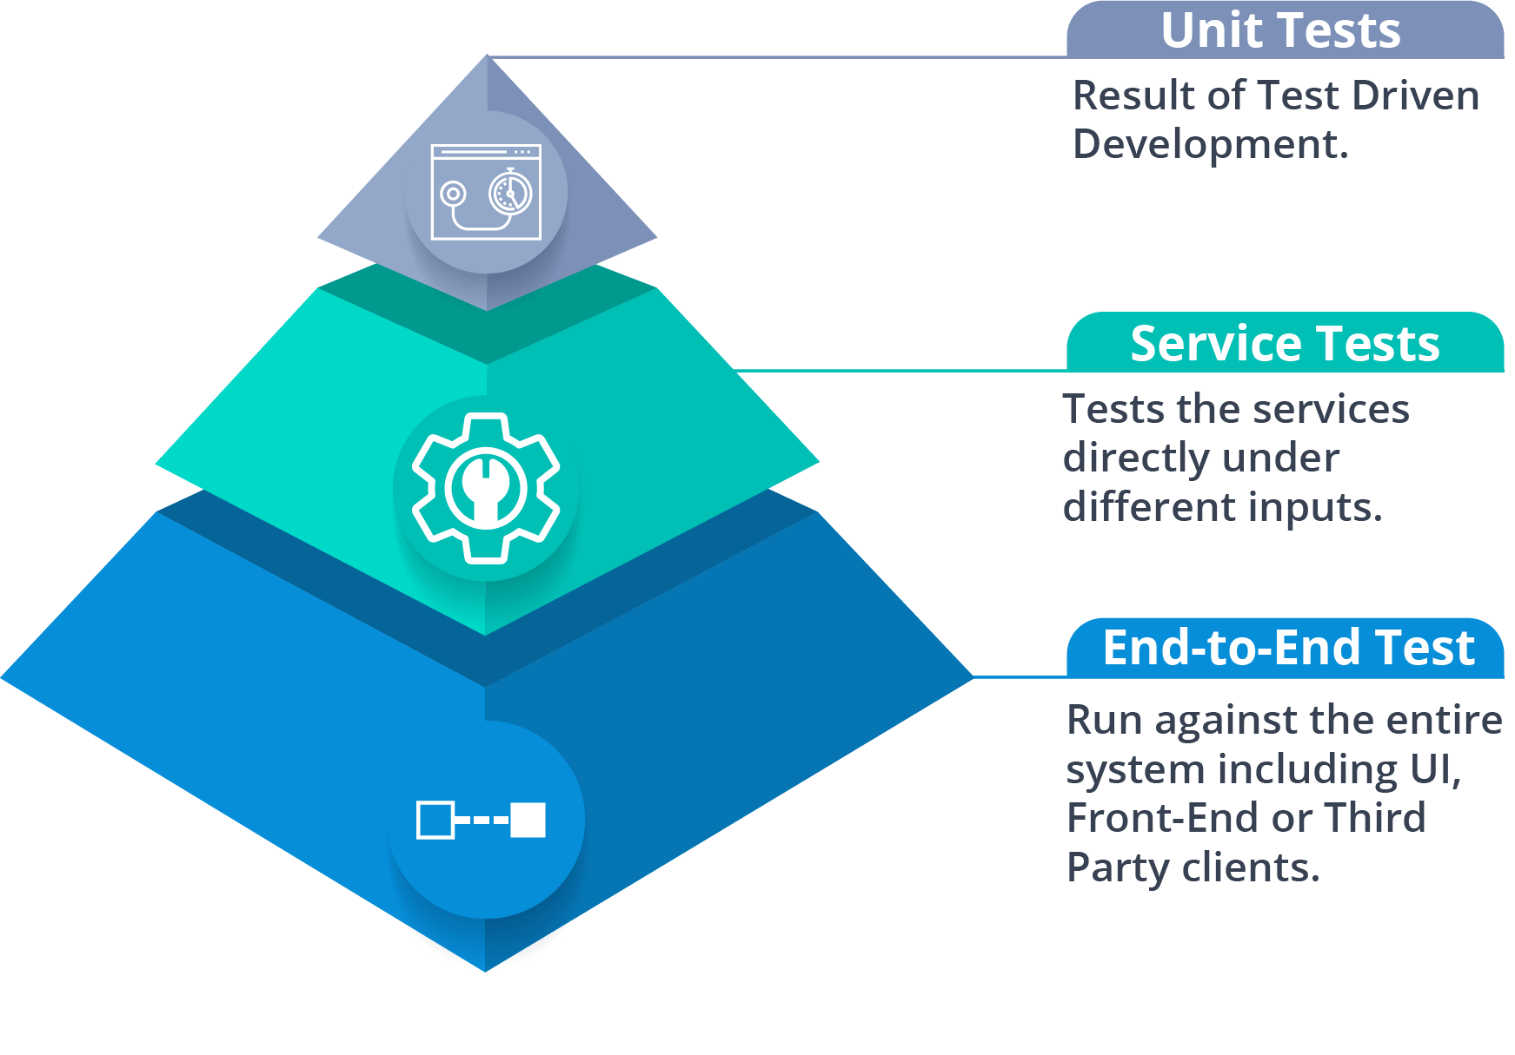

**Fig 16:**Mike Cohn’s Test Pyramid – Microservices Interview Questions

As per pyramid, the number of tests at first layer should be highest. At service layer, the number of tests should be less than at the unit test level, but more than at the end-to-end level.

**Q44. What is the purpose of Docker?**

**Docker** provides a container environment that can be used to host any application. In this, the software application and the dependencies which support it are tightly-packaged together.

So, this packaged product is called a **Container** and since it is done by Docker, it is called **Docker container!**

**Q45. What is Canary Releasing?**

**Canary Releasing** is a technique to reduce the risk of introducing a new software version in production. This is done by slowly rolling out the change to a small subset of users before giving it out to the entire infrastructure, i.e. making it available to everybody.

**Q46. What do you mean by Continuous Integration (CI)?**

**Continuous Integration (CI)** is the process of automating the build and testing of code every time a team member commits changes to version control. This encourages developers to share code and unit tests by merging the changes into a shared version control repository after every small task completion.

**Q47. What is Continuous Monitoring?**

**Continuous monitoring**gets into the depth of monitoring coverage, from in-browser front-end performance metrics, through application performance, and down to host virtualized infrastructure metrics.

**Q48. What is the role of an architect in Microservices architecture?**

An architect in microservices architecture plays the following roles:

* Decides broad strokes about the layout of the overall software system.
* Helps in deciding the zoning of the components. So, they make sure components are mutually cohesive, but not tightly coupled.
* Code with developers and learn the challenges faced in day-to-day life.
* Make recommendations for certain tools and technologies to the team developing microservices.
* Provide technical governance so that the teams in their technical development follow principles of Microservice.

**Q49. Can we create State Machines out of Microservices?**

As we know that each Microservice owning its own database is an independently deployable program unit, this, in turn, lets us create a State Machine out of it. So, we can specify different states and events for a particular microservice.

For Example, we can define an Order microservice. An Order can have different states. The transitions of Order states can be independent events in the Order microservice.

**Q50. What are Reactive Extensions in Microservices?**

Reactive Extensions also are known as Rx. It is a design approach in which we collect results by calling multiple services and then compile a combined response. These calls can be synchronous or asynchronous, blocking or non-blocking. Rx is a very popular tool in distributed systems which works opposite to legacy flows.

1. **What are the benefits of Microservices architecture?**

Microservices provide many benefits. Some of the key benefits are:

1. Scaling: Since there are multiple Microservices instead of one monolith, it is easier to scale up the service that is being used more. Eg. Let say, you have a Product Lookup service and Product Buy service. The frequency of Product Lookup is much higher than Product Buy service. In this case, you can just scale up the Product Lookup service to run on powerful hardware with multiple servers. Meanwhile, Product Buy service can remain on less powerful hardware.
2. Resilience: In Microservice architecture, if your one service goes down, it may not affect the rest of the system. The other parts can keep functioning, business as usual (BAU). Eg. Let say, you have Product Recommendation service and Product Buy service. If Product Recommendation service goes down, the Product Buy service can still keep running.
3. Technology Mix: With so many changes in technology everyday, you can keep using the latest technology for your new Microservices. You can adopt new technologies with less risk compared to Monolithic architecture. This is one of the best benefits of Microservices architecture.
4. Reuse: Microservices help you in reusing the lessons learnt from one service to another.
5. Easy Deployment: Microservices architecture, if done correctly, helps in making the deployment process smooth. If anything goes wrong, it can be rolled back easily and quickly in Microservices.

1. **What is the role of architect in Microservices architecture?**

Architects, in Microservices architecture, play the role of Town planners. They decide in broad strokes about the layout of the overall software system.

They help in deciding the zoning of the components. They make sure components are mutually cohesive but not tightly coupled. They need not worry about what is inside each zone.

Since they have to remain up to date with the new developments and problems, they have to code with developers to learn the challenges faced in day-to-day life.

They can make recommendations for certain tools and technologies, but the team developing a micro service is ultimately empowered to create and design the service. Remember, a micro service implementation can change with time.

They have to provide technical governance so that the teams in their technical development follow principles of Microservice.

At times they work as custodians of overall Microservices architecture.

1. **What is the advantage of Microservices architecture over Service Oriented Architecture (SOA)?**

Service Oriented Architecture (SOA) is an approach to develop software by creating multiple services. It creates small parts of services and promotes reusability of software. But SOA development can be slow due to use of things like communication protocols SOAP, middleware and lack of principles.

On the other hand, Microservices are agnostic to most of these things. You can use any technology stack, any hardware/middleware, any protocol etc. as long as you follow the principles of Microservices.

Microservices architecture also provides more flexibility, stability and speed of development over SOA architecture.

1. **Is it a good idea to provide a Tailored Service Template for Microservices development in an organization?**

If your organization is using similar set of technologies, then it is a good idea to provide a Service Template that can be tailored by development teams. It can make development faster. Also it can help in promoting adoption of various good practices that are already built into template.

But if your organization uses wide variety of technologies, then it may not be wise to produce and maintain a template for each service. Instead of that, it is better to introduce tools that help in maintaining same set of practices related to Microservices among all such technologies.

There are many organizations that provide tailored templates for Microservices. Eg. Dropwizard, Karyon etc. You can use these templates to make faster development of services in your organization.

Also remember that template code should not promote shared code.

This can lead to tight coupling between Microservices.

1. **What are the disadvantages of using Shared libraries approach to decompose a monolith application?**

You can create shared libraries to increase reuse and sharing of features among teams. But there are some downsides to it.

Since shared libraries are implemented in same language, it constrains you from using multiple types of technologies.

It does not help you with scaling the parts of system that need better performance.

Deployment of shared libraries is same as deployment of Monolith application, so it comes with same deployment issues.

Shared libraries introduce shared code that can increase coupling in software.

1. **What are the characteristics of a Good Microservice?**

Good Microservices have these characteristics:

1. Loose coupling: A Microservice knows little about any other service. It is as much independent as possible. The change made in one Microservice does not require changes in other Microservices.
2. Highly cohesive: Microservices are highly cohesive so that each one of them can provide one set of behaviour independently.
3. Bounded Context: A Microservice serves a bounded context in a domain and communicates with rest of the domain by using an interface for that Bounded context.
4. Business Capability: Microservices individually add business capability that is part of big picture in organization.

1. **What is Bounded Context?**

A bounded context is like a specific responsibility that is developed within a boundary. In a domain there can be multiple bounded contexts that are internally implemented. Eg. A hospital system can have bounded contexts like- Emergency Ward handling, Regular vaccination, Outpatient treatment etc. Within each bounded context, each sub-system can be independently designed and implemented.

1. **What are the points to remember during integration of Microservices?**

Some of the important points to remember during integration of

Microservices are:

Technology Agnostic APIs: Developing Microservices in a technology agnostic way helps in integration of multiple Microservices. With time, the technology implementation can change but the interface between Microservices can remain same.

Breaking Changes: Every change in Microservice should not become a breaking change for client. It is better to minimize the impact of a change on an existing client. So that existing clients’ do not have to keep changing their code to adapt to changes in a Microservice.

Implementation Hiding: Each Microservice should hide its internal implementation details from another one. This helps in minimizing the coupling between Microservices that are integrated for a common solution.

Simple to use: A Microservice should be simple to use for a consumer, so that the integration points are simpler. It should allow clients to choose their own technology stack.

1. **Is it a good idea for Microservices to share a common database?**

Sharing a common database between multiple Microservices increases coupling between them. One service can start accessing data tables of another service. This can defeat the purpose of bounded context. So it is not a good idea to share a common database between Microservices.

1. **What is the preferred type of communication between Microservices? Synchronous or Asynchronous?**

Synchronous communication is a blocking call in which client blocks itself from doing anything else, till the response comes back. In Asynchronous communication, client can move ahead with its work after making an asynchronous call. Therefore client is not blocked.

In synchronous communication, a Microservice can provide instant response about success or failure. In real-time systems, synchronous service is very useful. In Asynchronous communication, a service has to react based on the response received in future.

Synchronous systems are also known as request/response based.

Asynchronous systems are event-based.

Synchronous Microservices are not loosely coupled.

Depending on the need and critical nature of business domain, Microservices can choose synchronous or asynchronous form of communication.

1. **What is the difference between Orchestration and Choreography in Microservices architecture?**

In Orchestration, we rely on a central system to control and call various Microservices to complete a task. In Choreography, each Microservice works like a State Machine and reacts based on the input from other parts.

Orchestration is a tightly coupled approach for integrating Microservices. But Choreography introduces loose coupling. Also, Choreography based systems are more flexible and easy to change than Orchestration based systems.

Orchestration is often done by synchronous calls. But choreography is done by asynchronous calls. The synchronous calls are much simpler compared to asynchronous communication.

1. **What are the issues in using REST over HTTP for Microservices?**

In REST over HTTP, it is difficult to generate a client stub.

Some Web-Servers also do not support all the HTTP verbs like-GET, PUT, POST, DELETE etc.

Due to JSON or plain text in response, performance of REST over HTTP is better than SOAP. But it is not as good as plain binary communication.

There is an overhead of HTTP in each request for communication.

HTTP is not well suited for low-latency communications.

There is more work in consumption of payload. There may be overhead of serialization, deserialization in HTTP.

1. **Can we create Microservices as State Machines?**

Yes, Microservices are independent entities that serve a specific context. For that context, the Microservice can work as a State Machine. In a State Machine, there are lifecycle events that cause change in the state of the system.

Eg. In a Library service, there is a book that changes state based on different events like- issue a book, return a book, lose a book, late return of a book, add a new book to catalog etc. These events and book can form a state machine for Library Microservice.