Servlet
<html>
<head>
<meta http-equiv="Content-Type" content="text/html; charset=ISO-8859-1">
<title>Insert title here</title>
</head>
<body>
Line one of one.html
Line one of one.html
</body>
</html>

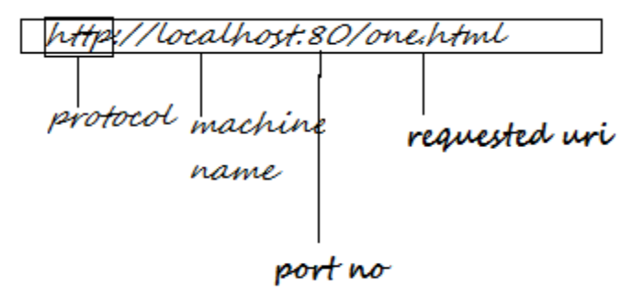

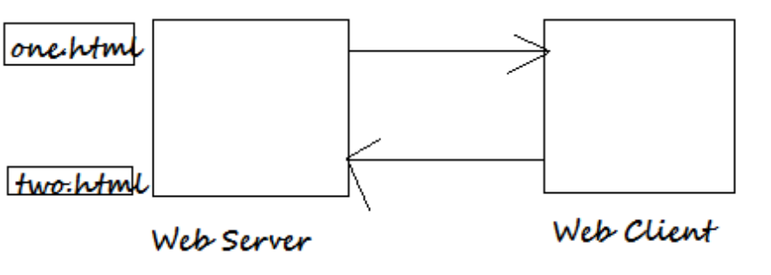

The web browser and the server communicates using HTTP(Hyper text transfer protocol)

According to Http, client and server must communicate by following the steps given velowL-

- The client must establish a connection
- The client must send a request to the server
- The server must process the reuest
- The server must send a response to the client

HTTP protocol specifies the format for the request and response:

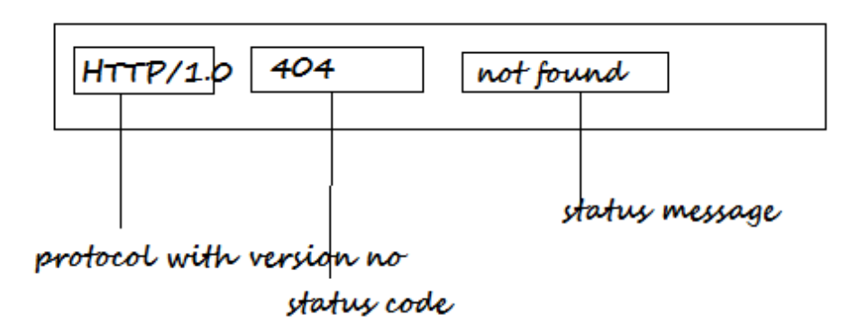

According to HTTP protocol the server can use one of the following types of status code:

1xx- for informational message
2xx- for indicating success
3xx- code to indicate redirection
4xx- cocde to indicate failure due to client
5xx- code to indicate failure due to server

Accorind to HTTP protocol a Server can support any number of request method

Some of the important request method are:-

GET, PUT, HEAD, POST, DELETE, TRACE etc.

C:\Inetpub\wwroot .. see of the file one.html

Q: what is the difference between GET and HEAD request method?

Ans: When the client sends GET request method, the server sends initial response line(IRL), Header Line, Blank line and body as part of response

When the client sends HEAD request method the server sends IRL, Header line and blank line as part of response( i.e. The body is not sent as part of the response)

PUT /test.html User-Agent: Ourbrowser 1.0 \r\n Current-Length \r\n\r\n ABCDEFGHIJK

PUT: request method can be used by client to put a resource on the server by default server are set not to allow PUT request method.

DELETE /test.txt HTTP/1.0 \r\n User-Agent: OurBrowser 1.0 \r\n\r\n

DELETE: request method can be used by the client to delete resource available on the server, by default this is not permitted

OPTION: When the OPTION request method is dend the server sends a response that contains Allow header name that provoide the infromation about the method that are allowed by the server

TRACE: A client can use TRACe request method to check wheather the server is working properly.

Servlet
Web container: A product that suppoert a web application developed using servlet technology is called as web container.

WebLogic, Apache Tomcat, websphere, SunOne Server, Oracle application server etc, support servlet technology and they can be called as container.

Java sof has provide a set of guidelines that must be by the developer for assembling (fitting together) the web application

package org.students;

import java.io.IOException;
import java.io.PrintWriter;

import javax.servlet.ServletException;
import javax.servlet.annotation.WebServlet;
import javax.servlet.http.HttpServlet;
import javax.servlet.http.HttpServletRequest;
import javax.servlet.http.HttpServletResponse;

/**
* Servlet implementation class ServOne
*/
@WebServlet("/ServOne")
public class ServOne extends HttpServlet {
private static final long serialVersionUID = 1L;

/**
* @see HttpServlet#HttpServlet()
*/
public ServOne() {
super();
// TODO Auto-generated constructor stub
}

/**
* @see HttpServlet#service(HttpServletRequest request, HttpServletResponse response)
*/
protected void service(HttpServletRequest request, HttpServletResponse response) throws ServletException, IOException {

System.out.println("Output of ServOne");
PrintWriter out=response.getWriter();
out.println("** Output of ServOne");
}

}

org.students.ServOne is called as Servlet class.

Path of Servlet related class of WebLogic & Tomcat.

C:\bea\WebLogic81\Server\lib\weblogic.jar
C:\Program Files\ Apache Software Foundation\ Tomcat 5.0\ comman\lib\servlet-api.jar

Note: Every webcontainer vendor provides a jar file that contains servlet related package.

e.g (i)servlet-api.jar provided by tomcat
(ii)weblogic.jar: provided by Weblogic

Procedure for assembling a web application

- Create a WEB Root directory( e.g f:\ourwapp)
- create a directory with the name WEB-INF under WEB Root directory
- create two directory with the name lib and classes WEB Root(f:\ourwapp\WEB-INF\classes)

- Provide the servlet under WEB-INF\classess according to package structure)
- Provide the static resources like html,xml,jpeg etc file under WEB Root directory(f:\ourwapp) or subdirectory of WEB Root but not under WEB-INF
- provide the configuration file for servlet under WEB Root\WEB-INF (i.e. ourwapp\WEB-INF\web.xml)

<web-app>
<display-name> Our first Web app</display-name>
<discription>My First Web Application</discription>
<servlet>
<servlet-name>sone</servlet-name>
<servlet-class>org.students.ServOne</servlet-class>
</servlet>
<servlet-mapping>
<servlet-name>sone</servlet-name>
<url-pattern>/one/two/srvone</url-pattern>
</servlet-mapping>
</web-app>

    - Create a war file using the jar tool
a) using cd command move to webroot directory ourwapp f:\>cd ourwapp
f:\ourwapp>
b) run the following command to create a war file f:\ourwapp>jar cvf ourwapp.war .

In order to use a web application we must deploy the application in web container

To deploye the web appliciation in weblogic copy the WAR (Web archive) file under application directory.

i.e. C:\bea\user-projects\domains\inetsolv\application

Note: directory structure will look like:-

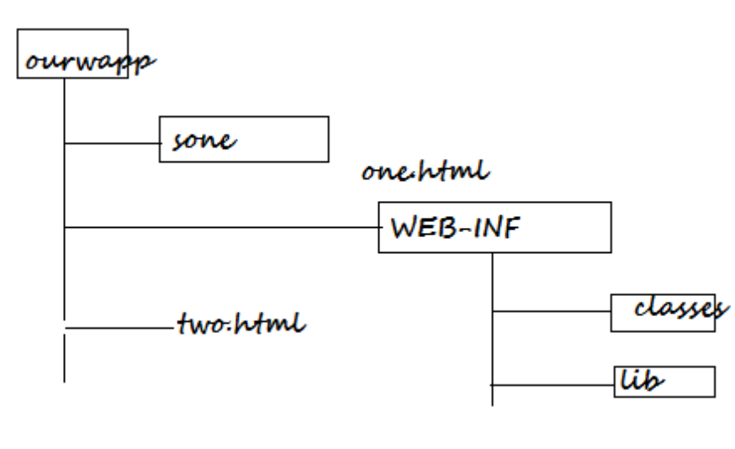

URL for weblogic:
http://localhost:7001/ourwapp/sone/one.html
http://localhost:7001/ourwapp/two.hmtl

Basic of Servlet

Javasoft has designed servlet technology in such a way that it can be used as par of various kind of server that support HTTP protocol.

Today the servlet technology is implemented by various companies in the server supported by HTTP protocol.

As shown in the above the diagram a servlet running inside a server supporting HTTP protocol is called as HttpServlet and a servlet running inside a server supporting pZ protocol can be called as PZServlet.

EJB (Enterprise Java Beans)
EJB’s are server side business components. In order to run the EJB’s, we must use an EJB container (Server) like Weblogic, Websphere, JBoss, SunOne Server, Oracle Application Server.
As a part of EJB we must provide the business method. As part of business method we must provide the business logic.
EJB is an open specification a, as a part of this specification a set fo guide line (rules) are provided. To develop the EJB container.
EJB 3 provides the simplified API for the development of the business component.

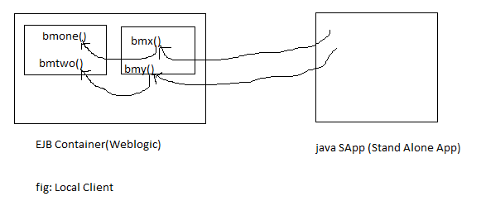
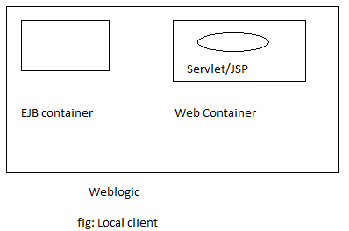

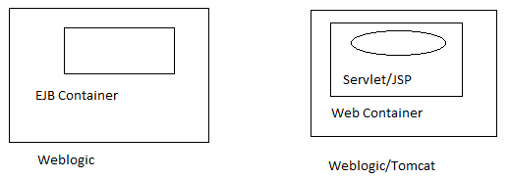
Fig: Remote Client

The caller of business methods on an EJB is called as EJB Client. There are two type of EJB Clients.
- Local Client.
- Remote Client.
Local client: if the code of the client runs in the same JVM then it is called as Local client of EJB. E.g fig(1).
Remote client: if the code of the client runs in the different JVM then it is called as Remote client of EJB. e.g. fig(2).
Applet/Servlet/JSP/Stand Alone java application that calls method on EJB is client.

EJB3 is a part of JEE 5 and it uses the features that are part of J2SE5.
Java 1.2.x
Java 1.3.x Java 2 SE
Java 1.4.x
Java 1.5.x
Java 1.6.x JSE 5
Java 1.7.x JEE 5
Java 1.8.x

Annotations: Annotations simplifies the development of java application.
There are 3 types of EJB’s in EJB 3

1) Stateless Session Bean
2) Stateful Session Bean
3) Message Driven Bean
As most of the developers has not used EntityBean in earlier projects developed using EJB1 & EJB2, Java Soft has not enhanced the design of entity beans.
As an alternative to entity bean java soft has provided JPA (Java persistence API).
To set the class path pointing to weblogic.jar and other jar files of weblogic 10.
Run the command :
setEnvironmentEnv.cmd - Window
setDomainEnv.sh - Linux
available in bin directory.
C:\bea\user_projects\domains\inetsolv> cd bin
C:\bea\user_projects\domains\inetsolv\ bin>setDomainEnv.cmd
F:\work>set CLASSPATH=% CLASSPATH%;.;F:\work\classes

Procedure for developing a Stateless Session Bean:-
- Decide about the method that are to be provided in the EJB(bean)
e.g. int bmOne(int I, int j);
String bmTwo(String studName)
- Provide the Remote business inter face and/or local inter face.
F:\work> javac –d classes RBInt.java
package inet.solve;

public interface RBInt {
int bmOne(int i, int j);
String bmTwo(String studName);
}
RBInt.java
package inet.solve;

public interface LBInt {
int bmOne(int i, int j);
String bmTwo(String studName);
}
LBInt.java
F:\work> javac –d classes LBInt.java
Note: Local client uses a Local interface & Remote client uses a remote interface

Note: if we need to develop only Remote client then remote interface is enough.

- Provide the bean

package inet.solve;

import javax.ejb.Stateless;

@Stateless(name="ourFB", mappedName="xxx/yyy")
public class FirstBean implements LBInt, RBInt, FirstBeanLocal, FirstBeanRemote {

public int bmOne(int i, int j) {
// TODO Auto-generated method stub
System.out.println("--bmOne--");
return (i+j);
}

public String bmTwo(String studName) {
// TODO Auto-generated method stub
return studName;
}

}
FirstBean.java

- Create a jar file following the step given below
F:\work>cd classes
F:\work\classes> jar cvf ourbean.jar
Note: autodeploy directory of weblogic10 is equivalent to application directory of weblogic 6

- When an EJB is deployed the EJB contains registers the information about local interface and remote interface.

Explanation: The EJB container creates an object based on a class that implements the local business interface(This will be generated by container) Store this object in the directory service. This process is called as registering the local interface. Similarly an object will be created implementing Remote business interface and this object will also be registered with directory service
Procedure for installing JBoss:-
- Copy jboss-4.2.1.GA.zip to a directory
(e.g. e:\)
- Using cd command move to directory in which the zip file of JBoss is copied.
c:\>e:
- Use the follosing command to extract the content of zip file.
E:\> jar xvf jboss-4.2.1.GA.zip
Note: the above command creates a directory with the name jboss-4.2.1.GA and copies all the files related to JBoss.
- Go to the directory
E:\ jboss-4.2.1.GA\server\default>
And search .xml file 8080 change 8080 as 8000 in the files
Jboss-service.xml, server.xml, jboss-beans.xml
Procedure for starting JBoss:-
- Using cd command move to
E:\ jboss-4.2.1.GA\bin> directory
- Set JAVA_HOME to directory in which java is installed.
Set JAVA_HOME=C:\Program Files\Java\Jdk1.5.0
- Run the command run.bat/run.sh
E:\ jboss-4.2.1.GA\bin>run
To deploy the EJB copy the jar file to
E:\ jboss-4.2.1.GA\server\default\deploy
To check information available in dir service of Jboss
- Open the browser and use the url given below:
http://localhost:8000/jmx-console
- Click on service=JNDI View
- Click on Invoke button available under list.
Note: When ourbean.jar is deployed JBoss registers the local interface with the name ourFB/local & Remote interface with the name OurFB/Remote

Weblogic makes the information about the remote business interface to available in the directory server but the information about the local business interface will not be available in directory service if weblogic 10.1.x
Environment→Server→AdminServer
Information about local interface will not be shown in JNDI service in weblogic 10.
To access the directory service of JBoss we must provide the following properties
Create the client:
package inet.solve;
import java.io.FileInputStream;
import java.util.Properties;

import javax.naming.InitialContext;
import javax.naming.Context;
public class App {

/**
* @param args
*/
public static void main(String[] args) throws Exception{
// TODO Auto-generated method stub
FileInputStream fis=new FileInputStream("f:/jndi.properties");
Properties props=new Properties();
props.load(fis);
Context ic=new InitialContext(props);
inet.solve.RBInt beanRef=(inet.solve.RBInt)ic.lookup("ourFB/remote");
System.out.println(beanRef);
System.out.println(beanRef.bmOne(5, 6));
System.out.println(beanRef.bmTwo("Hello Rakesh"));
//ic.lookup("ourFB/remote")

}

}

To run the client that has to access EJB's available in JBoss: jboss-client.jar file is required.
f:\work>set CLASSPATH=%CLASSPATH%;.;F:\work\classes;jboss-client.jar
Copy jboss-client.jar file in f:\work directory
But first set JAVA_HoME=c:\Program Files\Java\Jdk1.6.0
and start the server then run the client.

F:\work>java App
Note: You can create web client using JSP/Servlet and deploy that in
E:\jboss-4.2.1.GA\server\default\deploy
i.e. paste wapp and rename it webapp.war
Note: JBoss support only war file to be deployed
http://localhost:8080/wapp/ejbcli.jsp
<%@ page import=”java.naming.*,java.io.*,java.util.*” %>
<%
FileInputStream fis=new FileInputStream("f:/jndi.properties");
Properties props=new Properties();
props.load(fis);
Context ic=new InitialContext(props);
inet.solve.RBInt beanRef=(inet.solve.RBInt)ic.lookup("ourFB/remote");
System.out.println(beanRef);
System.out.println(beanRef.bmOne(5, 6));
System.out.println(beanRef.bmTwo("Hello Rakesh"));
//ic.lookup("ourFB/remote")

%>
To deploy servlet/JSP in JBoss:-
- Create a web root directory with extension .war (e.g. webapp.war)
- Create WEB-INF inside .war
- Create classes and lib directory inside WEB-INF
- Place .classes file in classes directory
- Place .jar file in lib directory
- Create web.xml in WEB-INF directory
- Copy webapp.war and paste it in e:\jboss-4.2.1.GA\server\default\deploy directory

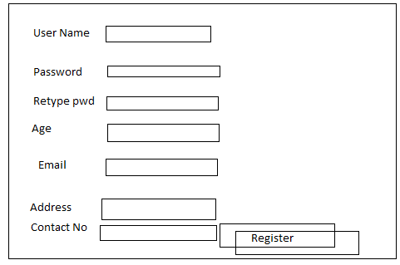

package inet.solve;

import javax.ejb.Local;

@Local
public interface UserManagerLocal {
public void registerUser(String uname,String pwd,int age,String address,String cno,String email);
public void unRegisterUser(String uname,String pwd);
}
UserManagerLocal.java
package inet.solve;

import javax.ejb.Remote;

@Remote
public interface UserManagerRemote {
public void registerUser(String uname,String pwd,int age,String address,String cno,String email);
public void unRegisterUser(String uname,String pwd);

}
UserManagerRemote.java

package inet.solve;

import javax.ejb.Stateless;

@Stateless(name="userManager", mappedName="UM")
public class UserManager implements UserManagerLocal, UserManagerRemote {
public void registerUser(String uname,String pwd,int age,String address,String cno,String email){
System.out.println("---Register User----");
}
public void unRegisterUser(String uname,String pwd){
System.out.println("---UnRegister User----");
}

}

package inet.solve;

import java.io.FileInputStream;
import java.util.Properties;

import javax.naming.Context;
import javax.naming.InitialContext;

public class EJBCli {

/**
* @param args
*/
public static void main(String[] args)throws Exception {
// TODO Auto-generated method stub
FileInputStream fis=new FileInputStream("f:/jndi.properties");
Properties props=new Properties();
props.load(fis);
Context ic=new InitialContext(props);
inet.solve.UserManagerRemote beanRef=(inet.solve.UserManagerRemote)ic.lookup("userManager/remote");
System.out.println(beanRef);
beanRef.registerUser("Rakesh", "", 26, "Delhi", "9968574221", "rakesh1.kumar@birlasoft.com");
beanRef.unRegisterUser("Hello Rakesh","dd");

}

} package inet.solve;

import java.io.FileInputStream;
import java.util.Properties;

import javax.naming.Context;
import javax.naming.InitialContext;

public class EJBCli {

/**
* @param args
*/
public static void main(String[] args)throws Exception {
// TODO Auto-generated method stub
FileInputStream fis=new FileInputStream("f:/jndi.properties");
Properties props=new Properties();
props.load(fis);
Context ic=new InitialContext(props);
inet.solve.UserManagerRemote beanRef=(inet.solve.UserManagerRemote)ic.lookup("userManager/remote");
System.out.println(beanRef);
beanRef.registerUser("Rakesh", "", 26, "Delhi", "9968574221", "rakesh1.kumar@birlasoft.com");
beanRef.unRegisterUser("Hello Rakesh","dd");

}

} package inet.solve;

import java.io.FileInputStream;
import java.util.Properties;

import javax.naming.Context;
import javax.naming.InitialContext;

public class EJBCli {

/**
* @param args
*/
public static void main(String[] args)throws Exception {
// TODO Auto-generated method stub
FileInputStream fis=new FileInputStream("f:/jndi.properties");
Properties props=new Properties();
props.load(fis);
Context ic=new InitialContext(props);
inet.solve.UserManagerRemote beanRef=(inet.solve.UserManagerRemote)ic.lookup("userManager/remote");
System.out.println(beanRef);
beanRef.registerUser("Rakesh", "", 26, "Delhi", "9968574221", "rakesh1.kumar@birlasoft.com");
beanRef.unRegisterUser("Hello Rakesh","dd");

}

} package inet.solve;

import java.io.FileInputStream;
import java.util.Properties;

import javax.naming.Context;
import javax.naming.InitialContext;

public class EJBCli {

/**
* @param args
*/
public static void main(String[] args)throws Exception {
// TODO Auto-generated method stub
FileInputStream fis=new FileInputStream("f:/jndi.properties");
Properties props=new Properties();
props.load(fis);
Context ic=new InitialContext(props);
inet.solve.UserManagerRemote beanRef=(inet.solve.UserManagerRemote)ic.lookup("userManager/remote");
System.out.println(beanRef);
beanRef.registerUser("Rakesh", "", 26, "Delhi", "9968574221", "rakesh1.kumar@birlasoft.com");
beanRef.unRegisterUser("Hello Rakesh","dd");

}

} package inet.solve;

import java.io.FileInputStream;
import java.util.Properties;

import javax.naming.Context;
import javax.naming.InitialContext;

public class EJBCli {

/**
* @param args
*/
public static void main(String[] args)throws Exception {
// TODO Auto-generated method stub
FileInputStream fis=new FileInputStream("f:/jndi.properties");
Properties props=new Properties();
props.load(fis);
Context ic=new InitialContext(props);
inet.solve.UserManagerRemote beanRef=(inet.solve.UserManagerRemote)ic.lookup("userManager/remote");
System.out.println(beanRef);
beanRef.registerUser("Rakesh", "", 26, "Delhi", "9968574221", "rakesh1.kumar@birlasoft.com");
beanRef.unRegisterUser("Hello Rakesh","dd");

}

} package inet.solve;

import java.io.FileInputStream;
import java.util.Properties;

import javax.naming.Context;
import javax.naming.InitialContext;

public class EJBCli {

/**
* @param args
*/
public static void main(String[] args)throws Exception {
// TODO Auto-generated method stub
FileInputStream fis=new FileInputStream("f:/jndi.properties");
Properties props=new Properties();
props.load(fis);
Context ic=new InitialContext(props);
inet.solve.UserManagerRemote beanRef=(inet.solve.UserManagerRemote)ic.lookup("userManager/remote");
System.out.println(beanRef);
beanRef.registerUser("Rakesh", "", 26, "Delhi", "9968574221", "rakesh1.kumar@birlasoft.com");
beanRef.unRegisterUser("Hello Rakesh","dd");

}

} package inet.solve;

import java.io.FileInputStream;
import java.util.Properties;

import javax.naming.Context;
import javax.naming.InitialContext;

public class EJBCli {

/**
* @param args
*/
public static void main(String[] args)throws Exception {
// TODO Auto-generated method stub
FileInputStream fis=new FileInputStream("f:/jndi.properties");
Properties props=new Properties();
props.load(fis);
Context ic=new InitialContext(props);
inet.solve.UserManagerRemote beanRef=(inet.solve.UserManagerRemote)ic.lookup("userManager/remote");
System.out.println(beanRef);
beanRef.registerUser("Rakesh", "", 26, "Delhi", "9968574221", "rakesh1.kumar@birlasoft.com");
beanRef.unRegisterUser("Hello Rakesh","dd");

}

}

package inet.solve;

import java.io.FileInputStream;
import java.util.Properties;

import javax.naming.Context;
import javax.naming.InitialContext;

public class EJBCli {

/**
* @param args
*/
public static void main(String[] args)throws Exception {
// TODO Auto-generated method stub
FileInputStream fis=new FileInputStream("f:/jndi.properties");
Properties props=new Properties();
props.load(fis);
Context ic=new InitialContext(props);
inet.solve.UserManagerRemote beanRef=(inet.solve.UserManagerRemote)ic.lookup("userManager/remote");
System.out.println(beanRef);
beanRef.registerUser("Rakesh", "", 26, "Delhi", "9968574221", "rakesh1.kumar@birlasoft.com");
beanRef.unRegisterUser("Hello Rakesh","dd");

}

}

We can develop a multi-tier application using EJB technology. The diagram shown below shows the architecture of typical JEE application using EJB.
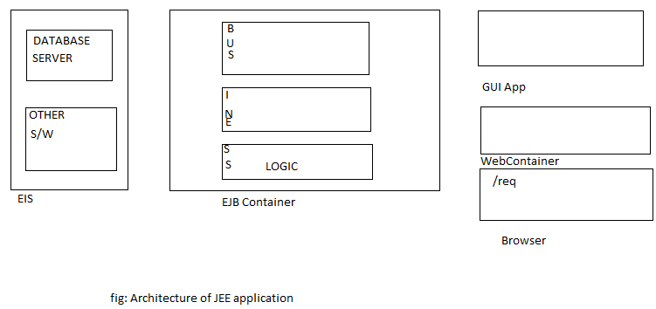

SQL> create table baccount(
Aid number(4) primary key,
Cust_name varchar2(10),
address varchar2(15),
curbal number(10,2),
status number(1));

In order to control the transaction JTA (Java Transaction API) will be used in EJB. For this we must use the connection pool of the weblogic server.
Step to get connection pool:
- http://localhost:7001/console using this login to weblogic console
- Click on Services→JDBC→DataSources
- Click on Lock & Edit → New Tab → and provide the information as follows.
Name= JDBDataSource
JNDI Name= org/students/orads
DataBase Type=oracle
DataBase Driver=Oracle Driver (Thin) Version 9.0.1.9.2.0.1.0
And click on Next
- Click on Next & provide the following information.
DataBase Name=xe
HostName=localhost
Port no=1521
Database user=scott
Password=tiger
And click on Next
- Click on Test Configuration
- Click on Next
- Choose AdminServer
- Click on Finish
- Click on Active Changes
Thus JNDI Name of DataSource: org/students/orads
In order to get the datasource we must use JNDI name of the DataSource e.g. JNDI Name= org/students/orads
In order ot get the connection from connection pool,
DataSource.getConnection() method must be used.
In order to get the datasource we must use JNDI name of the DataSource
e.g. JNDI Name=org/students/orads.
package inet.solve;

import javax.ejb.Remote;

@Remote
public interface RIBAManager {
public void createAccount(String aid,String cname,String address,String initBal);
public void closeAccount(String aid);
}

C:\bea\user_projects\domains\inetsolv\bin>setDomainEnv
Change drive using cd

F:/work>javac –d . RIBAManager.java
java.naming.factory.url=t3://localhost:7001/
java.naming.security.principal=admin
java.naming.security.credentials=inetadmin
java.naming.factory.initial=weblogic.jndi.WLInitialContextFactory
package inet.solve;
import java.sql.Connection;
import java.sql.PreparedStatement;
import java.sql.ResultSet;
import java.sql.SQLException;
import java.sql.Statement;
import javax.ejb.Stateless;
import javax.naming.Context;
import javax.naming.InitialContext;
import javax.sql.DataSource;
@Stateless(name="BA",mappedName="BA")
public class BAManager implements RIBAManager {
Connection con;
public void closeAccount(String aid) {
//code to update status=0
}
public void createAccount(String aid, String cname, String address,
String initBal) {
try{
Context ic=new InitialContext();
DataSource ds=(DataSource)ic.lookup("java:DerbyDS");
con=ds.getConnection();
/*String vsql="insert into baccount(?,?,?,?,?)";
PreparedStatement pstmt=con.prepareStatement(vsql);
pstmt.setString(1, aid);
pstmt.setString(2, cname);
pstmt.setString(3, address);
pstmt.setString(4, initBal);
pstmt.setString(5, "1");
pstmt.executeUpdate();*/
Statement stmt=con.createStatement();
ResultSet rs=stmt.executeQuery("select * from emp");
while (rs.next()) {
System.out.print("--"+rs.getString(1));
System.out.print("--"+rs.getString(2));
System.out.println("--"+rs.getString(3));

}
System.out.println("con-->"+con);
}catch (Exception e) {

}finally{
if(con!=null)
try {
con.close();
} catch (SQLException e) {
e.printStackTrace();
}
}
}
}
F:/work> cd classes
F:/work/classes> jar cvf babeans.jar .
Copy babean.jar in autodeploy dir in weblogic

package inet.solve;

import java.io.FileInputStream;
import java.util.Properties;

import javax.naming.Context;
import javax.naming.InitialContext;

public class TestCli {

public static void main(String[] args)throws Exception {
FileInputStream fis=new FileInputStream("f:/jndi.properties");
Properties props=new Properties();
props.load(fis);
Context ic=new InitialContext(props);
inet.solve.RIBAManager beanRef=(inet.solve.RIBAManager)ic.lookup("BA/remote");
beanRef.createAccount("", "", "", "");
}

}

JEE5 supports dependency injection feature.
In the above bean class we have used a datasource object, i.e. ourbean code require/depends on data source object. For getting the datasource object we have provided the code as shown below.

Context ic=new InitialContext();
DataSource ds=(DataSource)ic.lookup("java:DerbyDS");
con=ds.getConnection();

We can implement BAManager using dependency injection feature as shown below:

package inet.solve;
import java.sql.Connection;
import java.sql.PreparedStatement;
import java.sql.ResultSet;
import java.sql.SQLException;
import java.sql.Statement;
import javax.ejb.Stateless;
import javax.naming.Context;
import javax.naming.InitialContext;
import javax.sql.DataSource;
@Stateless(name="BA",mappedName="BA")
public class BAManager implements RIBAManager {
//Connection con;
//@Resource(name=”org/students/orads”)
@Resource(mappedName="java:DerbyDS")
DataSource ds;

public void closeAccount(String aid) {
//code to update status=0
}
public void createAccount(String aid, String cname, String address,
String initBal) {
try{
Connection con=ds.getConnection();
/*String vsql="insert into baccount(?,?,?,?,?)";
PreparedStatement pstmt=con.prepareStatement(vsql);
pstmt.setString(1, aid);
pstmt.setString(2, cname);
pstmt.setString(3, address);
pstmt.setString(4, initBal);
pstmt.setString(5, "1");
pstmt.executeUpdate();*/
Statement stmt=con.createStatement();
ResultSet rs=stmt.executeQuery("select * from emp");
while (rs.next()) {
System.out.print("--"+rs.getString(1));
System.out.print("--"+rs.getString(2));
System.out.println("--"+rs.getString(3));

}
System.out.println("con-->"+con);
}catch (Exception e) {

}finally{
if(con!=null)
try {
con.close();
} catch (SQLException e) {
e.printStackTrace();
}
}
}
}

<html>
<head><title>New Account</title></head>
<body>
<form action=””>
Account ID
<input type=”text” name=”aid”/><br/>
Customer Name
<input type=”text” name=”cname”/><br/>
Address
<input type=”text” name=”addr”/><br/>
Initial Deposit
<input type=”text” name=”id”/><br/>
<input type=”submit” value=”OpenAccount”/><br/>
</form>

</body>
</html>

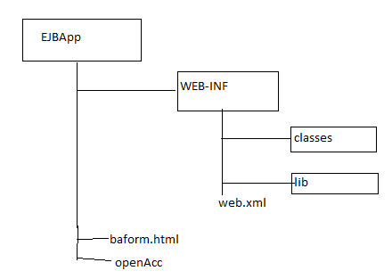

<%@page import=”javax.naming.*,java.io.*,java.util.*”%>
<%
String vaid=request.getParameter(“aid”);
String vcname=request.getParameter(“cname”);
String vaddr=request.getParameter(“addr”);
String vid=request.getParameter(“id”);
FileInputInStream fis=new FileInputInStream(“c:\jndi.properties”);
Properties props=new Properties();
props.load(fis);
Context ic=new InitialContext(props);
org.students.RIBAManager beanref=()ic.lookup(“BA#org.students.RIBAManager”);
beanref.createAccount(vaid,cname,vaddr,vid);
%>
openAcc.jsp

Note: javax.transaction.UserTransaction is a part of java transaction API(JTA). The method begin(),commit(),rollback() of UserTransaction can be used to control the transaction(Start /end of tx)

package inet.solve;

import javax.ejb.Local;

@Local
public interface ProductManagerBeanLocal {

public void insertProd(String pid,String pname,int price);
}

There are two type of transaction management strategies in ejb.
- Bean Managed Transaction
- Container Managed Transaction
If we choose BMT (Bean Managed Transaction) then we must provide the code in the bean to control the transaction(start/end tx)

package inet.solve;

import javax.ejb.Remote;

@Remote
public interface ProductManagerBeanRemote {
public void insertProd(String pid,String pname,int price);
}

ProductManagerBeanRemote.java

package inet.solve;

import java.sql.Connection;
import java.sql.PreparedStatement;

import javax.annotation.Resource;
import javax.ejb.SessionContext;
import javax.ejb.Stateless;
import javax.ejb.TransactionManagement;
import javax.ejb.TransactionManagementType;
import javax.naming.Context;
import javax.naming.InitialContext;
import javax.naming.NamingException;
import javax.sql.DataSource;
import javax.transaction.SystemException;
import javax.transaction.UserTransaction;

@Stateless(name="PM",mappedName="PM")
//Incase of Bean Managed Transaction
//@TransactionManagement(TransactionManagementType.BEAN)
//Incase of Container Managed Transaction
@TransactionManagement(TransactionManagementType.CONTAINER)
public class ProductManagerBean implements ProductManagerBeanLocal,
ProductManagerBeanRemote {
@Resource(mappedName="java:DerbyDS")
DataSource ds;
//In case of Bean Managed Transaction
/*
@Resource
UserTransaction ut;
*/
@Resource
SessionContext sessionContext;
Connection con;
public void insertProd(String pid,String pname,int price){
Context ic;
try {
ic = new InitialContext();
//DataSource ds=(DataSource)ic.lookup("");
con=ds.getConnection();
String vsql="insert into products values(?,?,?)";
//Incase of Bean Managed Transaction
//ut.begin();
PreparedStatement pstmt=con.prepareStatement(vsql);
pstmt.setString(1,pid);
pstmt.setString(2, pname);
pstmt.setInt(3, price);
pstmt.executeUpdate();
//Incase of Bean Managed Transaction
// ut.commit();
} catch (NamingException e) {
e.printStackTrace();
}catch (Exception e) {
try {
//Incase of Bean Managed Transaction
//ut.rollback();
//in case of CMT
sessionContext.setRollbackOnly();
con.close();
} catch (IllegalStateException e1) {
e1.printStackTrace();
} catch (SecurityException e1) {
e1.printStackTrace();
/*} catch (SystemException e1) {
e1.printStackTrace();
*/}catch (Exception ex) {
}
e.printStackTrace();
}

}}

package inet.solve;

import java.io.FileInputStream;
import java.util.Properties;

import javax.naming.Context;
import javax.naming.InitialContext;

public class ProdCli {

/**
* @param args
*/
public static void main(String[] args)throws Exception {
// TODO Auto-generated method stub
FileInputStream fis=new FileInputStream("f:/jndi.properties");
Properties props=new Properties();
props.load(fis);
Context ic=new InitialContext(props);
inet.solve.ProductManagerBeanRemote beanRef=(inet.solve.ProductManagerBeanRemote)ic.lookup("PM/remote");
beanRef.insertProd("p003", "Pencil", 5);
System.out.println("inserted");
}

}

If we choose CMT (Container Managed Transaction) ,the container take the responsibility of controlling the transaction.

Internally container uses JTA to start and end the transaction.

If we choose CMT (Container Managed Transaction) then as part of our bean code we should not use UserTransaction object to control the transaction.

Note: It is better to always use CMT instead of BMT for managing Transaction.

As CMT is the default for managing the transaction, there is no need of using annotation
- @TransactionManagement for using CMT
- Don’t use UserTransaction object and ut.begin() & ut.rollback() like method

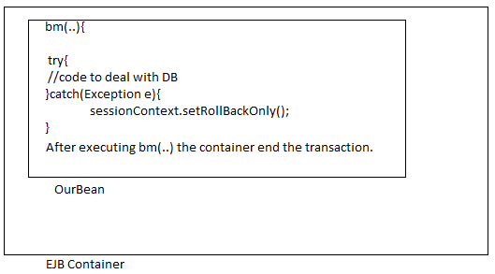

The diagram shows what will be done by the container befor and after executing a business method when we use CMT.

sessionContext.setRollbackOnly() is used to tell the container that something has gone wrong container must rollback Tx.
Ut.rollback()→ to rollback tx.
sessionContext.setRollbackOnly()→ does not roll back rather it tell the container to rollback if something has gone wrong & offcourse container rollback Tx.

package inet.solve;

import java.sql.Connection;
import java.sql.PreparedStatement;

import javax.annotation.Resource;
import javax.ejb.SessionContext;
import javax.ejb.Stateless;
import javax.ejb.TransactionManagement;
import javax.ejb.TransactionManagementType;
import javax.naming.Context;
import javax.naming.InitialContext;
import javax.naming.NamingException;
import javax.sql.DataSource;
import javax.transaction.SystemException;
import javax.transaction.UserTransaction;

@Stateless(name="PM",mappedName="PM")
//Incase of Bean Managed Transaction
//Incase of Container Managed Transaction
//@TransactionManagement(TransactionManagementType.CONTAINER)
public class ProductManagerBean implements ProductManagerBeanLocal,
ProductManagerBeanRemote {
@Resource(mappedName="java:DerbyDS")
DataSource ds;
//In case of Bean Managed Transaction
/*
@Resource
UserTransaction ut;
*/
@Resource
SessionContext sessionContext;
Connection con;
public void insertProd(String pid,String pname,int price){
Context ic;
try {
ic = new InitialContext();
//DataSource ds=(DataSource)ic.lookup("");
con=ds.getConnection();
String vsql="insert into products values(?,?,?)";
//Incase of Bean Managed Transaction
PreparedStatement pstmt=con.prepareStatement(vsql);
pstmt.setString(1,pid);
pstmt.setString(2, pname);
pstmt.setInt(3, price);
pstmt.executeUpdate();
//Incase of Bean Managed Transaction
} catch (NamingException e) {
e.printStackTrace();
}catch (Exception e) {
try {
//in case of CMT
sessionContext.setRollbackOnly();
con.close();
} catch (IllegalStateException e1) {
e1.printStackTrace();
} catch (SecurityException e1) {
e1.printStackTrace();
/*} catch (SystemException e1) {
e1.printStackTrace();
*/}catch (Exception ex) {
}
e.printStackTrace();
}

}
}

We can use Transactional attribute(Required,mandatory… etc.) to tell the container how it must control the Transaction.

Type of Session Bean
- Stateless Session Bean
- Statefull Session Bean
- Stateless Session Bean: does not remember conversational state of client (if a client provide some information while calling method1 then bean does not remember this information when client call method 2)
- Statefull Session Bean: is responsible for remembering the conversational state.

LIFE CYCLE OF STATELESS SESSION BEAN

For Stateless Session Bean (SLSB) Ejb container uses object pooling technique. As part of SLSB we can provide the annotated method @PostConstruct and @PreDestroy

The method name can be anything but method should not take any parameter and return type of method must be void.

package inet.solve;

import javax.ejb.Local;

@Local
public interface StateBeanLocal {
public void setName(String name);
public String getName();

}

package inet.solve;

import javax.ejb.Remote;

@Remote
public interface StateBeanRemote {
public void setName(String name);
public String getName();
}

package inet.solve;

import javax.annotation.PostConstruct;
import javax.annotation.PreDestroy;
import javax.annotation.Resource;
import javax.ejb.PostActivate;
import javax.ejb.PrePassivate;
import javax.ejb.SessionContext;
import javax.ejb.Stateful;

@Stateless(name="SB",mappedName="SB")
public class StateBean implements StateBeanLocal, StateBeanRemote {
@Resource
SessionContext sessionContext;
String name;

Public StateBean (){
System.out.println("--StateFullBean--");
System.out.println("Name"+name);
System.out.println("Session Context--"+sessionContext);
}
@PostConstruct
public void init(){
System.out.println("Post Construct method ");
System.out.println(name);
System.out.println(sessionContext);
}
@PreDestroy
public void destroy(){
System.out.println("Predestroy--");
}

@PrePassivate
public void passivate(){
System.out.println("--Pre Passivate---");
}

@PostActivate
public void activate(){
System.out.println("---Post Activate---");
}
public void setName(String name){

}
public String getName(){
return name;
}

}

The method for which PostConstruct and PreDestroy annotation are called as lifecycle method of bean

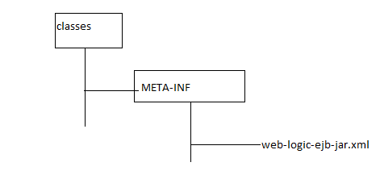

<weblogic-ejb-jar>
<weblogic-enterprise-bean>
<ejb-name>SB</ejb-name>
<statelsess-session-descriptor>
<pool>
<max-bean-in-free-pool>10</max-bean-in-free-pool>
<initial-bean-in-free-pool>5</ initial -bean-in-free-pool>
</pool>
</statelsess-session-descriptor>

</weblogic-enterprise-bean>

</weblogic-ejb-jar>

Q.1 When the container creates SLSB object?

R: According to the EJB specification the container can create any number of SLSB object at any point of time. When the above bean SB (name of StateBean) is deployed in weblogic, weblogic creates 5 SLSB object as we have specified initial-bean-in-free-pool 5 a pool. After creating the SLSB object container perform the following task.

- Perform the dependency injection (In our example the container set the variable sessionContext.
- Container call the PostConstruct method (in our case init() method will be called).
- When a client call the business method on SLSB the container pick up any one object available in the pool and execute the business method and container return the object to the pool.

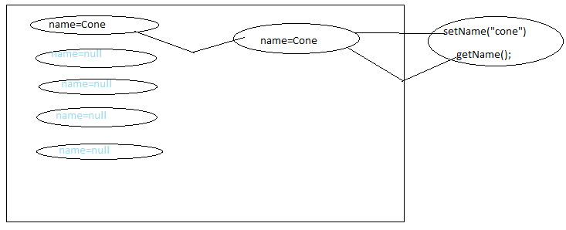
If five client calls the business method at a time, container pick-up five object from the available pool and start execution on these object.

If five objects are available in pool and 9 client has called the business method at once, the container creates 4 more bean object (even if it is not generated) the object to the pool & execute the business method on 9 objects.

If 11 client (more than max pool size) has called the business method and if 5 beans are available in the pool, container creates 5 more bean object to the pool (max-bean-in-free-pool =10) pick up 10 object from the pool and start execution of method on 10 client and keep the 11th client in the queue. After completing the execution of method on one of the bean the container uses that object on behalf of 11th object and execute the method for 11th client.

Q2. When does container removes SLSB object?

R: According to EJB Specification container can remove the SLSB obejct at any point of time from the pool, Before removing the object the container calls the method with annotation @PreDestroy.

Most of the container removes the object when the bean is un deployed.
If there are more number of beans (say 100) and only few of them (say 5) is used the container removes some of objects (say 50).

Q3. For what kind of EJB container uses object pooling technique?
R: For SLSB and Message Driven Bean.

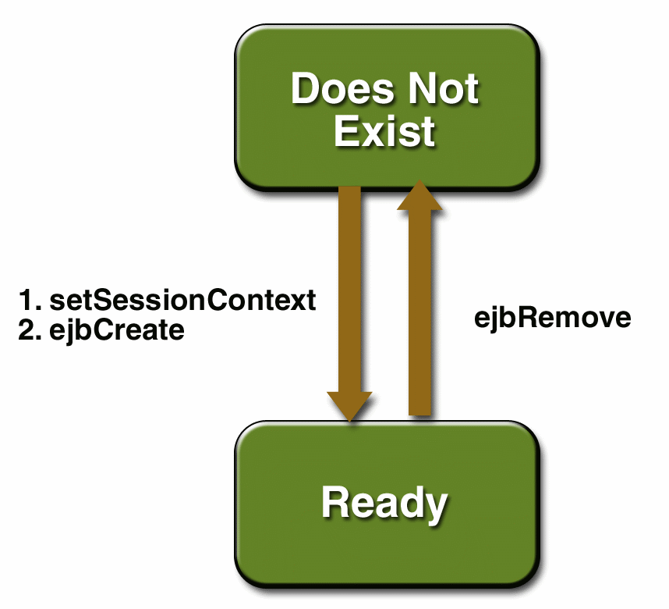

LIFE CYCLE OF STATEFULL SESSION BEAN
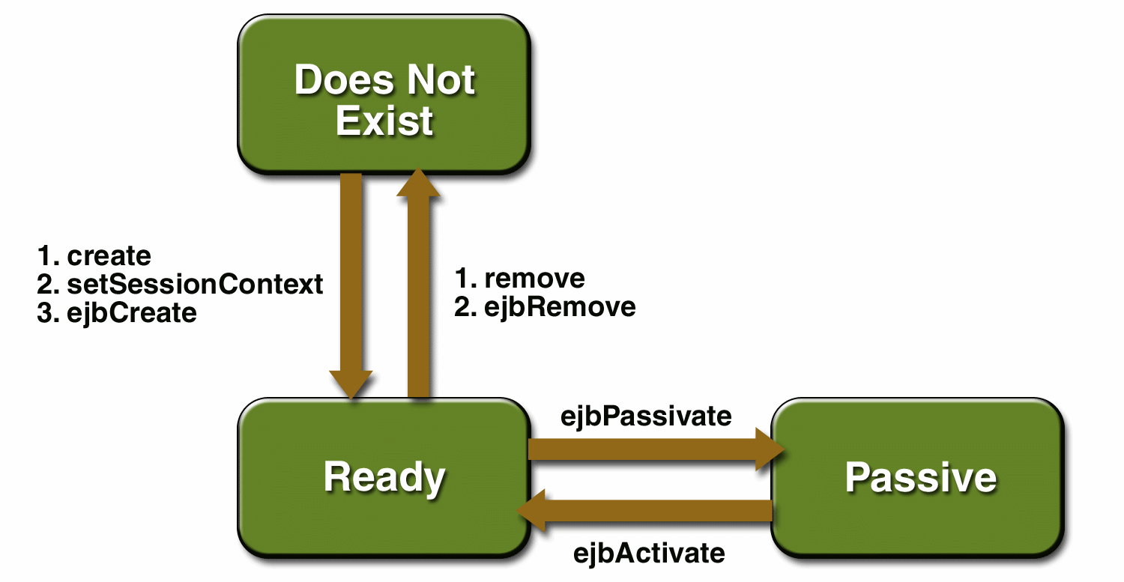

- The container does not uses object pooling for SFSB.
- The container is responsible for creating the bean object when the client uses ic.lookup(..) to get the reference of Remote business interface or local inter face.
- The container removes the object when the client call the method that is marked with the annotation @Remove. The name of method can be anything and this method should not take any parameter & return type must be void.
Note: SFSB is created for a particular client.
- A SFSB object can be either Active or Passive. When a bean is active the container can execute method on it otherwise container cannot execute method on it.
- When there is no space in the cache to create object the container passivates the object that are available in cache.
- During the passivation container carries out the following task:
- Container calls the method that is marked with annotation @Passivate
- Container uses the serialization technique and write the information about the object on disk.
- Takes out the object from the cache (even if the bean object is not available in the cache we should not consider object to be removed)
Q. When does the container passivate SFSB object?
R: When there is no space in the cache to create new object the container passivate the existing object.

Q. When does the container activate the SFSB objects?
R: When a method is invoked on object that was passive, the container activate the object while activating the object the container carries out the following steps:

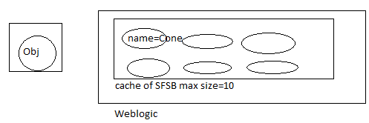
- Container uses deserialization technique & creates the object available in disk.
- Container uses deserialization techniques and creates object using info available in disk.
- Container calls the method that is marked with annotation PostActivate.
Q. What kind of code we must provide as part of PostConstruct & Predestroy?
R: As part of PostConstruct method we must provide the code to acquire resources like opening the socket connection etc.
In the predestroy method we must provide the code to deallocate the resources like closing the socket.
In the @Prepassivate & @PostActivate method code must be provided to take care of transient variable(Non serializable)
Note: Activate/Passivate is not used in SLSB.

package org.students;
Import javax.ejb.*;
@Remote
Public interface RIState{
public void setName(String name);
public void setName(String name);
public void remove();
}

package inet.solve;

import javax.annotation.PostConstruct;
import javax.annotation.PreDestroy;
import javax.annotation.Resource;
import javax.ejb.PostActivate;
import javax.ejb.PrePassivate;
import javax.ejb.SessionContext;
import javax.ejb.Stateful;

@Stateful(name="SFB",mappedName="SFB")
public class StateFullBean implements StateFullBeanLocal, StateFullBeanRemote {
@Resource
SessionContext sessionContext;
String name;
Transient Socket sock;//socket is non-serializable
@PostConstruct
public void init(){
try{
sock=new Socket();
}catch(Exception e){

}
}
@PreDestroy
public void destroy(){
System.out.println("Predestroy--");
try{
sock=null;
}catch(Exception e){

}

}

@PrePassivate
public void passivate(){
System.out.println("--Pre Passivate---");
try{
sock=null;
}catch(Exception e){

}

}

@PostActivate
public void activate(){
System.out.println("---Post Activate---");
try{
sock=new Socket();
}catch(Exception e){

}

}
public void setName(String name){
this.name=name;
}
public String getName(){
return name;
}
@Remove
public void remove(){
System.out.println("---Remove---");

}

}

There will be more burden on the server while maintaining SFSB’s.
Most of the developer prefer to use SLSB’s as part of their project.

The designer of an ejb can design entire project using only SLSB.

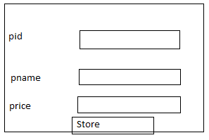

..setPid(“10”);
..setPname(“xyz”);
..setPrice(“10”);
Beanref.storeProd();
Webserver: A product that uses http protocol ( long back ago).
Application Server: The Server that provides the features like Transaction management (TM), creation, removal, activation, passivation managing the object) of object managing security etc & simplifies the developments of business logic are considered as Application Server.

TMS (Microsoft Transaction Server) the product like weblogic, websphere, JBoss are called as application Server. MITS (Internet Information Server), Apache Tomcat are example of webserver.

Q. what are the difference between EJB2 and EJB 3
R:
- In EJB3 there is no need of providing Local Home interface Remote Home interface.
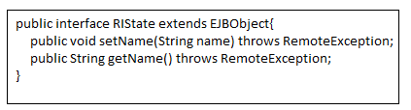
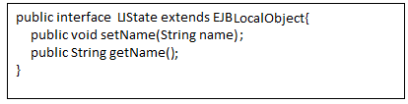
- POJI (Plain Old Java Interface) is supported in EJB3.
Remote business inter face and local business interface in EJB3 are POJI. In EJB2 RBI must be sub interface of EJBObject and LBI must be subinterface of EJBLocalObect. But in the new version RBI, LBI need not to be subinterface EJBObject, EJBLocalObect.
- The Bean classes of EJB3 are POJO (Plain Old Java Object) but in case of EJB2 while providing the session beans we must provide the bean class implementing the SessionBean interface but in EJB3 bean class need not to implement SessionBean interface. This is why EJB3 are called POJO classes.
- EJB3 support annotation but EJB2 does not.
- In EJB2 we must provide deployment descriptor file (ejb-jar.xml, weblogic-ejb-jar.xml). We can use annotation to provide the information about bean in place of deployment descriptor in EJB3.
Deployment descriptor are optional in EJB3. If some information is provided in annotation and in DD (deployment descriptor) the container uses the information provided in DD.
- Dependency injection is not supported in EJB2.
JPA( Java Persistence API)

- JPA is very much similar to hibernate/toplink
- The EntityBeans of EJB1 & EJB2 can be used only inside the EJB container.
- To access the data available in table we must use entity classes.
- The entity classes are very muc similar to POJO ckasses that we used in hibernate.
- JPA can be used inside the EJB container as well as outside the EJB container(JPA can be used as part of a web application,applet,ejb application, standalone java application)
Procedure for setting up MyEclipse for developing JPA based applications
- create a director for workspace(f:\eclws) and copy the jdbc driver ojdbc14.jar) to this directory
- start myeclipse6 and choose the directory created in step1 as workspace
- setup a database profile by following steps given below:
  - open prespective shos MyEclipse Database prespective
  - Right click to get the pop up menu inside DB browser view and choose new option
  - In database driver window choose oracle thin driver as template and provide the following details
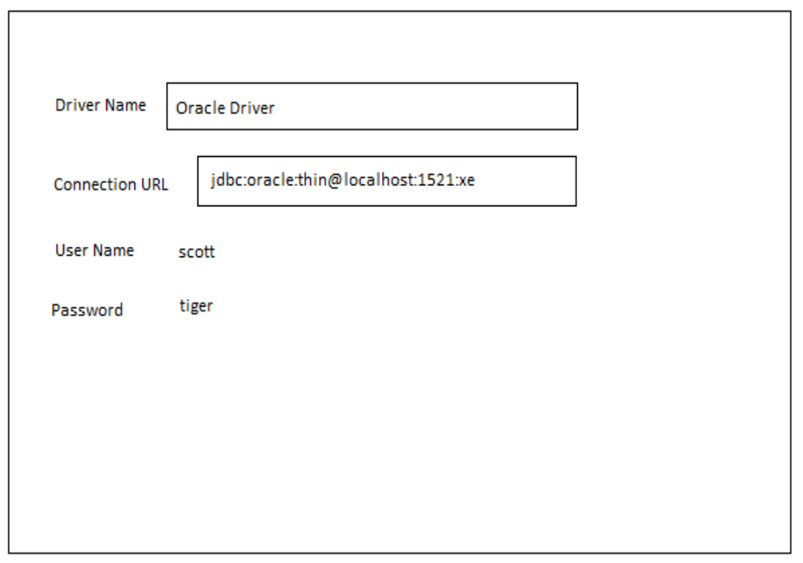
    - click on add jar button and choose ojdbc14.jar file and click on finish button

Procedure for developing JAVA PROJECT with JPA:

javax.persistance is a package that is part of JEE5. As part of this package following interfaces are provided:

- EntityManagerFactory
- EntityManager
- EntityTransaction
- Query
javax.persistance.Persistance is a class that must be used to get the EntityManagerFactory object.

Steps:
    - choose File-->New Project, choose Java-->project in New project window and click on next button
    - In New Java Project window provide the projcet name (jpa one) and click on finish
    - choose the project in package explorer and choose myeclipse-->Add JPA capablity
    - click on next button in Add JPA capablity window
    - provide persistance unit name(perone), choose oracle driver as dirver and click on update list butto choose scott as catalog/schema and click on Finish

Note: MyEclipse create a file with the name persistance.xml, inside this file, the details regarding persistance unit will be stored.

        - choose Myeclipse databse explorer perspective
        - Right click on oracle driver and choose open connection
        - choose table/tables abd right click to get the popup menu, choose JPA Reverse Engineering
        - choose src folder of the project as java src folder and provide org.students as java package and check the option Entity bean

        - click on finish button
Note: Myeclipse generated entity classes(POJO classes) with annotation like entity, id, column, table etc.

MDB(Message Driven Bean)

package org.jboss.book.jms.ex2;

import javax.ejb.MessageDrivenBean;
import javax.ejb.MessageDrivenContext;
import javax.ejb.EJBException;
import javax.jms.JMSException;
import javax.jms.Message;
import javax.jms.MessageListener;
import javax.jms.Queue;
import javax.jms.QueueConnection;
import javax.jms.QueueConnectionFactory;
import javax.jms.QueueSender;
import javax.jms.QueueSession;
import javax.jms.TextMessage;
import javax.naming.InitialContext;
import javax.naming.NamingException;

/**
* An MDB that transforms the TextMessages it receives and send the
* transformed messages to the Queue found in the incoming message
* JMSReplyTo header.
*
* @author Scott.Stark@jboss.org
* @version $Revision: 1.9 $
*/
public class TextMDB
implements MessageDrivenBean, MessageListener
{
private MessageDrivenContext ctx = null;
private QueueConnection conn;
private QueueSession session;

public TextMDB()
{
System.out.println("TextMDB.ctor, this="+hashCode());
}

public void setMessageDrivenContext(MessageDrivenContext ctx)
{
this.ctx = ctx;
System.out.println("TextMDB.setMessageDrivenContext, this=" +
hashCode());
}

public void ejbCreate()
{
System.out.println("TextMDB.ejbCreate, this="+hashCode());
try {
setupPTP();
} catch (Exception e) {
throw new EJBException("Failed to init TextMDB", e);
}
}

public void ejbRemove()
{
System.out.println("TextMDB.ejbRemove, this="+hashCode());
ctx = null;
try {
if (session != null) {
session.close();
}
if (conn != null) {
conn.close();
}
} catch(JMSException e) {
e.printStackTrace();
}
}

public void onMessage(Message msg)
{
System.out.println("TextMDB.onMessage, this="+hashCode());
try {
TextMessage tm = (TextMessage) msg;
String text = tm.getText() + "processed by: "+hashCode();
Queue dest = (Queue) msg.getJMSReplyTo();
sendReply(text, dest);
} catch(Throwable t) {
t.printStackTrace();
}
}

private void setupPTP()
throws JMSException, NamingException
{
InitialContext iniCtx = new InitialContext();
Object tmp = iniCtx.lookup("java:comp/env/jms/QCF");
QueueConnectionFactory qcf = (QueueConnectionFactory) tmp;
conn = qcf.createQueueConnection();
session = conn.createQueueSession(false,
QueueSession.AUTO_ACKNOWLEDGE);
conn.start();
}

private void sendReply(String text, Queue dest)
throws JMSException
{
System.out.println("TextMDB.sendReply, this=" +
hashCode() + ", dest="+dest);
QueueSender sender = session.createSender(dest);
TextMessage tm = session.createTextMessage(text);
sender.send(tm);
sender.close();
}
}

<?xml version="1.0"?>
<!DOCTYPE ejb-jar PUBLIC
"-//Sun Microsystems, Inc.//DTD Enterprise JavaBeans 2.0//EN"
"http://java.sun.com/dtd/ejb-jar_2_0.dtd">
<ejb-jar>
<enterprise-beans>
<message-driven>
<ejb-name>TextMDB</ejb-name>
<ejb-class>org.jboss.book.jms.ex2.TextMDB</ejb-class>
<transaction-type>Container</transaction-type>
<acknowledge-mode>AUTO_ACKNOWLEDGE</acknowledge-mode>
<message-driven-destination>
<destination-type>javax.jms.Queue</destination-type>
</message-driven-destination>
<res-ref-name>jms/QCF</res-ref-name>
<resource-ref>
<res-type>javax.jms.QueueConnectionFactory</res-type>
<res-auth>Container</res-auth>
</resource-ref>
</message-driven>
</enterprise-beans>
</ejb-jar>
Example 7.7. The MDB ejb-jar.xml descriptor

<?xml version="1.0"?>
<jboss>
<enterprise-beans>
<message-driven>
<ejb-name>TextMDB</ejb-name>
<destination-jndi-name>queue/B</destination-jndi-name>
<resource-ref>
<res-ref-name>jms/QCF</res-ref-name>
<jndi-name>ConnectionFactory</jndi-name>
</resource-ref>
</message-driven>
</enterprise-beans>
</jboss>

package org.jboss.book.jms.ex2;

import javax.jms.JMSException;
import javax.jms.Message;
import javax.jms.MessageListener;
import javax.jms.Queue;
import javax.jms.QueueConnection;
import javax.jms.QueueConnectionFactory;
import javax.jms.QueueReceiver;
import javax.jms.QueueSender;
import javax.jms.QueueSession;
import javax.jms.TextMessage;
import javax.naming.InitialContext;
import javax.naming.NamingException;

import EDU.oswego.cs.dl.util.concurrent.CountDown;

/**
* A complete JMS client example program that sends N TextMessages to
* a Queue B and asynchronously receives the messages as modified by
* TextMDB from Queue A.
*
* @author Scott.Stark@jboss.org
* @version $Revision: 1.9 $
*/
public class SendRecvClient
{
static final int N = 10;
static CountDown done = new CountDown(N);

QueueConnection conn;
QueueSession session;
Queue queA;
Queue queB;

public static class ExListener
implements MessageListener
{
public void onMessage(Message msg)
{
done.release();
TextMessage tm = (TextMessage) msg;
try {
System.out.println("onMessage, recv text="+tm.getText());
} catch(Throwable t) {
t.printStackTrace();
}
}
}

public void setupPTP()
throws JMSException, NamingException
{
InitialContext iniCtx = new InitialContext();
Object tmp = iniCtx.lookup("ConnectionFactory");
QueueConnectionFactory qcf = (QueueConnectionFactory) tmp;
conn = qcf.createQueueConnection();
queA = (Queue) iniCtx.lookup("queue/A");
queB = (Queue) iniCtx.lookup("queue/B");
session = conn.createQueueSession(false,
QueueSession.AUTO_ACKNOWLEDGE);
conn.start();
}

public void sendRecvAsync(String textBase)
throws JMSException, NamingException, InterruptedException
{
System.out.println("Begin sendRecvAsync");

// Setup the PTP connection, session
setupPTP();

// Set the async listener for queA
QueueReceiver recv = session.createReceiver(queA);
recv.setMessageListener(new ExListener());

// Send a few text msgs to queB
QueueSender send = session.createSender(queB);

for(int m = 0; m < 10; m ++) {
TextMessage tm = session.createTextMessage(textBase+"#"+m);
tm.setJMSReplyTo(queA);
send.send(tm);
System.out.println("sendRecvAsync, sent text=" + tm.getText());
}
System.out.println("End sendRecvAsync");
}

public void stop()
throws JMSException
{
conn.stop();
session.close();
conn.close();
}

public static void main(String args[])
throws Exception
{
System.out.println("Begin SendRecvClient,now=" +
System.currentTimeMillis());
SendRecvClient client = new SendRecvClient();
client.sendRecvAsync("A text msg");
client.done.acquire();
client.stop();
System.exit(0);
System.out.println("End SendRecvClient");
}

}

