Java
Core Java
JDK 1.6 features
- Improvement in collection framework
- JDBC 4.0 support
- Enhancement in internationalization
- Enhancement in Swing api like drag and drop support.
- I/O enhancement like Console: Contains methods to access a character-based console device. The readPassword() methods disable echoing thus they are suitable for retrieval of sensitive data such as passwords.
The method System.console() returns the unique console associated with the Java Virtual Machine.
- JConsole is Officially Supported in Java SE 6
The Java SE platform provides a graphical monitoring tool called JConsole. The JConsole tool implements the Java Management Extensions (JMX) API and enables you to monitor the performance of a Java VM and any instrumented applications
- Java SE 6 includes JSR 223: Scripting for the Java™ Platform API. This is a framework by which Java Applications can "host" script engines. Sun's implementation of Java SE 6 includes an example script engine based on Mozilla Rhino:JavaScript for Java. The scripting framework supports third-party script engines through jar "service discovery" mechanism. It is possible to "drop" any JSR-223 compliant script engine in the CLASSPATH and access the same from your Java applications (much like JDBC drivers, JNDI implementations are accessed).
- Security Enhancement like Sun's Java SE 6 implementation bundles the Smart Card I/O API defined by JSR 268 as well as a provider called SunPCSC which uses the platform's native PC/SC Smart Card stack, if available. Note that neither the API nor the SunPCSC provider are part of the Java SE 6 platform specification and may not be present on other compliant Java SE implementations

Collection framework enhancement:
These new collection interfaces are provided:
Interface | Description
Deque | a double ended queue, supporting element insertion and removal at both ends. Extends the Queue interface.
BlockingDeque | a Deque with operations that wait for the deque to become non-empty when retrieving an element, and wait for space to become available in the deque when storing an element. Extends both the Deque andBlockingQueue interfaces. (This interface is part of java.util.concurrent.)
NavigableSet | a SortedSet extended with navigation methods reporting closest matches for given search targets. A NavigableSet may be accessed and traversed in either ascending or descending order. This interface is intended to supersede the SortedSet interface.
NavigableMap | a SortedMap extended with navigation methods returning the closest matches for given search targets. A NavigableMap may be accessed and traversed in either ascending or descending key order. This interface is intended to supersede the SortedMap interface.
- ConcurrentNavigableMap | a ConcurrentMap that is also a NavigableMap. (This interface is part of java.util.concurrent.)

The following concrete implementation classes have been added:
Classes | Description
ArrayDeque | efficient resizable-array implementation of the Deque interface.
ConcurrentSkipListSet | concurrent scalable skip list implementation of the NavigableSet interface
ConcurrentSkipListMap | concurrent scalable skip list implementation of the ConcurrentNavigableMap interface
LinkedBlockingDeque | concurrent scalable optionally bounded FIFO blocking deque backed by linked nodes.
AbstractMap.SimpleEntry | simple mutable implementation of Map.Entry
AbstractMap.SimpleImmutableEntry | simple immutable implementation of Map.Entry

These existing classes have been retrofitted to implement new interfaces:
- LinkedList - retrofitted to implement the Deque interface.
- TreeSet - retrofitted to implement the NavigableSet interface.
- TreeMap - retrofitted to implement the NavigableMap interface.
Two new methods were added to the Collections utility class:
- newSetFromMap(Map) - creates a general purpose Set implementation from a general purpose Map implementation.
There is no IdentityHashSet class, but instead, just use
Set<Object> identityHashSet=
Collections.newSetFromMap(
new IdentityHashMap<Object, Boolean>());
- asLifoQueue(Deque) - returns a view of a Deque as a Last-in-first-out (Lifo) Queue.
The Arrays utility class now has methods copyOf and copyOfRange that can efficiently resize, truncate, or copy subarrays for arrays of all types.
Before:
int[] newArray = new int[newLength];
System.arraycopy(oldArray, 0, newArray, 0, oldArray.length);
After:
int[] newArray = Arrays.copyOf(a, newLength);

Core Java Internationalization

Locale Sensitive Services SPIs
To enable plug-in of locale sensitive data (e.g., date format strings) and services (e.g., date formatters), some Service Provider Interfaces (SPIs) for locale-sensitive classes in the java.text and java.util packages have been added. These SPIs make it much easier for developers to provide support of more locales in addition to the currently available locales in Java SE. For example, your own implementation of BreakIterator for Chinese could become available through theBreakIterator.getSentenceInstance factory in the Java runtime.

Unicode Normalizer API
The new java.text.Normalizer class supports the Unicode text normalization defined in Unicode Standard Annex #15.

Internationalized Domain Names Support
The new java.net.IDN class provides Internationalized Domain Names (IDNs) support based on RFC 3490, 3491, 3454, and 3492.

Japanese Imperial Calendar Support
A new Calendar implementation has been added to support the Japanese imperial era-based year numbering, such as Heisei 17 for 2005 (Gregorian). An instance of this Japanese imperial calendar can be created through theCalendar.getInstance factory by specifying a Locale("ja", "JP", "JP"). The java.text.SimpleDateFormat class now supports calendar specific eras and date formats for non-Gregorian calendar systems. Refer to the Supported Calendars documentation for details.

ResourceBundle Enhancements
The new nested java.util.ResourceBundle.Control class has been added to give applications more control over the resource bundle loading process. The class defines a set of callback methods that are invoked by theResourceBundle.getBundle factory during the resource bundle loading. Applications can override those callback methods to change the factory method behavior.

Additional Locales Support
The following locales are now available.
- zh_SG - Chinese (Simplified), Singapore
- en_MT - English, Malta
- en_PH - English, Philippines
- en_SG - English, Singapore
- el_CY - Greek, Cyprus
- id_ID - Indonesian, Indonesia
- ga_IE - Irish, Ireland
- ms_MY - Malay, Malaysia
- mt_MT - Maltese, Malta
- pt_BR - Portuguese, Brazil
- pt_PT - Portuguese, Portugal
- es_US - Spanish, United States

IO Enhancements in Java SE 6
- Console - Contains methods to access a character-based console device. The readPassword() methods disable echoing thus they are suitable for retrieval of sensitive data such as passwords. The method System.console() returns the unique console associated with the Java Virtual Machine.
The following new methods were added to File:
- Methods to retrieve disk usage information:
  - getTotalSpace() returns the size of the partition in bytes
  - getFreeSpace() returns the number of unallocated bytes in the partition
  - getUsableSpace() returns the number of bytes available on the partition and includes checks for write permissions and other operating system restrictions
- Methods to set or query file permissions:
  - setWritable(boolean writable, boolean ownerOnly) and setWritable(boolean writable) set the owner's or everybody's write permission
  - setReadable(boolean readable, boolean ownerOnly) and setReadable(boolean readable) set the owner's or everybody's read permission
  - setExecutable(boolean executable, boolean ownerOnly) and setExecutable(boolean executable) set the owner's or everybody's execute permission
  - canExecute() tests the value of the execute permission
Constructors were added to the following class:
- IOException supports exception chaining via the addition of the new constructors IOException(String, Throwable) and IOException(Throwable).
The behavior of the following method was modified:
- The File.isFile() Windows implementation has been modified to always return false for reserved device names such as CON, NUL, AUX, LPT, etc. Previously it returned true, which customers considered a bug because it was inconsistent with behavior for devices on Unix.
JDK 1.5 features
  - Generics
This long-awaited enhancement to the type system allows a type or method to operate on objects of various types while providing compile-time type safety. It adds compile-time type safety to the Collections Framework and eliminates the drudgery of casting
  - Enhanced for Loop
  - Autoboxing/Unboxing
  - Typesafe Enums
  - Varargs
Varargs is a helper syntax and it enables use of variable number of arguments in a method call. In method definition variable aruguments are indicated by elipsis (…) and is called as ‘variable arity method’ and ‘variable arity parameter’ in java language specification. While invoking the varargs method we can use any number of arguments of type specified and separated by comma.
package com.test;

public class VarArgSample {

static int sum(int i, int... marks) {
int total = 0;
for (int mark : marks) {
total = total + mark;
}
return total;
}

public static void main(String[] args) {

//invoking with variable arguments
System.out.println(sum(1, 2, 3));

//same invocation using an array
int arr[] = {2,3};
System.out.println(sum(1, arr));
}
}
Varargs Gotchas
As stated above java compiler removes elipsis (…) and replaces it with an array in bytecode. JVM is not aware of varargs and so when we use reflection there is no provision to pass variable arguments and we need to construct an array and pass it.

  - Static Import
The normal import declaration imports classes from packages, so that they can be used without package reference. Similarly the static import declaration imports static members from classes and allowing them to be used without class reference.
Consider the java example:
double r = Math.cos(Math.PI * theta);
How about writing the same java code like:
double r = cos(PI * theta);
– looks more readable right?
This is where static import in java comes to help you.
import static java.lang.Math.PI;
import static java.lang.Math.cos;

  - Metadata
Garbage collections
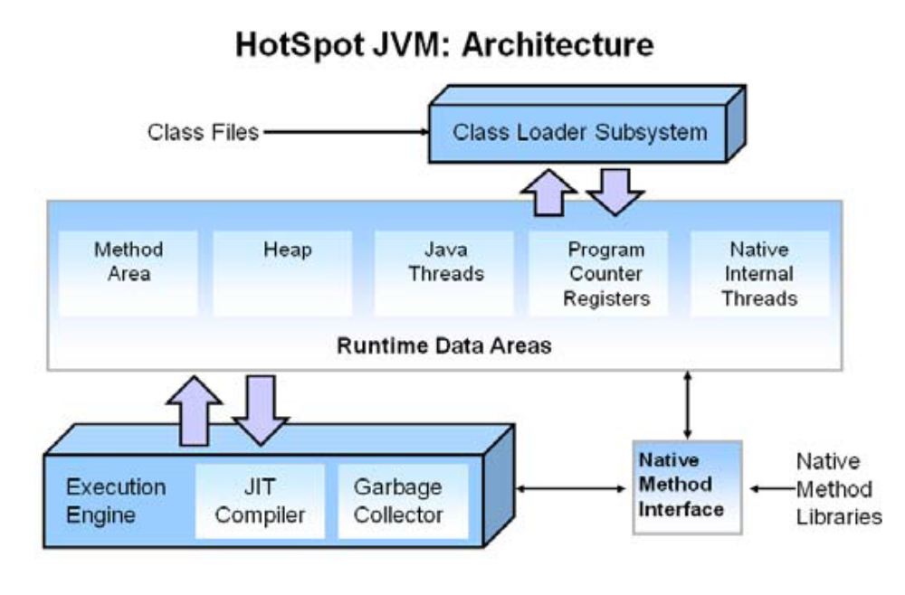
The main components of the JVM include the classloader, the runtime data areas, and the
execution engine.
Key Hotspot Components
The key components of the JVM that relate to performance are highlighted in the following image.
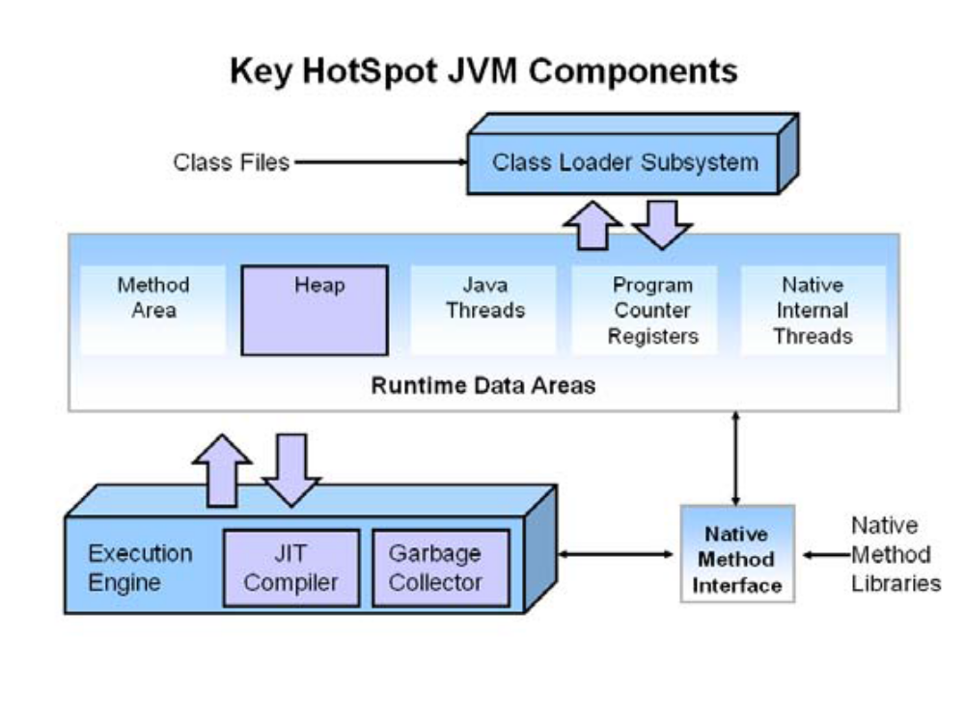
What is Automatic Garbage Collection?
Automatic garbage collection is the process of looking at heap memory, identifying which objects are in use and which are not, and deleting the unused objects. An in use object, or a referenced object, means that some part of your
program still maintains a pointer to that object. An unused object, or unreferenced object, is no longer referenced by
any part of your program. So the memory used by an unreferenced object can be reclaimed.
In a programming language like C, allocating and deallocating memory is a manual process. In Java, process of deallocating memory is handled automatically by the garbage collector. The basic process can be described as follows.
Step 1: Marking
The first step in the process is called marking. This is where the garbage collector identifies which pieces of memory are in use and which are not.
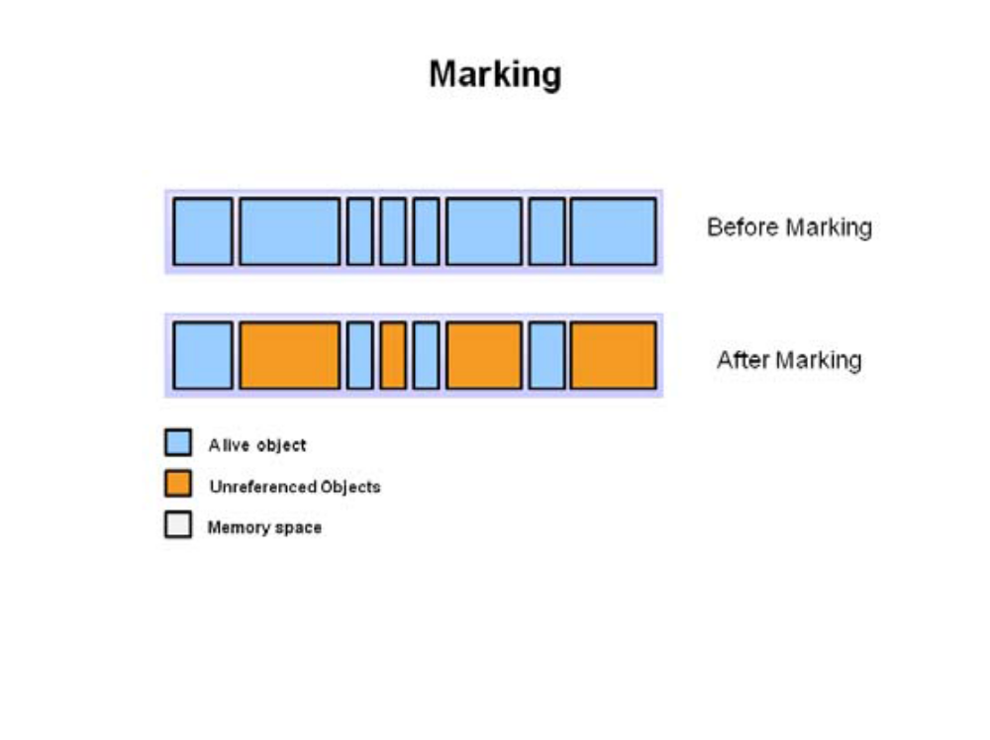
Referenced objects are shown in blue. Unreferenced objects are shown in gold. All objects are scanned in
the marking phase to make this determination. This can be a very time consuming process if all objects in a
system must be scanned.
Step 2: Normal Deletion
Normal deletion removes unreferenced objects leaving referenced objects and pointers to free space.
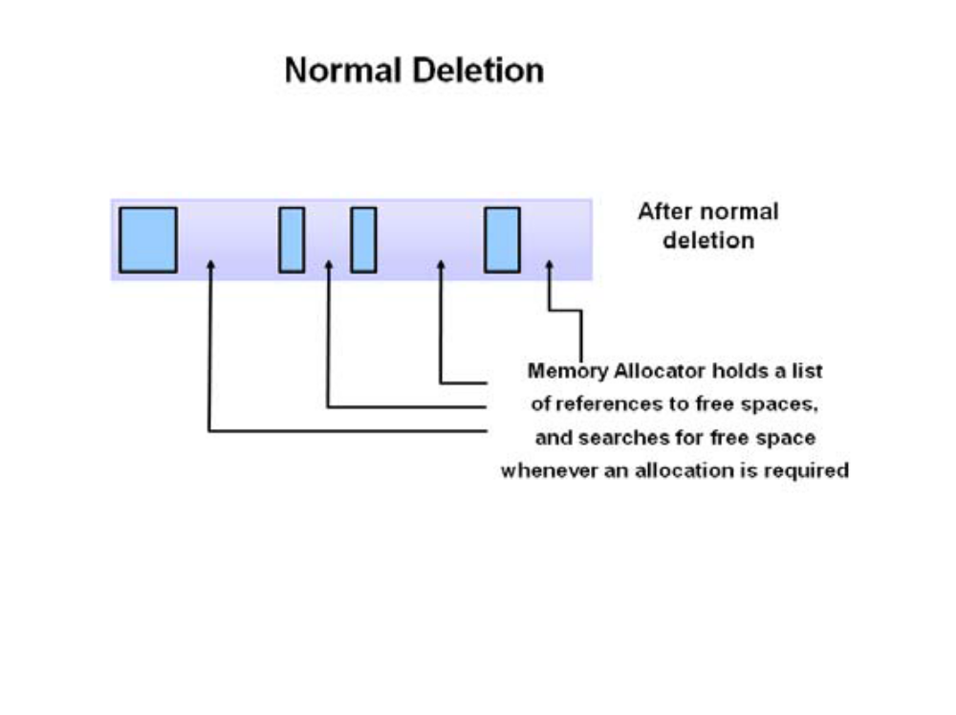
The memory allocator holds references to blocks of free space where new object can be allocated.
Step 2a: Deletion with Compacting
To further improve performance, in addition to deleting unreferenced objects, you can also compact the remaining referenced objects. By moving referenced object together, this makes new memory allocation much easier and faster.
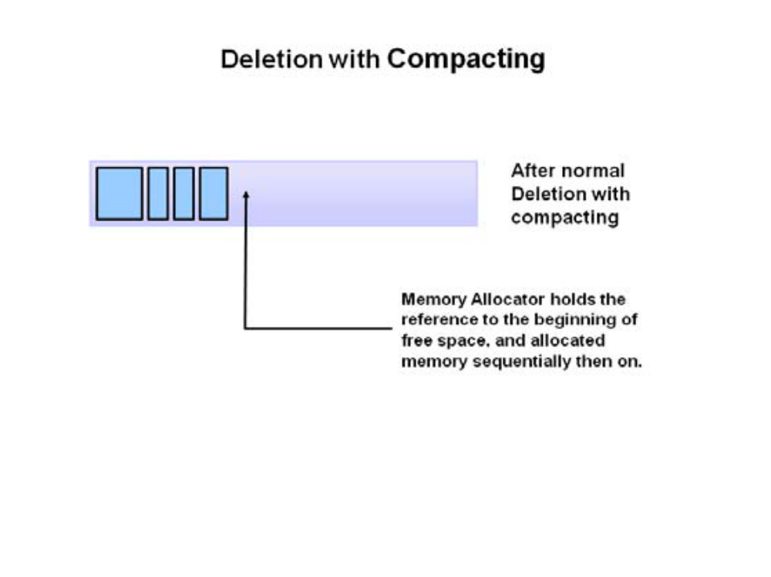
Why Generational Garbage Collection?
As stated earlier, having to mark and compact all the objects in a JVM is inefficient. As more and more objects are allocated, the list of objects grows and grows leading to longer and longer garbage collection time. However, empirical
analysis of applications has shown that most objects are short lived.
Here is an example of such data. The Y axis shows the number of bytes allocated and the X access shows the number of bytes allocated over time.
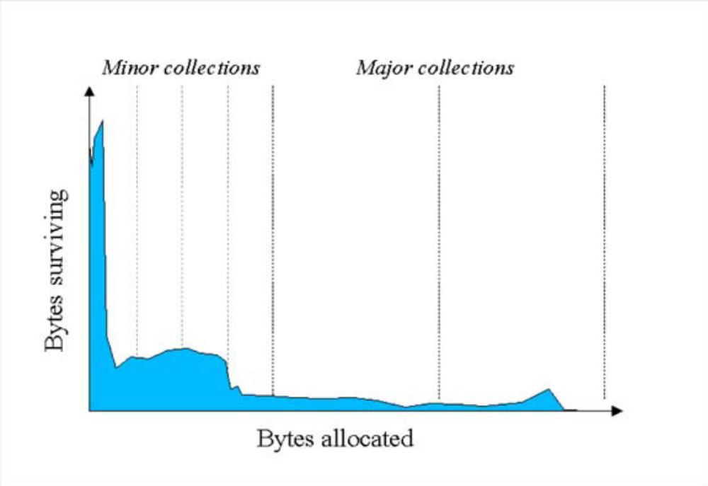
As you can see, fewer and fewer objects remain allocated over time. In fact most objects have a very short life as shown by the higher values on the left side of the graph.

JVM Generations
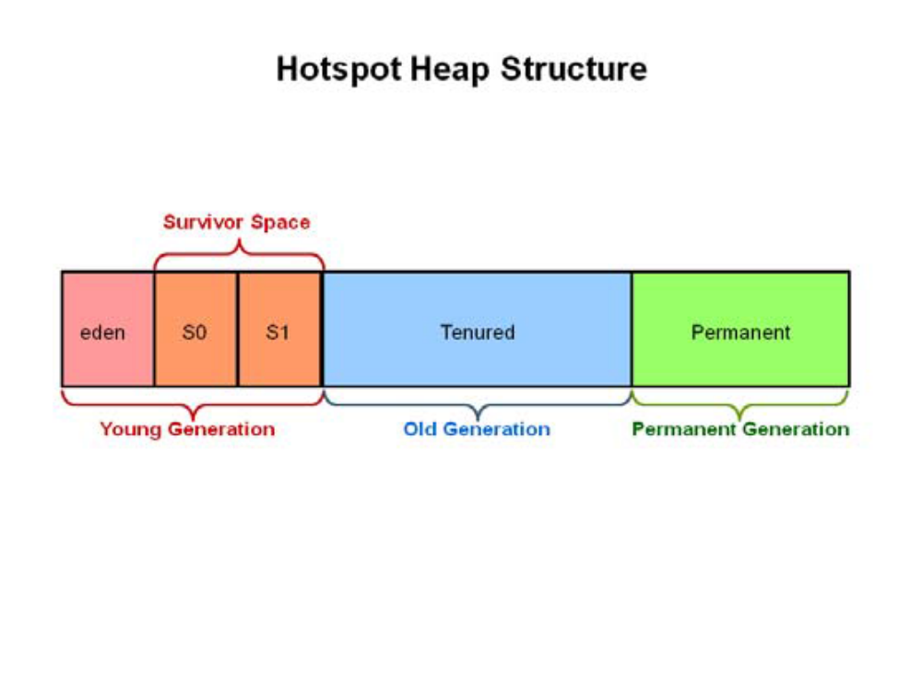
The information learned from the object allocation behavior can be used to enhance the performance of the JVM. Therefore, the heap is broken up into smaller parts or generations. The heap parts are: Young Generation, Old or Tenured Generation, and Permanent Generation

The Young Generation is where all new objects are allocated and aged. When the young generation fills up, this causes a minor garbage collection. Minor collections can be optimized assuming a high object mortality rate. A young generation full of dead objects is collected very quickly. Some surviving objects are
aged and eventually move to the old generation.
Stop the World Event - All minor garbage collections are "Stop the World" events. This means that all application threads are stopped until the operation completes. Minor garbage collections are always Stop the World events.
The Old Generation is used to store long surviving objects. Typically, a threshold is set for young generation object and when that age is met, the object gets moved to the old generation. Eventually the old generation needs to be collected. This event is called a major garbage collection.
Major garbage collection are also Stop the World events. Often a major collection is much slower because it involves all live objects. So for Responsive applications, major garbage collections should be minimized. Also note, that the length of the Stop the World event for a major garbage collection is affected by the kind of garbage collector that is used for the old generation space.
Classes may get collected (unloaded) if the JVM finds they are no longer needed and space may be needed
for other classes. The permanent generation is included in a full garbage collection.
(2) Tuning GC with JVM 5 - Section 3 Generations

General Garbage Collection process
Now that you understand why the heap is separated into different generations, it is time to look at how exactly these spaces interact. The pictures that follow walks through the object allocation and aging process in the JVM.

1. First, any new objects are allocated to the eden space. Both survivor 1. spaces start out empty.
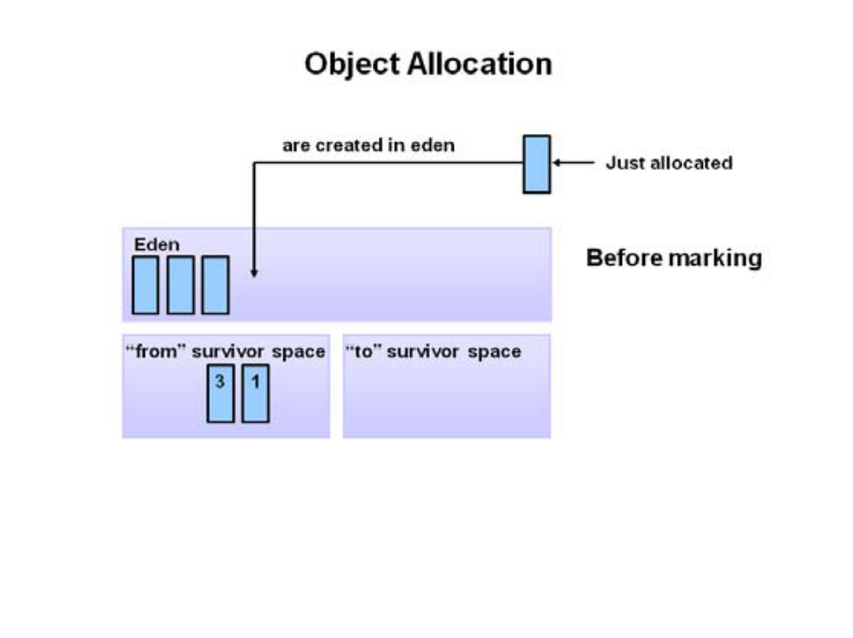
2. When the eden space fills up, a minor garbage collection is triggered.
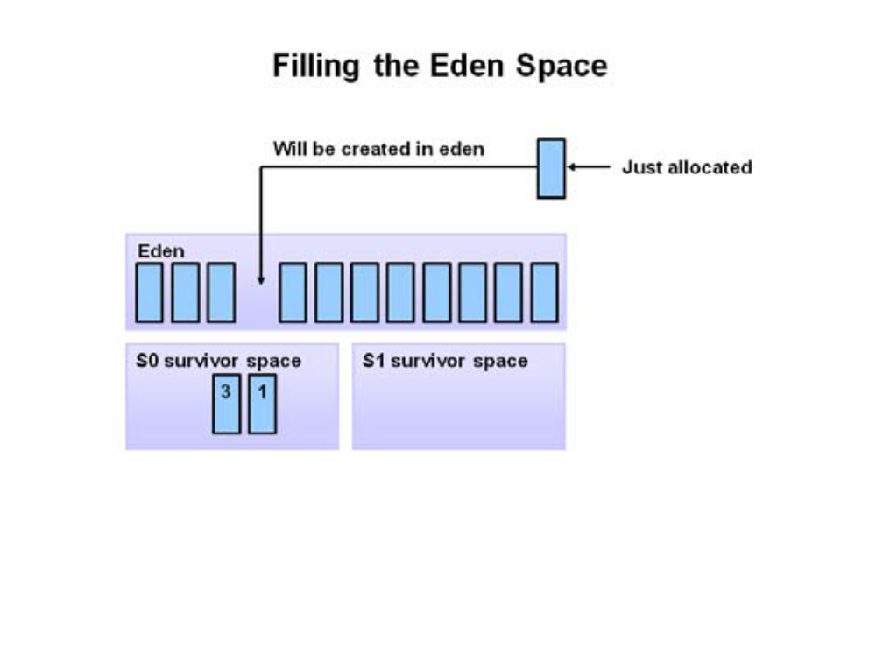
3. Referenced objects are moved to the first survivor space. Unreferenced objects are deleted when the eden space is cleared.
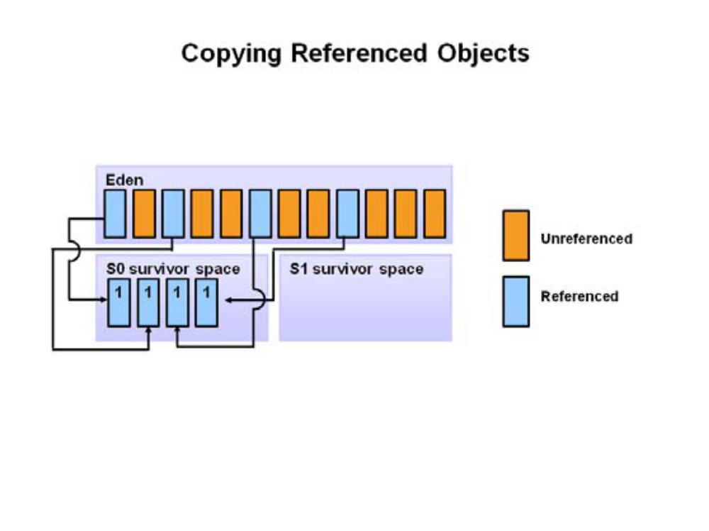
4. At the next minor GC, the same thing happens for the eden space. Unreferenced objects are deleted and referenced objects are moved to a survivor space. However, in this case, they are moved to the second survivor space (S1). In addition, objects from the last minor GC on the first survivor space (S0) have their age incremented and get moved to S1. Once all surviving objects have been moved to S1, both S0 and eden are cleared. Notice we now have differently aged object in the survivor space.
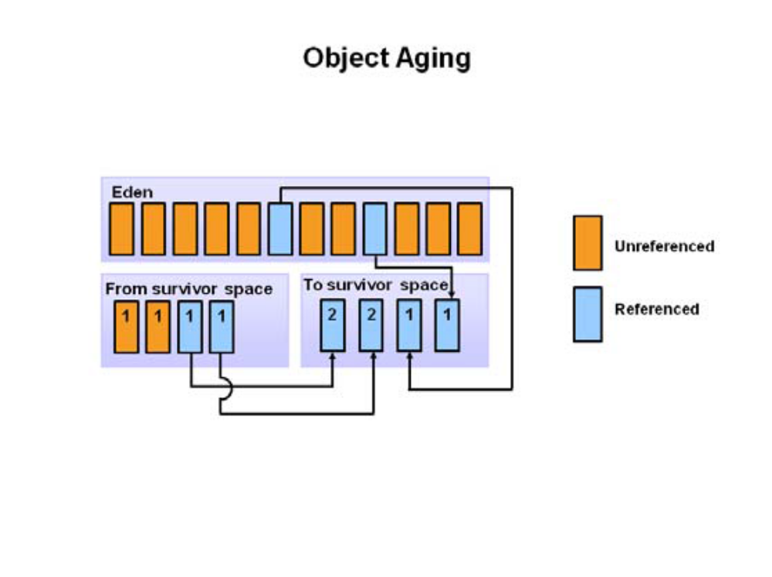
5. At the next minor GC, the same process repeats. However this time the survivor spaces switch. Referenced objects are moved to S0. Surviving objects are aged. Eden and S1 are cleared.
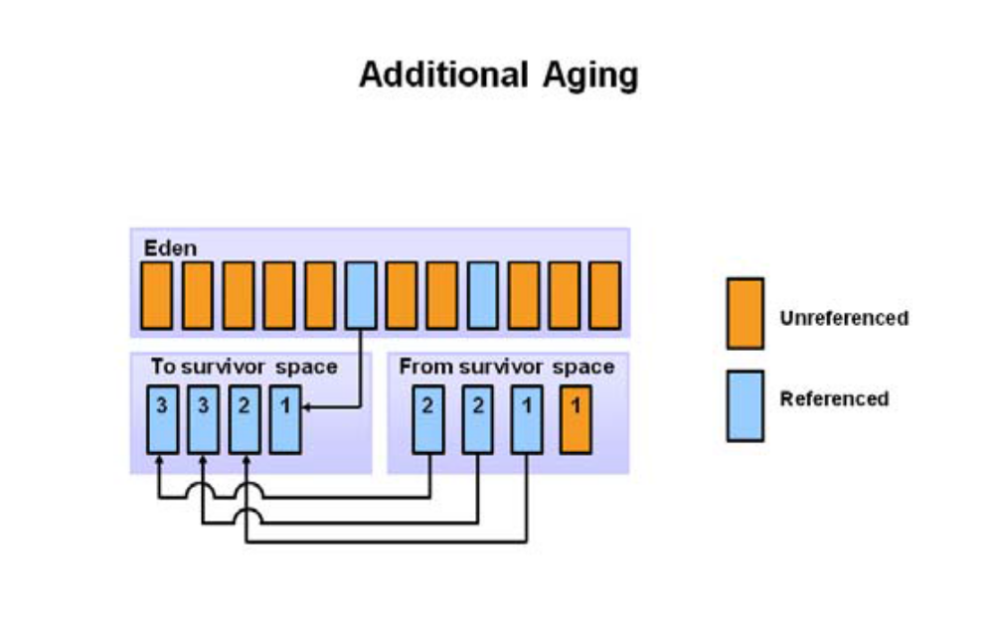
6. This slide demonstrates promotion. After a minor GC, when aged objects reach a certain age threshold (8 in this example) they are promoted from young generation to old eneration.
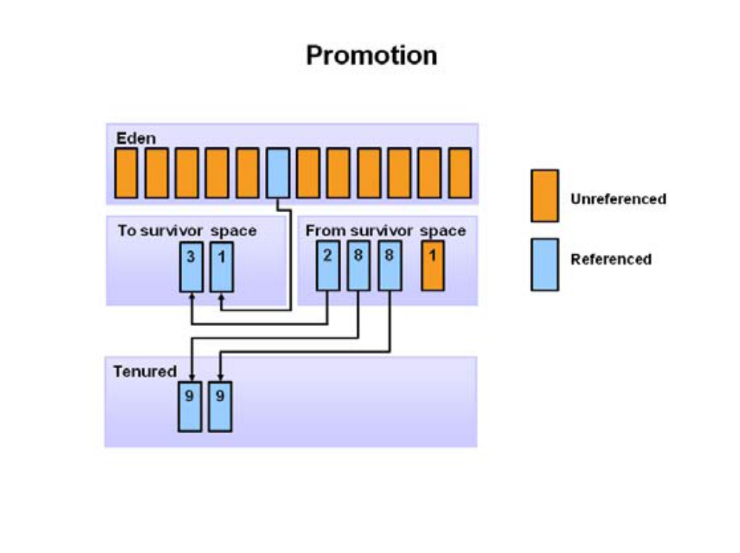
7.As minor GCs continue to occure objects will continue to be promoted to 7. the old generation space.
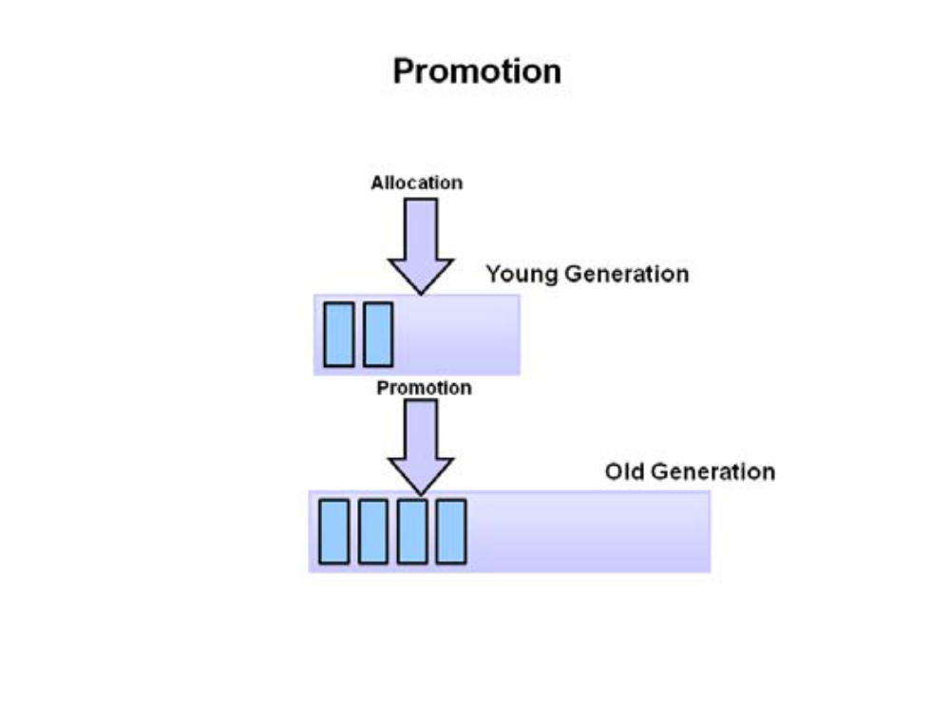
8.So that pretty much covers the entire process with the young generation. Eventually, a major GC will be performed on the old generation which cleans up and compacts that space.

Performing your own observations

Overview
You have seen the garbage collection process using a series of pictures. Now it is time to experience and explore the process live. In this activity, you will run a Java application and analyze the garbage collection process using Visual VM. The Visual VM program is included with the JDK and allows developers to monitor various aspects of a running JVM.

Serialization
- Define Serialization? What do you mean by Serialization in Java?

Serialization is a mechanism by which you can save or transfer the state of an object by converting it to a byte stream. This can be done in java by implementing Serialiazable interface. Serializable is defined as a marker interface which needs to be implemented for transferring an object over a network or persistence of its state to a file. Since its a marker interface, it does not contain any methods. Implementation of this interface enables the conversion of object into byte stream and thus can be transferred. The object conversion is done by the JVM using its default serialization mechanism.
Why is Serialization required? What is the need to Serialize?

Serialization is required for a variety of reasons. It is required to send across the state of an object over a network by means of a socket. One can also store an object’s state in a file. Additionally, manipulation of the state of an object as streams of bytes is required. The core of Java Serialization is the Serializable interface. When Serializable interface is implemented by your class it provides an indication to the compiler that java Serialization mechanism needs to be used to serialize the object.

- What is the Difference between Externalizable and Serializable Interfaces?

This is one of top serialization questions that is asked in many big companies to test your in-depth understanding of serialization. Serializable is a marker interface therefore you are not forced to implement any methods, however Externalizable contains two methods readExternal() and writeExternal() which must be implemented. Serializable interface provides a inbuilt serialization mechanism to you which can be in-efficient at times. However Externilizable interface is designed to give you greater control over the serialization mechanism. The two methods provide you immense opportunity to enhance the performance of specific object serialization based on application needs. Serializable interface provides a default serialization mechanism, on the other hand, Externalizable interface instead of relying on default Java Serialization provides flexibility to control this mechanism. One can drastically improve the application performance by implementing the Externalizable interface correctly. However there is also a chance that you may not write the best implementation, so if you are not really sure about the best way to serialize, I would suggest your stick to the default implementation using Serializable interface.

- When will you use Serializable or Externalizable interface? and why?

Most of the times when you want to do a selective attribute serialization you can use Serializable interface with transient modifier for variables not to be serialized. However, use of Externalizable interface can be really effective in cases when you have to serialize only some dynamically selected attributes of a large object. Lets take an example, Some times when you have a big Java object with hundreds of attributes and you want to serialize only a dozen dynamically selected attributes to keep the state of the object you should use Externalizable interface writeObject method to selectively serialize the chosen attributes. In case you have small objects and you know that most or all attributes are required to be serialized then you should be fine with using Serializable interface and use of transient variable as appropriate.
What are the ways to speed up Object Serialization? How to improve Serialization performance?

The default Java Serialization mechanism is really useful, however it can have a really bad performance based on your application and business requirements. The serialization process performance heavily depends on the number and size of attributes you are going to serialize for an object. Below are some tips you can use for speeding up the marshaling and un-marshaling of objects during Java serialization process.

Mark the unwanted or non Serializable attributes as transient. This is a straight forward benefit since your attributes for serialization are clearly marked and can be easily achieved using Serialzable interface itself.
Save only the state of the object, not the derived attributes. Some times we keep the derived attributes as part of the object however serializing them can be costly. Therefore consider calcualting them during de-serialization process.
Serialize attributes only with NON-default values. For examples, serializing a int variable with value zero is just going to take extra space however, choosing not to serialize it would save you a lot of performance. This approach can avoid some types of attributes taking unwanted space. This will require use of Externalizable interface since attribute serialization is determined at runtime based on the value of each attribute.
Use Externalizable interface and implement the readObject and writeObject methods to dynamically identify the attributes to be serialized. Some times there can be a custom logic used for serialization of various attributes.

- What is a Serial Version UID (serialVersionUID) and why should I use it? How to generate one?
The serialVersionUID represents your class version, and you should change it if the current version of your class is not backwards compatible with its earlier versions. This is extract from Java API Documentation

The serialization runtime associates with each serializable class a version number, called a serialVersionUID, which is used during deserialization to verify that the sender and receiver of a serialized object have loaded classes for that object that are compatible with respect to serialization.

Most of the times, we probably do not use serialization directly. In such cases, I would suggest to generate a default serializable uid by clicking the quick fix option in eclipse.

- What would happen if the SerialVersionUID of an object is not defined?

If you don't define serialVersionUID in your serilizable class, Java compiler will make one by creating a hash code using most of your class attributes and features. When an object gets serialized, this hash code is stamped on the object which is known as the SerialVersionUID of that object. This ID is required for the version control of an object. SerialVersionUID can be specified in the class file also. In case, this ID is not specified by you, then Java compiler will regenerate a SerialVersionUID based on updated class and it will not be possible for the already serialized class to recover when a class field is added or modified. Its recommended that you always declare a serialVersionUID in your Serializable classes.
Does setting the serialVersionUID class field improve Java serialization performance?

Declaring an explicit serialVersionUID field in your classes saves some CPU time only the first time the JVM process serializes a given Class. However the gain is not significant, In case when you have not declared the serialVersionUID its value is computed by JVM once and subsequently kept in a soft cache for future use.
What are the alternatives to Serialization? If Serialization is not used, is it possible to persist or transfer an object using any other approach?

In case, Serialization is not used, Java objects can be serialized by many ways, some of the popular methods are listed below:

Saving object state to database, this is most common technique used by most applications. You can use ORM tools (e.g. hibernate) to save the objects in a database and read them from the database.
Xml based data transfer is another popular mechanism, and a lot of XML based web services use this mechanism to transfer data over network. Also a lot of tools save XML files to persist data/configurations.
JSON Data Transfer - is recently popular data transfer format. A lot of web services are being developed in JSON due to its small footprint and inherent integration with web browser due to JavaScript format.

- What are transient variables? What role do they play in Serialization process?

The transient keyword in Java is used to indicate that a field should not be serialized. Once the process of de-serialization is carried out, the transient variables do not undergo a change and retain their default value. Marking unwanted fields as transient can help you boost the serialization performance. Below is a simple example where you can see the use of transient keyword.
view plainprint?

class MyVideo implements Serializable
{
private Video video;
private transient Image thumbnailVideo;

private void generateThumbnail()
{
// Generate thumbnail.
}

private void readObject(ObjectInputStream inputStream)
throws IOException, ClassNotFoundException
{
inputStream.defaultReadObject();
generateThumbnail();
}
}

- Why does serialization NOT save the value of static class attributes? Why static variables are not serialized?

The Java variables declared as static are not considered part of the state of an object since they are shared by all instances of that class. Saving static variables with each serialized object would have following problems

It will make redundant copy of same variable in multiple objects which makes it in-efficient.
The static variable can be modified by any object and a serialized copy would be stale or not in sync with current value.

- How to Serialize a collection in java? How to serialize a ArrayList, Hashmap or Hashset object in Java?

All standard implementations of collections List, Set and Map interface already implement java.io.Serializable. All the commonly used collection classes like java.util.ArrayList, java.util.Vector, java.util.Hashmap, java.util.Hashtable, java.util.HashSet, java.util.TreeSet do implement Serializable. This means you do not really need to write anything specific to serialize collection objects. However you should keep following things in mind before you serialize a collection object - Make sure all the objects added in collection are Serializable. - Serializing the collection can be costly therefore make sure you serialize only required data isntead of serializing the whole collection. - In case you are using a custom implementation of Collection interface then you may need to implement serialization for it.

- Is it possible to customize the serialization process? How can we customize the Serialization process?

Yes, the serialization process can be customized. When an object is serialized, objectOutputStream.writeObject (to save this object) is invoked and when an object is read, ObjectInputStream.readObject () is invoked. What most people do not know is that Java Virtual Machine provides you with an option to define these methods as per your needs. Once this is done, these two methods will be invoked by the JVM instead of the application of the default serialization process. Classes that require special handling during the serialization and deserialization process must implement special methods with these exact signatures:
view plainprint?

private void writeObject(java.io.ObjectOutputStream out)
throws IOException
private void readObject(java.io.ObjectInputStream in)
throws IOException, ClassNotFoundException;
private void readObjectNoData()
throws ObjectStreamException;

- How can a sub-class of Serializable super class avoid serialization? If serializable interface is implemented by the super class of a class, how can the serialization of the class be avoided?

In Java, if the super class of a class is implementing Serializable interface, it means that it is already serializable. Since, an interface cannot be unimplemented, it is not possible to make a class non-serializable. However, the serialization of a new class can be avoided. For this, writeObject () and readObject() methods should be implemented in your class so that a Not Serializable Exception can be thrown by these methods. And, this can be done by customizing the Java Serialization process. Below the code that demonstrates it
view plainprint?

class MySubClass extends SomeSerializableSuperClass {
private void writeObject(java.io.ObjectOutputStream out)
throws IOException {
throw new NotSerializableException(“Can not serialize this class”);
}
private void readObject(java.io.ObjectInputStream in)
throws IOException, ClassNotFoundException {
throw new NotSerializableException(“Can not serialize this class”);
}
private void readObjectNoData()
throws ObjectStreamException; {
throw new NotSerializableException(“Can not serialize this class”);
}
}

- What changes are compatible and incompatible to the mechanism of java Serialization?

This is one of a difficult and tricky questions and answering this correctly would mean you are an expert in Java Serialization concept. In an already serialized object, the most challenging task is to change the structure of a class when a new field is added or removed. As per the specifications of Java Serialization, addition of any method or field is considered to be a compatible change whereas changing of class hierarchy or non-implementation of Serializable interface is considered to be a non-compatible change. You can go through the Java serialization specification for the extensive list of compatible and non-compatible changes. If a serialized object need to be compatible with an older version, it is necessary that the newer version follows some rules for compatible and incompatible changes. A compatible change to the implementing class is one that can be applied to a new version of the class, which still keeps the object stream compatible with older version of same class. Some Simple Examples of compatible changes are:

Addition of a new field or class will not affect serialization, since any new data in the stream is simply ignored by older versions. the newly added field will be set to its default values when the object of an older version of the class is un marshaled.
The access modifiers change (like private, public, protected or default) is compatible since they are not reflected in the serialized object stream.
Changing a transient field to a non-transient field is compatible change since it is similar to adding a field.
Changing a static field to a non-static field is compatible change since it is also similar to adding a field.

Some Simple Examples of incompatible changes are:

Changing implementation from Serializable to Externalizable interface can not be done since this will result in the creation of an incompatible object stream.
Deleting a existing Serializable fields will cause a problem.
Changing a non-transient field to a transient field is incompatible change since it is similar to deleting a field.
Changing a non-static field to a static field is incompatible change since it is also similar to deleting a field.
Changing the type of a attribute within a class would be incompatible, since this would cause a failure when attempting to read and convert the original field into the new field.
Changing the package of class is incompatible. Since the fully-qualified class name is written as part of the object byte stream.

Java serialization is one of the most commonly misunderstood areas. Many developers still think its only used for saving objects on the file system.

Externalization

Externalization in Java
Before going into what externalization is, you need to have some knowledge on what serialization is because externalization is nothing but serialization but an alternative for it and Externalizable interface extends Serializable interface. Check Serialization article for information on serialization. Just as an overview, Serialization is the process of converting an object's state (including its references) to a sequence of bytes, as well as the process of rebuilding those bytes into a live object at some future time. Serialization can be achieved by an object by implementing Serializable interface or Externalizable interface.
Well, when serialization by implementing Serializable interface is serving your purpose, why should you go for externalization?
Good question! Serializing by implementing Serializable interface has some issues. Lets see one by one what they are.
Serialization is a recursive algorithm. What I mean to say here is, apart from the fields that are required, starting from a single object, until all the objects that can be reached from that object by following instance variables, are also serialized. This includes the super class of the object until it reaches the "Object" class and the same way the super class of the instance variables until it reaches the "Object" class of those variables. Basically all the objects that it can read. This leads to lot of overheads. Say for example, you need only car type and licence number but using serialization, you cannot stop there. All the information that includes description of car, its parts, blah blah will be serialized. Obviously this slows down the performance.

Both serializing and deserializing require the serialization mechanism to discover information about the instance it is serializing. Using the default serialization mechanism, will use reflection to discover all the field values. Also the information about class description is added to the stream which includes the descption of all the serializable superclasses, the description of the class and the instance data associated with the specific instance of the class. Lots of data and metadata and again performance issue.

You know that serialization needs serialVersionUID, a unique Id to identify the information persisted. If you dont explicitly set a serialiVersionUID, serialization will compute the serialiVersionUID by going through all the fields and methods. So based on the size of the class, again serialization mechanism takes respective amount of time to calculate the value. A third performance issue.
Above three points confirm serialization has performance issues. Apart from performance issues,
When an object that implements Serializable interface, is serialized or de-serialized, no constructor of the object is called and hence any initialization which is done in the constructor cannot be done. Although there is an alternative of writing all initialization logic in a separate method and call it in constructor and readObject methods so that when an object is created or deserialized, the initialization process can happen but it definitely is a messy approach.
The solution for all the above issues is Externalization. Cool. Here enters the actual topic.
So what is externalization?
Externalization is nothing but serialization but by implementing Externalizable interface to persist and restore the object. To externalize your object, you need to implement Externalizable interface that extends Serializable interface. Here only the identity of the class is written in the serialization stream and it is the responsibility of the class to save and restore the contents of its instances which means you will have complete control of what to serialize and what not to serialize. But with serialization the identity of all the classes, its superclasses, instance variables and then the contents for these items is written to the serialization stream. But to externalize an object, you need a default public constructor.
Unlike Serializable interface, Externalizable interface is not a marker interface and it provides two methods - writeExternal and readExternal. These methods are implemented by the class to give the class a complete control over the format and contents of the stream for an object and its supertypes. These methods must explicitly coordinate with the supertype to save its state. These methods supersede customized implementations of writeObject and readObject methods.
How serialization happens? JVM first checks for the Externalizable interface and if object supports Externalizable interface, then serializes the object using writeExternal method. If the object does not support Externalizable but implement Serializable, then the object is saved using ObjectOutputStream. Now when an Externalizable object is reconstructed, an instance is created first using the public no-arg constructor, then the readExternal method is called. Again if the object does not support Externalizable, then Serializable objects are restored by reading them from an ObjectInputStream.
Lets see a simple example.
import java.io.*;

public class Car implements Externalizable {

String name;
int year;

/*
* mandatory public no-arg constructor
*/
public Car() { super(); }

Car(String n, int y) {
name = n;
year = y;
}

/**
* Mandatory writeExernal method.
*/
public void writeExternal(ObjectOutput out) throws IOException {
out.writeObject(name);
out.writeInt(year);
}

/**
* Mandatory readExternal method.
*/
public void readExternal(ObjectInput in) throws IOException, ClassNotFoundException {
name = (String) in.readObject();
year = in.readInt();
}

/**
* Prints out the fields. used for testing!
*/
public String toString() {
return("Name: " + name + "\n" + "Year: " + year);
}
}

import java.io.*;

public class ExternExample {

public static void main(String args[]) {

// create a Car object
Car car = new Car("Mitsubishi", 2009);
Car newCar = null;

//serialize the car
try {
FileOutputStream fo = new FileOutputStream("tmp");
ObjectOutputStream so = new ObjectOutputStream(fo);
so.writeObject(car);
so.flush();
} catch (Exception e) {
System.out.println(e);
System.exit(1);
}

// de-serialize the Car
try {
FileInputStream fi = new FileInputStream("tmp");
ObjectInputStream si = new ObjectInputStream(fi);
newCar = (Car) si.readObject();
}
catch (Exception e) {
System.out.println(e);
System.exit(1);
}

/*
* Print out the original and new car information
*/
System.out.println("The original car is ");
System.out.println(car);
System.out.println("The new car is ");
System.out.println(newCar);
}
}

In this example, class Car implements Externalizable interface which means that car object is ready for serialization. This class have two public methods - "writeExternal" and "readExternal". Unlike Serializable interface which will serialize all the variables in the object with just by implementing the interface, here you have to explicitly mention what fields or variables you want to serialize and the same is done in "writeExternal" and "readExternal" methods. So in the "ExternExample" class, when you write the "Car" object to the OutputStream, the "writeExternal" method is called and the data is persisted. The same applies to "readExternal" method in the Car object i.e., when you read the "Car" object from the ObjectInputStream, "readExternal" method is called.

What will happen when an externalizable class extends a non externalizable super class?
Then in this case, you need to persist the super class fields also in the sub class that implements Externalizable interface. Look at this example.
/**
* The superclass does not implement externalizable
*/
class Automobile {

/*
* Instead of making thse members private and adding setter
* and getter methods, I am just giving default access specifier.
* You can make them private members and add setters and getters.
*/
String regNo;
String mileage;

/*
* A public no-arg constructor
*/
public Automobile() {}

Automobile(String rn, String m) {
regNo = rn;
mileage = m;
}
}

public class Car extends Automobile implements Externalizable {

String name;
int year;

/*
* mandatory public no-arg constructor
*/
public Car() { super(); }

Car(String n, int y) {
name = n;
year = y;
}

/**
* Mandatory writeExernal method.
*/
public void writeExternal(ObjectOutput out) throws IOException {
/*
* Since the superclass does not implement the Serializable interface
* we explicitly do the saving.
*/
out.writeObject(regNo);
out.writeObject(mileage);

//Now the subclass fields
out.writeObject(name);
out.writeInt(year);
}

/**
* Mandatory readExternal method.
*/
public void readExternal(ObjectInput in) throws IOException, ClassNotFoundException {
/*
* Since the superclass does not implement the Serializable interface
* we explicitly do the restoring
*/
regNo = (String) in.readObject();
mileage = (String) in.readObject();

//Now the subclass fields
name = (String) in.readObject();
year = in.readInt();
}

/**
* Prints out the fields. used for testing!
*/
public String toString() {
return("Reg No: " + regNo + "\n" + "Mileage: " + mileage +
"Name: " + name + "\n" + "Year: " + year );
}
}

Here the Automobile class does not implement Externalizable interface. So to persist the fields in the automobile class the writeExternal and readExternal methods of Car class are modified to save/restore the super class fields first and then the sub class fields.
Sounds good! What if the super class implements the Externalizable interface?
Well, in this case the super class will also have the readExternal and writeExternal methods as in Car class and will persist the respective fields in these methods.
import java.io.*;

/**
* The superclass implements externalizable
*/
class Automobile implements Externalizable {

/*
* Instead of making thse members private and adding setter
* and getter methods, I am just giving default access specifier.
* You can make them private members and add setters and getters.
*/
String regNo;
String mileage;

/*
* A public no-arg constructor
*/
public Automobile() {}

Automobile(String rn, String m) {
regNo = rn;
mileage = m;
}

public void writeExternal(ObjectOutput out) throws IOException {
out.writeObject(regNo);
out.writeObject(mileage);
}

public void readExternal(ObjectInput in) throws IOException, ClassNotFoundException {
regNo = (String)in.readObject();
mileage = (String)in.readObject();
}

}

public class Car extends Automobile implements Externalizable {

String name;
int year;

/*
* mandatory public no-arg constructor
*/
public Car() { super(); }

Car(String n, int y) {
name = n;
year = y;
}

/**
* Mandatory writeExernal method.
*/
public void writeExternal(ObjectOutput out) throws IOException {
// first we call the writeExternal of the superclass as to write
// all the superclass data fields
super.writeExternal(out);

//Now the subclass fields
out.writeObject(name);
out.writeInt(year);
}

/**
* Mandatory readExternal method.
*/
public void readExternal(ObjectInput in) throws IOException, ClassNotFoundException {
// first call the superclass external method
super.readExternal(in);

//Now the subclass fields
name = (String) in.readObject();
year = in.readInt();
}

/**
* Prints out the fields. used for testing!
*/
public String toString() {
return("Reg No: " + regNo + "\n" + "Mileage: " + mileage +
"Name: " + name + "\n" + "Year: " + year );
}
}
In this example since the Automobile class stores and restores its fields in its own writeExternal and readExternal methods, you dont need to save/restore the superclass fields in sub class but if you observe closely the writeExternal and readExternal methods of Car class closely, you will find that you still need to first call the super.xxxx() methods that confirms the statement the externalizable object must also coordinate with its supertype to save and restore its state.

Lets see the difference in sizes when you serialize using Serializable interface and serialize using Externalizable interface
Let's take a simple case, an object of type SimpleClass with just few fields - firstName, lastName, weight and location, containing data {"Brad", "Pitt", 180.5, {49.345, 67.567}}. When you serialize this object that is about 24 bytes by implementing Serializable interface, it turns into 220 bytes (approx). As it turns out, the basic serialization mechanism stores all kinds of information in the file so that it can deserialize without any other assistance. Look at the format below when the object is serialized and you will understand why it is turned out to 200 bytes.
Length: 220
Magic: ACED
Version: 5
OBJECT
CLASSDESC
Class Name: "SimpleClass"
Class UID: -D56EDC726B866EBL
Class Desc Flags: SERIALIZABLE;
Field Count: 4
Field type: object
Field name: "firstName"
Class name: "Ljava/lang/String;"
Field type: object
Field name: "lastName"
Class name: "Ljava/lang/String;"
Field type: float
Field name: "weight"
Field type: object
Field name: "location"
Class name: "Ljava/awt/Point;"
Annotation: ENDBLOCKDATA
Superclass description: NULL
STRING: "Brad"
STRING: "Pitt"
float: 180.5
OBJECT
CLASSDESC
Class Name: "java.awt.Point"
Class UID: -654B758DCB8137DAL
Class Desc Flags: SERIALIZABLE;
Field Count: 2
Field type: integer
Field name: "x"
Field type: integer
Field name: "y"
Annotation: ENDBLOCKDATA
Superclass description: NULL
integer: 49.345
integer: 67.567

Now if you serialize the same by extending Externalizable interface, the size will be reduced drastically and the information saved in the persistant store is also reduced a lot. Here is the result of serializing the same class, modified to be externalizable. Notice that the actual data is not parseable externally any more--only your class knows the meaning of the data!
Length: 54
Magic: ACED
Version: 5
OBJECT
CLASSDESC
Class Name: "SimpleClass"
Class UID: 5CB3777417A3AB5BL
Class Desc Flags: EXTERNALIZABLE;
Field Count: 0
Annotation
ENDBLOCKDATA
Superclass description
NULL
EXTERNALIZABLE:
[70 00 04 4D 61 72 6B 00 05 44 61 76 69 73 43 3C
80 00 00 00 00 01 00 00 00 01]

Well, externalization has its own limitations
Externalization efficiency comes at a price. The default serialization mechanism adapts to application changes due to the fact that metadata is automatically extracted from the class definitions (observe the format above and you will see that when the object is serialized by implementing Serializable interface, the class metadata(definitions) are written to the persistent store while when you serialize by implementing Externalizable interface, the class metadata is not written to the persistent store). Externalization on the other hand isn't very flexible and requires you to rewrite your marshalling and demarshalling code whenever you change your class definitions.
As you know a default public no-arg constructor will be called when serializing the objects that implements Externalizable interface. Hence, Externalizable interface can't be implemented by Inner Classes in Java as all the constructors of an inner class in Java will always accept the instance of the enclosing class as a prepended parameter and therefore you can't have a no-arg constructor for an inner class. Inner classes can achieve object serialization by only implementing Serializable interface.
If you are subclassing your externalizable class, you have to invoke your superclass’s implementation. So this causes overhead while you subclass your externalizable class. Observe the examples above where the superclass writeExternal method is explicitly called in the subclass writeExternal method.
Methods in externalizable interface are public. So any malicious program can invoke which results into loosing the prior serialized state.
Once your class is tagged with either Serializable or Externalizable, you can't change any evolved version of your class to the other format. You alone are responsible for maintaining compatibility across versions. That means that if you want the flexibility to add fields in the future, you'd better have your own mechanism so that you can skip over additional information possibly added by those future versions.

So much of it. Here are some final tips for serialization.
You can decide whether to implement Externalizable or Serializable on a class-by-class basis. Within the same application, some of your classes can be Serializable, and some can be Externalizable. This makes it easy to evolve your application in response to actual performance data and shifting requirements. You can do the following thing:
* Make all your classes implement Serializable.
* Then make some of them, the ones you send often and for which serialization is inefficient, implement Externalizable instead.
To reduce memory size:
* Write primitives or Strings directly. For example, instead of writing out a contained object, Point (in SimpleClass, we have a field of type Point), write out each of its integer coordinates separately. When you read them in, create a new Point from the two integers. This can be very significant in terms of size: an array of three Points takes 117 bytes; an array of 6 ints takes 51 bytes.
* Strings are special-cased and don't carry much of the object overhead; you will normally use them as is. However, the serialized representation of a String is UTF, which works great for ASCII characters, is neutral for most European characters, but causes a 50% increase in size for Japanese and other scripts. If you have significant strings of Asian text you better serialize a char array instead.

Collection
1.What is Java Collections API?
Java Collections framework API is a unified architecture for representing and manipulating collections. The API contains Interfaces, Implementations & Algorithm to help java programmer in everyday programming. In nutshell, this API does 6 things at high level

- Reduces programming efforts.
- Increases program speed and quality.
- Allows interoperability among unrelated APIs.
- Reduces effort to learn and to use new APIs.
- Reduces effort to design new APIs.
- Encourages & Fosters software reuse.

To be specific, There are six collection java interfaces. The most basic interface is Collection. Three interfaces extend Collection: Set, List, and SortedSet. The other two collection interfaces, Map and SortedMap, do not extend Collection, as they represent mappings rather than true collections.

- What is an Iterator?
Some of the collection classes provide traversal of their contents via a java.util.Iterator interface. This interface allows you to walk through a collection of objects, operating on each object in turn. Remember when using Iterators that they contain a snapshot of the collection at the time the Iterator was obtained; generally it is not advisable to modify the collection itself while traversing an Iterator.
- What is the difference between java.util.Iterator and java.util.ListIterator?
Iterator : Enables you to traverse through a collection in the forward direction only, for obtaining or removing elements ListIterator : extends Iterator, and allows bidirectional traversal of list and also allows the modification of elements.
- What is HashMap and Map?
Map is Interface which is part of Java collections framework. This is to store Key Value pair, and Hashmap is class that implements that using hashing technique.
- Difference between HashMap and HashTable? Compare Hashtable vs HashMap?
Both Hashtable & HashMap provide key-value access to data. The Hashtable is one of the original collection classes in Java (also called as legacy classes). HashMap is part of the new Collections Framework, added with Java 2, v1.2. There are several differences between HashMap and Hashtable in Java as listed below

The HashMap class is roughly equivalent to Hashtable, except that it is unsynchronized and permits nulls. (HashMap allows null values as key and value whereas Hashtable doesn’t allow nulls).
HashMap does not guarantee that the order of the map will remain constant over time. But one of HashMap's subclasses is LinkedHashMap, so in the event that you'd want predictable iteration order (which is insertion order by default), you can easily swap out the HashMap for a LinkedHashMap. This wouldn't be as easy if you were using Hashtable.
HashMap is non synchronized whereas Hashtable is synchronized.
Iterator in the HashMap is fail-fast while the enumerator for the Hashtable isn't. So this could be a design consideration.

- What does synchronized means in Hashtable context?
Synchronized means only one thread can modify a hash table at one point of time. Any thread before performing an update on a hashtable will have to acquire a lock on the object while others will wait for lock to be released.
What is fail-fast property?

At high level - Fail-fast is a property of a system or software with respect to its response to failures. A fail-fast system is designed to immediately report any failure or condition that is likely to lead to failure. Fail-fast systems are usually designed to stop normal operation rather than attempt to continue a possibly-flawed process. When a problem occurs, a fail-fast system fails immediately and visibly. Failing fast is a non-intuitive technique: "failing immediately and visibly" sounds like it would make your software more fragile, but it actually makes it more robust. Bugs are easier to find and fix, so fewer go into production. In Java, Fail-fast term can be related to context of iterators. If an iterator has been created on a collection object and some other thread tries to modify the collection object "structurally", a concurrent modification exception will be thrown. It is possible for other threads though to invoke "set" method since it doesn't modify the collection "structurally". However, if prior to calling "set", the collection has been modified structurally, "IllegalArgumentException" will be thrown.
- Why doesn't Collection extend Cloneable and Serializable?

From Sun FAQ Page: Many Collection implementations (including all of the ones provided by the JDK) will have a public clone method, but it would be mistake to require it of all Collections. For example, what does it mean to clone a Collection that's backed by a terabyte SQL database? Should the method call cause the company to requisition a new disk farm? Similar arguments hold for serializable. If the client doesn't know the actual type of a Collection, it's much more flexible and less error prone to have the client decide what type of Collection is desired, create an empty Collection of this type, and use the addAll method to copy the elements of the original collection into the new one. Note on Some Important Terms

Synchronized means only one thread can modify a hash table at one point of time. Basically, it means that any thread before performing an update on a hashtable will have to acquire a lock on the object while others will wait for lock to be released.
Fail-fast is relevant from the context of iterators. If an iterator has been created on a collection object and some other thread tries to modify the collection object "structurally”, a concurrent modification exception will be thrown. It is possible for other threads though to invoke "set" method since it doesn’t modify the collection "structurally”. However, if prior to calling "set", the collection has been modified structurally, "IllegalArgumentException" will be thrown.

- How can we make Hashmap synchronized?

HashMap can be synchronized by Map m = Collections.synchronizedMap(hashMap);
Where will you use Hashtable and where will you use HashMap?

There are multiple aspects to this decision: 1. The basic difference between a Hashtable and an HashMap is that, Hashtable is synchronized while HashMap is not. Thus whenever there is a possibility of multiple threads accessing the same instance, one should use Hashtable. While if not multiple threads are going to access the same instance then use HashMap. Non synchronized data structure will give better performance than the synchronized one. 2. If there is a possibility in future that - there can be a scenario when you may require to retain the order of objects in the Collection with key-value pair then HashMap can be a good choice. As one of HashMap's subclasses is LinkedHashMap, so in the event that you'd want predictable iteration order (which is insertion order by default), you can easily swap out the HashMap for a LinkedHashMap. This wouldn't be as easy if you were using Hashtable. Also if you have multiple thread accessing you HashMap then Collections.synchronizedMap() method can be leveraged. Overall HashMap gives you more flexibility in terms of possible future changes.
- Difference between Vector and ArrayList? What is the Vector class?

Vector & ArrayList both classes are implemented using dynamically resizable arrays, providing fast random access and fast traversal. ArrayList and Vector class both implement the List interface. Both the classes are member of Java collection framework, therefore from an API perspective, these two classes are very similar. However, there are still some major differences between the two. Below are some key differences

Vector is a legacy class which has been retrofitted to implement the List interface since Java 2 platform v1.2
Vector is synchronized whereas ArrayList is not. Even though Vector class is synchronized, still when you want programs to run in multithreading environment using ArrayList with Collections.synchronizedList() is recommended over Vector.
ArrayList has no default size while vector has a default size of 10.
The Enumerations returned by Vector's elements method are not fail-fast. Whereas ArraayList does not have any method returning Enumerations.

- What is the Difference between Enumeration and Iterator interface?

Enumeration and Iterator are the interface available in java.util package. The functionality of Enumeration interface is duplicated by the Iterator interface. New implementations should consider using Iterator in preference to Enumeration. Iterators differ from enumerations in following ways:

Enumeration contains 2 methods namely hasMoreElements() & nextElement() whereas Iterator contains three methods namely hasNext(), next(),remove().
Iterator adds an optional remove operation, and has shorter method names. Using remove() we can delete the objects but Enumeration interface does not support this feature.
Enumeration interface is used by legacy classes. Vector.elements() & Hashtable.elements() method returns Enumeration. Iterator is returned by all Java Collections Framework classes. java.util.Collection.iterator() method returns an instance of Iterator.

- Why Java Vector class is considered obsolete or unofficially deprecated? or Why should I always use ArrayList over Vector?

You should use ArrayList over Vector because you should default to non-synchronized access. Vector synchronizes each individual method. That's almost never what you want to do. Generally you want to synchronize a whole sequence of operations. Synchronizing individual operations is both less safe (if you iterate over a Vector, for instance, you still need to take out a lock to avoid anyone else changing the collection at the same time) but also slower (why take out a lock repeatedly when once will be enough)? Of course, it also has the overhead of locking even when you don't need to. It's a very flawed approach to have synchronized access as default. You can always decorate a collection using Collections.synchronizedList - the fact that Vector combines both the "resized array" collection implementation with the "synchronize every operation" bit is another example of poor design; the decoration approach gives cleaner separation of concerns. Vector also has a few legacy methods around enumeration and element retrieval which are different than the List interface, and developers (especially those who learned Java before 1.2) can tend to use them if they are in the code. Although Enumerations are faster, they don't check if the collection was modified during iteration, which can cause issues, and given that Vector might be chosen for its syncronization - with the attendant access from multiple threads, this makes it a particularly pernicious problem. Usage of these methods also couples a lot of code to Vector, such that it won't be easy to replace it with a different List implementation. Despite all above reasons Sun may never officially deprecate Vector class. (Read details Deprecate Hashtable and Vector)

- What is an enumeration?

An enumeration is an interface containing methods for accessing the underlying data structure from which the enumeration is obtained. It is a construct which collection classes return when you request a collection of all the objects stored in the collection. It allows sequential access to all the elements stored in the collection.

- What is the difference between Enumeration and Iterator?

The functionality of Enumeration interface is duplicated by the Iterator interface. Iterator has a remove() method while Enumeration doesn't. Enumeration acts as Read-only interface, because it has the methods only to traverse and fetch the objects, where as using Iterator we can manipulate the objects also like adding and removing the objects. So Enumeration is used whenever we want to make Collection objects as Read-only.

- Where will you use Vector and where will you use ArrayList?

The basic difference between a Vector and an ArrayList is that, vector is synchronized while ArrayList is not. Thus whenever there is a possibility of multiple threads accessing the same instance, one should use Vector. While if not multiple threads are going to access the same instance then use ArrayList. Non synchronized data structure will give better performance than the synchronized one.

- What is the importance of hashCode() and equals() methods? How they are used in Java?

The java.lang.Object has two methods defined in it. They are - public boolean equals(Object obj) public int hashCode(). These two methods are used heavily when objects are stored in collections. There is a contract between these two methods which should be kept in mind while overriding any of these methods. The Java API documentation describes it in detail. The hashCode() method returns a hash code value for the object. This method is supported for the benefit of hashtables such as those provided by java.util.Hashtable or java.util.HashMap. The general contract of hashCode is: Whenever it is invoked on the same object more than once during an execution of a Java application, the hashCode method must consistently return the same integer, provided no information used in equals comparisons on the object is modified. This integer need not remain consistent from one execution of an application to another execution of the same application. If two objects are equal according to the equals(Object) method, then calling the hashCode method on each of the two objects must produce the same integer result. It is not required that if two objects are unequal according to the equals(java.lang.Object) method, then calling the hashCode method on each of the two objects must produce distinct integer results. However, the programmer should be aware that producing distinct integer results for unequal objects may improve the performance of hashtables. As much as is reasonably practical, the hashCode method defined by class Object does return distinct integers for distinct objects. The equals(Object obj) method indicates whether some other object is "equal to" this one. The equals method implements an equivalence relation on non-null object references: It is reflexive: for any non-null reference value x, x.equals(x) should return true. It is symmetric: for any non-null reference values x and y, x.equals(y) should return true if and only if y.equals(x) returns true. It is transitive: for any non-null reference values x, y, and z, if x.equals(y) returns true and y.equals(z) returns true, then x.equals(z) should return true. It is consistent: for any non-null reference values x and y, multiple invocations of x.equals(y) consistently return true or consistently return false, provided no information used in equals comparisons on the objects is modified. For any non-null reference value x, x.equals(null) should return false. The equals method for class Object implements the most discriminating possible equivalence relation on objects; that is, for any non-null reference values x and y, this method returns true if and only if x and y refer to the same object (x == y has the value true). Note that it is generally necessary to override the hashCode method whenever this method is overridden, so as to maintain the general contract for the hashCode method, which states that equal objects must have equal hash codes. A practical Example of hashcode() & equals(): This can be applied to classes that need to be stored in Set collections. Sets use equals() to enforce non-duplicates, and HashSet uses hashCode() as a first-cut test for equality. Technically hashCode() isn't necessary then since equals() will always be used in the end, but providing a meaningful hashCode() will improve performance for very large sets or objects that take a long time to compare using equals().

- What is the difference between Sorting performance of Arrays.sort() vs Collections.sort() ? Which one is faster? Which one to use and when?

Many developers are concerned about the performance difference between java.util.Array.sort() java.util.Collections.sort() methods. Both methods have same algorithm the only difference is type of input to them. Collections.sort() has a input as List so it does a translation of List to array and vice versa which is an additional step while sorting. So this should be used when you are trying to sort a list. Arrays.sort is for arrays so the sorting is done directly on the array. So clearly it should be used when you have a array available with you and you want to sort it.

- What is java.util.concurrent BlockingQueue? How it can be used?

Java has implementation of BlockingQueue available since Java 1.5. Blocking Queue interface extends collection interface, which provides you power of collections inside a queue. Blocking Queue is a type of Queue that additionally supports operations that wait for the queue to become non-empty when retrieving an element, and wait for space to become available in the queue when storing an element. A typical usage example would be based on a producer-consumer scenario. Note that a BlockingQueue can safely be used with multiple producers and multiple consumers. An ArrayBlockingQueue is a implementation of blocking queue with an array used to store the queued objects. The head of the queue is that element that has been on the queue the longest time. The tail of the queue is that element that has been on the queue the shortest time. New elements are inserted at the tail of the queue, and the queue retrieval operations obtain elements at the head of the queue. ArrayBlockingQueue requires you to specify the capacity of queue at the object construction time itself. Once created, the capacity cannot be increased. This is a classic "bounded buffer" (fixed size buffer), in which a fixed-sized array holds elements inserted by producers and extracted by consumers. Attempts to put an element to a full queue will result in the put operation blocking; attempts to retrieve an element from an empty queue will be blocked.

- Set & List interface extend Collection, so Why doesn't Map interface extend Collection?

Though the Map interface is part of collections framework, it does not extend collection interface. This is by design, and the answer to this questions is best described in Sun's FAQ Page: This was by design. We feel that mappings are not collections and collections are not mappings. Thus, it makes little sense for Map to extend the Collection interface (or vice versa). If a Map is a Collection, what are the elements? The only reasonable answer is "Key-value pairs", but this provides a very limited (and not particularly useful) Map abstraction. You can't ask what value a given key maps to, nor can you delete the entry for a given key without knowing what value it maps to. Collection could be made to extend Map, but this raises the question: what are the keys? There's no really satisfactory answer, and forcing one leads to an unnatural interface. Maps can be viewed as Collections (of keys, values, or pairs), and this fact is reflected in the three "Collection view operations" on Maps (keySet, entrySet, and values). While it is, in principle, possible to view a List as a Map mapping indices to elements, this has the nasty property that deleting an element from the List changes the Key associated with every element before the deleted element. That's why we don't have a map view operation on Lists.

- Which implementation of the List interface provides for the fastest insertion of a new element into the middle of the list?

a. Vector b. ArrayList c. LinkedList ArrayList and Vector both use an array to store the elements of the list. When an element is inserted into the middle of the list the elements that follow the insertion point must be shifted to make room for the new element. The LinkedList is implemented using a doubly linked list; an insertion requires only the updating of the links at the point of insertion. Therefore, the LinkedList allows for fast insertions and deletions.
What is the difference between ArrayList and LinkedList? (ArrayList vs LinkedList.)

java.util.ArrayList and java.util.LinkedList are two Collections classes used for storing lists of object references Here are some key differences:

ArrayList uses primitive object array for storing objects whereas LinkedList is made up of a chain of nodes. Each node stores an element and the pointer to the next node. A singly linked list only has pointers to next. A doubly linked list has a pointer to the next and the previous element. This makes walking the list backward easier.
ArrayList implements the RandomAccess interface, and LinkedList does not. The commonly used ArrayList implementation uses primitive Object array for internal storage. Therefore an ArrayList is much faster than a LinkedList for random access, that is, when accessing arbitrary list elements using the get method. Note that the get method is implemented for LinkedLists, but it requires a sequential scan from the front or back of the list. This scan is very slow. For a LinkedList, there's no fast way to access the Nth element of the list.
Adding and deleting at the start and middle of the ArrayList is slow, because all the later elements have to be copied forward or backward. (Using System.arrayCopy()) Whereas Linked lists are faster for inserts and deletes anywhere in the list, since all you do is update a few next and previous pointers of a node.
Each element of a linked list (especially a doubly linked list) uses a bit more memory than its equivalent in array list, due to the need for next and previous pointers.
ArrayList may also have a performance issue when the internal array fills up. The arrayList has to create a new array and copy all the elements there. The ArrayList has a growth algorithm of (n*3)/2+1, meaning that each time the buffer is too small it will create a new one of size (n*3)/2+1 where n is the number of elements of the current buffer. Hence if we can guess the number of elements that we are going to have, then it makes sense to create a arraylist with that capacity during object creation (using construtor new ArrayList(capacity)). Whereas LinkedLists should not have such capacity issues.

- Where will you use ArrayList and Where will you use LinkedList? Or Which one to use when (ArrayList / LinkedList).

Below is a snippet from SUN's site. The Java SDK contains 2 implementations of the List interface - ArrayList and LinkedList. If you frequently add elements to the beginning of the List or iterate over the List to delete elements from its interior, you should consider using LinkedList. These operations require constant-time in a LinkedList and linear-time in an ArrayList. But you pay a big price in performance. Positional access requires linear-time in a LinkedList and constant-time in an ArrayList.

- What is performance of various Java collection implementations/algorithms? What is Big 'O' notation for each of them ?

Each java collection implementation class have different performance for different methods, which makes them suitable for different programming needs.
Performance of Map interface implementations
Hashtable
An instance of Hashtable has two parameters that affect its performance: initial capacity and load factor. The capacity is the number of buckets in the hash table, and the initial capacity is simply the capacity at the time the hash table is created. Note that the hash table is open: in the case of a "hash collision", a single bucket stores multiple entries, which must be searched sequentially. The load factor is a measure of how full the hash table is allowed to get before its capacity is automatically increased. The initial capacity and load factor parameters are merely hints to the implementation. The exact details as to when and whether the rehash method is invoked are implementation-dependent.
HashMap
This implementation provides constant-time [ Big O Notation is O(1) ] performance for the basic operations (get and put), assuming the hash function disperses the elements properly among the buckets. Iteration over collection views requires time proportional to the "capacity" of the HashMap instance (the number of buckets) plus its size (the number of key-value mappings). Thus, it's very important not to set the initial capacity too high (or the load factor too low) if iteration performance is important.
TreeMap
The TreeMap implementation provides guaranteed log(n) [ Big O Notation is O(log N) ] time cost for the containsKey, get, put and remove operations.
LinkedHashMap
A linked hash map has two parameters that affect its performance: initial capacity and load factor. They are defined precisely as for HashMap. Note, however, that the penalty for choosing an excessively high value for initial capacity is less severe for this class than for HashMap, as iteration times for this class are unaffected by capacity.

Performance of Set interface implementations

HashSet
The HashSet class offers constant-time [ Big O Notation is O(1) ] performance for the basic operations (add, remove, contains and size), assuming the hash function disperses the elements properly among the buckets. Iterating over this set requires time proportional to the sum of the HashSet instance's size (the number of elements) plus the "capacity" of the backing HashMap instance (the number of buckets). Thus, it's very important not to set the initial capacity too high (or the load factor too low) if iteration performance is important.
TreeSet
The TreeSet implementation provides guaranteed log(n) time cost for the basic operations (add, remove and contains).
LinkedHashSet
A linked hash set has two parameters that affect its performance: initial capacity and load factor. They are defined precisely as for HashSet. Note, however, that the penalty for choosing an excessively high value for initial capacity is less severe for this class than for HashSet, as iteration times for this class are unaffected by capacity.
Performance of List interface implementations
LinkedList
- Performance of get and remove methods is linear time [ Big O Notation is O(n) ] - Performance of add and Iterator.remove methods is constant-time [ Big O Notation is O(1) ]
ArrayList
- The size, isEmpty, get, set, iterator, and listIterator operations run in constant time. [ Big O Notation is O(1) ] - The add operation runs in amortized constant time [ Big O Notation is O(1) ] , but in worst case (since the array must be resized and copied) adding n elements requires linear time [ Big O Notation is O(n) ] - Performance of remove method is linear time [ Big O Notation is O(n) ] - All of the other operations run in linear time [ Big O Notation is O(n) ]. The constant factor is low compared to that for the LinkedList implementation.

Thread
- What is synchronization in respect to multi-threading in Java?

With respect to multi-threading, synchronization is the capability to control the access of multiple threads to shared resources. Without synchronization, it is possible for one Java thread to modify a shared variable while another thread is in the process of using or updating same shared variable. This usually leads to erroneous behavior or program.

- Explain different way of using thread?

A Java thread could be implemented by using Runnable interface or by extending the Thread class. The Runnable is more advantageous, when you are going for multiple inheritance.
What is the difference between Thread.start() & Thread.run() method?

Thread.start() method (native method) of Thread class actually does the job of running the Thread.run() method in a thread. If we directly call Thread.run() method it will executed in same thread, so does not solve the purpose of creating a new thread.
Why do we need run() & start() method both. Can we achieve it with only run method?
We need run() & start() method both because JVM needs to create a separate thread which can not be differentiated from a normal method call. So this job is done by start method native implementation which has to be explicitly called. Another advantage of having these two methods is we can have any object run as a thread if it implements Runnable interface. This is to avoid Java’s multiple inheritance problems which will make it difficult to inherit another class with Thread.

- What is ThreadLocal class? How can it be used?

Below are some key points about ThreadLocal variables

A thread-local variable effectively provides a separate copy of its value for each thread that uses it.
ThreadLocal instances are typically private static fields in classes that wish to associate state with a thread
In case when multiple threads access a ThreadLocal instance, separate copy of Threadlocal variable is maintained for each thread.
Common use is seen in DAO pattern where the DAO class can be singleton but the Database connection can be maintained separately for each thread. (Per Thread Singleton)

ThreadLocal variable are difficult to understand and I have found below reference links very useful in getting better understanding on them

- When InvalidMonitorStateException is thrown? Why?

This exception is thrown when you try to call wait()/notify()/notifyAll() any of these methods for an Object from a point in your program where u are NOT having a lock on that object.(i.e. u r not executing any synchronized block/method of that object and still trying to call wait()/notify()/notifyAll()) wait(), notify() and notifyAll() all throw IllegalMonitorStateException. since This exception is a subclass of RuntimeException so we r not bound to catch it (although u may if u want to). and being a RuntimeException this exception is not mentioned in the signature of wait(), notify(), notifyAll() methods.

- What is the difference between sleep(), suspend() and wait() ?

Thread.sleep() takes the current thread to a "Not Runnable" state for specified amount of time. The thread holds the monitors it has acquired. For example, if a thread is running a synchronized block or method and sleep method is called then no other thread will be able to enter this block or method. The sleeping thread can wake up when some other thread calls t.interrupt on it. Note that sleep is a static method, that means it always affects the current thread (the one executing sleep method). A common mistake is trying to call t2.sleep() where t2 is a different thread; even then, it is the current thread that will sleep, not the t2 thread. thread.suspend() is deprecated method. Its possible to send other threads into suspended state by making a suspend method call. In suspended state a thread keeps all its monitors and can not be interrupted. This may cause deadlocks therefore it has been deprecated. object.wait() call also takes the current thread into a "Not Runnable" state, just like sleep(), but with a slight change. Wait method is invoked on a lock object, not thread.

Here is the sequence of operations you can think

A thread T1 is already running a synchronized block with a lock on object - lets say "lockObject"
Another thread T2 comes to execute the synchronized block and find that its already acquired.
Now T2 calls lockObject.wait() method for waiting on lock to be release by T1 thread.
T1 thread finishes all its synchronized block work.
T1 thread calls lockObject.notifyAll() to notify all waiting threads that its done using the lock.
Since T2 thread is first in the queue of waiting it acquires the lock and starts processing.

- What happens when I make a static method as synchronized?

Synchronized static methods have a lock on the class "Class", so when a thread enters a synchronized static method, the class itself gets locked by the thread monitor and no other thread can enter any static synchronized methods on that class. This is unlike instance methods, as multiple threads can access "same synchronized instance methods" at same time for different instances.

Can a thread call a non-synchronized instance method of an Object when a synchronized method is being executed ?

Yes, a Non synchronized method can always be called without any problem. In fact Java does not do any check for a non-synchronized method. The Lock object check is performed only for synchronized methods/blocks. In case the method is not declared synchronized Jave will call even if you are playing with shared data. So you have to be careful while doing such thing. The decision of declaring a method as synchronized has to be based on critical section access. If your method does not access a critical section (shared resource or data structure) it need not be declared synchronized. Below is the example which demonstrates this, The Common class has two methods synchronizedMethod1() and method1() MyThread class is calling both the methods in separate threads,

public class Common {

public synchronized void synchronizedMethod1() {
System.out.println("synchronizedMethod1 called");
try {
Thread.sleep(1000);
} catch (InterruptedException e) {
e.printStackTrace();
}
System.out.println("synchronizedMethod1 done");
}
public void method1() {
System.out.println("Method 1 called");
try {
Thread.sleep(1000);
} catch (InterruptedException e) {
e.printStackTrace();
}
System.out.println("Method 1 done");
}
}

public class MyThread extends Thread {
private int id = 0;
private Common common;

public MyThread(String name, int no, Common object) {
super(name);
common = object;
id = no;
}

public void run() {
System.out.println("Running Thread" + this.getName());
try {
if (id == 0) {
common.synchronizedMethod1();
} else {
common.method1();
}
} catch (Exception e) {
e.printStackTrace();
}
}

public static void main(String[] args) {
Common c = new Common();
MyThread t1 = new MyThread("MyThread-1", 0, c);
MyThread t2 = new MyThread("MyThread-2", 1, c);
t1.start();
t2.start();
}
}

Here is the output of the program

Running ThreadMyThread-1
synchronizedMethod1 called
Running ThreadMyThread-2
Method 1 called
synchronizedMethod1 done
Method 1 done

This shows that method1() - is called even though the synchronizedMethod1() was in execution.

Can two threads call two different synchronized instance methods of an Object?

No. If a object has synchronized instance methods then the Object itself is used a lock object for controlling the synchronization. Therefore all other instance methods need to wait until previous method call is completed. See the below sample code which demonstrate it very clearly. The Class Common has 2 methods called synchronizedMethod1() and synchronizedMethod2() MyThread class is calling both the methods

public class Common {
public synchronized void synchronizedMethod1() {
System.out.println("synchronizedMethod1 called");
try {
Thread.sleep(1000);
} catch (InterruptedException e) {
e.printStackTrace();
}
System.out.println("synchronizedMethod1 done");
}

public synchronized void synchronizedMethod2() {
System.out.println("synchronizedMethod2 called");
try {
Thread.sleep(1000);
} catch (InterruptedException e) {
e.printStackTrace();
}
System.out.println("synchronizedMethod2 done");
}
}

public class MyThread extends Thread {
private int id = 0;
private Common common;

public MyThread(String name, int no, Common object) {
super(name);
common = object;
id = no;
}

public void run() {
System.out.println("Running Thread" + this.getName());
try {
if (id == 0) {
common.synchronizedMethod1();
} else {
common.synchronizedMethod2();
}
} catch (Exception e) {
e.printStackTrace();
}
}

public static void main(String[] args) {
Common c = new Common();
MyThread t1 = new MyThread("MyThread-1", 0, c);
MyThread t2 = new MyThread("MyThread-2", 1, c);
t1.start();
t2.start();
}
}

- What is a deadlock?

Deadlock is a situation where two or more threads are blocked forever, waiting for each other. This may occur when two threads, each having a lock on one resource, attempt to acquire a lock on the other's resource. Each thread would wait indefinitely for the other to release the lock, unless one of the user processes is terminated. In terms of Java API, thread deadlock can occur in following conditions:

When two threads call Thread.join() on each other.
When two threads use nested synchronized blocks to lock two objects and the blocks lock the same objects in different order.

- What is Starvation? and What is a Livelock?

Starvation and livelock are much less common a problem than deadlock, but are still problems that every designer of concurrent software is likely to encounter.
LiveLock
Livelock occurs when all threads are blocked, or are otherwise unable to proceed due to unavailability of required resources, and the non-existence of any unblocked thread to make those resources available. In terms of Java API, thread livelock can occur in following conditions:

When all the threads in a program execute Object.wait(0) on an object with zero parameter. The program is live-locked and cannot proceed until one or more threads call Object.notify() or Object.notifyAll() on the relevant objects. Because all the threads are blocked, neither call can be made.
When all the threads in a program are stuck in infinite loops.

Starvation
Starvation describes a situation where a thread is unable to gain regular access to shared resources and is unable to make progress. This happens when shared resources are made unavailable for long periods by "greedy" threads. For example, suppose an object provides a synchronized method that often takes a long time to return. If one thread invokes this method frequently, other threads that also need frequent synchronized access to the same object will often be blocked. Starvation occurs when one thread cannot access the CPU because one or more other threads are monopolizing the CPU. In Java, thread starvation can be caused by setting thread priorities inappropriately. A lower-priority thread can be starved by higher-priority threads if the higher-priority threads do not yield control of the CPU from time to time.

- How to find a deadlock has occurred in Java? How to detect a Deadlock in Java?

Earlier versions of Java had no mechanism to handle/detect deadlock. Since JDK 1.5 there are some powerful methods added in the java.lang.management package to diagnose and detect deadlocks. The java.lang.management.ThreadMXBean interface is management interface for the thread system of the Java virtual machine. It has two methods which can leveraged to detect deadlock in a Java application.

findMonitorDeadlockedThreads() - This method can be used to detect cycles of threads that are in deadlock waiting to acquire object monitors. It returns an array of thread IDs that are deadlocked waiting on monitor.
findDeadlockedThreads() - It returns an array of thread IDs that are deadlocked waiting on monitor or ownable synchronizers.

- What is immutable object? How does it help in writing concurrent application?

An object is considered immutable if its state cannot change after it is constructed. Maximum reliance on immutable objects is widely accepted as a sound strategy for creating simple, reliable code. Immutable objects are particularly useful in concurrent applications. Since they cannot change state, they cannot be corrupted by thread interference or observed in an inconsistent state. Examples of immutable objects from the JDK include String and Integer. Immutable objects greatly simplify your multi threaded program, since they are

Simple to construct, test, and use.
Automatically thread-safe and have no synchronization issues.

To create a object immutable You need to make the class final and all its member final so that once objects gets crated no one can modify its state. You can achieve same functionality by making member as non final but private and not modifying them except in constructor.

- How will you take thread dump in Java? How will you analyze Thread dump?

A Thread Dump is a complete list of active threads. A java thread dump is a way of finding out what each thread in the JVM is doing at a particular point of time. This is especially useful when your java application seems to have some performance issues. Thread dump will help you to find out which thread is causing this. There are several ways to take thread dumps from a JVM. It is highly recommended to take more than 1 thread dump and analyze the results based on it. Follow below steps to take thread dump of a java process

Step 1

On UNIX, Linux and Mac OSX Environment run below command:

ps -el | grep java

On Windows:

Press Ctrl+Shift+Esc to open the task manager and find the PID of the java process

Step 2:

Use jstack command to print the Java stack traces for a given Java process PID

jstack [PID]

More details of jstack command can be found here : JSTACK Command Manual

- What is a thread leak? What does it mean in Java?
Thread leak is when a application does not release references to a thread object properly. Due to this some Threads do not get garbage collected and the number of unused threads grow with time. Thread leak can often cause serious issues on a Java application since over a period of time too many threads will be created but not released and may cause applications to respond slow or hang.

How can I trace whether the application has a thread leak?
If an application has thread leak then with time it will have too many unused threads. Try to find out what type of threads is leaking out. This can be done using following ways

Give unique and descriptive names to the threads created in application. - Add log entry in all thread at various entry and exit points in threads.
Change debugging config levels (debug, info, error etc) and analyze log messages.
When you find the class that is leaking out threads check how new threads are instantiated and how they're closed.
Make sure the thread is Guaranteed to close properly by doing following - Handling all Exceptions properly.
Make sure the thread is Guaranteed to close properly by doing following
Handling all Exceptions properly.
releasing all resources (e.g. connections, files etc) before it closes.

- What is thread pool? Why should we use thread pools?
A thread pool is a collection of threads on which task can be scheduled. Instead of creating a new thread for each task, you can have one of the threads from the thread pool pulled out of the pool and assigned to the task. When the thread is finished with the task, it adds itself back to the pool and waits for another assignment. One common type of thread pool is the fixed thread pool. This type of pool always has a specified number of threads running; if a thread is somehow terminated while it is still in use, it is automatically replaced with a new thread. Below are key reasons to use a Thread Pool

Using thread pools minimizes the JVM overhead due to thread creation. Thread objects use a significant amount of memory, and in a large-scale application, allocating and de-allocating many thread objects creates a significant memory management overhead.
You have control over the maximum number of tasks that are being processed in parallel (= number of threads in the pool).

Most of the executor implementations in java.util.concurrent use thread pools, which consist of worker threads. This kind of thread exists separately from the Runnable and Callable tasks it executes and is often used to execute multiple tasks.

Can we synchronize the run method? If yes then what will be the behavior?
Yes, the run method of a runnable class can be synchronized. If you make run method synchronized then the lock on runnable object will be occupied before executing the run method. In case we start multiple threads using the same runnable object in the constructor of the Thread then it would work. But until the 1st thread ends the 2nd thread cannot start and until the 2nd thread ends the next cannot start as all the threads depend on lock on same object

- Can we synchronize the constructor of a Java Class?
As per Java Language Specification, constructors cannot be synchronized because other threads cannot see the object being created before the thread creating it has finished it. There is no practical need of a Java Objects constructor to be synchronized, since it would lock the object being constructed, which is normally not available to other threads until all constructors of the object finish
JDBC
JDBC technology drivers fit into one of four categories:

A JDBC-ODBC bridge provides JDBC API access via one or more ODBC drivers. Note that some ODBC native code and in many cases native database client code must be loaded on each client machine that uses this type of driver. Hence, this kind of driver is generally most appropriate when automatic installation and downloading of a Java technology application is not important. For information on the JDBC-ODBC bridge driver provided by Sun, see JDBC-ODBC Bridge Driver.
A native-API partly Java technology-enabled driver converts JDBC calls into calls on the client API for Oracle, Sybase, Informix, DB2, or other DBMS. Note that, like the bridge driver, this style of driver requires that some binary code be loaded on each client machine.
A net-protocol fully Java technology-enabled driver translates JDBC API calls into a DBMS-independent net protocol which is then translated to a DBMS protocol by a server. This net server middleware is able to connect all of its Java technology-based clients to many different databases. The specific protocol used depends on the vendor. In general, this is the most flexible JDBC API alternative. It is likely that all vendors of this solution will provide products suitable for Intranet use. In order for these products to also support Internet access they must handle the additional requirements for security, access through firewalls, etc., that the Web imposes. Several vendors are adding JDBC technology-based drivers to their existing database middleware products.
A native-protocol fully Java technology-enabled driver converts JDBC technology calls into the network protocol used by DBMSs directly. This allows a direct call from the client machine to the DBMS server and is a practical solution for Intranet access. Since many of these protocols are proprietary the database vendors themselves will be the primary source for this style of driver. Several database vendors have these in progress.

What are the types of statements in JDBC?

the JDBC API has 3 Interfaces, (1. Statement, 2. PreparedStatement, 3. CallableStatement ). The key features of these are as follows: Statement

This interface is used for executing a static SQL statement and returning the results it produces.
The object of Statement class can be created using Connection.createStatement() method.

PreparedStatement

A SQL statement is pre-compiled and stored in a PreparedStatement object.
This object can then be used to efficiently execute this statement multiple times.
The object of PreparedStatement class can be created using Connection.prepareStatement() method. This extends Statement interface.

CallableStatement

This interface is used to execute SQL stored procedures.
This extends PreparedStatement interface.
The object of CallableStatement class can be created using Connection.prepareCall() method.

What is a stored procedure? How to call stored procedure using JDBC API?

Stored procedure is a group of SQL statements that forms a logical unit and performs a particular task. Stored Procedures are used to encapsulate a set of operations or queries to execute on database. Stored procedures can be compiled and executed with different parameters and results and may have any combination of input/output parameters. Stored procedures can be called using CallableStatement class in JDBC API. Below code snippet shows how this can be achieved.
view plainprint?

CallableStatement cs = con.prepareCall("{call MY_STORED_PROC_NAME}");
ResultSet rs = cs.executeQuery();

What is Connection pooling? What are the advantages of using a connection pool?

Connection Pooling is a technique used for sharing the server resources among requested clients. It was pioneered by database vendors to allow multiple clients to share a cached set of connection objects that provides access to a database.

Getting connection and disconnecting are costly operation, which affects the application performance, so we should avoid creating multiple connection during multiple database interactions. A pool contains set of Database connections which are already connected, and any client who wants to use it can take it from pool and when done with using it can be returned back to the pool.

Apart from performance this also saves you resources as there may be limited database connections available for your application.
How to do database connection using JDBC thin driver ?

This is one of the most commonly asked questions from JDBC fundamentals, and knowing all the steps of JDBC connection is important.

import java.sql.*;
class JDBCTest {
public static void main (String args []) throws Exception
{
//Load driver class
Class.forName ("oracle.jdbc.driver.OracleDriver");
//Create connection
Connection conn = DriverManager.getConnection
("jdbc:oracle:thin:@hostname:1526:testdb", "scott", "tiger");
// @machineName:port:SID, userid, password

Statement stmt = conn.createStatement();
ResultSet rs = stmt.executeQuery("select 'Hi' from dual");
while (rs.next())
System.out.println (rs.getString(1)); // Print col 1 => Hi
stmt.close();
}
}

What does Class.forName() method do?

Method forName() is a static method of java.lang.Class. This can be used to dynamically load a class at run-time. Class.forName() loads the class if its not already loaded. It also executes the static block of loaded class. Then this method returns an instance of the loaded class. So a call to Class.forName('MyClass') is going to do following

- Load the class MyClass.
- Execute any static block code of MyClass.
- Return an instance of MyClass.

JDBC Driver loading using Class.forName is a good example of best use of this method. The driver loading is done like this

view plainprint?

Class.forName("org.mysql.Driver");

All JDBC Drivers have a static block that registers itself with DriverManager and DriverManager has static initializer method registerDriver() which can be called in a static blocks of Driver class. A MySQL JDBC Driver has a static initializer which looks like this:

static {
try {
java.sql.DriverManager.registerDriver(new Driver());
} catch (SQLException E) {
throw new RuntimeException("Can't register driver!");
}
}

Class.forName() loads driver class and executes the static block and the Driver registers itself with the DriverManager.

Which one will you use Statement or PreparedStatement? Or Which one to use when (Statement/PreparedStatement)? Compare PreparedStatement vs Statement.

By Java API definitions: Statement is a object used for executing a static SQL statement and returning the results it produces. PreparedStatement is a SQL statement which is precompiled and stored in a PreparedStatement object. This object can then be used to efficiently execute this statement multiple times. There are few advantages of using PreparedStatements over Statements

Since its pre-compiled, Executing the same query multiple times in loop, binding different parameter values each time is faster. (What does pre-compiled statement means? The prepared statement(pre-compiled) concept is not specific to Java, it is a database concept. Statement precompiling means: when you execute a SQL query, database server will prepare a execution plan before executing the actual query, this execution plan will be cached at database server for further execution.)
In PreparedStatement the setDate()/setString() methods can be used to escape dates and strings properly, in a database-independent way.
SQL injection attacks on a system are virtually impossible when using PreparedStatements.

What does setAutoCommit(false) do?

A JDBC connection is created in auto-commit mode by default. This means that each individual SQL statement is treated as a transaction and will be automatically committed as soon as it is executed. If you require two or more statements to be grouped into a transaction then you need to disable auto-commit mode using below command

con.setAutoCommit(false);

Once auto-commit mode is disabled, no SQL statements will be committed until you explicitly call the commit method. A Simple transaction with use of autocommit flag is demonstrated below.

con.setAutoCommit(false);
PreparedStatement updateStmt =
con.prepareStatement( "UPDATE EMPLOYEE SET SALARY = ? WHERE EMP_NAME LIKE ?");
updateStmt.setInt(1, 5000); updateSales.setString(2, "Jack");
updateStmt.executeUpdate();
updateStmt.setInt(1, 6000); updateSales.setString(2, "Tom");
updateStmt.executeUpdate();
con.commit();
con.setAutoCommit(true);

What are database warnings and How can I handle database warnings in JDBC?

Warnings are issued by database to notify user of a problem which may not be very severe. Database warnings do not stop the execution of SQL statements. In JDBC SQLWarning is an exception that provides information on database access warnings. Warnings are silently chained to the object whose method caused it to be reported. Warnings may be retrieved from Connection, Statement, and ResultSet objects. Handling SQLWarning from connection object

//Retrieving warning from connection object
SQLWarning warning = conn.getWarnings();

//Retrieving next warning from warning object itself
SQLWarning nextWarning = warning.getNextWarning();

//Clear all warnings reported for this Connection object.
conn.clearWarnings();

Handling SQLWarning from Statement object

//Retrieving warning from statement object
stmt.getWarnings();

//Retrieving next warning from warning object itself
SQLWarning nextWarning = warning.getNextWarning();

//Clear all warnings reported for this Statement object.
stmt.clearWarnings();

Handling SQLWarning from ResultSet object
view plainprint?

//Retrieving warning from resultset object
rs.getWarnings();

//Retrieving next warning from warning object itself
SQLWarning nextWarning = warning.getNextWarning();

//Clear all warnings reported for this resultset object.
rs.clearWarnings();

The call to getWarnings() method in any of above way retrieves the first warning reported by calls on this object. If there is more than one warning, subsequent warnings will be chained to the first one and can be retrieved by calling the method SQLWarning.getNextWarning on the warning that was retrieved previously. A call to clearWarnings() method clears all warnings reported for this object. After a call to this method, the method getWarnings returns null until a new warning is reported for this object. Trying to call getWarning() on a connection after it has been closed will cause an SQLException to be thrown. Similarly, trying to retrieve a warning on a statement after it has been closed or on a result set after it has been closed will cause an SQLException to be thrown. Note that closing a statement also closes a result set that it might have produced.

What is Metadata and why should I use it?

JDBC API has 2 Metadata interfaces DatabaseMetaData & ResultSetMetaData. The DatabaseMetaData provides Comprehensive information about the database as a whole. This interface is implemented by driver vendors to let users know the capabilities of a Database Management System (DBMS) in combination with the driver based on JDBC technology ("JDBC driver") that is used with it. Below is a sample code which demonstrates how we can use the DatabaseMetaData

DatabaseMetaData md = conn.getMetaData();
System.out.println("Database Name: " + md.getDatabaseProductName());
System.out.println("Database Version: " + md.getDatabaseProductVersion());
System.out.println("Driver Name: " + md.getDriverName());
System.out.println("Driver Version: " + md.getDriverVersion());

The ResultSetMetaData is an object that can be used to get information about the types and properties of the columns in a ResultSet object. Use DatabaseMetaData to find information about your database, such as its capabilities and structure. Use ResultSetMetaData to find information about the results of an SQL query, such as size and types of columns. Below a sample code which demonstrates how we can use the ResultSetMetaData

ResultSet rs = stmt.executeQuery("SELECT a, b, c FROM TABLE2");
ResultSetMetaData rsmd = rs.getMetaData();
int numberOfColumns = rsmd.getColumnCount();
boolean b = rsmd.isSearchable(1);

What is RowSet? or What is the difference between RowSet and ResultSet? or Why do we need RowSet? or What are the advantages of using RowSet over ResultSet?

RowSet is a interface that adds support to the JDBC API for the JavaBeans component model. A rowset, which can be used as a JavaBeans component in a visual Bean development environment, can be created and configured at design time and executed at run time. The RowSet interface provides a set of JavaBeans properties that allow a RowSet instance to be configured to connect to a JDBC data source and read some data from the data source. A group of setter methods (setInt, setBytes, setString, and so on) provide a way to pass input parameters to a rowset's command property. This command is the SQL query the rowset uses when it gets its data from a relational database, which is generally the case. Rowsets are easy to use since the RowSet interface extends the standard java.sql.ResultSet interface so it has all the methods of ResultSet. There are two clear advantages of using RowSet over ResultSet

RowSet makes it possible to use the ResultSet object as a JavaBeans component. As a consequence, a result set can, for example, be a component in a Swing application.
RowSet be used to make a ResultSet object scrollable and updatable. All RowSet objects are by default scrollable and updatable. If the driver and database being used do not support scrolling and/or updating of result sets, an application can populate a RowSet object implementation (e.g. JdbcRowSet) with the data of a ResultSet object and then operate on the RowSet object as if it were the ResultSet object.

What is a connected RowSet? or What is the difference between connected RowSet and disconnected RowSet? or Connected vs Disconnected RowSet, which one should I use and when?

Connected RowSet
A RowSet object may make a connection with a data source and maintain that connection throughout its life cycle, in which case it is called a connected rowset. A rowset may also make a connection with a data source, get data from it, and then close the connection. Such a rowset is called a disconnected rowset. A disconnected rowset may make changes to its data while it is disconnected and then send the changes back to the original source of the data, but it must reestablish a connection to do so. Example of Connected RowSet: A JdbcRowSet object is a example of connected RowSet, which means it continually maintains its connection to a database using a JDBC technology-enabled driver.
Disconnected RowSet
A disconnected rowset may have a reader (a RowSetReader object) and a writer (a RowSetWriter object) associated with it. The reader may be implemented in many different ways to populate a rowset with data, including getting data from a non-relational data source. The writer can also be implemented in many different ways to propagate changes made to the rowset's data back to the underlying data source. Example of Disconnected RowSet: A CachedRowSet object is a example of disconnected rowset, which means that it makes use of a connection to its data source only briefly. It connects to its data source while it is reading data to populate itself with rows and again while it is propagating changes back to its underlying data source. The rest of the time, a CachedRowSet object is disconnected, including while its data is being modified. Being disconnected makes a RowSet object much leaner and therefore much easier to pass to another component. For example, a disconnected RowSet object can be serialized and passed over the wire to a thin client such as a personal digital assistant (PDA).

What is the benefit of having JdbcRowSet implementation? Why do we need a JdbcRowSet like wrapper around ResultSet?

The JdbcRowSet implementation is a wrapper around a ResultSet object that has following advantages over ResultSet

This implementation makes it possible to use the ResultSet object as a JavaBeans component. A JdbcRowSet can be used as a JavaBeans component in a visual Bean development environment, can be created and configured at design time and executed at run time.
It can be used to make a ResultSet object scrollable and updatable. All RowSet objects are by default scrollable and updatable. If the driver and database being used do not support scrolling and/or updating of result sets, an application can populate a JdbcRowSet object with the data of a ResultSet object and then operate on the JdbcRowSet object as if it were the ResultSet object.
SERVLET AND JSP

HTTP—
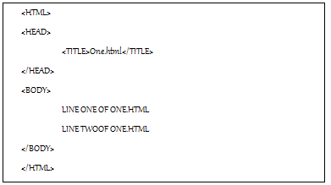
ONE.html
http://localhost:80/one.html

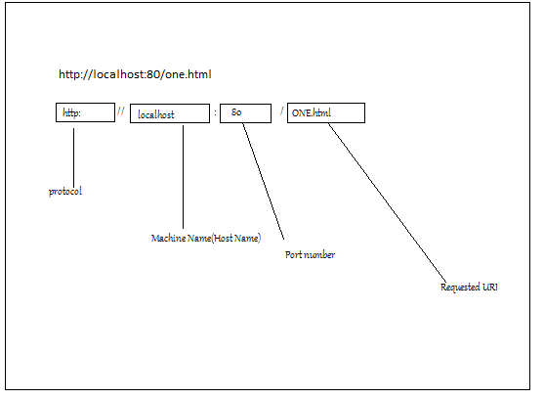
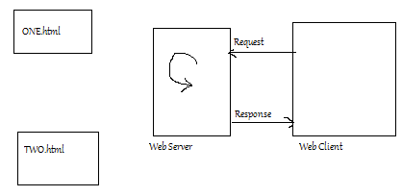

Servlet
Web container—A product that support a web application developed using servlet technology is called as Web Container.
Web Logic, Apache Tomcat,Websphere,Sun One Server, Oracle application Server etc. support Servlet technology and the can be said as web container.
Javasoft has provided a set of guide lines that must be followed by the developers for assembling (filling together) the webapplication.

package org.students;
import javax.servlet.*;
import javax.servlet.http.*;
import java.io.*;
public class SrvOne extends HttpServlet{
public void service(HttpServletRequest request, HttpServletResponse response) throws ServletException,IOException{

System.out.println(“output of SrvOne”);
PrintWriter out=response.getWriter();
out.println(“** Output of SrvOne”);
}
}
Note:- Path of Servlet related class of WEBLOGIC and Tomcat

C:\bea\WebLogic81\Server\lib\weblogic.jar
C:\Program Files\Apache Software Foundation\Tomcat 5.0\common\lib\servlet-api.jar

Note: every webcontainer vendor provides a jar fiel that contains servlet related package.
Eg. 1) servlet-api.jar: provided by tomcat
2)weblogic.jar: provided by WEBLOGIC

Procedure for assembling a webapplication:--
- Create a WebRoot directory(e.g. f:\ourwapp)
- Create a directory with the name WEB-INF under WebRoot directory.
- Create two directory with the name lib and classes under WEB-INF directory (e.g. f:\ourwapp\WEB-INF\lib, f:\ourwapp\WEB-INF\classes)
- Provide the servlet classes under WEB-INF\classess directory.
- Provide the static resources like html,xml,jpg,jsp under WebRoot directory but not WEB-INF directory.
- Provide the configuration file for servlet under WebRoot\WEB-INF directory.(e.g f:\\WEB-INF\web.xml

<?xml version="1.0" encoding="UTF-8"?>
<web-app xmlns:xsi="http://www.w3.org/2001/XMLSchema-instance" xmlns="http://java.sun.com/xml/ns/javaee" xmlns:web="http://java.sun.com/xml/ns/javaee/web-app_2_5.xsd" xsi:schemaLocation="http://java.sun.com/xml/ns/javaee http://java.sun.com/xml/ns/javaee/web-app_2_5.xsd" id="WebApp_ID" version="2.5">
<display-name>InetSolveServlet</display-name>
<welcome-file-list>
<welcome-file>index.jsp</welcome-file>
</welcome-file-list>
<servlet>
<servlet-name>sone</servlet-name>
<servlet-class>bs.SrvOne</servlet-class>
</servlet>
<servlet-mapping>
<servlet-name>sone</servlet-name>
<url-pattern>/one/two/srvone</url-pattern>
</servlet-mapping>
<servlet>
<description></description>
<display-name>SrvOne</display-name>
<servlet-name>SrvOne</servlet-name>
<servlet-class>bs.SrvOne</servlet-class>
</servlet>
<servlet-mapping>
<servlet-name>SrvOne</servlet-name>
<url-pattern>/SrvOne</url-pattern>
</servlet-mapping>
</web-app>
- Create a war file using the jar tool
- Using cd command move to webroot directory ourwapp
F:\>cd ourwapp
F:\ourwapp>

- Run the following command to creat a war file
F:\ourwapp>jar cvf ourwapp.war .

package bs;
import java.io.IOException;
import java.io.PrintWriter;
import java.sql.Connection;
import java.sql.DriverManager;
import java.sql.ResultSet;
import java.sql.Statement;
import javax.servlet.ServletException;
import javax.servlet.http.HttpServlet;
import javax.servlet.http.HttpServletRequest;
import javax.servlet.http.HttpServletResponse;
public class DBSone extends HttpServlet {
private static final long serialVersionUID = 1L;
public DBSone() {
super();
}
protected void service(HttpServletRequest request, HttpServletResponse response) throws ServletException, IOException {

try{
response.setContentType("text/html");
PrintWriter out=response.getWriter();
Class.forName("oracle.jdbc.OracleDriver");
Connection con=DriverManager.getConnection("java:oracle:thin:@localhost:1521:xe","rakesh","rakesh");
Statement stmt=con.createStatement();
ResultSet rs=stmt.executeQuery("select first_name,last_name from hr.employees");
out.print("<html><head><title>DBOne</title></head><body>");
out.print("<table><tr> <td>First Name</td><td>LastName</td><tr>");

while(rs.next()){
out.println("<tr>");
out.println("<td>");
out.println(rs.getString("first_name"));
out.println("</td>");
out.println("<td>");
out.println(rs.getString("last_name"));
out.println("</td>");
out.println("</tr>");
}
out.println("</table></body></html>");
}catch(Exception e){
e.printStackTrace();
}
}

}

Web.xml
<?xml version="1.0" encoding="UTF-8"?>
<web-app xmlns:xsi="http://www.w3.org/2001/XMLSchema-instance" xmlns="http://java.sun.com/xml/ns/javaee" xmlns:web="http://java.sun.com/xml/ns/javaee/web-app_2_5.xsd" xsi:schemaLocation="http://java.sun.com/xml/ns/javaee http://java.sun.com/xml/ns/javaee/web-app_2_5.xsd" id="WebApp_ID" version="2.5">
<display-name>InetSolveServlet</display-name>
<welcome-file-list>
<welcome-file>index.jsp</welcome-file>
</welcome-file-list>
<servlet>
<servlet-name>sone</servlet-name>
<servlet-class>bs.SrvOne</servlet-class>
</servlet>
<servlet-mapping>
<servlet-name>sone</servlet-name>
<url-pattern>/one/two/srvone</url-pattern>
</servlet-mapping>
<servlet>
<description></description>
<display-name>SrvOne</display-name>
<servlet-name>SrvOne</servlet-name>
<servlet-class>bs.SrvOne</servlet-class>
</servlet>
<servlet-mapping>
<servlet-name>SrvOne</servlet-name>
<url-pattern>/SrvOne</url-pattern>
</servlet-mapping>
<servlet>
<description></description>
<display-name>DBSone</display-name>
<servlet-name>DBSone</servlet-name>
<servlet-class>bs.DBSone</servlet-class>
</servlet>
<servlet-mapping>
<servlet-name>DBSone</servlet-name>
<url-pattern>/DBSone</url-pattern>
</servlet-mapping>
</web-app>

Note: we must use connection from the connection pool in web application, but in the above application we have used DriverManager.getConnection(..)
url:
http://localhost/InetSolveServlet/DBSone
Note: copy the ojdbc.14.jar in WEB-INF/lib directory

Note: we can use code shown below to report an error to the client
try{
}catch(Exception e){
response.sendError(504,”Error-→”+e)
}

We can make above servlet flexible using init-param or context-param

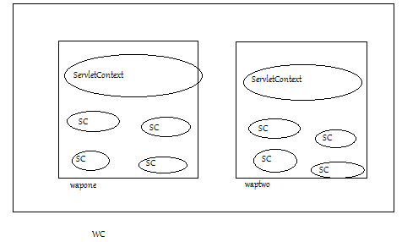
Note: SC→ServletConfig
There can be multiple web application running in a container(wapone,waptwo)
- The webcontainer reads web.xml and then it create a ServletContext object for a webapplication while starting the webapplication.
- While stoping the web application webcontainer removes ServletContext object.
- As there will be only one ServletContext object fro an application running in a webcontainer, it is alos known as application object.
- As a part of web application there can be multiple servlet(Sone,Stwo, … etc)
- For each servlet the webcontainer create one ServletConfig object
- As a part of web.xml we can provide the information regarding the initialazation parameter and context parameter as shown below.

<?xml version="1.0" encoding="UTF-8"?>
<web-app xmlns:xsi="http://www.w3.org/2001/XMLSchema-instance" xmlns="http://java.sun.com/xml/ns/javaee" xmlns:web="http://java.sun.com/xml/ns/javaee/web-app_2_5.xsd" xsi:schemaLocation="http://java.sun.com/xml/ns/javaee http://java.sun.com/xml/ns/javaee/web-app_2_5.xsd" id="WebApp_ID" version="2.5">
<context-param>
<param-name>cpone</param-name>
<param-value>AAA</param-value>
</context-param>
<display-name>InetSolveServlet</display-name>

<servlet>
<servlet-name>Sone</servlet-name>
<servlet-class>bs.Sone</servlet-class>
<init-param>
<param-name>ipone</param-name>
<param-value>XXX</param-value>
</init-param>
</servlet>
<servlet-mapping>
<servlet-name>Sone</servlet-name>
<url-pattern>/Sone</url-pattern>
</servlet-mapping>
</web-app>
- A context-param can be accessed by all the servlet of a web application (cpone can be accessed by sone,stwo)
- A init-param can be accessed by only the servlet for which it was defined in a web application (ipone can be accessed by only sone)

package bs;

import java.io.IOException;
import java.io.PrintWriter;

import javax.servlet.ServletConfig;
import javax.servlet.ServletContext;
import javax.servlet.ServletException;
import javax.servlet.http.HttpServlet;
import javax.servlet.http.HttpServletRequest;
import javax.servlet.http.HttpServletResponse;

public class Sone extends HttpServlet {
private static final long serialVersionUID = 1L;

protected void service(HttpServletRequest request,
HttpServletResponse response) throws ServletException, IOException {
PrintWriter out = response.getWriter();
ServletConfig config = getServletConfig();
ServletContext application = config.getServletContext();

out.print("initparam--" + config.getInitParameter("ipone"));
out.print("contextparam--" + application.getInitParameter("cpone"));
}

}

Q). What is the difference between ServletContext and ServletConfig objects.
R): There will be only one ServletContext object in a webapplication. But there can be multiple ServletConfig object in a web application.

Context-param can be accessed by using ServletContext object and init-param can be accessed by ServletConfig object.

Note: when servlet object will be created and removed?

We can make DBSone flexible by reimplementing the code using context-param as shown below:
<?xml version="1.0" encoding="UTF-8"?>
<web-app xmlns:xsi="http://www.w3.org/2001/XMLSchema-instance" xmlns="http://java.sun.com/xml/ns/javaee" xmlns:web="http://java.sun.com/xml/ns/javaee/web-app_2_5.xsd" xsi:schemaLocation="http://java.sun.com/xml/ns/javaee http://java.sun.com/xml/ns/javaee/web-app_2_5.xsd" id="WebApp_ID" version="2.5">
<context-param>
<param-name>drvcls</param-name>
<param-value>oracle.jdbc.OracleDriver</param-value>
</context-param>
<context-param>
<param-name>url</param-name>
<param-value>jdbc:oracle:thin:@localhost:1521:xe</param-value>
</context-param>
<context-param>
<param-name>username</param-name>
<param-value>rakesh</param-value>
</context-param>
<context-param>
<param-name>pwd</param-name>
<param-value>rakesh</param-value>
</context-param>

<servlet>
<servlet-name>DBSone</servlet-name>
<servlet-class>bs.DBSone</servlet-class>
</servlet>
<servlet-mapping>
<servlet-name>DBSone</servlet-name>
<url-pattern>/DBSone</url-pattern>
</servlet-mapping>
</web-app>

package bs;

import java.io.IOException;
import java.io.PrintWriter;
import java.sql.Connection;
import java.sql.DriverManager;
import java.sql.ResultSet;
import java.sql.Statement;

import javax.servlet.ServletConfig;
import javax.servlet.ServletContext;
import javax.servlet.ServletException;
import javax.servlet.http.HttpServlet;
import javax.servlet.http.HttpServletRequest;
import javax.servlet.http.HttpServletResponse;

public class DBSone extends HttpServlet {
private static final long serialVersionUID = 1L;
protected void service(HttpServletRequest request, HttpServletResponse response) throws ServletException, IOException {

try{
response.setContentType("text/html");
PrintWriter out=response.getWriter();
ServletConfig config = getServletConfig();
ServletContext application = config.getServletContext();

Class.forName(application.getInitParameter("drvcls"));//"oracle.jdbc.OracleDriver");
Connection con=DriverManager.getConnection(application.getInitParameter("url"),application.getInitParameter("username"),application.getInitParameter("pwd"));//"java:oracle:thin:@localhost:1521:xe","rakesh","rakesh");
Statement stmt=con.createStatement();
ResultSet rs=stmt.executeQuery("select first_name,last_name from hr.employees");
out.print("<html><head><title>DBOne</title></head><body>");
out.print("<table><tr> <td>First Name</td><td>LastName</td><tr>");

while(rs.next()){
out.println("<tr>");
out.println("<td>");
out.println(rs.getString("first_name"));
out.println("</td>");
out.println("<td>");
out.println(rs.getString("last_name"));
out.println("</td>");
out.println("</tr>");
}
out.println("</table></body></html>");

}catch(Exception e){
e.printStackTrace();
}
}

}

- To improve performance browser uses caching mechanism. When a browser gets the content from the server apart from displaying the content the browser store the content in disk. Next time if the request come for the same content the browser pickups the content from it(cache) instead of sending request to server. If the content has no expired.
- DBSone servlet generates the content without setting the expiry date and time. The browser caches the content generated by DBSOne and uses the same content instead of sending a request from second time ownwards.
- We can provide the code to set the expiry date and tie of the content generated by servlet as shown below:
java.util.Date now=new java.util.Date();
long lnow=now.getTime();
long expdate=lnow-(1000*60*60);
response.setDateHeader(“Expires” ,expdate);

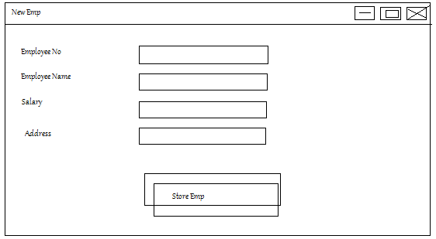

<html>
<head><title>New Emp</title>
</head>
<body>
<form action=”fhsrv” method=”get”>
<table>
<tr>
<td>Employee No</td>
<td><input type=”text” name=”empNo”/></td>
</tr>
<tr>
<td>Employee Name</td>
<td><input type=”text” name=”empName”/></td>
</tr>
<tr>
<td>Salary</td>
<td><input type=”text” name=”salary”/></td>
</tr>
<tr>
<td>Address</td>
<td><input type=”text” name=”empaddr”/></td>
</tr>

</table>
</body>
</html>

- empNo,empName,salary,empAddr are called as the name of the input fields/parameters name of properties
- In order to handle the above form we can provide a servlet class with name FHSrv name and configure it as shown below:

import java.io.IOException;
import java.io.PrintWriter;

import javax.servlet.ServletException;
import javax.servlet.http.HttpServlet;
import javax.servlet.http.HttpServletRequest;
import javax.servlet.http.HttpServletResponse;

public class FHSrv extends HttpServlet {
private static final long serialVersionUID = 1L;

protected void service(HttpServletRequest request, HttpServletResponse response) throws ServletException, IOException {
PrintWriter out=response.getWriter();
String vempNo=request.getParameter("");
String vempName=request.getParameter("");
String vsalary=request.getParameter("");
String vempAddr=request.getParameter("");
out.print(vempNo);
out.print(vempName);
out.print(vsalary);
out.print(vempAddr);

out.print("* Output of SrvOne");
}

}

- String var=request.getParameter(“fldName”);
- The above method returns a null, if the field with the name fldName is not there in the form.
- The above method returns blank the user has not provided the value.
- In both of the above cases the application can consider that user has not provided the value for the field.
Q.) what is the difference between get and Post method?
R: <form action=”fhsrv” method=”get”>
<form action=”fhsrv” method=”post”>

- GET: when user provide the data using get method as (100,Eone,1000,Aone) and click on store employee buttons the browser
- Collects the data
- Appends the data as a query string to the url
/fhsrv?empNo=100&empName=Eone&salary=1000&empaddr=Aone

- Send a get request to server.
- Problem: (i) There is a limitation on the size of url(1024 bytes/256 char) by most of the browser. If more amount of data is provided and if the size of the URL exceeds the limit, then browser will not be able to send data to the server.
(ii) if the sensitive data(e.g. password) is provided the user for a field the browser displays the value in address bar as a part of query string and the data will be revealed(known to other) with the people immediately standing behind.

- POST: When the user provides the data and clicks on storeEmp button, the browser
- Collects data
- Send a POST request method to the server by putting the data as part of body of the request.
- The browser can send the huge amount of data as part of the body of the request. And in this case data will not be displayed as part of query string in address bar.
- On the server talkin data available in the query string requires less amount of time than taking data available in the body of the request. This is why we can say get request method gives better performance
- (In modern computer the difference is negligible) in performance

BASICS OF SERVLET
- Javasoft has designed servlet technology in such a way that it can be used as part of various kind of server that support HTTP protocol.
- Today the servlet technology is implemented by various companies in the server supported by HTTP protocol.

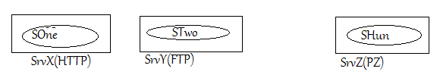
- In the above diagram a servlet running inside a server supportin HTTP protocol is called as HttpServlet and a servlet running inside a server supporting PZ protocol can be called as PZServlet. Like this there can be inifinite types of servlets

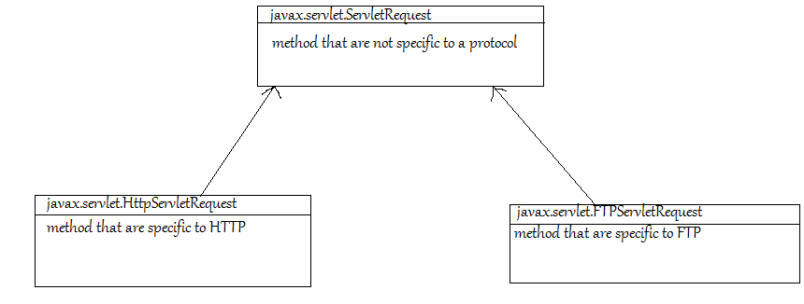

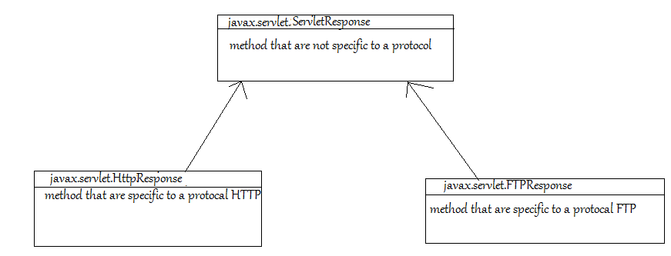

ServletRequest/Response, HttpServletRequest/Response are developed by javasoft and implemented by weblogic, Tomcat websphere etc.
As a part of weblogic, the implementor(vendoer) has provided the classes implementing HttpServletRequest,HttpServletResponse, similarly tomcat implementor has provided classes implementing those interfaces.( ServletRequest/Resopnse implemented indirectly).

It is the responsibility of a container (weblogic, Tomcat etc) to create a request and response object using the classes provided by them.
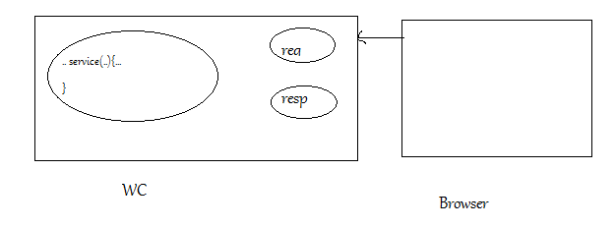

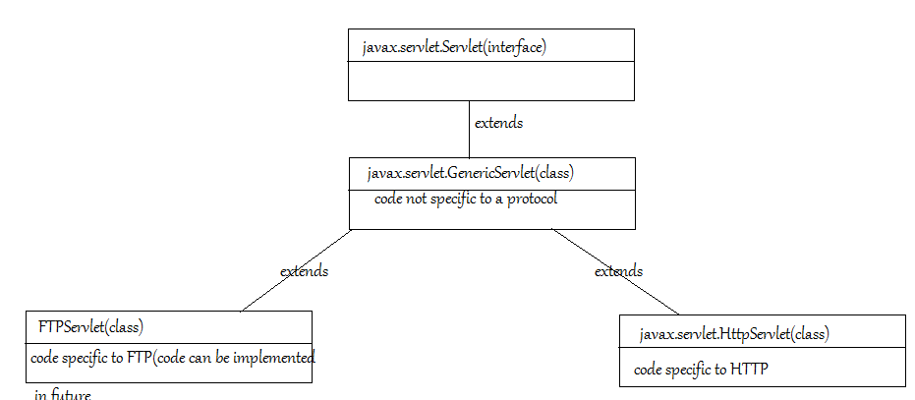

Servlet(interface): javasoft want to implement this interface to be implemented on different server supporting different protocol.
Servlet: a servlet is a java object that provides the implementation of javax.servlet.ServletInterface.
As shown in the diagram below there are inifinete way of implementing a Servlet Interface.
- By providing a class that directly implements Servlet Interface(like SOne)
- By providing a sub class of GenericServlet class (like STwo)
- By providing a sub class of HttpServlet class (like SThr)
- A company can design a class like XSrv and provide the code that is commonly required for most of the servlet class as subclass of Xsrv
- Like this we can say there are infinite way implementing a servlet

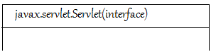
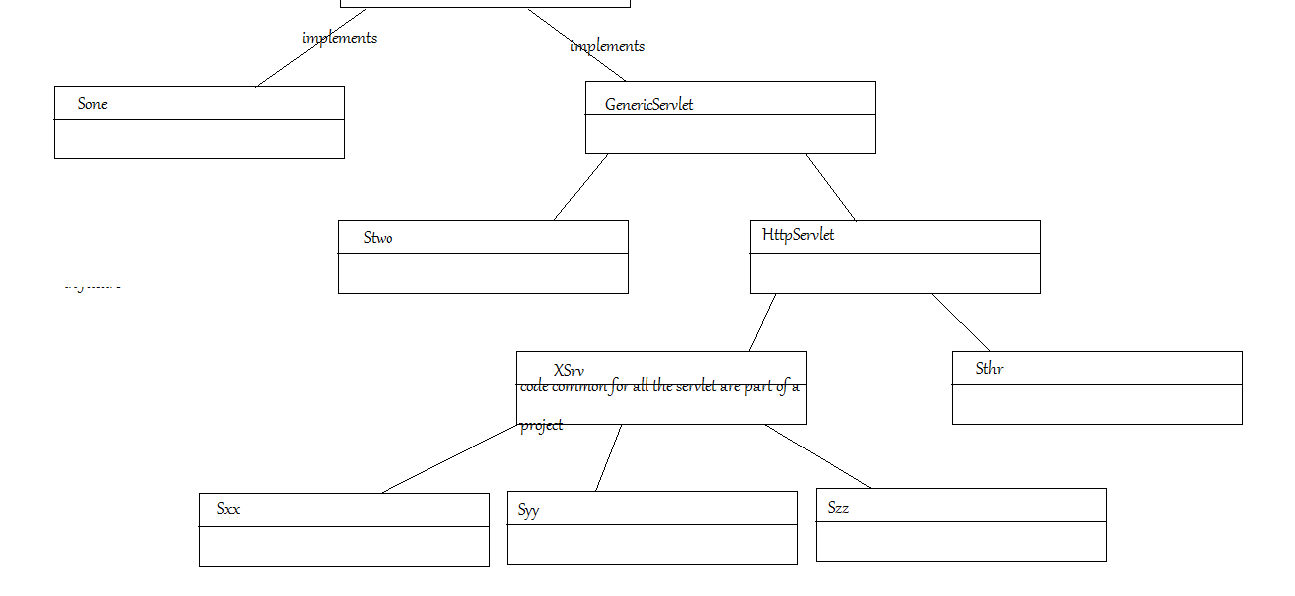
Method of Servlet interface :-
Void init(ServletConfig config)..
Void destroy()
Void service(ServletRequest req,ServletResponse resp) throws ..
String getServletInfo();
ServletContext getServletContext()

F:\work>javap javax.servlet.Servlet
F:\work>javap javax.servlet.Servlet > Sone.java

package bs;

import java.io.IOException;
import java.io.PrintWriter;

import javax.servlet.Servlet;
import javax.servlet.ServletConfig;
import javax.servlet.ServletContext;
import javax.servlet.ServletException;
import javax.servlet.ServletRequest;
import javax.servlet.ServletResponse;
import javax.servlet.http.HttpServlet;
import javax.servlet.http.HttpServletRequest;
import javax.servlet.http.HttpServletResponse;

public class Sone implements Servlet {
ServletConfig config=null;

@Override
public void init(ServletConfig config) throws ServletException {
this.config=config;
}

@Override
public void destroy() {
System.out.println("Destroy");

}

@Override
public ServletConfig getServletConfig() {
return this.config;
}

@Override
public String getServletInfo() {
String info="Developed by X for learning";
return info;
}

@Override
public void service(ServletRequest request, ServletResponse response)
throws ServletException, IOException {

HttpServletRequest req=(HttpServletRequest)request;
HttpServletResponse res=(HttpServletResponse)response;
System.out.println(req.toString()+res.toString());

}
//constructor
public Sone(){
System.out.println("Sone object created");
}
}

- WC is responsible for calling the init (..) method immediately after creating the servlet object.
- WC is responsible for calling the service(..) method when client send a request for a servlet.
- WC responsible for calling the destroy method before removing servlet object.
In the life of the servlet init(..), destroy(..) are called only once and service method will be called zero or more than zero times.
Q). How WC creates a servlet object?
R: 1) WC like Tomcat weblogic are java application
- During startup Wc read web.xml get name of servlet class
- The webcontainer uses the code similar to:-
Class c=Class.forName(vclsName);
//vclsname is the variable holding the name of servlet class
c.newInstance();
Q) can we provide a constructor in a servle class?
newInstance() method uses a zero argument constructor for creating an object, we can provide a zero argument constructor (Generally a constructor is not provided in java file of a Servlet class)

Q) When the WC creates a servlet objects and when it removes the servlet objects?
R:
- According to the servlet specification WC can create a servlet object at any point of time
- If we provide <load-on-startup> tag as part of time web.xml, WC are responsible for creating the servlet object while starting the web application.
<servlet>
</servlet>
<servlet-name>sone</servlet-name>
<servlet-class>Sone</servlet-class>
</servlet>
<servlet>
</servlet>
<servlet-name>stwo</servlet-name>
<servlet-class>STwo</servlet-class>
</servlet>

- If we provide the information about the servlet as shown above the WC creates STwo objects(one with lowest no in load-on-startup tag) then it create SOne object while starting the webapplication it create SOne object while starting the webapplication.
- If we configure a servlet as shown below:
Wc creates generally(not guaranteed ) the servlet object when the WC receives the first request.
<servlet>
</servlet>
<servlet-name>sone</servlet-name>
<servlet-class>Sone</servlet-class>
</servlet>
- In case of same containers(weblogic) when a servlet class is replaced with new class(modify .java file and compile and copy .class file and paste to WC )and a first request is sent after replacement WC removes the Old servlet object and creates a new servlet object based on new class.
- A container can remove a servlet object if there is no memofry to create a new servlet object( assume ate 1:30 o’clock WC has remove se servlet) and if a request for the removed object is came from client(assume client has sent a request at 11 O’clock)
- A container can logic like create object, call init, service,destroy, and remove the servlet but this logic is taking lot of time.
Q . when does WC removes the Servlet objects?
- According to Servlet specification WC can remove the Servlet object at any point of time.
- Generally, the container removes Servlet object when application is stopped.
- WC can remove a servlet object when there is no space to create a new objects.
- Some WC(Weblogic) removes the servlet object based on old class when if first request is sent after replacing old class.
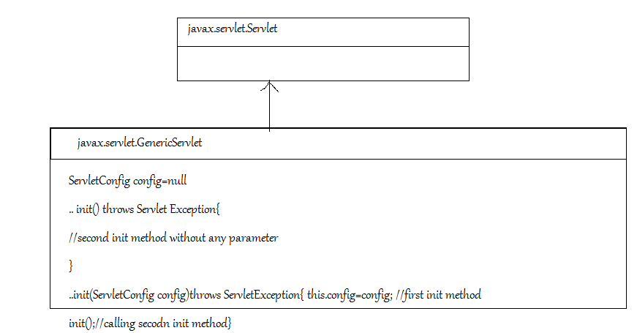
According to servlet specification,WC must call the first init method after creating the servlet object.

...
public SrvOne extends HttpServelt{
public void init() throws ServletException{
System.out.println(“SrvOne:second init--”);
}
public void service(HttpServletRequest req,HttpServletResponse res) throws ServletException,IOException{
PrintWriter out=resp.getWriter();
out.println(“SrvOne--”+getServletName());
}
}

When the WC creates the servlet object based on the above SrvOne class the following step will be carried out:

a) WC call the init method
b) JVM check for first init method in SrvOne, then it checks for first init method in HttpServlet class,after this it checks for first init method in GenericServlet class. As the method is available JVM start execution of first init method.

c)When the first init method of GenericServlet class calls the init method, the JVM checks for
seconds init method in SrvOne.(as object of SrvOne is calling the method) as method is available the JVM executes the second init method.

public SrvTwo extends HttpServelt{
public void init(ServletConfig config) throws ServletException{
System.out.println(“SrvTwo: first init--”);
}
public void service(HttpServletRequest req,HttpServletResponse res) throws ServletException,IOException{
PrintWriter out=resp.getWriter();
out.println(“SrvTwo--”+getServletName());
}
}

When the WC creates the servlet object based on the above SrvTwo class the following step will be carried out:

a) WC call the first init method
b) JVM check for first init method in SrvTwo, As the method is available JVM start execution of first init method.

Note:- In this case the JVM does not executes the first init method available in GenericServlet class and config variable of GenericServelt class will be set to null. But most of the method internally tries to use the ServletConfig, they will fail.

To solve the problem we can use one of the following two solutions:-

- Provide a second init method as in SrvOne.
- Provide a first init method (As in SrvThr). First init method must call the superclass first method.

public SrvThr extends HttpServelt{
public void init(ServletConfig config) throws ServletException{
super.init(config);
System.out.println(“SrvTwo: first init--”);
}
public void service(HttpServletRequest req,HttpServletResponse res) throws ServletException,IOException{
PrintWriter out=resp.getWriter();
out.println(“SrvTwo--”+getServletName());
}
...
}

Q. can we call destroy method from our servlet?
R: It is not advisable to call the destroy method from our code( It is responsiblity of WC to call init method(..), service(..),destroy() method. If the destroy method unreferences the ServletConfig object, the method that depends on ServletConfig will fail.

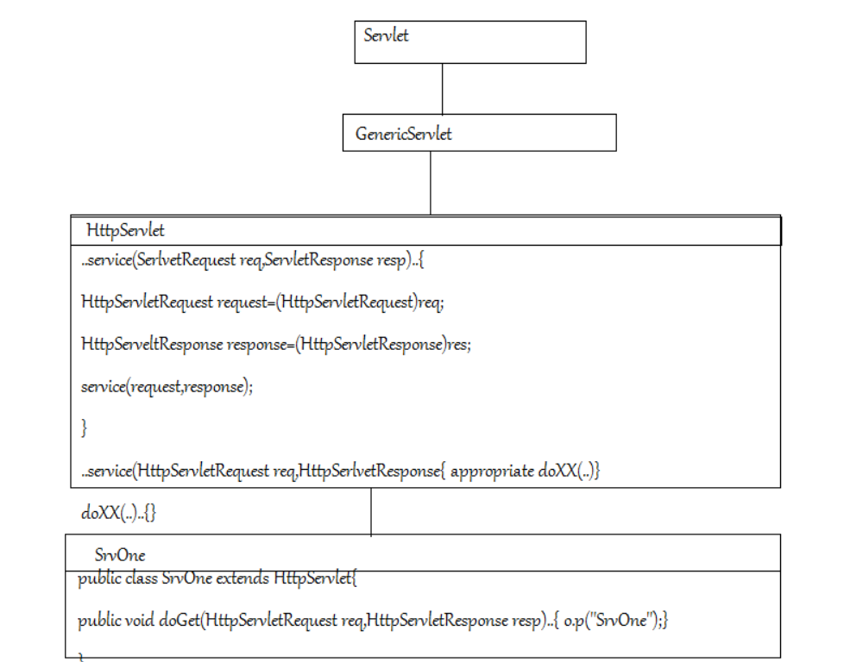

When the client send a request fo above SrvOne servlet following steps will be taken place:--
- Wc call first service method of HttpServlet class
- The JVM starts the execution of the first service method
- when the first service method of HttpServlet method will call second service method, as second service method is not available in SrvOne, the Jvm starts the execution of second service method of HttpServlet.
- The second serivce method of HttpServlet call doGet assume client has sent doGet request.
- The JVM execute doGet(..) method available in SrvOne.
Note :- if the post request is sent by client/browser to the above servlet an error will be sent by Server to client(the error will be sent by doPost(...) method available in HttpServlet class.
HIBERNATE

Advantages of Hibernate:

The following are the benefits of using an ORM framework:

- Productivity: Because you use metadata to persist and query data, development
time decreases and productivity increases.
- Prototyping: Using an ORM framework is extremely useful for quick prototyping.
- Maintainability: Because much of the work is done through configuration, your
code has fewer lines and thus requires less maintenance

- Vendor independence: An ORM abstracts an application from the underlying SQL
database and SQL dialect. This gives you the portability to support multiple
databases

ORM frameworks also have some disadvantages:
- Learning curve: You may experience a steep learning curve as you learn how to
map and, possibly, learn a new query language.
- Overhead: For simple applications that use a single database and data without
many business requirements for complex querying, an ORM framework can be
extra overhead.
- Slower performance: For large batch updates, performance is slower.

Problems with Using JDBC
Using JDBC means you can execute any kind of SQL statements. For a simple task, you have to code
many SELECT, INSERT, UPDATE, and DELETE statements repeatedly. This results in the following issues:

- Too much copy code: When you perform object retrieval, you need to copy the
fields in a ResultSet to the properties of an object. When you perform object
persistence, you need to copy the properties of an object to the parameters in
PreparedStatement.
- Manually handled associations: When you perform object retrieval, you have to
perform a table join or read from several tables to get an object graph. When you
perform object persistence, you must update several tables accordingly.
- Database dependent: The SQL statements you wrote for one database may not
work with another brand of database. Although the chance is very small, you may
have to migrate to another database.

Configuration:

<?xml version="1.0" encoding="UTF-8"?>
<!DOCTYPE hibernate-configuration PUBLIC
"-//Hibernate/Hibernate Configuration DTD 3.0//EN"
"http://hibernate.sourceforge.net/hibernate-configuration-3.0.dtd">
<hibernate-configuration>
<session-factory name="MysqlSF">
<property name="hibernate.connection.driver_class">com.mysql.jdbc.Driver</property>
<property name="hibernate.connection.password">root</property>
<property name="hibernate.connection.url">jdbc:mysql://localhost:3306/hib_recipie</property>
<property name="hibernate.connection.username">root</property>
<property name="hibernate.dialect">org.hibernate.dialect.MySQL5Dialect</property>
</session-factory>
</hibernate-configuration>

CREATE TABLE PUBLISHER (
CODE VARCHAR(4) NOT NULL ,
PUBLISHER_NAME VARCHAR(100) NOT NULL, ADDRESS VARCHAR(200), PRIMARY KEY
(CODE)
);
CREATE TABLE BOOK
(ISBN VARCHAR(50) NOT NULL,
BOOK_NAME VARCHAR(100) NOT NULL,
PUBLISHER_CODE VARCHAR(4), PUBLISH_DATE DATE,
PRICE integer,
PRIMARY KEY (ISBN), FOREIGN KEY (PUBLISHER_CODE)
REFERENCES PUBLISHER (CODE)
);

CREATE TABLE CHAPTER
(BOOK_ISBN VARCHAR(50) NOT NULL,
IDX integer NOT NULL,
TITLE VARCHAR(100) NOT NULL,
NUM_OF_PAGES integer,
PRIMARY KEY (BOOK_ISBN, IDX),
FOREIGN KEY (BOOK_ISBN)
REFERENCES BOOK (ISBN)
);

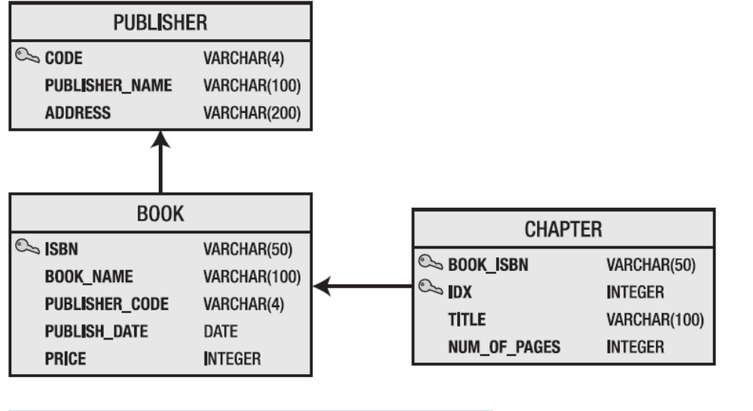
INSERT INTO PUBLISHER(CODE, publisher_name, address)
VALUES ('001', 'Apress', 'New York ,New York');
INSERT INTO PUBLISHER(CODE, publisher_name, address)
VALUES ('002', 'Manning', 'San Francisco', 'CA');
INSERT INTO book(isbn, book_name, publisher_code, publish_date, price)
VALUES ('PBN123', 'Spring Recipes', '001', DATE('2008-02-02'), 30);
INSERT INTO book(isbn, book_name, publisher_code, publish_date, price)
VALUES ('PBN456', 'Hibernate Recipes', '002', DATE('2008-11-02'), 40)
package com.hibernaterecipes.annotations.domain;

import java.util.Date;
import javax.persistence.Column;
import javax.persistence.*;
import javax.persistence.Entity;
import javax.persistence.Table;
/**
* @author Rakesh
*
*/
@Entity
@Table (name="BOOK")
public class Book {
@Column (name="isbn")
@Id
String isbn;
@Column (name="book_Name")
String bookName;
@Column (name="publisher_code")
String publisherCode;
@Column (name="publish_date")
Date publishDate;
@Column (name="price")
Long price;
/**
* @return the isbn
*/
public String getIsbn() {
return isbn;
}
/**
* @param isbn the isbn to set
*/
public void setIsbn(String isbn) {
this.isbn = isbn; }
/**
* @return the bookName
*/
public String getBookName() {
return bookName;
}
/**
* @param bookName the bookName to set
*/
public void setBookName(String bookName) {
this.bookName = bookName;
}
/**
* @return the publisherCode
*/
public String getPublisherCode() {
return publisherCode;
}
/**
* @param publisherCode the publisherCode to set
*/
public void setPublisherCode(String publisherCode) {
this.publisherCode = publisherCode;
}
/**
* @return the publishDate
*/ public Date getPublishDate() {
return publishDate;
}
/**
* @param publishDate the publishDate to set
*/
public void setPublishDate(Date publishDate) {
this.publishDate = publishDate;
}
/**
* @return the price
*/
public Long getPrice() {
return price;
}
/**
* @param price the price to set
*/
public void setPrice(Long price) {
this.price = price;
}
}

package com.hibernaterecipes.annotations.utils;

import org.hibernate.SessionFactory;
import org.hibernate.cfg.AnnotationConfiguration;

public class SessionManager {
private static final SessionFactory sessionFactory = buildSessionFactory();
private static SessionFactory buildSessionFactory() {
try {
// Create the SessionFactory from hibernate.cfg.xml
return new AnnotationConfiguration().configure().buildSessionFactory();
}catch (Throwable ex) {
// Make sure you log the exception, as it might be swallowed
ex.printStackTrace();
throw new ExceptionInInitializerError(ex);
}
}
public static SessionFactory getSessionFactory() {
return sessionFactory;
}
}

package com.hibernaterecipes.annotations.dao;

import java.util.List;

import org.hibernate.Session;

import com.hibernaterecipes.annotations.domain.Book;
import com.hibernaterecipes.annotations.utils.SessionManager;

public class BookDAO {
/**
* To query all details of a book
* @return
*/
public List<Book> readAll() {
Session session = SessionManager.getSessionFactory().openSession();
session.beginTransaction();
List<Book> booksList = session.createQuery("from Book").list();
session.getTransaction().commit();
return booksList;
}
/**
* To create a book
* @return
*/
public void create(Book bookObj) {
Session session=SessionManager.getSessionFactory().getCurrentSession();
session.beginTransaction();
session.saveOrUpdate(bookObj);
session.getTransaction().commit();
}
public static void main(String[] args) {
BookDAO bdo=new BookDAO();
System.out.println(bdo.readAll());
}
}

Inspecting the SQL Statements Issued by Hibernate
Hibernate generates SQL statements that let you access the database behind the scene. You can set the
show_sql property to true in the hibernate.cfg.xml XML configuration file to print the SQL statements to
stdout:
<property name="show_sql">true</property>
Configuring Log4j
Hibernate can also use the log4j logging library to log SQL statements and parameters. Make sure the
log4j.jar file is included in your project’s classpath. Create a properties file named log4j.properties in
the source root folder; this file is used to configure the log4j library:
### direct log messages to stdout ###
log4j.appender.stdout=org.apache.log4j.ConsoleAppender
log4j.appender.stdout.Target=System.out
log4j.appender.stdout.layout=org.apache.log4j.PatternLayout
log4j.appender.stdout.layout.ConversionPattern=%d{yyyy-MM-dd HH:mm:ss} %5p %c{1}:%L - %m%n
### direct messages to file hibernate.log ###
#log4j.appender.file=org.apache.log4j.FileAppender
#log4j.appender.file.File=hibernate.log
#log4j.appender.file.layout=org.apache.log4j.PatternLayout
#log4j.appender.file.layout.ConversionPattern=%d{yyyy-MM-dd HH:mm:ss} %5p %c{1}:%L - %m%n
log4j.rootLogger=error, stdout
log4j.logger.org.hibernate.SQL=debug
log4j.logger.org.hibernate.type=debug

EJB (Enterprise Java Beans)
EJB’s are server side business components. In order to run the EJB’s, we must use an EJB container (Server) like Weblogic, Websphere, JBoss, SunOne Server, Oracle Application Server.
As a part of EJB we must provide the business method. As part of business method we must provide the business logic.
EJB is an open specification a, as a part of this specification a set fo guide line (rules) are provided. To develop the EJB container.
EJB 3 provides the simplified API for the development of the business component.

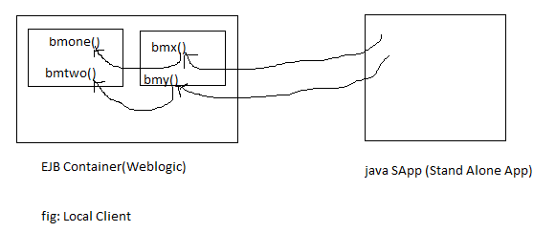
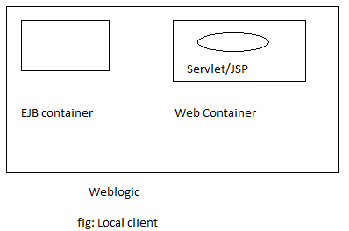

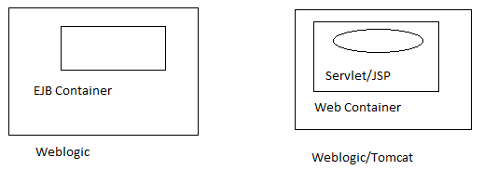
Fig: Remote Client

The caller of business methods on an EJB is called as EJB Client. There are two type of EJB Clients.
- Local Client.
- Remote Client.
Local client: if the code of the client runs in the same JVM then it is called as Local client of EJB. E.g fig(1).
Remote client: if the code of the client runs in the different JVM then it is called as Remote client of EJB. e.g. fig(2).
Applet/Servlet/JSP/Stand Alone java application that calls method on EJB is client.

EJB3 is a part of JEE 5 and it uses the features that are part of J2SE5.
Java 1.2.x
Java 1.3.x Java 2 SE
Java 1.4.x
Java 1.5.x
Java 1.6.x JSE 5
Java 1.7.x JEE 5
Java 1.8.x

Annotations: Annotations simplifies the development of java application.
There are 3 types of EJB’s in EJB 3

1) Stateless Session Bean
2) Stateful Session Bean
3) Message Driven Bean
As most of the developers has not used EntityBean in earlier projects developed using EJB1 & EJB2, Java Soft has not enhanced the design of entity beans.
As an alternative to entity bean java soft has provided JPA (Java persistence API).
To set the class path pointing to weblogic.jar and other jar files of weblogic 10.
Run the command :
setEnvironmentEnv.cmd - Window
setDomainEnv.sh - Linux
available in bin directory.
C:\bea\user_projects\domains\inetsolv> cd bin
C:\bea\user_projects\domains\inetsolv\ bin>setDomainEnv.cmd
F:\work>set CLASSPATH=% CLASSPATH%;.;F:\work\classes

Procedure for developing a Stateless Session Bean:-
- Decide about the method that are to be provided in the EJB(bean)
e.g. int bmOne(int I, int j);
String bmTwo(String studName)
- Provide the Remote business inter face and/or local inter face.
F:\work> javac –d classes RBInt.java
package inet.solve;

public interface RBInt {
int bmOne(int i, int j);
String bmTwo(String studName);
}
RBInt.java
package inet.solve;

public interface LBInt {
int bmOne(int i, int j);
String bmTwo(String studName);
}
LBInt.java
F:\work> javac –d classes LBInt.java
Note: Local client uses a Local interface & Remote client uses a remote interface

Note: if we need to develop only Remote client then remote interface is enough.

- Provide the bean

package inet.solve;

import javax.ejb.Stateless;

@Stateless(name="ourFB", mappedName="xxx/yyy")
public class FirstBean implements LBInt, RBInt, FirstBeanLocal, FirstBeanRemote {

public int bmOne(int i, int j) {
// TODO Auto-generated method stub
System.out.println("--bmOne--");
return (i+j);
}

public String bmTwo(String studName) {
// TODO Auto-generated method stub
return studName;
}

}
FirstBean.java

- Create a jar file following the step given below
F:\work>cd classes
F:\work\classes> jar cvf ourbean.jar
Note: autodeploy directory of weblogic10 is equivalent to application directory of weblogic 6

- When an EJB is deployed the EJB contains registers the information about local interface and remote interface.

Explanation: The EJB container creates an object based on a class that implements the local business interface(This will be generated by container) Store this object in the directory service. This process is called as registering the local interface. Similarly an object will be created implementing Remote business interface and this object will also be registered with directory service
Procedure for installing JBoss:-
- Copy jboss-4.2.1.GA.zip to a directory
(e.g. e:\)
- Using cd command move to directory in which the zip file of JBoss is copied.
c:\>e:
- Use the follosing command to extract the content of zip file.
E:\> jar xvf jboss-4.2.1.GA.zip
Note: the above command creates a directory with the name jboss-4.2.1.GA and copies all the files related to JBoss.
- Go to the directory
E:\ jboss-4.2.1.GA\server\default>
And search .xml file 8080 change 8080 as 8000 in the files
Jboss-service.xml, server.xml, jboss-beans.xml
Procedure for starting JBoss:-
- Using cd command move to
E:\ jboss-4.2.1.GA\bin> directory
- Set JAVA_HOME to directory in which java is installed.
Set JAVA_HOME=C:\Program Files\Java\Jdk1.5.0
- Run the command run.bat/run.sh
E:\ jboss-4.2.1.GA\bin>run
To deploy the EJB copy the jar file to
E:\ jboss-4.2.1.GA\server\default\deploy
To check information available in dir service of Jboss
- Open the browser and use the url given below:
http://localhost:8000/jmx-console
- Click on service=JNDI View
- Click on Invoke button available under list.
Note: When ourbean.jar is deployed JBoss registers the local interface with the name ourFB/local & Remote interface with the name OurFB/Remote

Weblogic makes the information about the remote business interface to available in the directory server but the information about the local business interface will not be available in directory service if weblogic 10.1.x
Environment→Server→AdminServer
Information about local interface will not be shown in JNDI service in weblogic 10.
To access the directory service of JBoss we must provide the following properties
Create the client:
package inet.solve;
import java.io.FileInputStream;
import java.util.Properties;

import javax.naming.InitialContext;
import javax.naming.Context;
public class App {

/**
* @param args
*/
public static void main(String[] args) throws Exception{
// TODO Auto-generated method stub
FileInputStream fis=new FileInputStream("f:/jndi.properties");
Properties props=new Properties();
props.load(fis);
Context ic=new InitialContext(props);
inet.solve.RBInt beanRef=(inet.solve.RBInt)ic.lookup("ourFB/remote");
System.out.println(beanRef);
System.out.println(beanRef.bmOne(5, 6));
System.out.println(beanRef.bmTwo("Hello Rakesh"));
//ic.lookup("ourFB/remote")

}

}

To run the client that has to access EJB's available in JBoss: jboss-client.jar file is required.
f:\work>set CLASSPATH=%CLASSPATH%;.;F:\work\classes;jboss-client.jar
Copy jboss-client.jar file in f:\work directory
But first set JAVA_HoME=c:\Program Files\Java\Jdk1.6.0
and start the server then run the client.

F:\work>java App
Note: You can create web client using JSP/Servlet and deploy that in
E:\jboss-4.2.1.GA\server\default\deploy
i.e. paste wapp and rename it webapp.war
Note: JBoss support only war file to be deployed
http://localhost:8080/wapp/ejbcli.jsp
<%@ page import=”java.naming.*,java.io.*,java.util.*” %>
<%
FileInputStream fis=new FileInputStream("f:/jndi.properties");
Properties props=new Properties();
props.load(fis);
Context ic=new InitialContext(props);
inet.solve.RBInt beanRef=(inet.solve.RBInt)ic.lookup("ourFB/remote");
System.out.println(beanRef);
System.out.println(beanRef.bmOne(5, 6));
System.out.println(beanRef.bmTwo("Hello Rakesh"));
//ic.lookup("ourFB/remote")

%>
To deploy servlet/JSP in JBoss:-
- Create a web root directory with extension .war (e.g. webapp.war)
- Create WEB-INF inside .war
- Create classes and lib directory inside WEB-INF
- Place .classes file in classes directory
- Place .jar file in lib directory
- Create web.xml in WEB-INF directory
- Copy webapp.war and paste it in e:\jboss-4.2.1.GA\server\default\deploy directory

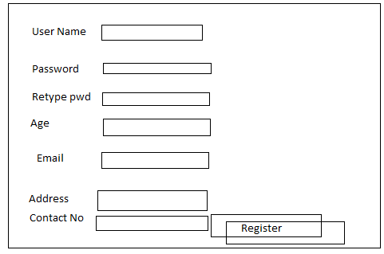

package inet.solve;

import javax.ejb.Local;

@Local
public interface UserManagerLocal {
public void registerUser(String uname,String pwd,int age,String address,String cno,String email);
public void unRegisterUser(String uname,String pwd);
}
UserManagerLocal.java
package inet.solve;

import javax.ejb.Remote;

@Remote
public interface UserManagerRemote {
public void registerUser(String uname,String pwd,int age,String address,String cno,String email);
public void unRegisterUser(String uname,String pwd);

}
UserManagerRemote.java

package inet.solve;

import javax.ejb.Stateless;

@Stateless(name="userManager", mappedName="UM")
public class UserManager implements UserManagerLocal, UserManagerRemote {
public void registerUser(String uname,String pwd,int age,String address,String cno,String email){
System.out.println("---Register User----");
}
public void unRegisterUser(String uname,String pwd){
System.out.println("---UnRegister User----");
}

}

package inet.solve;

import java.io.FileInputStream;
import java.util.Properties;

import javax.naming.Context;
import javax.naming.InitialContext;

public class EJBCli {

/**
* @param args
*/
public static void main(String[] args)throws Exception {
// TODO Auto-generated method stub
FileInputStream fis=new FileInputStream("f:/jndi.properties");
Properties props=new Properties();
props.load(fis);
Context ic=new InitialContext(props);
inet.solve.UserManagerRemote beanRef=(inet.solve.UserManagerRemote)ic.lookup("userManager/remote");
System.out.println(beanRef);
beanRef.registerUser("Rakesh", "", 26, "Delhi", "9968574221", "rakesh1.kumar@birlasoft.com");
beanRef.unRegisterUser("Hello Rakesh","dd");

}

} package inet.solve;

import java.io.FileInputStream;
import java.util.Properties;

import javax.naming.Context;
import javax.naming.InitialContext;

public class EJBCli {

/**
* @param args
*/
public static void main(String[] args)throws Exception {
// TODO Auto-generated method stub
FileInputStream fis=new FileInputStream("f:/jndi.properties");
Properties props=new Properties();
props.load(fis);
Context ic=new InitialContext(props);
inet.solve.UserManagerRemote beanRef=(inet.solve.UserManagerRemote)ic.lookup("userManager/remote");
System.out.println(beanRef);
beanRef.registerUser("Rakesh", "", 26, "Delhi", "9968574221", "rakesh1.kumar@birlasoft.com");
beanRef.unRegisterUser("Hello Rakesh","dd");

}

} package inet.solve;

import java.io.FileInputStream;
import java.util.Properties;

import javax.naming.Context;
import javax.naming.InitialContext;

public class EJBCli {

/**
* @param args
*/
public static void main(String[] args)throws Exception {
// TODO Auto-generated method stub
FileInputStream fis=new FileInputStream("f:/jndi.properties");
Properties props=new Properties();
props.load(fis);
Context ic=new InitialContext(props);
inet.solve.UserManagerRemote beanRef=(inet.solve.UserManagerRemote)ic.lookup("userManager/remote");
System.out.println(beanRef);
beanRef.registerUser("Rakesh", "", 26, "Delhi", "9968574221", "rakesh1.kumar@birlasoft.com");
beanRef.unRegisterUser("Hello Rakesh","dd");

}

} package inet.solve;

import java.io.FileInputStream;
import java.util.Properties;

import javax.naming.Context;
import javax.naming.InitialContext;

public class EJBCli {

/**
* @param args
*/
public static void main(String[] args)throws Exception {
// TODO Auto-generated method stub
FileInputStream fis=new FileInputStream("f:/jndi.properties");
Properties props=new Properties();
props.load(fis);
Context ic=new InitialContext(props);
inet.solve.UserManagerRemote beanRef=(inet.solve.UserManagerRemote)ic.lookup("userManager/remote");
System.out.println(beanRef);
beanRef.registerUser("Rakesh", "", 26, "Delhi", "9968574221", "rakesh1.kumar@birlasoft.com");
beanRef.unRegisterUser("Hello Rakesh","dd");

}

} package inet.solve;

import java.io.FileInputStream;
import java.util.Properties;

import javax.naming.Context;
import javax.naming.InitialContext;

public class EJBCli {

/**
* @param args
*/
public static void main(String[] args)throws Exception {
// TODO Auto-generated method stub
FileInputStream fis=new FileInputStream("f:/jndi.properties");
Properties props=new Properties();
props.load(fis);
Context ic=new InitialContext(props);
inet.solve.UserManagerRemote beanRef=(inet.solve.UserManagerRemote)ic.lookup("userManager/remote");
System.out.println(beanRef);
beanRef.registerUser("Rakesh", "", 26, "Delhi", "9968574221", "rakesh1.kumar@birlasoft.com");
beanRef.unRegisterUser("Hello Rakesh","dd");

}

} package inet.solve;

import java.io.FileInputStream;
import java.util.Properties;

import javax.naming.Context;
import javax.naming.InitialContext;

public class EJBCli {

/**
* @param args
*/
public static void main(String[] args)throws Exception {
// TODO Auto-generated method stub
FileInputStream fis=new FileInputStream("f:/jndi.properties");
Properties props=new Properties();
props.load(fis);
Context ic=new InitialContext(props);
inet.solve.UserManagerRemote beanRef=(inet.solve.UserManagerRemote)ic.lookup("userManager/remote");
System.out.println(beanRef);
beanRef.registerUser("Rakesh", "", 26, "Delhi", "9968574221", "rakesh1.kumar@birlasoft.com");
beanRef.unRegisterUser("Hello Rakesh","dd");

}

} package inet.solve;

import java.io.FileInputStream;
import java.util.Properties;

import javax.naming.Context;
import javax.naming.InitialContext;

public class EJBCli {

/**
* @param args
*/
public static void main(String[] args)throws Exception {
// TODO Auto-generated method stub
FileInputStream fis=new FileInputStream("f:/jndi.properties");
Properties props=new Properties();
props.load(fis);
Context ic=new InitialContext(props);
inet.solve.UserManagerRemote beanRef=(inet.solve.UserManagerRemote)ic.lookup("userManager/remote");
System.out.println(beanRef);
beanRef.registerUser("Rakesh", "", 26, "Delhi", "9968574221", "rakesh1.kumar@birlasoft.com");
beanRef.unRegisterUser("Hello Rakesh","dd");

}

}

package inet.solve;

import java.io.FileInputStream;
import java.util.Properties;

import javax.naming.Context;
import javax.naming.InitialContext;

public class EJBCli {

/**
* @param args
*/
public static void main(String[] args)throws Exception {
// TODO Auto-generated method stub
FileInputStream fis=new FileInputStream("f:/jndi.properties");
Properties props=new Properties();
props.load(fis);
Context ic=new InitialContext(props);
inet.solve.UserManagerRemote beanRef=(inet.solve.UserManagerRemote)ic.lookup("userManager/remote");
System.out.println(beanRef);
beanRef.registerUser("Rakesh", "", 26, "Delhi", "9968574221", "rakesh1.kumar@birlasoft.com");
beanRef.unRegisterUser("Hello Rakesh","dd");

}

}

We can develop a multi-tier application using EJB technology. The diagram shown below shows the architecture of typical JEE application using EJB.
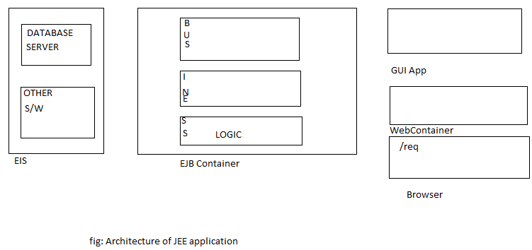

SQL> create table baccount(
Aid number(4) primary key,
Cust_name varchar2(10),
address varchar2(15),
curbal number(10,2),
status number(1));

In order to control the transaction JTA (Java Transaction API) will be used in EJB. For this we must use the connection pool of the weblogic server.
Step to get connection pool:
- http://localhost:7001/console using this login to weblogic console
- Click on Services→JDBC→DataSources
- Click on Lock & Edit → New Tab → and provide the information as follows.
Name= JDBDataSource
JNDI Name= org/students/orads
DataBase Type=oracle
DataBase Driver=Oracle Driver (Thin) Version 9.0.1.9.2.0.1.0
And click on Next
- Click on Next & provide the following information.
DataBase Name=xe
HostName=localhost
Port no=1521
Database user=scott
Password=tiger
And click on Next
- Click on Test Configuration
- Click on Next
- Choose AdminServer
- Click on Finish
- Click on Active Changes
Thus JNDI Name of DataSource: org/students/orads
In order to get the datasource we must use JNDI name of the DataSource e.g. JNDI Name= org/students/orads
In order ot get the connection from connection pool,
DataSource.getConnection() method must be used.
In order to get the datasource we must use JNDI name of the DataSource
e.g. JNDI Name=org/students/orads.
package inet.solve;

import javax.ejb.Remote;

@Remote
public interface RIBAManager {
public void createAccount(String aid,String cname,String address,String initBal);
public void closeAccount(String aid);
}

C:\bea\user_projects\domains\inetsolv\bin>setDomainEnv
Change drive using cd

F:/work>javac –d . RIBAManager.java
java.naming.factory.url=t3://localhost:7001/
java.naming.security.principal=admin
java.naming.security.credentials=inetadmin
java.naming.factory.initial=weblogic.jndi.WLInitialContextFactory
package inet.solve;
import java.sql.Connection;
import java.sql.PreparedStatement;
import java.sql.ResultSet;
import java.sql.SQLException;
import java.sql.Statement;
import javax.ejb.Stateless;
import javax.naming.Context;
import javax.naming.InitialContext;
import javax.sql.DataSource;
@Stateless(name="BA",mappedName="BA")
public class BAManager implements RIBAManager {
Connection con;
public void closeAccount(String aid) {
//code to update status=0
}
public void createAccount(String aid, String cname, String address,
String initBal) {
try{
Context ic=new InitialContext();
DataSource ds=(DataSource)ic.lookup("java:DerbyDS");
con=ds.getConnection();
/*String vsql="insert into baccount(?,?,?,?,?)";
PreparedStatement pstmt=con.prepareStatement(vsql);
pstmt.setString(1, aid);
pstmt.setString(2, cname);
pstmt.setString(3, address);
pstmt.setString(4, initBal);
pstmt.setString(5, "1");
pstmt.executeUpdate();*/
Statement stmt=con.createStatement();
ResultSet rs=stmt.executeQuery("select * from emp");
while (rs.next()) {
System.out.print("--"+rs.getString(1));
System.out.print("--"+rs.getString(2));
System.out.println("--"+rs.getString(3));

}
System.out.println("con-->"+con);
}catch (Exception e) {

}finally{
if(con!=null)
try {
con.close();
} catch (SQLException e) {
e.printStackTrace();
}
}
}
}
F:/work> cd classes
F:/work/classes> jar cvf babeans.jar .
Copy babean.jar in autodeploy dir in weblogic

package inet.solve;

import java.io.FileInputStream;
import java.util.Properties;

import javax.naming.Context;
import javax.naming.InitialContext;

public class TestCli {

public static void main(String[] args)throws Exception {
FileInputStream fis=new FileInputStream("f:/jndi.properties");
Properties props=new Properties();
props.load(fis);
Context ic=new InitialContext(props);
inet.solve.RIBAManager beanRef=(inet.solve.RIBAManager)ic.lookup("BA/remote");
beanRef.createAccount("", "", "", "");
}

}

JEE5 supports dependency injection feature.
In the above bean class we have used a datasource object, i.e. ourbean code require/depends on data source object. For getting the datasource object we have provided the code as shown below.

Context ic=new InitialContext();
DataSource ds=(DataSource)ic.lookup("java:DerbyDS");
con=ds.getConnection();

We can implement BAManager using dependency injection feature as shown below:

package inet.solve;
import java.sql.Connection;
import java.sql.PreparedStatement;
import java.sql.ResultSet;
import java.sql.SQLException;
import java.sql.Statement;
import javax.ejb.Stateless;
import javax.naming.Context;
import javax.naming.InitialContext;
import javax.sql.DataSource;
@Stateless(name="BA",mappedName="BA")
public class BAManager implements RIBAManager {
//Connection con;
//@Resource(name=”org/students/orads”)
@Resource(mappedName="java:DerbyDS")
DataSource ds;

public void closeAccount(String aid) {
//code to update status=0
}
public void createAccount(String aid, String cname, String address,
String initBal) {
try{
Connection con=ds.getConnection();
/*String vsql="insert into baccount(?,?,?,?,?)";
PreparedStatement pstmt=con.prepareStatement(vsql);
pstmt.setString(1, aid);
pstmt.setString(2, cname);
pstmt.setString(3, address);
pstmt.setString(4, initBal);
pstmt.setString(5, "1");
pstmt.executeUpdate();*/
Statement stmt=con.createStatement();
ResultSet rs=stmt.executeQuery("select * from emp");
while (rs.next()) {
System.out.print("--"+rs.getString(1));
System.out.print("--"+rs.getString(2));
System.out.println("--"+rs.getString(3));

}
System.out.println("con-->"+con);
}catch (Exception e) {

}finally{
if(con!=null)
try {
con.close();
} catch (SQLException e) {
e.printStackTrace();
}
}
}
}

<html>
<head><title>New Account</title></head>
<body>
<form action=””>
Account ID
<input type=”text” name=”aid”/><br/>
Customer Name
<input type=”text” name=”cname”/><br/>
Address
<input type=”text” name=”addr”/><br/>
Initial Deposit
<input type=”text” name=”id”/><br/>
<input type=”submit” value=”OpenAccount”/><br/>
</form>

</body>
</html>

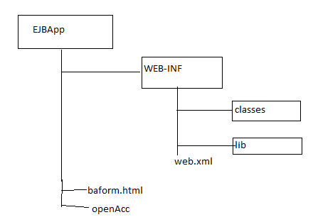

<%@page import=”javax.naming.*,java.io.*,java.util.*”%>
<%
String vaid=request.getParameter(“aid”);
String vcname=request.getParameter(“cname”);
String vaddr=request.getParameter(“addr”);
String vid=request.getParameter(“id”);
FileInputInStream fis=new FileInputInStream(“c:\jndi.properties”);
Properties props=new Properties();
props.load(fis);
Context ic=new InitialContext(props);
org.students.RIBAManager beanref=()ic.lookup(“BA#org.students.RIBAManager”);
beanref.createAccount(vaid,cname,vaddr,vid);
%>
openAcc.jsp

Note: javax.transaction.UserTransaction is a part of java transaction API(JTA). The method begin(),commit(),rollback() of UserTransaction can be used to control the transaction(Start /end of tx)

package inet.solve;

import javax.ejb.Local;

@Local
public interface ProductManagerBeanLocal {

public void insertProd(String pid,String pname,int price);
}

There are two type of transaction management strategies in ejb.
- Bean Managed Transaction
- Container Managed Transaction
If we choose BMT (Bean Managed Transaction) then we must provide the code in the bean to control the transaction(start/end tx)

package inet.solve;

import javax.ejb.Remote;

@Remote
public interface ProductManagerBeanRemote {
public void insertProd(String pid,String pname,int price);
}

ProductManagerBeanRemote.java

package inet.solve;

import java.sql.Connection;
import java.sql.PreparedStatement;

import javax.annotation.Resource;
import javax.ejb.SessionContext;
import javax.ejb.Stateless;
import javax.ejb.TransactionManagement;
import javax.ejb.TransactionManagementType;
import javax.naming.Context;
import javax.naming.InitialContext;
import javax.naming.NamingException;
import javax.sql.DataSource;
import javax.transaction.SystemException;
import javax.transaction.UserTransaction;

@Stateless(name="PM",mappedName="PM")
//Incase of Bean Managed Transaction
//@TransactionManagement(TransactionManagementType.BEAN)
//Incase of Container Managed Transaction
@TransactionManagement(TransactionManagementType.CONTAINER)
public class ProductManagerBean implements ProductManagerBeanLocal,
ProductManagerBeanRemote {
@Resource(mappedName="java:DerbyDS")
DataSource ds;
//In case of Bean Managed Transaction
/*
@Resource
UserTransaction ut;
*/
@Resource
SessionContext sessionContext;
Connection con;
public void insertProd(String pid,String pname,int price){
Context ic;
try {
ic = new InitialContext();
//DataSource ds=(DataSource)ic.lookup("");
con=ds.getConnection();
String vsql="insert into products values(?,?,?)";
//Incase of Bean Managed Transaction
//ut.begin();
PreparedStatement pstmt=con.prepareStatement(vsql);
pstmt.setString(1,pid);
pstmt.setString(2, pname);
pstmt.setInt(3, price);
pstmt.executeUpdate();
//Incase of Bean Managed Transaction
// ut.commit();
} catch (NamingException e) {
e.printStackTrace();
}catch (Exception e) {
try {
//Incase of Bean Managed Transaction
//ut.rollback();
//in case of CMT
sessionContext.setRollbackOnly();
con.close();
} catch (IllegalStateException e1) {
e1.printStackTrace();
} catch (SecurityException e1) {
e1.printStackTrace();
/*} catch (SystemException e1) {
e1.printStackTrace();
*/}catch (Exception ex) {
}
e.printStackTrace();
}

}}

package inet.solve;

import java.io.FileInputStream;
import java.util.Properties;

import javax.naming.Context;
import javax.naming.InitialContext;

public class ProdCli {

/**
* @param args
*/
public static void main(String[] args)throws Exception {
// TODO Auto-generated method stub
FileInputStream fis=new FileInputStream("f:/jndi.properties");
Properties props=new Properties();
props.load(fis);
Context ic=new InitialContext(props);
inet.solve.ProductManagerBeanRemote beanRef=(inet.solve.ProductManagerBeanRemote)ic.lookup("PM/remote");
beanRef.insertProd("p003", "Pencil", 5);
System.out.println("inserted");
}

}

If we choose CMT (Container Managed Transaction) ,the container take the responsibility of controlling the transaction.

Internally container uses JTA to start and end the transaction.

If we choose CMT (Container Managed Transaction) then as part of our bean code we should not use UserTransaction object to control the transaction.

Note: It is better to always use CMT instead of BMT for managing Transaction.

As CMT is the default for managing the transaction, there is no need of using annotation
- @TransactionManagement for using CMT
- Don’t use UserTransaction object and ut.begin() & ut.rollback() like method

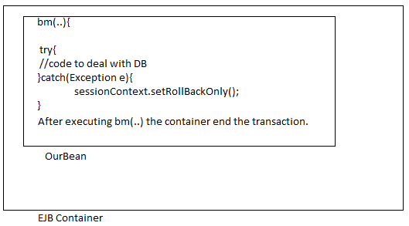

The diagram shows what will be done by the container befor and after executing a business method when we use CMT.

sessionContext.setRollbackOnly() is used to tell the container that something has gone wrong container must rollback Tx.
Ut.rollback()→ to rollback tx.
sessionContext.setRollbackOnly()→ does not roll back rather it tell the container to rollback if something has gone wrong & offcourse container rollback Tx.

package inet.solve;

import java.sql.Connection;
import java.sql.PreparedStatement;

import javax.annotation.Resource;
import javax.ejb.SessionContext;
import javax.ejb.Stateless;
import javax.ejb.TransactionManagement;
import javax.ejb.TransactionManagementType;
import javax.naming.Context;
import javax.naming.InitialContext;
import javax.naming.NamingException;
import javax.sql.DataSource;
import javax.transaction.SystemException;
import javax.transaction.UserTransaction;

@Stateless(name="PM",mappedName="PM")
//Incase of Bean Managed Transaction
//Incase of Container Managed Transaction
//@TransactionManagement(TransactionManagementType.CONTAINER)
public class ProductManagerBean implements ProductManagerBeanLocal,
ProductManagerBeanRemote {
@Resource(mappedName="java:DerbyDS")
DataSource ds;
//In case of Bean Managed Transaction
/*
@Resource
UserTransaction ut;
*/
@Resource
SessionContext sessionContext;
Connection con;
public void insertProd(String pid,String pname,int price){
Context ic;
try {
ic = new InitialContext();
//DataSource ds=(DataSource)ic.lookup("");
con=ds.getConnection();
String vsql="insert into products values(?,?,?)";
//Incase of Bean Managed Transaction
PreparedStatement pstmt=con.prepareStatement(vsql);
pstmt.setString(1,pid);
pstmt.setString(2, pname);
pstmt.setInt(3, price);
pstmt.executeUpdate();
//Incase of Bean Managed Transaction
} catch (NamingException e) {
e.printStackTrace();
}catch (Exception e) {
try {
//in case of CMT
sessionContext.setRollbackOnly();
con.close();
} catch (IllegalStateException e1) {
e1.printStackTrace();
} catch (SecurityException e1) {
e1.printStackTrace();
/*} catch (SystemException e1) {
e1.printStackTrace();
*/}catch (Exception ex) {
}
e.printStackTrace();
}

}
}

We can use Transactional attribute(Required,mandatory… etc.) to tell the container how it must control the Transaction.

Type of Session Bean
- Stateless Session Bean
- Statefull Session Bean
- Stateless Session Bean: does not remember conversational state of client (if a client provide some information while calling method1 then bean does not remember this information when client call method 2)
- Statefull Session Bean: is responsible for remembering the conversational state.

LIFE CYCLE OF STATELESS SESSION BEAN

For Stateless Session Bean (SLSB) Ejb container uses object pooling technique. As part of SLSB we can provide the annotated method @PostConstruct and @PreDestroy

The method name can be anything but method should not take any parameter and return type of method must be void.

package inet.solve;

import javax.ejb.Local;

@Local
public interface StateBeanLocal {
public void setName(String name);
public String getName();

}

package inet.solve;

import javax.ejb.Remote;

@Remote
public interface StateBeanRemote {
public void setName(String name);
public String getName();
}

package inet.solve;

import javax.annotation.PostConstruct;
import javax.annotation.PreDestroy;
import javax.annotation.Resource;
import javax.ejb.PostActivate;
import javax.ejb.PrePassivate;
import javax.ejb.SessionContext;
import javax.ejb.Stateful;

@Stateless(name="SB",mappedName="SB")
public class StateBean implements StateBeanLocal, StateBeanRemote {
@Resource
SessionContext sessionContext;
String name;

Public StateBean (){
System.out.println("--StateFullBean--");
System.out.println("Name"+name);
System.out.println("Session Context--"+sessionContext);
}
@PostConstruct
public void init(){
System.out.println("Post Construct method ");
System.out.println(name);
System.out.println(sessionContext);
}
@PreDestroy
public void destroy(){
System.out.println("Predestroy--");
}

@PrePassivate
public void passivate(){
System.out.println("--Pre Passivate---");
}

@PostActivate
public void activate(){
System.out.println("---Post Activate---");
}
public void setName(String name){

}
public String getName(){
return name;
}

}

The method for which PostConstruct and PreDestroy annotation are called as lifecycle method of bean

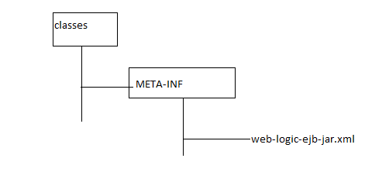

<weblogic-ejb-jar>
<weblogic-enterprise-bean>
<ejb-name>SB</ejb-name>
<statelsess-session-descriptor>
<pool>
<max-bean-in-free-pool>10</max-bean-in-free-pool>
<initial-bean-in-free-pool>5</ initial -bean-in-free-pool>
</pool>
</statelsess-session-descriptor>

</weblogic-enterprise-bean>

</weblogic-ejb-jar>

Q.1 When the container creates SLSB object?

R: According to the EJB specification the container can create any number of SLSB object at any point of time. When the above bean SB (name of StateBean) is deployed in weblogic, weblogic creates 5 SLSB object as we have specified initial-bean-in-free-pool 5 a pool. After creating the SLSB object container perform the following task.

- Perform the dependency injection (In our example the container set the variable sessionContext.
- Container call the PostConstruct method (in our case init() method will be called).
- When a client call the business method on SLSB the container pick up any one object available in the pool and execute the business method and container return the object to the pool.

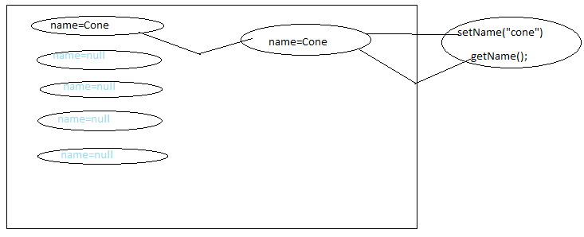
If five client calls the business method at a time, container pick-up five object from the available pool and start execution on these object.

If five objects are available in pool and 9 client has called the business method at once, the container creates 4 more bean object (even if it is not generated) the object to the pool & execute the business method on 9 objects.

If 11 client (more than max pool size) has called the business method and if 5 beans are available in the pool, container creates 5 more bean object to the pool (max-bean-in-free-pool =10) pick up 10 object from the pool and start execution of method on 10 client and keep the 11th client in the queue. After completing the execution of method on one of the bean the container uses that object on behalf of 11th object and execute the method for 11th client.

Q2. When does container removes SLSB object?

R: According to EJB Specification container can remove the SLSB obejct at any point of time from the pool, Before removing the object the container calls the method with annotation @PreDestroy.

Most of the container removes the object when the bean is un deployed.
If there are more number of beans (say 100) and only few of them (say 5) is used the container removes some of objects (say 50).

Q3. For what kind of EJB container uses object pooling technique?
R: For SLSB and Message Driven Bean.

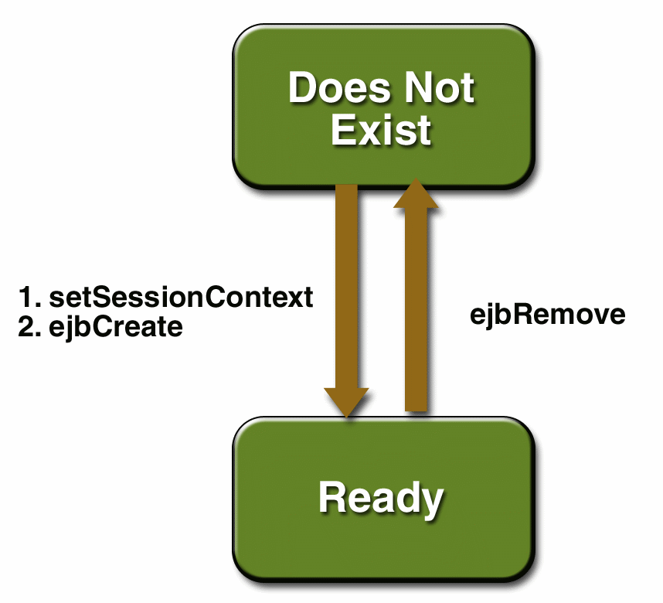

LIFE CYCLE OF STATEFULL SESSION BEAN
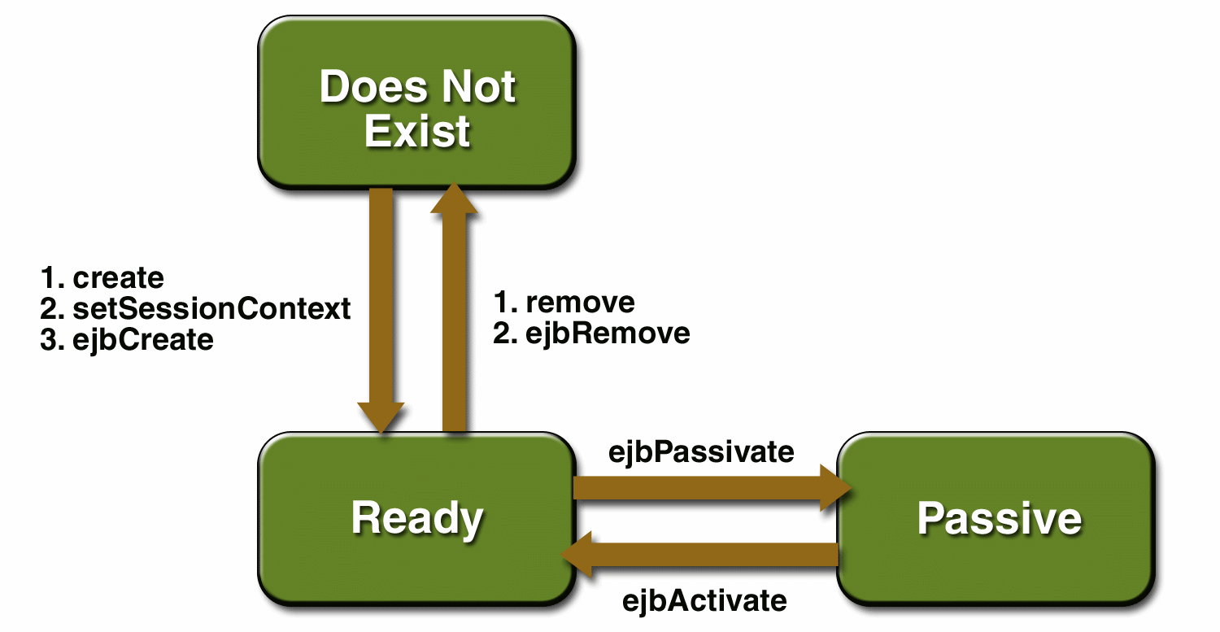

- The container does not uses object pooling for SFSB.
- The container is responsible for creating the bean object when the client uses ic.lookup(..) to get the reference of Remote business interface or local inter face.
- The container removes the object when the client call the method that is marked with the annotation @Remove. The name of method can be anything and this method should not take any parameter & return type must be void.
Note: SFSB is created for a particular client.
- A SFSB object can be either Active or Passive. When a bean is active the container can execute method on it otherwise container cannot execute method on it.
- When there is no space in the cache to create object the container passivates the object that are available in cache.
- During the passivation container carries out the following task:
- Container calls the method that is marked with annotation @Passivate
- Container uses the serialization technique and write the information about the object on disk.
- Takes out the object from the cache (even if the bean object is not available in the cache we should not consider object to be removed)
Q. When does the container passivate SFSB object?
R: When there is no space in the cache to create new object the container passivate the existing object.

Q. When does the container activate the SFSB objects?
R: When a method is invoked on object that was passive, the container activate the object while activating the object the container carries out the following steps:

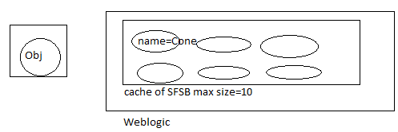
- Container uses deserialization technique & creates the object available in disk.
- Container uses deserialization techniques and creates object using info available in disk.
- Container calls the method that is marked with annotation PostActivate.
Q. What kind of code we must provide as part of PostConstruct & Predestroy?
R: As part of PostConstruct method we must provide the code to acquire resources like opening the socket connection etc.
In the predestroy method we must provide the code to deallocate the resources like closing the socket.
In the @Prepassivate & @PostActivate method code must be provided to take care of transient variable(Non serializable)
Note: Activate/Passivate is not used in SLSB.

package org.students;
Import javax.ejb.*;
@Remote
Public interface RIState{
public void setName(String name);
public void setName(String name);
public void remove();
}

package inet.solve;

import javax.annotation.PostConstruct;
import javax.annotation.PreDestroy;
import javax.annotation.Resource;
import javax.ejb.PostActivate;
import javax.ejb.PrePassivate;
import javax.ejb.SessionContext;
import javax.ejb.Stateful;

@Stateful(name="SFB",mappedName="SFB")
public class StateFullBean implements StateFullBeanLocal, StateFullBeanRemote {
@Resource
SessionContext sessionContext;
String name;
Transient Socket sock;//socket is non-serializable
@PostConstruct
public void init(){
try{
sock=new Socket();
}catch(Exception e){

}
}
@PreDestroy
public void destroy(){
System.out.println("Predestroy--");
try{
sock=null;
}catch(Exception e){

}

}

@PrePassivate
public void passivate(){
System.out.println("--Pre Passivate---");
try{
sock=null;
}catch(Exception e){

}

}

@PostActivate
public void activate(){
System.out.println("---Post Activate---");
try{
sock=new Socket();
}catch(Exception e){

}

}
public void setName(String name){
this.name=name;
}
public String getName(){
return name;
}
@Remove
public void remove(){
System.out.println("---Remove---");

}

}

There will be more burden on the server while maintaining SFSB’s.
Most of the developer prefer to use SLSB’s as part of their project.

The designer of an ejb can design entire project using only SLSB.

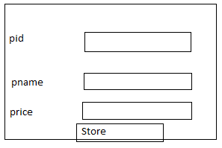

..setPid(“10”);
..setPname(“xyz”);
..setPrice(“10”);
Beanref.storeProd();
Webserver: A product that uses http protocol ( long back ago).
Application Server: The Server that provides the features like Transaction management (TM), creation, removal, activation, passivation managing the object) of object managing security etc & simplifies the developments of business logic are considered as Application Server.

TMS (Microsoft Transaction Server) the product like weblogic, websphere, JBoss are called as application Server. MITS (Internet Information Server), Apache Tomcat are example of webserver.

Q. what are the difference between EJB2 and EJB 3
R:
- In EJB3 there is no need of providing Local Home interface Remote Home interface.
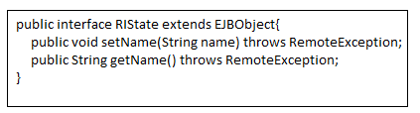
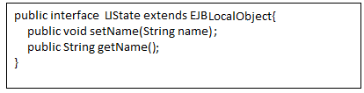
- POJI (Plain Old Java Interface) is supported in EJB3.
Remote business inter face and local business interface in EJB3 are POJI. In EJB2 RBI must be sub interface of EJBObject and LBI must be subinterface of EJBLocalObect. But in the new version RBI, LBI need not to be subinterface EJBObject, EJBLocalObect.
- The Bean classes of EJB3 are POJO (Plain Old Java Object) but in case of EJB2 while providing the session beans we must provide the bean class implementing the SessionBean interface but in EJB3 bean class need not to implement SessionBean interface. This is why EJB3 are called POJO classes.
- EJB3 support annotation but EJB2 does not.
- In EJB2 we must provide deployment descriptor file (ejb-jar.xml, weblogic-ejb-jar.xml). We can use annotation to provide the information about bean in place of deployment descriptor in EJB3.
Deployment descriptor are optional in EJB3. If some information is provided in annotation and in DD (deployment descriptor) the container uses the information provided in DD.
- Dependency injection is not supported in EJB2.
JPA( Java Persistence API)

- JPA is very much similar to hibernate/toplink
- The EntityBeans of EJB1 & EJB2 can be used only inside the EJB container.
- To access the data available in table we must use entity classes.
- The entity classes are very muc similar to POJO ckasses that we used in hibernate.
- JPA can be used inside the EJB container as well as outside the EJB container(JPA can be used as part of a web application,applet,ejb application, standalone java application)
Procedure for setting up MyEclipse for developing JPA based applications
- create a director for workspace(f:\eclws) and copy the jdbc driver ojdbc14.jar) to this directory
- start myeclipse6 and choose the directory created in step1 as workspace
- setup a database profile by following steps given below:
  - open prespective shos MyEclipse Database prespective
  - Right click to get the pop up menu inside DB browser view and choose new option
  - In database driver window choose oracle thin driver as template and provide the following details
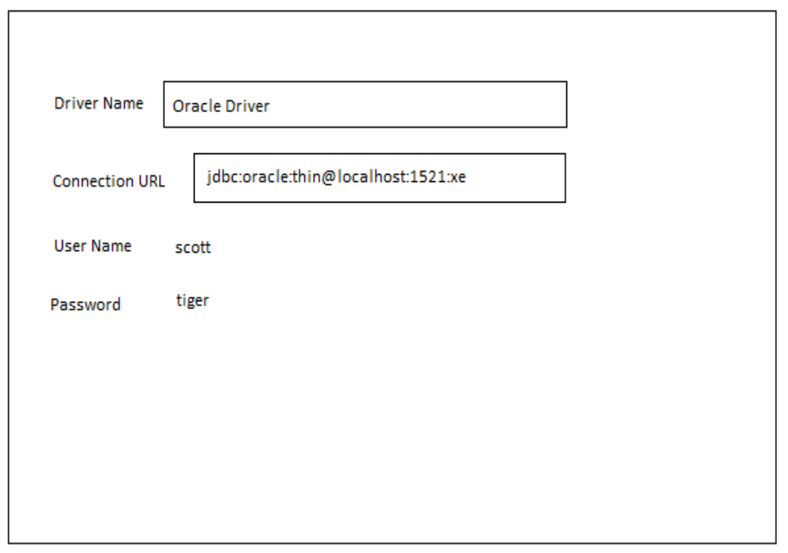
    - click on add jar button and choose ojdbc14.jar file and click on finish button

Procedure for developing JAVA PROJECT with JPA:

javax.persistance is a package that is part of JEE5. As part of this package following interfaces are provided:

- EntityManagerFactory
- EntityManager
- EntityTransaction
- Query
javax.persistance.Persistance is a class that must be used to get the EntityManagerFactory object.

Steps:
    - choose File-->New Project, choose Java-->project in New project window and click on next button
    - In New Java Project window provide the projcet name (jpa one) and click on finish
    - choose the project in package explorer and choose myeclipse-->Add JPA capablity
    - click on next button in Add JPA capablity window
    - provide persistance unit name(perone), choose oracle driver as dirver and click on update list butto choose scott as catalog/schema and click on Finish

Note: MyEclipse create a file with the name persistance.xml, inside this file, the details regarding persistance unit will be stored.

        - choose Myeclipse databse explorer perspective
        - Right click on oracle driver and choose open connection
        - choose table/tables abd right click to get the popup menu, choose JPA Reverse Engineering
        - choose src folder of the project as java src folder and provide org.students as java package and check the option Entity bean

        - click on finish button
Note: Myeclipse generated entity classes(POJO classes) with annotation like entity, id, column, table etc.

MDB(Message Driven Bean)

package org.jboss.book.jms.ex2;

import javax.ejb.MessageDrivenBean;
import javax.ejb.MessageDrivenContext;
import javax.ejb.EJBException;
import javax.jms.JMSException;
import javax.jms.Message;
import javax.jms.MessageListener;
import javax.jms.Queue;
import javax.jms.QueueConnection;
import javax.jms.QueueConnectionFactory;
import javax.jms.QueueSender;
import javax.jms.QueueSession;
import javax.jms.TextMessage;
import javax.naming.InitialContext;
import javax.naming.NamingException;

/**
* An MDB that transforms the TextMessages it receives and send the
* transformed messages to the Queue found in the incoming message
* JMSReplyTo header.
*
* @author Scott.Stark@jboss.org
* @version $Revision: 1.9 $
*/
public class TextMDB
implements MessageDrivenBean, MessageListener
{
private MessageDrivenContext ctx = null;
private QueueConnection conn;
private QueueSession session;

public TextMDB()
{
System.out.println("TextMDB.ctor, this="+hashCode());
}

public void setMessageDrivenContext(MessageDrivenContext ctx)
{
this.ctx = ctx;
System.out.println("TextMDB.setMessageDrivenContext, this=" +
hashCode());
}

public void ejbCreate()
{
System.out.println("TextMDB.ejbCreate, this="+hashCode());
try {
setupPTP();
} catch (Exception e) {
throw new EJBException("Failed to init TextMDB", e);
}
}

public void ejbRemove()
{
System.out.println("TextMDB.ejbRemove, this="+hashCode());
ctx = null;
try {
if (session != null) {
session.close();
}
if (conn != null) {
conn.close();
}
} catch(JMSException e) {
e.printStackTrace();
}
}

public void onMessage(Message msg)
{
System.out.println("TextMDB.onMessage, this="+hashCode());
try {
TextMessage tm = (TextMessage) msg;
String text = tm.getText() + "processed by: "+hashCode();
Queue dest = (Queue) msg.getJMSReplyTo();
sendReply(text, dest);
} catch(Throwable t) {
t.printStackTrace();
}
}

private void setupPTP()
throws JMSException, NamingException
{
InitialContext iniCtx = new InitialContext();
Object tmp = iniCtx.lookup("java:comp/env/jms/QCF");
QueueConnectionFactory qcf = (QueueConnectionFactory) tmp;
conn = qcf.createQueueConnection();
session = conn.createQueueSession(false,
QueueSession.AUTO_ACKNOWLEDGE);
conn.start();
}

private void sendReply(String text, Queue dest)
throws JMSException
{
System.out.println("TextMDB.sendReply, this=" +
hashCode() + ", dest="+dest);
QueueSender sender = session.createSender(dest);
TextMessage tm = session.createTextMessage(text);
sender.send(tm);
sender.close();
}
}

<?xml version="1.0"?>
<!DOCTYPE ejb-jar PUBLIC
"-//Sun Microsystems, Inc.//DTD Enterprise JavaBeans 2.0//EN"
"http://java.sun.com/dtd/ejb-jar_2_0.dtd">
<ejb-jar>
<enterprise-beans>
<message-driven>
<ejb-name>TextMDB</ejb-name>
<ejb-class>org.jboss.book.jms.ex2.TextMDB</ejb-class>
<transaction-type>Container</transaction-type>
<acknowledge-mode>AUTO_ACKNOWLEDGE</acknowledge-mode>
<message-driven-destination>
<destination-type>javax.jms.Queue</destination-type>
</message-driven-destination>
<res-ref-name>jms/QCF</res-ref-name>
<resource-ref>
<res-type>javax.jms.QueueConnectionFactory</res-type>
<res-auth>Container</res-auth>
</resource-ref>
</message-driven>
</enterprise-beans>
</ejb-jar>
Example 7.7. The MDB ejb-jar.xml descriptor

<?xml version="1.0"?>
<jboss>
<enterprise-beans>
<message-driven>
<ejb-name>TextMDB</ejb-name>
<destination-jndi-name>queue/B</destination-jndi-name>
<resource-ref>
<res-ref-name>jms/QCF</res-ref-name>
<jndi-name>ConnectionFactory</jndi-name>
</resource-ref>
</message-driven>
</enterprise-beans>
</jboss>

package org.jboss.book.jms.ex2;

import javax.jms.JMSException;
import javax.jms.Message;
import javax.jms.MessageListener;
import javax.jms.Queue;
import javax.jms.QueueConnection;
import javax.jms.QueueConnectionFactory;
import javax.jms.QueueReceiver;
import javax.jms.QueueSender;
import javax.jms.QueueSession;
import javax.jms.TextMessage;
import javax.naming.InitialContext;
import javax.naming.NamingException;

import EDU.oswego.cs.dl.util.concurrent.CountDown;

/**
* A complete JMS client example program that sends N TextMessages to
* a Queue B and asynchronously receives the messages as modified by
* TextMDB from Queue A.
*
* @author Scott.Stark@jboss.org
* @version $Revision: 1.9 $
*/
public class SendRecvClient
{
static final int N = 10;
static CountDown done = new CountDown(N);

QueueConnection conn;
QueueSession session;
Queue queA;
Queue queB;

public static class ExListener
implements MessageListener
{
public void onMessage(Message msg)
{
done.release();
TextMessage tm = (TextMessage) msg;
try {
System.out.println("onMessage, recv text="+tm.getText());
} catch(Throwable t) {
t.printStackTrace();
}
}
}

public void setupPTP()
throws JMSException, NamingException
{
InitialContext iniCtx = new InitialContext();
Object tmp = iniCtx.lookup("ConnectionFactory");
QueueConnectionFactory qcf = (QueueConnectionFactory) tmp;
conn = qcf.createQueueConnection();
queA = (Queue) iniCtx.lookup("queue/A");
queB = (Queue) iniCtx.lookup("queue/B");
session = conn.createQueueSession(false,
QueueSession.AUTO_ACKNOWLEDGE);
conn.start();
}

public void sendRecvAsync(String textBase)
throws JMSException, NamingException, InterruptedException
{
System.out.println("Begin sendRecvAsync");

// Setup the PTP connection, session
setupPTP();

// Set the async listener for queA
QueueReceiver recv = session.createReceiver(queA);
recv.setMessageListener(new ExListener());

// Send a few text msgs to queB
QueueSender send = session.createSender(queB);

for(int m = 0; m < 10; m ++) {
TextMessage tm = session.createTextMessage(textBase+"#"+m);
tm.setJMSReplyTo(queA);
send.send(tm);
System.out.println("sendRecvAsync, sent text=" + tm.getText());
}
System.out.println("End sendRecvAsync");
}

public void stop()
throws JMSException
{
conn.stop();
session.close();
conn.close();
}

public static void main(String args[])
throws Exception
{
System.out.println("Begin SendRecvClient,now=" +
System.currentTimeMillis());
SendRecvClient client = new SendRecvClient();
client.sendRecvAsync("A text msg");
client.done.acquire();
client.stop();
System.exit(0);
System.out.println("End SendRecvClient");
}

}

