Ex.no:8 | MINI PROJECT – HOTEL BOOKINGS  DATA ANALYTICS

Domain and Problem Statement:
Domain: Hospitality Analytics & Tourism Management
Problem Statement: Hotel chains face revenue instability caused by high cancellation rates, fluctuating seasonal demand, and unoptimized pricing strategies (ADR). This project addresses these challenges by transforming raw booking transactional records into structured business intelligence across Power BI and Tableau to evaluate booking performance, geographic trends, and customer segments.

Dataset Description:
Dataset Name: Hotel Booking Demand Dataset.
Granularity: Each row represents a single hotel reservation transaction.
Timeframe Covered: 2015 to 2017.
Key Entities & Attributes:
- Demographics: country, customer_type, market_segment, distribution_channel.
- Booking Details: hotel, is_canceled, lead_time, arrival_date_year, arrival_date_month, arrival_date_day_of_month.
- Financials: adr (Average Daily Rate), deposit_type, stays_in_weekend_nights, stays_in_week_nights.

Data Source:
Primary Source: Kaggle Open Datasets (Hotel Booking Demand).
Storage Infrastructure: Cleaned transactional records hosted within a local MySQL database instance (hotel_analytics).

Architecture:
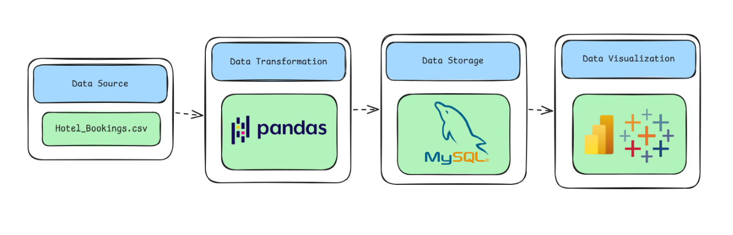

Program:
1. Python – Data Cleaning & Transformation
import pandas as pd
from sqlalchemy import create_engine, text

# Load dataset
df = pd.read_csv("hotel_bookings.csv")

# Create a copy for processing
hotel = df.copy()
# Remove unnecessary columns
hotel.drop(columns=["agent", "company"], inplace=True)

# Handle missing values
hotel["children"] = hotel["children"].fillna(0)
hotel["country"] = hotel["country"].fillna("Unknown")
# Remove duplicate records
hotel.drop_duplicates(inplace=True)

# Create arrival date
hotel["arrival_date"] = pd.to_datetime(
hotel["arrival_date_year"].astype(str) + "-" +
hotel["arrival_date_month"] + "-" +
hotel["arrival_date_day_of_month"].astype(str),
format="%Y-%B-%d"
)

# Create derived columns
hotel["total_nights"] = (
hotel["stays_in_weekend_nights"] +
hotel["stays_in_week_nights"]
)

hotel["total_guests"] = (
hotel["adults"] +
hotel["children"] +
hotel["babies"]
)

hotel["total_extra_requests"] = (
hotel["total_of_special_requests"] +
hotel["required_car_parking_spaces"]
)

# Standardize column names
hotel.columns = (
hotel.columns
.str.lower()
.str.strip()
.str.replace(" ", "_")
)
print("Original Shape:", df.shape)
print("Cleaned Shape:", hotel.shape)
hotel.head()

2. MySQL – Database and Data Loading
MySQL Command Prompt:
net start MySQL80
mysql -u root -p
MySQL:
CREATE DATABASE IF NOT EXISTS hotel_analytics;
Python/Jupyter:
username = "root"
password = "YOUR_MYSQL_PASSWORD"
host = "localhost"
port = 3306

# Connect to MySQL database
db_engine = create_engine(
f"mysql+pymysql://{username}:{password}@{host}:{port}/hotel_analytics"
)

# Load cleaned data into MySQL
hotel.to_sql(
"hotel_bookings",
con=db_engine,
if_exists="replace",
index=False,
chunksize=5000
)

print("Data loaded successfully into MySQL.")
Verify:
pd.read_sql(
"SELECT COUNT(*) AS total_rows FROM hotel_bookings",
db_engine
)
Procedure:

Step 1: Data Preparation & Preprocessing (Python / Pandas)
- Load the raw Kaggle dataset into a Jupyter Notebook / Python script using pandas.read_csv().
- Inspect for null values and handle missing data in country, children, and agent columns.
- Feature engineer total stay length by combining weekend and weeknight stays:
$$\text{total_stays}=\text{stays_in_weekend_nights}+\text{stays_in_week_nights}$$
- Filter out invalid rows (e.g., zero total guests or negative ADR entries) and export the cleaned DataFrame to MySQL using sqlalchemy and to_sql().

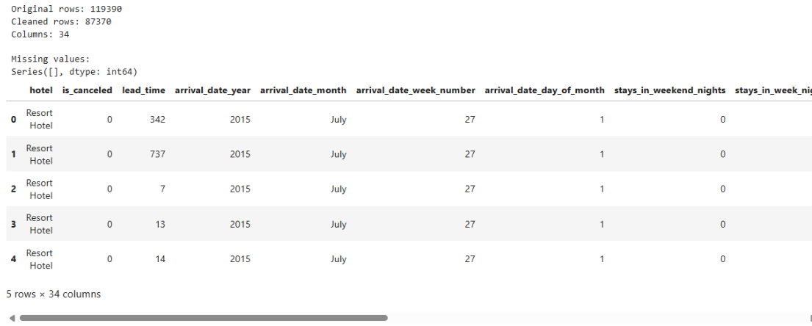

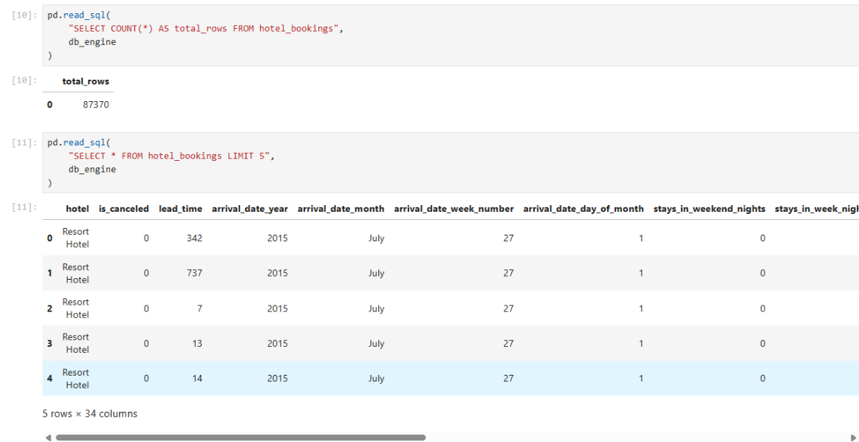

Step 2: SQL Database Connection & Data Ingestion
- Open Power BI Desktop $→$ Click Get Data $→$ Select MySQL Database.
- Enter the Server (localhost:3306) and Database Name (hotel_analytics).
- Enter authentication credentials, select the cleaned flat table (hotel_bookings / hotel_analytics), and click Transform Data to open Power Query
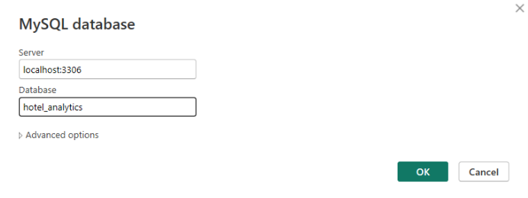

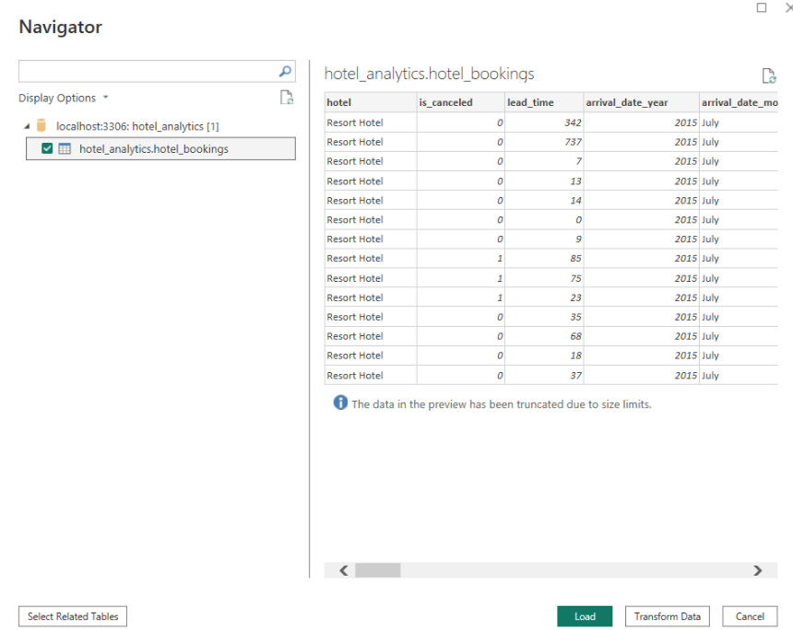

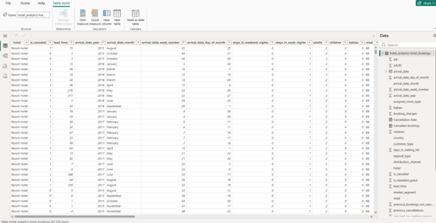

Step 3: Star Schema Data Modeling (Power BI)
- Table Splitting in Power Query:
  - Duplicate the imported flat table (hotel_bookings) three times to create separate entities: Fact_Bookings, Dim_Customer, Dim_Hotel, and Dim_Date.
  - In Dim_Customer, keep customer_type, market_segment, distribution_channel, and country. Remove duplicates and add an Index Column as CustomerID.
  - In Dim_Hotel, keep hotel. Remove duplicates and add an Index Column as HotelID.
  - In Fact_Bookings, merge with dimension tables to map CustomerID and HotelID, then remove raw text columns.
  - Click Close & Apply.
- Establishing Relationships in Model View:
  - Open the Model View tab in Power BI.
  - Connect Dim_Customer[CustomerID] $→$ Fact_Bookings[CustomerID] ($1:*$).
  - Connect Dim_Hotel[HotelID] $→$ Fact_Bookings[HotelID] ($1:*$).
  - Connect Dim_Date[Date] $→$ Fact_Bookings[arrival_date] ($1:*$).
  - Hide foreign key columns inside Fact_Bookings to keep the report fields pane organized.
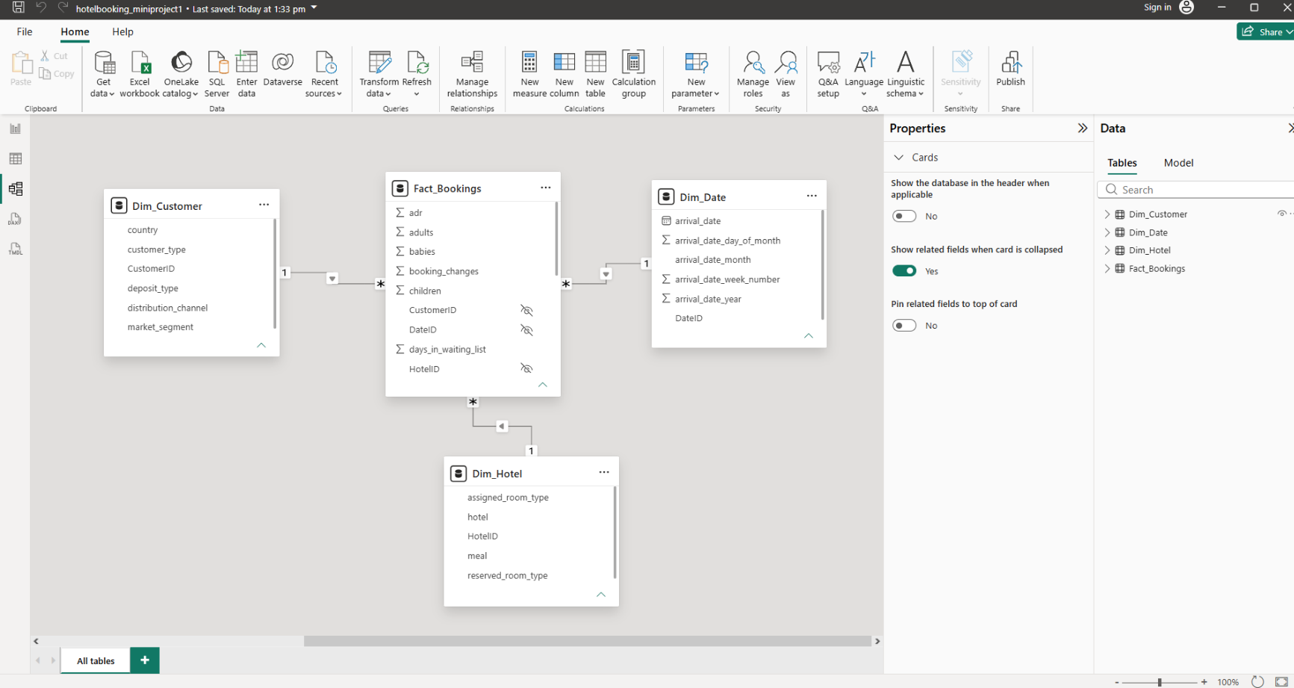

Step 4: Core Calculations & Measures (DAX)
Power BI Measures (DAX)
Create a dedicated _Measures table and add the following DAX calculations:
- Total Bookings:
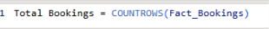
- Total Revenue:
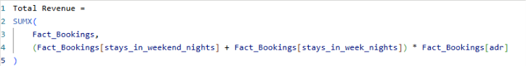

- Cancellation Rate (%):
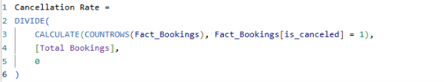

- Average Daily Rate (ADR):
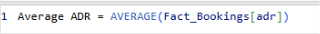
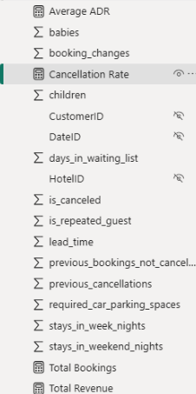

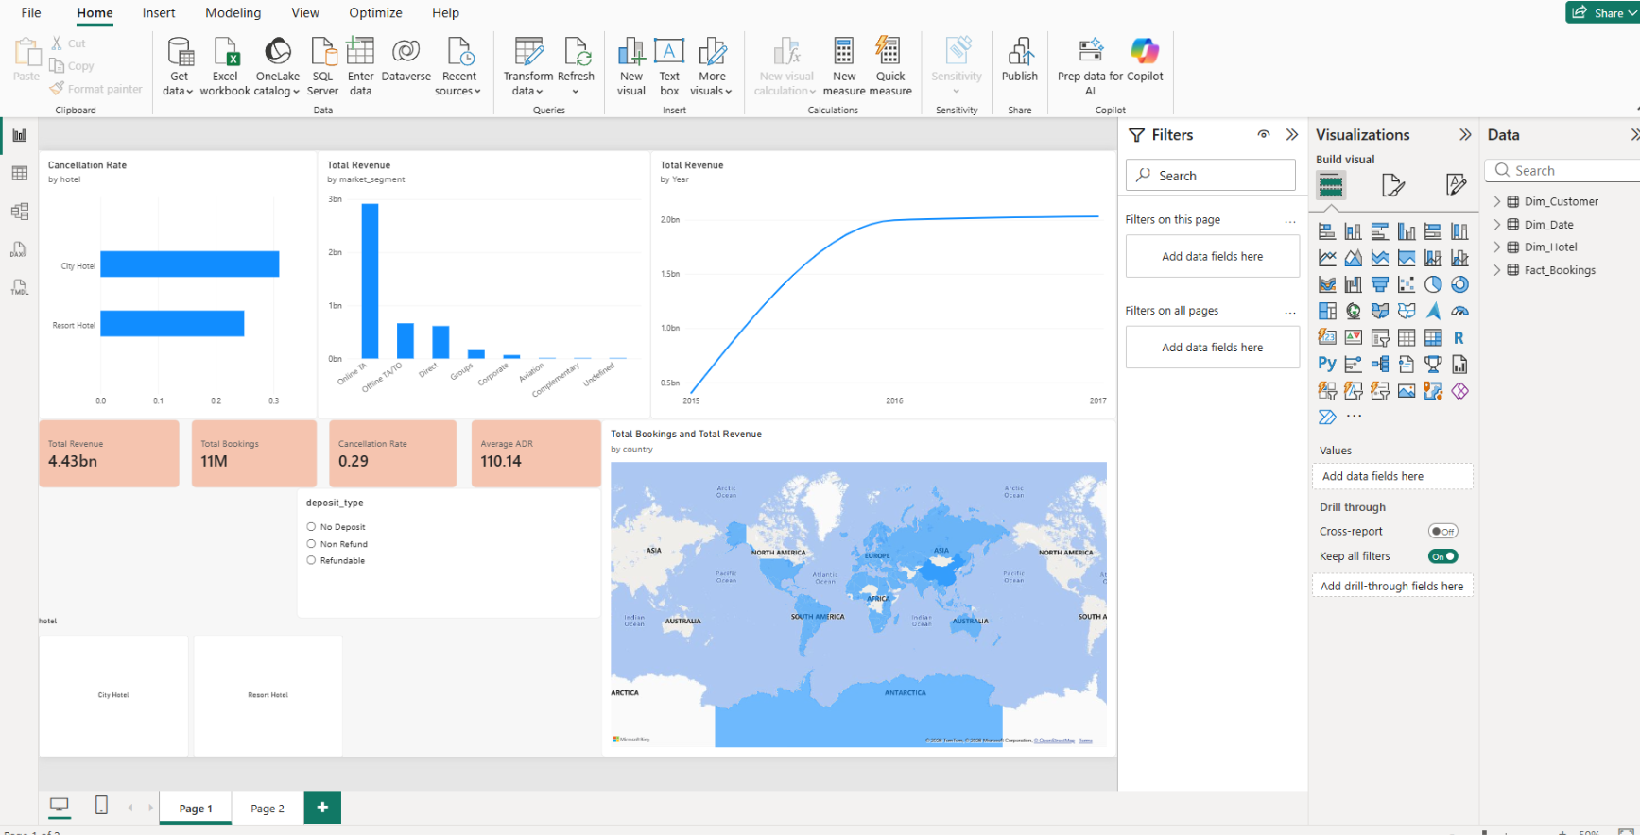
Step 5: Power BI Final Executive Dashboard & Drill-Through

- Executive Canvas:
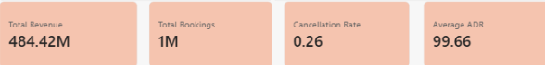
  - Place Card Visuals across the top: Total Revenue, Total Bookings, Cancellation Rate, Average ADR.

  - Add a Line Chart mapped to Dim_Date[arrival_date] with hierarchy drill-down enabled (Year $→$ Quarter $→$ Month).
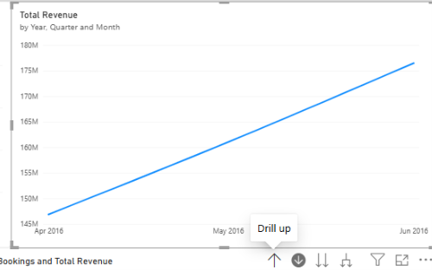

  - Add a Clustered Bar Chart for Cancellation Rate by Dim_Hotel[hotel].
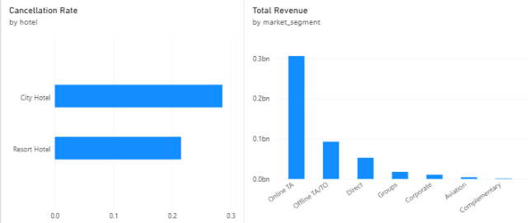

  - Add Slicers for hotel, deposit_type
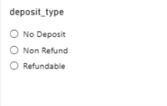

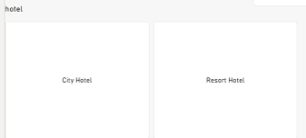

- Country Details Drill-Through Page:
  - Create a second page named Country Details.
  - Drag Dim_Customer[country] into the Drill-through field bucket.
  - Add a detailed Matrix/Table visual showing country, Total Bookings, Total Revenue, and Cancellation Rate.
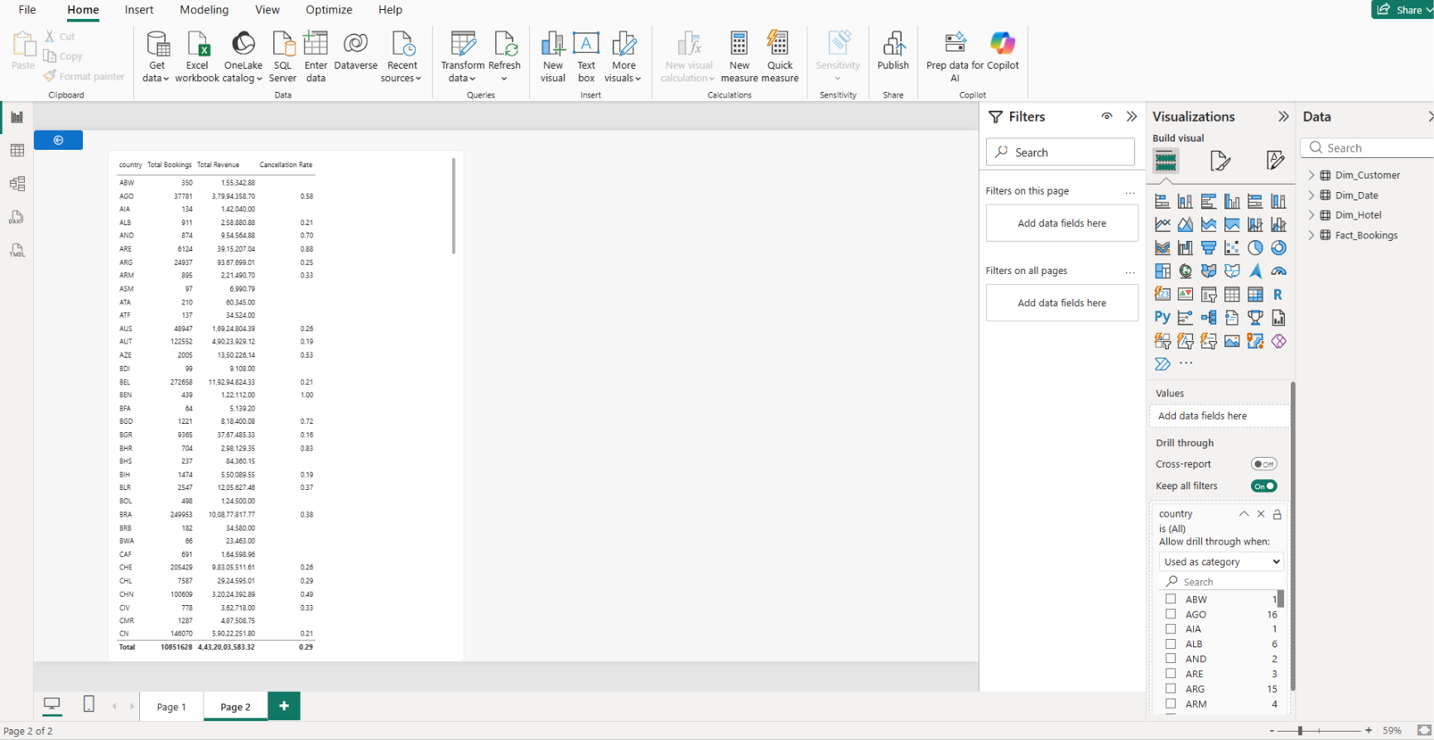

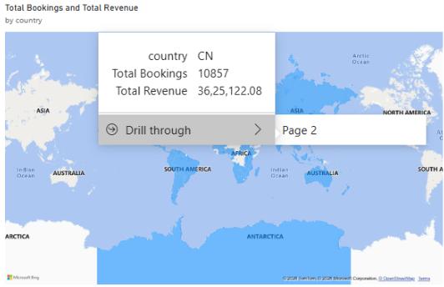

Step 6: Tableau Data Connection & Preparation
- Open Tableau Desktop / Tableau Public.
- Under To a Server, select MySQL
- Enter Server (localhost), Database (hotel_analytics), and user credentials to pull the cleaned dataset onto the canvas.
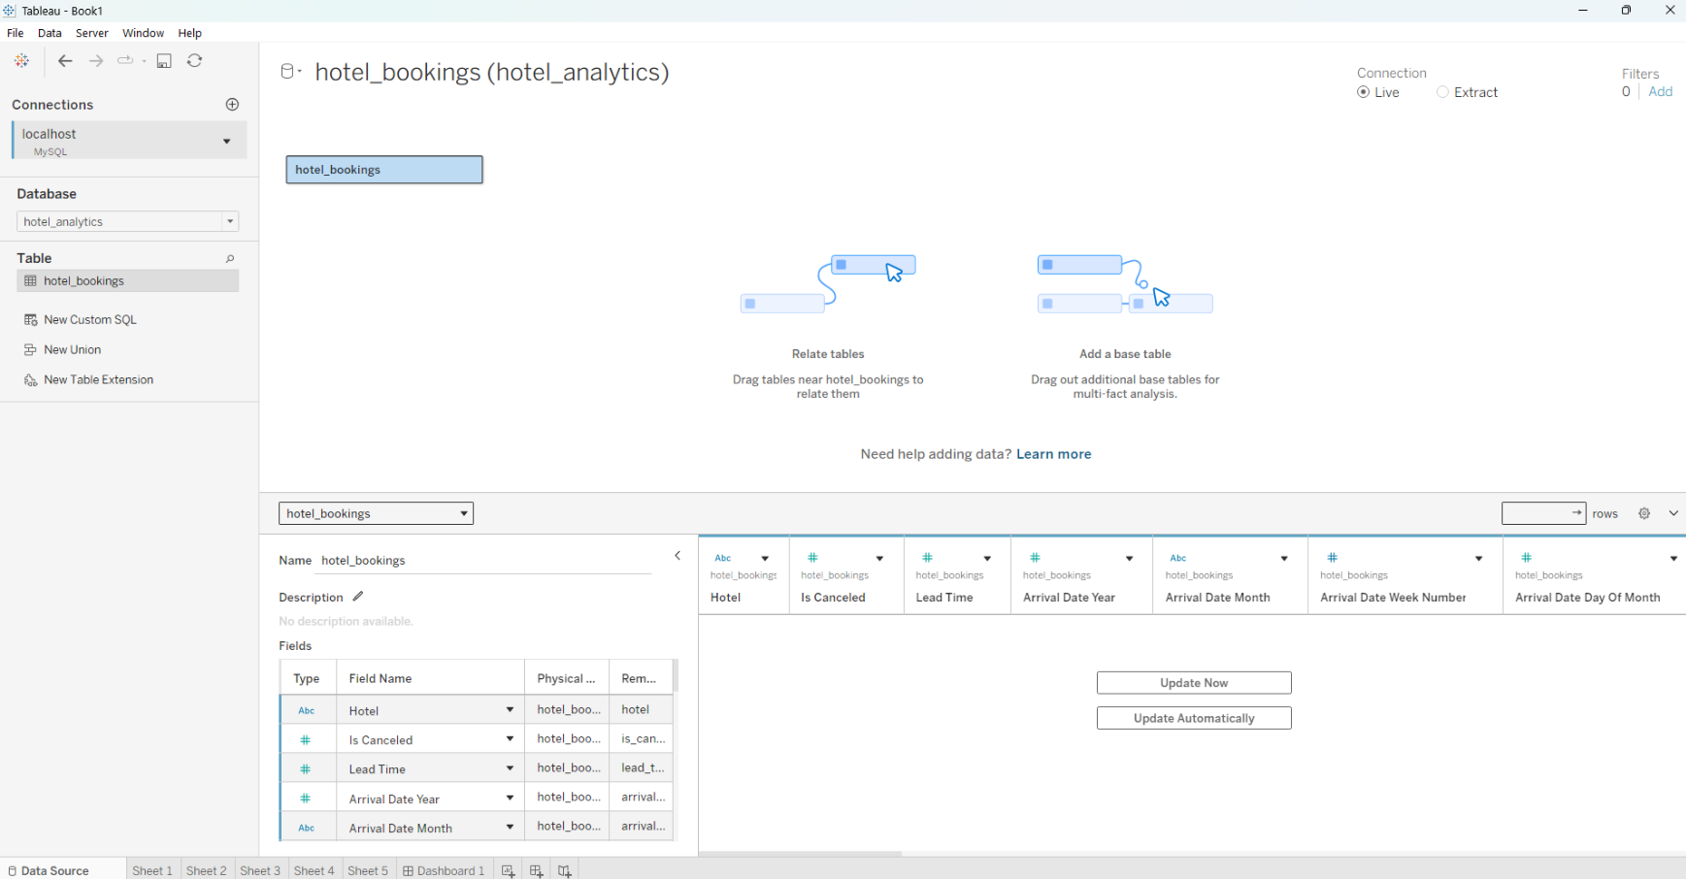

- Go to any sheet and build calculated fields:
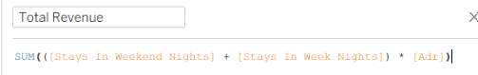
  - Total Revenue

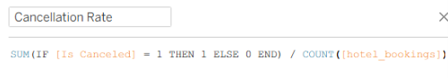
  - Cancellation Rate

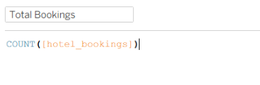
  - Total Bookings

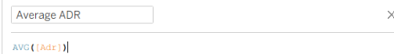
  - Average ADR

  - Select Metric Parameter: String list containing "Total Revenue", "Total Bookings", "Cancellation Rate".
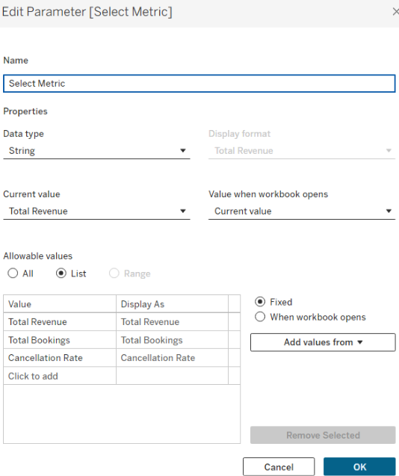

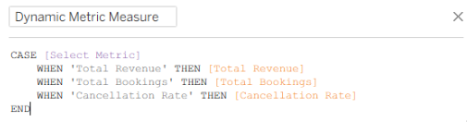
  - Dynamic Measure Formula:

Step 7: Tableau Companion Dashboard & Interactive Story
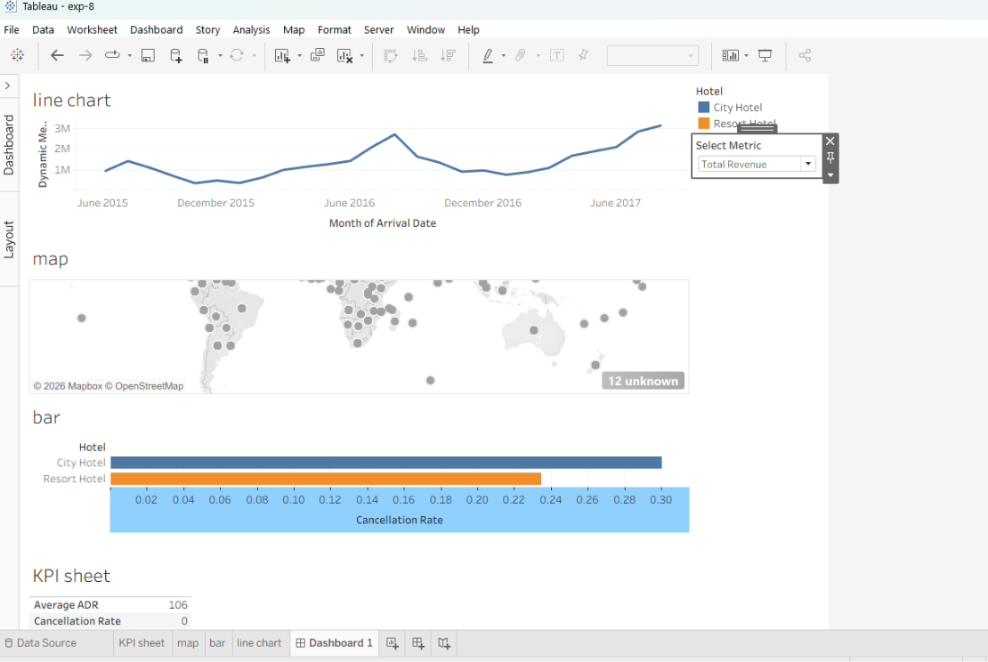

- Worksheets: Build KPI Cards, Revenue Trend Line Chart (using Dynamic Measure), Hotel Cancellation Bar Chart, and Country Map.
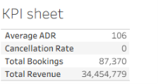
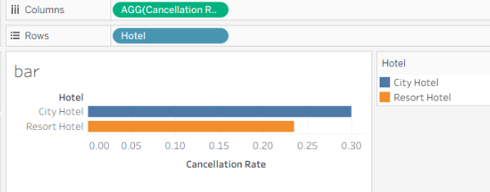

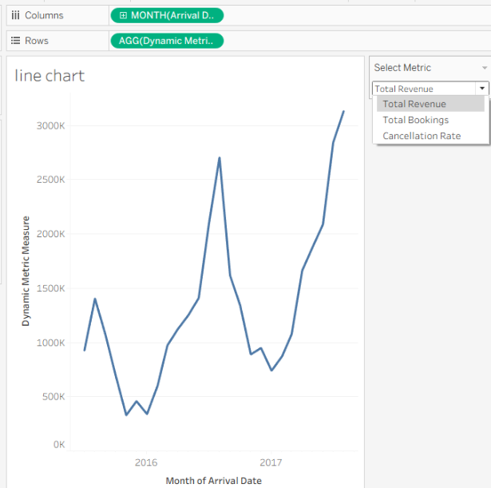

- Global Filters & Actions:
  - Drag Hotel, Deposit Type, and Arrival Date to Filters $→$ set to Apply to Worksheets $→$ All Using This Data Source.
  - Drag sheets onto a new Dashboard tab and click the Use as Filter funnel icon on the Country Map visual.
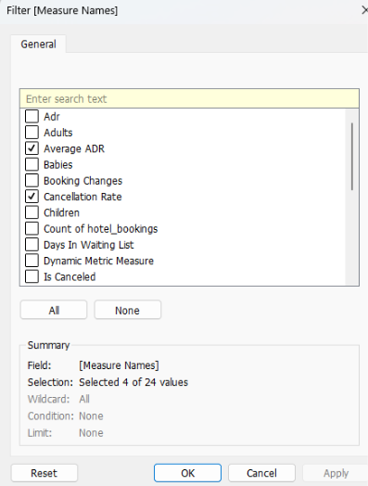

- Drill-down map:
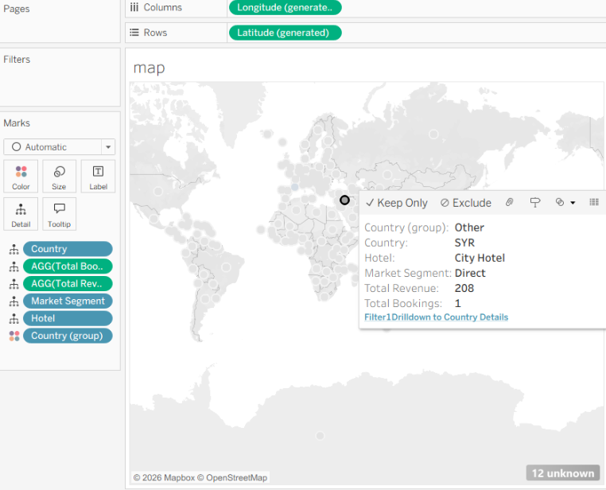

Observed Insights:
- Portfolio Revenue & Booking Volume: The dataset captures 119.4K Total Bookings generating $484.42M in Gross Revenue, maintaining a portfolio Average Daily Rate (ADR) of $99.66.
- Cancellation Rates: The overall portfolio reflects a 26% Cancellation Rate, with City Hotels exhibiting higher cancellation volatility compared to Resort Hotels.
- Seasonality Trends: Booking volume and revenue peak significantly during the European summer window (June–August), followed by a sharp drop in winter (December–January).
- Geographic Market Distribution: Demand is heavily concentrated in Western Europe, with Portugal (PRT) serving as the top origin market, followed by Great Britain (GBR), France (FRA), and Spain (ESP).

