Ex.no:2 | EDA-DATA IMPORT AND EXPORT

Aim:
To inspect dataset features, detect null values, and export data into CSV, Excel, and SQLite database formats.
Algorithm:
- Import pandas and sqlite3 libraries.
- Read hotel_bookings.csv using pd.read_csv().
- Inspect data structure using .head(), .tail(), .info(), .describe(), and .isnull().sum().
- Export DataFrame to .csv and .xlsx formats using .to_csv() and .to_excel().
- Connect to hotel_booking.db using sqlite3 and write data into an SQL table via .to_sql().
- Close the database connection and end execution.

Program:
# Import required libraries
import pandas as pd

# Load the Hotel Booking dataset
df = pd.read_csv("hotel_bookings.csv")

# Display the complete dataset
print("===== DATASET =====")
print(df)

# Display first five records
print("\n===== FIRST FIVE ROWS =====")
print(df.head())

# Display last five records
print("\n===== LAST FIVE ROWS =====")
print(df.tail())

# Display dataset information
print("\n===== DATASET INFORMATION =====")
print(df.info())

# Display statistical summary
print("\n===== STATISTICAL SUMMARY =====")
print(df.describe(include='all'))

# Display dataset shape
print("\nDataset Shape:", df.shape)

# Display column names
print("\nColumns:")
print(df.columns)

# Check missing values
print("\n===== MISSING VALUES =====")
print(df.isnull().sum())

# Export dataset to CSV
df.to_csv("hotel_bookings_export.csv", index=False)
print("CSV file exported successfully!")

# Export dataset to Excel
df.to_excel("hotel_bookings_export.xlsx", index=False)
print("Excel file exported successfully!")

import sqlite3

# Create SQLite database
conn = sqlite3.connect("hotel_booking.db")

# Export DataFrame to SQL table
df.to_sql(
"hotel_bookings",
conn,
if_exists="replace",
index=False
)
print("Dataset exported successfully to SQLite database!")
conn.close()

Output:
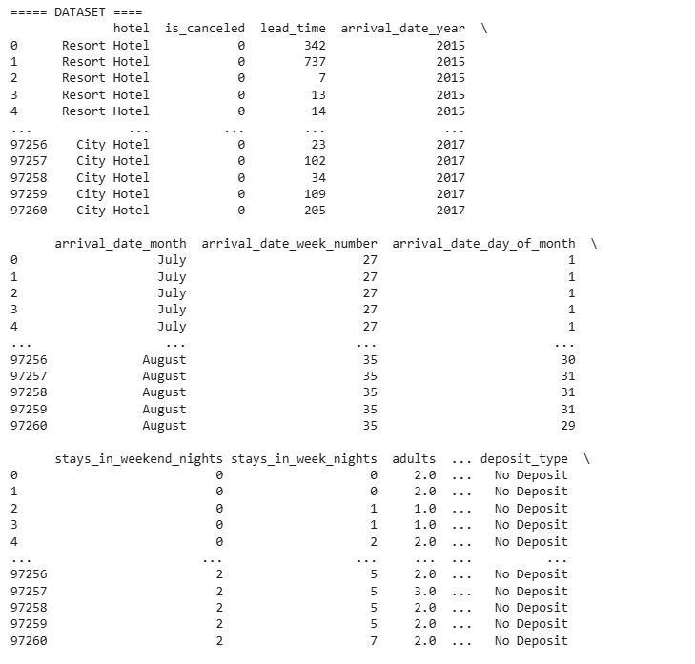
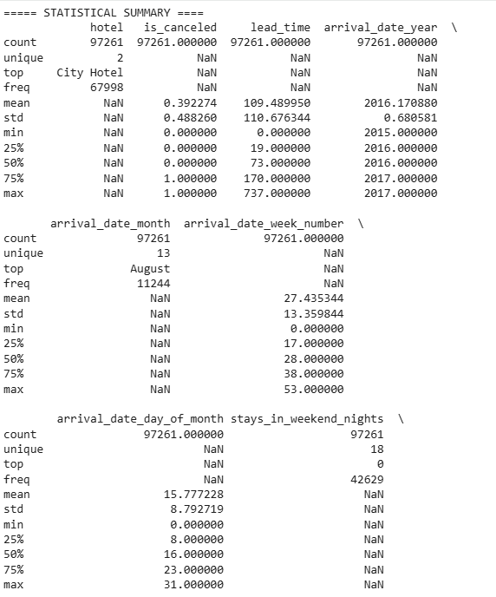
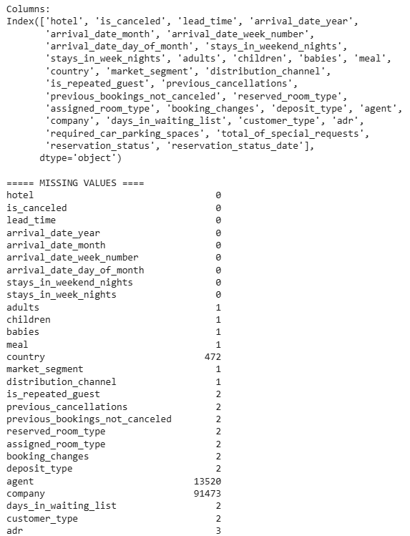

Result:

