Ex.no:3 | DATA CLEANING

Aim:

Algorithm:
Check Missing Values:
- Start.
- Import the pandas library.
- Load the dataset into a DataFrame (df).
- Display dataset information using df.info().
- Check missing values using df.isnull().
- Count missing values using df.isnull().sum().
- Check missing values using df.isna().
- Check non-missing values using df.notnull().
- Display the results.

Drop Missing Values
- Start.
- Import the pandas library.
- Load the dataset into a DataFrame (df).
- Drop missing rows using dropna().
- Drop rows (axis=0) or columns (axis=1).
- Use how='any' to remove rows/columns containing any missing value.
- Use how='all' to remove rows/columns only if all values are missing.
- Use thresh=N to keep rows/columns with at least N non-missing values.
- Use subset=['column_name'] to drop rows based on specific columns.
- Use inplace=True to modify the original DataFrame.
- Display the cleaned DataFrame.

Program:
import pandas as pd
import matplotlib.pyplot as plt
from sklearn.preprocessing import MinMaxScaler, LabelEncoder

# Load data
df = pd.read_csv('fs.csv')

# Handle missing values
mean_values = df.mean(numeric_only=True)
df.fillna(mean_values, inplace=True)

# Detect outliers
Q1 = df['Revenue'].quantile(0.25)
Q3 = df['Revenue'].quantile(0.75)
IQR = Q3 - Q1
outliers = df[(df['Revenue'] < Q1 - 1.5 * IQR) | (df['Revenue'] > Q3 + 1.5 * IQR)]

# Plot outliers
plt.figure(figsize=(8, 5))
plt.boxplot(df['Revenue'].dropna())
plt.title("Revenue Outlier Detection")
plt.ylabel("Revenue")
plt.show()

# Normalize feature
scaler = MinMaxScaler()
df[['Revenue']] = scaler.fit_transform(df[['Revenue']])

# Encode feature
encoder = LabelEncoder()
df['Category'] = encoder.fit_transform(df['Category'])

# One-hot encode
category_dummies = pd.get_dummies(df['Category'])

Output:
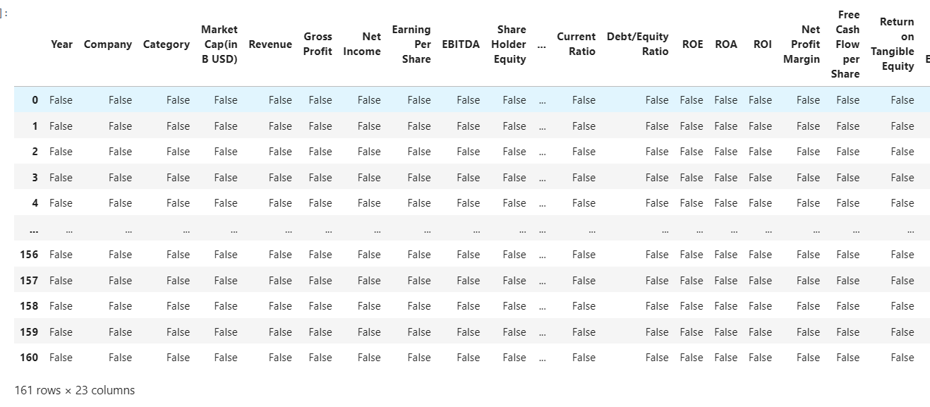
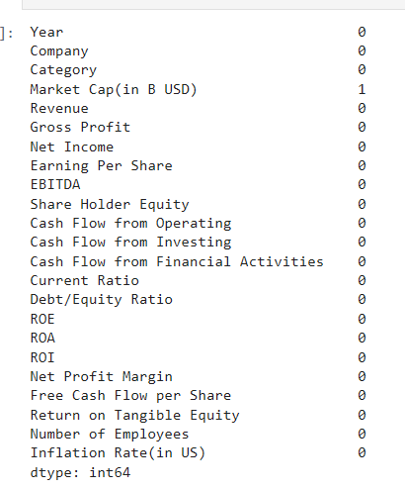
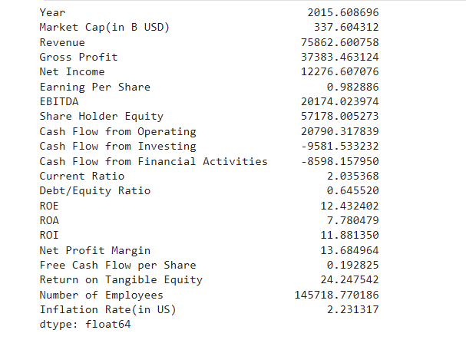
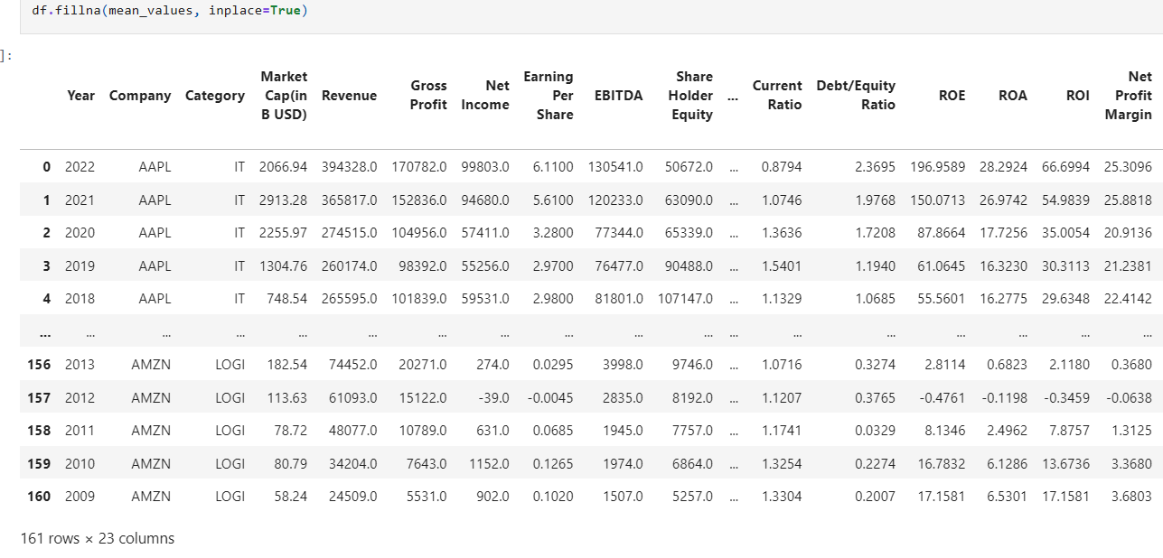

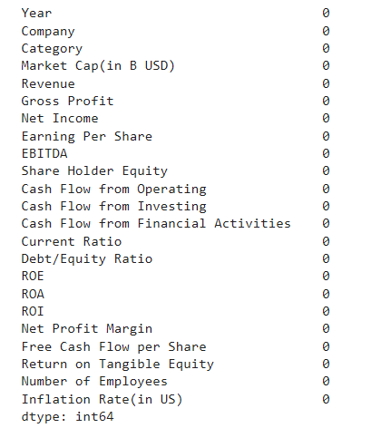
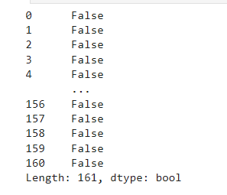
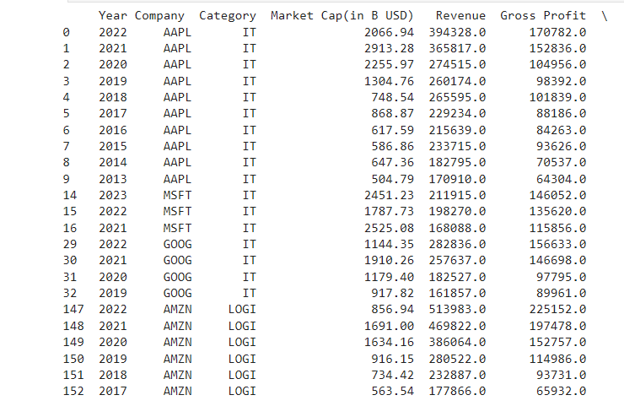

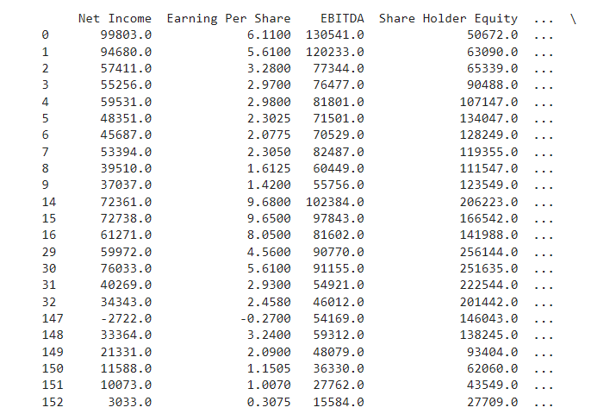
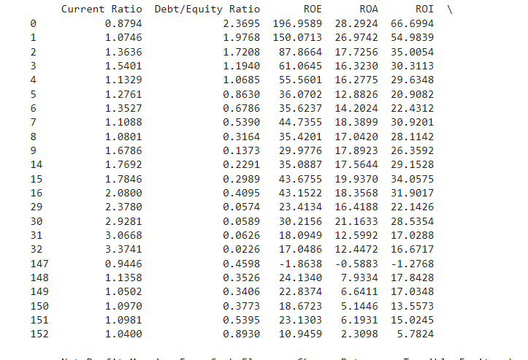
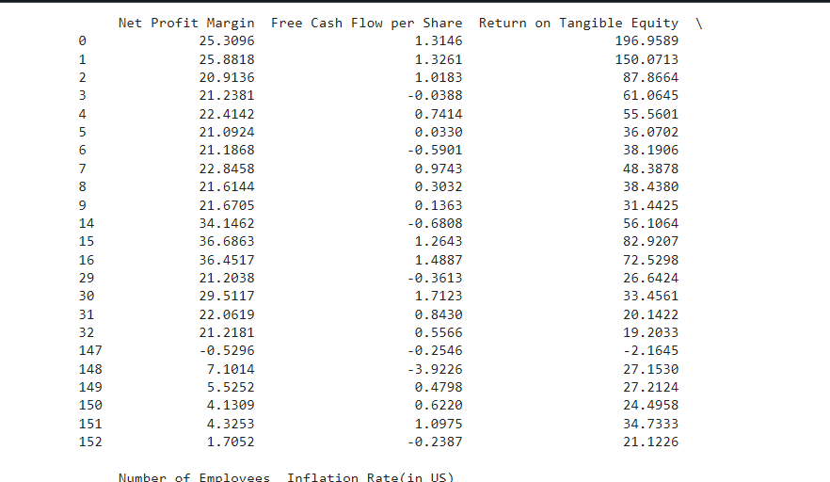

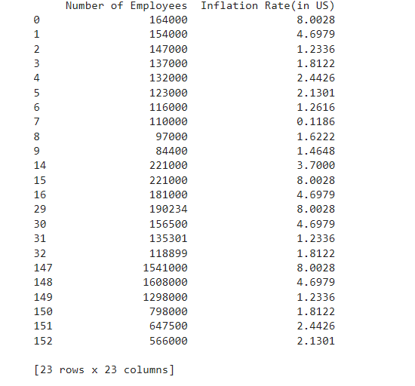
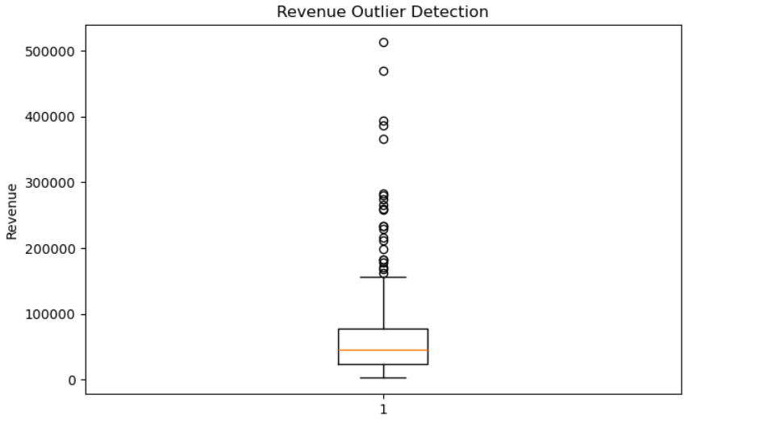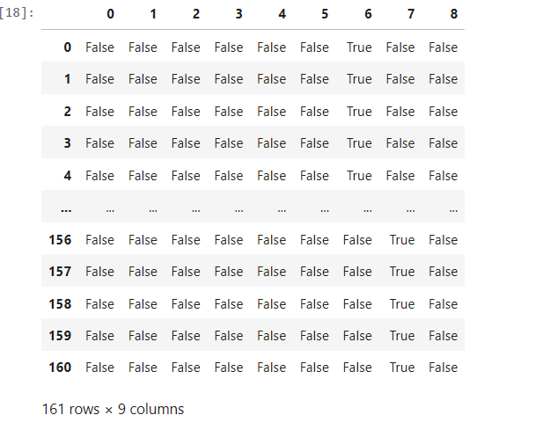

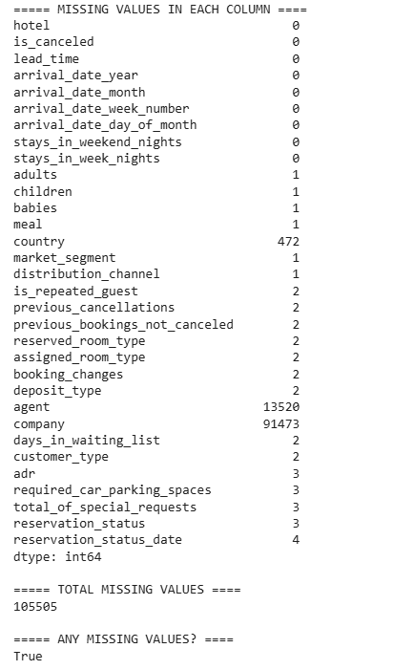
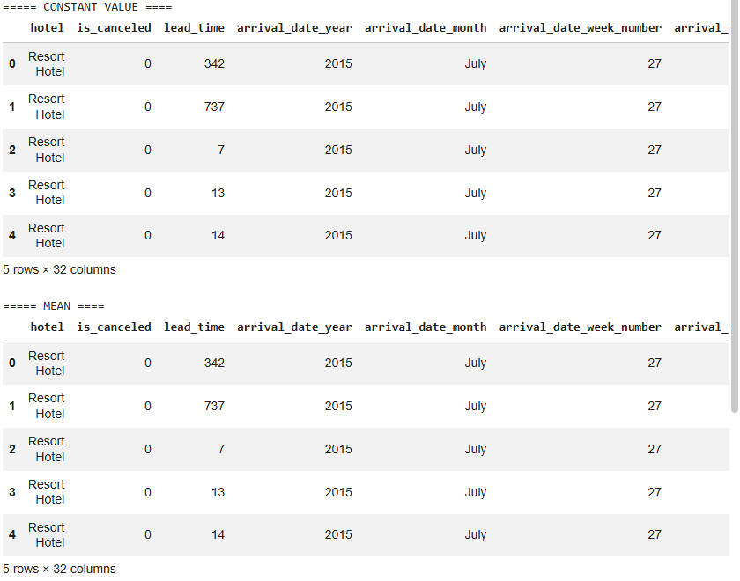
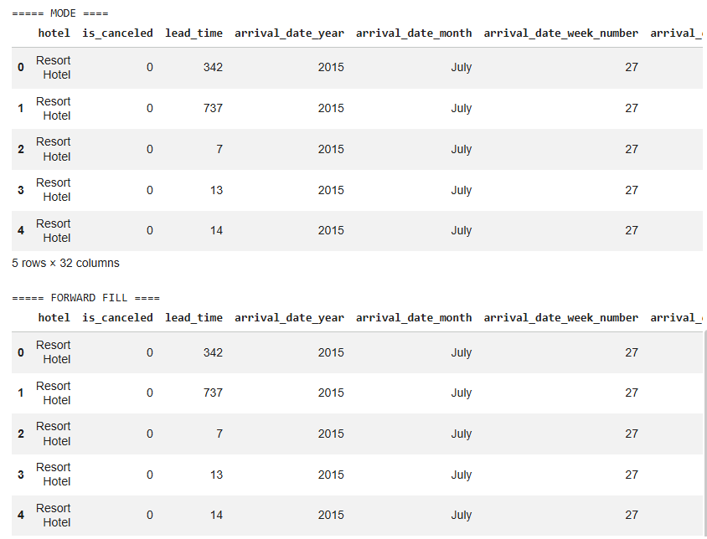

Result:

