Ex.no:4 | EXPLORATORY DATA ANALYSIS (EDA) – DATA INSPECTION, FILTERING, STATISTICAL ANALYSIS AND CORRELATION

Aim:
To perform data inspection, conditional filtering, sorting, statistical summary, group aggregation, correlation analysis, and data visualization on a hotel bookings dataset using Pandas and Matplotlib.

Algorithm:
- Start.
- Import the required Python libraries: pandas and matplotlib.pyplot.
- Load the dataset hotel_bookings.csv into a pandas DataFrame using pd.read_csv().
- Inspect the basic structure, initial records, shape, column data types, and numerical summaries using df.head(), df.shape, df.dtypes, and df.describe().
- Filter rows based on specific business conditions (e.g., adr > 100 and hotel == "Resort Hotel").
- Sort the dataset by adr in descending order using df.sort_values().
- Compute statistical metrics for adr including mean, median, mode, and standard deviation.
- Group data by hotel type and aggregate to find the average adr using df.groupby().
- Calculate the pairwise correlation matrix for numerical features using df.corr().
- Generate a bar plot for average adr by hotel type and a scatter plot of lead_time versus adr using Matplotlib.

Program:
import numpy as np
import pandas as pd
import matplotlib.pyplot as plt

# ==========================================
# 1. LOAD AND CLEAN THE DATASET
# ==========================================
# Load the financial dataset
df = pd.read_csv("fs.csv")

# Clean column names by removing extra spaces
df.columns = df.columns.str.strip()

print("--- First 5 Rows of the Dataset ---")
print(df.head())
print("\nDataset Shape (Rows, Columns):")
print(df.shape)

# ==========================================
# 2. FILTERING AND SORTING OPERATIONS
# ==========================================
# Filter: Revenue greater than 250,000
high_revenue_df = df[df["Revenue"] > 250000]

print("\n--- Years with Revenue > 250,000 ---")
print(high_revenue_df[["Year", "Company", "Revenue"]])

# Dynamically find the exact column name that contains the word "Inflation"
inflation_col = [col for col in df.columns if "Inflation" in col][0]

# Filter using the discovered column name: Inflation Rate less than 3.0
low_inflation_df = df[df[inflation_col] < 3.0]

print(f"\n--- Years with Inflation Rate < 3.0% (Using column: '{inflation_col}') ---")
print(low_inflation_df[["Year", "Company", inflation_col]].head()) # displaying head for brevity
print(f"Total matching rows: {len(low_inflation_df)}")

# Find the exact column containing 'Market'
market_col = [c for c in df.columns if "Market" in c][0]

sorted_df = df.sort_values(by=market_col, ascending=False)

print(f"\n--- Dataset Sorted by Market Cap (Using: '{market_col}') ---")
print(sorted_df[["Year", "Company", market_col]].head(10))

# ==========================================
# 3. STATISTICAL ANALYSIS AND AGGREGATIONS
# ==========================================
# Find the exact column containing 'Net'
net_inc_col = [c for c in df.columns if "Net" in c][0]

print(f"\n--- Net Income Statistics (Using: '{net_inc_col}') ---")
print("Mean =", df[net_inc_col].mean())
print("Median =", df[net_inc_col].median())
print("Mode =\n", df[net_inc_col].mode().to_string())
print("Standard Deviation =", df[net_inc_col].std())

# Find the exact column containing 'Gross'
gross_col = [c for c in df.columns if "Gross" in c][0]

category_avg_profit = df.groupby("Category")[gross_col].mean()

print(f"\n--- Category-wise Average Gross Profit (Using: '{gross_col}') ---")
print(category_avg_profit)

# Correlation Matrix between Revenue and Net Income
rev_col = [c for c in df.columns if "Revenue" in c][0]
correlation_matrix = df[[rev_col, net_inc_col]].corr()

print(f"\n--- Correlation Matrix: {rev_col} vs {net_inc_col} ---")
print(correlation_matrix)

# ==========================================
# 4. DATA VISUALIZATIONS
# ==========================================
# Plot 1: Market Cap Evolution
year_col = [c for c in df.columns if "Year" in c][0]
df_sorted = df.sort_values(by=year_col)

plt.figure(figsize=(8, 4))
plt.plot(
df_sorted[year_col],
df_sorted[market_col],
marker="o",
color="blue",
linewidth=2,
)
plt.title("Market Cap Evolution (2017 - 2022)")
plt.xlabel("Year")
plt.ylabel("Market Capitalization")
plt.grid(True, linestyle="--", alpha=0.6)
plt.show()

# Plot 2: Revenue vs Net Income Comparison (Side-by-Side Bar Chart)
x = np.arange(len(df_sorted[year_col]))
width = 0.35

plt.figure(figsize=(9, 5))
plt.bar(x - width / 2, df_sorted[rev_col], width, label="Revenue", color="teal")
plt.bar(
x + width / 2,
df_sorted[net_inc_col],
width,
label="Net Income",
color="orange",
)
plt.title("Revenue vs Net Income Comparison")
plt.xlabel("Year")
plt.ylabel("Financial Amount")
plt.xticks(x, df_sorted[year_col])
plt.legend()
plt.grid(axis="y", linestyle="--", alpha=0.5)
plt.show()

# Plot 3: Impact of Inflation on Net Income (Scatter Plot)
plt.figure(figsize=(7, 4.5))
plt.scatter(df[inflation_col], df[net_inc_col], color="red", s=100, edgecolors="black")
plt.title("Impact of Inflation on Net Income")
plt.xlabel("Inflation Rate (%)")
plt.ylabel("Net Income")
plt.grid(True, linestyle=":", alpha=0.6)
plt.show()

Output:
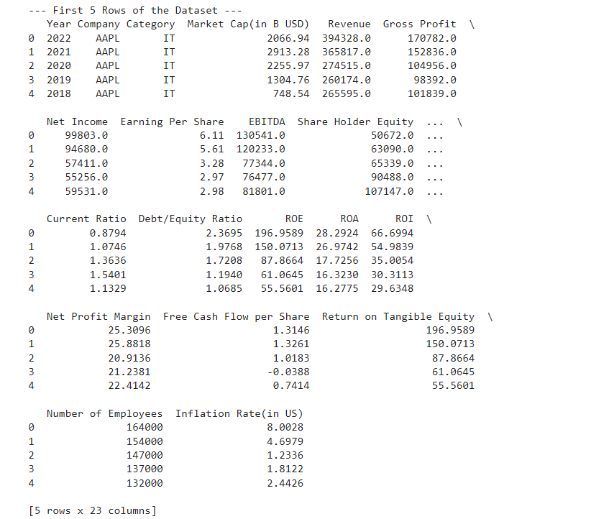


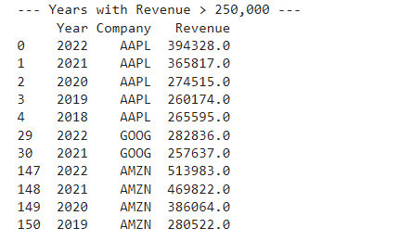
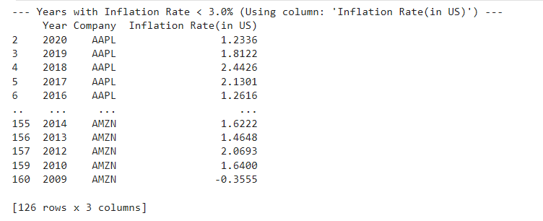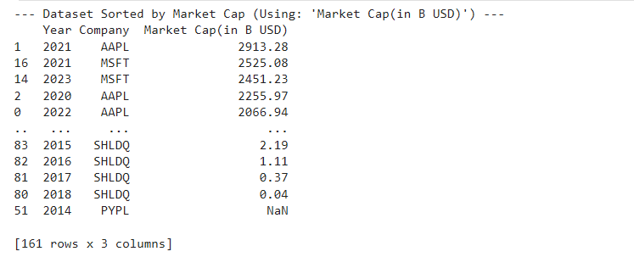
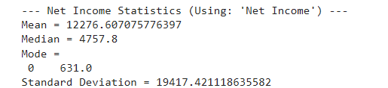
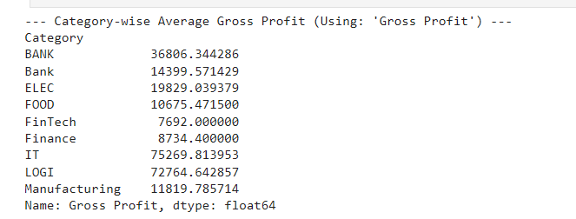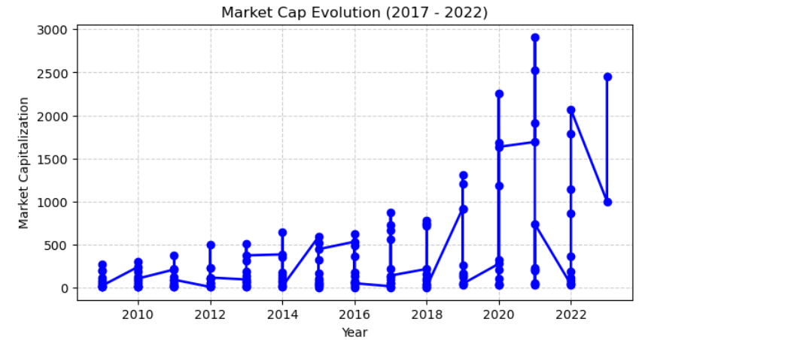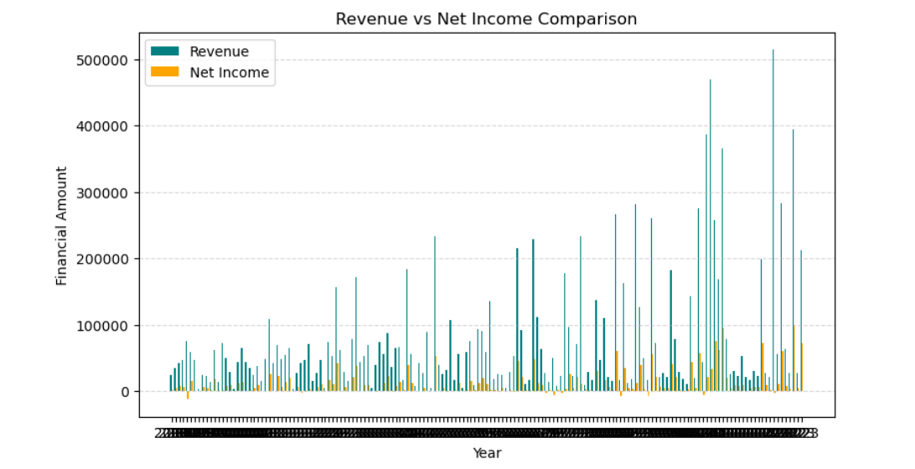
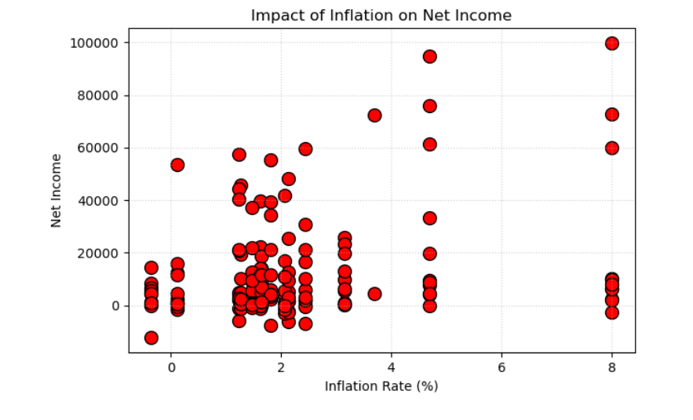

Result:

