Ex.no:5 | DATA VISUALIZATION USING MATPLOTLIB

Aim:
To visualize dataset features and distributions using line charts, bar charts, pie charts, histograms, scatter plots, and box plots using Matplotlib.

ALGORITHM 1: LINE CHART
Objective: To visualize the number of hotel bookings across different months.
Steps
- Load the hotel bookings dataset.
- Count the number of bookings for each arrival month.
- Arrange the months in chronological order.
- Plot the monthly booking counts using a line chart.
- Add title and axis labels.
- Display the graph.
Interpretation
The line chart shows how the number of hotel bookings varies across different months and helps identify booking trends.

months = [
"January", "February", "March", "April",
"May", "June", "July", "August",
"September", "October", "November", "December"
]
monthly_bookings = df["arrival_date_month"].value_counts().reindex(months)
plt.figure(figsize=(10,5))
plt.plot(months, monthly_bookings, marker='o')
plt.title("Monthly Hotel Bookings")
plt.xlabel("Month")
plt.ylabel("Number of Bookings")
plt.xticks(rotation=45)
plt.grid(True)
plt.show()

ALGORITHM 2: BAR CHART
Objective: To compare the number of bookings for different hotel types.
Steps
- Select the hotel column.
- Count the number of bookings for each hotel type.
- Create a bar chart using the hotel types and their booking counts.
- Add title and axis labels.
- Display the chart.
Interpretation
The bar chart provides a comparison of booking volumes between the different hotel types in the dataset.

hotel_bookings = df["hotel"].value_counts()
plt.figure(figsize=(7,5))
plt.bar(hotel_bookings.index, hotel_bookings.values)
plt.title("Bookings by Hotel Type")
plt.xlabel("Hotel Type")
plt.ylabel("Number of Bookings")
plt.show()

ALGORITHM 3: PIE CHART
Objective: To visualize the distribution of different customer types.
Steps
- Select the customer_type column.
- Count the occurrences of each customer type.
- Calculate their proportions.
- Create a pie chart.
- Display percentage labels.
- Add a suitable title.
Interpretation
The pie chart shows the percentage contribution of each customer type to the total bookings.

customer_type = df["customer_type"].value_counts()
plt.figure(figsize=(8,6))
plt.pie(
customer_type.values,
labels=customer_type.index,
autopct='%1.1f%%'
)
plt.title("Customer Type Distribution")
plt.show()

ALGORITHM 4: HISTOGRAM
Objective: To visualize the distribution of booking lead time.
Steps
- Select the lead_time column.
- Divide the lead-time values into intervals or bins.
- Create a histogram using Matplotlib.
- Add title and axis labels.
- Display the histogram.
Interpretation
The histogram shows the frequency distribution of the number of days between booking and arrival. It helps understand how far in advance customers generally make reservations.

plt.figure(figsize=(8,5))
plt.hist(df["lead_time"], bins=30)
plt.title("Distribution of Booking Lead Time")
plt.xlabel("Lead Time (Days)")
plt.ylabel("Frequency")
plt.show()

ALGORITHM 5: SCATTER PLOT
Objective: To analyze the relationship between lead time and Average Daily Rate (ADR).
Steps
- Select lead_time as the X-axis variable.
- Select adr as the Y-axis variable.
- Plot the observations using a scatter plot.
- Add title and axis labels.
- Display the graph.
Interpretation
The scatter plot helps identify whether there is any visible relationship between how early a customer makes a booking and the Average Daily Rate.

plt.figure(figsize=(8,5))
plt.scatter(df["lead_time"],df["adr"],alpha=0.3)
plt.title("Lead Time vs Average Daily Rate")
plt.xlabel("Lead Time (Days)")
plt.ylabel("Average Daily Rate (ADR)")
plt.show()

ALGORITHM 6: BOX PLOT
Objective: To visualize the distribution and identify possible outliers in Average Daily Rate.
Steps
- Select the adr column.
- Remove missing values if present.
- Create a box plot using Matplotlib.
- Add a suitable title and axis label.
- Display the plot.
Interpretation
The box plot shows the central distribution of ADR and helps identify unusually high or low ADR values.

plt.figure(figsize=(7,5))
plt.boxplot(df["adr"].dropna())
plt.title("Average Daily Rate (ADR) Box Plot")
plt.ylabel("ADR")
plt.show()

ALGORITHM 7: MULTIPLE LINE CHART
Objective: To compare total bookings and cancelled bookings across different months.
Steps
- Count total bookings for each arrival month.
- Count cancelled bookings for each arrival month.
- Arrange both datasets in chronological order.
- Plot total bookings using a line chart.
- Plot cancelled bookings using another line on the same graph.
- Add labels and a legend.
- Display the graph.
Interpretation
The multiple line chart allows comparison of total bookings with cancelled bookings across months and helps identify months with relatively higher cancellation activity.

Output:
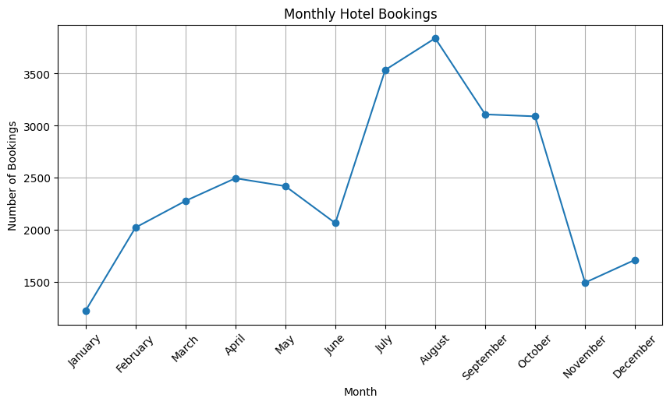

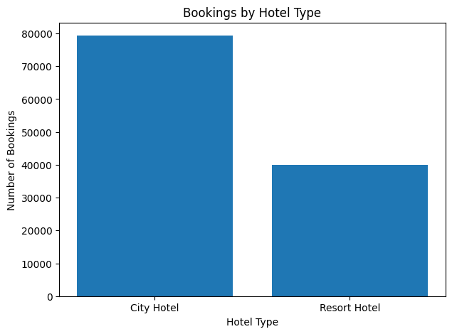
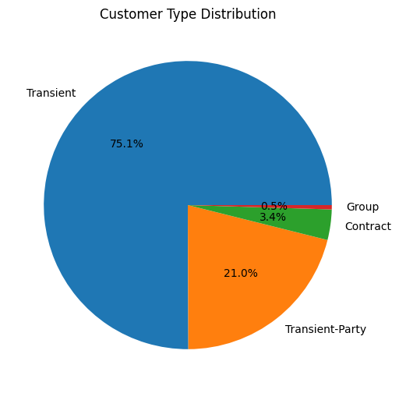

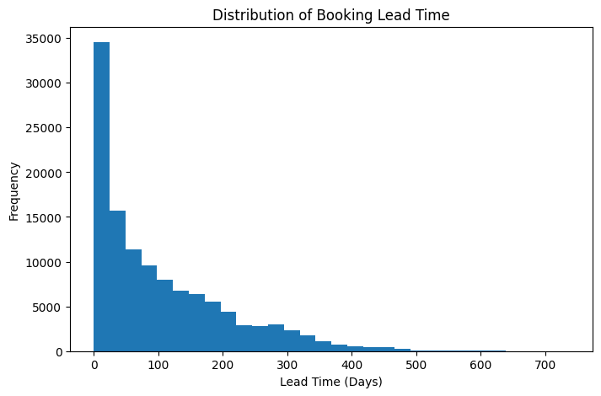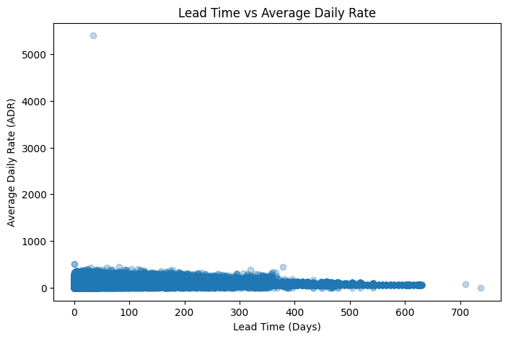

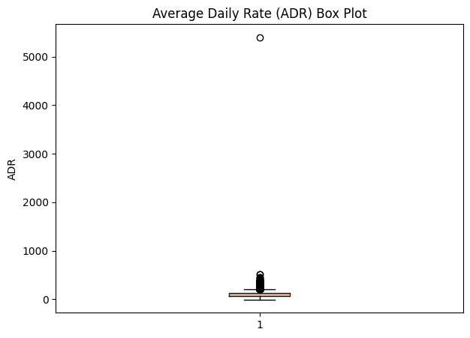

Result:

