18.236.109.203
-----------------------------------------------install git-----------------------------------------------------
sudo yum install -y git
git --version
git config --global user.name "rakeshraheja89"
git config --global user.email rakesh.raheja89@gmail.com
ssh-keygen -t rsa -b 4096
go to git hub-->setting ---> ssh ---> new ssh key and paste it
copy any code --> fork --> now clone or download -->use ssh instead of https
git clone git@github.com:rakeshraheja89/cicd-pipeline-gradle.git
git checkout -b (why b = new branch if not required then just git checkout)
git status
git add .
git status
git commit -m "added devfile for testing"
git status
git push (if didnt work thne we used)--> git config --global push.default simple---> git push --set-upstream origin devbranch
create pr
merge the branchs

-----------------------------------------------------GRADLE if need---------------------------------------------
./gradlew build
sudo yum -y install unzip java-1.8.0-openjdk
./gradlew init
#to run project

./gradlew bootRun

-----------------------------install jenkins and how to use it-----------------------------------------------

sudo yum -y install epel-release
sudo yum install -y wget
sudo wget -O /etc/yum.repos.d/jenkins.repo http://pkg.jenkins-ci.org/redhat-stable/jenkins.repo (going to the repo)
sudo rpm --import https://jenkins-ci.org/redhat/jenkins-ci.org.key (this is for importing the key)
sudo yum install -y jenkins-2.121.1
sudo systemctl enable jenkins
sudo systemctl start jenkins
sudo cat /var/lib/jenkins/secrets/initialAdminPassword-->take password and paste it on browser
open browser and configure plugins for jenkins---> http://54.201.135.74:8080/ --> install plugins --> add user name and email -->http://54.201.135.74:8080

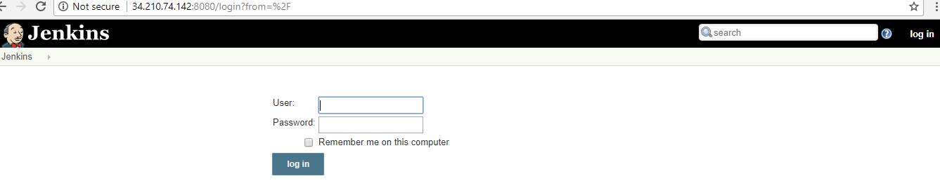

9 . Now configure git and jenkins
10 . settings--> developer settings ( https://github.com/settings/developers)

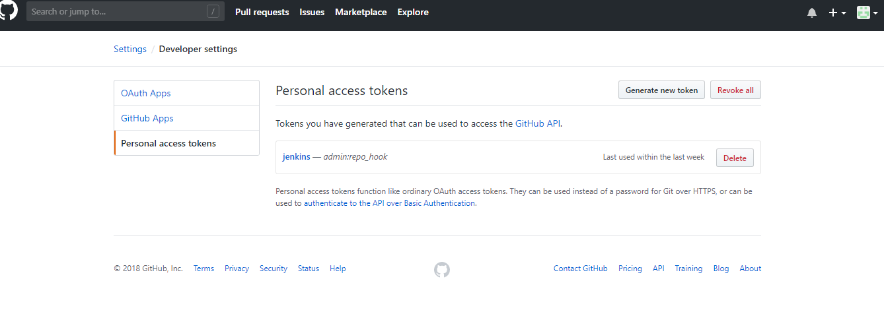

- go to personal access tokens---> generate new key--> enter details --> token description --->admin:repo_hook (check this)--> generate token

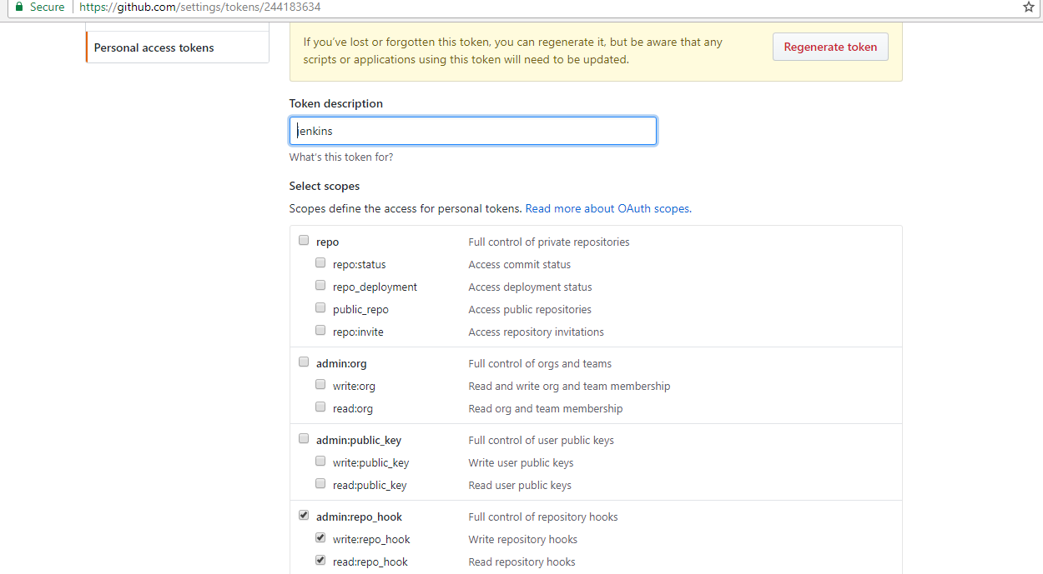

- copy your personal access token --> eea74ccc0dcdd13b30a81b4d351ebc7dd2069c7a12.

- go to jenkins --> manage jenkins--> configure system --> add github servers --> add jenkins --> kind (secret text) --> copy token in secret and id as jenkins

14. save--> test connection --> verified
15. manage hooks --> commmit the code --> jenkins wil come to know that code is committed
- apply and save

- add new jobs in jenkins---> enter job name --> click on freestyle project – ok
- go to github- cpy project url - paste it on jenkins github - prjct url

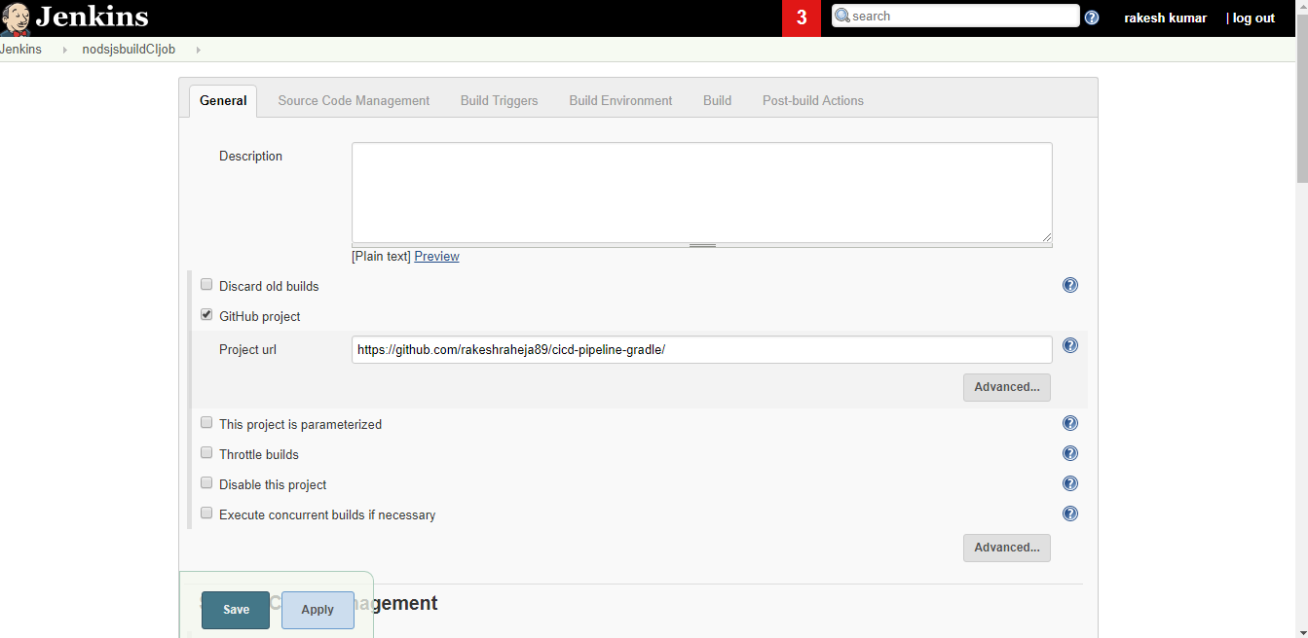

- go to jenkins --> source code management

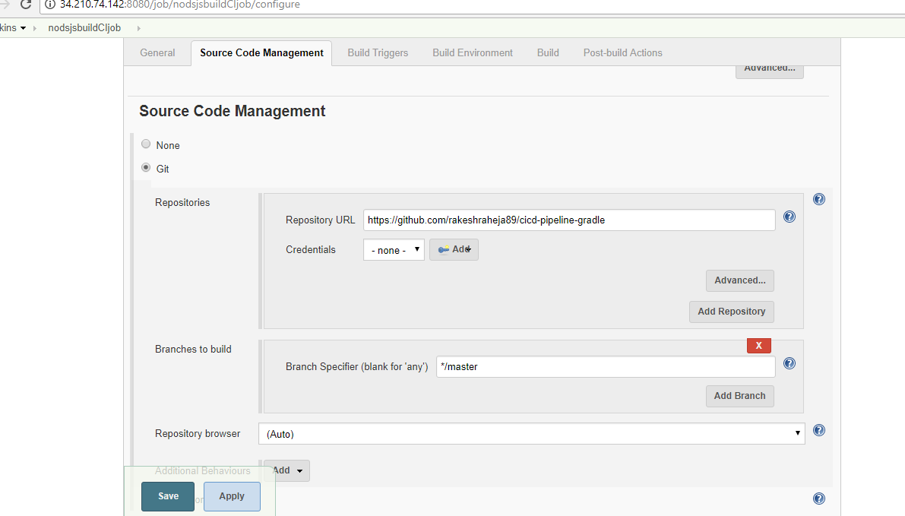

20. build trigger --> check this --(GitHub hook trigger for GITScm polling)
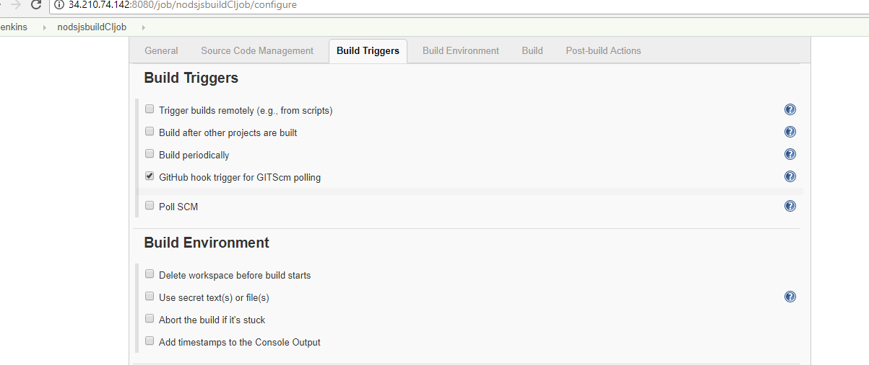
- build step - add gradle script --->Use Gradle Wrapper --> tasks me add (build - textfiled )

22. Post-build Actions --> select archive the artifacts---> give (dist/sampleapp.zip)
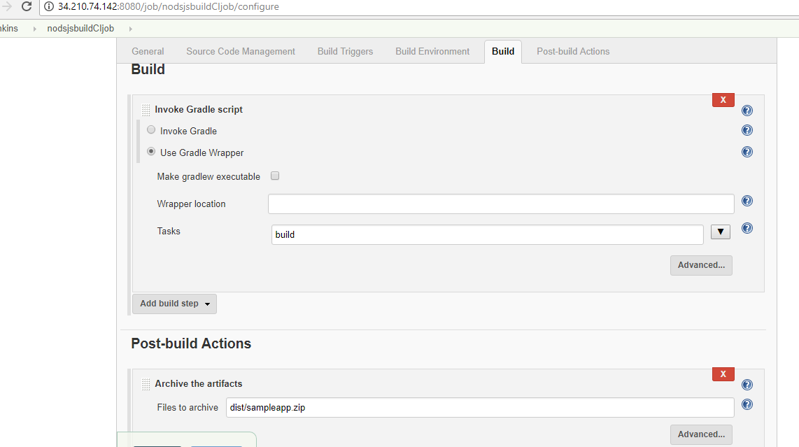

- apply---save
- build now

24. if you face build issue ----> JENKINS_USER="root" --> https://stackoverflow.com/questions/29926773/run-shell-command-in-jenkins-as-root-user
sudo vi /etc/sysconfig/jenkins
Find this $JENKINS_USER and change to “root”:
$JENKINS_USER="root"
Then change the ownership of Jenkins home, webroot and logs:
sudo chown -R root:root /var/lib/jenkins
sudo chown -R root:root /var/cache/jenkins
sudo chown -R root:root /var/log/jenkins
25 . Restart Jenkins and check the user has been changed:
26 . service jenkins restart
27 . ps -ef | grep jenkins

-------------------------------------------Jenkins with maven ------------------------------------------

- go to jenkins --> plugin manager --> install maven plugin --> restart
- check after installation on same screen
- create new job for maven
- configure

--------------------------------------------create multibranch pipeline with jenkins--------------------------

- add new file in application project named as jenkinsfile

pipeline {
agent any
stages {
stage ('Build') {
steps {
echo 'Running Build Automation'
sh './gradlew build --no-daemon'
archiveArtifacts artifacts: 'dist/sampleapp.zip'
}
}
}
}

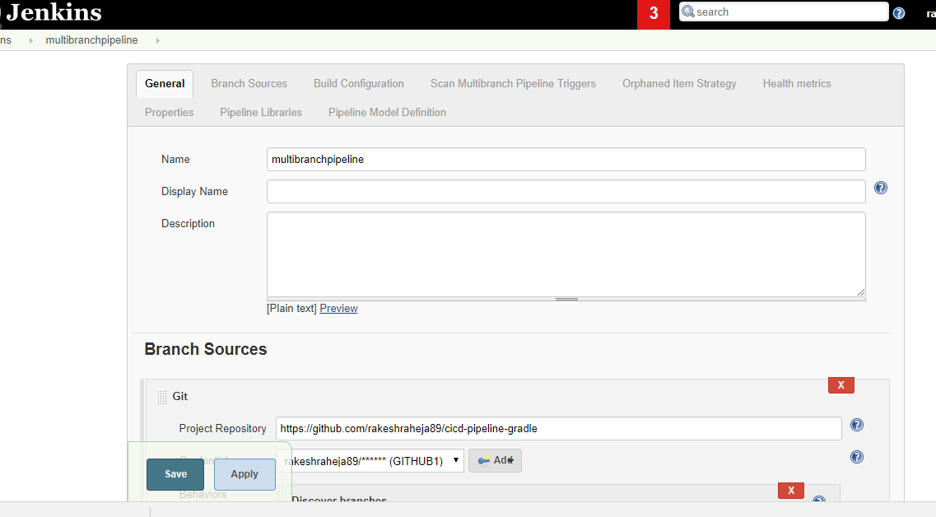
2.

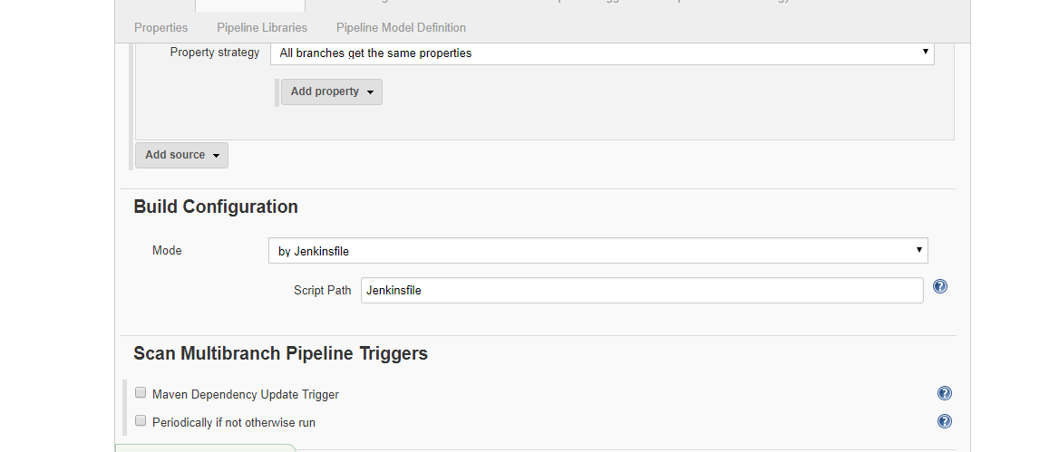

apply –save
------------------------------------------Jenkins with maven---------------------------

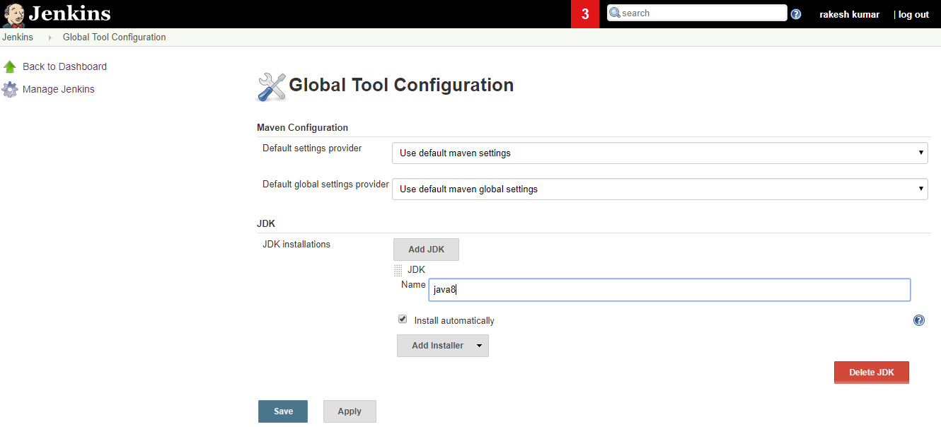

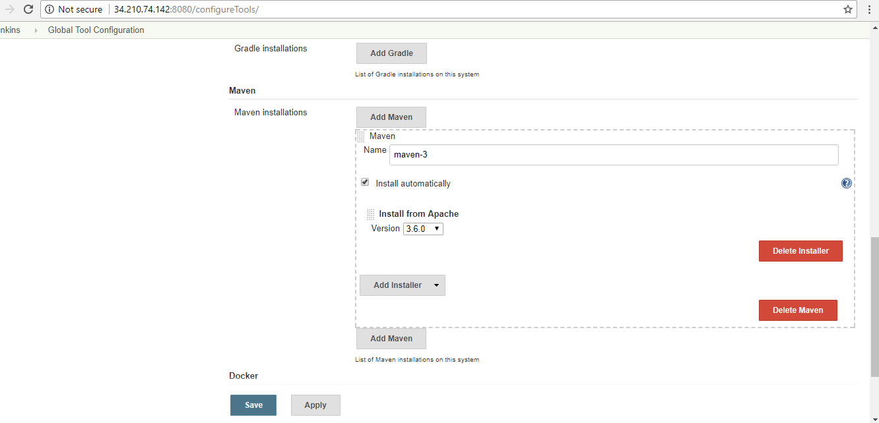

if java is not installed or maven is not installed then do this

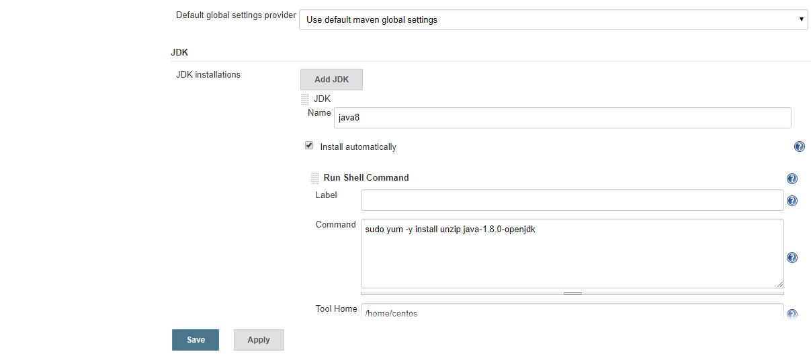

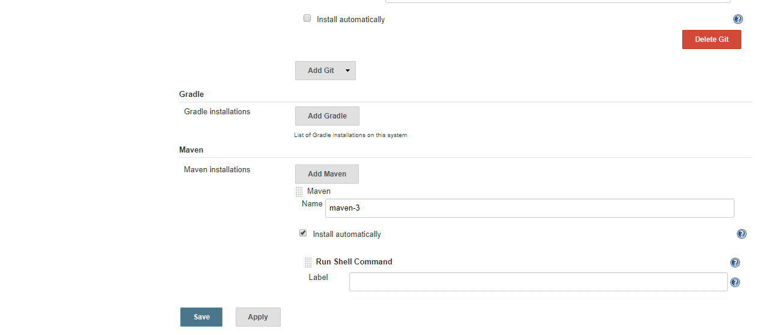
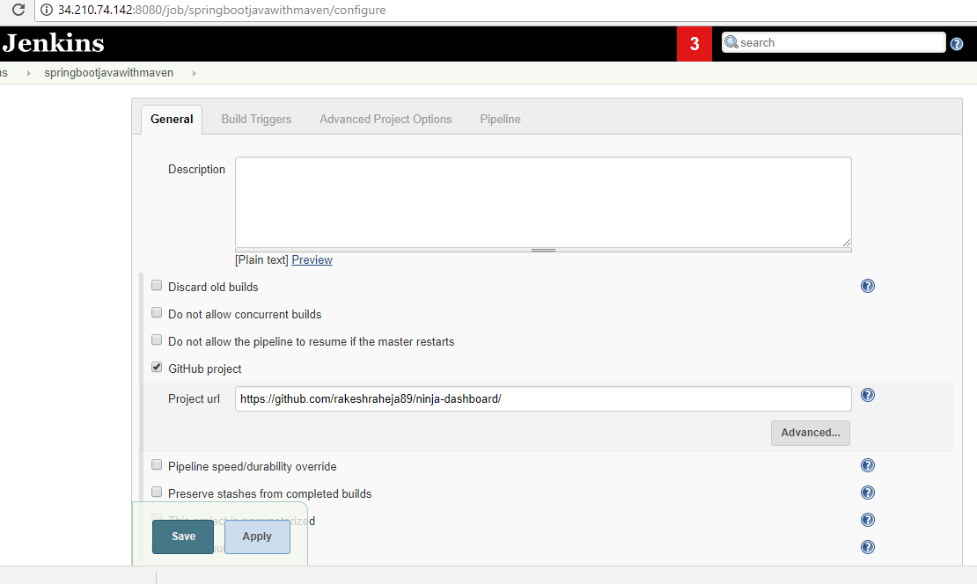
1)

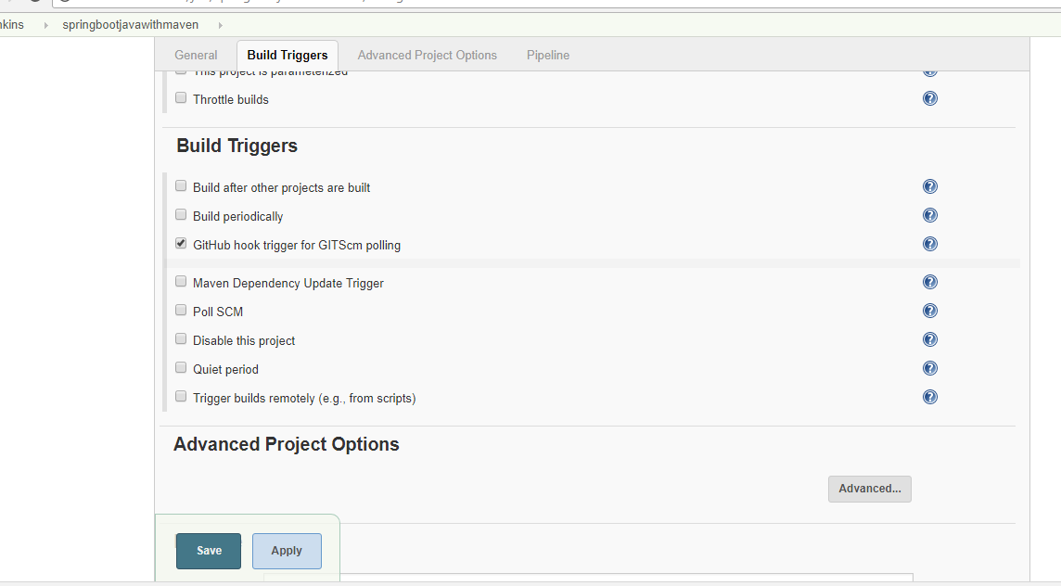

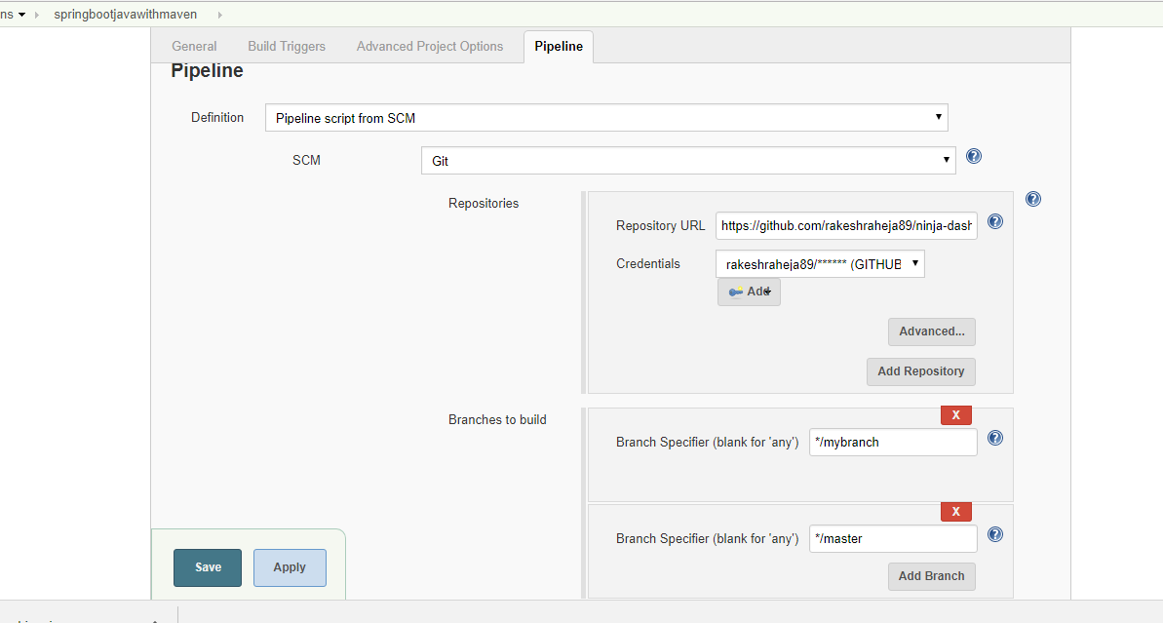

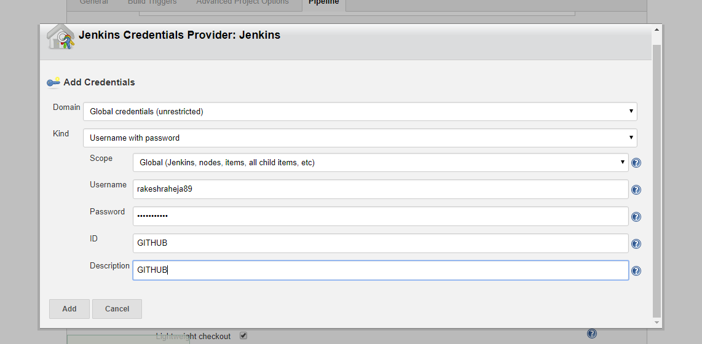

----------------------------------docker install ----------------------------------------

sudo yum install docker
sudo systemctl start docker
sudo systemctl status docker
sudo systemctl enable docker
-------------------logs below --------------
[centos@ip-10-0-1-195 cicd-pipeline-gradle]$ sudo systemctl status docker
● docker.service - Docker Application Container Engine
Loaded: loaded (/usr/lib/systemd/system/docker.service; enabled; vendor preset: disabled)
Active: active (running) since Thu 2018-12-13 07:14:12 UTC; 1min 0s ago
Docs: http://docs.docker.com
Main PID: 22903 (dockerd-current)
CGroup: /system.slice/docker.service
├─22903 /usr/bin/dockerd-current --add-runtime docker-runc=/usr/libexec/docker/docker-runc-current --default-runtime=docker-runc --exec-opt native.cgroupd...
└─22909 /usr/bin/docker-containerd-current -l unix:///var/run/docker/libcontainerd/docker-containerd.sock --metrics-interval=0 --start-timeout 2m –state-...
----------------logs end---------------------

how to check docker is up and running ?
sudo docker run hello-world

echo $USER –which user islogged in
sudo groupadd docker ---to make root user
sudo usermod -aG docker $USER

#now validate
sudo systemctl restart docker
docker run hello-world

#check all docker image in local
docker images

#when you compile docker –it will form docker image
#when you run docker it wil form container

FROM node:carbon ------------------ // take nodejs from parent
WORKDIR /usr/src/app ----------------- creating a work dir and go there
COPY package*.json ./ ------------------- copying the same package
RUN npm install -----------------------
COPY . . ---------------------from this to this
EXPOSE 8080 ------------------------this port (request will go to my app not to jenkins )
CMD ["npm","start"]

#compile and run
sudo docker build -t rakeshraheja89/jenkins .
docker images
sudo docker run -p 8081:3000 -d rakesh/sampleapp

or

sudo docker run -p 3001:8080 -d rakesh/sampleapp

or

sudo docker run -p 3001:8080 -d rakeshraheja89/jenkins

or if you want to give volume (backup for data ) - for taking backup of data
docker container run -d -p 3001:8080 -v /var/run/docker.sock:/var/run/docker.sock rakeshraheja89/jenkins

#why -d
to suppress the logs
sudo docker ps

#how to stop docker
docker ps -a
docker exec -it 2dc956675844 bash (this will give container ----> )
docker stop

# how to remove docker image
docker rmi $imageid

#force delete
docker rmi $imageid -f

root@2dc956675844:/usr/src/app# cd /usr/src/app
root@2dc956675844:/usr/src/app#

#whats the diff between copy and add

copy – it wil just copy in your container

add – copy zip folder into your container and unzip folder
it can download and copy in your container.

#when we expose port ?
we expose container post not application port

----------------------------------------------------docker inside docker------------------------------------
jenkins is a docker container
jenkins -docker and then install jenkins inside docker

cmd - --> one line command -->
entrypoint.sh -- > series of command

--------------------------------inside contatner--------------------------------------------

docker login –username=rakeshraheja89
docker push <<imagename>>

now got to --> https://hub.docker.com/

check hub and validate image

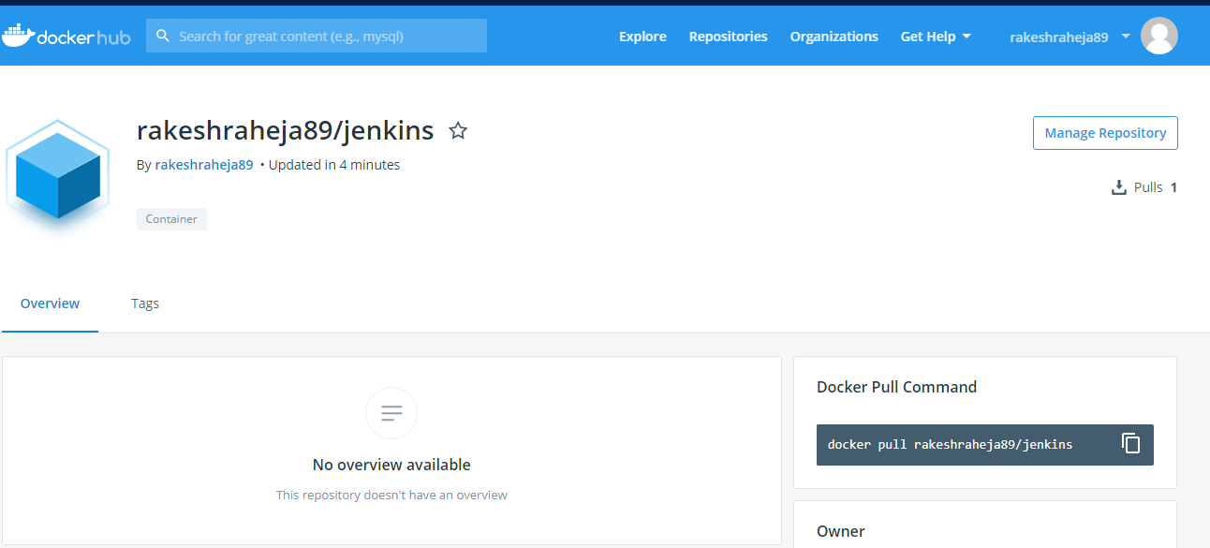
------------------------------------KNOWLEDGE-------------------------------------------

if jenkins is not working --

docker pull jenkins/jenkins
docker run -itd -p 8080:8080 --name jenkins_container jenkins
Use the browser to navigate to:
localhost:8080 or my_pc:8080
To get at the token at the path given on the login screen:
docker exec -it jenkins_container /bin/bash
Then navigate to the token file and copy/paste the code into the login screen. You can use the edit/copy/paste menus in the kde/gnome/lxde/xfce terminals to copy the terminal text, then paste it with ctrl-v
War File
Or use the jenkins.war file. For development purposes you can run jenkins as your user (or as jenkins) from the command line or create a short script in /usr/local or /opt to start it.
Download the jenkins.war from the jenkins download page:
https://jenkins.io/download/
Then put it somewhere safe, ~/jenkins would be a good place.
mkdir ~/jenkins; cp ~/Downloads/jenkins.war ~/jenkins
Then run:
nohup java -jar ~/jenkins/jenkins.war > ~/jenkins/jenkins.log 2>&1
To get the initial admin password token, copy the text output of:
cat /home/my_home_dir/.jenkins/secrets/initialAdminPassword
and paste that into the box with ctrl-v as your initial admin password.
Hope this is detailed enough to get you on your way...
shareimprove this answer

