-----------------------------------------------install git-----------------------------------------------------
1. sudo yum install -y git
2. git --version
3. git config --global user.name "rakeshraheja89"
4. git config --global user.email rakesh.raheja89@gmail.com
5. ssh-keygen -t rsa -b 4096
6. go to git hub-->setting ---> ssh ---> new ssh key and paste it
7. copy any code --> fork --> now clone or download -->use ssh instead of https
git clone git@github.com:rakeshraheja89/cicd-pipeline-gradle.git
8. git checkout -b (why b = new branch if not required then just git checkout)
9. git status
10. git add .
11. git status
12 . git commit -m "added devfile for testing"
13. git status
14. git push (if didnt work thne we used)--> git config --global push.default simple---> git push --set-upstream origin devbranch
15. create pr
16. merge the branchs

-----------------------------------------------------GRADLE-------------------------------------------------
1. ./gradlew build
2. sudo yum -y install unzip java-1.8.0-openjdk
3. ./gradlew init

-----------------------------install jenkins and how to use it-----------------------------------------------

1.sudo yum -y install epel-release
2 sudo yum install -y wget
3 sudo wget -O /etc/yum.repos.d/jenkins.repo http://pkg.jenkins-ci.org/redhat-stable/jenkins.repo (going to the repo)
4 sudo rpm --import https://jenkins-ci.org/redhat/jenkins-ci.org.key (this is for importing the key)
5 sudo yum install -y jenkins-2.121.1
6. sudo systemctl enable jenkins
7 sudo cat /var/lib/jenkins/secrets/initialAdminPassword-->take password and paste it on browser
8 .open browser and configure plugins for jenkins---> http://54.201.135.74:8080/ --> install plugins --> add user name and email -->http://54.201.135.74:8080

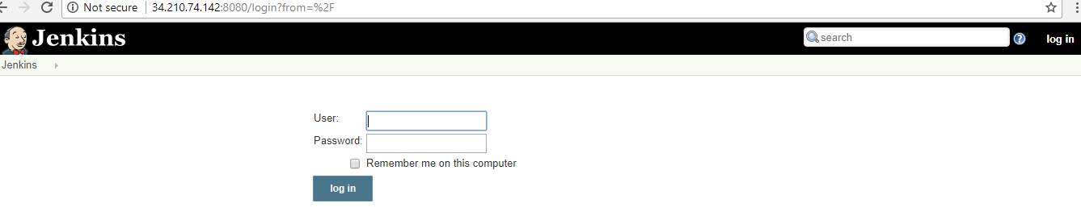

9 . Now configure git and jenkins
10 . settings--> developer settings ( https://github.com/settings/developers)

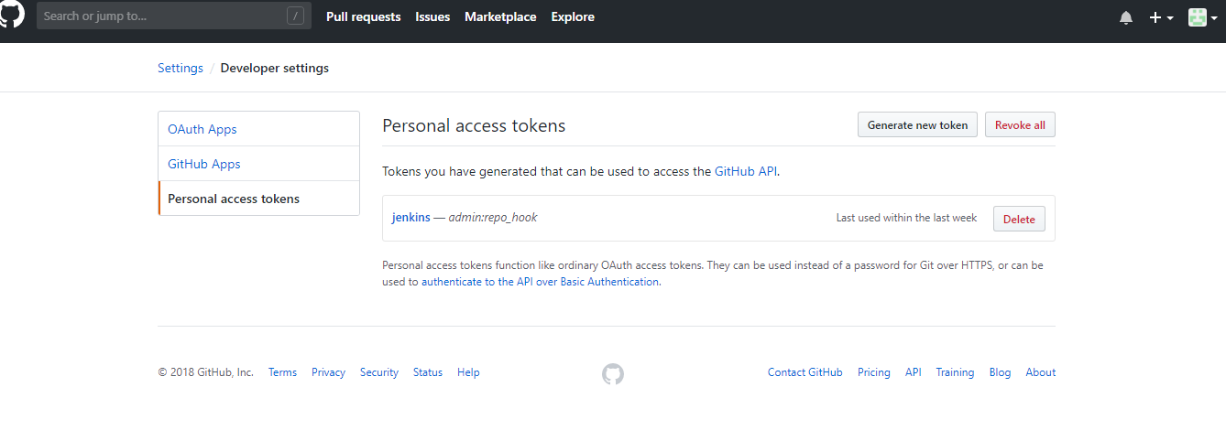

- go to personal access tokens---> generate new key--> enter details --> token description --->admin:repo_hook (check this)--> generate token

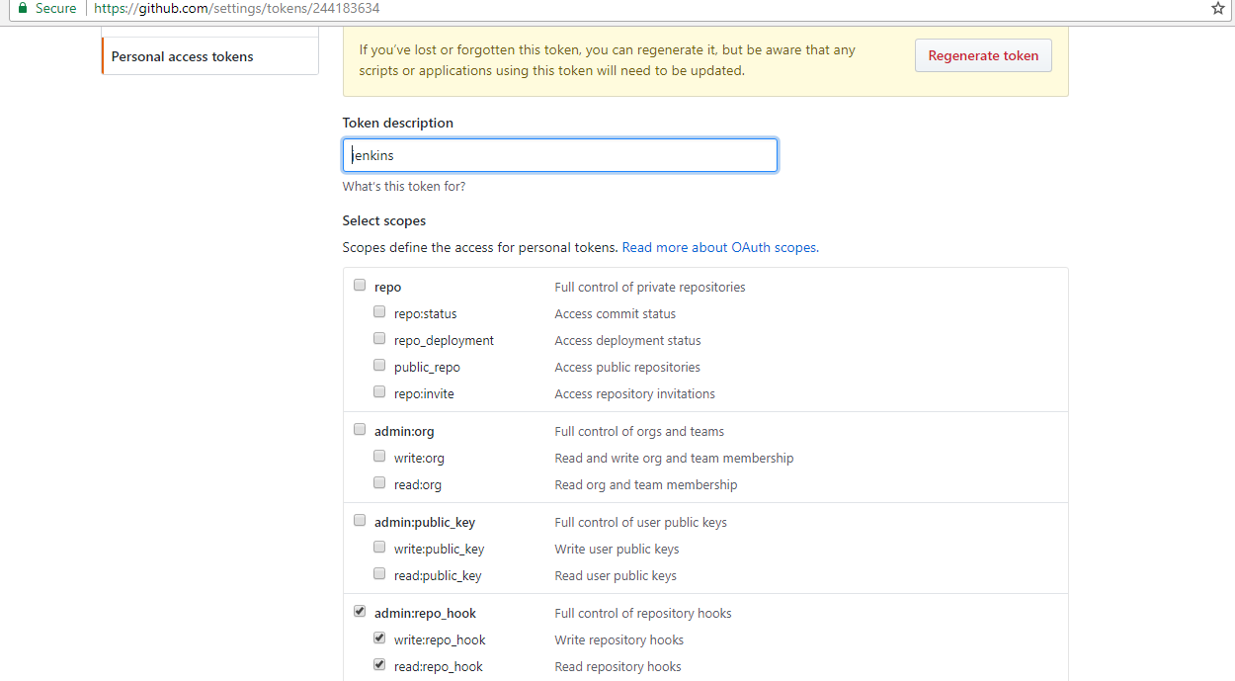

- copy your personal access token --> eea74ccc0dcdd13b30a81b4d351ebc7dd2069c7a12.

- go to jenkins --> manage jenkins--> configure system --> add github servers --> add jenkins --> kind (secret text) --> copy token in secret and id as jenkins

14. save--> test connection --> verified
15. manage hooks --> commmit the code --> jenkins wil come to know that code is committed
- apply and save

- add new jobs in jenkins---> enter job name --> click on freestyle project – ok
- go to github- cpy project url - paste it on jenkins github - prjct url

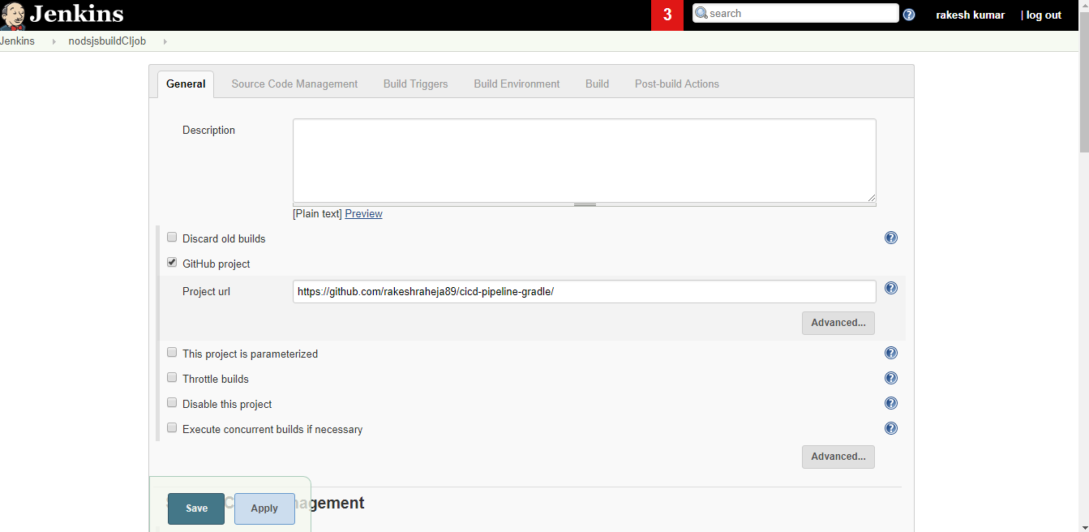

- go to jenkins --> source code management

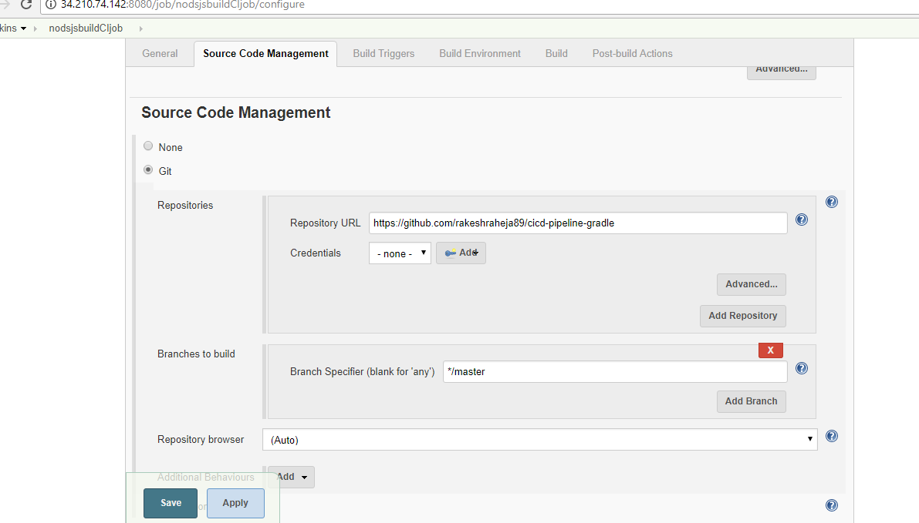

20. build trigger --> check this --(GitHub hook trigger for GITScm polling)
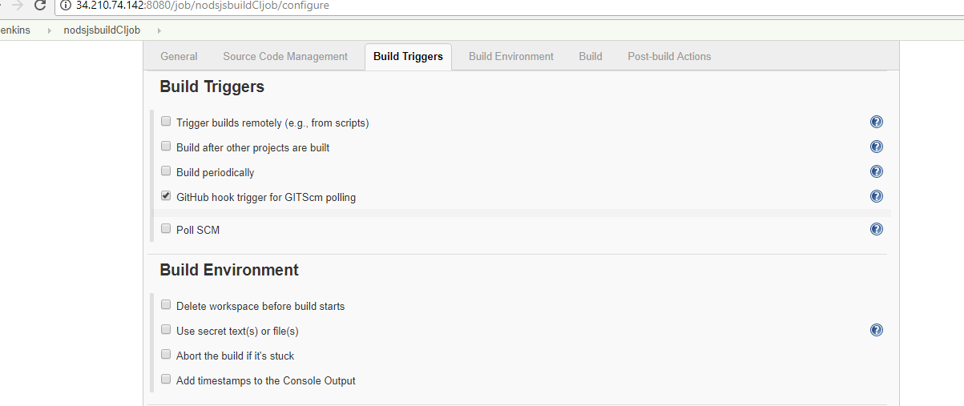
- build step - add gradle script --->Use Gradle Wrapper --> tasks me add (build - textfiled )

22. Post-build Actions --> select archive the artifacts---> give (dist/sampleapp.zip)
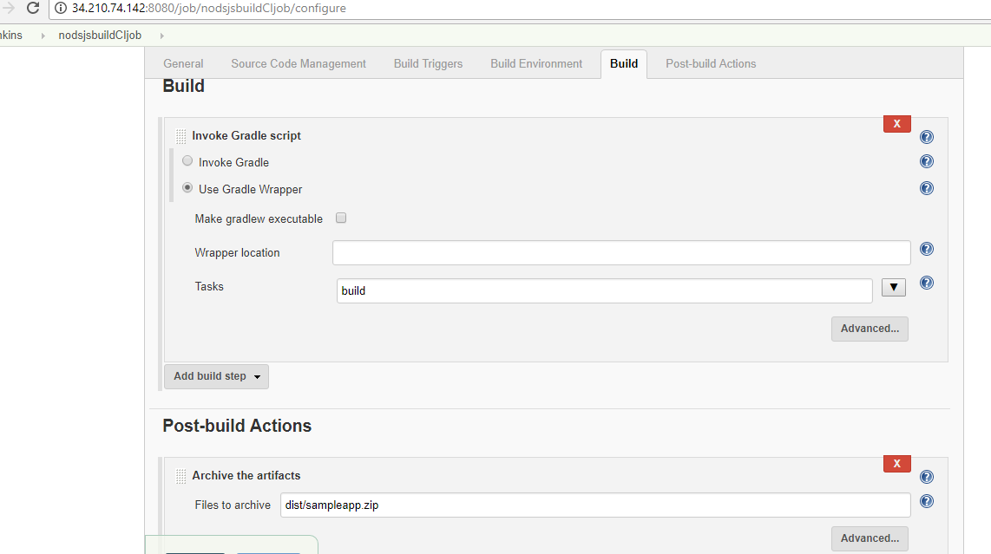

- apply---save
- build now

24. if you face build issue ----> JENKINS_USER="root" --> https://stackoverflow.com/questions/29926773/run-shell-command-in-jenkins-as-root-user
sudo vi /etc/sysconfig/jenkins
Find this $JENKINS_USER and change to “root”:
$JENKINS_USER="root"
Then change the ownership of Jenkins home, webroot and logs:
sudo chown -R root:root /var/lib/jenkins
sudo chown -R root:root /var/cache/jenkins
sudo chown -R root:root /var/log/jenkins
25 . Restart Jenkins and check the user has been changed:
26 . service jenkins restart
27 . ps -ef | grep jenkins

-------------------------------------------Jenkins with maven ------------------------------------------

- go to jenkins --> plugin manager --> install maven plugin --> restart
- check after installation on same screen
- create new job for maven
- configure

--------------------------------------------create multibranch pipeline with jenkins--------------------------

- add new file in application project named as jenkinsfile

pipeline {
agent any
stages {
stage ('Build') {
steps {
echo 'Running Build Automation'
sh './gradlew build --no-daemon'
archiveArtifacts artifacts: 'dist/sampleapp.zip'
}
}
}
}

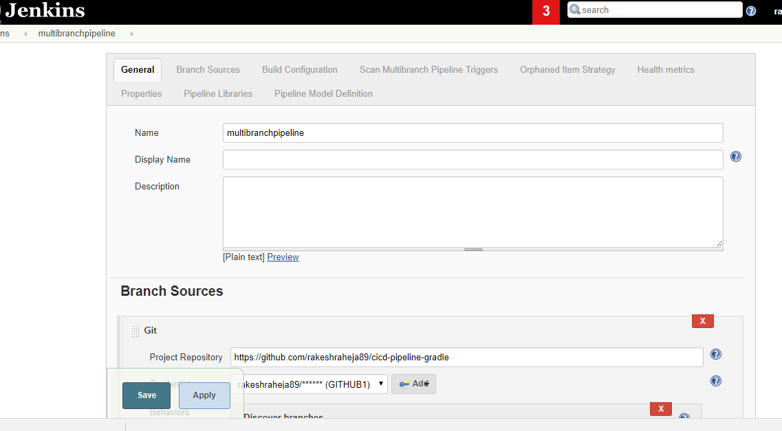
2.

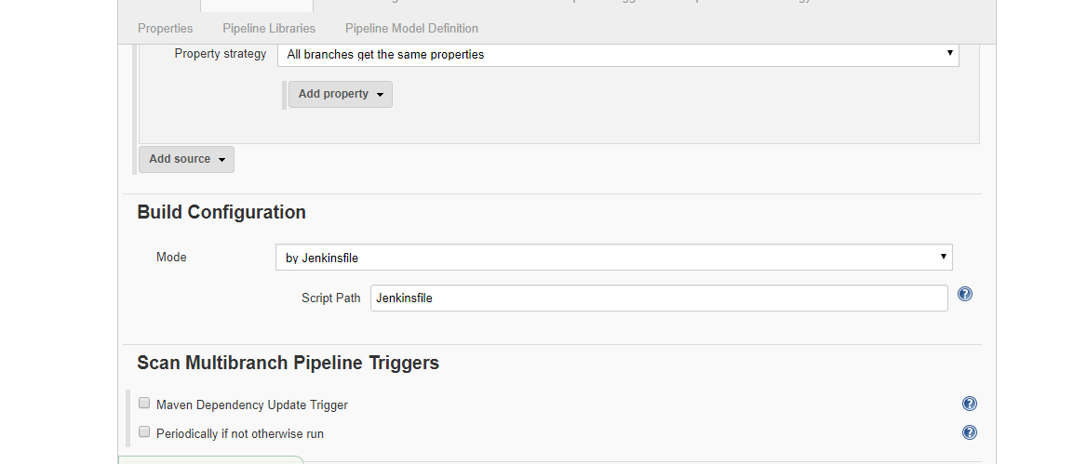

apply –save
------------------------------------------Jenkins with maven---------------------------

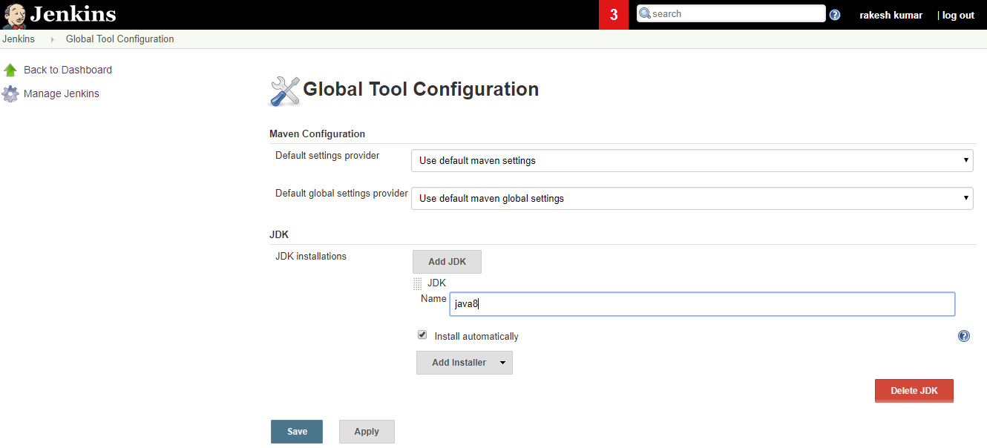

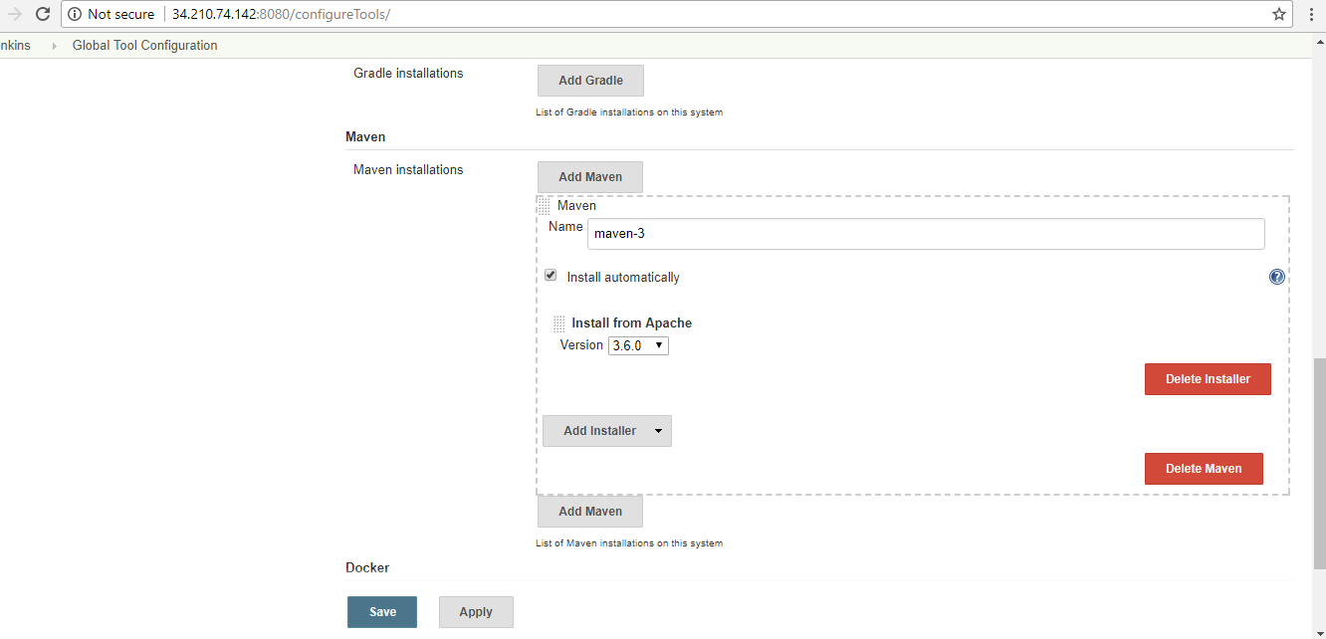

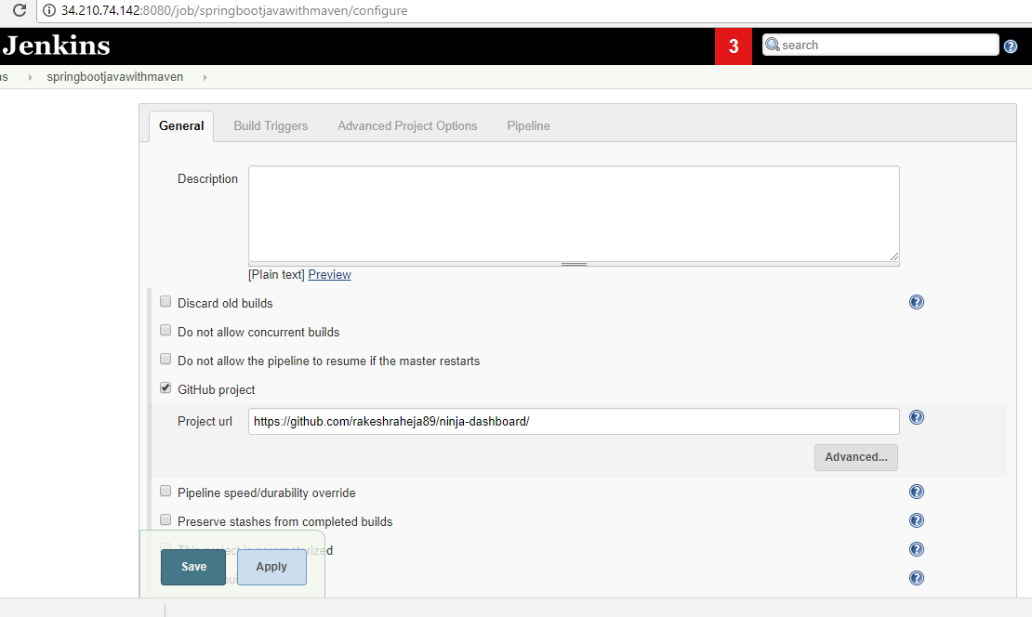
1)

