18.236.109.203
-----------------------------------------------install git-----------------------------------------------------
sudo yum install -y git
git --version
git config --global user.name "rakeshraheja89"
git config --global user.email rakesh.raheja89@gmail.com
ssh-keygen -t rsa -b 4096
go to git hub-->setting ---> ssh ---> new ssh key and paste it
copy any code --> fork --> now clone or download -->use ssh instead of https
git clone git@github.com:rakeshraheja89/cicd-pipeline-gradle.git
git checkout -b (why b = new branch if not required then just git checkout)
git status
git add .
git status
git commit -m "added devfile for testing"
git status
git push (if didnt work thne we used)--> git config --global push.default simple---> git push --set-upstream origin devbranch
create pr
merge the branchs

-----------------------------------------------------GRADLE if need---------------------------------------------
./gradlew build
sudo yum -y install unzip java-1.8.0-openjdk
./gradlew init
#to run project

./gradlew bootRun

-----------------------------install jenkins and how to use it-----------------------------------------------

sudo yum -y install epel-release
sudo yum install -y wget
sudo wget -O /etc/yum.repos.d/jenkins.repo http://pkg.jenkins-ci.org/redhat-stable/jenkins.repo (going to the repo)
sudo rpm --import https://jenkins-ci.org/redhat/jenkins-ci.org.key (this is for importing the key)
sudo yum install -y jenkins-2.121.1
sudo systemctl enable jenkins
sudo systemctl start jenkins
sudo cat /var/lib/jenkins/secrets/initialAdminPassword-->take password and paste it on browser
open browser and configure plugins for jenkins---> http://54.201.135.74:8080/ --> install plugins --> add user name and email -->http://54.201.135.74:8080

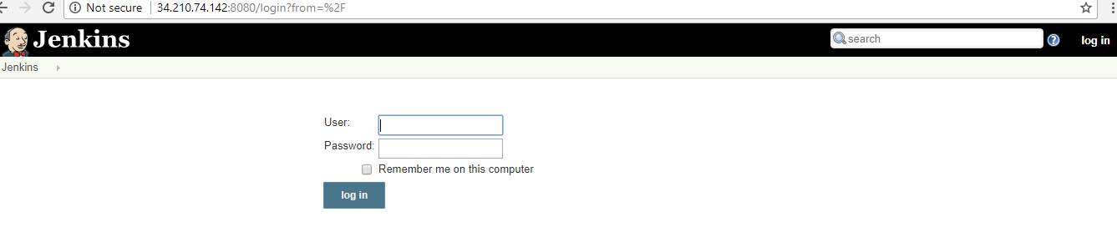

9 . Now configure git and jenkins
10 . settings--> developer settings ( https://github.com/settings/developers)

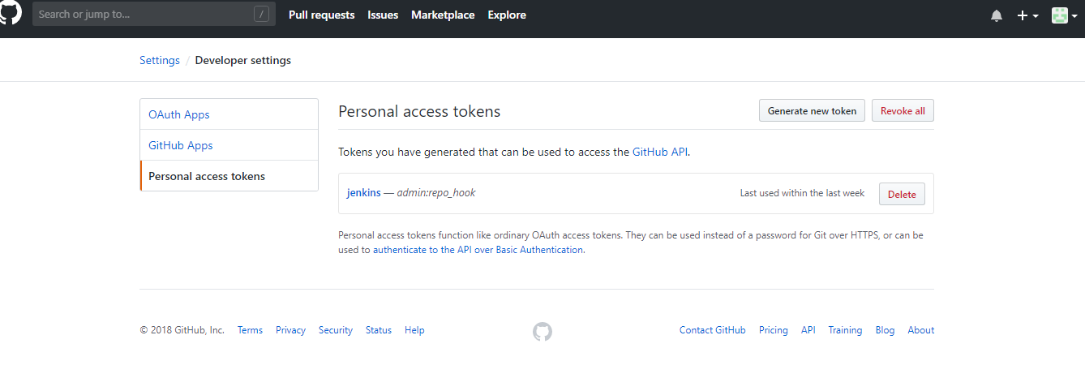

- go to personal access tokens---> generate new key--> enter details --> token description --->admin:repo_hook (check this)--> generate token

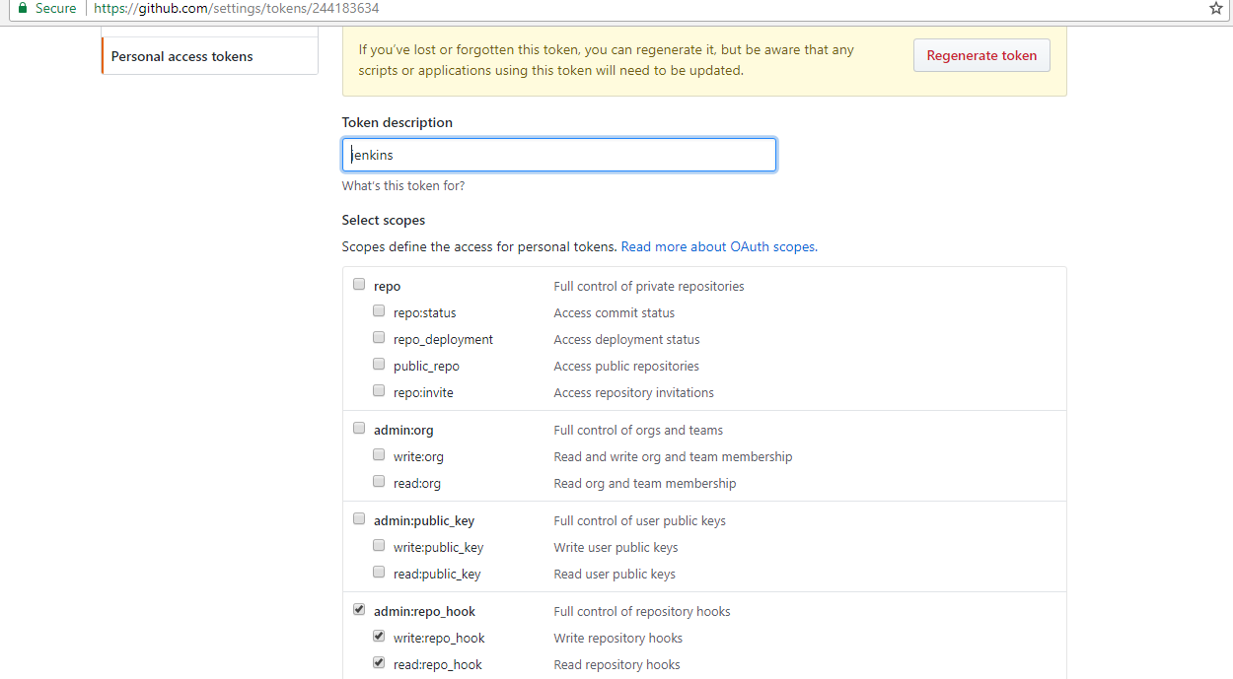

- copy your personal access token --> eea74ccc0dcdd13b30a81b4d351ebc7dd2069c7a12.

- go to jenkins --> manage jenkins--> configure system --> add github servers --> add jenkins --> kind (secret text) --> copy token in secret and id as jenkins

14. save--> test connection --> verified
15. manage hooks --> commmit the code --> jenkins wil come to know that code is committed
- apply and save

- add new jobs in jenkins---> enter job name --> click on freestyle project – ok
- go to github- cpy project url - paste it on jenkins github - prjct url

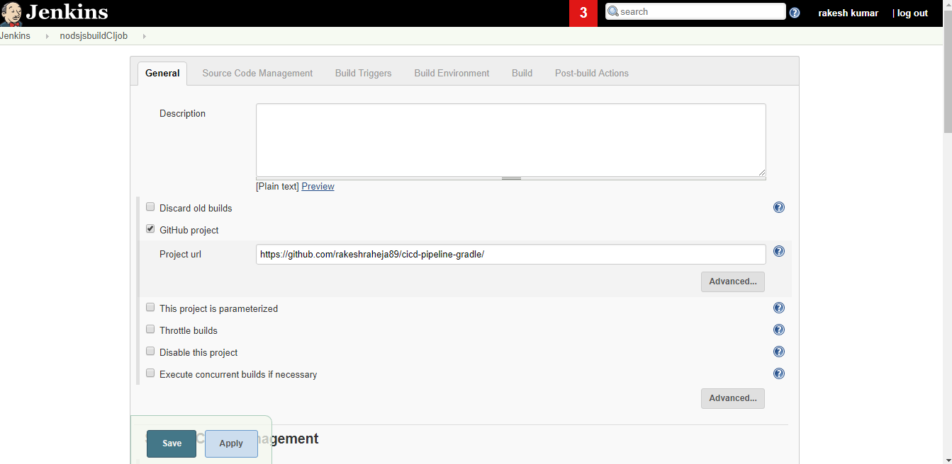

- go to jenkins --> source code management

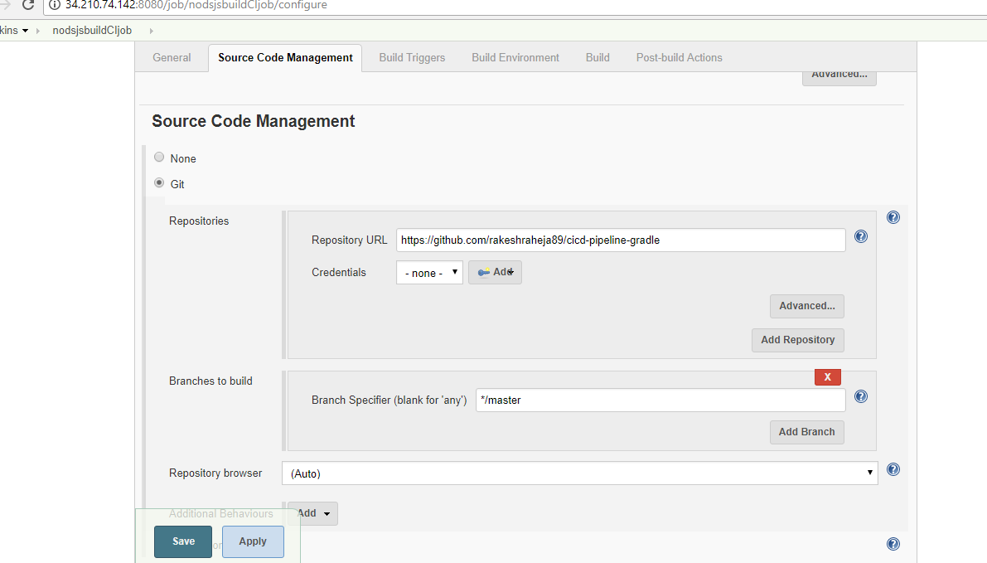

20. build trigger --> check this --(GitHub hook trigger for GITScm polling)
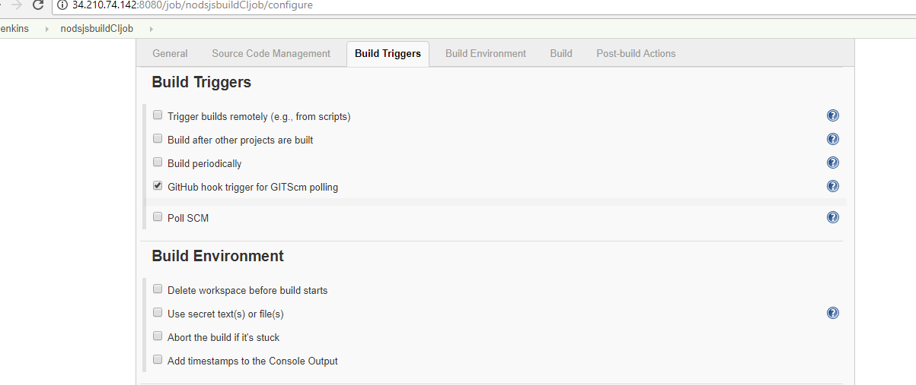
- build step - add gradle script --->Use Gradle Wrapper --> tasks me add (build - textfiled )

22. Post-build Actions --> select archive the artifacts---> give (dist/sampleapp.zip)
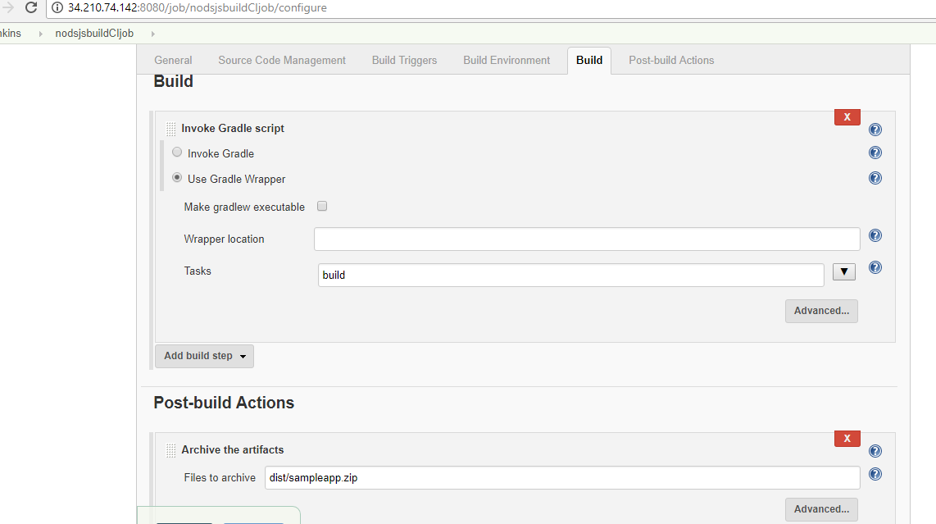

- apply---save
- build now

24. if you face build issue ----> JENKINS_USER="root" --> https://stackoverflow.com/questions/29926773/run-shell-command-in-jenkins-as-root-user
sudo vi /etc/sysconfig/jenkins
Find this $JENKINS_USER and change to “root”:
$JENKINS_USER="root"
Then change the ownership of Jenkins home, webroot and logs:
sudo chown -R root:root /var/lib/jenkins
sudo chown -R root:root /var/cache/jenkins
sudo chown -R root:root /var/log/jenkins
25 . Restart Jenkins and check the user has been changed:
26 . service jenkins restart
27 . ps -ef | grep jenkins

-------------------------------------------Jenkins with maven ------------------------------------------

- go to jenkins --> plugin manager --> install maven plugin --> restart
- check after installation on same screen
- create new job for maven
- configure

--------------------------------------------create multibranch pipeline with jenkins--------------------------

- add new file in application project named as jenkinsfile

pipeline {
agent any
stages {
stage ('Build') {
steps {
echo 'Running Build Automation'
sh './gradlew build --no-daemon'
archiveArtifacts artifacts: 'dist/sampleapp.zip'
}
}
}
}

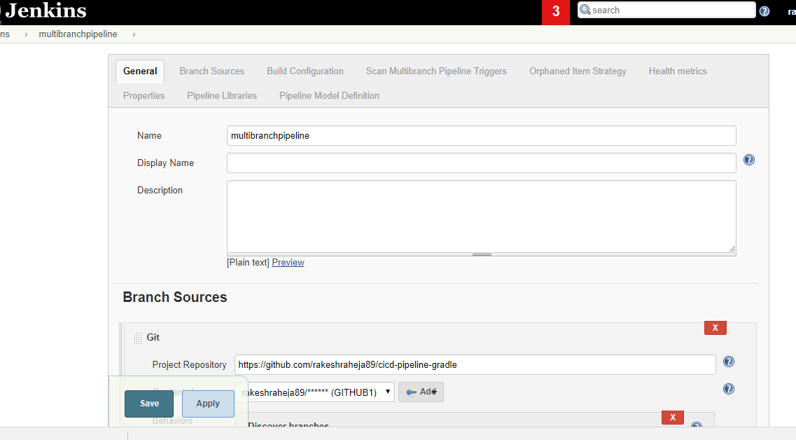
2.

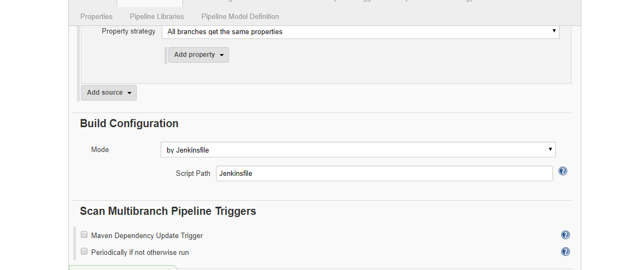

apply –save
------------------------------------------Jenkins with maven---------------------------

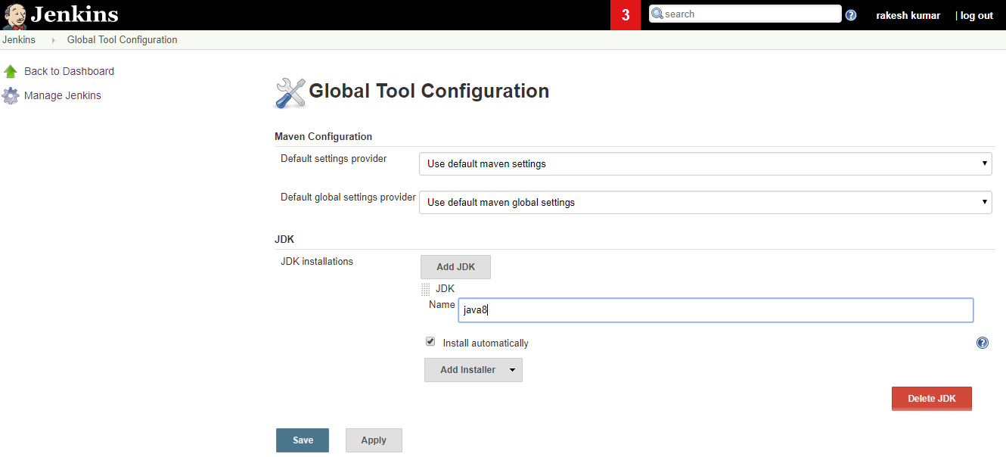

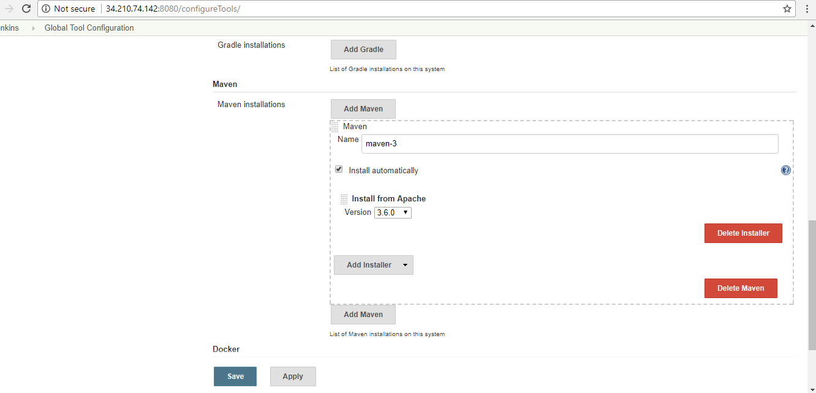

if java is not installed or maven is not installed then do this

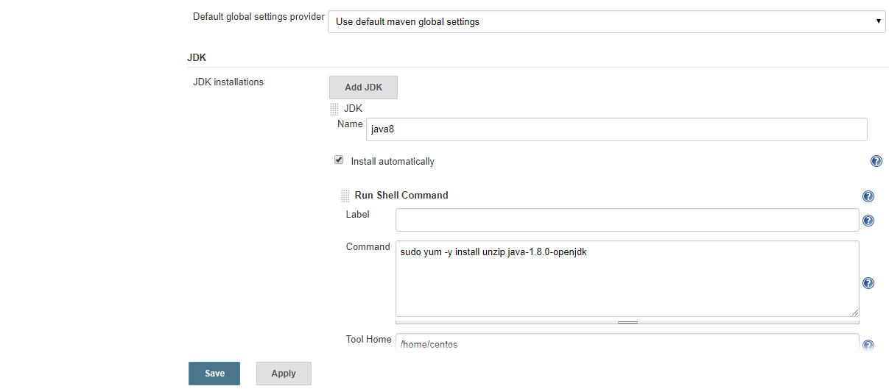

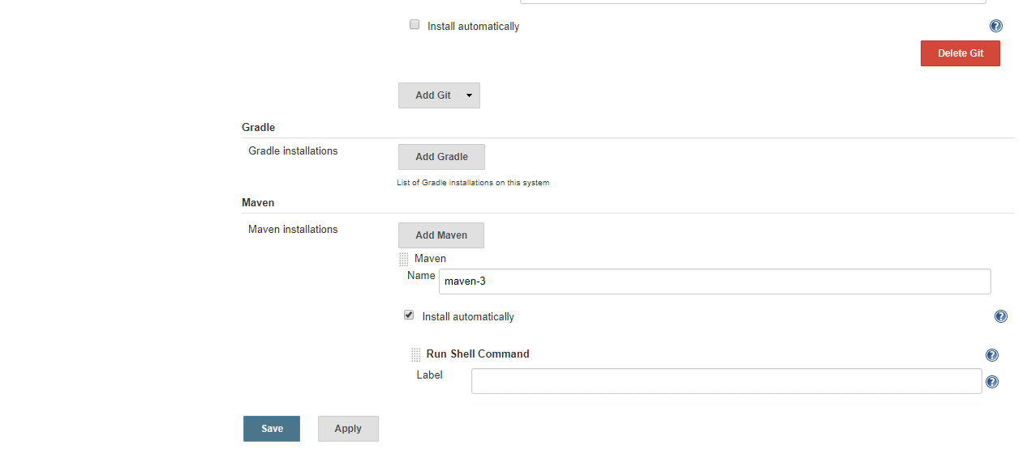
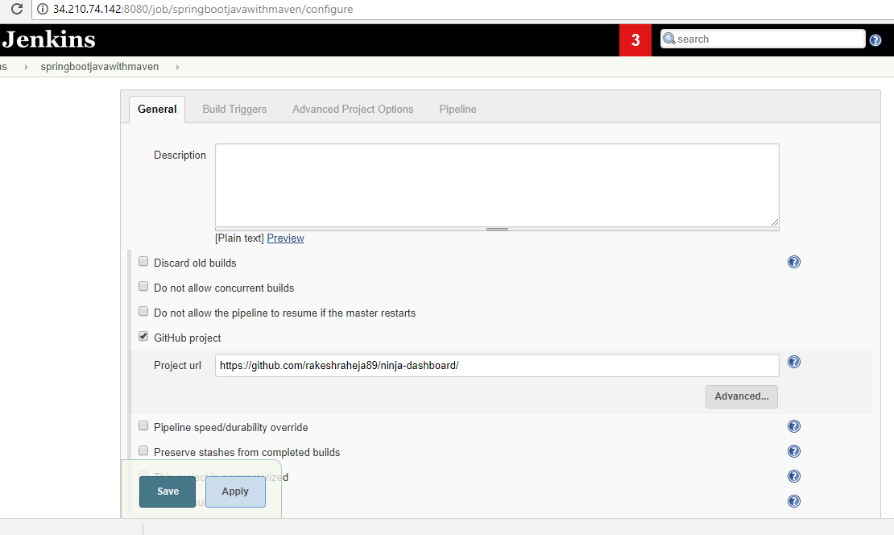
1)

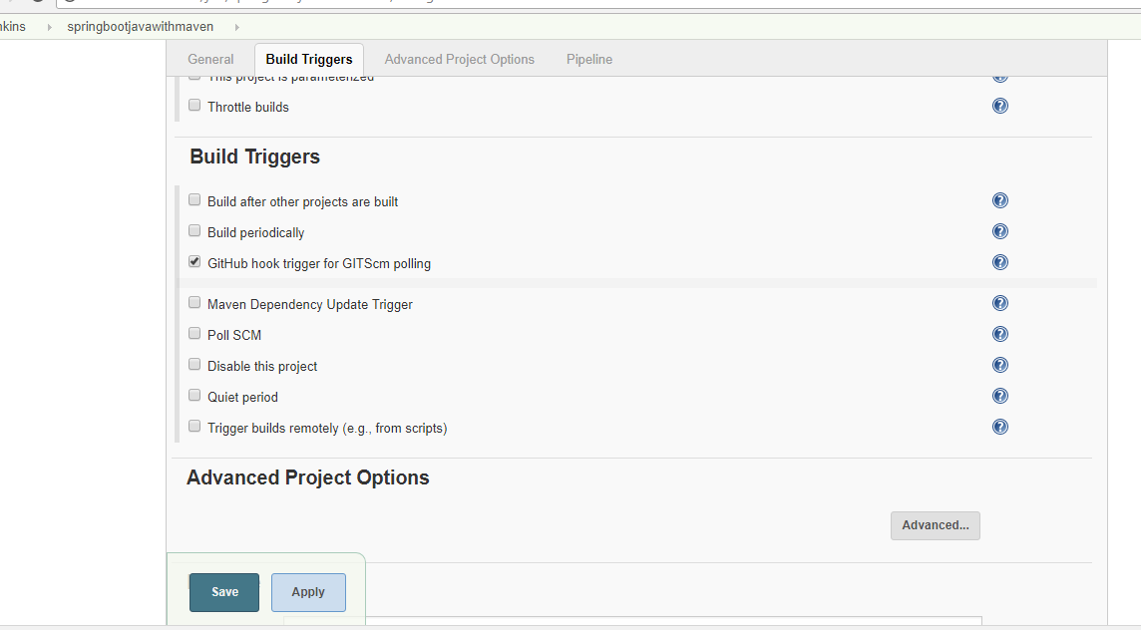

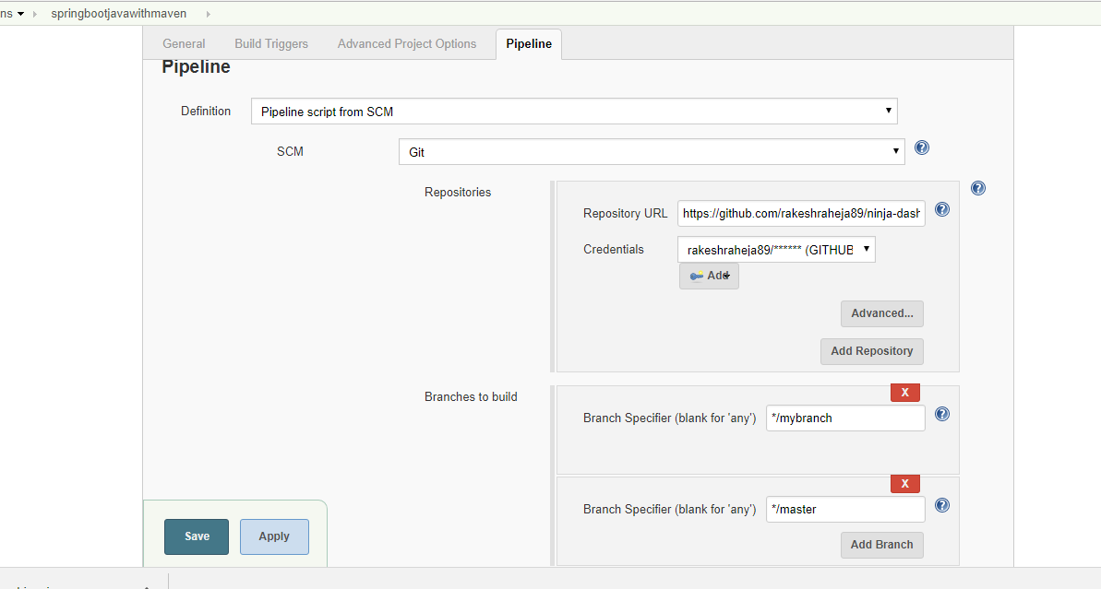

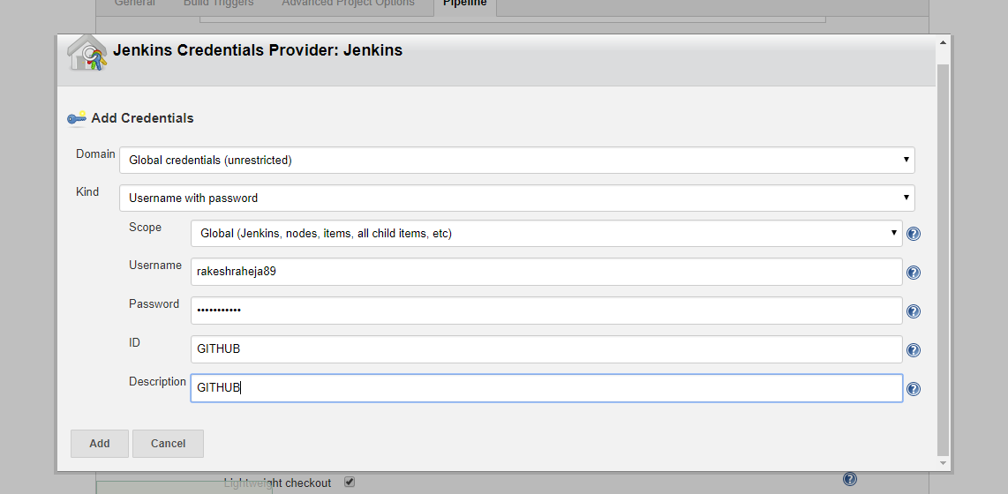

----------------------------------docker install ----------------------------------------

sudo yum install docker
sudo systemctl start docker
sudo systemctl status docker
sudo systemctl enable docker
-------------------logs below --------------
[centos@ip-10-0-1-195 cicd-pipeline-gradle]$ sudo systemctl status docker
● docker.service - Docker Application Container Engine
Loaded: loaded (/usr/lib/systemd/system/docker.service; enabled; vendor preset: disabled)
Active: active (running) since Thu 2018-12-13 07:14:12 UTC; 1min 0s ago
Docs: http://docs.docker.com
Main PID: 22903 (dockerd-current)
CGroup: /system.slice/docker.service
├─22903 /usr/bin/dockerd-current --add-runtime docker-runc=/usr/libexec/docker/docker-runc-current --default-runtime=docker-runc --exec-opt native.cgroupd...
└─22909 /usr/bin/docker-containerd-current -l unix:///var/run/docker/libcontainerd/docker-containerd.sock --metrics-interval=0 --start-timeout 2m –state-...
----------------logs end---------------------

how to check docker is up and running ?
sudo docker run hello-world

echo $USER –which user islogged in
sudo groupadd docker ---to make root user
sudo usermod -aG docker $USER

#now validate
sudo systemctl restart docker
docker run hello-world

#check all docker image in local
docker images

#when you compile docker –it will form docker image
#when you run docker it wil form container

FROM node:carbon ------------------ // take nodejs from parent
WORKDIR /usr/src/app ----------------- creating a work dir and go there
COPY package*.json ./ ------------------- copying the same package
RUN npm install -----------------------
COPY . . ---------------------from this to this
EXPOSE 8080 ------------------------this port (request will go to my app not to jenkins )
CMD ["npm","start"]

#compile and run
sudo docker build -t rakeshraheja89/jenkins .
docker images
sudo docker run -p 8081:3000 -d rakesh/sampleapp

or

sudo docker run -p 3001:8080 -d rakesh/sampleapp

or

sudo docker run -p 3001:8080 -d rakeshraheja89/jenkins

or if you want to give volume (backup for data ) - for taking backup of data
docker container run -d -p 3001:8080 -v /var/run/docker.sock:/var/run/docker.sock rakeshraheja89/jenkins

#why -d
to suppress the logs
sudo docker ps

#how to stop docker
docker ps -a
docker exec -it 2dc956675844 bash (this will give container ----> )
docker stop

# how to remove docker image
docker rmi $imageid

#force delete
docker rmi $imageid -f

root@2dc956675844:/usr/src/app# cd /usr/src/app
root@2dc956675844:/usr/src/app#

#whats the diff between copy and add

copy – it wil just copy in your container

add – copy zip folder into your container and unzip folder
it can download and copy in your container.

#when we expose port ?
we expose container post not application port

----------------------------------------------------docker inside docker------------------------------------
jenkins is a docker container
jenkins -docker and then install jenkins inside docker

cmd - --> one line command -->
entrypoint.sh -- > series of command

--------------------------------inside contatner--------------------------------------------

docker login –username=rakeshraheja89
docker push <<imagename>>

now got to --> https://hub.docker.com/

check hub and validate image

pMTnYifbdkhoVtTDznN3qjVjdwYYrgai

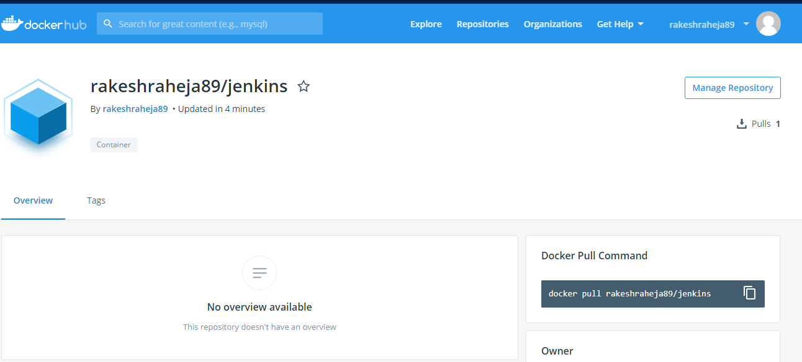
------------------------------------KNOWLEDGE-------------------------------------------

if jenkins is not working --

docker pull jenkins/jenkins
docker run -itd -p 8080:8080 --name jenkins_container jenkins
Use the browser to navigate to:
localhost:8080 or my_pc:8080
To get at the token at the path given on the login screen:
docker exec -it jenkins_container /bin/bash
Then navigate to the token file and copy/paste the code into the login screen. You can use the edit/copy/paste menus in the kde/gnome/lxde/xfce terminals to copy the terminal text, then paste it with ctrl-v
War File
Or use the jenkins.war file. For development purposes you can run jenkins as your user (or as jenkins) from the command line or create a short script in /usr/local or /opt to start it.
Download the jenkins.war from the jenkins download page:
https://jenkins.io/download/
Then put it somewhere safe, ~/jenkins would be a good place.
mkdir ~/jenkins; cp ~/Downloads/jenkins.war ~/jenkins
Then run:
nohup java -jar ~/jenkins/jenkins.war > ~/jenkins/jenkins.log 2>&1
To get the initial admin password token, copy the text output of:
cat /home/my_home_dir/.jenkins/secrets/initialAdminPassword
and paste that into the box with ctrl-v as your initial admin password.
Hope this is detailed enough to get you on your way...
shareimprove this answer

wget -qO

Authenticating with public key "imported-openssh-key"
Last login: Wed Dec 19 11:23:04 2018 from 125.22.111.162
[centos@ip-10-0-1-231 ~]$ ls -lrt
total 12
-rw-rw-r--. 1 centos centos 693 Dec 19 06:50 sonarQube.yaml
-rw-rw-r--. 1 centos centos 983 Dec 19 07:03 postgres_deployment.yaml
-rw-rw-r--. 1 centos centos 9 Dec 19 07:04 password
[centos@ip-10-0-1-231 ~]$ sudo -i
[root@ip-10-0-1-231 ~]# ls -lrt
total 1648
-rw-------. 1 root root 6577 Jun 5 2018 original-ks.cfg
-rw-------. 1 root root 6921 Jun 5 2018 anaconda-ks.cfg
-rw-r--r--. 1 root root 1661676 Dec 18 12:19 get-pip.py
-rwxr-xr-x. 1 root root 4866 Dec 18 12:31 cluster.sh
drwxr-xr-x. 2 root root 6 Dec 19 05:24 team1
drwxr-xr-x. 2 root root 146 Dec 19 07:37 sonar
drwxr-xr-x. 2 root root 50 Dec 19 07:40 team3
drwxr-xr-x. 2 root root 74 Dec 19 08:08 team2
drwxr-xr-x. 2 root root 122 Dec 19 09:30 ddOps
drwxr-xr-x. 2 root root 188 Dec 19 09:40 sonarqube
[root@ip-10-0-1-231 ~]# cd team2
[root@ip-10-0-1-231 team2]# ls -lrt
total 12
-rw-r--r--. 1 root root 617 Dec 19 06:50 application.yaml
-rw-r--r--. 1 root root 805 Dec 19 07:50 jenkins.yaml_bkp
-rw-r--r--. 1 root root 813 Dec 19 07:51 jenkins.yaml
[root@ip-10-0-1-231 team2]# cd ..
[root@ip-10-0-1-231 ~]# l s-lrt
-bash: l: command not found
[root@ip-10-0-1-231 ~]# ls -lrt
total 1648
-rw-------. 1 root root 6577 Jun 5 2018 original-ks.cfg
-rw-------. 1 root root 6921 Jun 5 2018 anaconda-ks.cfg
-rw-r--r--. 1 root root 1661676 Dec 18 12:19 get-pip.py
-rwxr-xr-x. 1 root root 4866 Dec 18 12:31 cluster.sh
drwxr-xr-x. 2 root root 6 Dec 19 05:24 team1
drwxr-xr-x. 2 root root 146 Dec 19 07:37 sonar
drwxr-xr-x. 2 root root 50 Dec 19 07:40 team3
drwxr-xr-x. 2 root root 74 Dec 19 08:08 team2
drwxr-xr-x. 2 root root 122 Dec 19 09:30 ddOps
drwxr-xr-x. 2 root root 188 Dec 19 09:40 sonarqube
[root@ip-10-0-1-231 ~]# kubectl create ns devops2
namespace/devops2 created
[root@ip-10-0-1-231 ~]# wget -qO - https://artifacts.elastic.co/GPG-KEY-elasticsearch | sudo apt-key
sudo: apt-key: command not found
[root@ip-10-0-1-231 ~]# ls -lrt
total 1648
-rw-------. 1 root root 6577 Jun 5 2018 original-ks.cfg
-rw-------. 1 root root 6921 Jun 5 2018 anaconda-ks.cfg
-rw-r--r--. 1 root root 1661676 Dec 18 12:19 get-pip.py
-rwxr-xr-x. 1 root root 4866 Dec 18 12:31 cluster.sh
drwxr-xr-x. 2 root root 6 Dec 19 05:24 team1
drwxr-xr-x. 2 root root 146 Dec 19 07:37 sonar
drwxr-xr-x. 2 root root 50 Dec 19 07:40 team3
drwxr-xr-x. 2 root root 74 Dec 19 08:08 team2
drwxr-xr-x. 2 root root 188 Dec 19 09:40 sonarqube
drwxr-xr-x. 2 root root 114 Dec 19 12:26 ddOps
[root@ip-10-0-1-231 ~]# cd team2
[root@ip-10-0-1-231 team2]# ls -lrt
total 12
-rw-r--r--. 1 root root 617 Dec 19 06:50 application.yaml
-rw-r--r--. 1 root root 805 Dec 19 07:50 jenkins.yaml_bkp
-rw-r--r--. 1 root root 813 Dec 19 07:51 jenkins.yaml
[root@ip-10-0-1-231 team2]# vi kibana-controller.yaml
[root@ip-10-0-1-231 team2]# vi kibana-service.yaml
[root@ip-10-0-1-231 team2]# vi logstash-controller.yaml
[root@ip-10-0-1-231 team2]# vi logstash-service.yaml
[root@ip-10-0-1-231 team2]# vi service-account.yaml
[root@ip-10-0-1-231 team2]# ls -lrt
total 36
-rw-r--r--. 1 root root 617 Dec 19 06:50 application.yaml
-rw-r--r--. 1 root root 805 Dec 19 07:50 jenkins.yaml_bkp
-rw-r--r--. 1 root root 813 Dec 19 07:51 jenkins.yaml
-rw-r--r--. 1 root root 677 Dec 19 12:27 kibana-controller.yaml
-rw-r--r--. 1 root root 251 Dec 19 12:28 kibana-service.yaml
-rw-r--r--. 1 root root 786 Dec 19 12:28 logstash-controller.yaml
-rw-r--r--. 1 root root 244 Dec 19 12:29 1
-rw-r--r--. 1 root root 244 Dec 19 12:29 logstash-service.yaml
-rw-r--r--. 1 root root 58 Dec 19 12:29 service-account.yaml
[root@ip-10-0-1-231 team2]# vi kibana-service.yaml
[root@ip-10-0-1-231 team2]# kubectl create -f service-account.yaml
serviceaccount/elk created
[root@ip-10-0-1-231 team2]# kubectl create -f logstash-service.yaml
service/logstash created
[root@ip-10-0-1-231 team2]# kubectl create -f logstash-controller.yaml
replicationcontroller/logstash created
[root@ip-10-0-1-231 team2]#
[root@ip-10-0-1-231 team2]# kubectl create -f kibana-service.yamlkubectl create -f kibana-service.yaml
error: Unexpected args: [create]
See 'kubectl create -h' for help and examples.
[root@ip-10-0-1-231 team2]# kubectl create -f kibana-service.yaml
The Service "kibana" is invalid: spec.ports[0].nodePort: Forbidden: may not be used when `type` is 'ClusterIP'
[root@ip-10-0-1-231 team2]# kubectl create -f kibana-controller.yaml
replicationcontroller/kibana created
[root@ip-10-0-1-231 team2]# kubectl get pods
NAME READY STATUS RESTARTS AGE
kibana-2dlzm 1/1 Running 0 8s
logstash-qdfrd 1/1 Running 0 28s
[root@ip-10-0-1-231 team2]# kubectl get service kibana
Error from server (NotFound): services "kibana" not found
[root@ip-10-0-1-231 team2]# kubectl get service kibana -n devops2
Error from server (NotFound): services "kibana" not found
[root@ip-10-0-1-231 team2]# kubectl get services
NAME TYPE CLUSTER-IP EXTERNAL-IP PORT(S) AGE
kubernetes ClusterIP 100.64.0.1 <none> 443/TCP 2h
logstash ClusterIP 100.68.40.63 <none> 5043/TCP 4m
[root@ip-10-0-1-231 team2]#
[root@ip-10-0-1-231 team2]#
[root@ip-10-0-1-231 team2]# kubectl delete service logstash
service "logstash" deleted
[root@ip-10-0-1-231 team2]# kubectl delete service kubernetes
service "kubernetes" deleted
[root@ip-10-0-1-231 team2]# kubectl get deployments
No resources found.
[root@ip-10-0-1-231 team2]# kubectl get deployment
No resources found.
[root@ip-10-0-1-231 team2]# kubectl get pods
NAME READY STATUS RESTARTS AGE
kibana-2dlzm 1/1 Running 0 5m
logstash-qdfrd 1/1 Running 0 5m
[root@ip-10-0-1-231 team2]# kubectl delete pod kibana-2dlzm
pod "kibana-2dlzm" deleted

[root@ip-10-0-1-231 team2]#
[root@ip-10-0-1-231 team2]#
[root@ip-10-0-1-231 team2]#

kubectl create -f es-discovery-svc.yaml
kubectl create -f es-svc.yaml
kubectl create -f es-master.yaml
kubectl rollout status -f es-master.yaml

kubectl create -f es-ingest-svc.yaml
kubectl create -f es-ingest.yaml
kubectl rollout status -f es-ingest.yaml

kubectl create -f es-data.yaml
kubectl rollout status -f es-data.yaml

kubectl get services -n kube-system

kubectl delete service elasticsearch elasticsearch-discovery -n devops2
kubectl get deployments -n devops2
kubectl delete deployment es-data es-master -n devops2

kubectl delete service elasticsearch-logging -n kube-system
1065 kubectl delete service elasticsearch elasticsearch-master -n kube-system
1068 kubectl delete deployment elasticsearch-master -n kube-system
1073 kubectl delete configmaps es-config -n kube-system
1075 kubectl delete statefulsets.apps elasticsearch-data elasticsearch-logging -n kube-system
1078 kubectl delete deployments -n kube-system
1089 kubectl delete deployments elasticsearch-master -n kube-system
1097 kubectl delete service elasticsearch-master elasticsearch -n kube-system
1098 kubectl delete statefulsets.apps elasticsearch-data -n kube-system
1099 kubectl delete configmaps es-config -n kube-system
1100 kubectl delete deployment elasticsearch-master -n kube-system
1115 kubectl delete service elasticsearch-master elasticsearch -n kube-system
1116 kubectl delete configmaps es-config -n kube-system
1117 kubectl delete statefulsets.apps elasticsearch-data -n kube-system
1118 kubectl delete service elasticsearch-master elasticsearch -n kube-system
1122 kubectl delete service elasticsearch-master elasticsearch -n kube-system
1123 kubectl delete configmaps es-config -n kube-system
1124 kubectl delete statefulsets.apps elasticsearch-data -n kube-system
1125 kubectl delete service elasticsearch-master elasticsearch -n kube-system
1126 kubectl delete deployment elasticsearch-master -n kube-system
1168 kubectl delete elasticsearch elasticsearch-master kibana-logging -n kube-system
1169 kubectl delete service elasticsearch elasticsearch-master kibana-logging -n kube-system
1171 kubectl delete deployments elasticsearch-master kibana-logging -n kube-system
1173 kubectl delete configmaps es-config -n kube-system
1174 history | grep kubectl | grep delete | grep kube-system

kubectl delete serviceaccounts elasticsearch-logging -n kube-system
kubectl delete clusterroles.rbac.authorization.k8s.io elasticsearch-logging -n kube-system
kubectl delete clusterrolebindings.rbac.authorization.k8s.io elasticsearch-logging -n kube-system
kubectl delete statefulsets.apps elasticsearch-logging -n kube-system

kubectl create -f es-statefulset.yaml -n kube-system

kubectl create -f kibana-service.yaml -n kube-system
kubectl create -f kibana-deployment.yaml -n kube-system
https://api.aigdevopscoe.net/api/v1/namespaces/kube-system/services/elasticsearch-logging/proxy/
https://api.aigdevopscoe.net/api/v1/namespaces/kube-system/services/kibana-logging/proxy/app/kibana#/home/tutorial_directory/logging?_g=()

- Install the plugin.
- Go to the Jenkins Configuration.
- Find the Logger for Fluentd panel.
- Provide a logger name (it is used as a prefix for Fluentd the tag) and other setting if needed.
- Go to any job configuration.
- Add "Post Build Action" -> "Send to Fluentd".
- Specify the desired file (and extension in JSON format if needed).

https://api.aigdevopscoe.net/api/v1/namespaces/kube-system/services/kibana-logging/proxy/app/kibana#/management/kibana/index?_g=()

=============Password

below command for password to kubecluster
kops get secrets kube --type secret -o plaintext
below command for password to kubedashbaord
kops get secrets admin --type secret -o plaintext
https://api.aigdevopscoe.net/api/v1/namespaces/kube-system/services/https:kubernetes-dashboard:/proxy/

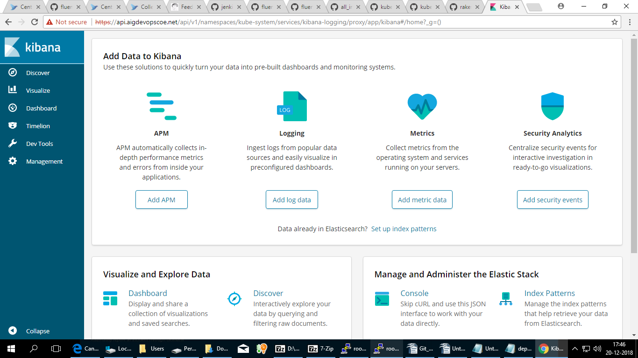

PMTnYifbdkhoVtTDznN3qjVjdwYYrgai

pMTnYifbdkhoVtTDznN3qjVjdwYYrgai

pMTnYifbdkhoVtTDznN3qjVjdwYYrgai

