Steps to install ODBC Driver:

- Goto: Control Panel -> Administrative Tools -> Data Sources(ODBC)

2. Follow the instructions: Click Add
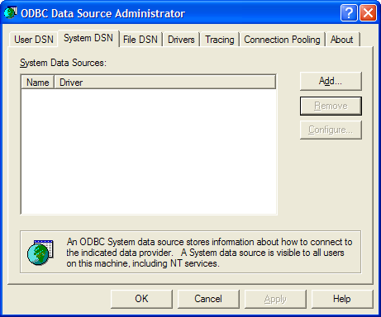

3. Select ‘Microsoft Access Driver (*.mdb)’ and then click Finish
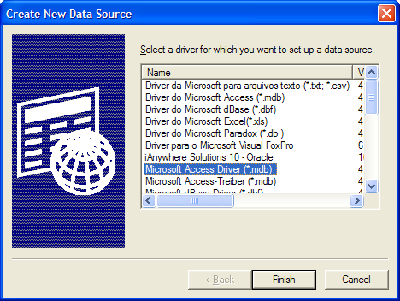

4. Type Data Source Name as ‘Puyo_Game’, then click Select
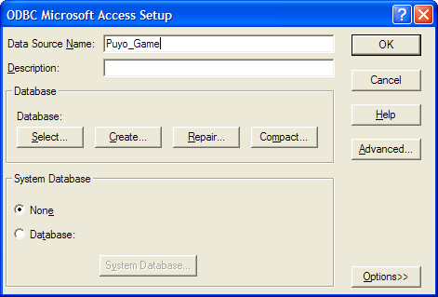

5. Type the physical location where you have unzipped Puyo-Puyo.zip and then lead to the Puyo_Game.mdb. Then, click OK.
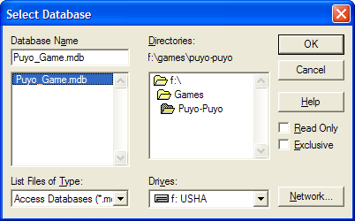

6. Then, click OK.
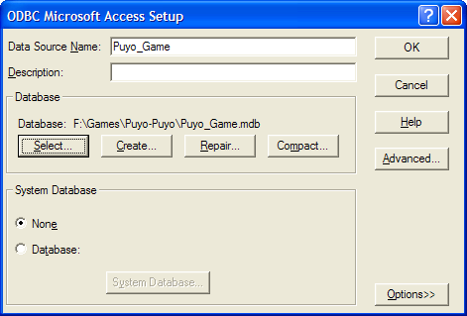

7. Now, ODBC is configured. Enjoy the game!!!

