Puyo-Puyo game

Welcome to puyo-puyo game developed by Rakesh. This is a game similar to tetris. This document explains the rules of the game, user controls etc.

Requirements: JDK 1.6, Microsoft Access DB.

This is a game built on 12 rows X 6 columns. In future, the board can be widened.

Puyos of different colors come in pairs from top. Game can be played in 3 levels:

Level 1: Easy
Level 2: Medium
Level 3: Hard

Objective of the game is to guide similar puyos together. If four similar puyos are collected row-wise or column-wise, they are cleared and hence four points is awarded. If the puyo reaches the top most row and has no space to fall, the game ends.

The user can control the fall of puyo by pressing the four arrow keys.

Pressing ‘P’ anytime will pause the game. Then, pressing ‘P’ again will resume the game.

Right Arrow key: Moves the puyos to the right.
Example:
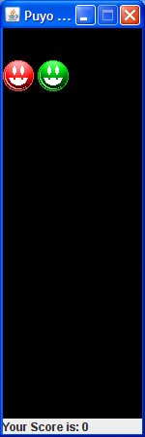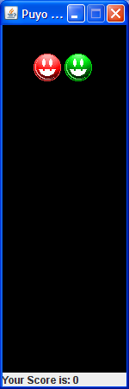
From this To this

Left Arrow key: Moves the puyos to the left.
Example:
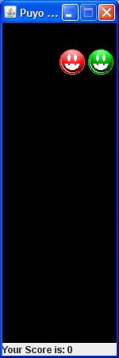
From this To this

Up and Down Arrow key: Rotates the puyos by 90 degrees each time.
Example:
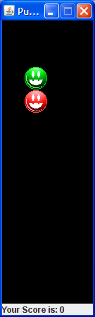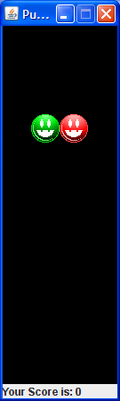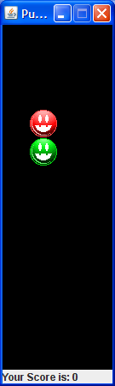

Scoring Scheme:

Level 1: Each label cleared gives the user 1 point. If a chain of more than 4 is cleared, 5 points is awarded for each label from the 5th label, in addition to the first 4 points.

Level 2: Each label cleared gives the user 2 points. If a chain of more than 4 is cleared, 10 points is awarded for each label from the 5th label, in addition to the first 8 points.

Level 3: Each label cleared gives the user 3 points. If a chain of more than 4 is cleared, 15 points is awarded for each label from the 5th label, in addition to the first 12 points.

The user will be taken to the next level, if he/she reaches 500 points. However, the game shall continue until it ends, when 3rd level is reached.

