Table of Content

1) VM Setup
2) Jenkins - Install
3) Source Code and Git hub repo
4) VM - Micro K8s Setup

Virtual Machines:

- Jenkins Build Server
  - Ubuntu 24.04 Server
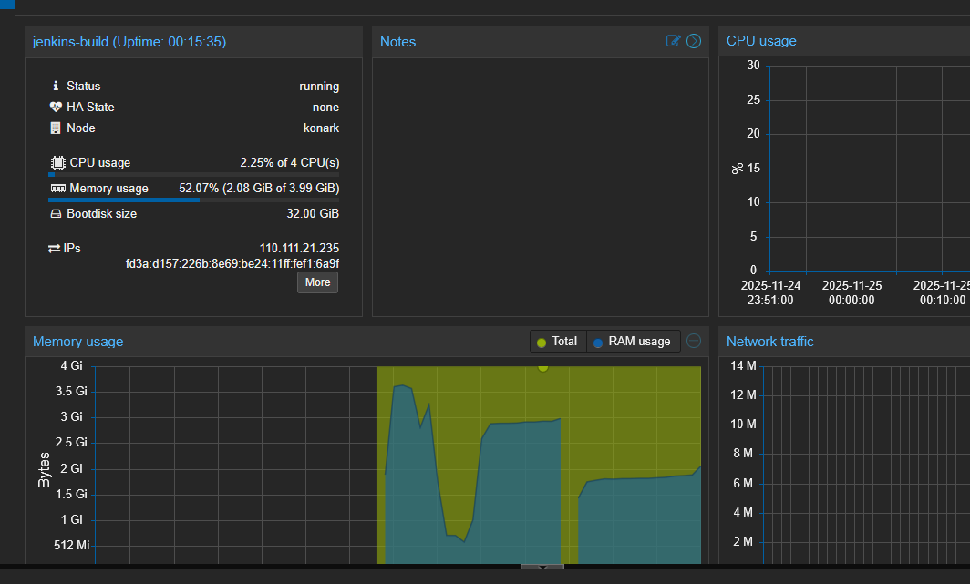

  - Install Jenkins on the Above Server
Connected using ssh [powershell]
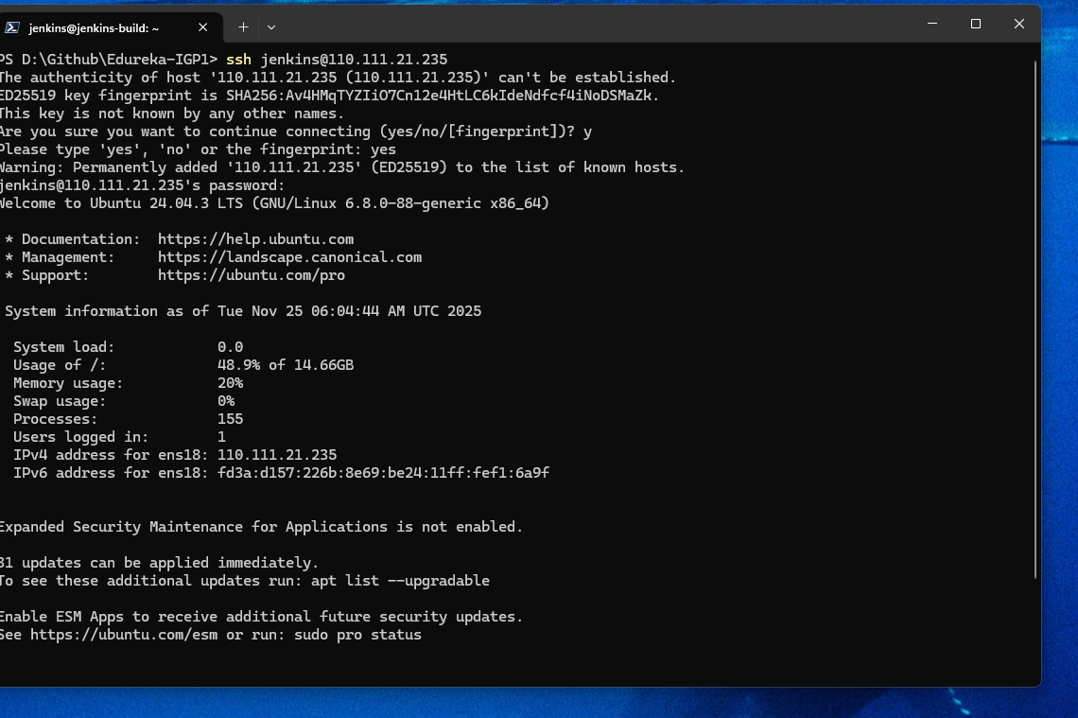

Followed instruction from the jenkins help page to install Jenkins on above VM

https://www.jenkins.io/doc/book/installing/linux/

sudo wget -O /etc/apt/keyrings/jenkins-keyring.asc \
https://pkg.jenkins.io/debian-stable/jenkins.io-2023.key
echo "deb [signed-by=/etc/apt/keyrings/jenkins-keyring.asc]" \
https://pkg.jenkins.io/debian-stable binary/ | sudo tee \
/etc/apt/sources.list.d/jenkins.list > /dev/null
sudo apt update
sudo apt install jenkins

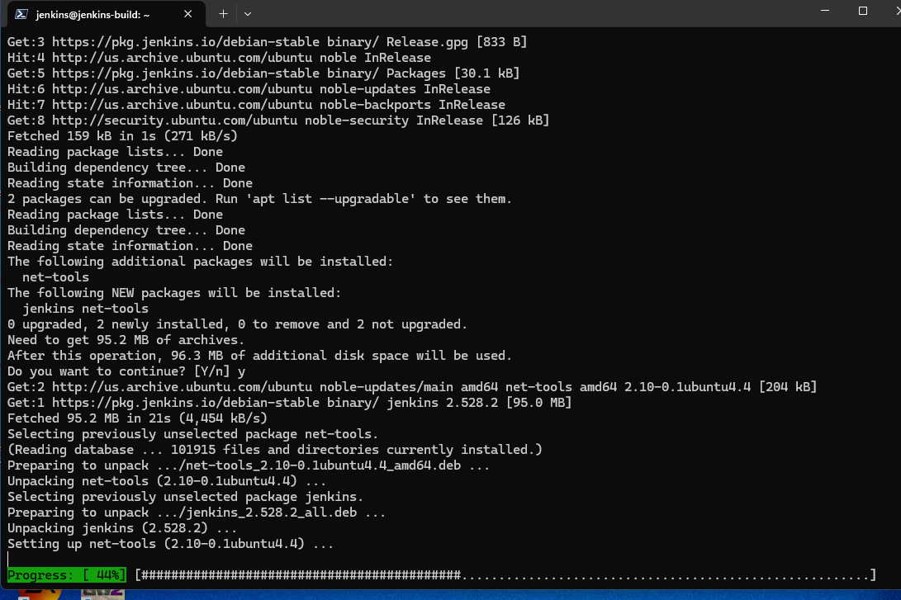
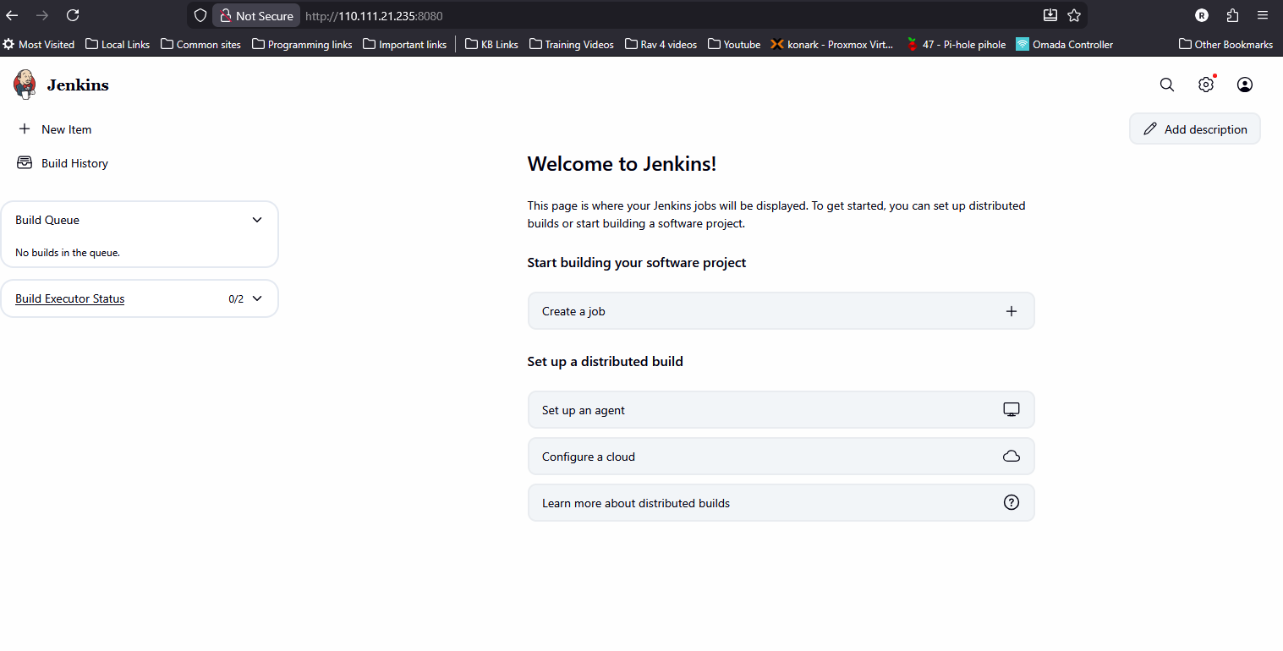

3) Install Docker
Docker is required on the jenkins server to build the application and deployment image
https://docs.docker.com/engine/install/ubuntu/

sudo apt install apt-transport-https ca-certificates curl software-properties-common

curl -fsSL https://download.docker.com/linux/ubuntu/gpg | sudo gpg --dearmor -o /usr/share/keyrings/docker-archive-keyring.gpg

echo "deb [arch=$(dpkg --print-architecture) signed-by=/usr/share/keyrings/docker-archive-keyring.gpg] https://download.docker.com/linux/ubuntu $(lsb_release -cs) stable" | sudo tee /etc/apt/sources.list.d/docker.list > /dev/null

sudo apt update

sudo apt install docker-ce docker-ce-cli containerd.io docker-buildx-plugin docker-compose-plugin

sudo usermod -aG docker $USER

sudo docker run hello-world

