**VELS VIDYASHRAM**

**PALLAVARAM**

**INFORMATICS PRACTICES PROJECT**

**2022-2023**

**Book Donation Camp**



**DONE BY:**

**CLASS:** XII-E

**REGISTRATION NUMBER:**

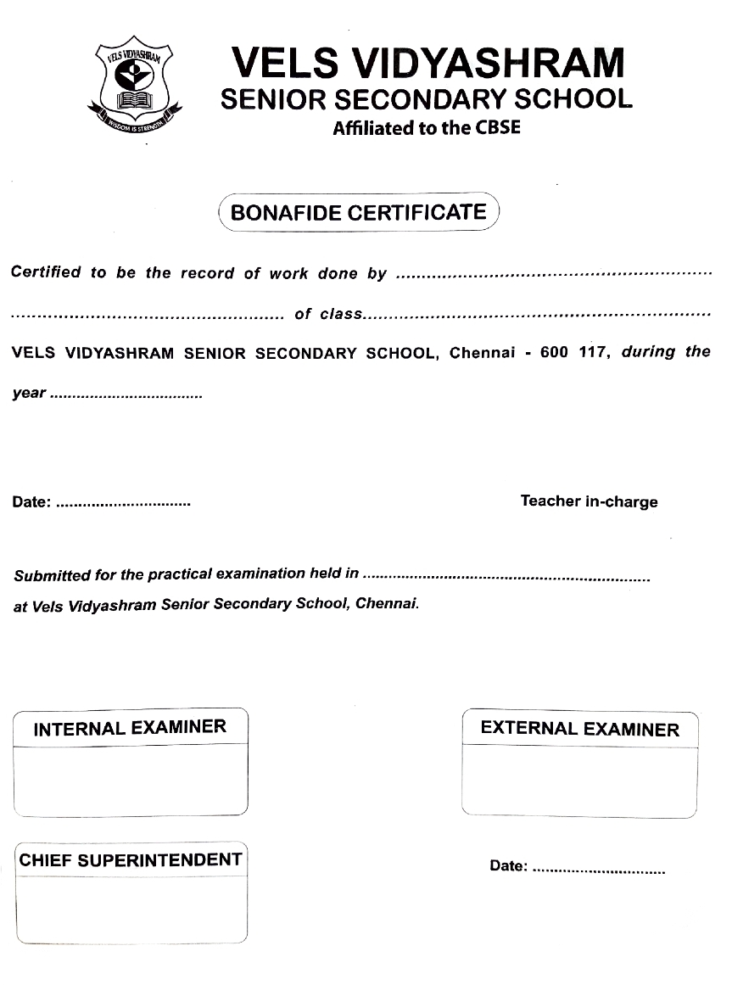

**INDEX:**

| **S.NO** | **CONTENT** | **Page No.** |
| --- | --- | --- |
| **1.** | Acknowledgement | 4 |
| **2.** | About the Project | 5 |
| **3.** | Hardware & Software Requirements | 6 |
| **4.** | About Pandas | 7 |
| **5.** | Source Code | 11 |
| **6.** | Output | 16 |
| **7.** | Back - End Tables | 24 |
| **8.** | Conclusion | 24 |
| **9.** | Bibliography | 25 |

**Acknowledgement:**

I would like to express my sincere gratitude and special thanks to

my IP teacher Mrs. B. Vasupriya, our IP Lab In-Charge

as well as our Principal, Mrs. Katheeja. J. A

who provided the golden opportunity to complete this wonderful project on the topic of *“Book Donation Camp”*

which has helped me learn about a diverse variety of new things

through extensive research.

Secondly, I would like to thank my friends, who helped me finish this project within the stipulated time.

It helped me widen my knowledge and skills.

**Brief Description about the Project:**

Realizing the importance of the Reduce, Reuse and Recycle initiative, the Bookworm Club of our school organizes an annual Book Donation Camp. The Book Donation Camp collects books and notebooks, after which, volunteers assess the condition of the books and categorize them as ‘Fit’, ‘Needs Mending’, or ‘Unfit’. Pages of ‘Unfit’ books are used to create paper bags and envelopes, whereas, other categories of books are resold at half the price. The Book Donation Camp accepts notebooks that have pages left in the, which are torn, and then attractively bound to create a new notebook which is resold. They collect a variety of second-hand items which are sold again after being refurbished, or recycled into different objects.

For this purpose, the Bookworm Club wishes to create software to store details about the camp and to be able to efficiently store, retrieve and visualize data, using the Pandas and Matplotlib libraries in Python, along with CSV Files to implement it.

**The Source of the Dataset:**

The Dataset for our Book Donation Camp’s back-end table was taken based on the data and statistics collected as a result of extensive scouting and surveyance, regarding the frequency of the different types of books (and their condition) stored by several libraries and bookshops present across our local district and city.

**Hardware Requirements:**

* Operating System :- Windows 10 and above
* Processor :- PENTIUM
* Motherboard :- 1.845 OR 915,995 FOR PENTIUM
* RAM :- 512 MB+
* Hard disk :- SATA 40 GB OR ABOVE
* CD/DVD r/w multi-drive combo :- (If back-up required)
* Floppy Drive 1.44 MB :- (If back-up required)
* Monitor 14.1 or 15 - 17 inch
* Keyboard and mouse
* Printer
* GeForce RTX 20 Series Graphic Card

**Software Requirements:**

* Windows OS
* Python
* Microsoft Excel

**About Pandas:**

**Introduction to Pandas:-**

* Python libraries contain a collection of built-in modules that allow us to perform many functions.
* NumPy, Pandas and Matplotlib are three well-established Python libraries for scientific and analytical use.
* These libraries allow us to manipulate, transform and visualize data easily and efficiently.

**Pandas:-**

* PANDAS (PANEL DATA) is a high-level data manipulation tool used for analysing data.
* It makes it straightforward to import and export data using the PANDAS library which has a very rich set of functions.

**Series:-**

* A series is a 1-Dimensional array containing a sequence of any datatype (int, float, list, string, etc) which, by default, includes numeric data labels starting from zero, marking the position of each element.
* The data label associated with the particular value is called its index.

**Example:**

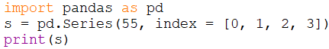

**Output:**

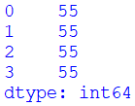

**Dataframe:**

* Dataframe is a 2-Dimensional labelled data structure from the Python Pandas library, similar to a MySQL table.
* It contains rows and columns, and therefore, has both a row and a column index respectively.
* In Dataframe, axis = 0 represents the rows, whereas axis = 1 is used to depict the columns.
* In a DataFrame, each column can have a different type of value such as numeric, string, boolean, etc., as in tables of a database.

**Example:**

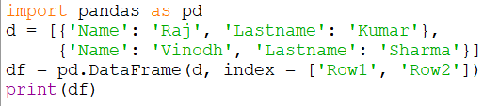

**Output:**



**CSV File:**

* A Comma-Separated Value (CSV) file is a text file where each value is separated by a comma.
* read_csv() is used to load the data from a file into a DataFrame.
* to_csv() is used to save a DataFrame to a CSV file.

**Matplotlib:**

* The matplotlib library is used for creating static, animated and interactive 2D plots or figures in Python.
* Its .pyplot module contains a collection of functions that can be used to work on a graph.
* It can be used to produce publication-level graphs, ranging from line plots, bar charts, histograms, pie charts and scatterplots.
* A figure is regarded as the overall window where the outputs of python functions are plotted, using the matplotlib library.

**Example:**

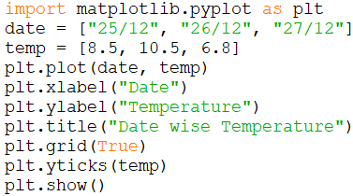

**Output:**

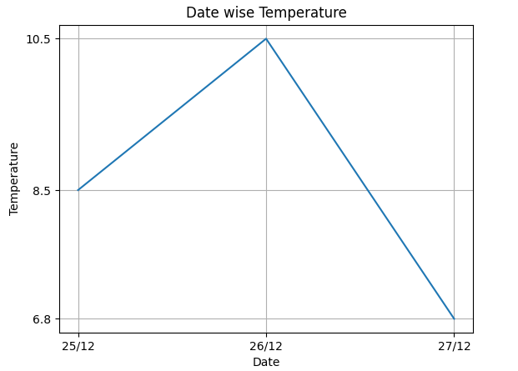

**Source Code:**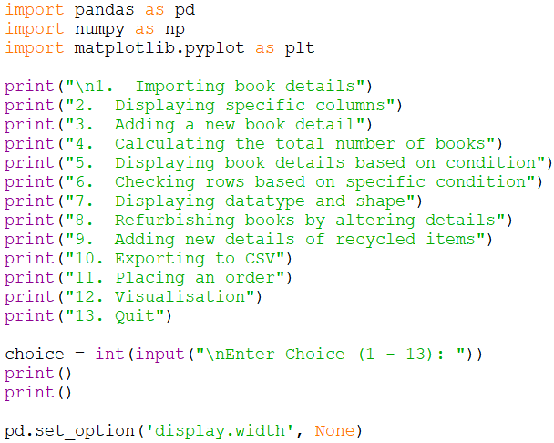

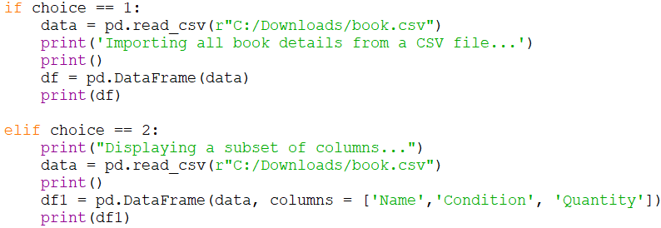

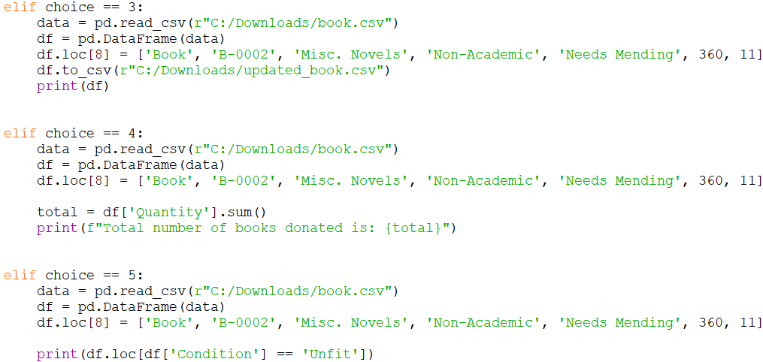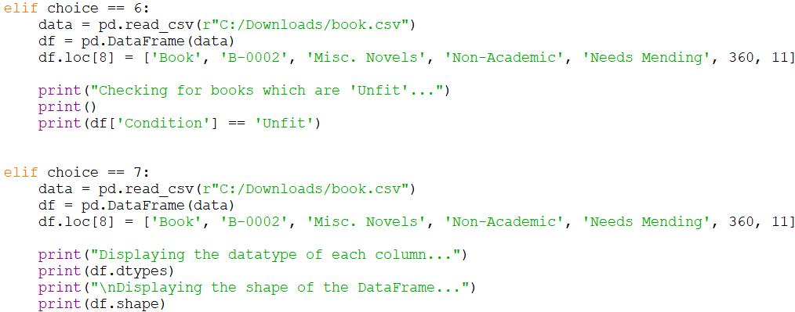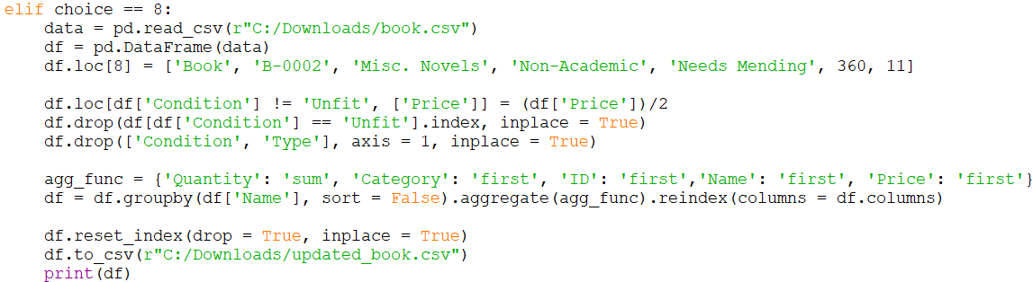

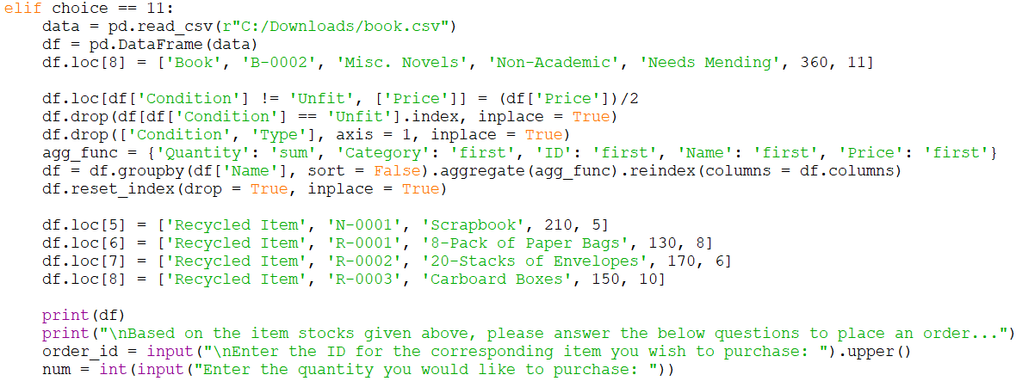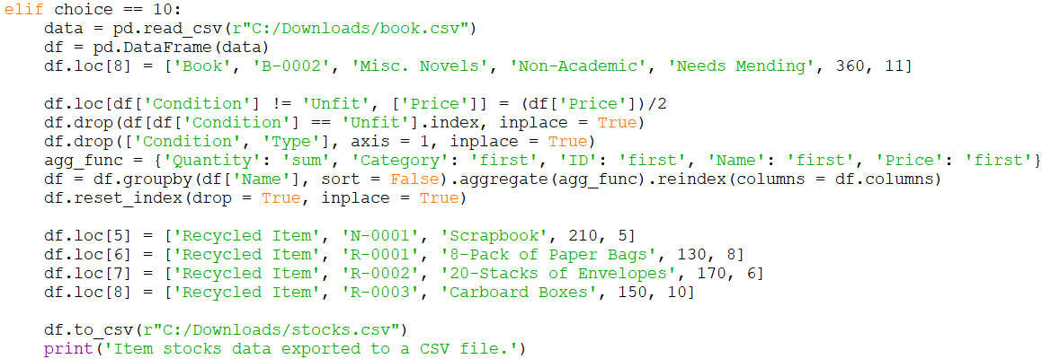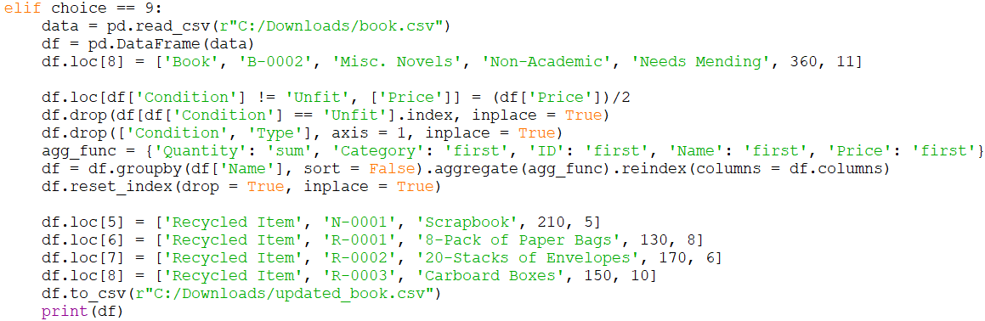

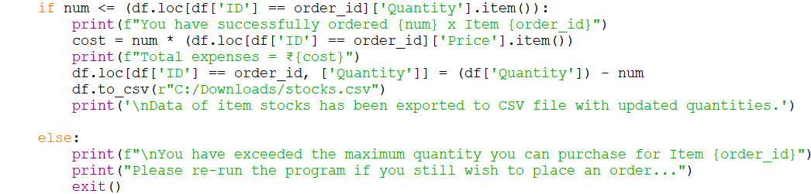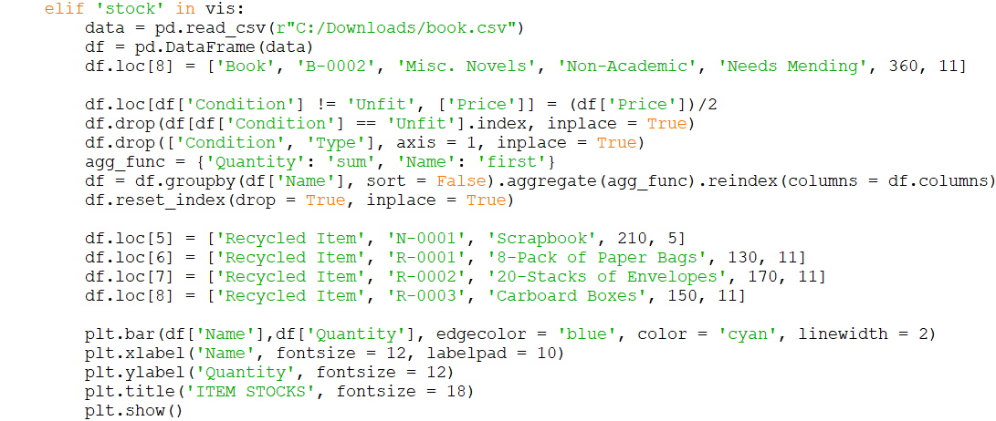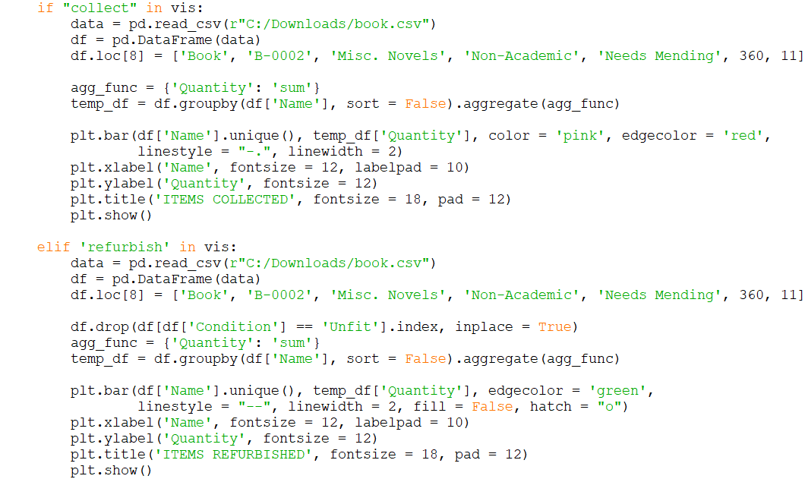

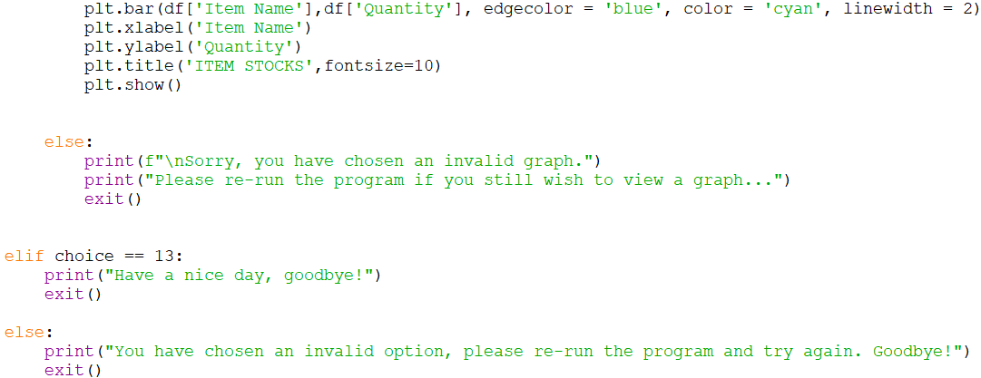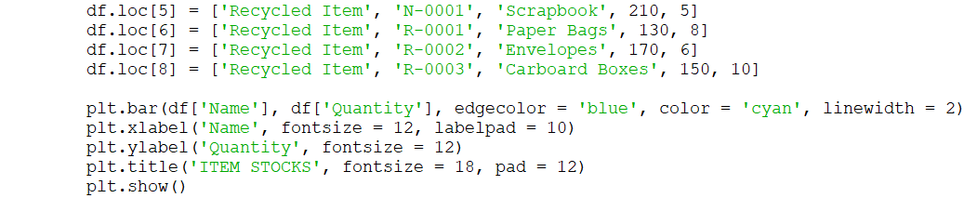

**Output Screen:**

**Menu:-**

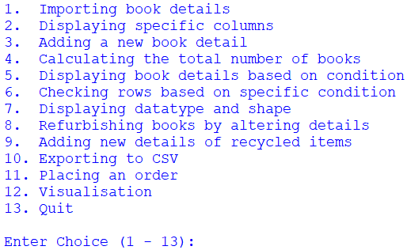

**1) Importing Book Details:-**

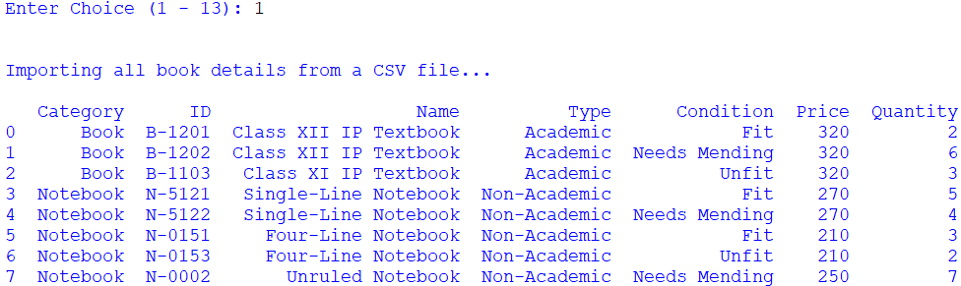

**2) Displaying a subset of columns:-**

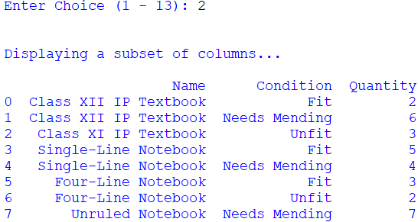

**3) Adding a new book detail:-**

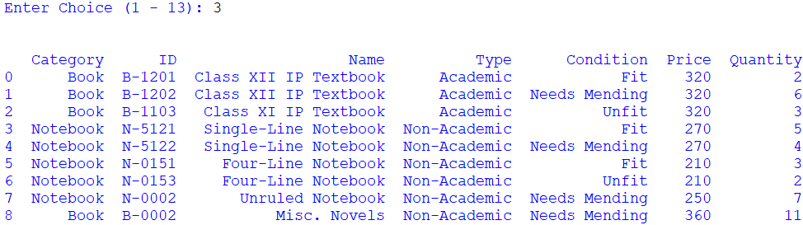

**4) Calculating the total number of books donated:-**

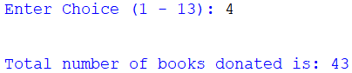

**5) Displaying book details based on their category:-**

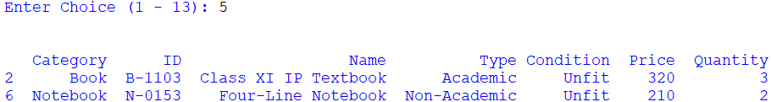

**6) Checking rows based on a specific condition:-**

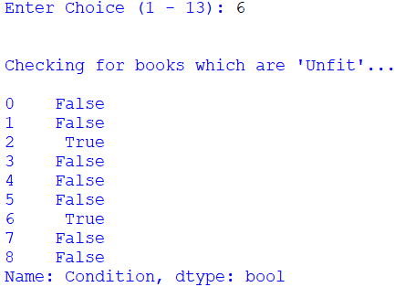

**7) Displaying the datatype and shape of the DataFrame:-**

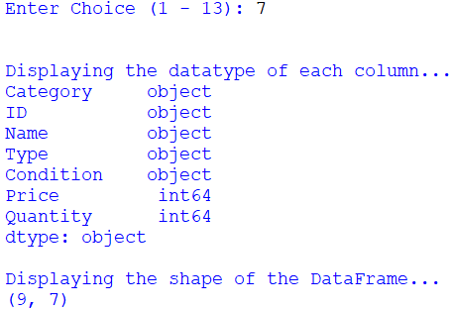

**8) Refurbishing books by altering details:-**

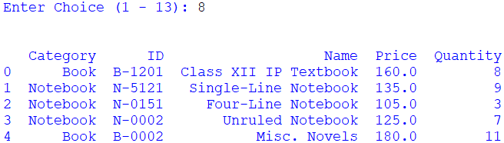

**9) Adding new details of refurbished Items:-**

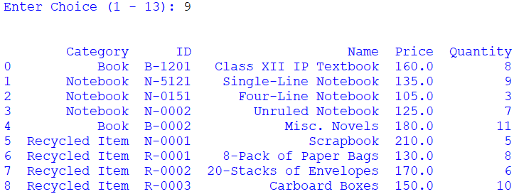

**10) Exporting updated DataFrame to a CSV File:-**

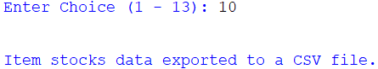

**11- a) Placing a valid order:-**

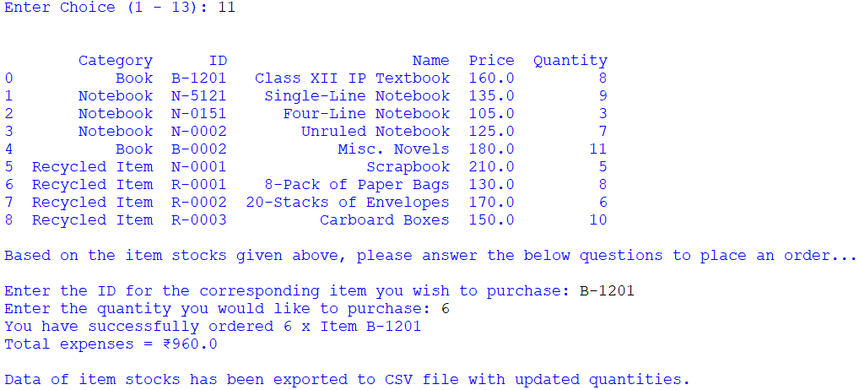

**11- b) Placing an invalid order:-**

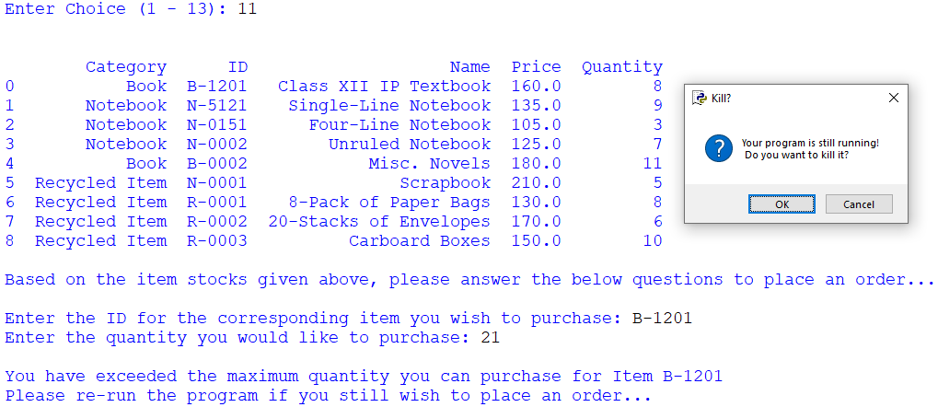

**12- a) Visualisation - Bar Graph for the “Books Collected”:-**

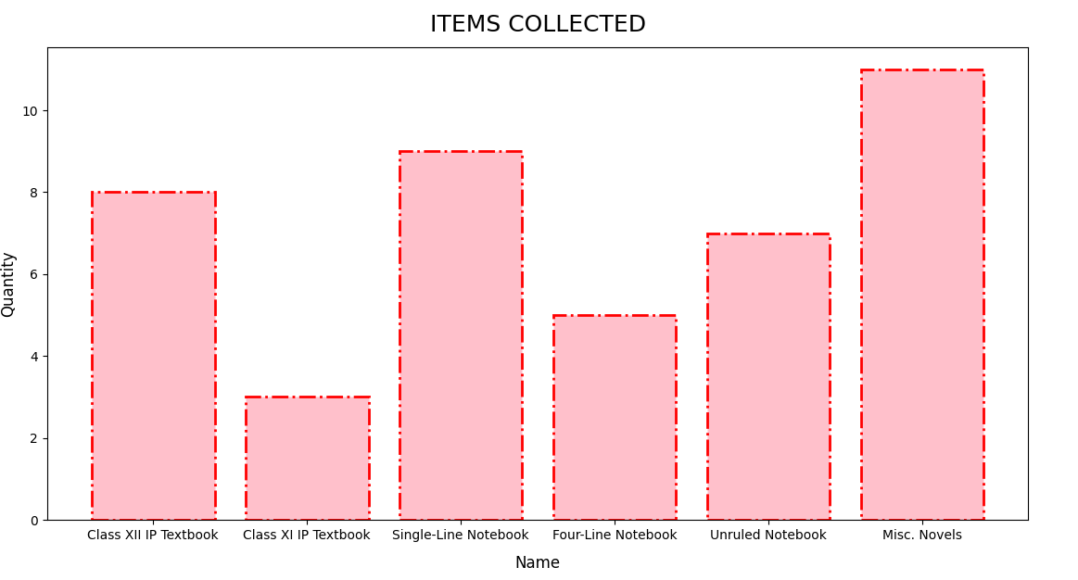

**12- b) Visualisation - Bar Graph for the Books Refurbished:-**

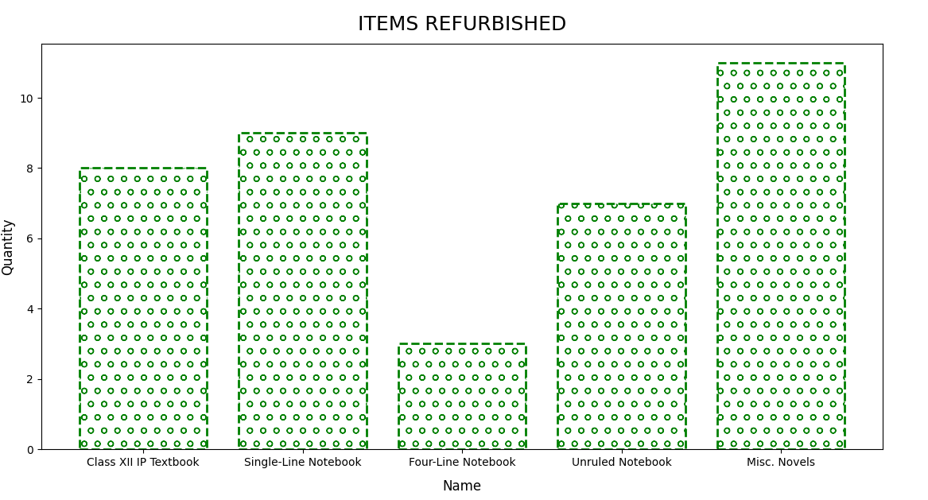

**12- c) Visualisation - Bar Graph for Item Stocks:-**

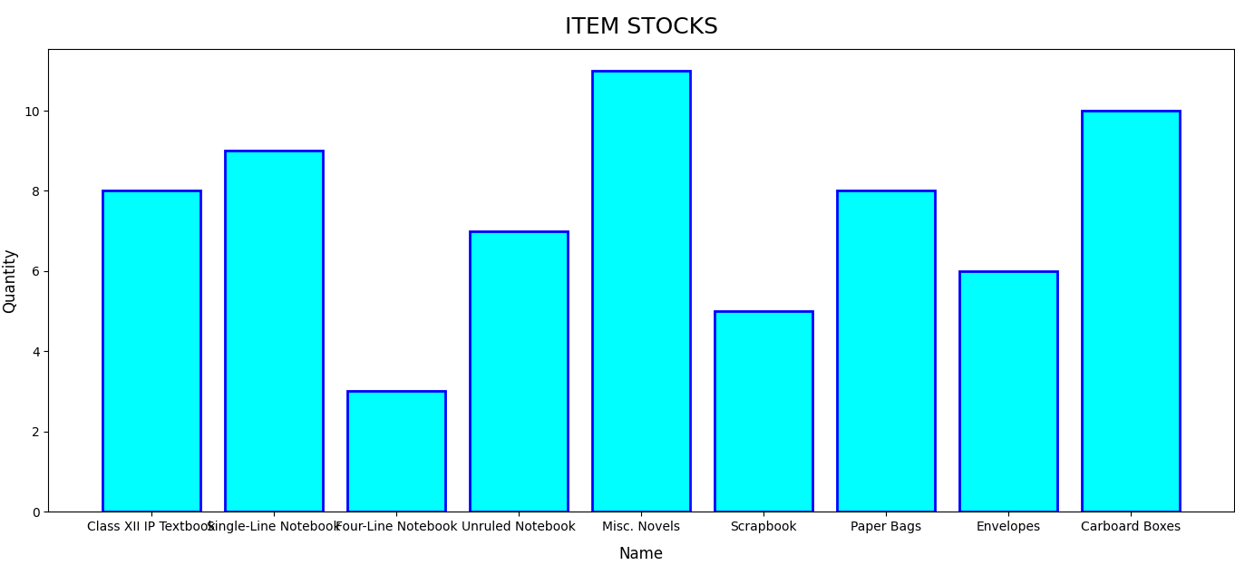

**12- d) Visualisation - Invalid Graph Chosen:-**

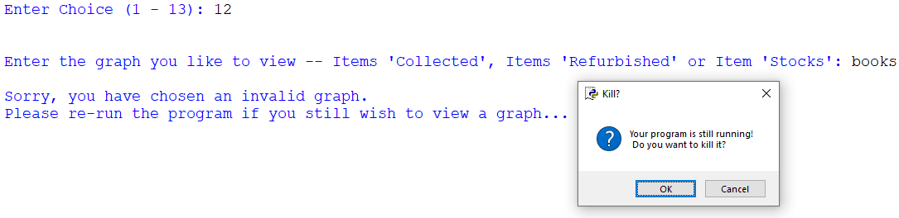

**13) Quit:-**

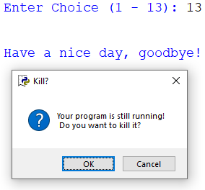

**### (If no valid choice is given by the user):-**

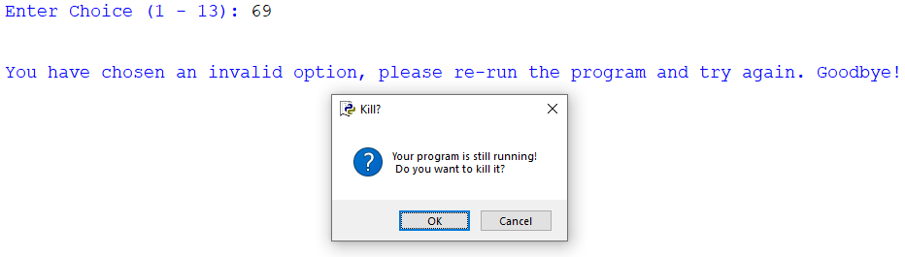

**CSV / Back-End Tables:**

**book.csv**

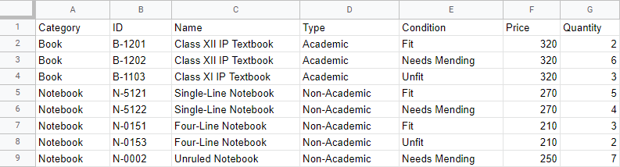

**stocks.csv**

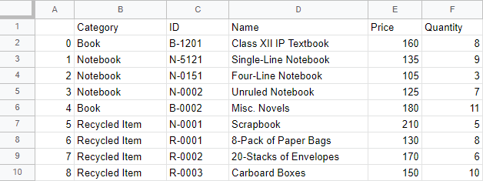

**Conclusion:**

Thus, through the effective usage of data visualisation by applying bar graphs, we were efficiently able to keep track of data corresponding to the Book Donation Camp, and seamlessly make the necessary changes.

**References / Bibliography:**

* NCERT Informatics Practices Textbook for Class 12
* Internet
* Google