

2015

UMKC HACKATHON

**Team: Total Demolition 2.0**

**Ravi Kiran Yadavalli**

**Rakesh Reddy Bandi**

**Santosh Kumar**

**Nihar Dudam**

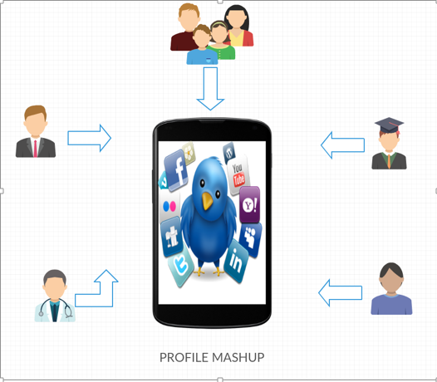

Social applications are the buzz of the day .With hundreds of applications growing each day and letting us consume huge, rich and diverse content. This throws the consumers with the challenge of dealing with more number of applications and especially mobile applications. So our application “Profile Mashup” deals with avoiding the overhead of handling of multiple applications and lets consumers to enjoy all their favorite applications under one application.

**Why Mash Up?**

With exponential increase of hand held devices and the consumption of the data, the storage and access of wide variety of contents has become a wild goose chase for the developers .There has been evolution of billions of nodes with social networking growing leaps and bounds and it is expected to grow further more. This leads to a wide variety of choices to the end user in consuming the web content, especially on mobile devices. In order to make the end users life easier, there is a need for a custom and hybrid applications which could render rich data with efficiency and accuracy.

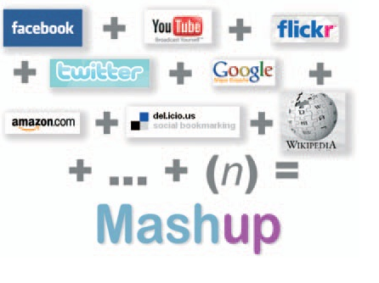

Mash Ups could deliver scalable content over hybrid architure.Mash Ups are the technology for the future.

1. **ARCHITECURTE DIAGRAM**

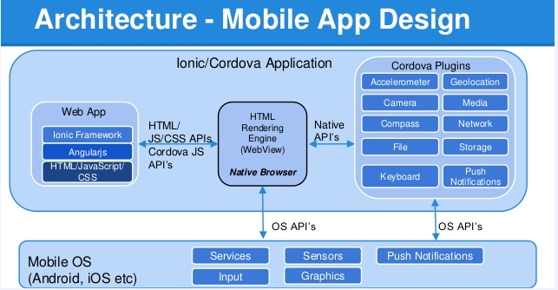

|  |
| --- |
| TECHNOLOGY USED |
| Ionic/Cordova |
| Angular JS, JavaScript |
| HTML 5.0 |
| Android OS and IOS compitable |
| IBM Bluemix |
| Mongo DB |

The above table mentions about the various technologies used in our application

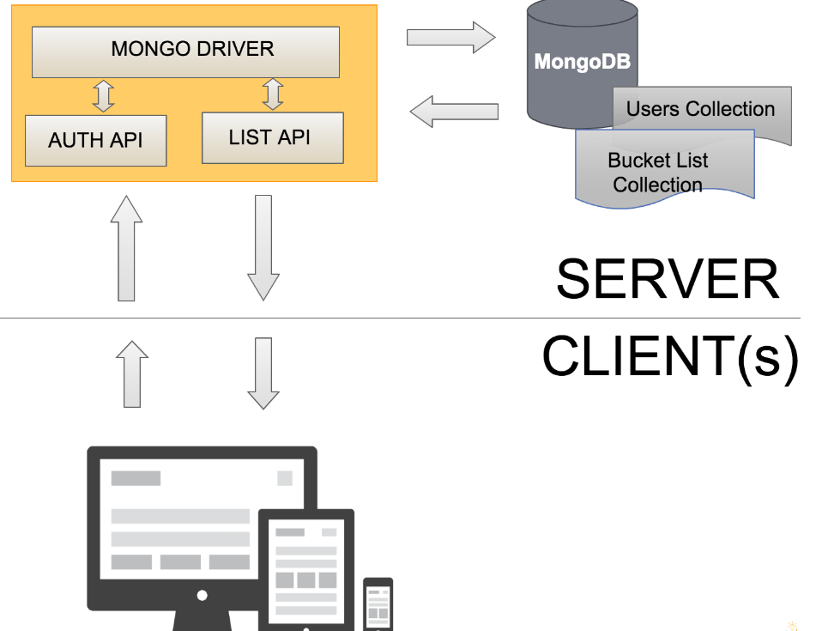

The above mentioned diagram illustrates about architecture.

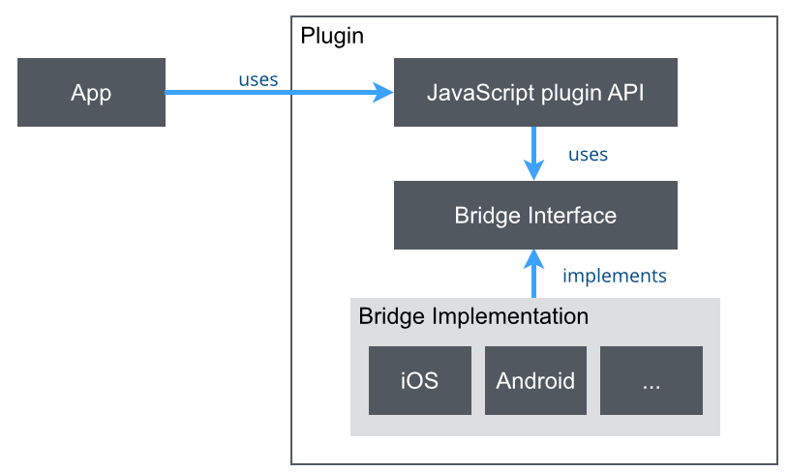

The above figure illustrates the plugin usage in our Profile Application

1. **WIRE FRAMES**

**Login Page**

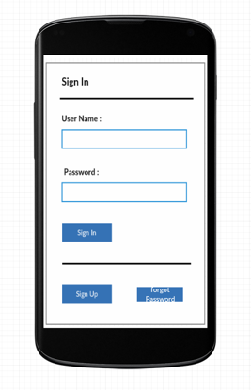

Users need to login with their respective accounts to access the app features.

**Sign Up Page:**

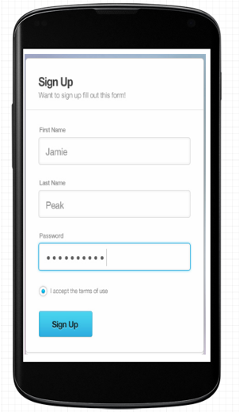

New users can register to this app and can have full access to the app features.

**Authorization of various social networks:**

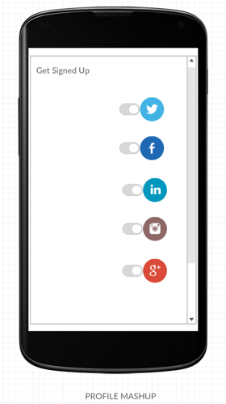

The user can provide authentication with various social networks to access their data.

**Authorizing Twitter app:**

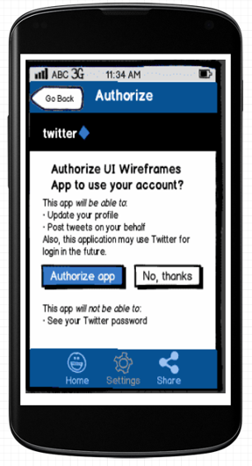

Authorizing the twitter app by providing the user details of twitter account.

**Twitter timeline:**

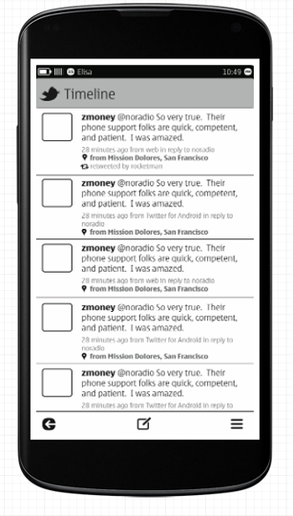

Fetching the twitter timeline after getting the authorization with twitter.

**Mashup of different social networks:**

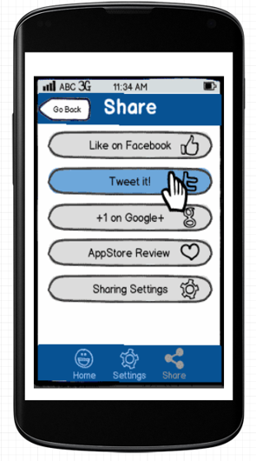

After authorizing all the different networks, we can get/push data across various sites simultaneously.

**Sharing using various networks:**

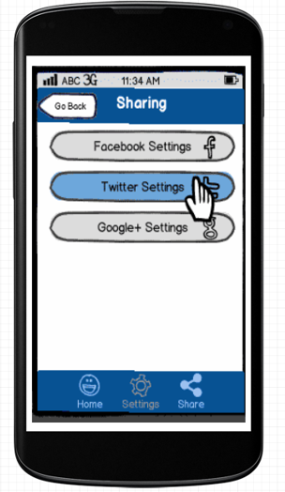

Using the sharing functionality of different social networks in a single page.

**Home Page (User profile mash up):**

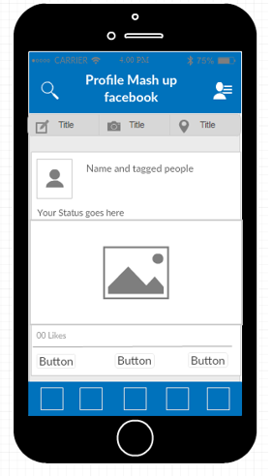

The user profile mash up, this page contains the details of a user fetched from various social networks.

**MOCK UP DIAGRAMS:**

1. **Login Page:**

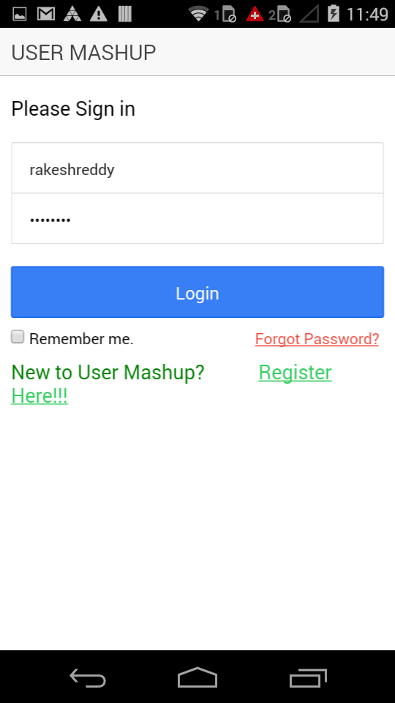

The above figure depicts login page

1. **Register Page**

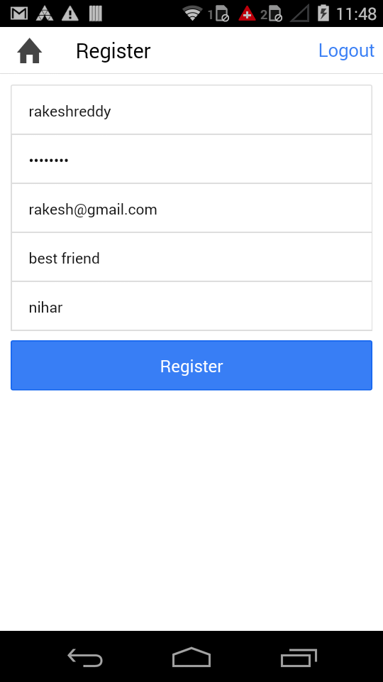

The above figure explains about register Page

3.Home Page

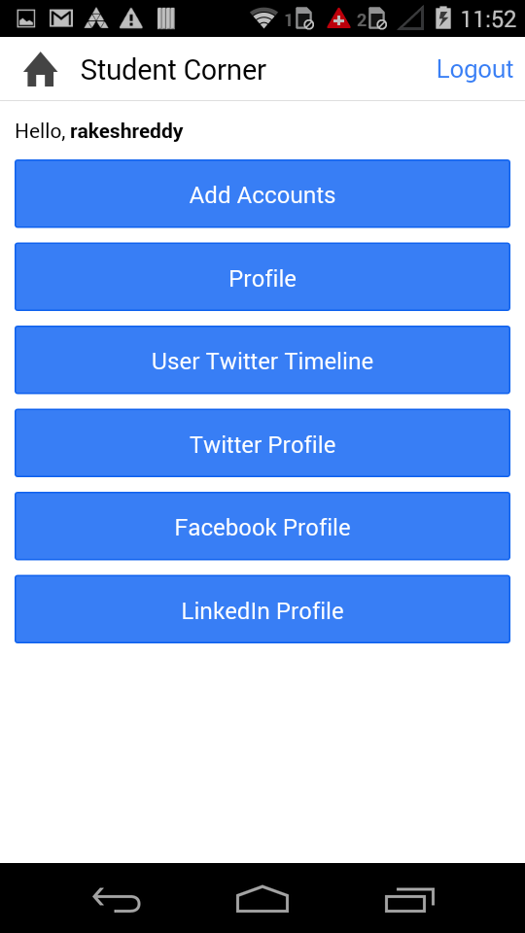

The above figure explains about Home Page of our application

**4.Add Accounts Page**

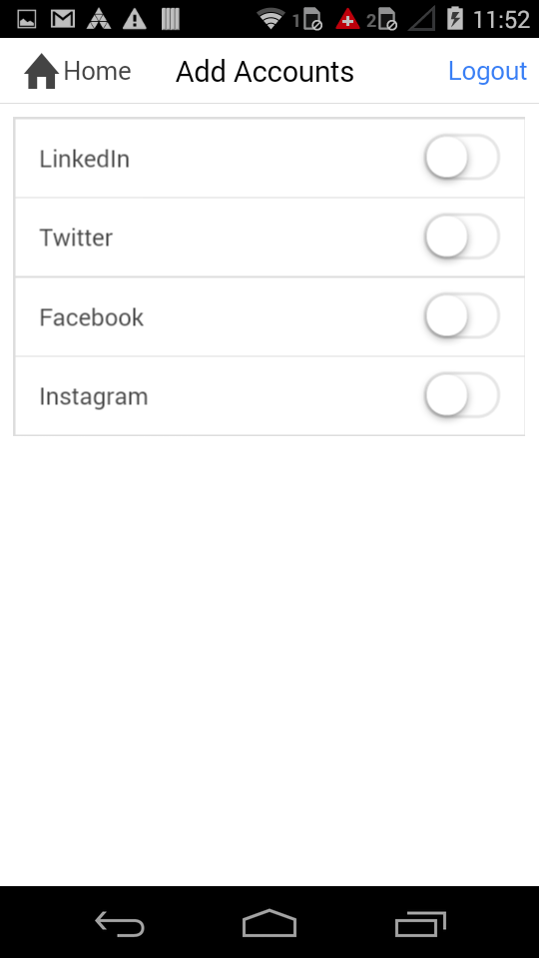

The above diagram explains about adding accounts in our application

**5.Linked in Sign in page**

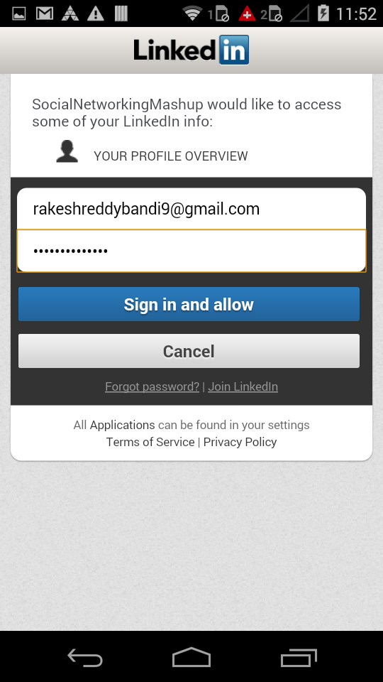

The above diagram depicts adding linked in Sign in page

**6.Enabling Linkedin account**

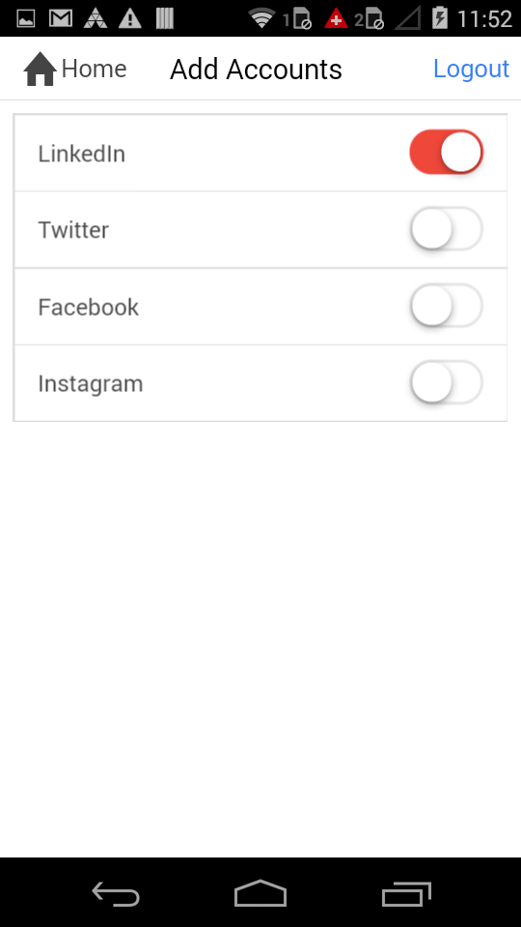

**7.Linkedin profile and feed**

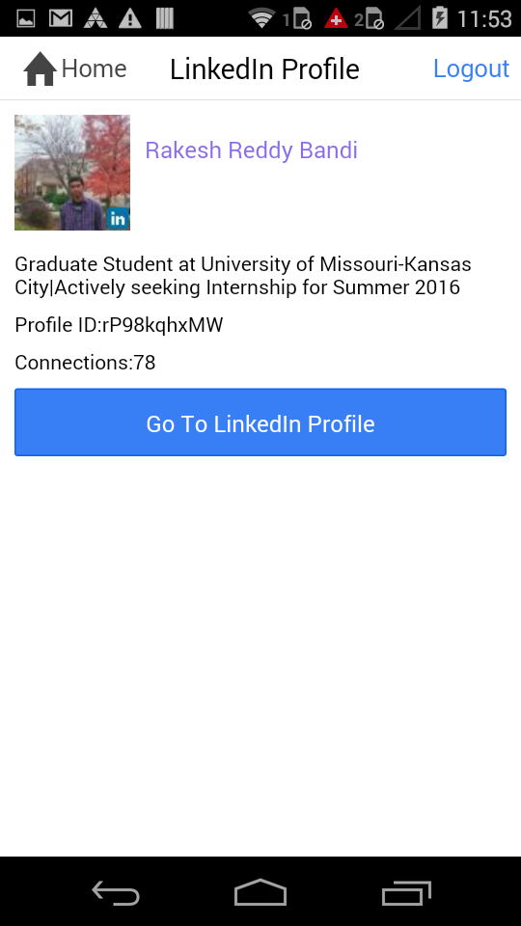

**8. Authorization of twitter App**

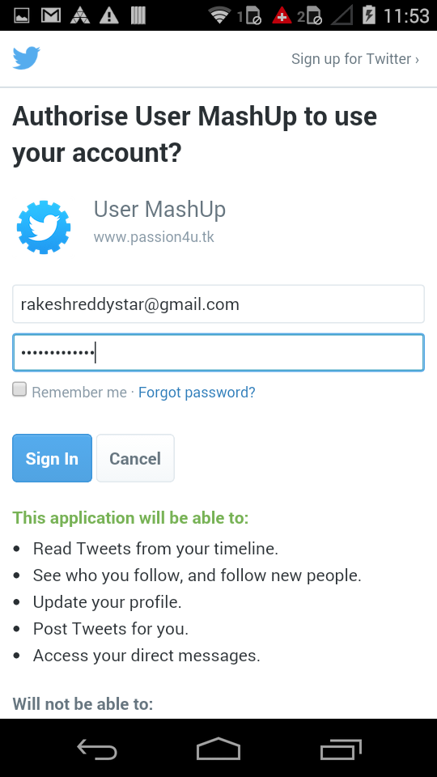

**9.Enabling Twitter account**

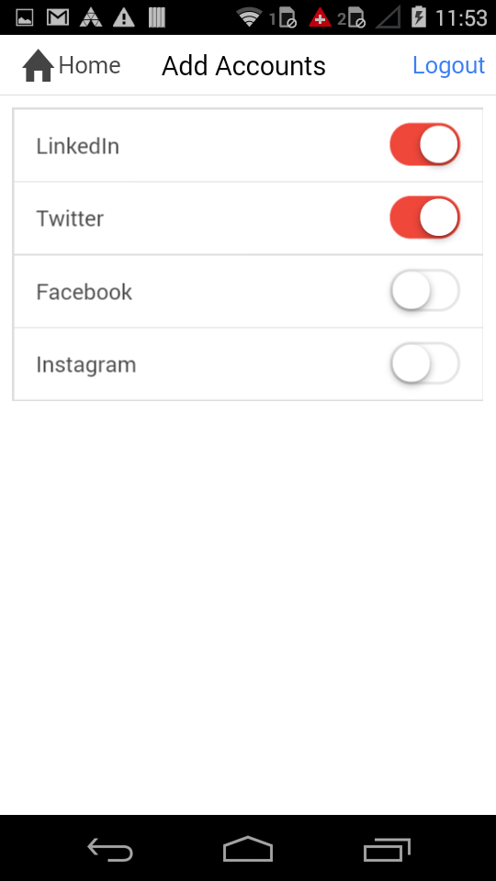

**10.Twitter feed**

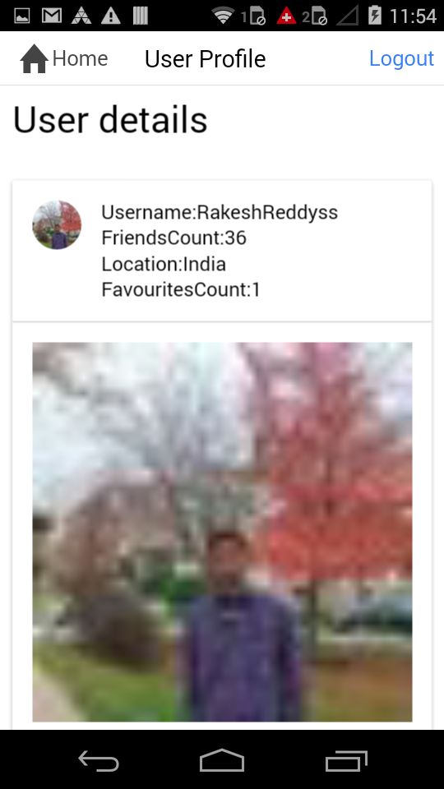

**11.Twitter Feed**

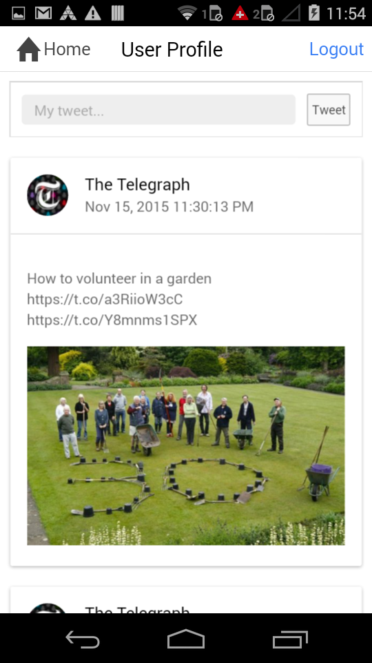

**12.Posting to Twitter wall**

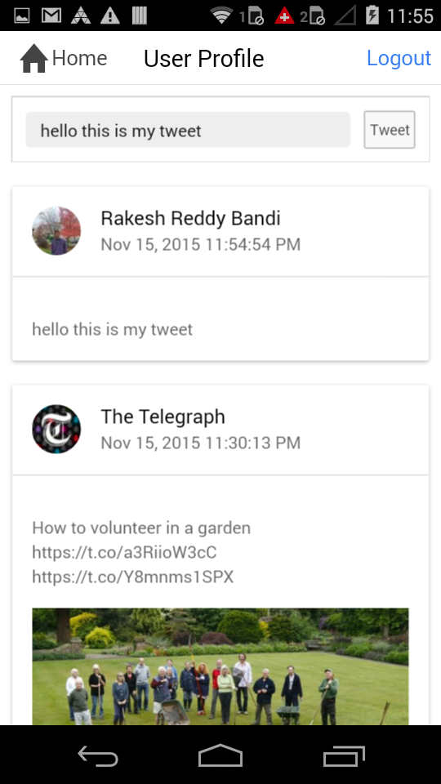

**13. Authorizing facebook**

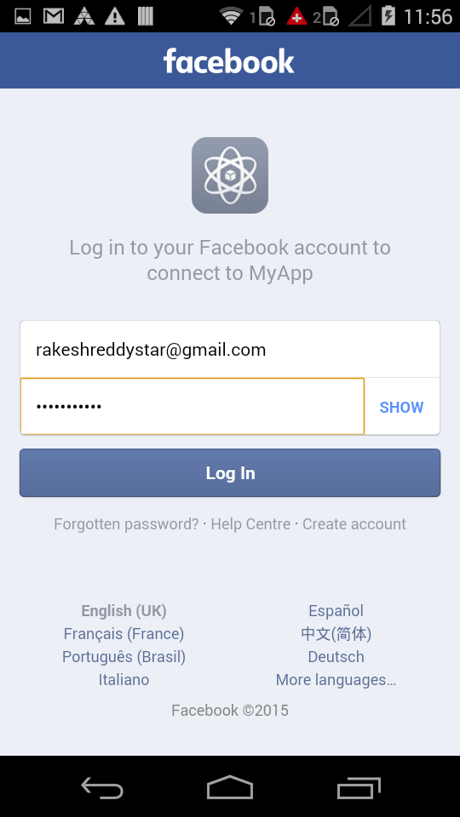

**14. logging into facebook**

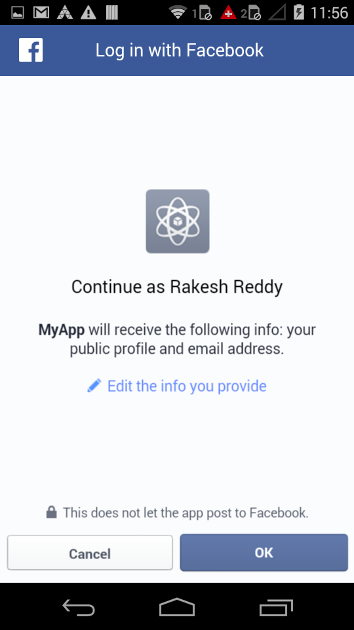

**15. Enabling Facebook account**

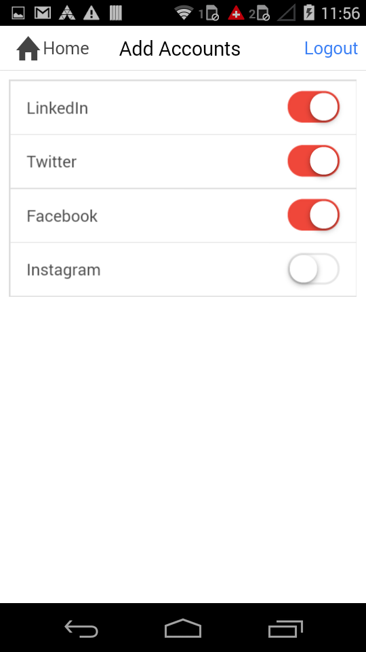

**16.Facebook profile feed**

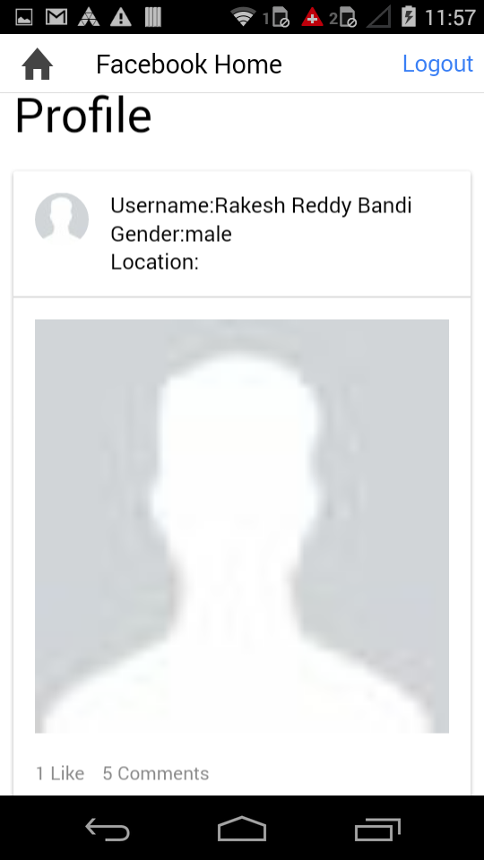

**17. Forgot password**

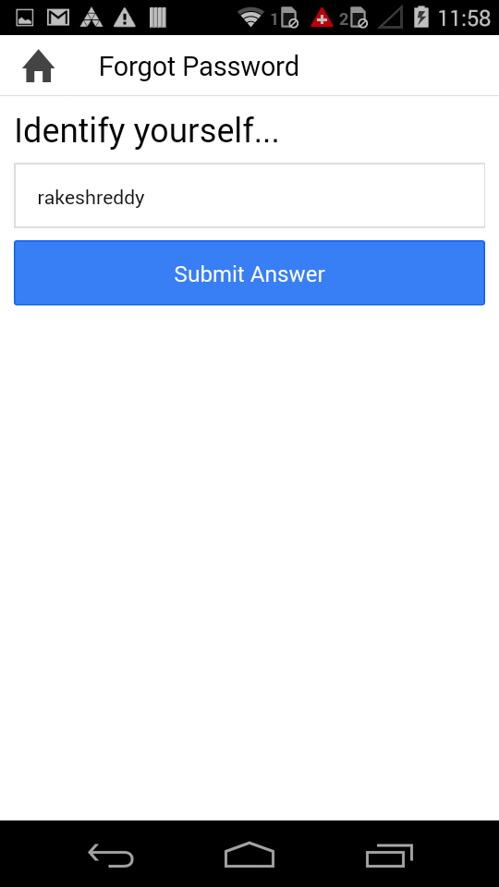

**18. Entering Security Question**

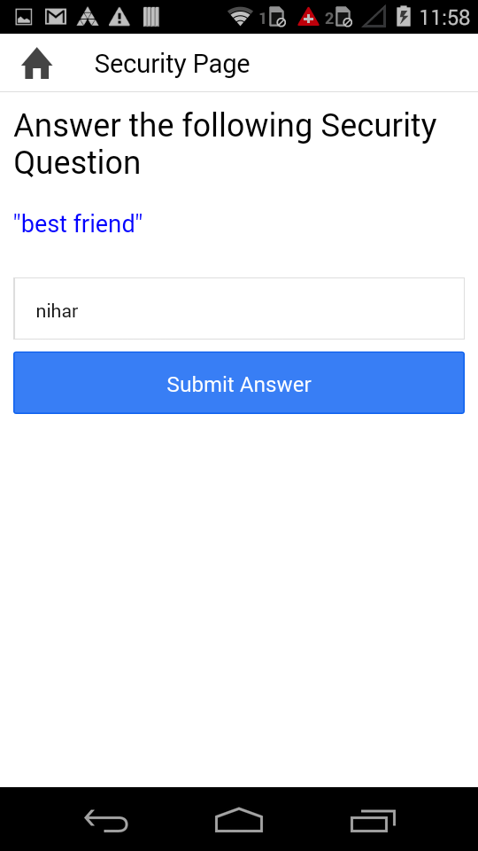

**19. Finally resetting a password**

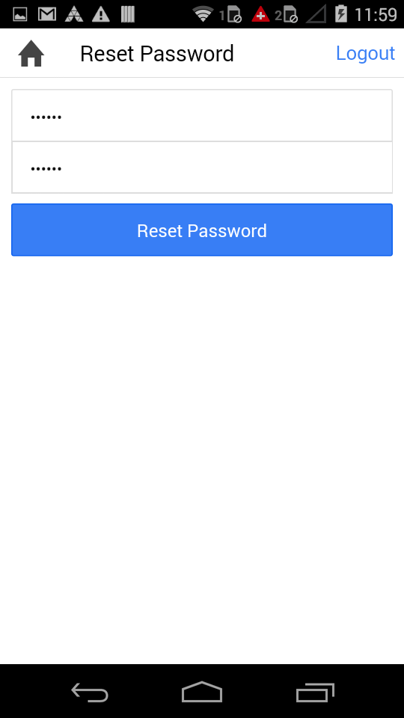

**20. Success message of resetting password**

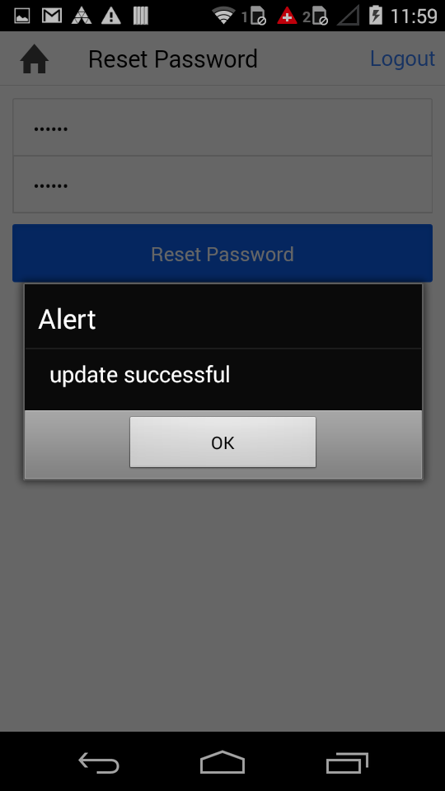

**Major Implementation outcomes in our application:**

1. **Users are able to login in our application.**
2. **The login page has a forgot password link.**
3. **Using OAuth, user is able to integrate various social networks like Facebook, Instagram, LinkedIn and Twitter.**
4. **Users are able to mashup their profiles into a single page.**
5. **We have implemented various functionalities using AJAX calls.**
6. **Users account is deactivated if he gets three consecutive failure attempts while logging into his/her account.**
7. **Users are able to log off from our app.**
8. **Users also have a “Remember Me” option which helps them to remember their login credentials.**