**Introduction:**

This application is used to publish the Nintex workflows in to the SharePoint Environment. It is developed using windows forms and Nintex web-services to publish the workflows. The application provides user to choose the target environment’s list/library names from a tree structure.

The user has to just click publish button by going to Nintex workflow designer for all the library/list to which this application publishes the workflows.

**Working:**

1. Browse to select a Nintex workflow. You can also select multiple workflows using ctrl key.

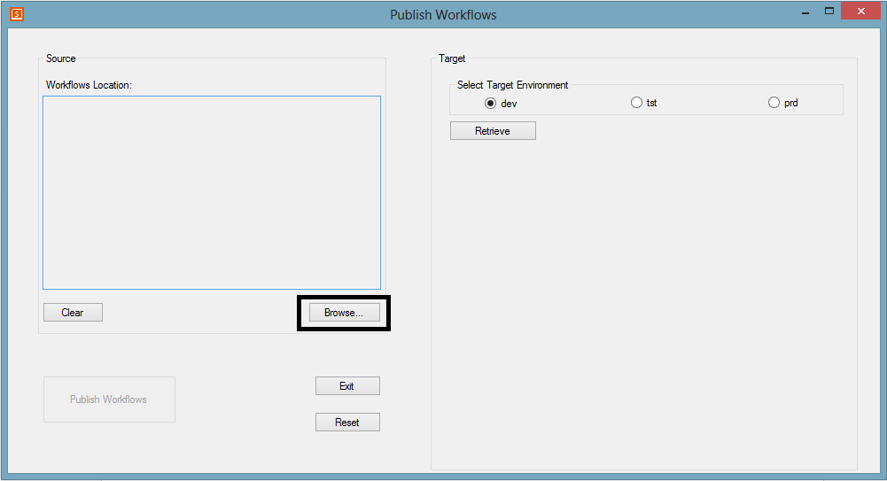

Use the “Clear” button to remove the selected the workflows.

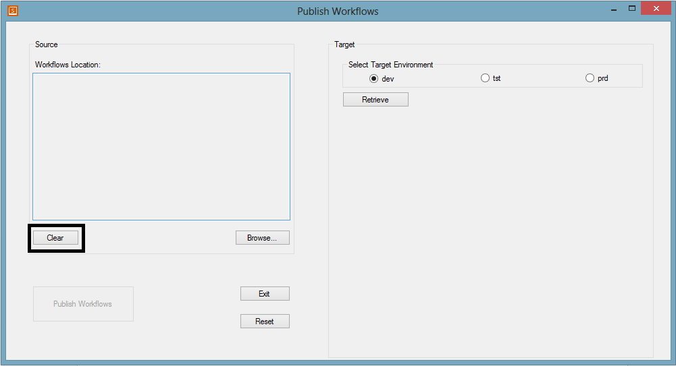

1. Select a target environment to which you want to publish the workflow.

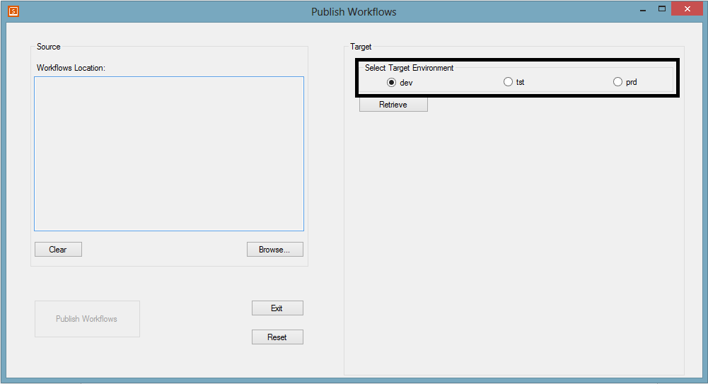

1. Click retrieve button to populate all the list of sites and its list/library content in a tree view structure.

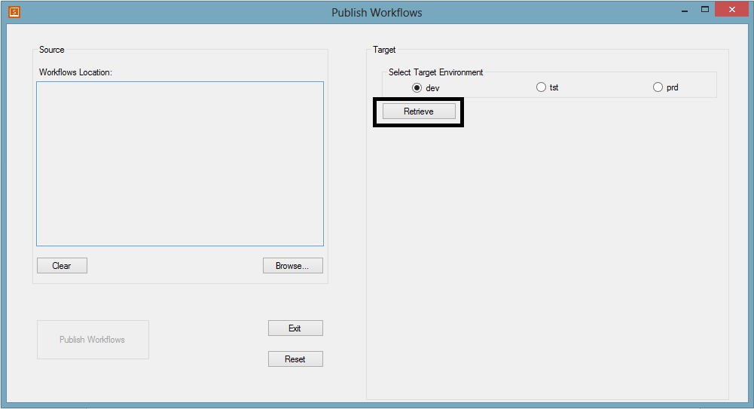

1. Select the required library/list names to which the workflow has to be published. Here, note that selecting a site names selects all the lists/libraries of that particular site.

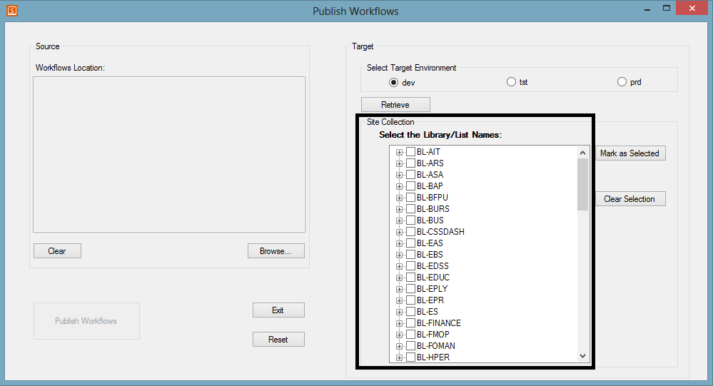

Selection showing all the site content selected and just a couple of libraries selected.

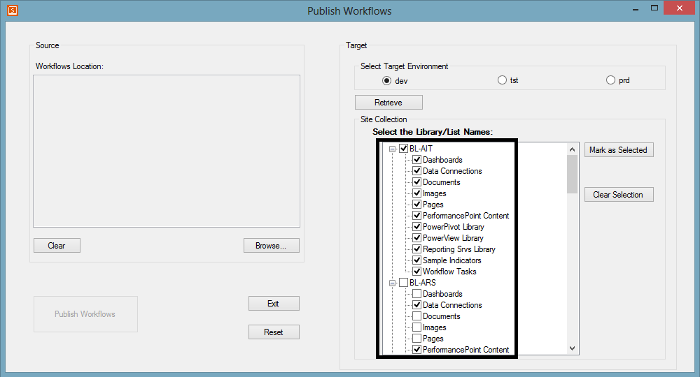

1. Click Mark as Selected to enable the Publish workflow button and to confirm the library/list names.

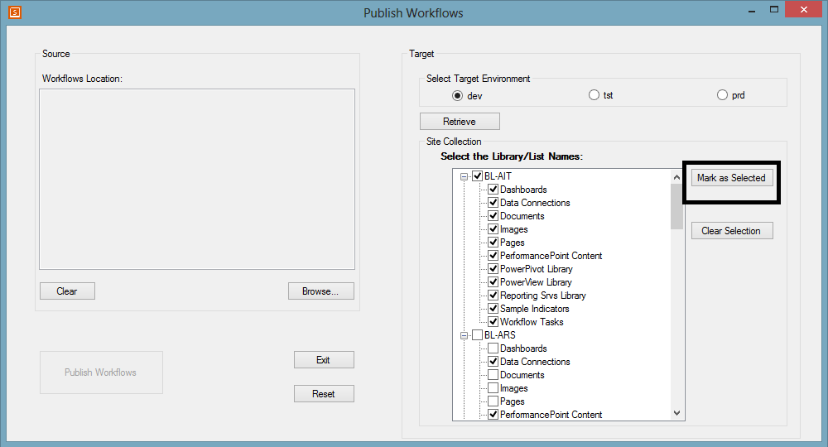

To clear the selected list/library names click on the clear selection button.

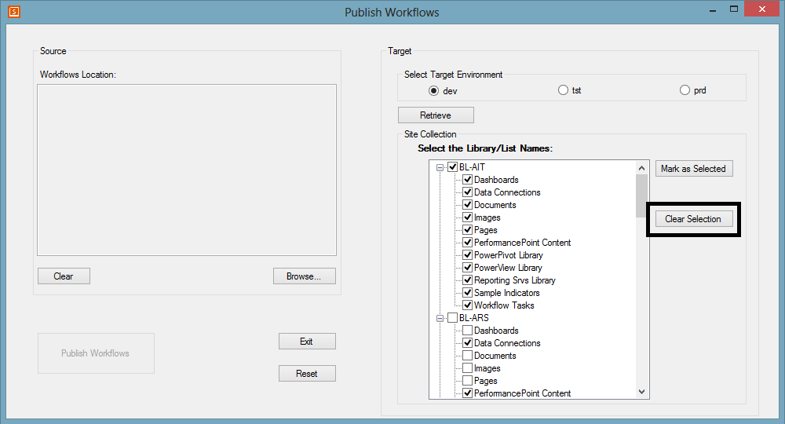

1. After the step 5, the button to publish the workflow is enabled which does the major work. It published the workflow in the selected target list/libraries.

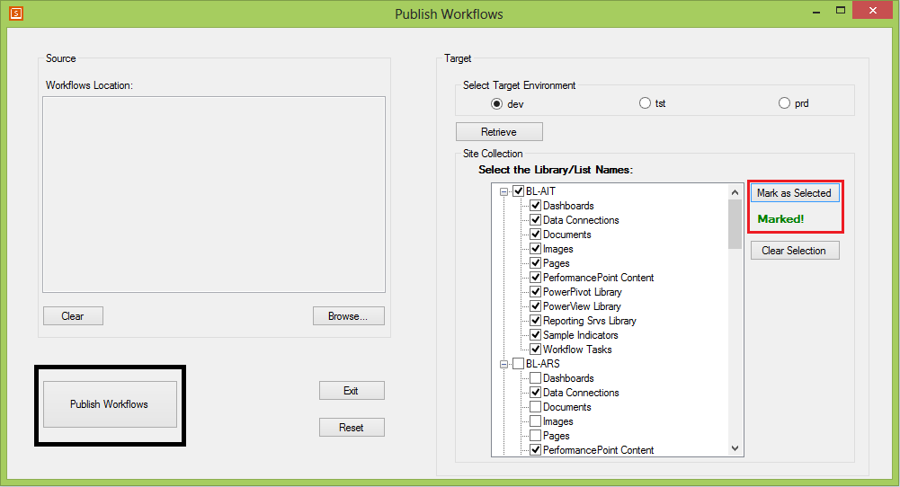

Note that a label indicating the confirmation of the items selecting and the button to publish the workflow. Click on the publish Workflows to further proceed through the process of publishing. It takes some time to publish and you may find that the application freezes during this process. This is because of the web service calls to Nintex workflows. Eventually, a label indicating the percentage of the process done will be showed beside the publish button. After successful completion of the process, a message “Done” indicate the completion of the process.

**Exit and Reset:**

**Reset**: Resets the complete application and brings it to the starting point.

**Exit**: Exists the application. It is the same as closing the application using “X” symbol.

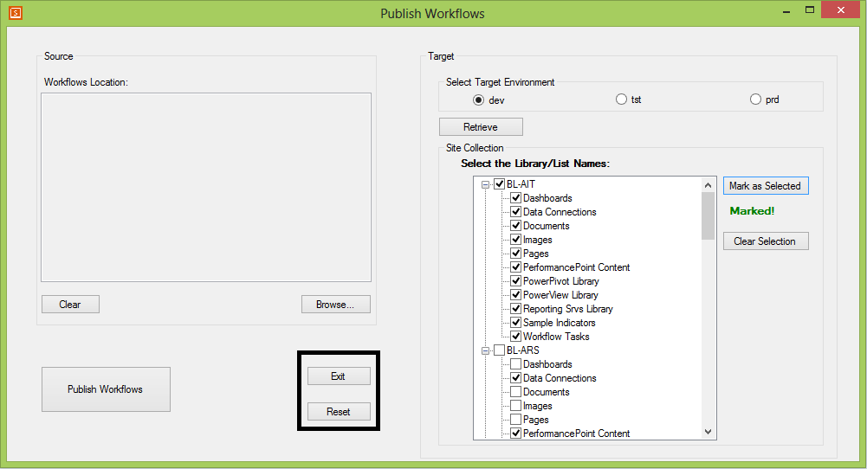

**Validations:**

1. There should be at least one workflow to be chosen to publish the workflow otherwise it give a message to select a workflow and resets the application.
2. By default “dev” environment will be selected when the application starts up.
3. The application doesn’t check for any selected list/library names. It proceeds with the zero number of list/library items and eventually no workflow will be published.

**Limitations:**

The workflow which have been deployed using Nintex web-services cannot be initiated because it further needs a binding with the respective list/library. This binding is only possible by using VS in SharePoint development environment. But it removes the manual process of importing the workflow in every library/list.