**Name: Rakesh Revashetti**

**Date: 3rd July 2025**

**Objective: Deploy the Python API using AWS ECR and AWS ECS, Terraform-managed infrastructure, and Docker**

This playbook documents the steps taken to provision AWS infrastructure using **Terraform**, build and push the Python API Docker image to **Amazon ECR**, and prepare the environment for deploying an containerized app using Amazon ECS

**Architecture Diagram**:

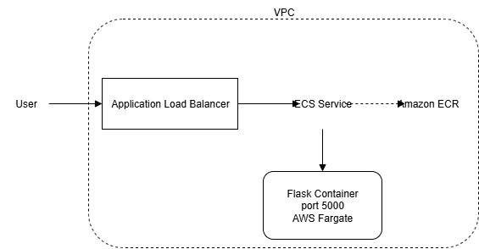

User 🡪 Application Load Balancer 🡪 AWS ECS service 🡪 Docker container running Flask API on port 5000

* User request goes to ALB
* ALB forwards to ECS Service
* ECS runs task on Fargate with Flask container
* Flask image is pulled from ECR

**Components provisioned:**

- VPC with public subnets

- Security groups for ALB and ECS

- Application Load Balancer (ALB)

- ECS Cluster (Fargate)

- ECS Task Definition + Service

- IAM Role for ECS Task Execution

**Code repository:**

Github URL contains python API code, terraform code and docker build script: <https://github.com/rakeshrevashetti/tribal_assessment.git>

**Folder structure:** <https://github.com/rakeshrevashetti/tribal_assessment.git>

**tribal_assessment**

├── README.md

├── deployment_script.sh

├── python-api

│ ├── Dockerfile

│ ├── README.md

│ ├── app.py

│ └── requirements.txt

└── terraform

├── ecs

│ ├── alb

│ │ ├── alb.tf

│ │ ├── output.tf

│ │ └── variable.tf

│ ├── ecs_cluster

│ │ ├── ecs_cluster.tf

│ │ ├── output.tf

│ │ └── variable.tf

│ ├── iam.tf

│ ├── output.tf

│ ├── task_definition

│ │ ├── iam.tf

│ │ ├── output.tf

│ │ ├── task_definition.tf

│ │ └── variable.tf

│ ├── vpc

│ │ ├── output.tf

│ │ ├── variable.tf

│ │ └── vpc.tf

│ └── vpc.tf

├── main.tf

├── output.tf

├── terraform.tfstate

├── terraform.tfstate.backup

├── terraform.tfvars

└── variable.tf

**Tools Used**

* AWS ECS (Fargate)
* AWS ALB
* AWS IAM, VPC, Subnets
* Docker, Flask
* Terraform

**Steps involved in the process**:

1. **Containerized the Flask API, we have written a docker file**:

FROM python:3.7.11-slim

WORKDIR /python-api

COPY requirements.txt requirements.txt

RUN pip install -r requirements.txt

COPY . /python-api

CMD [ "python3", "-m" , "flask", "run", "--host=0.0.0.0"]

1. **Bash deployment scrip**t to build docker image and push that docker image to AWS ECR, with repo name as the accountID with image tag as latest and we need to configure aws credentials to authenticate to aws cloud:

#!/bin/bash

AWS_REGION="us-east-1"

REPO_NAME="flask-api"

IMAGE_TAG="latest"

ACCOUNT_ID=$(aws sts get-caller-identity --query Account --output text)

docker build -t $REPO_NAME ./python-api

aws ecr get-login-password --region $AWS_REGION | docker login --username AWS --password-stdin $ACCOUNT_ID.dkr.ecr.$AWS_REGION.amazonaws.com

aws ecr describe-repositories --repository-names $REPO_NAME --region $AWS_REGION >/dev/null || aws ecr create-repository --repository-name $REPO_NAME --region $AWS_REGION

docker tag $REPO_NAME:latest $ACCOUNT_ID.dkr.ecr.$AWS_REGION.amazonaws.com/$REPO_NAME:$IMAGE_TAG

docker push $ACCOUNT_ID.dkr.ecr.$AWS_REGION.amazonaws.com/$REPO_NAME:$IMAGE_TAG

1. **Provisioning the infrastructure resources using IaaC tool terraform**, we have used terraform modules to provision the resources module wise, given input variables through variable.tf file, and made use of output.tf file to output the alb dns link to access the flask api, given values to the input variables through terraform.tfvars file, and provisioned infrastructure with commands like:

terraform init

terraform validate

terraform plan

terraform apply

1. **Health checks**:

The ALB periodically sends health checks to the container (typically at /) to ensure the app is running.

If a container fails the health check, ECS automatically replaces it with a new task, ALB will stop routing traffic to it.

1. **Security Groups:**

ALB and ECS service run in the same VPC (public subnet).

The security group for the ALB allows HTTP traffic from the internet.

The security group for ECS tasks allows traffic from the ALB on port 5000.

