Machine Learning [Assignment 1]

Question 1

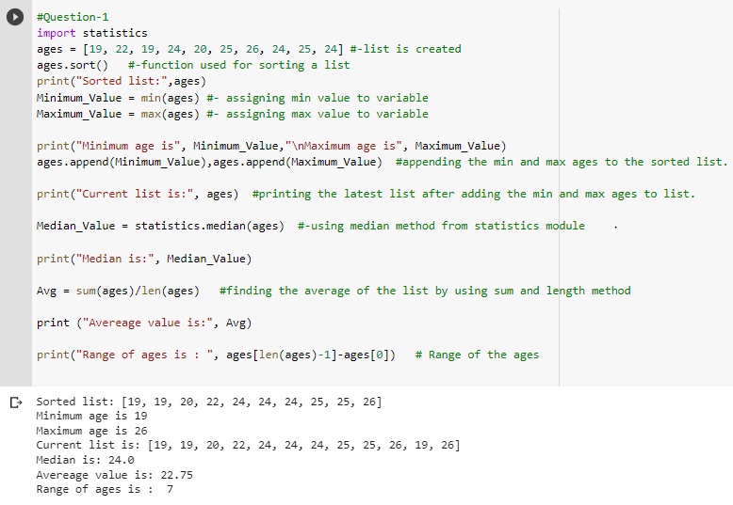

Explanation:

In this solution , we have list called ages where it contain some age values into it. To make an ordered list we have used sort() method which shuffle the ages into assencending order. Later we have taken 2 variables Minimum_Value and Maximum_Value for assigning the min and max values from the ages list. Initially we have imported statistics module to use the median method from it, and after finding median value , it is assigned to a variable Median_Value. To get the average of the list we have added all the elements by using sum method and divided it with the length of the list. Ange of the ages can be determined by subtracting the last value from the list and starting value from the list.

Question 2

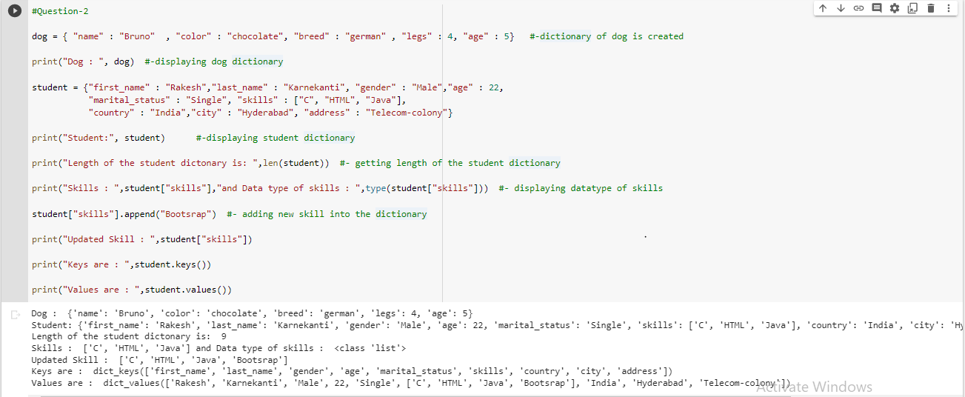

Explanation:

In the above code, a dictionary is created with variable called dog and it has keys and values into it. Another variable is also created with student variable and added all required keys and values into it. Len () is used to get the length if the student dictionary. Data type of keys in student is identified by type() method. To add the new skills into the dictionary we have used append() method. At last we have printed the keys and values from student dictionary separately.

Question 3:

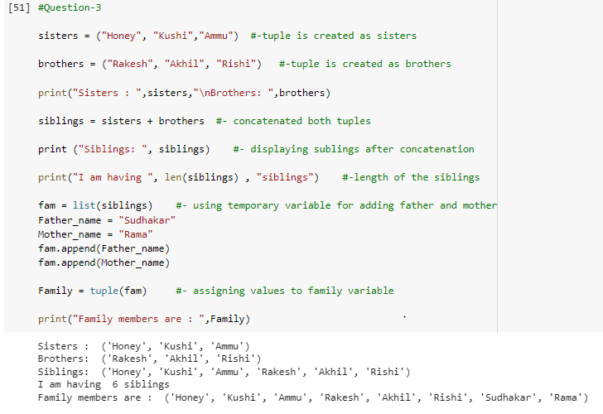

Explanation:

In the above solution, we have created 2 tuples with variable of sisters and brothers, and added values into it. Later we have combined both the tuples as siblings by using concatenation operator (+). Directly we cannot change the state of tuple so we have converted tuple into list and added father-name and mother_name to it. After completing changes to list , it has been converted list to tuples again and displayed all elements in the tuple which are present.

Question 4:

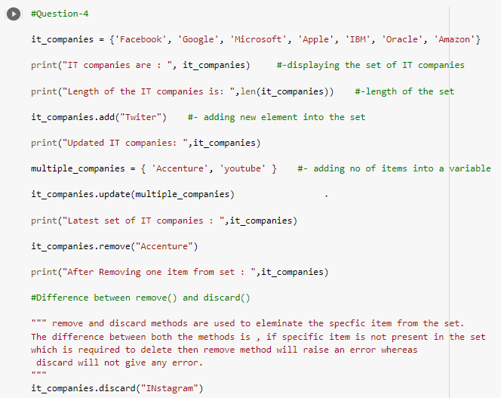

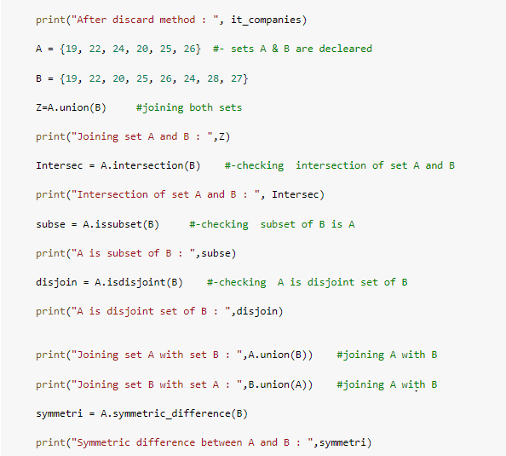

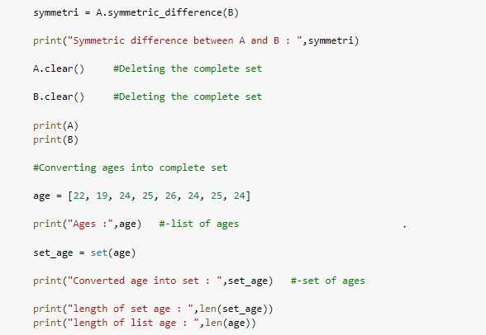

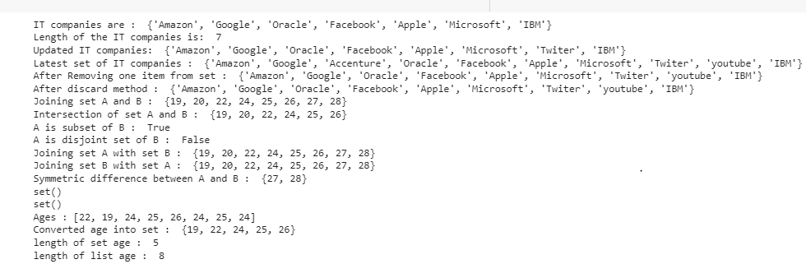

Explanation:

Firstly, we have take a set ( it_companies) and add the values into it and displayed by using print method. Length of the set is identified by using len(). With the help of add() we added an element into the set. To add the multiple elements at a time, we have created a new set called multiple_companies and updated the it_companies set by using update(). remove() is used to remove a value from the set. Remove and Discard methods are used to eleminate thespecific item from the set. The difference between both the methods is , if specific item is not presentin the set which is required to delete then remove method will raise an error whereas descard will not give any error.

Secondly, two sets are declared A and B , and added values into it. Now perform some operations to the sets:union() – used to join 2 sets by eleminating repeated values,intersection() – checks wheather set of elements present in both A and B, issubset() – checks all elements in one set present in another set or not, isdisjoint() – checks set does not have common values.

Thirdly , list of ages is converted into sets by using set(). Compared the length of list and set with the help len() method.

Question 5

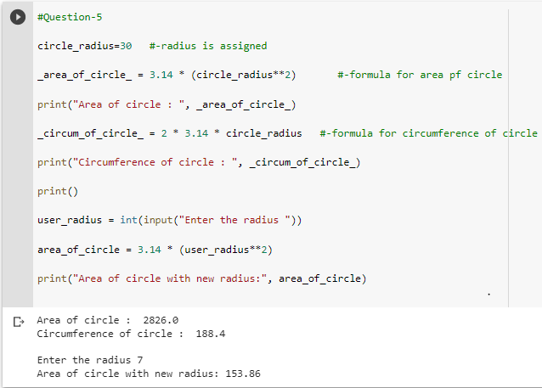

Explanation:

In this problem, radius of circle is given and calculated the area & circumference of circle by using following formulas:

_area_of_circle_ = 3.14 * (circle_radius**2)

_circum_of_circle_ = 2 * 3.14 * circle_radius

Later we have taken the radius from the user and calcualted area for it.

Question 6:

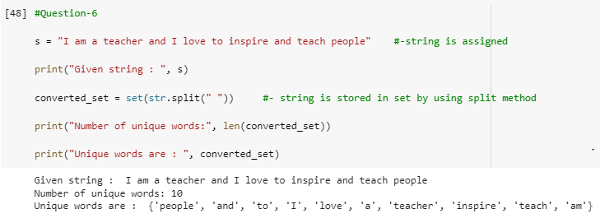

Explanation:

In the above code , given string is cconverted into set by using split() method and printed all the unique words from the given string. len() is used to find out the length of the set.

Question 7:

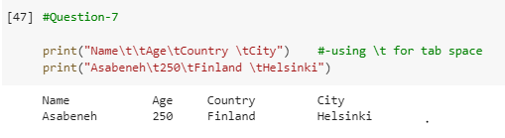

Explanation:

In the above code we have used the \t for tab space to get output in the required pattern

Question 8:

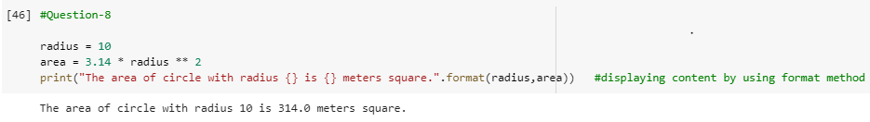

Explanation:

This problem can be done in couple of ways . But in the above code we have used sting format() method to get the output as required.

Question 9:

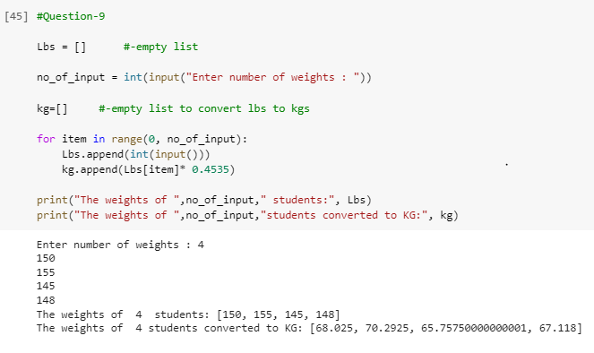

Explanation:

In the above solution, we have taken 2 empty lists Lbs and kg. Number of students which given by the user is assigned to no_of_input variable. We have used for loop to take weights from the user. Within the for loop, values given by the user is added into Lbs list by using append() method and simultaneously converting the given weights into kgs by performing some mathematical calculations and adding values into kg list. At last weight of students is printed in Lbs and kgs separately.

Mathematical calculation: kg.append(Lbs[item]* 0.4535)

Question 10

