AKS architecture

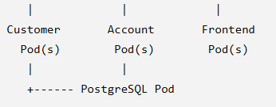
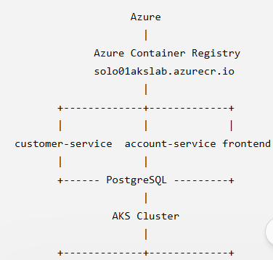

For Kubernetes, don't think of a container as the directly managed unit.
The relationship is:
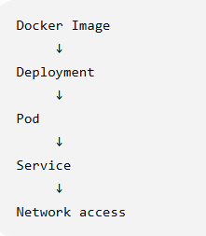

Step 1 — Login to Azure
Open Azure CLI / PowerShell / Cloud Shell.
az login
Then:
az account show

Expected output
You should see the subscription/account information.
Explain to participants:
az login authenticates us with Azure.
az account show confirms which Azure subscription we are currently working with
specific to subscription
az account set --subscription 8e9f59d1-c6fb-4065-a194-e0ecaf0d48f3
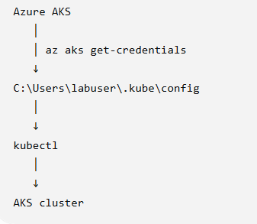
az aks get-credentials --resource-group solo01-rg --name aks-lab --overwrite-existing
--not needed everyday as it is used to is used to connect your local kubectl command to the AKS cluster. It retrieves the Kubernetes credentials for:

Resource group: solo01-rg
AKS cluster: aks-lab
and stores/updates them in:
C:\Users\labuser\.kube\config
The --overwrite-existing option means that if a context for aks-lab already exists, Azure CLI updates it rather than asking you to keep the old credentials.

- kubectl config current-context ---aks-lab
- kubectl get nodes
NAME STATUS ROLES AGE VERSION
aks-nodepool1-36525510-vmss000004 Ready <none> 32m v1.35.8
aks-nodepool1-36525510-vmss000005 Ready <none> 32m v1.35.8
aks-nodepool1-36525510-vmss000006 Ready <none> 32m v1.35.8
aks-nodepool1-36525510-vmss000007 Ready <none> 32m v1.35.8

Step 2 — Verify the ACR
Your registry name is:
Registry: solo01akslab.azurecr.io
Username: solo01akslab
Password: 7VMmR8K0ijnV3VnLw0WMVRgA3DTiI5rEYTFh13jO3X6F3bFJiNShJQQJ99CIACGhslBEqg7NAAACAZCRaAHC

solo01akslab
Registry login server:
solo01akslab.azurecr.io
Run:
az acr show --name solo01akslab --output table

Then:
docker login solo01akslab.azurecr.io
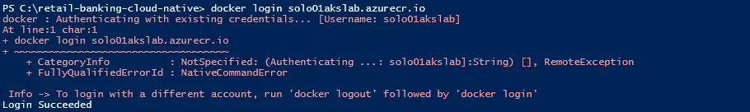
az acr login --name solo01akslab ---not needed as it is succeeded
Expected:
Login Succeeded

PUSH the images to ACR
- check the images locally

docker images

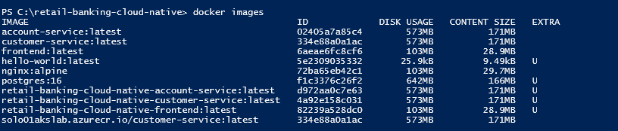
- Tag the images before pushing

dock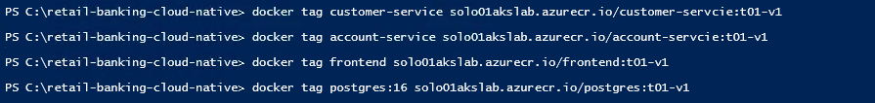

After tagging push it
- docker push solo01akslab.azurecr.io/customer-service:t01-v1
- docker push solo01akslab.azurecr.io/account-service:t01-v1
- docker push solo01akslab.azurecr.io/frontend:t01-v1
- docker push solo01akslab.azurecr.io/postgres:t01-v1

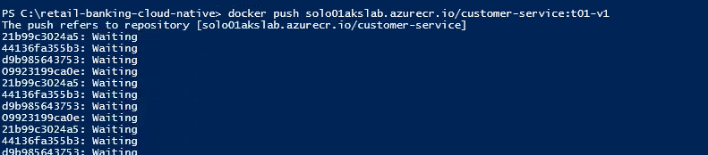

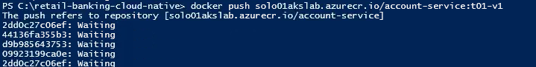

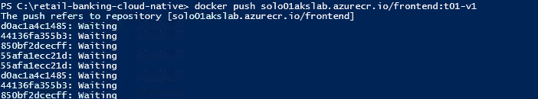

PART 2 — Check the Images
Before deploying to AKS, verify that the four images exist in ACR.

Run:
az acr repository list --name solo01akslab --output table
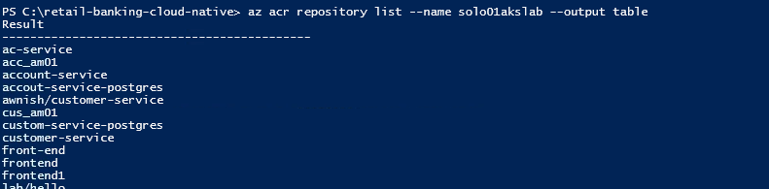

You should eventually see something similar to:
Result
------------------
account-service
customer-service
frontend
postgres
Then inspect each repository.
az acr repository show-tags --name solo01akslab --repository customer-service --output table
az acr repository show-tags --name solo01akslab --repository account-service --output table
az acr repository show-tags --name solo01akslab --repository frontend --output table
az acr repository show-tags --name solo01akslab --repository postgres --output table

push the image to ACR

Suppose you have:
customer-service:1.0
account-service:1.0
frontend:1.0
postgres:18
Then the complete image references are:
solo01akslab.azurecr.io/customer-service:1.0
solo01akslab.azurecr.io/account-service:1.0
solo01akslab.azurecr.io/frontend:1.0
solo01akslab.azurecr.io/postgres:18

Important
The image name in the Kubernetes YAML must exactly match the image stored in ACR.
For example:
image: solo01akslab.azurecr.io/customer-service:1.0
not:
image: customer-service

PART 3 — Connect AKS to ACR
This is a very important part of your Day 4 session.
The AKS cluster needs permission to pull container images from ACR.
Microsoft's recommended integration for a standard ACR/AKS setup is to attach the ACR to AKS, which grants the AKS kubelet identity the appropriate image-pull permission.
You need the following information from the IT team:
AKS Resource Group
AKS Cluster Name
For example, let's assume:
Resource Group = rg-aks-training
AKS Cluster = aks-training
Use the actual values supplied by your IT team.

Step 3 — Attach ACR

Check the AKS resource group and name
az aks list --output table

az aks update \
--resource-group rg-aks-training \
--name aks-training \
--attach-acr solo01akslab

az aks update --resource-group solo01-rg --name aks-lab --attach-acr solo01akslab ---- one time

What does this do?
It establishes:
AKS
|
| AcrPull permission
↓
ACR
So when Kubernetes says:
Pull this image:
solo01akslab.azurecr.io/customer-service:t01-v1
the AKS node is authorized to retrieve that image.
Microsoft documents az aks update --attach-acr specifically for attaching an existing ACR to an existing AKS cluster.

Step 4 — Verify ACR connectivity
Run:
az aks check-acr \
--resource-group solo01-rg \
--name aks-lab \
--acr solo01akslab.azurecr.io

Execute

Use a different temporary directory
In PowerShell, create a temp folder you can write to:

New-Item -ItemType Directory -Path C:\aztemp –Force
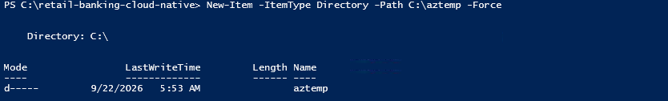
Then set the temporary environment variables:
$env:TEMP="C:\aztemp"
$env:TMP="C:\aztemp"
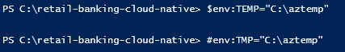
Verify
This is a useful validation before deployment because it checks connectivity/authentication between AKS and ACR.

PART 4 — Connect kubectl to AKS

Step 5 — Get AKS credentials
Run:
az aks get-credentials \
--resource-group rg-aks-training \
--name aks-training \
--overwrite-existing
Already executed
This configures your local kubectl to
communicate with the shared AKS cluster. Microsoft uses the same workflow in its AKS documentation.

Step 6 — Verify the connection
kubectl get nodes

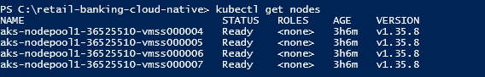
Expected example:
NAME STATUS ROLES AGE VERSION
aks-agentpool-xxxx-vmss000000 Ready <none> 2d v1.xx.x
aks-agentpool-xxxx-vmss000001 Ready <none> 2d v1.xx.x
Explain:
These are the worker nodes of our AKS cluster. Kubernetes schedules our application Pods on these nodes.
Then:
kubectl get namespaces

PART 5 — Create an Application Namespace
I recommend using a dedicated namespace for your training application.
Create:
kubectl create namespace retail-banking
Verify:
kubectl get namespaces
You should see:
retail-banking
Now your application resources will be isolated:
AKS Cluster
|
+-- retail-banking
|
+-- customer-service
+-- account-service
+-- frontend
+-- postgres

PART 6 — Create Kubernetes Deployment Files
I recommend you create a folder:
k8s
Inside:
k8s
├── namespace.yaml
├── postgres.yaml
├── customer-service.yaml
├── account-service.yaml
└── frontend.yaml
You can also combine these into one banking-app.yaml, which is easier for a session.
For your first AKS deployment, I recommend separate YAML files, because participants can understand each Kubernetes resource independently.

PART 7 — PostgreSQL Deployment
This is the first important dependency.
Your architecture is:
customer-service
|
↓
PostgreSQL

account-service
|
↓
PostgreSQL
Create:
postgres.yaml
Example:
apiVersion: v1
kind: Secret
metadata:
name: postgres-secret
namespace: retail-banking
type: Opaque
stringData:
POSTGRES_USER: postgres
POSTGRES_PASSWORD: "banking"
POSTGRES_DB: banking
---
apiVersion: v1
kind: PersistentVolumeClaim
metadata:
name: postgres-pvc
namespace: retail-banking
spec:
accessModes:
- ReadWriteOnce
storageClassName: managed-csi # Azure Disk storage
resources:
requests:
storage: 10Gi
---
apiVersion: apps/v1
kind: Deployment
metadata:
name: postgres
namespace: retail-banking
spec:
replicas: 1
selector:
matchLabels:
app: postgres
template:
metadata:
labels:
app: postgres
spec:
containers:
- name: postgres
image: solo01akslab.azurecr.io/postgres:t01-v1
ports:
- containerPort: 5432
env:
# Fixes the "directory is not empty" error on Azure Disk
- name: PGDATA
value: /var/lib/postgresql/data/pgdata
- name: POSTGRES_USER
valueFrom:
secretKeyRef:
name: postgres-secret
key: POSTGRES_USER
- name: POSTGRES_PASSWORD
valueFrom:
secretKeyRef:
name: postgres-secret
key: POSTGRES_PASSWORD
- name: POSTGRES_DB
valueFrom:
secretKeyRef:
name: postgres-secret
key: POSTGRES_DB
resources:
requests:
memory: "256Mi"
cpu: "250m"
limits:
memory: "1Gi"
cpu: "500m"
readinessProbe:
exec:
command: ["pg_isready", "-U", "postgres"]
initialDelaySeconds: 5
periodSeconds: 10
livenessProbe:
exec:
command: ["pg_isready", "-U", "postgres"]
initialDelaySeconds: 15
periodSeconds: 20
volumeMounts:
- name: postgres-storage
mountPath: /var/lib/postgresql/data
volumes:
- name: postgres-storage
persistentVolumeClaim:
claimName: postgres-pvc
---
apiVersion: v1
kind: Service
metadata:
name: postgres
namespace: retail-banking
spec:
selector:
app: postgres
ports:
- port: 5432
targetPort: 5432
type: ClusterIP

Important explanation
The Deployment creates the PostgreSQL Pod.
The Service gives the Pod a stable Kubernetes DNS name:
postgres
Therefore your application should not use:
localhost
inside AKS.
This is extremely important.

Why localhost is wrong inside Kubernetes
Suppose:
customer-service Pod
|
| localhost:5432
↓
localhost means:
this same Pod/container.
It does not mean PostgreSQL.
Instead:
customer-service
|
| postgres:5432
↓
postgres Service
|
↓
PostgreSQL Pod
So the database hostname becomes:
postgres
or:
postgres.retail-banking.svc.cluster.local
For training, use:
postgres
because Kubernetes DNS resolves the Service name within the namespace.

Step 8 — Deploy PostgreSQL
kubectl apply -f k8s/postgres.yml
Expected:
deployment.apps/postgres created
service/postgres created
Check:
kubectl get pods -n retail-banking
Eventually:
NAME READY STATUS RESTARTS AGE
postgres-xxxxxxxxxx-xxxxx 1/1 Running 0 30s
Check service:
kubectl get svc -n retail-banking
Expected:
NAME TYPE CLUSTER-IP PORT(S)
postgres ClusterIP 10.xxx.xxx.xxx 5432/TCP

PART 8 — Customer Service
Now deploy:
customer-service
Example:
apiVersion: apps/v1
kind: Deployment
metadata:
name: customer-service
namespace: retail-banking
spec:
replicas: 1
selector:
matchLabels:
app: customer-service
template:
metadata:
labels:
app: customer-service
spec:
containers:
- name: customer-service
image: solo01akslab.azurecr.io/customer-service:1.0
ports:
- containerPort: 8081
env:
- name: SPRING_DATASOURCE_URL
value: jdbc:postgresql://postgres:5432/banking
- name: SPRING_DATASOURCE_USERNAME
value: postgres
- name: SPRING_DATASOURCE_PASSWORD
value: postgres
---
apiVersion: v1
kind: Service
metadata:
name: customer-service
namespace: retail-banking
spec:
selector:
app: customer-service
ports:
- port: 8081
targetPort: 8081
type: ClusterIP
Important: adjust the environment-variable names to match your actual Spring Boot configuration if your application uses different property names.
Deploy:
kubectl apply -f k8s/customer-service.yaml
Expected:
deployment.apps/customer-service created
service/customer-service created
Check:
kubectl get pods -n retail-banking

PART 9 — Account Service
Your account service needs:
- PostgreSQL
- Customer service
So conceptually:
account-service
|
+--------> postgres:5432
|
+--------> customer-service:8081
Example:
apiVersion: apps/v1
kind: Deployment
metadata:
name: account-service
namespace: retail-banking
spec:
replicas: 1
selector:
matchLabels:
app: account-service
template:
metadata:
labels:
app: account-service
spec:
containers:
- name: account-service
image: solo01akslab.azurecr.io/account-service:1.0
ports:
- containerPort: 8082
env:
- name: SPRING_DATASOURCE_URL
value: jdbc:postgresql://postgres:5432/account_db
- name: SPRING_DATASOURCE_USERNAME
value: postgres
- name: SPRING_DATASOURCE_PASSWORD
value: postgres
- name: CUSTOMER_SERVICE_BASE_URL
value: http://customer-service:8081
---
apiVersion: v1
kind: Service
metadata:
name: account-service
namespace: retail-banking
spec:
selector:
app: account-service
ports:
- port: 8082
targetPort: 8082
type: ClusterIP
Deploy:
kubectl apply -f k8s/account-service.yaml
Then:
kubectl get pods -n retail-banking

PART 10 — Frontend
Now deploy the React frontend.
Suppose your frontend container listens on:
80
Create:
frontend.yaml
Example:
apiVersion: apps/v1
kind: Deployment
metadata:
name: frontend
namespace: retail-banking
spec:
replicas: 1
selector:
matchLabels:
app: frontend
template:
metadata:
labels:
app: frontend
spec:
containers:
- name: frontend
image: solo01akslab.azurecr.io/frontend:1.0
ports:
- containerPort: 80
---
apiVersion: v1
kind: Service
metadata:
name: frontend
namespace: retail-banking
spec:
selector:
app: frontend
ports:
- port: 80
targetPort: 80
type: LoadBalancer
Deploy:
kubectl apply -f k8s/frontend.yaml

PART 11 — Check the Entire Application
Now:
kubectl get all -n retail-banking
You should eventually see something similar to:
NAME READY STATUS RESTARTS
pod/postgres-xxxxxxxxxx 1/1 Running 0
pod/customer-service-xxxxxxxxxx 1/1 Running 0
pod/account-service-xxxxxxxxxx 1/1 Running 0
pod/frontend-xxxxxxxxxx 1/1 Running 0
Deployments:
deployment.apps/postgres
deployment.apps/customer-service
deployment.apps/account-service
deployment.apps/frontend
Services:
service/postgres
service/customer-service
service/account-service
service/frontend

PART 12 — Get the Frontend IP Address
Run:
kubectl get svc -n retail-banking
You may get:
NAME TYPE CLUSTER-IP EXTERNAL-IP PORT(S)
postgres ClusterIP 10.0.x.x <none> 5432/TCP
customer-service ClusterIP 10.0.x.x <none> 8081/TCP
account-service ClusterIP 10.0.x.x <none> 8082/TCP
frontend LoadBalancer 10.0.x.x 20.xxx.xxx.xxx 80:xxxxx/TCP
The important value is:
EXTERNAL-IP
For example:
20.xxx.xxx.xxx
Open:
http://20.xxx.xxx.xxx
The React application should load.

Very Important: Why only Frontend is LoadBalancer?
This is a good architectural point.
We don't normally expose everything publicly.

PostgreSQL
ClusterIP
because the database should be accessible internally.

Customer Service
ClusterIP
because it is an internal backend service.

Account Service
ClusterIP
because it is also an internal backend service.

Frontend
LoadBalancer
because users need access from outside the AKS cluster.
So:
Internet
|
↓
LoadBalancer
|
↓
Frontend
|
+---------+---------+
↓ ↓
customer-service account-service
| |
+--------+----------+
↓
postgres

PART 13 — Verify Individual Services

Customer service
kubectl get svc customer-service -n retail-banking

Account service
kubectl get svc account-service -n retail-banking

PostgreSQL
kubectl get svc postgres -n retail-banking

PART 14 — Check Logs
This is important to learn how to determine whether deployment succeeded.
First:
kubectl get pods -n retail-banking
Then:
kubectl logs deployment/customer-service -n retail-banking
Account:
kubectl logs deployment/account-service -n retail-banking
PostgreSQL:
kubectl logs deployment/postgres -n retail-banking
Frontend:
kubectl logs deployment/frontend -n retail-banking

PART 15 — Describe a Pod
If something isn't working:
kubectl describe pod <pod-name> -n retail-banking
For example:
kubectl describe pod customer-service-xxxxxxxxx -n retail-banking
This is particularly useful for:
ImagePullBackOff
ErrImagePull
CrashLoopBackOff
Pending
Microsoft specifically identifies incorrect image names, permissions and registry connectivity as common causes of ErrImagePull / ImagePullBackOff.

PART 16 — The Most Important Troubleshooting Commands
Give participants this table.
Problem | Command
See nodes | kubectl get nodes
See Pods | kubectl get pods -n retail-banking
See deployments | kubectl get deployments -n retail-banking
See services | kubectl get svc -n retail-banking
See everything | kubectl get all -n retail-banking
Pod details | kubectl describe pod <pod> -n retail-banking
Application logs | kubectl logs <pod> -n retail-banking
Deployment logs | kubectl logs deployment/customer-service -n retail-banking
Deployment status | kubectl rollout status deployment/customer-service -n retail-banking
Restart deployment | kubectl rollout restart deployment/customer-service -n retail-banking

PART 17 — Very Important Concept
Make this distinction very clear to participants:

ACR
ACR stores images.
ACR
|
+-- customer-service:1.0
+-- account-service:1.0
+-- frontend:1.0
+-- postgres:18

AKS
AKS runs containers.
AKS
|
+-- Deployment
|
+-- Pod
|
+-- Container

Kubernetes Service
Service provides stable networking.
Service
|
↓
Pod
So:
Docker
↓
Build Image
↓
ACR
↓
Kubernetes Deployment
↓
Pod
↓
Service
↓
Application

PART 18 — What Happens When You Push an Image?
This is the question you asked earlier and it is worth demonstrating.
Suppose:
docker push solo01akslab.azurecr.io/customer-service:1.0
The image goes into:
ACR
Nothing is automatically created in AKS.
You then execute:
kubectl apply -f customer-service.yaml
Kubernetes sees:
image: solo01akslab.azurecr.io/customer-service:1.0
and creates:
Deployment
↓
ReplicaSet
↓
Pod
↓
Container
The Pod then pulls:
solo01akslab.azurecr.io/customer-service:1.0
from ACR.
That distinction is fundamental to understanding AKS.

Recommended Day 4 Lab Sequence
For your actual training session, I would run it in this exact order:

Phase 1 — AKS orientation
1. What is AKS?
2. AKS architecture
3. Node
4. Pod
5. Deployment
6. Service
7. Namespace

Phase 2 — Connect
az login
az account show

az aks get-credentials ...
kubectl get nodes
kubectl get namespaces

Phase 3 — ACR integration
az acr login --name solo01akslab

az acr repository list \
--name solo01akslab \
--output table

az aks update \
--resource-group <RG> \
--name <AKS_NAME> \
--attach-acr solo01akslab

az aks check-acr \
--resource-group <RG> \
--name <AKS_NAME> \
--acr solo01akslab.azurecr.io

Phase 4 — Namespace
kubectl create namespace retail-banking

Phase 5 — PostgreSQL
kubectl apply -f postgres.yaml
kubectl get pods -n retail-banking

Phase 6 — Customer service
kubectl apply -f customer-service.yaml
kubectl get pods -n retail-banking

Phase 7 — Account service
kubectl apply -f account-service.yaml
kubectl get pods -n retail-banking

Phase 8 — Frontend
kubectl apply -f frontend.yaml
kubectl get pods -n retail-banking

Phase 9 — Verify
kubectl get all -n retail-banking

Phase 10 — Access
kubectl get svc -n retail-banking
Get the frontend EXTERNAL-IP and open it in the browser.

One thing I would change before you give this to participants
Because your actual application already has specific Spring Boot ports, PostgreSQL databases, frontend configuration, and service-to-service URLs, we should not blindly copy the example YAML above. The important values should be aligned with our actual application:
customer-service
port: 8081
database: banking

account-service
port: 8082
database: account_db
customer-service: http://customer-service:8081

frontend
container port: depends on Dockerfile
Also, for a training lab, I would initially use one PostgreSQL Pod with the required databases, rather than trying to make PostgreSQL highly available. Later, when teaching production considerations, you can explain StatefulSets, PersistentVolumes, Secrets, managed PostgreSQL, backups, etc.
If your four Dockerfiles / Docker Compose file are the versions you are using for this training, upload that file and I can make the exact four Kubernetes YAMLs matching your application, including the correct ports, environment variables, database names, frontend-to-backend URLs, and the exact kubectl apply sequence.
The Azure-specific AKS/ACR flow above follows Microsoft's current AKS guidance for obtaining cluster credentials, attaching an existing ACR, and validating ACR connectivity.

