PART 1

Lab 1 — Revisit the failed customer-service container
Start by asking participants:
Yesterday we successfully created the Docker image. Why did the container stop?
Show:
docker ps -a
Then:
docker logs customer-service
Expected important message:
Connection to localhost:5432 refused
Explain:

Before Docker
Spring Boot
|
↓
localhost:5432
|
↓
Windows PostgreSQL

Inside Docker
customer-service container
|
↓
localhost:5432
|
↓
customer-service container itself
Therefore:
localhost inside a container does not mean the Windows host.
This is the key problem we solve today.

PART 2 — Docker networking

Lab 2 — View existing Docker networks
docker network ls

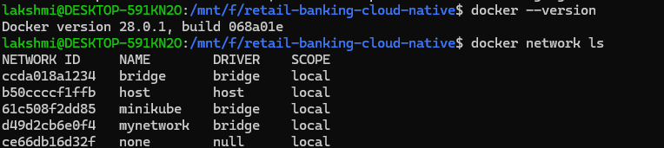
Expected output will contain networks similar to:
NETWORK ID NAME DRIVER SCOPE
xxxxxx bridge bridge local
xxxxxx host host local
xxxxxx none null local

- bridge — common Docker network.
- host — host networking mode on supported platforms.
- none — no network connectivity.
- We will create our own application network.

Lab 3 — Create banking network
Run:
docker network create banking-network

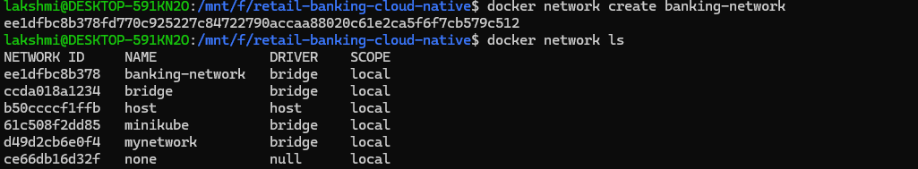
Expected:
<network-id>
Verify:
docker network ls
You should see:
banking-network
Inspect:
docker network inspect banking-network

Containers attached to the same Docker network can communicate using container/service names.

Lab 4 — Demonstrate container-name communication
Run a temporary Nginx container:
docker run -d --name test-nginx --network banking-network nginx:alpine
Check:
docker ps
Inspect the network:
docker network inspect banking-network
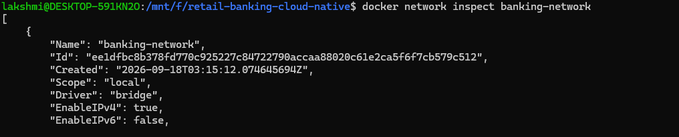
You should see test-nginx.
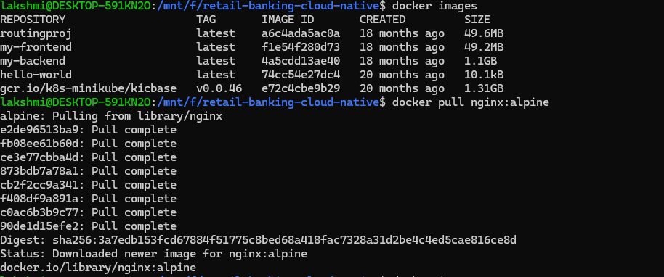
Remove it after the demonstration:
docker rm -f test-nginx

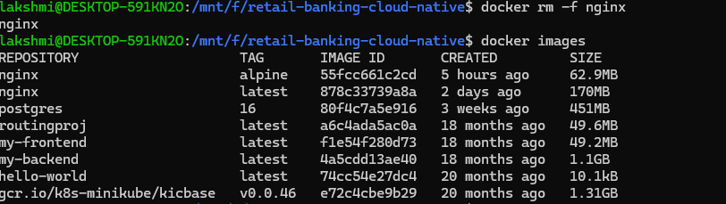

PART 3 — PostgreSQL container

Lab 5 — Pull PostgreSQL
docker pull postgres:16

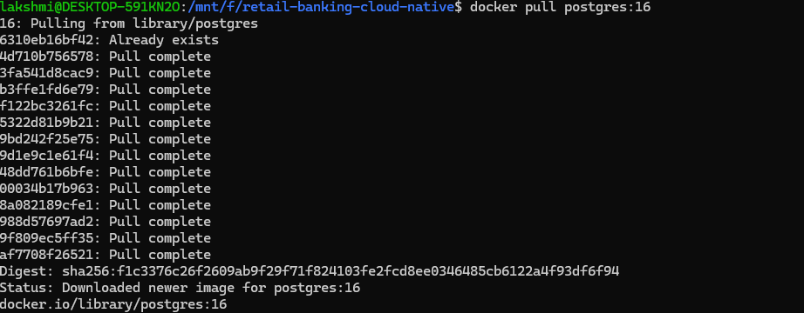
Verify:
docker images
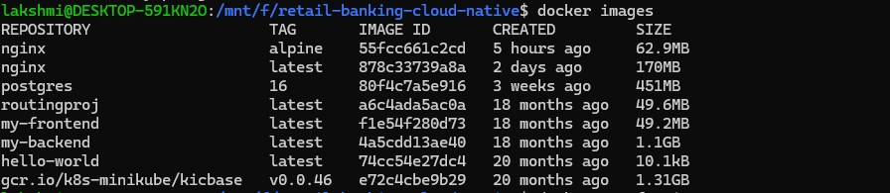

Lab 6 — Create PostgreSQL volume

A container is disposable. Database data should not depend on the lifetime of the container.
Create the volume:
docker volume create postgres-data

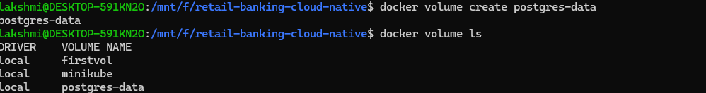
Verify:
docker volume ls
Inspect:
docker volume inspect postgres-data
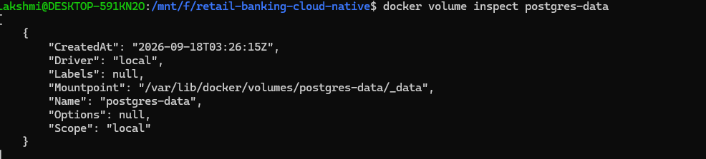

PostgreSQL container
|
↓
/var/lib/postgresql/data
|
↓
postgres-data volume

Lab 7 — Create PostgreSQL container
Before starting, explain that this database will be shared by the two backend services.
Run:
docker run -d ^
--name postgres ^
--network banking-network ^
-p 5432:5432 ^
-v postgres-data:/var/lib/postgresql/data ^
-e POSTGRES_DB=customer_db ^
-e POSTGRES_USER=banking ^
-e POSTGRES_PASSWORD=banking ^
postgres:18

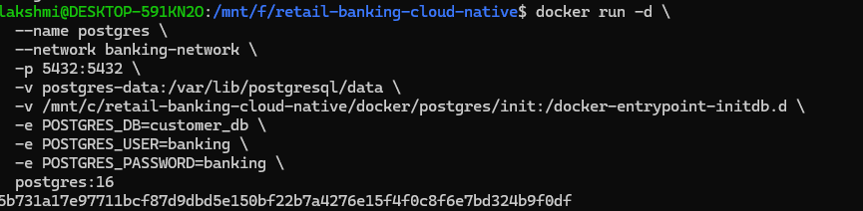

Verify:

docker ps

Expected:
postgres postgres:16 Up ...
Check logs:
docker logs postgres

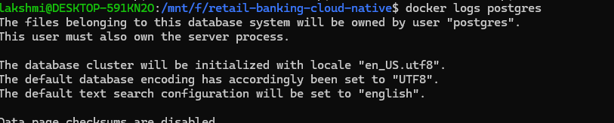
Look for:
database system is ready to accept connections

Lab 8 — Create account database
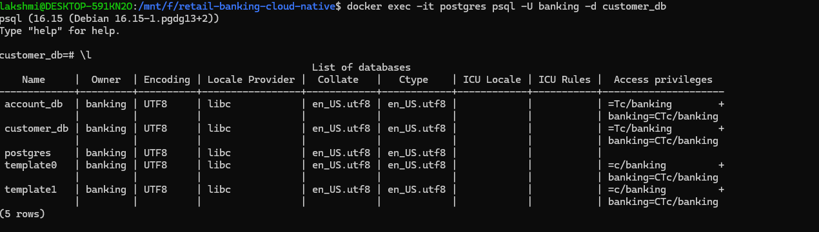

The PostgreSQL initialization above creates:
customer_db
We also need:
account_db
Enter PostgreSQL:
docker exec -it postgres psql -U banking -d customer_db
Create the second database:
CREATE DATABASE account_db;
Verify:
\l
You should see:
customer_db
account_db
Exit:
\q

Lab 9 — Configure PostgreSQL permissions –this is for manual
Included the script which runs automatically for the first time
Connect to customer DB:
docker exec -it postgres psql -U banking -d customer_db
Run:
GRANT ALL PRIVILEGES ON DATABASE customer_db TO banking;
GRANT ALL PRIVILEGES ON SCHEMA public TO banking;
GRANT ALL PRIVILEGES ON ALL TABLES IN SCHEMA public TO banking;
GRANT ALL PRIVILEGES ON ALL SEQUENCES IN SCHEMA public TO banking;

ALTER DEFAULT PRIVILEGES IN SCHEMA public
GRANT ALL PRIVILEGES ON TABLES TO banking;

ALTER DEFAULT PRIVILEGES IN SCHEMA public
GRANT ALL PRIVILEGES ON SEQUENCES TO banking;
Now switch:
\c account_db
Run:
GRANT ALL PRIVILEGES ON DATABASE account_db TO banking;
GRANT ALL PRIVILEGES ON SCHEMA public TO banking;
GRANT ALL PRIVILEGES ON ALL TABLES IN SCHEMA public TO banking;
GRANT ALL PRIVILEGES ON ALL SEQUENCES IN SCHEMA public TO banking;

ALTER DEFAULT PRIVILEGES IN SCHEMA public
GRANT ALL PRIVILEGES ON TABLES TO banking;

ALTER DEFAULT PRIVILEGES IN SCHEMA public
GRANT ALL PRIVILEGES ON SEQUENCES TO banking;
Verify:
SELECT has_schema_privilege('banking', 'public', 'USAGE'),
has_schema_privilege('banking', 'public', 'CREATE');
Expected:
t | t
Exit:
\q

Do manually create:
customer
account
transaction
tables.
Flyway will create the application tables.

PART 4 — Environment variables

Lab 10 — Explain externalized configuration
Current local configuration might be:
url: jdbc:postgresql://localhost:5432/customer_db
For Docker, this becomes:
jdbc:postgresql://postgres:5432/customer_db
Instead of hardcoding it, use:
spring:
datasource:
url: ${DB_URL:jdbc:postgresql://localhost:5432/customer_db}
username: ${DB_USERNAME:banking}
password: ${DB_PASSWORD:banking}
Explain the syntax:
${DB_URL:default-value}
Meaning:
Use DB_URL if supplied; otherwise use the default value.
This lets the same application work in:
Local
Docker
Azure
ARO
without changing Java code.

PART 5 — Customer-service

Lab 11 — Verify customer-service configuration
File:
backend\customer-service\src\main\resources\application.yml
Use:
server:
port: 8081

spring:
application:
name: customer-service

datasource:
url: ${DB_URL:jdbc:postgresql://localhost:5432/customer_db}
username: ${DB_USERNAME:banking}
password: ${DB_PASSWORD:banking}

jpa:
hibernate:
ddl-auto: validate
show-sql: true

flyway:
enabled: true

management:
endpoints:
web:
exposure:
include: health,info,metrics,prometheus
Important:
ddl-auto: validate
means Hibernate should validate the schema rather than create it.
Flyway handles database schema creation.

Lab 12 — Build customer-service
cd C:\retail-banking-cloud-native\backend\customer-service
Run:
mvn clean package
Verify:
dir target
You should see the generated JAR.

Lab 13 — Build Docker image
docker build -t customer-service:1.0 .

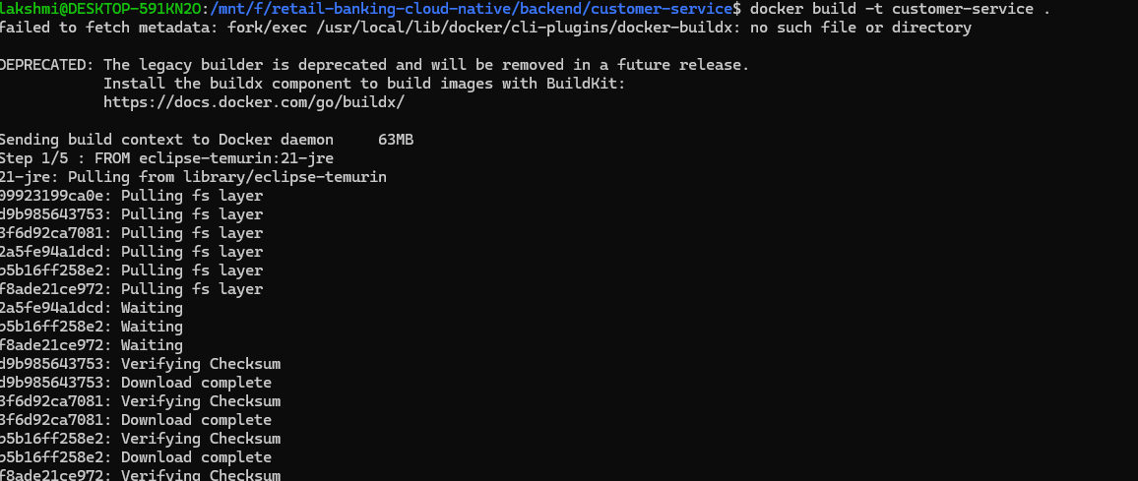
Verify:
docker images
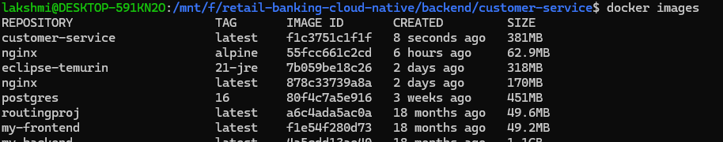
Expected:
customer-service 1.0

Lab 14 — Run customer-service on Docker network for linux syntax
docker run -d ^
--name customer-service ^
--network banking-network ^
-p 8081:8081 ^
-e DB_URL=jdbc:postgresql://postgres:5432/customer_db ^
-e DB_USERNAME=banking ^
-e DB_PASSWORD=banking ^
customer-service:1.0
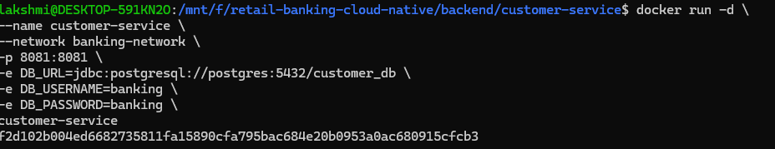

Check:
docker ps
Logs:
docker logs customer-service

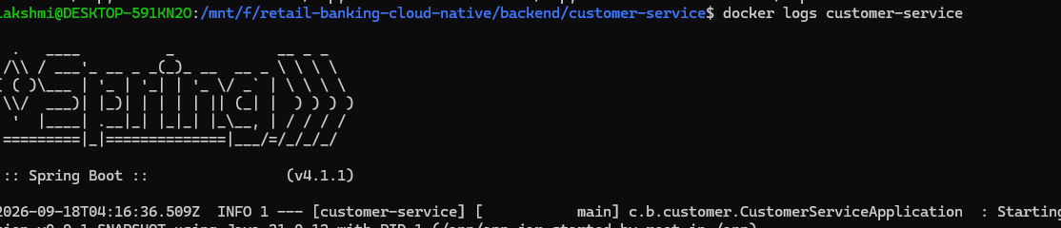
Follow logs if required:
docker logs -f customer-service
Stop following with:
Ctrl+C

Lab 15 — Test customer-service
From the Windows host:
curl http://localhost:8081/actuator/health
Expected:
{"status":"UP"}
The exact response may contain additional fields depending on the Spring Boot configuration.

PART 6 — Account-service

Lab 16 — Configure account-service

Dockerfile should be created

Use:
server:
port: 8082

spring:
application:
name: account-service

datasource:
url: ${DB_URL:jdbc:postgresql://localhost:5432/account_db}
username: ${DB_USERNAME:banking}
password: ${DB_PASSWORD:banking}

jpa:
hibernate:
ddl-auto: validate
show-sql: true

flyway:
enabled: true

customer-service:
base-url: ${CUSTOMER_SERVICE_URL:http://localhost:8081}

management:
endpoints:
web:
exposure:
include: health,info,metrics,prometheus

Lab 17 — Build account-service
cd C:\retail-banking-cloud-native\backend\account-service
Run:
mvn clean package
Build:
docker build -t account-service:1.0 .

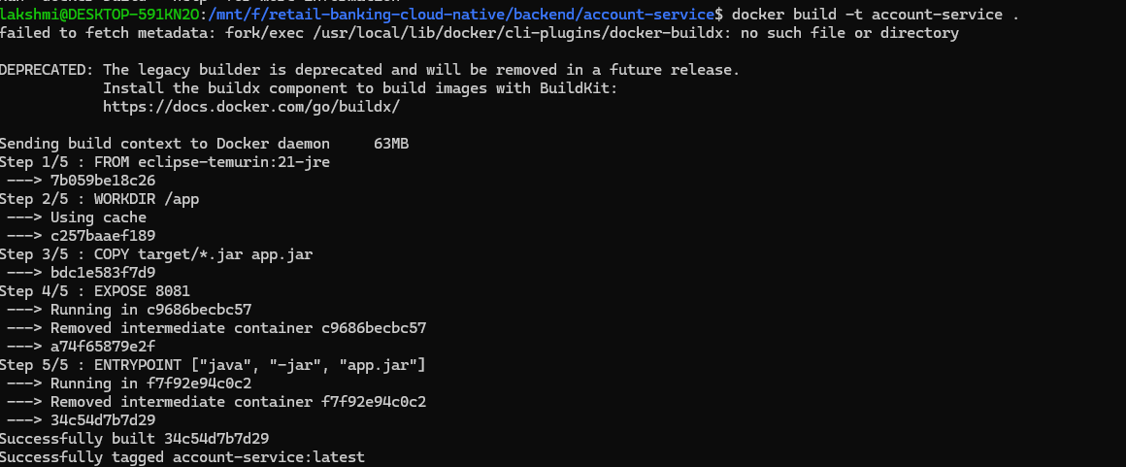
Verify:
docker images

Lab 18 — Run account-service

Linux syntax
docker run -d ^
--name account-service ^
--network banking-network ^
-p 8082:8082 ^
-e DB_URL=jdbc:postgresql://postgres:5432/account_db ^
-e DB_USERNAME=banking ^
-e DB_PASSWORD=banking ^
-e CUSTOMER_SERVICE_URL=http://customer-service:8081 ^
account-service:1.0

windows syntax
docker run -d \
--name account-service \
--network banking-network \
-p 8082:8082 \
-e DB_URL=jdbc:postgresql://postgres:5432/account_db \
-e DB_USERNAME=banking \
-e DB_PASSWORD=banking \
-e CUSTOMER_SERVICE_URL=http://customer-service:8081 \
account-service
Check:
docker ps

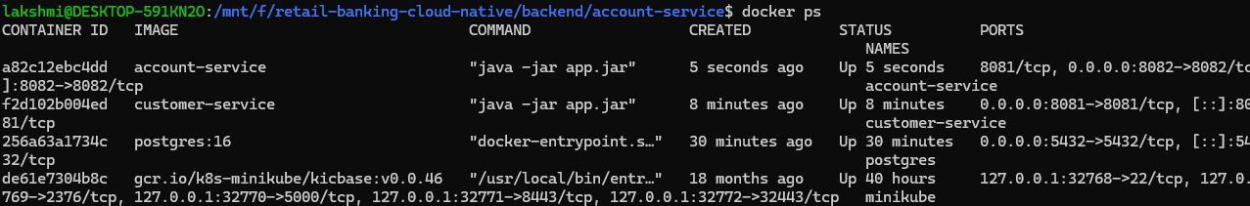
Logs:
docker logs account-service

Lab 19 — understand backend-to-backend communication
This is very important.
Account-service must not use:
http://localhost:8081
inside its container.
It uses:
http://customer-service:8081
because:
account-service
|
| Docker network
↓
customer-service
Docker resolves:
customer-service
to the appropriate container IP.

PART 7 — Health checks

Lab 20 — Understand health checks

A container being "running" does not necessarily mean that the application inside it is ready.
For example:
Container = running
Application = starting
Database = unavailable
Therefore we introduce health checks.
For PostgreSQL:
healthcheck:
test: ["CMD-SHELL", "pg_isready -U banking -d customer_db"]
interval: 10s
timeout: 5s
retries: 5
Explain:
- test — command used to check health.
- interval — how frequently to check.
- timeout — maximum time for a check.
- retries — number of failures before unhealthy status.

PART 8 — Production frontend
This is the major frontend change for Day 3.

Lab 21 — Demonstrate Vite development mode
Go to:
cd C:\retail-banking-cloud-native\frontend
Install dependencies:
npm install
Run:
npm run dev
Usually Vite displays:
Local: http://localhost:5173/
Open:
http://localhost:5173
Explain:
This is the development server. We are not going to package this development server into our production container.
Stop it:
Ctrl+C

Lab 22 — Create production build
Run:
npm run build
Expected:
dist/
Verify:
dir dist
Explain:
React source
↓
Vite
↓
Optimized static assets
↓
dist/

Lab 23 — Create frontend Dockerfile
Create:
C:\retail-banking-cloud-native\frontend\Dockerfile
Use:
FROM node:20-alpine AS build

WORKDIR /app

COPY package*.json ./

RUN npm ci

COPY . .

RUN npm run build

FROM nginx:alpine

COPY --from=build /app/dist /usr/share/nginx/html

EXPOSE 80

CMD ["nginx", "-g", "daemon off;"]

Explain the two stages
Stage 1
Node.js
↓
npm ci
↓
npm run build
↓
dist/

Stage 2
Nginx
↓
copy dist/
↓
serve application
The final image does not need Node.js to serve the React application.

Lab 24 — Add Nginx SPA configuration
If the React application uses client-side routes, configure Nginx to redirect unknown paths to index.html.
Create:
frontend\nginx.conf
Use:
server {
listen 80;

server_name retailbank.local;

root /usr/share/nginx/html;
index index.html;

location / {
try_files $uri $uri/ /index.html;
}
}
Then modify the final Nginx stage:
FROM nginx:alpine

COPY --from=build /app/dist /usr/share/nginx/html
COPY nginx.conf /etc/nginx/conf.d/default.conf

EXPOSE 80

CMD ["nginx", "-g", "daemon off;"]
This is useful for React routes such as:
/customers
/accounts
/transactions

Lab 25 — Build frontend image Before executing this Dockerfile and nginx.conf should be ready
From:
cd C:\retail-banking-cloud-native\frontend
Run:
docker build -t banking-frontend:1.0 .

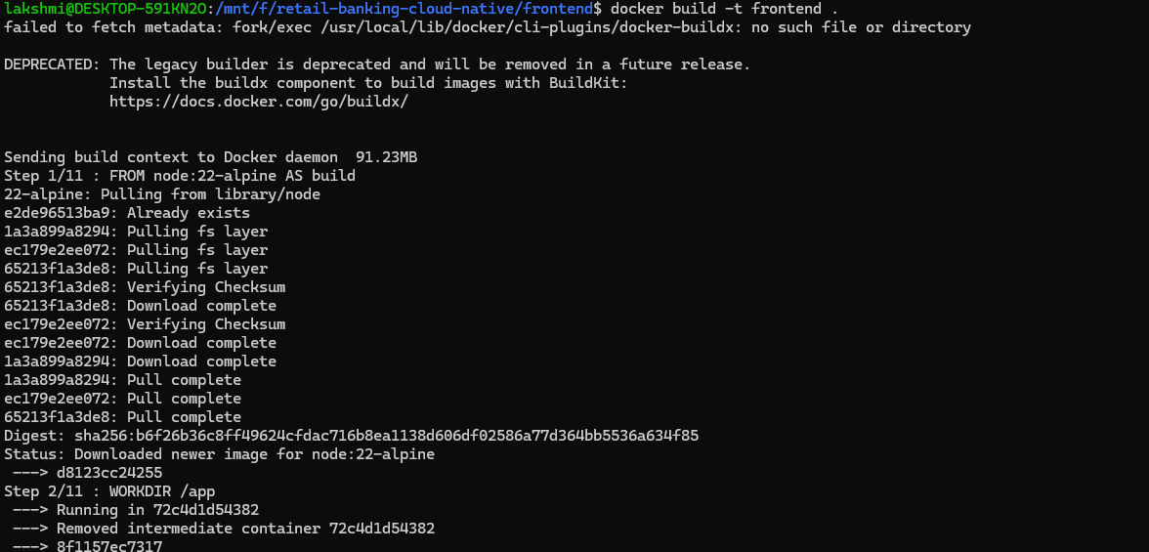
Verify:
docker images

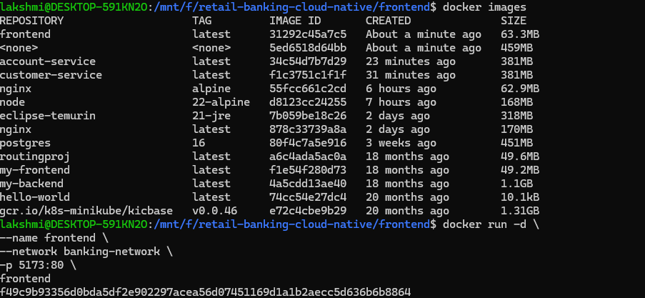

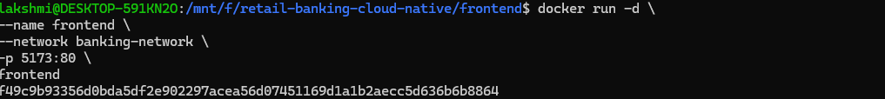

lakshmi@DESKTOP-591KN2O:/mnt/f/retail-banking-cloud-native/frontend$ docker run -d \
--name frontend \
--network banking-network \
-p 5173:80 \
frontend
f49c9b93356d0bda5df2e902297acea56d07451169d1a1b2aecc5d636b6b8864

