**Vendor Simulate Issue**

**Steps to Replicate the issue**

* **/IRM/EPLILM**
* **Put in Extend as Vendor List Type Z6EX**

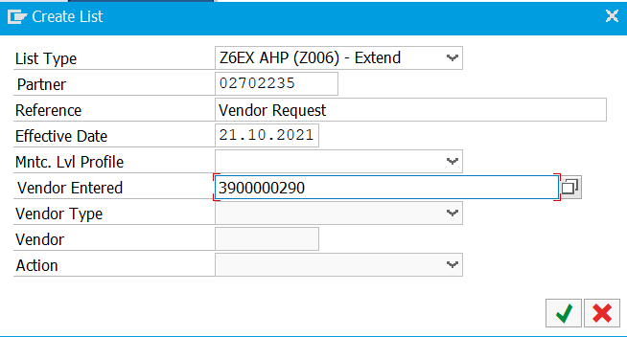

* 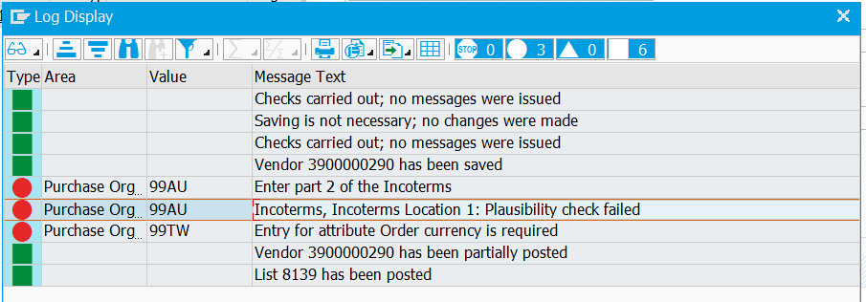

While posting system gives above error, It should give similar error on Simulation as well.

***Postings give error while simulate doesn’t***

**Vendor to be extended**

3900000290

**Vendor List Created**

8137 / 8138 / 8139

**After posting**

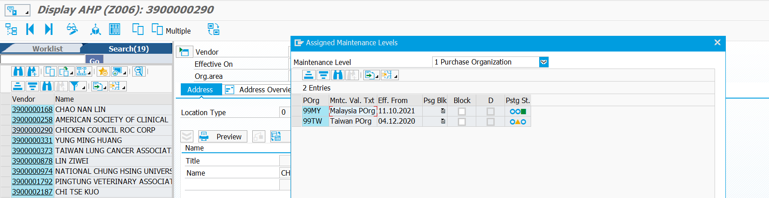

Newly extended Purchasing Org is added and activated and older purchasing org becomes partially posted, throwing DMR / S4 out of Sync.

**Function Module**

/IRM/EPLI_MAINTAIN

**BADI Implementation**

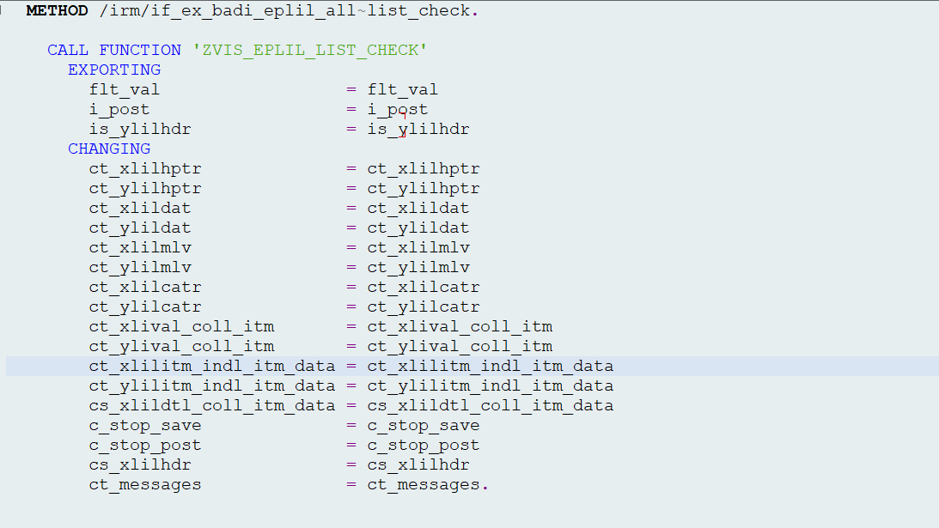

ABAP Stack for Validation

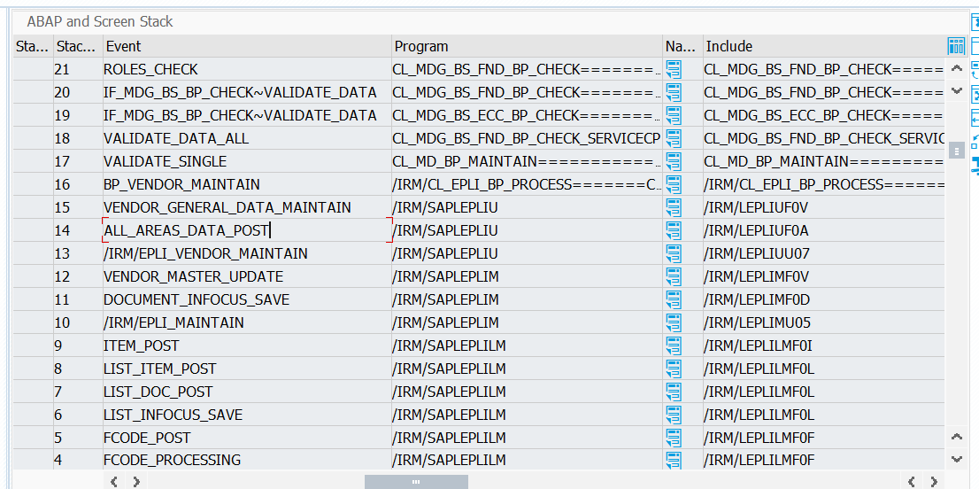

CL_MD_BP_MAINTAIN

Errors that I got

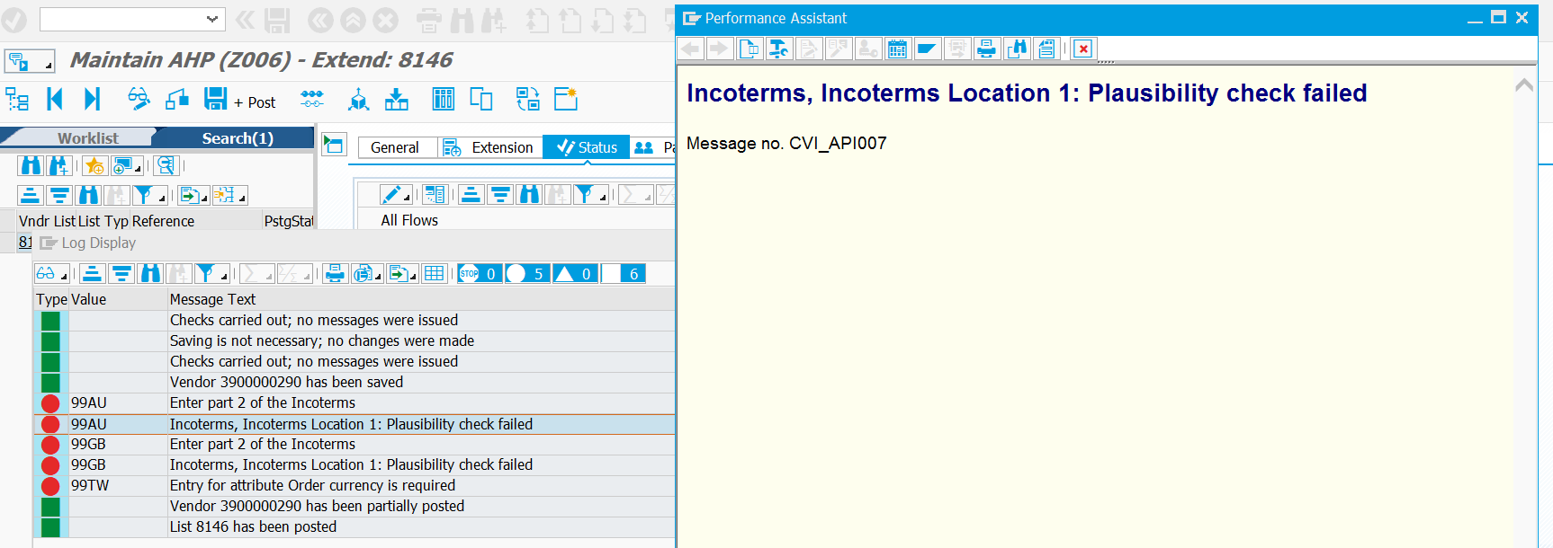

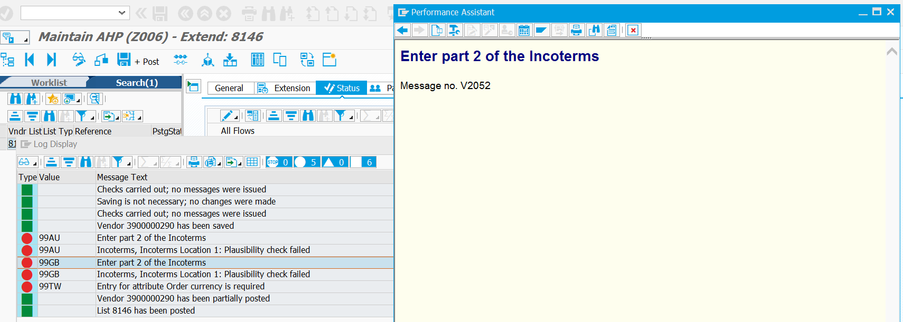

Also DMR Errors

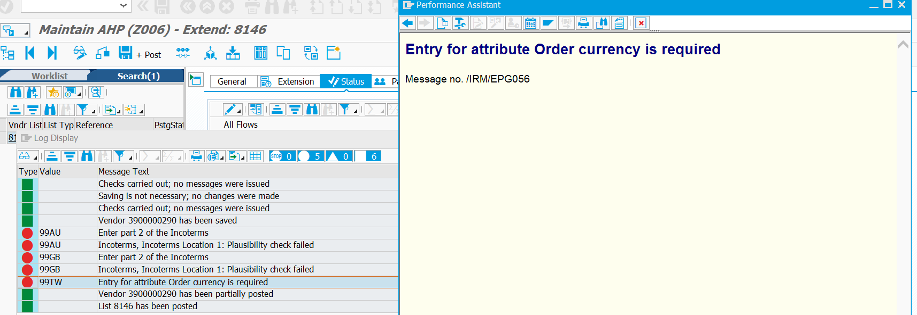

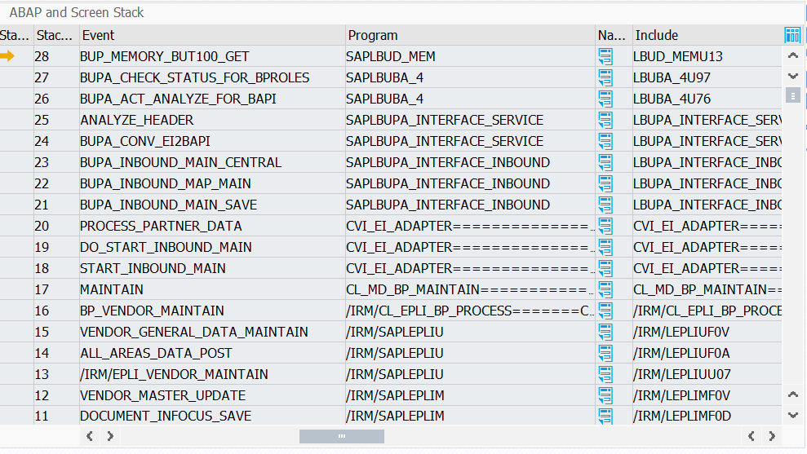

/IRM/CL_EPLI_BP_PROCESS

In EPLI_CHECK Function Module, we have gs_lidoc_infocus and gs_licatrdoc_infocus which forms the input to method BP_VENDOR_MAINTAIN

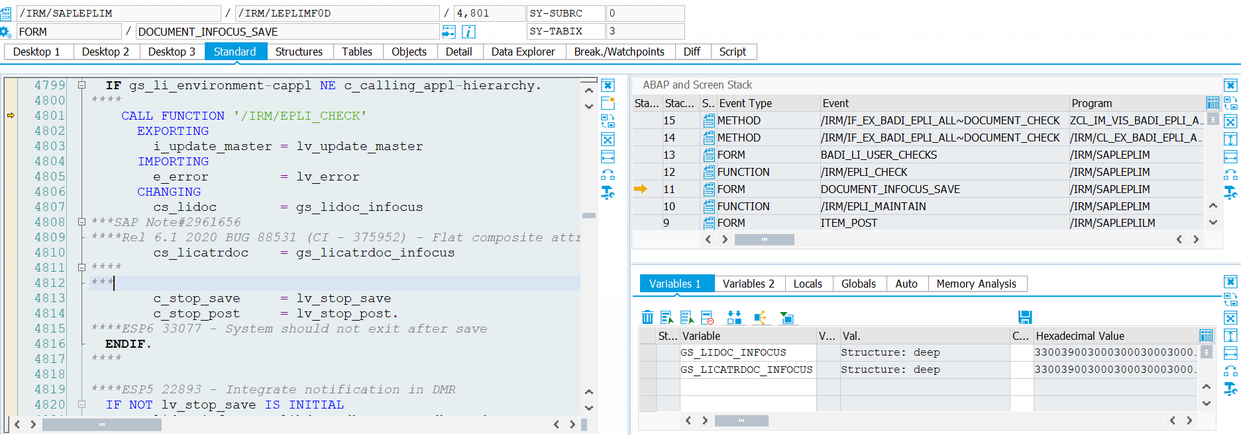

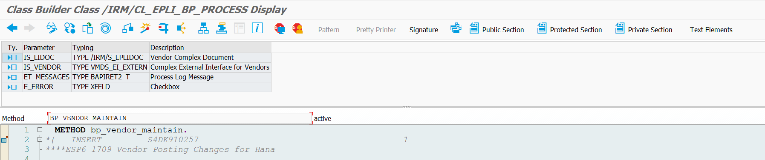

* Get these 2 variables and use them in document check

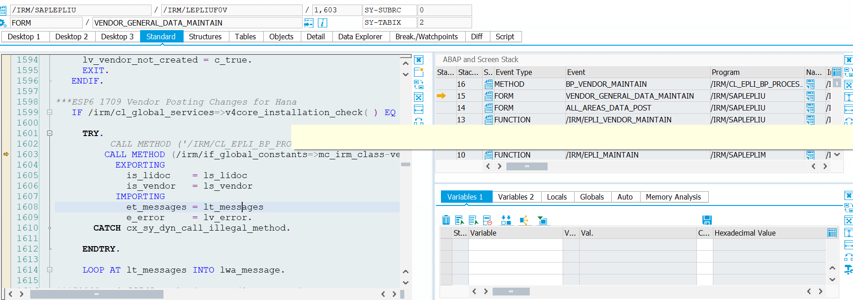

Can we play with iv_test_run_mode to get only validations done

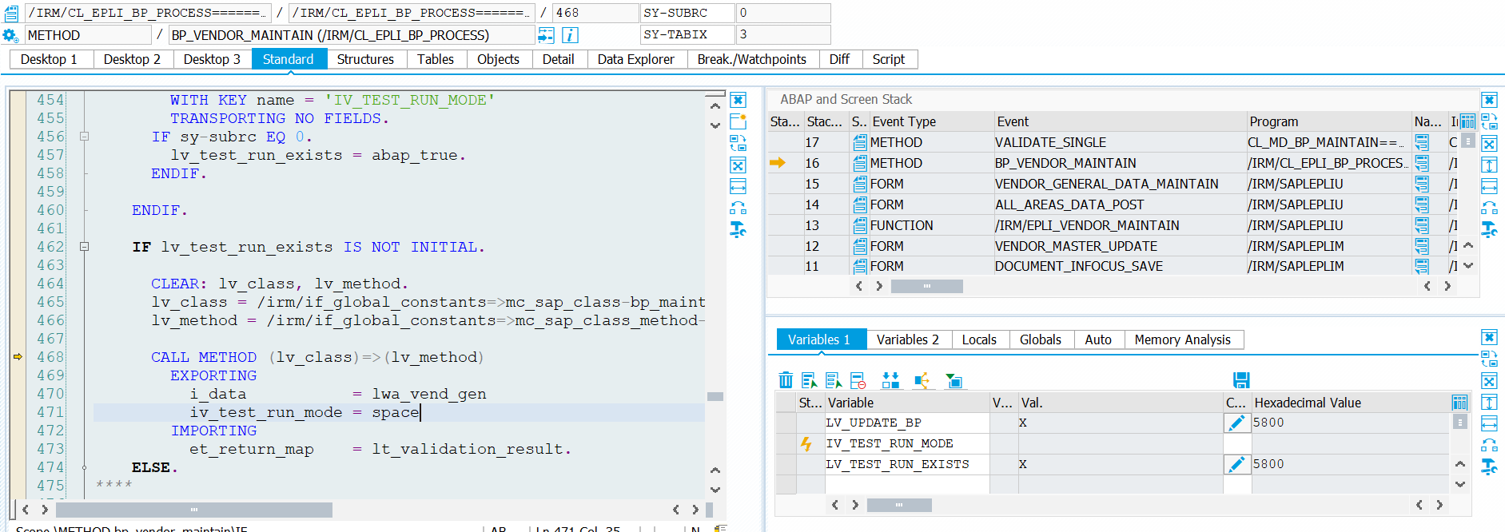

After Vendor General Data Maintain, There’s one more cycle for Purchase org data maintain

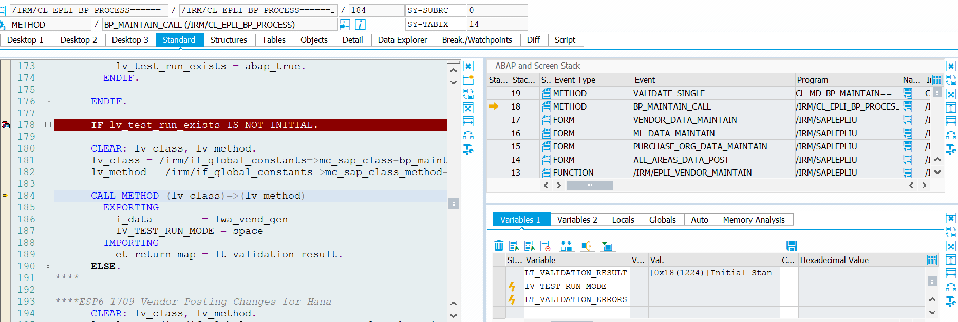

BP_MAINTAIN_CALL

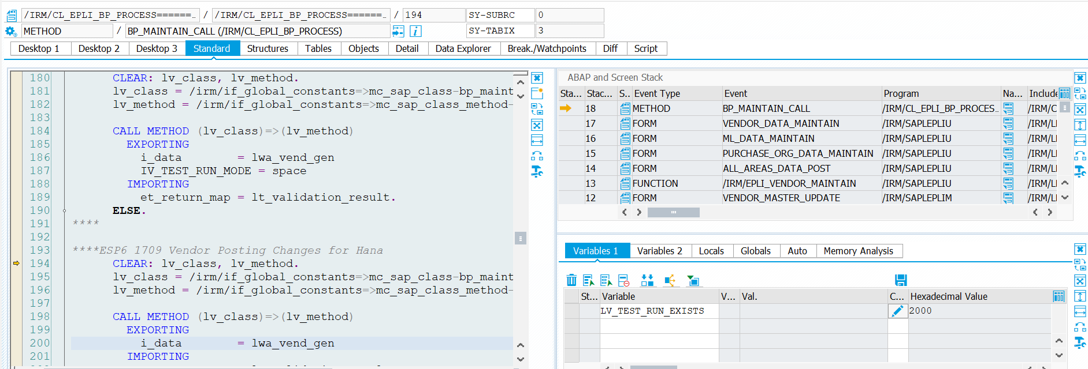

Commit testing

/IRM/LEPLIUF0V

