**Assignment**

1. Connect your previous node assignment to this assignment. Create a login page. Use usernames and passwords created in last assignment to login successfully. You don’t have to create new user and password(sign up page). You can manually enter the data in backend and verify that with frontend(i.e., Just create login page). Follow REST API folder hierarchy (Server.js should be entry, router.js, controller.js, service.js, model.js). Refer the folder structure in attached images.
2. 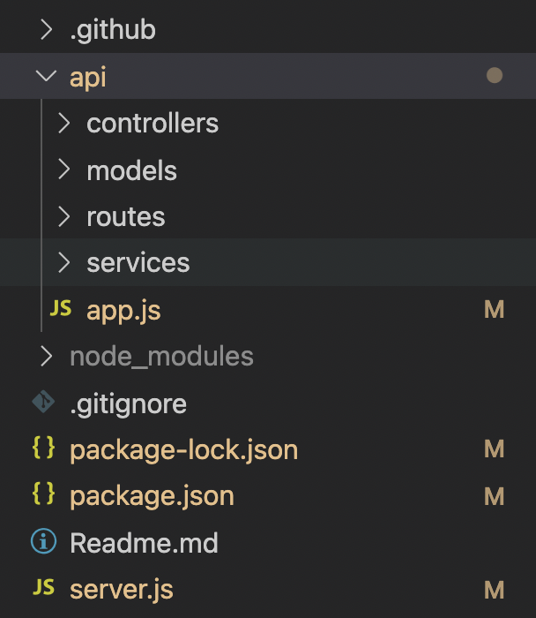Graphical user interface, text

   Description automatically generated

Create 4 pages using react components and react-router (Home, About-us, Jobs, Contact) as shown in the lab. Make sure to follow separate folder structure for every component.

1. Add a card component on each page giving detail about each page. (Similar to the"complex_component_single.htm" example shown in the class and in folder react scripts uploaded in files). Use react map() to create dynamic component at least on one of the page.
2. Feel free to use CSS and some additional text to make pages pretty.
3. Upload the assignment on git. Add Readme and gitignore(add node modules in gitignore) and explain the assignment in readme properly. If readme and gitignore is missing points will be deducted.