Database Assignment Solution – 2

Problem 1:

Answer (a) :

Data is loaded into the database using bulk insert as provided in the files:

Cake Table:
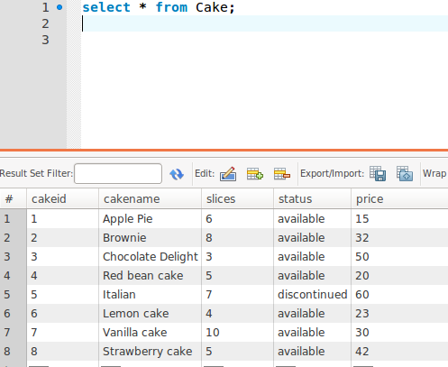

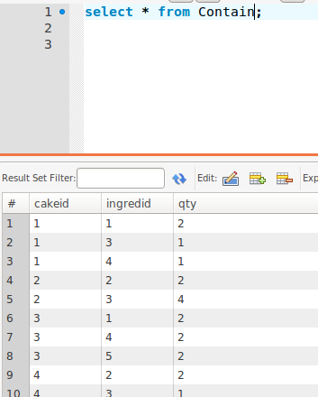
Contain Table:

Customer Table:

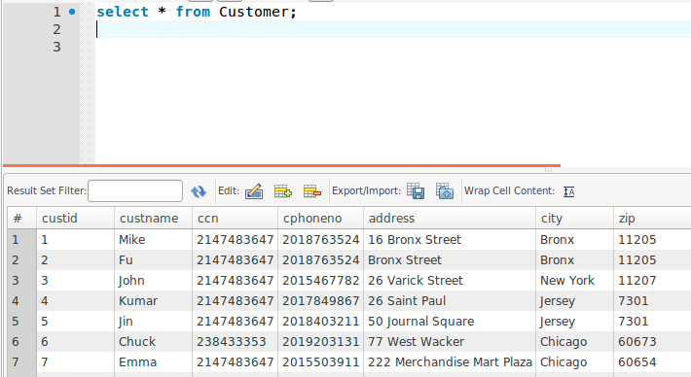
Ingredient Table:

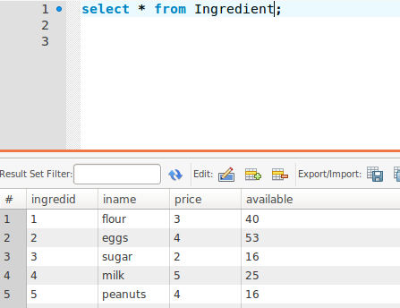

Order Table:

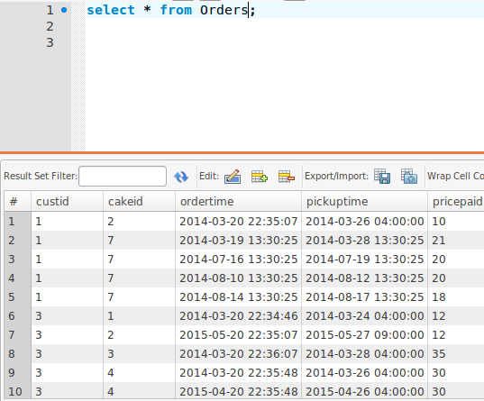
As you can see all the data are loaded into the table.

Answer(b):
(I) -
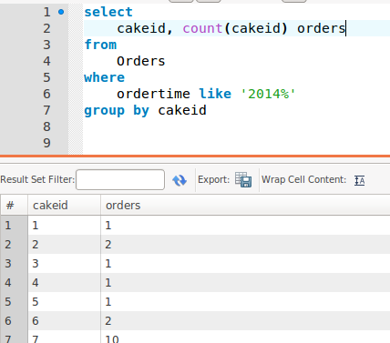

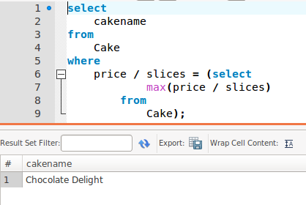
(ii) -

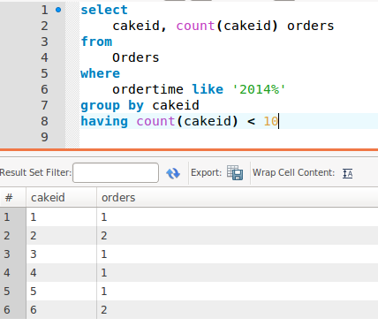
(iii) -

(iv) -
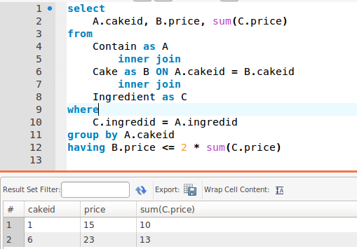
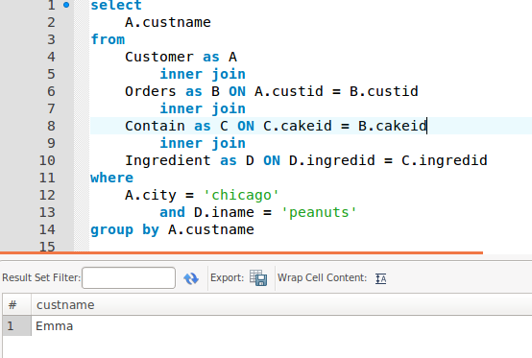
(v) -

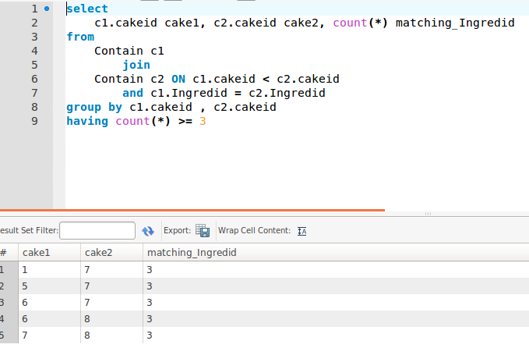
(vi) -

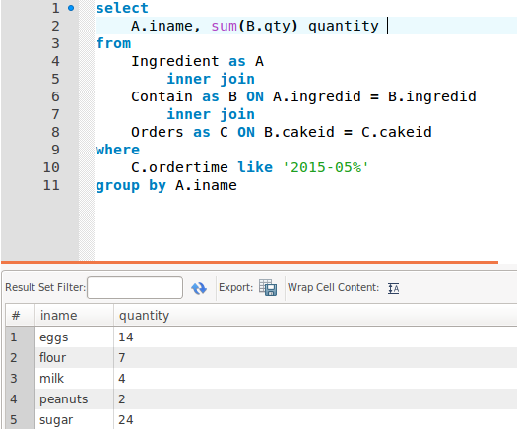
(vii) -

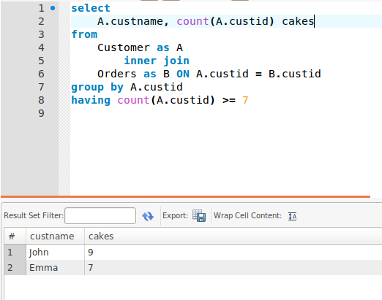
(viii) -

Answer (d) :

(1) :
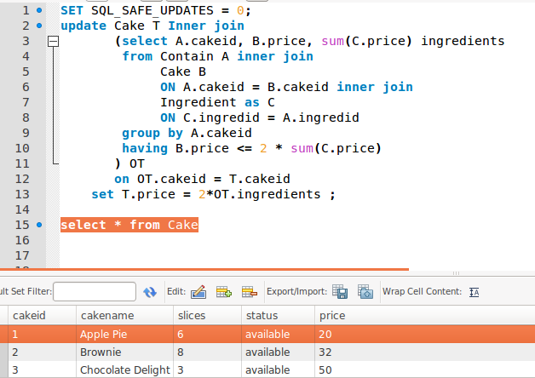
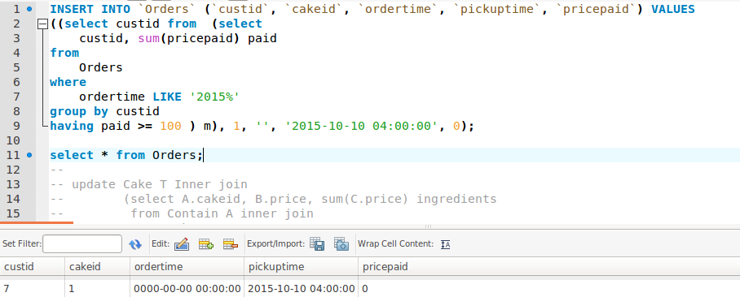
(2) :

(3) :

Problems 2:

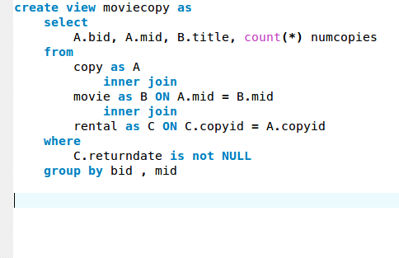
(a) -

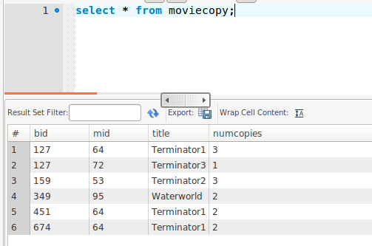

(a) (I) there is no godfather copies are present here

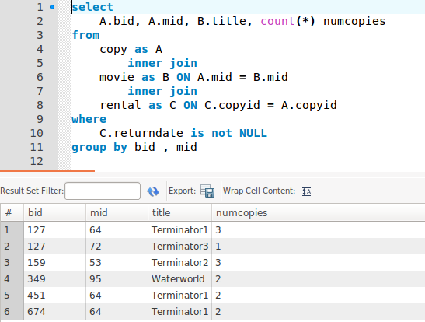
2(a)(ii)

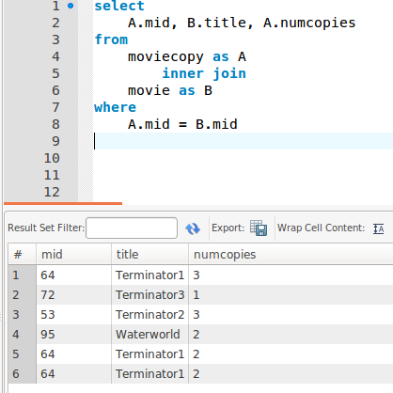

2(b)

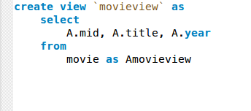

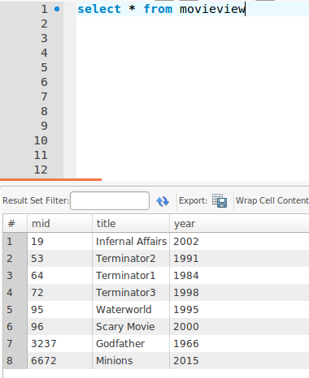

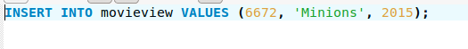
2(b)(i) -

You can see the view already added

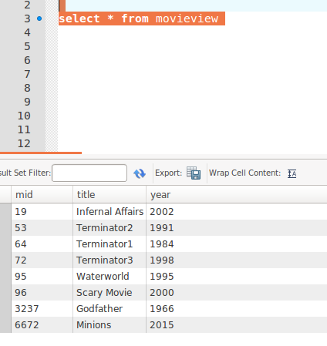

2(c)(i) - You can imagine view as kind of logical view of your physical data. You can do any manipulation on the view but if you add some data on view, then it will directly go and save in your base table. View is actually refering to the base table, so any modification you do to the view table. it will be reflected to the base table

But you cannot delete rows from view since the view will actually refer to the base table, and deleting is not allowed.

2(d)(i) -
