Curriculum Vitae

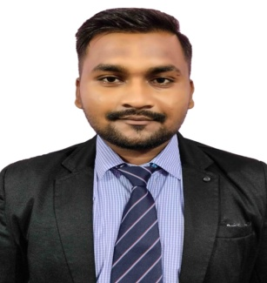**Name**: **Pradeep Kumar Mohapatra**

AT/PO - Jamapara

DIST - Kendrapara

PS - Patkura

BLOCK - Marshaghai

Pin - 754244

Mob No -6371761175

E-Mail ID: pmohapatra2021@gift.edu.in ,

Pradeepkumarmohapatra59@gmail.com

**CAREER OBJECTIVE**

To secure a challenging position in a reputable organization where I can learn new skills, expand my knowledge & build my career.

**EDUCATION QUALIFICATION**

* Pursuing M.B.A **(HR & MARKETING**) in GANDHIINSTITUTEFORTECHNOLOGY**,** **BHUBANESWAR** which is affiliated to Biju Patnaik University of Technology (BPUT).
* Completed Graduation with BCA (BCA honors) From SALIPUR AUTO COLLEGE, CUTTACKin the academic year **2020** with 6.60 CGPA.
* Completed intermediate SALIPUR (AUTO) COLLEGE, CUTTACKin the academic year **2017** with 54.16 % secured.
* Completed Matriculation from PANCHYATA NAGAMANI HIGH SCHOOL, HARIDASPUR, KENDRAPADA, ODISHA in the academic year **2015** with 51.33%.

**TECHNICAL SKILL**

* MSWord
* MS PowerPoint
* MS Excel

**ACHIEVEMENTS**

* Got 1st prize in Block Level Debate competition.
* In my schooling I also got a 3rd prize in science exhibition .

**STRENGTHS**

* Self Motivated
* Time management
* Communication
* Creativity
* Problem Solving
* Flexibility

**HOBBIES**

* Travelling
* cooking
* Gardening
* Listening music

**PERSONAL DETAILS**

**Father’s Name :** **Mr**. **Bibhutibhusan Mohapatra**

**Mother’s Name : Mrs. Renubala Mohapatra**

**Nationality : Indian**

**Marital Status : Unmarried**

**DOB : 2/03/2000**

**Gender : Male**

**Languages Known : Odia, Hindi, English**

**Date: 18.07.2022 Pradeep kumar mohapatra**

**Place: -** Bhubaneswar **Signature**