I added knowledge base content — including webpages like https://www.callhippo.com and some PDF documents — but after integrating and testing the call, it didn’t provide any information from the knowledge base
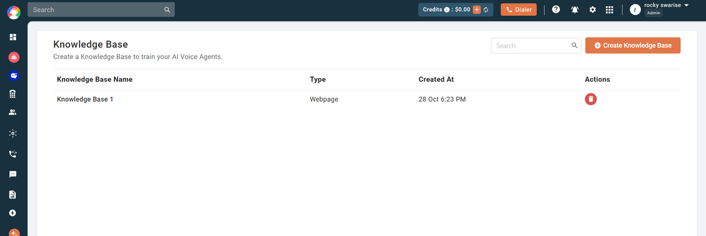
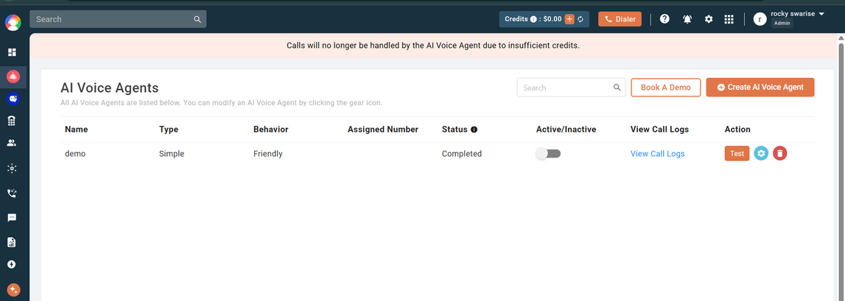
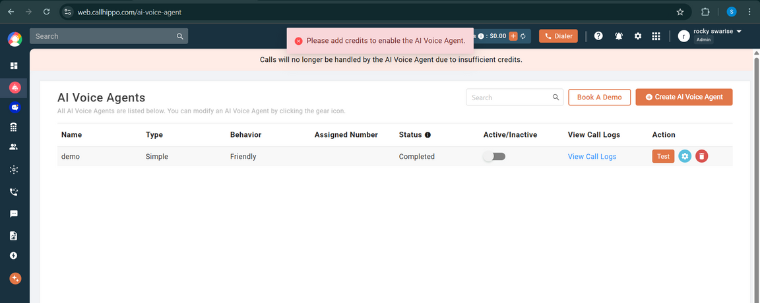
On the last screenshot, when I click Activate, it shows the message: ‘Please add credits to enable the AI Voice Agent.’
The AI/IVR calling feature has not been upgraded yet. When I try to click the IVR option, it displays ‘Upgrade the plan’.
This option is located under Numbers → Actions (Edit Number) → ivrWelcomeMessage.”
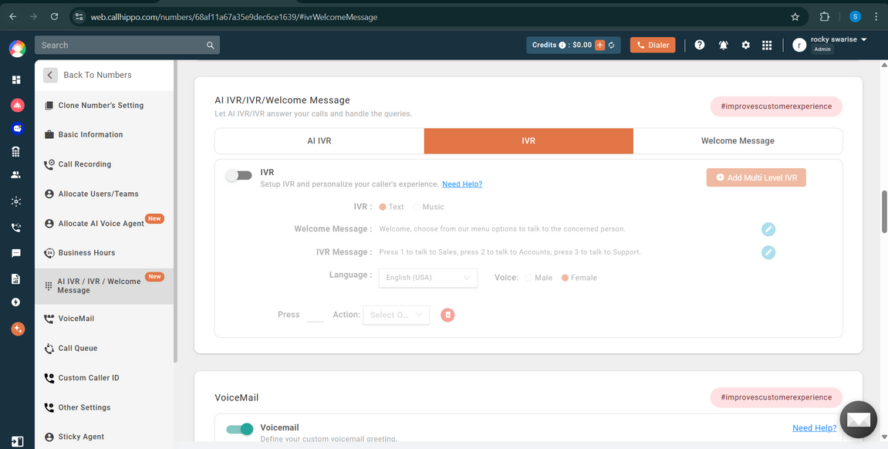
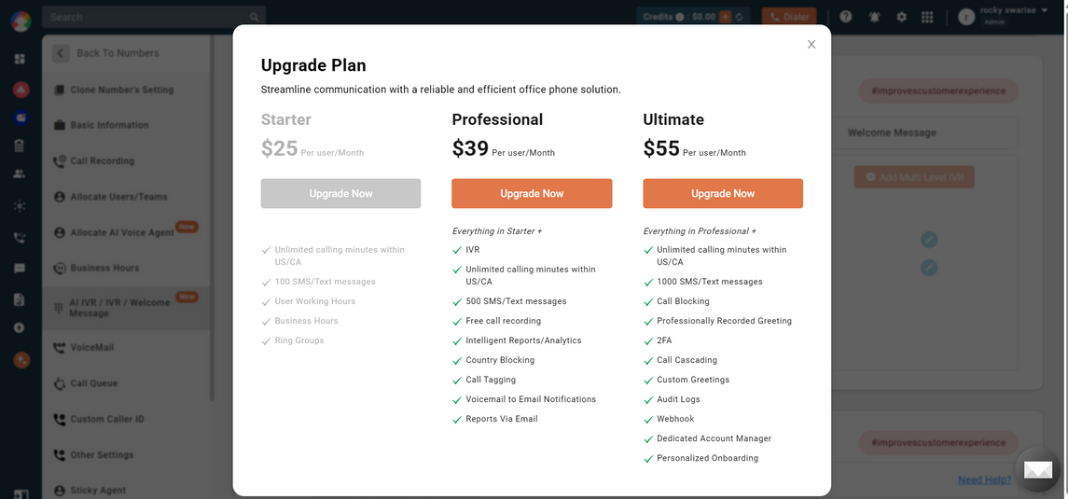

📘 RAG Retrieval Performance Comparison (FAISS vs Pinecone, LangChain vs LlamaIndex)
This document summarizes the performance of four different RAG stack configurations using identical input data (164 documents, ~314 chunks).
The comparison focuses on index build time, retrieval time, and LLM latency.
📊 Performance Summary Table
MODEL - Gemini 2.0 Flash Lite - (FASTER Retrieval )
Overall Comparison
RAG Setup | Index Build Time | Retrieval Time | LLM Time (Avg) | Notes
LangChain + FAISS (Local) | 9.09 sec | 0.425 sec | ~3 sec | Fastest overall; ideal for local workloads
LlamaIndex + Local Vector Store | 11.20 sec | 0.523 sec | ~3 sec | Stable & fast; good abstraction
LlamaIndex + Pinecone | 86.05 sec | 1.304 sec | ~3 sec | Good scalability; slow indexing
LangChain + Pinecone | 19.80 sec | 3.463 sec | ~3 sec | Highest retrieval latency

📝 Detailed Observations
1. Index Build Time
- FAISS (LangChain) is the fastest at 9.09 sec.
- Local Vector Store (LlamaIndex) is close at 11.20 sec.
- Pinecone (LangChain) takes ~20 seconds due to network latency.
- Pinecone (LlamaIndex) is the slowest at 86 sec because embeddings + inserts happen per node.
2. Retrieval Time
- FAISS (LangChain) is the fastest retrieval at 0.425 sec.
- Local Vector Store (LlamaIndex) also performs well at 0.523 sec.
- Pinecone setups introduce network latency, resulting in slower retrieval:
  - LlamaIndex: 1.304 sec
  - LangChain: 3.463 sec (slowest)
3. LLM Time
- LLM invocation times are consistent across all setups (~3–4 sec).
- This depends on the model (Gemini) and not the retrieval system.
🏆 Final Recommendation
If your priority is raw speed, low latency, and local execution:
✔ Use LangChain + FAISS
Best overall: fastest indexing & retrieval.
OR
✔ Use LlamaIndex + Local Vector Store
Great abstraction, simple pipeline, still very fast.
🌐 When to Use Pinecone
Use Pinecone only if:
- You need scalability beyond local machine
- Data is large (>1M vectors)
- You require distributed access
For small to mid-size local RAG systems, Pinecone adds unnecessary network latency.

